Revelation 15 – 18
Week 6 of 8
David M. Colburn
A Daily Bible Study in 7-Day Sections with a Summary-Commentary, Discussion Questions, KTALZ Teaching tools (often pictures), and Daily Application

Sunday (Revelation 15)
The Final Plagues
15:1 Then I saw another great and astounding sign in heaven: seven angels who have seven final plagues (they are final because in them God’s anger is completed).
15:2 Then I saw something like a sea of glass mixed with fire, and those who had conquered the beast and his image and the number of his name. They were standing by the sea of glass, holding harps given to them by God.
15:3 They sang the song of Moses the servant of God and the song of the Lamb:
“Great and astounding are your deeds,
Lord God, the All-Powerful!
Just and true are your ways,
King over the nations!
15:4 Who will not fear you, O Lord, and glorify your name, because you alone are holy?
All nations will come and worship before you for your righteous acts have been revealed.”
15:5 After these things I looked, and the temple (the tent of the testimony) was opened in heaven,
15:6 and the seven angels who had the seven plagues came out of the temple, dressed in clean bright linen, wearing wide golden belts around their chests.
15:7 Then one of the four living creatures gave the seven angels seven golden bowls filled with the wrath of God who lives forever and ever,
15:8 and the temple was filled with smoke from God’s glory and from his power.
Thus no one could enter the temple until the seven plagues from the seven angels were completed.

Prayer
Lord, Your perfect justice will bring an end to the conflict, in the meanwhile the consequence of choices will unfold as it must. May I cling tightly to You for safety in the storms of life.

Summary & Commentary
The meaning of “something like a sea of glass mixed with fire” has spawned much speculation – perhaps it mixes the image of the great flood and the fire which consumed Babylon – as both were terrible tools of judgment for massive sin.
The consequences of thousands of years of rebellion are “bowls of wrath”, the terrible outpouring of a mercy-free cause and effect, a world without the tempering grace of the Lord God.
Standing with the angels, holding the bowls of God’s wrath, were “... those who had conquered the beast and his image and the number of his name”.
The believers were not in the midst of the sea and fire but off to the side “holding harps given to them by God”.
Conquering the beast would have been accomplished through the faith-enabled power of the Lord.
Conquering his image, the animated-idol which so many will worship would happen in the same way.
Conquering “... the number of his name” remains a mystery to be known in its time, but will also only happen through the faith-enabled power of the Lord. [It is interesting to note that “the number of his name” is phrased, in this text, more like a concept or philosophy than a literal numeric digit.]
Despite their preference for evil and rebellion every nation will recognize and submit to the holy power of the Lord God.
While the “bowls of wrath” are being poured-out the Lord God becomes unapproachable in the temple, perhaps a parallel to the “furnace” of Daniel 3, which was so hot that servants who drew too-near were consumed by the heat, or Moses at the “burning bush” in Exodus 3, at which time (and later during the making of the Ten Commandments) he was warned to take care to not approach too-closely and/or to turn away.

Interaction

Consider
Those who stood with the Lord God during the most trying times continued to be held near to Him.

Discuss
What are some other times in the Bible where the Lord God set boundaries in His relationship with humankind, due to His righteous-anger, on which occasions it was only His grace which kept Him from destroying them?

Reflect
The Lord God is the definition of, and the sole source of, holiness.

Share
What is an example of a time when testimonies were shared and the presence of the glory and power of the Lord among His people seemed exceptionally real?

KTALZ

Leaning upon John's qualifier “something like a sea of glass mixed with fire” it may have appeared to him vaguely like the eerie picture above (manipulated a little in an image editor).
Glasslike-water mixed with fire and the people in the distance on the shore.

Faith in Action

Prayer:
Ask the Holy Spirit to inspire in your heart a greater sense of worshipful-awe of the Lord God such that you naturally declare to others your certainty that He will one day return and leave no doubt as to His absolute perfection and power.

Action:
Today I will share this text with someone who opens an opportunity to discuss matters of the return of Jesus or the prophesies of the last days of the end times or something similar. I will gently, respectfully, and boldly share my personal certainty that all that the Lord says will happen, in His Word, will indeed happen.
Be Specific ______________________________________________________

Monday (Revelation 16:1-14)
The Bowls of God’s Wrath
16:1 Then I heard a loud voice from the temple declaring to the seven angels: “Go and pour out on the earth the seven bowls containing God’s wrath.”
16:2 So the first angel went and poured out his bowl on the earth. Then ugly and painful sores appeared on the people who had the mark of the beast and who worshiped his image.
16:3 Next, the second angel poured out his bowl on the sea and it turned into blood, like that of a corpse, and every living creature that was in the sea died.
16:4 Then the third angel poured out his bowl on the rivers and the springs of water, and they turned into blood.
16:5 Now I heard the angel of the waters saying: “You are just – the one who is and who was, the Holy One – because you have passed these judgments,
16:6 because they poured out the blood of your saints and prophets, so you have given them blood to drink. They got what they deserved!”
16:7 Then I heard the altar reply, “Yes, Lord God, the All-Powerful, your judgments are true and just!”
16:8 Then the fourth angel poured out his bowl on the sun, and it was permitted to scorch people with fire.
16:9 Thus people were scorched by the terrible heat, yet they blasphemed the name of God, who has ruling authority over these plagues, and they would not repent and give him glory.
16:10 Then the fifth angel poured out his bowl on the throne of the beast so that darkness covered his kingdom, and people began to bite their tongues because of their pain.
16:11 They blasphemed the God of heaven because of their sufferings and because of their sores, but nevertheless they still refused to repent of their deeds.
16:12 Then the sixth angel poured out his bowl on the great river Euphrates and dried up its water to prepare the way for the kings from the east.
16:13 Then I saw three unclean spirits that looked like frogs coming out of the mouth of the dragon, out of the mouth of the beast, and out of the mouth of the false prophet.
16:14 For they are the spirits of the demons performing signs who go out to the kings of the earth to bring them together for the battle that will take place on the great day of God, the All-Powerful.

Prayer
Lord, You are always just, it is humankind which is both rebellious and unjust. May I pray for salvation and share Your truth with those who do not yet have a saving relationship with You.

Summary & Commentary
Choices have consequences.
Observe that it says “... every living creature” in the sea died. This breaks the food-cycle of the entire planet.
“... the angel of the waters”, the being dispatched to deliver the third bowl of God's wrath upon the waters, declared the justice of the Egypt-like plague (turning the waters to blood), then those gathered around the altar of Heaven agreed in unison.
Vs 16:6 justice and vs. 16:7 affirmation.
Vs 16:8 an incredible expression of power, from a human standpoint, that the massive sun could be stimulated to expel enough energy - above and beyond the usual - to burn people on the earth. Despite the acknowledgment that the source of the plague was God, same as the three prior plagues, the unrepentant people still refused to “... give Him glory but, rather, blasphemed His name.”
Sores on their bodies, no fish in the sea, no water to drink, burns, and oppressive heat, and now darkness – yet the unrepentant continue to rebel.
A huge highway is made from the river bed as it is about time for the battle of Armageddon - and the armies need to gather.
God allows the demons to summon the human kings of the rebellious people.

Interaction

Consider
Consequences come to unrepentant humans who choose Satan over God. As distasteful as it is – this is justice. Note that the text refers over and over to their continued choice to blaspheme God rather than to surrender and worship Him.

Discuss
What are some practical ways to show people the Lord God’s consistency from Genesis to Revelation? (He tells us how to be right before Him and what are the consequences of rebellion. He uses many of the same consequences over and over, so that none may be surprised when they come again in His final judgment.)

Reflect
The depth of arrogant-rebellion is amazing; even under these devastatingly-horrific conditions people continue to assert their independence from God and their reliance upon Satan – who clearly is powerless to protect them and who is also part of the reason for their suffering.

Share
What is an example of contemporary events where despite overwhelming evidence some people refuse to accept truth because it would require them to be aligned with a group or person whom they have been propagandized to hate?

KTALZ

Everything will be dying, even the water will be turned to blood, yet they will persist in their rebellion.

Faith in Action

Prayer:
Ask the Holy Spirit to reveal to you a place in your life where you have accepted a lie because to think and/or act otherwise would force you to make peace with someone or some organization for whom you have developed a strong dislike.

Action:
Today I agree to cooperate with the Holy Spirit, and as necessary to recruit an accountability and prayer partner, as I walk through the process of accepting a hard truth as I reconcile with a hard-to-like and hard-to-love person or group of people.
Be Specific ______________________________________________________

Tuesday (Revelation 16:15-21)
16:15 (Look! I will come like a thief!
Blessed is the one who stays alert and does not lose his clothes so that he will not have to walk around naked and his shameful condition be seen.)
16:16 Now the spirits gathered the kings and their armies to the place that is called Armageddon in Hebrew.
16:17 Finally the seventh angel poured out his bowl into the air and a loud voice came out of the temple from the throne, saying: “It is done!”
16:18 Then there were flashes of lightning, roaring, and crashes of thunder, and there was a tremendous earthquake – an earthquake unequaled since humanity has been on the earth, so tremendous was that earthquake.
16:19 The great city was split into three parts and the cities of the nations collapsed. So Babylon the great was remembered before God, and was given the cup filled with the wine made of God’s furious wrath.
16:20 Every island fled away and no mountains could be found.
16:21 And gigantic hailstones, weighing about a hundred pounds each, fell from heaven on people, but they blasphemed God because of the plague of hail, since it was so horrendous.

Prayer
Lord, as the final bowl of Your righteous-wrath is poured-out what Jesus defeated when He said “it is finished” is thereby completed. May I be both glad and sad as this means that the time has come for You to gather Your children home and to destroy evil, yet many will perish and suffer for their rebellion.

Summary & Commentary
The “bowls” have been prophesies of what is to come. The next day of study begins the process of deeper explanation and additional visualization given to John.
Jesus again declares that He will return to end the days of fallen man on this earth – and no one but God knows that day – so we must be at the ready. We do not want to be found being careless about the things He required of us in faithful response to His gift.
Armageddon means the high place of Megiddo, it is the OT location of two major victories, and is also where both Saul and Josiah died. It is a place in history of massive conflict and of massive losses.
The OT judgment of Sodom and Gomorrah, and the last words of Jesus on the Cross, are echoed “it is done” or “it is finished” as the flow of evil out from Babylon is now reversed against it.
The cities are gone, the fish are dead, the water is undrinkable, people suffer sores and sunburns, great armies have gathered at Megiddo, the land has been leveled and there are no islands to which anyone may escape.
Then the “... gigantic hailstones” fall. (The smoke and ash and dust from the burning and crumbling cities have seeded the clouds?)
But still the unrepentant people blasphemed God rather than turn to the all-powerful One and the only One who can save them.
The Lord is showing them the “sign” that they demanded in Mark 8:11-12, and as Jesus knew “in His Spirit”, would make no difference.

Interaction

Consider
Jesus will return and those without a saving relationship with Him will be as if they were without clothes, their sin visible to earth and heaven, their doom sealed.

Discuss
Why is it important that we presume that the day of His return may be tomorrow, rather than some specific date in the distant future?

Reflect
The Lord allowed Cain's descendants to establish the first city and throughout history cities have served as places of concentrated sin.

Share
When have you observed a person, aware of a deadline, awaiting the last minute to complete tasks in which they should have engaged daily without regard to the deadline?

KTALZ
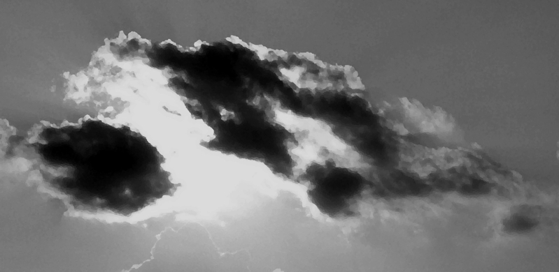

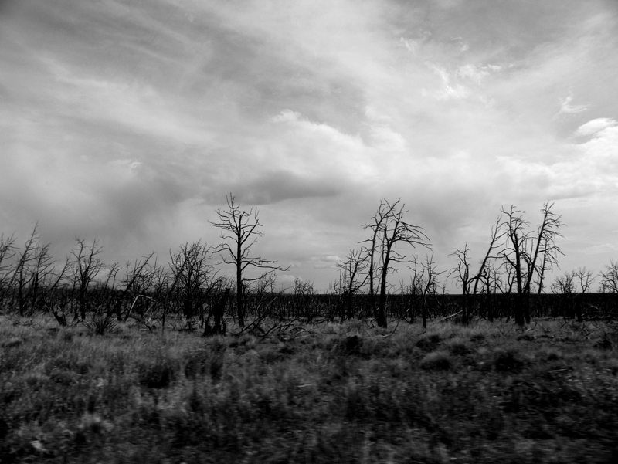
Once again the Lord will use the weather as a tool. The land will be dead then huge “hailstones” will fall on the people. Bleak, hopeless, no mercy for the unrepentant.

Faith in Action

Prayer:
Ask the Holy Spirit to reveal to you one area of your live where you have procrastinated dealing with sin.

Action:
Today I will prayerfully confess and repent of both the sin and the procrastination, I will partner with the Holy Spirit to drive that sin from my life, and I will pray daily against its return.
Be Specific ______________________________________________________

Wednesday (Revelation 17:1-9a)
The Great Prostitute and the Beast
17:1 Then one of the seven angels who had the seven bowls came and spoke to me. “Come,” he said, “I will show you the condemnation and punishment of the great prostitute who sits on many waters,
17:2 with whom the kings of the earth committed sexual immorality and the earth’s inhabitants got drunk with the wine of her immorality.”
17:3 So he carried me away in the Spirit to a wilderness, and there I saw a woman sitting on a scarlet beast that was full of blasphemous names and had seven heads and ten horns.
17:4 Now the woman was dressed in purple and scarlet clothing, and adorned with gold, precious stones, and pearls. She held in her hand a golden cup filled with detestable things and unclean things from her sexual immorality.
17:5 On her forehead was written a name, a mystery: “Babylon the Great, the Mother of prostitutes and of the detestable things of the earth.”
17:6a I saw that the woman was drunk with the blood of the saints and the blood of those who testified to Jesus.
17:6b I was greatly astounded when I saw her. 17:7 But the angel said to me, “Why are you astounded? I will interpret for you the mystery of the woman and of the beast with the seven heads and ten horns that carries her. 17:8a The beast you saw was, and is not, but is about to come up from the abyss and then go to destruction.”
17:8b The inhabitants of the earth – all those whose names have not been written in the book of life since the foundation of the world – will be astounded when they see that the beast was, and is not, but is to come.
17:9 (This requires a mind that has wisdom.)

Prayer
Lord, Your children are not involved in the pouring-out of Your wrath, but the immense evil that is described is profound. May my prayer-filled empathy for those not-yet-saved grow and my outreach to them increase.

Summary & Commentary
The detail of the working-out of the prophesies of the “bowls” is now explained and visualized further to John.
The great prostitute is over “peoples, multitudes, nations, and languages” (see Verse 17:15). It/she is the worldly philosophy or system which teaches rebellion against God and the pursuit of sin.
“Mystery” is a term which often refers to something difficult to understand and generally involving a spiritual element. Many of the word pictures John uses are common between Revelation and elsewhere in the NT and OT. This “woman” is not the same as the “prostitute”.
Wisdom was elsewhere referred to as “she” and here the opposite of wisdom is also described using a feminine imagery.
Seven is a number used in Creation and again in Revelation to refer to those belonging to the Lord God – Satan, always a pretender to God's throne copies Him with the use of seven.
Satan hates truth and all who reject Jesus are slaves to him. Those who hate truth hate those who love the truth. The world system is his tool of manipulation in the world and it joins him in a desire to destroy all believers - because believers convict them of their blasphemous life choices.
The beast was swept from the earth “... was, and is not” but will be released to face judgment. The unsaved will be shocked when they see that God not only took the beast, whom they worshiped, away and that He may at-will bring him back for judgment.

Interaction

Consider
Leaders of nations, perhaps also sub-groups within nations, entice the people to follow apostate religions, leading them away from the truth of the Lord God. The Word teaches that “... people perish for lack of knowledge.” [Hosea 4:6]

Discuss
How can the Biblical-Christian church more-effectively educate people about the essentials of the faith so that they are not as easily deceived?

Reflect
The Enemy, and his associates, have done – and will do – a great deal of harm, but the Lord God is greater and His great plan will be completed.

Share
When have you experienced or observed a leader causing people to look away from Biblical teaching and at “another gospel”?

KTALZ



Like an alligator or crocodile the beast is seen, then not, then seen again – seen or unseen just knowing it is somewhere in the area is unnerving.
In the case of the Biblical text the power demonstrated by God over the beast would be like caging a gator, that seemed too powerful to capture, only to release it later.

Faith in Action

Prayer:
Ask the Holy Spirit to reveal to you an opportunity to educate people about the essentials of the Biblical-Christian faith.

Action:
Today I will prayerfully and practically, directly and/or indirectly, teach, serve, and assist in discipleship in every way that the Holy Spirit directs and provides.
Be Specific ______________________________________________________

Thursday (Revelation 17:9b-18)
17:9b “The seven heads are seven mountains the woman sits on.
They are also seven kings: 17:10 five have fallen; one is, and the other has not yet come, but whenever he does come, he must remain for only a brief time.
17:11 “The beast that was, and is not, is himself an eighth king and yet is one of the seven, and is going to destruction.
17:12 “The ten horns that you saw are ten kings who have not yet received a kingdom, but will receive ruling authority as kings with the beast for one hour.
17:13 “These kings have a single intent, and they will give their power and authority to the beast.
17:14 “They will make war with the Lamb, but the Lamb will conquer them, because he is Lord of lords and King of kings, and those accompanying the Lamb are the called, chosen, and faithful.”
17:15 Then the angel said to me, “The waters you saw (where the prostitute is seated) are peoples, multitudes, nations, and languages.
17:16 The ten horns that you saw, and the beast – these will hate the prostitute and make her desolate and naked. They will consume her flesh and burn her up
with fire.
17:17 For God has put into their minds to carry out his purpose by making a decision to give their royal power to the beast until the words of God are fulfilled.”
“17:18 As for the woman you saw, she is the great city that has sovereignty over the kings of the earth.”

Prayer
Lord, no matter how many fallen angels and rebellious humans join with the enemy, You will always prevail. May I trust You, rest in the certainty that soon all imperfection will be obliterated, and serve you with complete confidence of right and victory.

Summary & Commentary
Some have taken this, and some text to follow, to refer to literal human kings in past history. Others take it to refer philosophies or religions. If this follows (in terms of a sequential timeline) then the events of Rev. 16 describing the leveling of the mountains intended to say some rather than all, this is not a sequential event (the text strongly indicates that it is sequential), or else the term “mountain” here is rhetorical and not literal.
The beast can be both one of the seven and also an eighth king because this one was a king that had fallen but was later brought back becomes a king again.
The time-sequence of Revelation is somewhat mysterious; some have speculated that John, in a non-linear time experience, is seeing the past, present and future, others suggest that he is seeing only the future (following his time), and yet others that the events are entirely from the Tribulation-forward.
It has been suggested that these are usurpers of worldly political authority in ten states or regions who are manipulated into power so that they may transfer the sovereign powers of the ten to a single one-world power.
The “Lamb” (the Son of God, member of the Trinity) has superior authority and power and will always prevail.
There is ultimately no “honor among thieves” as here they turn upon 'one' of their own in vs 17:16.
Vs 17:18 refers to the rhetorical Babylon, the world system of God-less immorality.

Interaction

Consider
The big picture of sin is that it pollutes “peoples, multitudes, nations, and languages”.

Discuss
What are some practical ways to explain the Biblical meaning of “Babylon”?

Reflect
What are the subtle and not-so-subtle ways that sin is able to spread across to much of the world and yet not be recognized and rejected as destructive?

Share
What is an example from your life where you discovered hidden sin in your life which had been promoted by culture, tradition, government, or language?

KTALZ

As you think about John's effort to describe the vast-reach of the sin-inducing effect of the “woman” try to visualize the incredible scene of her sitting at-once upon many mountains.

Faith in Action

Prayer:
Ask the Holy Spirit to reveal to you ways that enticements to sin are being brought into your life, promoted by culture, tradition, government, or language.

Action:
Today I agree to do what I can to avoid and/or purge those things where I can, to pray for God’s protection, and to enter into a prayer and accountability relationship with a fellow believer to keep myself safe.
Be Specific ______________________________________________________

Friday (Revelation 18:1-8)
Babylon is Destroyed
18:1 After these things I saw another angel, who possessed great authority, coming down out of heaven, and the earth was lit up by his radiance.
18:2 He shouted with a powerful voice: “Fallen, fallen, is Babylon the great! She has become a lair for demons, a haunt for every unclean spirit, a haunt for every unclean bird, a haunt for every unclean and detested beast.
18:3 “For all the nations have fallen from the wine of her immoral passion, and the kings of the earth have committed sexual immorality with her, and the merchants of the earth have gotten rich from the power of her sensual behavior.”
18:4 Then I heard another voice from heaven saying, “Come out of her, my people, so you will not take part in her sins and so you will not receive her plagues,
18:5 “because her sins have piled up all the way to heaven and God has remembered her crimes.
18:6 “Repay her the same way she repaid others; pay her back double corresponding to her deeds. In the cup she mixed, mix double the amount for her.
18:7 “As much as she exalted herself and lived in sensual luxury, to this extent give her torment and grief because she said to herself, ‘I rule as queen and am no widow; I will never experience grief!’
18:8 “For this reason, she will experience her plagues in a single day: disease, mourning, and famine, and she will be burned down with fire, because the Lord God who judges her is powerful!”

Prayer
Lord, the philosophies and people who promote evil-rebellion must soon be eliminated by You, and Your children must learn to avoid them in the meanwhile. May I be watchful, warning others, and accepting the wisdom of Your Holy Spirit to avoid evil in my own life.

Summary & Commentary
As discussed in previous weeks the events of Revelation are unlikely to be time-linear but, rather, moving from scenario to scenario to explain different elements of the last days of the end times.
Chapter 18 begins with “After these things ...” then in vs 4 mentions saved people coming out from association with the sinfulness of Babylon, placing that moment clearly prior to the Wrath of God.
The angelic being referenced is not Jesus, any more than the angel in 10:1 was. It has all of the Biblical markings of an “archangel” such as Gabriel or Michael.
The angel of the Lord God brings light into a very dark world much as every believer is instructed to bring both light and salt into the world around them.
The discussion of “Babylon” in Rev. 17 may be worth revisiting for perspective.
Selling-out to anything but the Lord God is immoral and is a form of slavery to the lusts of the flesh.
Vs 4 reads like a parallel to the Lord God’s call upon Lot, via Abraham, to flee Sodom and Gomorrah.
The source of of encouragement, the false prophets and religions (to rebel against the Lordship of God) is now punished by God.

Interaction

Consider
The world system, fed by the evil of the enemy, seduces and compromises all who trust it.

Discuss
What are some good ways to help people to recognize the difference between the things of the Lord God and those of the world, without becoming too legalistic, yet without compromising with sin?

Reflect
How different are we when it comes to things of pleasure?

Share
When have you experienced or observed the people of God being persuaded that worldly priorities are acceptable when they clearly are not?

KTALZ

The angel (archangel) illuminated the sky of the fallen earth, darkened by sin, with the light of heaven.

Faith in Action

Prayer:
Ask the Holy Spirit to reveal to you a place in your life where you have been led astray by the community and/or people of influence (in your life) around you.

Action:
Today I will confess and repent of my drift into unrighteous priorities, I will restructure my life to replace them with the things of God, and I will prayerfully review daily or weekly to assure that I don’t drift back into worldly ways.
Be Specific ______________________________________________________

Saturday (Revelation 18:9-24)
18:9 Then the kings of the earth who committed immoral acts with her and lived in sensual luxury with her will weep and wail for her when they see the smoke from the fire that burns her up.
18:10 They will stand a long way off because they are afraid of her torment, and will say, “Woe, woe, O great city, Babylon the powerful city! For in a single hour your doom has come!”
18:11 Then the merchants of the earth will weep and mourn for her because no one buys their cargo any longer – 18:12 cargo such as gold, silver, precious stones, pearls, fine linen, purple cloth, silk, scarlet cloth, all sorts of things made of citron wood, all sorts of objects made of ivory, all sorts of things made of expensive wood, bronze, iron and marble, 18:13 cinnamon, spice, incense, perfumed ointment, frankincense, wine, olive oil and costly flour, wheat, cattle and sheep, horses and four-wheeled carriages, slaves and human lives. 18:14 (The ripe fruit you greatly desired has gone from you, and all your luxury and splendor have gone from you – they will never ever be found again!)
18:15 The merchants who sold these things, who got rich from her, will stand a long way off because they are afraid of her torment. They will weep and mourn, 18:16 saying, “Woe, woe, O great city –dressed in fine linen, purple and scarlet clothing, and adorned with gold, precious stones, and pearls –18:17a because in a single hour such great wealth has been destroyed!”
18:17b And every ship’s captain, and all who sail along the coast – seamen, and all who make their living from the sea, stood a long way off 18:18 and began to shout when they saw the smoke from the fire that burned her up, “Who is like the great city?”
18:19 And they threw dust on their heads and were shouting with weeping and mourning, “Woe, Woe, O great city – in which all those who had ships on the sea got rich from her wealth – because in a single hour she has been destroyed!”
18:20 (Rejoice over her, O heaven, and you saints and apostles and prophets, for God has pronounced judgment against her on your behalf!)
18:21 Then one powerful angel picked up a stone like a huge millstone, threw it into the sea, and said, “With this kind of sudden violent force Babylon the great city will be thrown down and it will never be found again!
18:22 And the sound of the harpists, musicians, flute players, and trumpeters will never be heard in you again. No craftsman who practices any trade will ever be found in you again; the noise of a mill will never be heard in you again. 18:23 Even the light from a lamp will never shine in you again! The voices of the bridegroom and his bride will never be heard in you again. For your merchants were the tycoons of the world, because all the nations were deceived by your magic spells! 18:24 The blood of the saints and prophets was found in her, along with the blood of all those who had been killed on the earth.”

Prayer
Lord, You have made no secret of what You love and hate, and have been patient. May I never look back to the past and long to be in those sinful places again.

Summary & Commentary
The longing of the merchants and others for the city being destroyed, because of sin, is a parallel to perspective of Lot’s wife who so longed for the worldly she disobeyed the angel and looked back – and was turned to a pillar of salt.
The people described in verses 18:9 and 18:15 are so obsessed with the things of the world that they miss the reality that the same God who destroyed Babylon has the power to destroy or save them. In verses 17b-19, once again, they miss the point.
Verse 20 is about justice.
The legend of Atlantis probably flowed from an unattributed thread of John's text here in this part of Revelation (or perhaps pieces of OT prophesy which foretold key elements of this text). The mystery in the fable of Atlantis is how and why the great city of Atlantis was suddenly destroyed. There are many such fables, which some claim to pre-date the Bible, but which actually only represent mere fragments of the Biblical story - evidence of the link to the Biblical source has been long-lost.
The direct point of the text is that justice is meted-out upon rhetorical Babylon, also anthropomorphised as a woman, well-spring of rebellious selfishness.

Interaction

Consider
What terrible blindness those observing the destruction had; they were so consumed with their momentary selfishness that they missed the big-picture reality of Who was doing the destroying and why.

Discuss
What are some ways that the sinful influence of “Babylon”, as described here, is expressed through individuals, institutions, philosophies, and false religions today?

Reflect
How are modern people so entangled in the world that when the end comes that will fail to recognize the evil of the world system and/or comprehend that “her” (Babylon's) fate may also become theirs?

Share
When have you observed an example of an individual, institution, philosophy, or religion that has sold-out to “Babylon”?

KTALZ

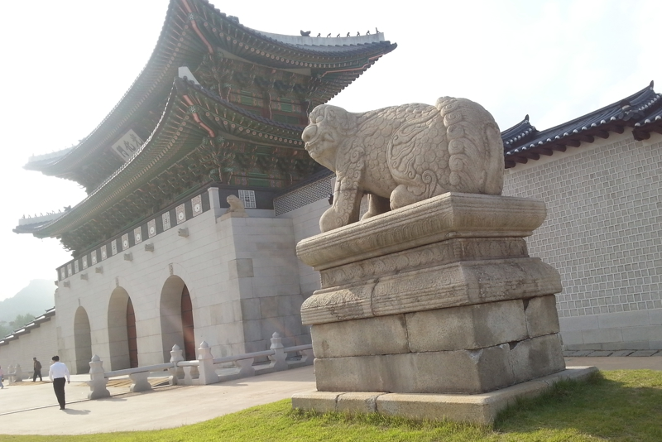

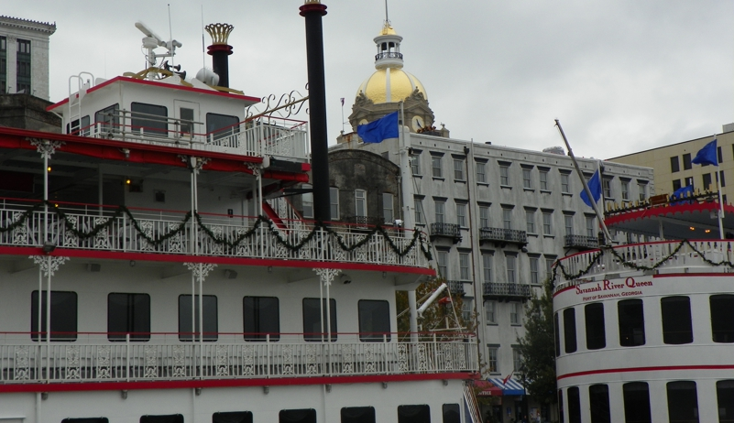
There are many images we may think of when we try to picture all of the things that the world considers valuable. Study these and make a list of worldly-value that contrasts with the highest value of God – restored relationship between humankind and Him.

Faith in Action

Prayer
Ask the Holy Spirit to reveal to you a place in your life where you have been tolerating a Babylon-like influence for reasons of comfort, convenience, power, or profit.

Action
Today I will partner with the Holy Spirit, and as is appropriate, a fellow believer (for accountability and prayer) to purge that influence from my life – no matter the cost.
Be Specific ______________________________________________________
All Bible text is from the NET unless otherwise indicated - http://bible.org
Note 1: These Studies often rely upon the guidance of the NET Translators from their associated notes. Careful attention has been given to cite that source where it has been quoted directly or closely paraphrased. Feedback is encouraged where credit has not been sufficiently assigned.
Note 2: When NET text is quoted in commentary and discussion all pronouns referring to God are capitalized, though they are lower-case in the original NET text.
Commentary text is from David M. Colburn, D.Min. unless otherwise noted.
Copyright © 2012 by David M. Colburn. This is a BibleSeven Study – “Revelation” Section – Revelation 4 – 5 – prepared by David M. Colburn and edited for bible.org in June of 2012. This text may be used for non-profit educational purposes only, with credit; all other usage requires prior written consent of the author.

