Revelation 8 - 14
David M. Colburn
A Daily Bible Study in 7-Day Sections with a Summary-Commentary, Discussion Questions, and Daily Application
From this point on much of the Book of Revelation becomes far more difficult to understand. Before moving into four weeks of somewhat deeper study of these final texts three tools of perspective may help:
1. Most of what John describes is symbolic, not literal; dividing between that which is symbolic and literal is an exercise in careful linkage to the prior content of the Bible, wisdom (as John repeatedly states), and prayer.
2. As noted earlier in the study of this Book, the texts are often not intended to present a purely time-linear series of events (those which are sequential bear a linking-preface such as “then”); rather, like Genesis 1 and 2, Kings and Chronicles, and the Gospels there is a telling and retelling which layer message and meaning.
3. Two techniques may lend themselves to a sense of context, perspective, and peace: a. As you read through the rest of the Book - without break - play some music which you find encourages your heart and mind in faith (this author likes “Take You At Your Word” and “If My People Pray” by Avalon, perhaps classics such as “Onward Christian Soldiers” or “Amazing Grace” may bless others), b. Accept that you will not understand every detail, that you are not expected to, and that understanding every detail will not change anything – though the big picture message at the end should energize (perhaps transform) your faith life and faith walk.

Sunday (Revelation 8 – 10)
The Seventh Seal
8:1 Now when the Lamb opened the seventh seal there was silence in heaven for about half an hour.
8:2 Then I saw the seven angels who stand before God, and seven trumpets were given to them. 8:3 Another angel holding a golden censer came and was stationed at the altar. A large amount of incense was given to him to offer up, with the prayers of all the saints, on the golden altar that is before the throne. 8:4 The smoke coming from the incense, along with the prayers of the saints, ascended before God from the angel’s hand. 8:5 Then the angel took the censer, filled it with fire from the altar, and threw it on the earth, and there were crashes of thunder, roaring, flashes of lightning, and an earthquake.”
8:6 Now the seven angels holding the seven trumpets prepared to blow them. 8:7 The first angel blew his trumpet, and there was hail and fire mixed with blood, and it was thrown at the earth so that a third of the earth was burned up, a third of the trees were burned up, and all the green grass was burned up.”
8:8 Then the second angel blew his trumpet, and something like a great mountain of burning fire was thrown into the sea. A third of the sea became blood, 8:9 and a third of the creatures living in the sea died, and a third of the ships were completely destroyed.”
8:10 Then the third angel blew his trumpet, and a huge star burning like a torch fell from the sky; it landed on a third of the rivers and on the springs of water. 8:11 (Now the name of the star is Wormwood.) So a third of the waters became wormwood, and many people died from these waters because they were poisoned.
8:12 Then the fourth angel blew his trumpet, and a third of the sun was struck, and a third of the moon, and a third of the stars, so that a third of them were darkened. And there was no light for a third of the day and for a third of the night likewise.
8:13 Then I looked, and I heard an eagle flying directly overhead, proclaiming with a loud voice, “Woe! Woe! Woe to those who live on the earth because of the remaining sounds of the trumpets of the three angels who are about to blow them!”
9:1 Then the fifth angel blew his trumpet, and I saw a star that had fallen from the sky to the earth, and he was given the key to the shaft of the abyss.
9:2 He opened the shaft of the abyss and smoke rose out of it like smoke from a giant furnace. The sun and the air were darkened with smoke from the shaft. 9:3 Then out of the smoke came locusts onto the earth, and they were given power like that of the scorpions of the earth.
9:4 They were told not to damage the grass of the earth, or any green plant or tree, but only those people who did not have the seal of God on their forehead. 9:5 The locusts were not given permission to kill them, but only to torture them for five months, and their torture was like that of a scorpion when it stings a person. 9:6 In those days people will seek death, but will not be able to find it; they will long to die, but death will flee from them.
9:7 Now the locusts looked like horses equipped for battle. On their heads were something like crowns similar to gold, and their faces looked like men’s faces. 9:8 They had hair like women’s hair, and their teeth were like lions’ teeth. 9:9 They had breastplates like iron breastplates, and the sound of their wings was like the noise of many horse-drawn chariots charging into battle. 9:10 They have tails and stingers like scorpions, and their ability to injure people for five months is in their tails.
9:11 They have as king over them the angel of the abyss, whose name in Hebrew is Abaddon, and in Greek, Apollyon.
9:12 The first woe has passed, but two woes are still coming after these things!
9:13 Then the sixth angel blew his trumpet, and I heard a single voice coming from the horns on the golden altar that is before God, 9:14 saying to the sixth angel, the one holding the trumpet, “Set free the four angels who are bound at the great river Euphrates!” 9:15 Then the four angels who had been prepared for this hour, day, month, and year were set free to kill a third of humanity. 9:16 The number of soldiers on horseback was two hundred million; I heard their number.
9:17 Now this is what the horses and their riders looked like in my vision: The riders had breastplates that were fiery red, dark blue, and sulfurous yellow in color. The heads of the horses looked like lions’ heads, and fire, smoke, and sulfur came out of their mouths.
9:18 A third of humanity was killed by these three plagues, that is, by the fire, the smoke, and the sulfur that came out of their mouths. 9:19 For the power of the horses resides in their mouths and in their tails, because their tails are like snakes, having heads that inflict injuries.
9:20 The rest of humanity, who had not been killed by these plagues, did not repent of the works of their hands, so that they did not stop worshiping demons and idols made of gold, silver, bronze, stone, and wood – idols that cannot see or hear or walk about. 9:21 Furthermore, they did not repent of their murders, of their magic spells, of their sexual immorality, or of their stealing.
The Angel with the Little Scroll
10:1 Then I saw another powerful angel descending from heaven, wrapped in a cloud, with a rainbow above his head; his face was like the sun and his legs were like pillars of fire.
10:2 He held in his hand a little scroll that was open, and he put his right foot on the sea and his left on the land. 10:3 Then he shouted in a loud voice like a lion roaring, and when he shouted, the seven thunders sounded their voices.
10:4 When the seven thunders spoke, I was preparing to write, but just then I heard a voice from heaven say, “Seal up what the seven thunders spoke and do not write it down.”
10:5 Then the angel I saw standing on the sea and on the land raised his right hand to heaven 10:6 and swore by the one who lives forever and ever, who created heaven and what is in it, and the earth and what is in it, and the sea and what is in it, “There will be no more delay! 10:7 But in the days when the seventh angel is about to blow his trumpet, the mystery of God is completed, just as he has proclaimed to his servants the prophets.”
10:8 Then the voice I had heard from heaven began to speak to me again, “Go and take the open scroll in the hand of the angel who is standing on the sea and on the land.” 10:9 So I went to the angel and asked him to give me the little scroll. He said to me, “Take the scroll and eat it. It will make your stomach bitter, but it will be as sweet as honey in your mouth.” 10:10 So I took the little scroll from the angel’s hand and ate it, and it did taste as sweet as honey in my mouth, but when I had eaten it, my stomach became bitter. 10:11 Then they told me: “You must prophesy again about many peoples, nations, languages, and kings.”

Prayer
Lord, that of which You have warned will come, and there will be accountability for rebellion. May I be faithful in warning those who have not yet accepted Christ, faithful in praying for the same, and comforted to know that Your wrath is reserved only for those whose names are not recorded in “The Book of Life”.

Summary & Commentary
It is unclear how John marked time but one may reasonably take the delay to reflect his sense of anticipation and the seriousness of the moment.
Observe the continuing importance God assigns to “... the prayers of the all the saints”, which means every believer.
Some of the symbolism parallels the plagues that the Lord brought upon Egypt.
If one were to put a more-fine point to the sequencing of events, one might postulate that the Tribulation is followed by the three “woes” of the Lord God’s Wrath; Consequence, Judgment, and Destruction.
This is the beginning of the Judgment, to follow the Consequence of rebellion – the withdrawal of the Lord God’s protection from the evil powers of the “pit” where He has long-restrained the worst of the forces of Satan.
[Note: In 6:9-11 some who had died for their faith cried out for the justice of God, not in a sense of revenge, but in a desire for a new heaven and earth free of sin. There is there a reference to a “number” required prior to the “end” and it has been speculated that said number referred to the “144,000” found in 7:3-4 and again later in 9:3. The two challenges here go to the question of their presence during the Wrath and to the location of the rest of the saved. Verse 9:20 makes it clear that no believers are counted among those suffering the Wrath because those who are alive and still on the earth are utterly unrepentant. The text of Revelation does not, to this point, explicitly state the removal of believers – such is described in a later 'layer' of descriptive text using the term “harvesting”.]
Whereas blood was a symbol of the covering of sin in the OT, and of sin washed-away in the NT, here in the pouring-out of the Wrath of God (8:7) it represents judgment.
It seems that the intended difference in 8:7 is that the Wrath was to be expressed via “hail and fire mixed with blood” against the surface of the planet whereas in 9:3 it was against rebellious humankind. It is notable that “locusts”, previously used against crops of food are here used against the human products of unrepentant sin.
There is a repeated pattern of “a third” - which reminds one of the percentage of angels who fell from Heaven with Satan in rebellion, it has also been speculated that when a man died without a will the law specified that one-third portion was to be given to the widow and the other two-thirds to the heir. When Jesus “died” His “widow” was the unsaved – thus judgment symbolically comes to one-third.
It has been speculated that the “huge star” could be an asteroid, though a little further along in the text it appears that it may be a reference to an angel, or a group of angels.
Wormwood was well-known to John's readers as a very bitter substance in the Middle East – in this case it was toxic – physically and/or spiritually. Note also that “bitter” was a term used to refer to tragedy such as death of a loved one, illness, loss in battle, or lost resources such as a crop failure – often due to persistent drought.
Proclamations of woe were common in OT times, sometimes as a means to demoralize a surrounded enemy, sometimes to warn a people in rebellion against God of chastisement to come.
The NET translator’s notes suggest that in 8:13 “angel” rather than “eagle” is an acceptable alternative – in either case this being is issuing a clarion call of doom.
Note that in 7:3-4 a mark had been placed on the foreheads of the 144,000 specially set-apart by the Lord. In 9:3 the being who had come to open the “abyss” was forbidden to “damage the grass of the earth, or any green plant or tree, but only those people who did not have the seal of God on their forehead.” - which modified the temporary prior allowance of damage to grass and plants and trees.
The “key” in vs 9:1 may refer to authority or knowledge or power, in this case it is associated with the capacity to open access to “the abyss”. In the Book of Job it was the Enemy, or one of his minions, who was allowed by God to bring into the earth a taste of life without God’s protection. As in Job God sets limits. Observe again that this is the Wrath, not the Tribulation, as God has already removed those who are already His.
This contains an additional detail as to the term “star”, which is not notated in Chapter 8, here the “star” is identified as a being rather than an inanimate object. It is also possible that the “star” is an angel sent by God.
John uses “like” because his descriptions were the nearest he could get. The “five months” parallels the Flood as well as the normal activity of locusts. During this period of the Wrath there was no escape from the suffering of a God-free existence even via death.
Various speculations have Abaddon/Apollyon refer to Satan, the Antichrist, or the demonic equivalent of an archangel.
The “seven thunders” are not directly identified in the text but may be yet another phrase used to refer to the “seven spirits” whom we discussed earlier in the Revelation series.
Daniel 12:4, 9, and 2 Cor. 12:4 also report revelation that was withheld.
John appeared to be looking ahead “But in the days when ...”. “The mystery of God ...” is also referenced elsewhere in the Bible, including by Paul.
John recognized that his task “You must prophesy again about many peoples, nations, languages, and kings.” would be a largely bitter experience even as the truth of God would be a sweet taste in his mouth.

Interaction

Consider
Sometimes the Lord God doesn’t tell us all things but only the things we need to know when we need to know them. The Lord continued to place value on the prayers of the “saints” - believers.

Discuss
What are some practical ways to share the truth, which to those who love truth is sweet, but to those who do not it is bitter? How do we share difficult truths without losing our own love for truth in the process?

Reflect
The intentional process of God causes each step to happen in perfect time and sequence.

Share
What is an example from your life where you were able to share a difficult truth with someone and they remained open to further truth rather than hiding from it for fear that they might receive additional challenging information? (The calamities described are a reflection of the absence of God’s hand of protection – withdrawn because people have rejected Him, followed by God’s judgment because of their hard hearts against His truth.)

KTALZ
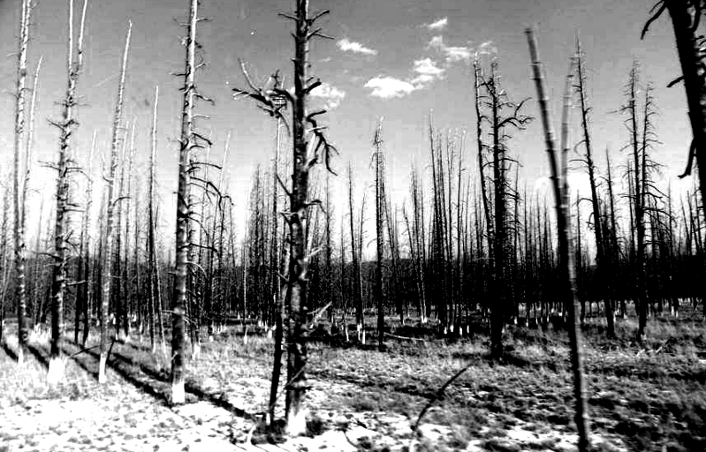


Visualize one-third of the trees on the entire planet burned up, along with the grass and much more, food, fuel, construction materials, shelter – clearly a massive trauma to the entire planet.
Then imagine the fear when one-third of the sun, moon, and stars are all blotted out – no light one third of day or night.
Something is happening at a massive scale and it's source is obviously far bigger than mere humans.

Faith in Action

Prayer:
Ask the Holy Spirit to reveal to you an area of your life where you may be resisting a difficult word and thus have been rejecting a portion of His truth.

Action:
Today I will agree to welcome the Holy Spirit into this area of my life and to accept whatever the Lord has to teach me. I am also choosing to pray specifically for an individual or a family who do not yet have a saving relationship with Jesus – so that they will not have to face the Wrath of God.
Be Specific ______________________________________________________

Monday (Revelation 11:1-14)
“The Fate of the Two Witnesses
11:1 Then a measuring rod like a staff was given to me, and I was told, “Get up and measure the temple of God, and the altar, and the ones who worship there. 11:2 But do not measure the outer courtyard of the temple; leave it out, because it has been given to the Gentiles, and they will trample on the holy city for forty-two months.”
11:3 “And I will grant my two witnesses authority to prophesy for 1,260 days, dressed in sackcloth.”
11:4 (These are the two olive trees and the two lampstands that stand before the Lord of the earth.)
11:5 “If anyone wants to harm them, fire comes out of their mouths and completely consumes their enemies. If anyone wants to harm them, they must be killed this way.”
11:6 “These two have the power to close up the sky so that it does not rain during the time they are prophesying. They have power to turn the waters to blood and to strike the earth with every kind of plague whenever they want.”
11:7 “When they have completed their testimony, the beast that comes up from the abyss will make war on them and conquer them and kill them.”
11:8 “Their corpses will lie in the street of the great city that is symbolically called Sodom and Egypt, where their Lord was also crucified.”
11:9 “For three and a half days those from every people, tribe, nation, and language will look at their corpses, because they will not permit them to be placed in a tomb.
11:10 “And those who live on the earth will rejoice over them and celebrate, even sending gifts to each other, because these two prophets had tormented those who live on the earth.”
11:11 But after three and a half days a breath of life from God entered them, and they stood on their feet, and tremendous fear seized those who were watching them.
11:12 Then they heard a loud voice from heaven saying to them: “Come up here!” So the two prophets went up to heaven in a cloud while their enemies stared at them.
11:13 Just then a major earthquake took place and a tenth of the city collapsed; seven thousand people were killed in the earthquake, and the rest were terrified and gave glory to the God of heaven.”
11:14 The second woe has come and gone; the third is coming quickly.

Prayer
Lord, You send Your prophets to declare Your truth and to bring vexations upon the rebels to teach them respect. May I be found teachable rather than making such vexations necessary in my life.

Summary & Commentary
“Gentiles” does not refer here to non-Jews but to non-believers. It is probably a poor choice as a translation as it creates confusion, even though it is an accurate literal translation of the Greek. The NET Translators suggest that “nations” is an acceptable option, a term that refers to secular people.
Sackcloth is the clothing one wears in mourning.
The term “witnesses” is most often used in the Bible in a legal context where more than one is required to convict. In this case it appears that the mission of these witness/prophets is to illustrate unquestionably the case for the God’s judgment against a world in rebellion.
This text includes a reference to Zechariah 4 where the prophet was shown a similar vision. Various explanations have been offered, the “witnesses” are symbolic of the “church” and the “state” because the olive trees and lampstands are “types” of each, but that makes little sense in this context. One may read this as the Holy Spirit pouring His truth into the Church (believers) who are to then be light – but it is then a challenge to explain why there are two. Others conclude that they are literally men and the oil is the Holy Spirit pouring the truth of God into them so that they may shine His light. This latter explanation appears to come closest to matching the apparent intent of the text.
Several of the negative events described in the text parallel the plagues upon Egypt, same as in the text of Chapter 7.
The witnesses are a 'type' of Jesus, and of all who follow Him; the Enemy attacks both the truth and the messengers of truth.
John again qualifies his text, this time instead of “like” he uses “symbolically”.
This is s similar time-period to that during which Jesus was dead – following His crucifixion. Observe that “... these two prophets had tormented those who live on the earth”, suggesting again that all were unsaved – post Tribulation (Wrath). There is no evidence in this text that anyone mourned their death.
Resurrection is a type' of Jesus – in Rev. 13:3 we read that that the Enemy will counterfeit resurrection in order to borrow credibility.
Ascension is a 'type' of Jesus. Elijah was also taken-up in a vaguely similar way.
There are many atheists who cry out to God in a moment of abject terror in a 'foxhole', but that's not about salvation, it's merely a superstitious hope that some 'magical being' would rescue them. The same appears to be true here, except that they have a much better notion of Whom they should be terrified, thus they declared His power. The phrase “gave glory” is about the recognition of God’s power, it does not denote a submission to His Lordship, nor a surrender of worldly loyalties.

Interaction

Consider
Prior to pouring-out His just-Wrath upon the unrepentant world the Lord God sees fit to one final time send prophets to tell the story of why they are about to be condemned. Truth is preached and, as in the past, the truth-teller is murdered.

Discuss
What are some practical ways to allow the Lord God to pour His truth into you so that you may be a light in the dark world all around you?

Reflect
There is a difference between one who recognizes the glory and power of God (even Satan recognizes that) and one who submits appropriately to that (only a genuine believer).

Share
What is an example from your life when fear caused you to “give glory”, the recognition of power, to someone or to some thing – but not so that you intended to worship it or them. (e.g. a scary storm, a menacing bully, a threatening animal, a dictatorial boss, etc.)

KTALZ

Two prophets of the Law will come in the early moments of the Wrath because those who are not in Christ remain under the Law.

Faith in Action

Prayer:
Ask the Holy Spirit to reveal to you ways that you might partner with Him to better-receive His “oil” for your “lamp” so that you may become a more effective truth-teller.

Action:
Today I am choosing to seek a specific area where I may have been blocking the flow of His “oil” or have been failing to keep His “light” burning as brightly as I could and should.
Be Specific ______________________________________________________

Tuesday (Revelation 11:15 – 12:6)
The Seventh Trumpet
11:15 Then the seventh angel blew his trumpet, and there were loud voices in heaven saying:
“The kingdom of the world has become the kingdom of our Lord and of his Christ, and he will reign for ever and ever.”
11:16 Then the twenty-four elders who are seated on their thrones before God threw themselves down with their faces to the ground and worshiped God 11:17 with these words: “We give you thanks, Lord God, the All-Powerful, the one who is and who was, because you have taken your great power and begun to reign. 11:18 The nations were enraged, but your wrath has come, and the time has come for the dead to be judged, and the time has come to give to your servants, the prophets, their reward, as well as to the saints and to those who revere your name, both small and great, and the time has come to destroy those who destroy the earth.”
11:19 Then the temple of God in heaven was opened and the ark of his covenant was visible within his temple. And there were flashes of lightning, roaring, crashes of thunder, an earthquake, and a great hailstorm.
The Woman, the Child, and the Dragon
12:1 Then a great sign appeared in heaven: a woman clothed with the sun, and with the moon under her feet, and on her head was a crown of twelve stars. 12:2 She was pregnant and was screaming in labor pains, struggling to give birth.
12:3 Then another sign appeared in heaven: a huge red dragon that had seven heads and ten horns, and on its heads were seven diadem crowns. 12:4a Now the dragon’s tail swept away a third of the stars in heaven and hurled them to the earth.
12:4b Then the dragon stood before the woman who was about to give birth, so that he might devour her child as soon as it was born.
12:5 So the woman gave birth to a son, a male child, who is going to rule over all the nations with an iron rod. Her child was suddenly caught up to God and to his throne, 12:6 and she fled into the wilderness where a place had been prepared for her by God, so she could be taken care of for 1,260 days.

Prayer
Lord, Your righteous-wrath came upon the enemy and he desperately tried to drag as many others as possible along with him. May I trust Your timing, Your justice, and Your perfect loving protection of those who belong to You.

Summary & Commentary
The Lord God is about to finish the cleaning-out of fallen things and to wrest the final vestiges of power over the world from Satan, who has been the prince of this world since the Fall in Eden. There is celebration in Heaven.
This last phase is about God’s Wrath, poured-out upon an unrepentant world, in a three-woe process.
This text describes the beginning of the third and final woe.
Up until this point a clear sequence of events seemed to be in view, all the way up to the third and final “woe” of the pouring-out of the Wrath of God, and the text of Rev. 11:14-18 clearly supports that reading. However, it appears that the text following may refer to events in the spiritual realm parallel to the previous record of earth-bound events.
The sun and the moon have varying Biblical meaning. We know from John’s qualifier “a great sign” that the “woman” is symbolic rather than literal, though not necessarily utterly exclusive of literal meaning. Some have postulated the woman as representing Israel, some the Church (in the Historicist model more the institutional organization, in the all-of-the-above model she would represent believers), others (Preterist) literally Mary, and yet others (Idealist) the coming of a philosophy purporting to represent God. The Futurist might have one postulate of a literal Israel returning to the forefront of Biblical events, perhaps the “completion” of Jews as they accept Jesus as Messiah, or perhaps one of “The Church” (believers) “... struggling to give birth” to truth in a world that prefers the darkness of lies.
The dragon is generally understood as a symbol of evil, or of Satan himself. The sweeping away of “a third of the stars in heaven” has appeared previously to describe angels whom he led into his rebellion against God – though the timing of that that would be a reference to the past (perhaps part of a broad summary of the works of the enemy) – or perhaps that he was dragging one-third of the angels formerly with God into destruction with him (they have already been with him but now approaching their final doom – following a great battle).
Depending on the view of the woman’s identity the birth could literally be of Jesus, figuratively Jesus ushering-in the Church, figuratively the organized church impacting the world, figuratively Israel turning to their Messiah, or figuratively Jesus gathering His Church together to “birth” the “new heaven and new earth” - which would, of course, mean the end of Satan – or some blend of multiple meanings.
There are widely varying methodologies which impact how one interprets Revelation; Preterist (allegorical and symbolic from John’s time), Historicist (allegorical and symbolic of church history), Idealist (illustrating spiritual truths with incidental relationship to history or future), Futurist (describing the latter days of the end times). It is this student’s view that the answer is all-of-the-above rather than any one of them to the exclusion of the others. The Bible is filled with layers of meaning and there is no sound reason to believe that Revelation is suddenly an exception, one must be as equally cautious to not exclude meaning as one is to not impose meaning. It is also helpful to recall that while Creation is locked-into linear time, one event follows another in order within a fixed flow of time and no one can move back and forth in time, such is not true of God. It is also helpful to recall that what seems like a long time on earth to man is but a moment in time to God.
Revelation 11:19 describes a scene that sounds a lot like the events at the death of Jesus on the Cross “... the temple of God in heaven was opened and the ark of his covenant was visible within his temple. And there were flashes of lightning, roaring, crashes of thunder, an earthquake, and a great hailstorm.”
[It is beyond this Study to attempt the granular exploration necessary to compare and contrast the many vagaries among analyses of Revelation. Biblical themes - which are critical to salvation and righteous living - are reinforced in Revelation and those, more than anything else, must be understood and applied.]
The essential message John is delivering here is that the forces aligned against God are gathering for the final conflict.

Interaction

Consider
The message is clear that there is a massive spiritual battle and we are in the middle of it, indeed, we are the treasure over which the Lord God and Satan are warring.

Discuss
What are some practical ways to help people to see the pattern, in the Bible, of Satan as our implacable enemy and the Lord God as our tenacious ally?

Reflect
The consistent pattern of the Biblical teaching is that the faithful are blessed with God’s love, and the rebellious are cursed with the absence of God’s love.

Share
When have you observed (or experienced) a newly saved person, or a growing and effective outreach of evangelistic-missions, whom or which the enemy has attacked? How did God defend that person or ministry?

KTALZ



A great beast may be imagined in many ways, one may be of a massive-tailed dinosaur, another may be something far more fantastic – such as the mythical dragon.
As the storm of catastrophic and final battle approaches the dark forces of evil gather.

Faith in Action

Prayer:
Ask the Holy Spirit to show you one area of your walk with Him where you need to be strengthened in your knowledge of and trust in Him.

Action:
Today I am choosing to step-out without fear and to bear-up when the enemy attacks, because the Lord is my courage and He is my strength and my great defender.
Be Specific ______________________________________________________

Wednesday (Revelation 12:7-18)
War in Heaven
12:7 Then war broke out in heaven: Michael and his angels fought against the dragon, and the dragon and his angels fought back.
12:8 But the dragon was not strong enough to prevail, so there was no longer any place left in heaven for him and his angels.
12:9 So that huge dragon – the ancient serpent, the one called the devil and Satan, who deceives the whole world – was thrown down to the earth, and his angels along with him.
12:10 Then I heard a loud voice in heaven saying, “The salvation and the power and the kingdom of our God, and the ruling authority of his Christ, have now come, because the accuser of our brothers and sisters, the one who accuses them day and night before our God, has been thrown down.”
12:11 “But they overcame him by the blood of the Lamb and by the word of their testimony, and they did not love their lives so much that they were afraid to die.
12:12 “Therefore you heavens rejoice, and all who reside in them! But woe to the earth and the sea because the devil has come down to you! He is filled with terrible anger, for he knows that he only has a little time!”
12:13 Now when the dragon realized that he had been thrown down to the earth, he pursued the woman who had given birth to the male child.
12:14 But the woman was given the two wings of a giant eagle so that she could fly out into the wilderness, to the place God prepared for her, where she is taken care of – away from the presence of the serpent – for a time, times, and half a time.
12:15 Then the serpent spouted water like a river out of his mouth after the woman in an attempt to sweep her away by a flood,
12:16 but the earth came to her rescue; the ground opened up and swallowed the river that the dragon had spewed from his mouth.”
12:17 So the dragon became enraged at the woman and went away to make war on the rest of her children, those who keep God’s commandments and hold to the testimony about Jesus.
(12:18) And the dragon stood on the sand of the seashore.

Prayer
Lord, You cast Satan out of Heaven – together with the fallen-angels – and they sought revenge against Your children here on Earth. May I be found faithful so that rather than partnering with Your enemy, and mine, I am Your instrument of blessing.

Summary & Commentary
One possible implication of this text is a jump back to the original fall of Satan and one-third of the angels, which may or may not imply that everything (or some things) up to this point was prior to the fall in Heaven.
In our study of Genesis 1-4 there was a reasonable suggestion that the fall of man paralleled the fall of Satan; that when he tempted Eve he was verbalizing for the first time his own rebellion. That said, the Biblical text elsewhere refers to the spiritual battle “in the heavenlies”, so perhaps this text refers to a time where God called an end to that post-Fall conflict (prior Revelation text had chronicled a major change throughout Heaven and all of Creation).
Another implication is that this text continues the description of a cataclysmic event following a period of time after the fall of Satan, as it refers to his past; indeed, the term “ancient” is used.
This text, paired with the gospel understanding of the impact of Jesus’ death and resurrection upon the power of Satan and of death, may suggest a moment has been reached for the final impact of “... the accuser” being “... thrown down” by “Christ”.
The text says “... our brothers” the believers “overcame” because they were fearless in their faith. The term “overcame” could be past, or present, or both.
Within the flow of Revelation vs 12:12 one may discern a description of the release of Satan and his minions upon the earth as the woes” unfold.
The NET translators conclude that “... a time, times, and half a time.” refers to 1,260 days, the same as referenced elsewhere in the text of Revelation. There are seemingly endless reports of God’s provision of a safe place for those whom He loves, so this matches the character of God.
God defends those who are his.
The “children” of the “woman” are identified as faithful and under attack. If this refers to a moment in what has generally appeared to be a continuous flow of time, and is taken literally, then the believers would be newly “birthed” during the Wrath. If more allegorical then it could refer to the enemy's efforts to cause the condemnation of believers in the Lord – a quixotic endeavor. It is notable that Jesus described “sand” as a poor choice of places on which to build a house as it tends to be washed away more easily.

Interaction

Consider
Satan directly challenged the rule of Heaven by the Lord God and lost. There are two Biblical postulates to explain why Satan and the fallen angels were not obliterated; the first is that Satan’s Fall was directly-associated with that of Adam & Eve – so his future became linked to that of all of humankind, and the second is that part of the process of justice was to demonstrate why Satan and the fallen angels had to be destroyed.

Discuss
How might you use this text to help believers to trust the Lord God more and to become more-watchful for the evil schemes of the enemy?

Reflect
Despite the cataclysmic battle the Lord God troubles Himself to protect His children.

Share
When have you observed a circumstance where someone tried to harm a fellowship but they were detected and further harm prevented?

KTALZ
A simplified perspective from modern world history to help with context for the battle between the Enemy and God …
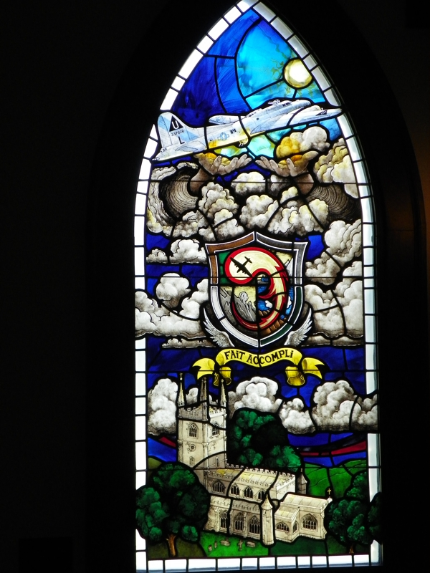

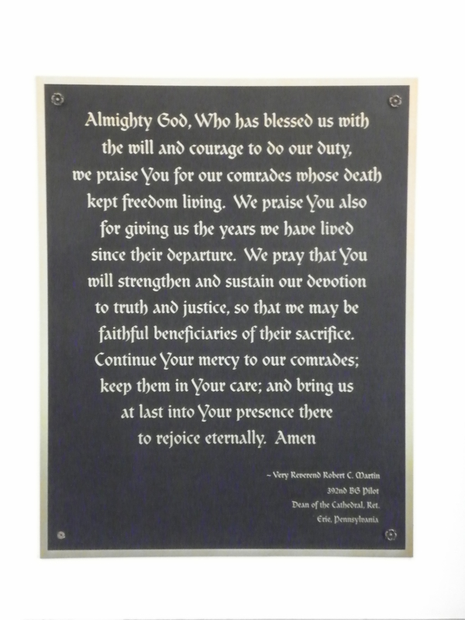

The stained glass image depicting what looks like a military plane battling a dragon, and the associated plaque, are from a recreation of a chapel in Europe as a tribute to those who served.
World War I represented the German government seeking to overthrow other governments and dominate the rest of the world. The other nations rose up, contested them, and ultimately prevailed after huge losses on both sides.
World War II represented the German and Japanese governments seeking to overthrow other governments and dominate the rest of the world. The other nations rose up, contested them, and ultimately prevailed after huge losses on both sides.
The Vietnamese and Korean conflicts represented the effort of the forces of communism to overthrow other governments and dominate the rest of the world. Several nations rose up, contested them, and ultimately prevailed (limiting the spread of communism) after huge losses on both sides.
Battles of ideology and lust for power are evidence of evil in the world.

Faith in Action

Prayer:
Ask the Holy Spirit to reveal to you something that you believe that is not actually truly-Biblical but is, rather, a trick of the enemy to create conflict between you and your Lord Jesus.

Action:
Today I will humbly and gratefully accept the Heavenly-warning. I will seek-out a fellow believer, and perhaps one who is Biblically-qualified as an elder, to walk with me toward truth.
Be Specific ______________________________________________________

Thursday (Revelation 13:1-9)
The Two Beasts
13:1 Then I saw a beast coming up out of the sea. It had ten horns and seven heads, and on its horns were ten diadem crowns, and on its heads a blasphemous name.
13:2 Now the beast that I saw was like a leopard, but its feet were like a bear’s, and its mouth was like a lion’s mouth. The dragon gave the beast his power, his throne, and great authority to rule.
13:3 One of the beast’s heads appeared to have been killed, but the lethal wound had been healed. And the whole world followed the beast in amazement;
13:4 they worshiped the dragon because he had given ruling authority to the beast, and they worshiped the beast too, saying: “Who is like the beast?” and “Who is able to make war against him?”
13:5 The beast was given a mouth speaking proud words and blasphemies, and he was permitted to exercise ruling authority for forty-two months.
13:6 So the beast opened his mouth to blaspheme against God – to blaspheme both his name and his dwelling place, that is, those who dwell in heaven.
13:7 The beast was permitted to go to war against the saints and conquer them.
He was given ruling authority over every tribe, people, language, and nation,
13:8 and all those who live on the earth will worship the beast,
everyone whose name has not been written since the foundation of the world in the book of life belonging to the Lamb who was killed.
13:9 If anyone has an ear, he had better listen!

Prayer
Lord, for forty-two months You will allow the “beast” to play-god in order that there is a sifting of rebels from believers. May I trust You to protect those who belong to You and that Jesus is far more powerful than the “beast” and will defeat him.

Summary & Commentary
In this case, and some others, “then” does not necessarily indicate a sequential event in a timeline but rather a different vision of a different event with a different meaning than the one just described.
Because believers are present this has to either be a pre-Wrath event (kind of a flash-back then overlap of the events recently described) or else some new believers have appeared during the Wrath. This latter assertion would require textual evidence to manage the prior assertion that all humankind present during the Wrath were unrepentant. (In this last case it may be possible to argue that the “all humankind” was a snapshot rather than inclusive of the entire period of the Wrath – but that may be a tough argument to make.)
While the “beast” is initially described as an “it”, suggesting that it could be a group or an organization, the text then switches to a masculine gender “his”. This suggests that the beast also has a clear human or human-like focus or leader. Since the “dragon” is a symbol of Satan, and he is the prince of this world, he is able to give power to the “beast” - and God allows it as part of His unfolding judgment.
Note that in Proverbs, and elsewhere, wisdom is sometimes referred to using a female gender “she” or “her” - in the maritime world sailors have often referred to a ship as “she”.
The “beast” counterfeits the healing and/or resurrection by Jesus and His disciples in order to borrow/steal credibility.
Worship is what Satan always wanted, despite the fact that only the Lord God is to be worshiped.
John 4:3 teaches that the spirit of the antichrist is already in the world, so this appears to be more of an unbridled-release than an entirely new activity.
Everyone will worship the beast (and Satan) except for believers, because their names have been written in the Lamb’s Book of Life, and they only worship God.
[Note: “everyone whose name has not been written since the foundation of the world in the book of life” is written in the negative “everyone … not … written” but the `corollary positive reading means that across the years since the foundation of the world names have been written in the book of life. It does not mean that they were written prior to or at the foundation of the world.]
An Old Testament “type” for this experience is Daniel, who in captivity continued to worship God, even though jealous schemers had manipulated the king into a declaration requiring that the people could only worship him.

Interaction

Consider
A clear line is drawn between the faithful and the rebellious, those who belong to this fallen world and those who belong to the kingdom of heaven. This world gets the leadership it desires – apart from the Lord God – and believers endure as God works-out His perfect plan. (There is history where the Israelites demanded “a king like the nations around us” despite God warning that such was both unnecessary and certain to bring trouble.)

Discuss
What are some examples of the ways that people are being conditioned to believe lies and to follow obvious-liars in the world today?

Reflect
The Lord God allows Satan a time to pretend to be God and to manipulate and terrorize the unsaved into worshiping him - as well as those to whom he delegates power. Any time that we drift into the functional-worship of any sort of idol (celebrity, money, possessions, power, etc) we make it easier for Satan to persuade people to worship him rather than God.

Share
When have you experienced or observed someone claiming authority in the Christian world who lied about the Lord God and about themselves? (Think of cults.)

KTALZ
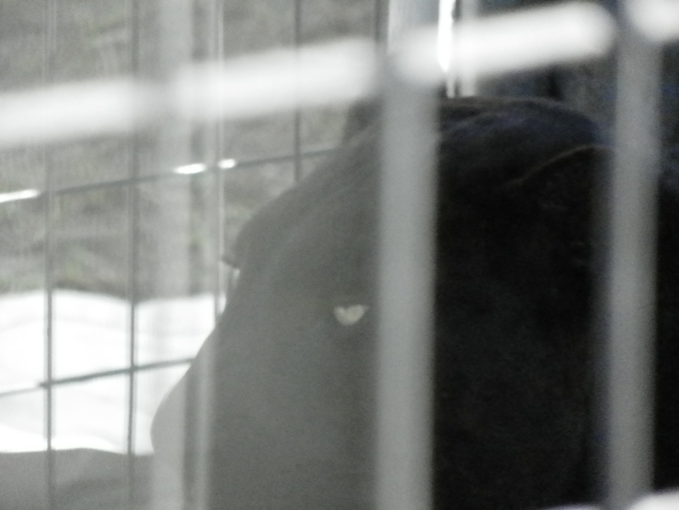
The image above is less unsettling because of the cage – same as the Enemy is 'caged' (limited for a time), but who would want to be where this cat is loose and when the cat is in an out-of-control rage?
That will be the world when Satan is fully loosed.

Faith in Action

Prayer:
Ask the Holy Spirit to reveal to you a place where you believe something, that you should recognize as false (or you are doing something you know to be unwise), but that you want to believe (or do) - so you are deliberately ignoring the truth.

Action:
Today I will humbly confess and seek forgiveness for my offense against the truth. I will accept the Lord Gods forgiveness as I truly-repent, I will prayerfully reconcile with and be restored to a healthier relationship with Him – without that sin in the way.
Be Specific ______________________________________________________

Friday (Revelation 13:10-18)
13:10 If anyone is meant for captivity, into captivity he will go. If anyone is to be killed by the sword, then by the sword he must be killed. This requires steadfast endurance and faith from the saints.
13:11 Then I saw another beast coming up from the earth. He had two horns like a lamb, but was speaking like a dragon.
13:12 He exercised all the ruling authority of the first beast on his behalf, and made the earth and those who inhabit it worship the first beast, the one whose lethal wound had been healed.
13:13 He performed momentous signs, even making fire come down from heaven in front of people 13:14a and, by the signs he was permitted to perform on behalf of the beast, he deceived those who live on the earth.
13:14b He told those who live on the earth to make an image to the beast who had been wounded by the sword, but still lived.
13:15 The second beast was empowered to give life to the image of the first beast so that it could speak, and could cause all those who did not worship the image of the beast to be killed.
13:16 He also caused everyone (small and great, rich and poor, free and slave) to obtain a mark on their right hand or on their forehead.
13:17 Thus no one was allowed to buy or sell things unless he bore the mark of the beast – that is, his name or his number.
13:18 This calls for wisdom: Let the one who has insight calculate the beast’s number, for it is man’s number, and his number is 666.

Prayer
Lord, You allow the enemy to bring his best against the world so as to cull the faithful out from ‘fakesville’, a terribly-painful refining process. May I be prepared to stand-apart from the world system and to stand with You, with your strength – not mine - no matter what.

Summary & Commentary
This text is in the context of the era of the “two beasts” - so it is important that one have a clear sense of when that era is so that one does not inappropriately extrapolate to an era when this text does not apply.
Verses 13:7-8 described “war against the saints and conquer them” and a great deception except those whose names have been written in “the book of life belonging to the Lamb who was killed” - so in some way believers “saints” were present – again adding to the prior speculation that some may have saved during the Wrath – or that this is another sweeping and overlapping layer of history, including a time prior to the initiation of the Wrath.
The phrase “and made the earth and those who inhabit it” suggests that this has never happened before since at no time has the whole earth worshiped one visible false god.
Verse 13:10 teaches that believers during part of this era will suffer for their faithfulness to God. It is unclear if “meant for” requires that God has ordained the manner of death, for His purposes, or if it means that whatever comes one must endure in faith. It is also unclear if this is visiting a pre-Wrath period of time within a larger layer of history.
Some have suggested a parallel to Jesus’ words in Matthew 26:52 “... everyone who takes up the sword will die by the sword”, but the NET translator’s argue for the Jeremiah 15:2 meaning of endurance.
A creature with horns like a lamb, and other features like a dragon, is a common image in satanism and witchcraft.
This odd-looking creature is one whose power was delegated by the beast, whose own power was delegated by Satan.
The deception of non-believers was amplified using false signs and wonders.
What was presented in vss 13:14b-15 was an animated idol with the power to kill those who did not worship it. This is not necessarily a singular physical being, or a literal animated-statue, but may be symbolic of a political-religious system.
There has been much debate as to the precise meaning of the “mark”. The timing of this must be prior to the Wrath, as that is reserved for non-believers (unless one argues for salvation during the Wrath), and the lesson appears to be that believers need a form of bartering and/or interdependence - independent of the world system of commerce – because they will not accept “the mark of the beast” and therefore will not be allowed to participate in general commerce.
There are many speculations about the “number” one must reconcile; “the number … 666” is the number of humankind, the number of the name of the antichrist, and the number of the “mark” - none of them alone necessarily equal a literal “666”
Some schemes have purported to assign numbers to letters and then to discover words that use them, of course they do this in English – a language that did not exist at the time – to be legitimate this must be done in the original language, ancient Greek. Perhaps the wisdom to “calculate the number” has not yet been given to humankind by the Lord God. If so then it is wisdom to wait rather than to guess.

Interaction

Consider
If the time-layer of the “mark” is pre-Wrath do we have a plan to survive, brothers and sisters helping one-another, for that time when we have to reject the “mark” and therefore are unable to gain access to resources via the normal worldly system of commerce?

Discuss
If the “mark” prevents believers from participation in the commerce of the world if that more likely to finally motivate us to work together, or will we all suffer terrible poverty – isolated and unprepared?

Reflect
Those who are obsessed with guessing the meaning of “666” via some scheme may be proving their lack of wisdom.

Share
When have you experienced an example of suffering for your faith?

KTALZ






Borrowing from a little Aussie humor ...
When a Christian imagines anyone worshiping some odd looking creature (see the first picture) they are incredulous.
But the world looks at Christians who worship the One True Creator & source of salvation – our Lord God – and calls us names like dumb monkeys (see second picture).
However, at the end of the day the truth is that one who rejects the only One who can save must be a looney-bird (see the third picture).

Faith in Action

Prayer:
Ask the Holy Spirit to reveal to you some way that you, and perhaps a number of other believers, might prepare yourselves to support one-another – physically and spiritually – should the “mark” become real during your lifetime.

Action:
Today I will discuss with fellow believer how we might acquire the necessities of life apart from the world system of commerce. We will also discuss how we can support one-another in bearing-up under the terrible oppression – perhaps learning from modern-day believers in the Sudan and other systematically and/or violently anti-Christian nations or regions.
Be Specific ______________________________________________________

Saturday (Revelation 14)
An Interlude: The Song of the 144,000
14:1 Then I looked, and here was the Lamb standing on Mount Zion, and with him were one hundred and forty-four thousand, who had his name and his Father’s name written on their foreheads.
14:2 I also heard a sound coming out of heaven like the sound of many waters and like the sound of loud thunder. Now the sound I heard was like that made by harpists playing their harps, 14:3 and they were singing a new song before the throne and before the four living creatures and the elders. No one was able to learn the song except the one hundred and forty-four thousand who had been redeemed from the earth.
14:4 These are the ones who have not defiled themselves with women, for they are virgins. These are the ones who follow the Lamb wherever he goes. These were redeemed from humanity as firstfruits to God and to the Lamb, 14:5 and no lie was found on their lips; they are blameless.
Three Angels and Three Messages
14:6 Then I saw another angel flying directly overhead, and he had an eternal gospel to proclaim to those who live on the earth – to every nation, tribe, language, and people.
14:7 He declared in a loud voice: “Fear God and give him glory, because the hour of his judgment has arrived, and worship the one who made heaven and earth, the sea and the springs of water!”
14:8 A second angel followed the first, declaring: “Fallen, fallen is Babylon the great city! She made all the nations drink of the wine of her immoral passion.”
14:9 A third angel followed the first two, declaring in a loud voice: “If anyone worships the beast and his image, and takes the mark on his forehead or his hand, 14:10 that person will also drink of the wine of God’s anger that has been mixed undiluted in the cup of his wrath, and he will be tortured with fire and sulfur in front of the holy angels and in front of the Lamb. 14:11 And the smoke from their torture will go up forever and ever, and those who worship the beast and his image will have no rest day or night, along with anyone who receives the mark of his name.”
14:12 This requires the steadfast endurance of the saints – those who obey God’s commandments and hold to their faith in Jesus.”
14:13 Then I heard a voice from heaven say, “Write this: ‘Blessed are the dead, those who die in the Lord from this moment on!’” “Yes,” says the Spirit, “so they can rest from their hard work, because their deeds will follow them.”
14:14 Then I looked, and a white cloud appeared, and seated on the cloud was one like a son of man! He had a golden crown on his head and a sharp sickle in his hand. 14:15 Then another angel came out of the temple, shouting in a loud voice to the one seated on the cloud, “Use your sickle and start to reap, because the time to reap has come, since the earth’s harvest is ripe!” 14:16 So the one seated on the cloud swung his sickle over the earth, and the earth was reaped.”
14:17 Then another angel came out of the temple in heaven, and he too had a sharp sickle. 14:18 Another angel, who was in charge of the fire, came from the altar and called in a loud voice to the angel who had the sharp sickle, “Use your sharp sickle and gather the clusters of grapes off the vine of the earth, because its grapes are now ripe.”
14:19 So the angel swung his sickle over the earth and gathered the grapes from the vineyard of the earth and tossed them into the great winepress of the wrath of God. 14:20 Then the winepress was stomped outside the city, and blood poured out of the winepress up to the height of horses’ bridles for a distance of almost two hundred miles.”

Prayer
Lord, Your love is so great that even in the midst of terrible judgment You still choose to offer a final opportunity for salvation. May I honor Your love and patience and more-intentionally partner with the Holy Spirit to follow You more closely.

Summary & Commentary
This is a celebration, a prelude to the great redemption of God’s children into an eternity of perfect relationship with Him – a moment He has long desired and patiently brought to fruition.
It could be that the “new song” is the praise of the newly redeemed 144,000, a new song (or a new “choir”) never before heard in Heaven.
Clearly there is none but Jesus Who ever lived on this fallen earth who were truly “undefiled” and truly “blameless”, any more so than was Job; the meaning of the phrase is in the context of blasphemy and relative-righteousness to unrepentant humankind.
If the text is taken somewhat literally one might take the 144,000 to represent children, taken prior to the so-called age of accountability, and might represent a selective-rapture, and also might refer to the absence of volitional-sin versus salvific-blamelessness (none but Jesus achieved that).
The discussion of the 144,000 has previously been considered and it is improbable, though not impossible, that these are a different 144,000 than the first group.
The description of the 144,000 could be treated as rhetorical, as all who are given new bodies are instantly “virgins”, and because they have been made holy – in Christ – and they are also “blameless”.
Vss 14:6-7 may be a final call to faith to those remaining on earth, may be the final clarion call of the end of the fallen world, and may be a declaration of the last chance to take sides (the “mark” serving as a last decision-point).
Vs 14:12 mentions “saints”, suggesting that – depending upon where one positions the time-sequence of these events (layered across the Tribulation and the Wrath) - some appear to have newly come-to-faith after the Tribulation and/or during the Wrath.
The Lord God calls for endurance in faith during an exceptionally difficult time and He promises blessing.
If the One on the “white cloud” is Jesus then the angel was not issuing a command but was, rather, making a celebratory declaration.
If this being was “like a son of man”, it could mean that it looked-human, or that it looked more than merely-human – more like Jesus. (Since 14:17 refers to a parallel being as an “angel” one may reasonably postulate this also to be an angel – or at least an angelic-like being.)
Those in unrepentant-rebellion may have had their rhetorical (spiritual) life-blood, rather than literal blood, pressed out of them so that they no longer contained the breath of life that the Lord God once gave them (thought the text describing distance and depth seems to imply literal blood).

Interaction

Consider
A “new song”, never before heard in Heaven, will be sung as those whom He has redeemed enter the presence of God with thanksgiving.

Discuss
What are some practical ways to live “blameless” and “undefiled” lives before our loving and gracious Lord God, insofar as is possible in these fallen bodies in this fallen world, even with the help of the Holy Spirit?

Reflect
Even after thousands of years of history, and all of the events of the last days of these end times, the Lord God still offers a final opportunity to people to choose sides.

Share
What example(s) of endurance in the face of persecution-for-faith can you share and how was the strengthening of the Holy Spirit apparent to you during those events? (Either as a participant or as an observer.)

KTALZ






Babylon – a synonym for rebellion, sin, worldiness versus obedience, righteousness, and faithfulness – symbolized by the many obsessions of humankind with pleasure and the strange allure of witchcraft.
Symbolic of the fruit of rhetorical Babylon are the clusters of grapes, those people who have sold their souls to the devil for worldly pleasures and have unrepentantly turned away from the gift of salvation-through-Christ offered them by a loving God.
Imagine enough blood to cover 200 miles up to the height of a horse's bridle.

Faith in Action

Prayer:
Ask the Holy Spirit to reveal to you a place in your walk where you could become more intentionally “blameless” and “undefiled” in a specific and practical way.

Action:
Today I will ask a fellow believer to pray in-agreement, and to be an accountability-partner, in my journey toward greater maturity as a child of the Lord God.
Be Specific ______________________________________________________
All Bible text is from the NET unless otherwise indicated - http://bible.org
Note 1: These Studies often rely upon the guidance of the NET Translators from their associated notes. Careful attention has been given to cite that source where it has been quoted directly or closely paraphrased. Feedback is encouraged where credit has not been sufficiently assigned.
Note 2: When NET text is quoted in commentary and discussion all pronouns referring to God are capitalized, though they are lower-case in the original NET text.
Commentary text is from David M. Colburn, D.Min. unless otherwise noted.
Copyright © 2012 by David M. Colburn. This is a BibleSeven Study – “Revelation” Section – Revelation 4 – 5 – prepared by David M. Colburn and edited for bible.org in June of 2012. This text may be used for non-profit educational purposes only, with credit; all other usage requires prior written consent of the author.

