Revelation 4:1 – 5:14
David M. Colburn
A Daily Bible Study in 7-Day Sections with a Summary-Commentary, Discussion Questions, and Daily Application

Sunday (Revelation 4:1-3)
The Amazing Scene in Heaven
4:1 After these things I looked, and there was a door standing open in heaven!
And the first voice I had heard speaking to me like a trumpet
said: “Come up here so that I can show you what must happen after these things.””
4:2 Immediately I was in the Spirit,
and a throne was standing in heaven with someone seated on it!
4:3 And the one seated on it was like jasper and carnelian in appearance,
and a rainbow looking like it was made of emerald encircled the throne.

Prayer
Lord, You are the only One worthy of a throne, all others are pretenders. May I stand in awe of You, may You always be my first love, and may I worship You alone.

Summary & Commentary
While it was clear that the first voice John heard in Rev. 1-3 was that of Jesus it is now less clear if the voice continues to be that of Jesus or if is of an angel – it is not necessary to know because The Lord God was in complete control.
Since thrones are reserved for kings it would be reasonable to postulate that the One on the throne was either God the Father or God the Son, both are described elsewhere in the Bible as sitting on a throne; since they are in-essence the same, it is not important which member of the Godhead chose to visualize Himself to John.
It is apparent that John is struggling to describe what he is observing “in the Spirit” using his limited worldly experience – the reader may observe that he again uses the qualifier “...like”, in this section of text he uses it twice.
Interpreting the description of the precious stones, red and green, and of the “emerald rainbow” is somewhat speculative.
Revelation 21:11 refers to a crystal-clear Jasper whereas some say that common Jasper is spotted and reddish and rare Jasper may be greenish – the key here, and in v 21:11 is that John was referring to the most-rare form of Jasper to approximate an attribute of God as most-rare.
Carnelian is reportedly a reddish-tinted translucent stone with characteristics of very hard quartz. Once again it is the rarity of the stone which John intended to emphasize as he struggled to build a word-picture for his readers.
An emerald-rainbow would be outside the experience of the usual rainbow such that it also would build a word-picture of something beautiful and 'other-worldly'.

Interaction

Consider
This awe-inspiring and spiritually overwhelming experience, shared by John, brings to us a small taste of the glory of Heaven that awaits.

Discuss
What are the times and places where you have sensed the most-powerful presence of the Lord God?

Reflect
The Lord God is not like us, though we bear a shadow of likeness to Him, our Creator.

Share
What is a practical example of a time when in worship, in song, in prayer, in the sharing of testimonies (or in some other experience) has the Lord God made His presence especially clear to you? How were you assured that it was really of-God?

KTALZ


Picture the beautiful rainbow above as made of a bright translucent crystal-like Emerald – that is something like what John was trying to visualize.

Faith in Action

Prayer:
Ask the Holy Spirit to reveal to you someone with whom you should share this text.

Action:
Today I will share this text with a fellow believer, prayerfully reflecting upon it together (perhaps also reading Ezekiel Chapter 1), and celebrating the magnificence of the Lord God in Heaven.
Be Specific ______________________________________________________

Monday (Revelation 4:4-7)
4:4 In a circle around the throne were twenty-four other thrones, and seated on those thrones were twenty-four elders. They were dressed in white clothing and had golden crowns on their heads.
4:5 From the throne came out flashes of lightning and roaring and crashes of thunder. Seven flaming torches, which are the seven spirits of God, were burning in front of the throne
4:6a and in front of the throne was something like a sea of glass, like crystal.
4:6b In the middle of the throne and around the throne were four living creatures full of eyes in front and in back.
4:7 The first living creature was like a lion,
the second creature like an ox,
the third creature had a face like a man’s,
and the fourth creature looked like an eagle flying.

Prayer
Lord, You exist in a realm that humankind is incapable of fully-comprehending, and You have taught us that Your “... ways are not our ways”. May I be in awe of You, may I never try to force my concept of You into a man-sized box, and may my worship be guided by an ever-deepening sense of humility.

Summary & Commentary
We may only speculate who these “elders” were. The NT teaches that Jesus will appoint believers to rule with Him. The term elder is only used in reference to humans, not angels.
According to the Greek Translator's Notes the term “crowns” may refer to a symbol of royal rank or may be a synonym for the eternal blessedness for ones faithfulness.
The “seven spirits” are associated with the “seven lampstands” which were defined by John in Rev. 1:20 as the “seven churches” (sub-groups within the body of believers).
Given John's ecstatic state, and his unfamiliarity with much of what he was observing, his expressions “... flashes of lightning and roaring and crashes of thunder” while “in the spirit” are difficult to interpret; the NET Translator's suggest that “sounds” or “voices” may also be acceptable renderings of the Greek in this context. John later prefaces another description with “something like”, indicating a continuing lack of descriptive precision.
“Lion” is a synonym for great strength.
“Ox” is synonym for new, or young, as in a sprout or a calf.
Man-face is synonym for some element, perhaps the partial likeness of God, to be found in humankind – though badly distorted by the Fall.
The flying-eagle is a synonym for purposeful action or purpose.
The NET translators propose that “In the middle of the throne ...” may also be translated “in the throne area”. A similar description of the “four” is found in Ezekiel 1:5 and following.

Interaction

Consider
The Lord God is not like us, His dwelling place is nothing like anything we have ever seen, and the inseparable physical-spiritual nature of the beings around Him are manifestations we cannot truly comprehend.

Discuss
What other verses in the Bible come to mind when you read the descriptions of God, and/or the various “creatures” and “elders”, and their surroundings?

Reflect
The Lord God chose to reveal this surreal imagery to us for a reason – He wants us to understand the vast difference between Heaven and earth.

Share
When have you experienced a sense of awe about the Lord God as you read a description of Him in His Word?

KTALZ
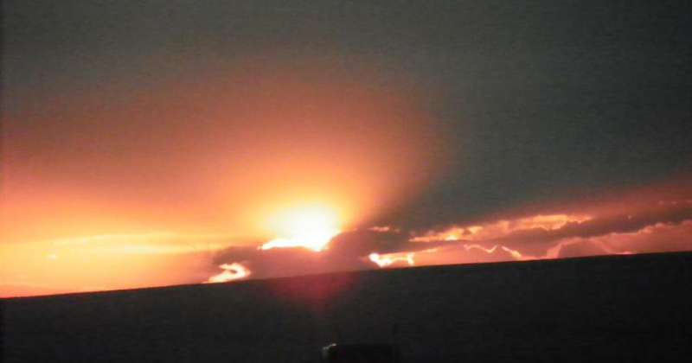
What looks like fire in the sky – in the picture - isn't, but like John's word-picture of the throne of God it triggers one's imagination as to what might be generating such a huge and amazing sight.
Of course the sun, so very far away, is the source of massive light and heat – some of which reaches the earth – just as the power of God caused the sights John was observing and trying to describe to others.

Faith in Action

Prayer:
Ask the Holy Spirit to reveal to you something about the Lord God that you have misunderstood, perhaps as the result of careless teaching, and all because someone tried to reduce Him to a simplicity that humankind may pretend to comprehend.

Action:
Today I will ask the Holy Spirit to show me where I need to just stand in awe of the Lord God and where I need clear understanding. I will also ask Him to bring alongside me a person or persons (Biblically-qualified as elders) to be a resource when I need clarification and confirmation.
Be Specific ______________________________________________________

Tuesday (Revelation 4:8)
4:8 Each one of the four living creatures had six wings and was full of eyes all around and inside.
They never rest day or night,
saying: “Holy Holy Holy is the Lord God,
the All-Powerful,
Who was
and who is,
and who is still to come!”

Prayer
Lord, You Were, You Are, and You will always Be, and yet You choose to love me. May I be ever-amazed, ever-humbled, ever-worshipful of my awesome Lord God!

Summary & Commentary
This heavenly image of worship, submission to the only One worthy of worship no matter what is ones earthly or heavenly title, the identity of God as Creator, and His identity as sustainer of all things is consistent with the rest of the Bible.
The Lion, synonym of great strength, the Ox, synonym of new or young as in a sprout or a calf, the man-face, synonym for some element - perhaps the partial likeness of God in humankind, and the flying-eagle, a synonym for purposeful action or purpose are proclaiming the immeasurable holiness of the Lord God. One may well take this to be synonymous for all of creation.
The phrase “Who was ...” was a reminder that the Lord God exists beyond linear time, which He created for humankind, and therefore He existed prior to it.
The phrase “... who is” was to remind that He is present with us.
The phrase “... who is still to come!” was to remind us that in linear time the Lord will return for His and to just everyone who ever lived, and then will come the end to linear time (and everything bound to it), as the children of God join Him in timeless eternity.

Interaction

Consider
Do we have right-sized view of the enormity of the majesty of the Lord God?

Discuss
How would you explain the difference between God's creation, contained inside linear time – which He created for that purpose, and God – who exists apart from His creation?

Reflect
When a human demands worship, which no human ever should, it is unlike the worship of heavenly beings – created for that solitary purpose – but is, rather, to feed the ego of a pitiful fallen creature.

Share
When have you observed the fruits of a person who demanded worship – something reserved for the Lord God alone?

Faith in Action

Prayer:
Ask the Holy Spirit to reveal to you a renewed sense of wonder that our magnificent Lord God loves you.

Action:
Today I will share my wonder and gratitude for the Lord's love with a fellow believer, and/or someone considering Christ.
Be Specific ______________________________________________________

Wednesday (Revelation 4:9-11)
4:9 And whenever the living creatures give glory, honor, and thanks to the one who sits on the throne, who lives forever and ever,
4:10 the twenty-four elders throw themselves to the ground before the one who sits on the throne and worship the one who lives forever and ever, and they offer their crowns before his throne, saying:
4:11 “You are worthy, our Lord and God, to receive glory and honor and power, since you created all things, and because of your will they existed and were created!”

Prayer
Lord, You are worthy! May I remember that every time I review my calendar and my checkbook to assess my priorities.

Summary & Commentary
The “four living creatures” are the same as in Rev. 4:6 where the NET Translator's Notes offer “Of the four peculiar beings at God’s throne, whose description Rv 4:6-9 reminds one of the ζῷα in Ezk 1:5ff, the cherubim.”
There is some discussion as to who are, or what is represented, by the twenty-four elders.
One suggestion is they are the four Heavenly creatures, each with six wings, but such appears to be precluded by the implied controlling-conditional in the text; “whenever the living creatures ...” [then] “… the twenty-four elders”.
Another suggestion is that the twenty-four elders represent a “heavenly Sanhedrin”, but the traditional full Sanhedrin was seventy-one and the so-called “small Sanhedrin” was twenty-three.
A third suggestion is that they represent the spiritual “courses” of twenty-four that were offered by the priests.
In either case the important point is that the Lord God is praised by every being in Heaven “... give glory, honor, and thanks to the one who sits on the throne, who lives forever and ever”, whether angelic or somehow associated with humankind “... since you created all things, and because of your will they existed and were created!”

Interaction

Consider
Honor is due to the One who sits on the throne, Who exists eternally, and Who created.

Discuss
Do we give glory, honor, and thanks to the Lord God daily?

Reflect
How might this daily pattern of worship be replicated in the lives of Christians without it becoming a meaningless ritual?

Share
When have you observed Christian leaders humbling themselves before the Lord God? Have you ever felt inspired to a deeper level of humble worship in the presence of someone who was giving the Lord praise?

KTALZ
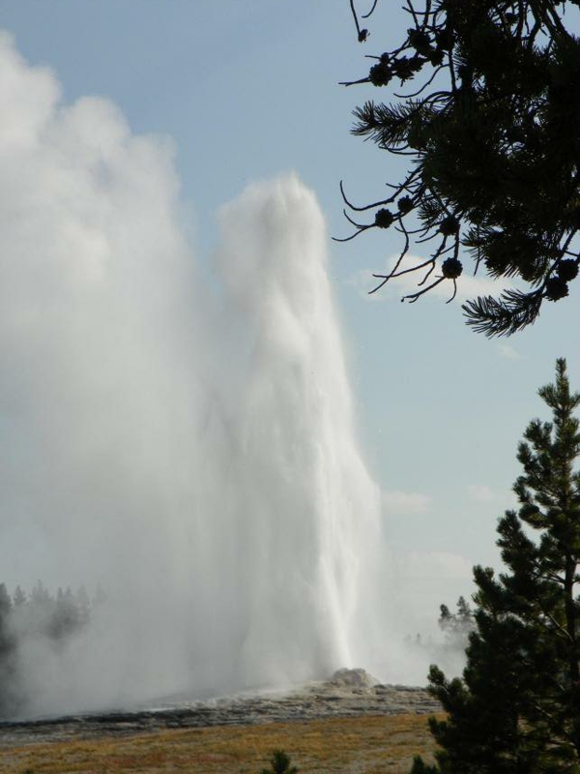


The first picture is of Old Faithful in Yellowstone National Park, located in the northwest region of the continental USA. It is a massive geyser of steam and hot water which shoots through an opening in the ground, and which is generated by a massive percolating volcano below. According to the Park “Old Faithful erupts every 35 to 120 minutes for 1 1/2 to 5 minutes. Its maximum height ranges from 90 to 184 feet.” There are larger geysers at the Park but their activity is more rare and irregular. There are smaller geysers which are even more precise in their cycles of activity. Old Faithful is the best combination of regularity and size.
No one is certain when the volcano below will blow, only that it will some day, and that it could be massively destructive when it does. One cannot help but be amazed by the power of the geyser, the regularity with which it blows (thus the name), the various colors of minerals displayed in the soil, “paintpots”, and water in the area, and the power contained in the volcano below.
The second is one of those views which may be found in hundreds of locations around the world, and it is one which causes the viewer to catch their breath and just say “wow”. Such splendor is a mere shadow of the presence of God.

Faith in Action

Prayer:
Ask the Holy Spirit to reveal to you a way that you may be more intentional about the worship of the Lord God daily as well as to seek opportunities to join others in humble-yet-powerful corporate worship.

Action:
Today I will ask a fellow believer to hold me accountable, and to pray in-agreement for protection, as I begin a consistent daily time of worship for the Lord God.
Be Specific ______________________________________________________

Thursday (Revelation 5:1-5)
The Opening of the Scroll
5:1 Then I saw in the right hand of the one who was seated on the throne a scroll written on the front and back and sealed with seven seals.
5:2 And I saw a powerful angel proclaiming in a loud voice: “Who is worthy to open the scroll and to break its seals?”
5:3 But no one in heaven or on earth or under the earth was able to open the scroll or look into it.
5:4 So I began weeping bitterly because no one was found who was worthy to open the scroll or to look into it.
5:5 Then one of the elders said to me, “Stop weeping! Look, the Lion of the tribe of Judah, the root of David, has conquered; thus he can open the scroll and its seven seals.

Prayer
Lord, the scroll was a necessary element in Your great plan of cleansing and redemption, and You- alone were worthy to stand in the gap and to move it along. May I stand in awe of You, recognize that You are the only way to Heaven, and share that with others.

Summary & Commentary
It is apparent that the One on the throne is not Jesus, which is a clarification of the lack of specificity in the earlier chapter.
The “powerful angel” would presumably be one of the rare beings referred to also as “archangels”.
The “scroll” contained the necessary instructions to move through the final stages of the fulfillment of the redemption of the children of God.
The One Who could open and read it had to meet, perfectly, the requirements of the Law on behalf of those to whom the scrolls content applied.
John was weeping for humankind because he knew, short of the completion of the redemptive process of God, salvation was impossible for anyone. (John was, obviously, ”too close to the forest to see the trees” as he knew that Jesus was The Christ. He was so overwhelmed by his environment, and so engrossed in the details, he lost sight of the reality that he was viewing a judgment of all-but-Christ “no one in heaven or on earth” - but Jesus was far more than a mere denizen of Heaven or Earth – He is God.

Interaction

Consider
In Heaven things proceed in perfect order.

Discuss
Where else in the Bible have you read about “archangels”?

Reflect
In his spirit John had been given an awareness of the importance of the scroll.

Share
When have you had to await someone with the authority to act so that a critical next step in an important process might be taken?

KTALZ
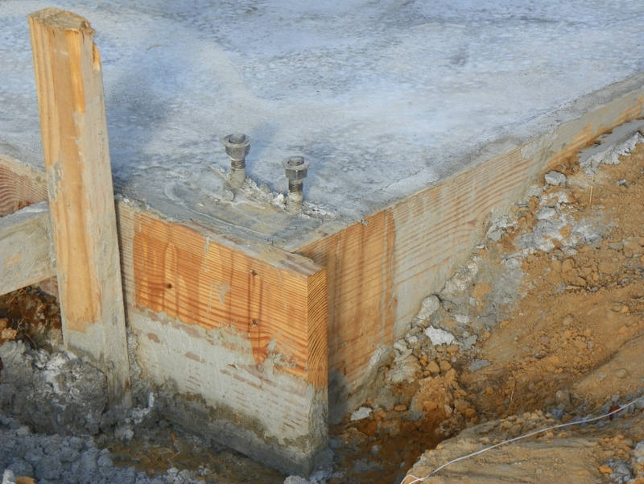


Just as the successful construction of a sturdy building requires a sequence of correctly completed steps, so does the successful conclusion of the perfect plan of redemption of humankind from the terrible rebellion of Adam & Eve in the Garden.



Across history there have been many powerful and potentially-deadly animals, including those pictured above; big cats and dinosaurs. The appearance of a full-grown healthy lion combines elegance with power and thus is used in the Bible as a word picture of an attribute of God.

Faith in Action

Prayer:
Ask the Holy Spirit to reveal to you where you fit, in a series of His steps, so that you may be His instrument in some small way in His great and perfect plan.

Action:
Today I will humbly pray and listen, read the Word and – as necessary - consult a mature and prayerful fellow Biblical-Christian, to discern and follow where the Holy Spirit has directed.
Be Specific ______________________________________________________

Friday (Revelation 5:6-10)
5:6 Then I saw standing in the middle of the throne and of the four living creatures,
and in the middle of the elders,
a Lamb that appeared to have been killed.
He had seven horns and seven eyes, which are the seven spirits of God sent out into all the earth.”
“5:7 Then he came and took the scroll from the right hand of the one who was seated on the throne,
5:8 and when he had taken the scroll, the four living creatures and the twenty-four elders threw themselves to the ground before the Lamb.
Each of them had a harp and golden bowls full of incense (which are the prayers of the saints).”
“5:9 They were singing a new song:
“You are worthy to take the scroll and to open its seals because you were killed,
and at the cost of your own blood you have purchased for God persons from every tribe, language, people, and nation.”
“5:10 You have appointed them as a kingdom and priests to serve our God,
and they will reign on the earth.”

Prayer
Lord, You made Yourself into the lamb Who was slain, and You created the opportunity for humankind to be redeemed from the error of Eden. May I join in Your praise!

Summary & Commentary
The word-picture varies but the theme is consistent. The “seven” are the “churches” to whom Jesus was speaking through the “seven spirits” in the earlier chapters of Revelation.
The eyes represent the all-seeing attribute of God.
Note that “... the prayers of the saints”, all believers, are collected by God.
Note also that their prayers were symbolized as “harps”, music to God's ears, and “golden bowls full of incense”, a delight to His nostrils (as were the rightly-submitted sacrifices of the Israelites during the literal-sacrificial period).
The “reign” of those “purchased” would not begin until a while later in the process, see Rev. 20:4, and that reign will last for 1,000 years.
[Note: There are a variety of perspectives as to the time-line of the events of Revelation. This author sees some movement from future to past as future events are linked to past events rather than a purely-continuous time-line.]

Interaction

Consider
The intent of the enemy had been to lead the religious leaders and foolish people into killing Jesus so as to prevent Him from creating redemption, and by extension, to prevent the gathering of the Church.

Discuss
How might it impact the prayers of Biblical-Christians in your fellowship if they visualized their prayers as incense in the throne-room of the Lord God?

Reflect
The “twenty-four elders” had “harps” (musical instruments) and were singing praise and worship in the throne-room of the Lord God.

Share
When have you heard that your prayers were as-music or as-incense in the throne-room of the Lord God?

KTALZ
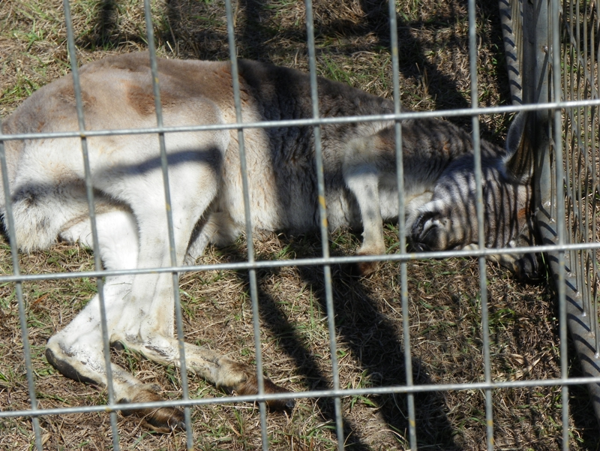

Looking at the first picture imagine the creature lying motionless in a gathering place surrounded by people who were sad as they thought it was dead. Then it rises and is transformed into something that looks very different – that is the symbolism of the lamb transformed into the being with seven eyes and seven horns.
Then look at the unusual tree. Do you notice that the buds, viewed from the correct angle, look like crosses? Visualize those crosses as symbolic, as were the “horns” and “eyes” on the transformed “lamb” which John was trying to describe.

Faith in Action

Prayer:
Ask the Holy Spirit to reveal to you a prayer that He especially loves to hear from you.

Action:
Today I will set aside some time to read the Word, reflect on my relationship with the Lord, and to lift heartfelt prayers as I feel led.
Be Specific ______________________________________________________

Saturday (Revelation 5:11-14)
5:11 Then I looked and heard the voice of many angels in a circle around the throne, as well as the living creatures and the elders.
Their number was ten thousand times ten thousand – thousands times thousands –
5:12 all of whom were singing in a loud voice:
“Worthy is the lamb who was killed to receive power and wealth and wisdom and might and honor and glory and praise!”
5:13 Then I heard every creature – in heaven, on earth, under the earth, in the sea, and all that is in them – singing: “To the one seated on the throne and to the Lamb be praise, honor, glory, and ruling power forever and ever!”
5:14 And the four living creatures were saying “Amen,”
and the elders threw themselves to the ground and worshiped.

Prayer
Lord, You need no praise or worship, but Your creation needs a One true and perfect Lord God to know pure love and meaning. May I draw nearer to You every day and in every way.

Summary & Commentary
The point of the “... ten thousand times ten thousand – thousands times thousands” text, numbering the angels plus living creatures plus elders, is elsewhere is described as “too numerous to count”.
“Worthy is the lamb ...” is a repeated theme of Revelation.
“Every creature ...” sang praise and worship of and to Him.
The “... four living creatures”, who we discussed previously, agreed with “Amen”.
The elders, previously numbered as twenty-four and described, humbled themselves by bowing.

Interaction

Consider
Do we have the same awe and reverence for God as these beings? Note that in this context the one whom we have previously recognized as Jesus allows Himself to be worshiped, therefore He must be God; yet another affirmation of the Trinity.

Discuss
What might it mean to a watching fellowship for the spiritual leaders to be more visibly humble in their public praise and worship?

Reflect
The Lord God is consistent; a Messiah was always necessary, once He pronounced the righteous-curse and the grace-filled provision of redemption in the Garden. Only He could be our intercessor.

Share
When have you experienced a moment of awe which caused you to stop and worship Him?

KTALZ



Consider the first picture of falling snow, each crystal is unique and the sky is filled with them; then contemplate counting them.
Look then at the second picture, can you count the grains of sand; on this single beach, let alone all of the sandy beaches in all of the world?
John's use of the phrase “without number” is intended to elicit a similar sense of numeric-awe.

Faith in Action

Prayer:
Ask the Holy Spirit to touch your heart in a special way so that you are drawn-near and gently-humbled before Him.

Action:
Today I am choosing to pause and to pray several times, knowing that God not only hears my prayers, but that He gathers them up together with those of all “saints” (believers) like incense and music.
Be Specific ______________________________________________________
All Bible text is from the NET unless otherwise indicated - http://bible.org
Note 1: These Studies often rely upon the guidance of the NET Translators from their associated notes. Careful attention has been given to cite that source where it has been quoted directly or closely paraphrased. Feedback is encouraged where credit has not been sufficiently assigned.
Note 2: When NET text is quoted in commentary and discussion all pronouns referring to God are capitalized, though they are lower-case in the original NET text.
Commentary text is from David M. Colburn, D.Min. unless otherwise noted.
Copyright © 2013 by David M. Colburn. This is a BibleSeven Study – “Revelation” Section – Revelation 4 – 5 – prepared by David M. Colburn and edited for bible.org Fall 2013. This text may be used for non-profit educational purposes only, with credit; all other usage requires prior written consent of the author.

