Revelation 2 - 3
David M. Colburn
A Daily Bible Study in 7-Day Sections with a Summary-Commentary, Discussion Questions, and Daily Application

Sunday (Revelation 2:1-7)
2:1 To the angel of the church in Ephesus, write the following:
“This is the solemn pronouncement of the one who has a firm grasp on the seven stars in his right hand – the one who walks among the seven golden lampstands:
2:2 ‘I know your works as well as your labor and steadfast endurance, and that you cannot tolerate evil.
You have even put to the test those who refer to themselves as apostles (but are not), and have discovered that they are false.
2:3 I am also aware that you have persisted steadfastly, endured much for the sake of my name, and have not grown weary.
2:4 But I have this against you: You have departed from your first love!
2:5 Therefore, remember from what high state you have fallen and repent!
Do the deeds you did at the first; if not, I will come to you and remove your lampstand from its place – that is, if you do not repent.
2:6 But you do have this going for you: You hate what the Nicolaitans practice – practices I also hate.
2:7 The one who has an ear had better hear what the Spirit says to the churches.
To the one who conquers, I will permit him to eat from the tree of life that is in the paradise of God.'

Prayer
Lord, You stand with those who stand with You, in steadfastness for truth. May I be found steadfast, a “good Berean” who tests everything against the Word, bold to challenge carelessness and deception.

Summary & Commentary
See explanations for “angel”, “stars”, and “lampstands” in the prior study of Revelation 1.
John was told to write to “the angel of the church”, rather than directly to “the church”, which was the body of believers gathered for the Lord God's purposes. There is much speculation as to the intent of the unusual phrase, the NET Translator's Greek notes allow it to refer to a messenger/pastor/spokesman – who would be responsible for delivering and explaining the message, which appears probable. It is also possible that He referred to the true apostles, an alternative that better-helps to explain the text following.
As remains common today believers drifted away from the true gospel into extra-Biblical variations, preferring less challenging messages and/or less rigorous lifestyle expectations.
The Nicolatians's taught that one may freely sin, without regret, and still be saved.
The key leaders had to have been decisive and strong, as well as faithful to the Word (that of the Word which they had at the time), since they challenged false leaders – even those who claimed to be apostles.
The key leaders would have been true apostles, elders/bishops, men who had earned the respect of believers through their faithfulness to the Lord's calling.
Their “first love” was expressed through undivided attention to the Lord God Who had delivered to them salvation and the Holy Spirit and Whom they had served unreservedly. They (messenger, pastor, teacher, preacher, apostle, or bishop) bore the highest level of responsibility before the Lord God (see James 3:1), so that their standing – should they fail to meet His standard – would fall.
Since the church was new, and under attack, it was critical that key leaders demanded strict adherence to the Word of God or else the foundation of the church would be weak or destroyed.
The reference to their common dislike for the false-teaching of the Nicolatians's implied that they were not truly at-risk, just righteously-offended, and them hearing the reminder of His desire to give to them eternal-life from the fruit in the Garden was an encouragement.

Interaction

Consider
The early church was under withering-attack from a frantic enemy who used a variety of weak people in his evil effort to sabotage.

Discuss
What are some practical ways to disciple believers to keep the Lord God, and His priorities, as their “first love”?

Reflect
The spiritual health and Biblical felicity of leaders within fellowships, and even of families, remains critical.

Share
What is an example of someone trying to bring a Nicolatian-like teaching into your community and/or your fellowship?

KTALZ
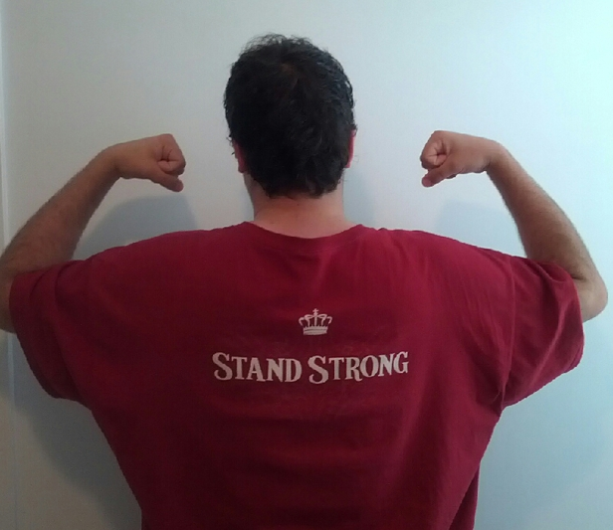

Study the pictures. First you were so sure, like the apostle Peter when he was with Jesus, that you – more so than anyone else – would stand strong. Now, like the woman on the beach – taking a moment of quiet reflection – you start to remember promises neglected ...
Recall the list of promises you made to God after you were first saved and you were so excited about what He had done for you.
What was on your list? Stop using bad words? Meet your responsibilities without complaining? Be kind to people who were hard to even like? No more cheating? No more lies? No more flirting? Cut down on overeating & take better care of the temple of the Holy Spirit that is your body? Stop drinking and/or abusing drugs? Avoid people and places that tempt you to sin? No more lusting? No more experimenting with false religion or anything even close to witchcraft? Help a local fellowship of Christians as they seek to disciple believers and to reach the lost? Support domestic or foreign missions?
How have you done in keeping those promises to the God who humbled Himself to come and suffer and die for you? Have you forgotten your “first love”?

Faith in Action

Prayer:
Ask the Holy Spirit to reveal to you some ways that you may have drifted, perhaps rationalizing a sin, perhaps just allowing yourself to be “captured” by “the tyranny of the urgent” (in a worldly rather than a Biblical sense).

Action:
Today I am choosing to ask a fellow believer to pray in-agreement and to walk with me as I intentionally realign my priorities to those of the Lord God.
Be Specific ______________________________________________________

Monday (Revelation 2:8-17)
To the Church in Smyrna
2:8 “To the angel of the church in Smyrna write the following: “This is the solemn pronouncement of the one who is the first and the last, the one who was dead, but came to life:
2:9 ‘I know the distress you are suffering and your poverty (but you are rich). I also know the slander against you by those who call themselves Jews and really are not, but are a synagogue of Satan.
2:10 Do not be afraid of the things you are about to suffer. The devil is about to have some of you thrown into prison so you may be tested, and you will experience suffering for ten days. Remain faithful even to the point of death, and I will give you the crown that is life itself.
2:11 The one who has an ear had better hear what the Spirit says to the churches. The one who conquers will in no way be harmed by the second death.’
To the Church in Pergamum
12 “To the angel of the church in Pergamum write the following: “This is the solemn pronouncement of the one who has the sharp double-edged sword:
2:13 ‘I know where you live – where Satan’s throne is. Yet you continue to cling to my name and you have not denied your faith in me, even in the days of Antipas, my faithful witness, who was killed in your city where Satan lives.
2:14 But I have a few things against you: You have some people there who follow the teaching of Balaam, who instructed Balak to put a stumbling block before the people of Israel so they would eat food sacrificed to idols and commit sexual immorality.
2:15 In the same way, there are also some among you who follow the teaching of the Nicolaitans.
2:16 Therefore, repent! If not, I will come against you quickly and make war against those people with the sword of my mouth.
2:17 The one who has an ear had better hear what the Spirit says to the churches. To the one who conquers, I will give him some of the hidden manna, and I will give him a white stone, and on that stone will be written a new name that no one can understand except the one who receives it.’

Prayer
Lord, You understand the struggles we have in this dark and fallen world, and You stand ready to represent for those who have surrendered all - to You - in response to Your invitation through Your Gospel. May I be encouraged and strengthened, hope-filled and humbled by all that You have done for me.

Summary & Commentary
Jesus acknowledged, to the leaders of the Church in Smyrna, the wealth of their love (for Him and for one-another) versus their worldly poverty.
He warned them of the persecution to come, He permitted it because it had value in His great plan, and He encouraged them to persevere.
Jesus affirmed the assurance of their salvation “... no way be harmed by the second death.”
To the Church in Pergamum He said ‘I know where you live – where Satan’s throne is”. Jesus was assuring them that He understood they were dealing with a world in which Satan is Prince (temporarily), and that they were challenged every day. (In their local case the enemy apparently had a strong follower and spiritual foothold.)
Jesus challenged them to put-out those among them who promoted the false sin-is-OK-under-grace teaching of the Nicolaitans.
There has been much speculation about the “hidden manna” and the “white stone” in verse 2:17. Manna, as in the John 6 telling of the story of feeding the five thousand, referred to Jesus “the Bread of Life” - transforming the known history of the miraculously-provided physical food of the past to a spiritual illustration.
Including the Bible.org provided Greek translation notes this author takes the meaning to be the peace, perspective, and power from the promised salvation that is recognized by “the one who receives it”; the Word (revealed by the Holy Spirit), imparted-righteousness (royal-robes of white in Heaven), and Jesus as their advocate and propitiation at the Great White Throne Judgment.

Interaction

Consider
The wealth we have in the promise of Heaven, the presence of the Holy Spirit, and the comfort of fellow-believers is far more valuable than anything this temporary world can offer. The Bible never promises worldly peace or prosperity to Christians. While the non-saved often live pointless and wasted lives the Lord God is active in the lives of His children – to the degree to which we do not make rebellious choices – and with a priority for the impact on eternity rather than this temporary world.

Discuss
What are some practical ways to help fellow believers to understand the reality of Satan in the world all around us, without drifting into an obsession with evil or into silly superstition?

Reflect
Jesus not only provided our path to salvation, the Lord sees us clothed in white through Him, and He stands ready to speak for us at the Great White Throne Judgment.

Share
When have you experienced, or observed, the obvious attack of the enemy against a believer?

KTALZ
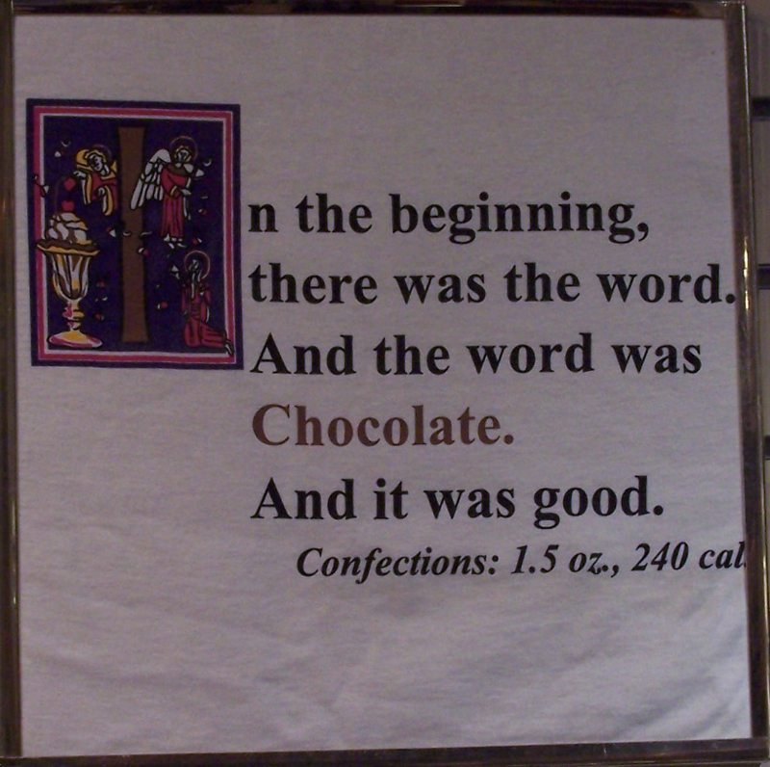

The first picture is intended to be humor but contains an unintended second message – we may often be led to displace God with things which bring us momentary pleasure – it's the same lie the Serpent told Eve in the Garden.
The second picture is of the famous Golden Gate Bridge in San Francisco, California in the USA. It was the dream of a man who never saw it built, it was something many said could not be done since the span was so long (once completed it was the longest in the world for 27 years), yet it has also become the site of many suicides and suicide attempts “The most you can hope for is to be noticed in your dying.” is the lie that the enemy tells to confused and sad people.

Faith in Action

Prayer:
Ask the Holy Spirit to reveal to you some who needs encouragement as they confront false teaching or an attack from the enemy.

Action:
Today I will pray in-agreement and in-earnest for the one identified to me by the Lord and, as is appropriate, I will offer to walk alongside them through the challenge in other ways.
Be Specific ______________________________________________________

Tuesday (Revelation 2:18-29)
“2:18 “To the angel of the church in Thyatira write the following:
“This is the solemn pronouncement of the Son of God, the one who has eyes like a fiery flame and whose feet are like polished bronze:
2:19 ‘I know your deeds: your love, faith, service, and steadfast endurance. In fact, your more recent deeds are greater than your earlier ones.
2:20 But I have this against you: You tolerate that woman Jezebel, who calls herself a prophetess, and by her teaching deceives my servants to commit sexual immorality and to eat food sacrificed to idols.
2:21 I have given her time to repent, but she is not willing to repent of her sexual immorality.
2:22 Look! I am throwing her onto a bed of violent illness, and those who commit adultery with her into terrible suffering, unless they repent of her deeds.
2:23 Furthermore, I will strike her followers with a deadly disease, and then all the churches will know that I am the one who searches minds and hearts. I will repay each one of you what your deeds deserve.
2:24 But to the rest of you in Thyatira, all who do not hold to this teaching (who have not learned the so-called “deep secrets of Satan”), to you I say: I do not put any additional burden on you.
2:25 However, hold on to what you have until I come.”
“2:26 And to the one who conquers and who continues in my deeds until the end, I will give him authority over the nations –
2:27 he will rule them with an iron rod and like clay jars he will break them to pieces,
2:28 just as I have received the right to rule from my Father – and I will give him the morning star.
2:29 The one who has an ear had better hear what the Spirit says to the churches.’

Prayer
Lord, You want to deliver a righteous and victorious church, yet humankind is constantly attacked by the promoters of unrighteousness – from the inside and outside. May I be encouraged by Your patient love and be willing to stand against those who seek to diminish and to destroy Your church.

Summary & Commentary
The “Son of God” appeared to John with what he loosely-described as “eyes like a fiery flame” and with “feet like polished brass”; therefore, His glory was apparent to John in his spiritual state and His foundation “feet” gave the appearance of the strength of metal and the quality of well-crafted and well cared for metal found in the possession of earthly royalty/wealth.
Jesus congratulated the believers at Thyatira for standing their ground in His name.
He challenged them for starting to drift because they were tolerating bad teaching and behavior – spawned by Jezebel.
Jesus returned to His teaching that depravity and false teaching must be purged, He warned that He was going to send disease to her, and that it would spread from her to those who engaged in sinful conduct with her.
Note: Jezebel may have been a symbol for the same sort of teaching as the Nicolaitans, who were mentioned in warnings to the other communities.
Jesus prophesied suffering and trouble for those who engaged in witchcraft the “deep secrets of satan”.
He promised that the faithful would, in the very last days, rule with Him as He dismantled the pagan nations. (The NET Translators's notes observe that this is a partial reference to Psalm 2:8-9.) This is likely to also be a reference to Revelation 20:1-10.
Jesus drew a spiritual parallel to His partnership with the faithful, as they broke down the strongholds of sin in their lives, and He promised to deliver His church as “the morning star”.

Interaction

Consider
Jesus emphasized avoidance of false teaching, be it the toleration of sin among those within their fellowship, or those who rebelled into the spiritual pit of witchcraft.

Discuss
What are some some practical ways to identify and remove philosophies which promote the toleration of sin and witchcraft in your local fellowship without becoming legalistic? (Begin with ways to compare and contrast individual and fellowship lifestyles that reflect purity and righteousness with excuses for constantly testing the threshold of over sin or folding-in elements of other religions – none of which are compatible with Biblical Christianity.)

Reflect
How different are we than those discussed in this text? Are we not also prone to tolerate the profane, on television, the Internet, music, movies, art, and even in our fellowships?

Share
What is an example from your life, or fellowship, where excuses for sin and/or witchcraft had drifted in? How were you successful in purging those influences?

KTALZ
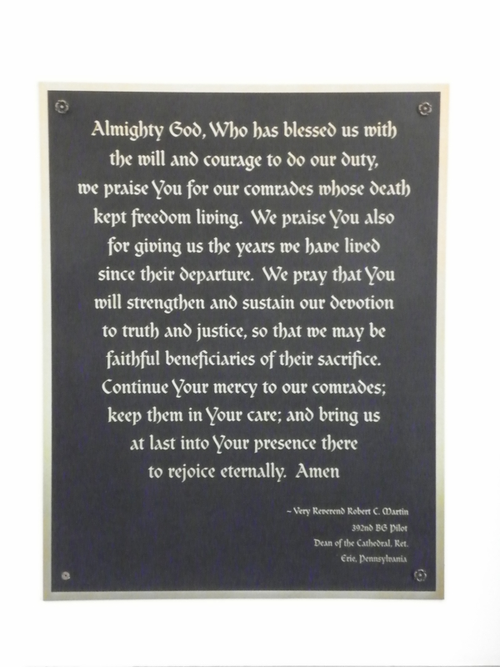


The first picture is from a plaque in a chapel which honors the sacrifice of pilots during World War II, like many early day Christians (as well as throughout history and to this very day), they suffered and died for what they believed.
The second picture is of a city in the USA called New Orleans. Like many in Thyatira people are led astray by the bright lights, music, and promises of pleasures. You may observe in the lower left corner the puddle of water in the broken-down street – much of the city is dangerous and dirty.

Faith in Action

Prayer:
Ask the Holy Spirit to reveal to you one or more subtle, or not so subtle, ways that the toleration of sin and/or witchcraft has entered your life and/or that of your fellowship.

Action:
Today I agree to partner with a fellow believer, and the Holy Spirit, to fearlessly purge those things from my life – and as is appropriate, and possible, to challenge the same destructive elements in my fellowship - as all sin offends the Lord God.
Be Specific ______________________________________________________

Wednesday (Revelation 3:1-6)
To the Church in Sardis
3:1 “To the angel of the church in Sardis write the following: “This is the solemn pronouncement of the one who holds the seven spirits of God and the seven stars:
‘I know your deeds, that you have a reputation that you are alive, but in reality you are dead.”
“3:2 Wake up then, and strengthen what remains that was about to die, because I have not found your deeds complete in the sight of my God.”
“3:3 Therefore, remember what you received and heard, and obey it, and repent.
If you do not wake up, I will come like a thief, and you will never know at what hour I will come against you.”
“3:4 But you have a few individuals in Sardis who have not stained their clothes, and they will walk with me dressed in white, because they are worthy.
3:5 The one who conquers will be dressed like them in white clothing, and I will never erase his name from the book of life, but will declare his name before my Father and before his angels.
3:6 The one who has an ear had better hear what the Spirit says to the churches.'”

Prayer
Lord, you warn us that a partial surrender to You is inadequate, it is all or nothing at all – and for those who have clearly heard there is no excuse at all. May I not only be a willing instrument - the fruits of the Spirit as His tools - may I also be bold in challenging others to do the same.

Summary & Commentary
Jesus warned that there were many who had heard the gospel, and had pretended to surrender, but had not; therefore, they were not saved and were facing His sudden wrath.
What was left of their original response to truth, left un-nurtured (falling short of saving-faith), was to be seized upon and nurtured before it died - otherwise they would be completely alienated from God.
Jesus used the term “repent”, which means to turn away – in this case from all of the things of the world which stood in opposition to Him.
He then returned to His teaching that He would return unannounced and those who remain “asleep” (a different use of the same term often used to describe the dead-in-Christ), without having secured their salvation, would be lost.
Jesus acknowledged the presence of a sub-population within the community who were truly saved, He described how He saw them - dressed in white like Him – with their salvation secure.

Interaction

Consider
Do we have a clear and present sense of the imminence of the return of the Lord, including our limited lifespan (which could end at any moment), after which nothing can be done?

Discuss
How might your fellowship do a better job in clarifying the elements of a genuine personal salvation (absolute surrender)?

Reflect
How different are we from those described in Revelation – are we also guilty of holding-back from a complete surrender – and do we understand the risks?

Share
When have you heard the truth about salvation as an absolute surrender preached/taught and what was the reaction?

KTALZ

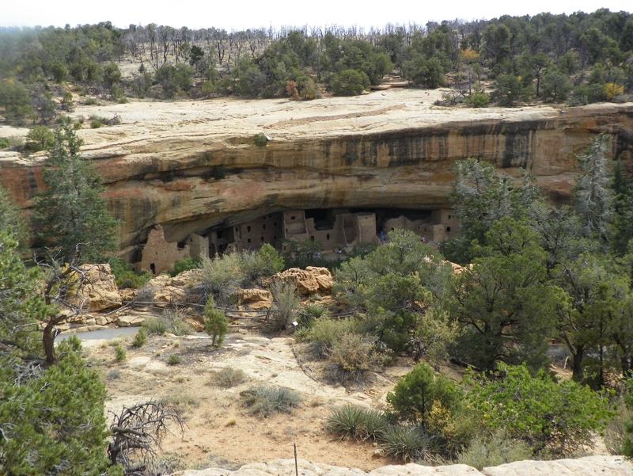

The first picture is of a raised bed garden. It looks like a place where things would grow, but once the seeds have been planted - if not fertilized and watered - little good will come of it. The same is true of one who has been told about Jesus but who has not surrendered to His Lordship – there is no growth without life, food, and water.
The second picture is from Mesa Verde in the southeastern USA. The ruins of a very creative culture who built their homes into sandstone, protected above by a massive stone overhang, yet they suddenly disappeared. Many are 'religious' but not fully surrendered, such people can become busy about the tasks of life and/or rituals yet lose it all because they lack a saving-relationship with the only One Who can sustain them.
The third picture is of the bright light of the sun across a field. If we have not surrendered, so that we may be discipled as His children, then will the return of Jesus find us looking like an unkempt field of weeds?

Faith in Action

Prayer:
Ask the Holy Spirit to reveal to you a place in your life, or in that of one for whom He wants you to pray, where you (or they) are holding-back from an absolute surrender to the Lord God. (Note: One may not lose one's salvation, once genuinely received, but may miss many blessings and be a poor instrument without discipleship.)

Action:
Today I will ask a fellow believer to pray in-agreement for me to get right with the Lord, and/or for the same in the walk of one whom the Holy Spirit has revealed to me, and humbly we will do whatever it takes to become His completely.
Be Specific ______________________________________________________

Thursday (Revelation 3:7-13)
“To the Church in Philadelphia
3:7 “To the angel of the church in Philadelphia write the following: “This is the solemn pronouncement of the Holy One, the True One, who holds the key of David, who opens doors no one can shut, and shuts doors no one can open:
3:8 ‘I know your deeds. (Look! I have put in front of you an open door that no one can shut.)
I know that you have little strength, but you have obeyed my word and have not denied my name.”
“3:9 Listen! I am going to make those people from the synagogue of Satan – who say they are Jews yet are not, but are lying – Look, I will make them come and bow down at your feet and acknowledge that I have loved you.”
“3:10 Because you have kept my admonition to endure steadfastly, I will also keep you from the hour of testing that is about to come on the whole world to test those who live on the earth.
3:11 I am coming soon. Hold on to what you have so that no one can take away your crown.
3:12 The one who conquers I will make a pillar in the temple of my God, and he will never depart from it. I will write on him the name of my God and the name of the city of my God (the new Jerusalem that comes down out of heaven from my God), and my new name as well.
3:13 The one who has an ear had better hear what the Spirit says to the churches.’”

Prayer
Lord, You see past our facades, nothing is hidden from You. May I be found steadfastly devoted to You, striving to resist allowing tests to become temptations and then volitional sin – with strength from Your Holy Spirit.

Summary & Commentary
Jesus recognizes our weakness and promises that if we choose the path of faith-guided truth He will hold open the door to Heaven and no created-being can ever close it to us.
Philadelphia was created by the Greeks to convert the culture of what was to become modern Turkey from one with their own language and traditions to Greek – they were remarkably successful – then with the coming of the Romans – God used the same beachhead to deliver His message of Redemption. (Paraphrased from William Barclay, The Revelation of John, Volume I, The Westminster Press, Philadelphia, p. 158 as cited here: https://bible.org/seriespage/message-philadelphia-rev-37-13)
The expression “... the key of David” would have been understood by John's readers who were familiar with pre-Jewish, Jewish, and very recent Christian history.
The text really should include a highlight of “the” in “the key” because its history actually dates back to Adam and Eve (the “key” is to Heaven and it is the Redeemer). One place that the expression may be found is in Isaiah 22 where God, through the king, transferred the key to “the house of David” to Eliakim – in the line between David and Joseph, the earthly father (legal not genetic) of Jesus.
The promised “redeemer” of Genesis 3:15 was given to humankind and passed down through the generations, including for a time through Israel, and afterward to every believer.
It is important to remember that the line of kings, while prophesied by God, were not His preferred path for Israel – He warned them of the troubles to come yet they were unteachable in their desire to be like the nations around them – therefore the emphasis must always be on the faith-aspect of David, not his worldly kingship, nor his many personal failures.
It's unclear why the NET Translator's chose to be unclear in the rendering of 3:9, where it reads “ I am going to make those people ...” the NET Greek Notes allow it to read “I am going to humble (or strike) those people ...”, which would appear a more-complete and still-accurate rendering. The phrase “those people” referred to the false teachers who, likely at least partially Jewish in heritage, “are not, are lying” because they misrepresented what God had taught about Jesus the Christ (“The Messiah”).
Jesus condemned the religious leaders when on earth because of their misrepresentations of God; in Rev. 3:9 “... synagogue of Satan” refers to those who have become tools of Satan because their teaching had drifted so far from the truth, and the hearts of their followers had paralleled the perversity of their toxic leadership.
Jesus acknowledged the steadfastness of the faithful at Philadelphia and warned them that challenges were to come – but that he would protect them.
His warning about their “crown” being at risk refers to their efforts being thwarted by lies as they faithfully tried to evangelize and disciple others, not their salvation at risk. [We know this to be His intent because in 1Cor. 10:13 He says that those who are saved cannot be deceived so greatly that they can lose their salvation and Paul referred to his “crown” as those He had evangelized and discipled (Phil. 4:1 and 1 Thess. 2:14).]

Interaction

Consider
Jesus does not expect us to be perfect, the Bible does not teach works-righteousness, nor does it anticipate flawless-righteousness in our Fallen bodies. [This is why we must be “made new” at the threshold to Heaven.]

Discuss
How could your fellowship strike a clearer balance between advocating that all believers seek-after righteousness and yet avoid drifting into legalistic prescriptions for the pursuit of impossible-to-achieve sin-free lives of perfection? (The Biblical teaching is to pursue excellence.)

Reflect
The Lord has repeatedly made examples of false teachers, humbling them – and lifting-up those who had clung to right doctrine, but other false teachers always rise in their place. The Enemy is active.

Share
When have you observed a leader who, despite attack, stood his ground on the Word and persevered to victory?

KTALZ


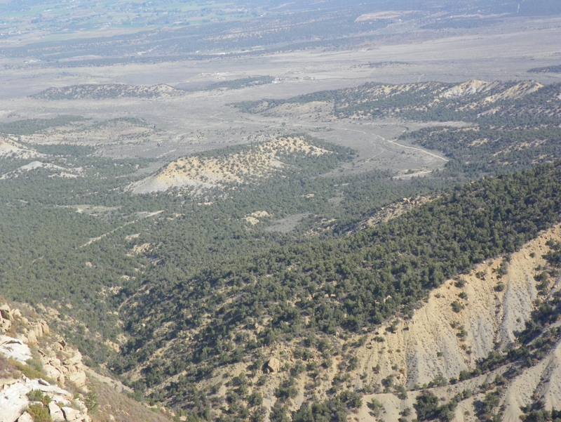
This tunnel passes through a part of a mountain. It is a necessary avenue for passage from one side to the other. Someone had to create it and someone has to maintain it. In some places such tunnels require payment to use – this one requires no fee. Some tunnels forbid certain cargo to travel through – typically explosives and tankers carrying toxic chemicals. Note the turn-off to the right – this is for vehicles to stop should they, for some reason, pause before entering the tunnel. Our Redeemer, Jesus, created the only passageway between this Fallen Creation and Heaven. He paid for it, He built everything involved, and He provides it for free to any who are faithful to Him. Those still carrying the explosive/toxic cargo of sin, because a saving relationship with Him is the only way to remove that cargo, may not pass. Travel through the mountains can be scary due to the steep roads and sharp drops-off near to the sides of the road. Bears and snakes may lurk in the woods. Faithfulness, despite challenges, is one evidence of genuine salvation.

Faith in Action

Prayer:
Ask the Holy Spirit to reveal to you a challenge for which you must prepare, one in which your clarity is critical, and where that clarity will help you to assist others who would otherwise drift into confusion and/or panic.

Action:
Today I will prayerfully study the Word, as I am discipled by the Holy Spirit, and as necessary I will consult one who meets the Biblical standard of “elder” - should I need clarification. I will ask a fellow believer to walk alongside in prayer and study – together we will prepare and together we will come alongside others as they accept the need to prepare as well.
Be Specific ______________________________________________________

Friday (Revelation 3:14-18)
“To the Church in Laodicea
3:14 “To the angel of the church in Laodicea write the following: “This is the solemn pronouncement of the Amen, the faithful and true witness, the originator of God’s creation:
3:15 ‘I know your deeds, that you are neither cold nor hot. I wish you were either cold or hot!
3:16 So because you are lukewarm, and neither hot nor cold, I am going to vomit you out of my mouth!”
“3:17 Because you say, “I am rich and have acquired great wealth, and need nothing,”
but do not realize that you are wretched, pitiful, poor, blind, and naked,
3:18 take my advice and buy gold from me refined by fire so you can become rich!
Buy from me white clothing so you can be clothed and your shameful nakedness will not be exposed,
and buy eye salve to put on your eyes so you can see!”

Prayer
Lord, You are the source of authority for all truth, and You desire that we live in that truth. May be certain to be unafraid of truth, unwilling to to compromise truth to avoid conflict, and cautious to avoid the idolatry of money.

Summary & Commentary
The term “Amen” generally means “I believe” or perhaps “I understand and agree” but may also mean “the truth”. In this context it may be understood to refer to the One Who gives authority to truth.
Jesus wants everyone to be engaged with the challenges of truth and of righteous living.
His frustration with the Laodiceans was their avoidance of a decision – making them unteachable.
We are taught elsewhere that the Lord God “is no respecter of persons”, which means that He cares not for our worldly possessions or titles, only for the condition of our hearts.
Jesus warned repeatedly of the distractions of money and worldly pursuits.

Interaction

Consider
The Lord God is the source of all truth and the authority behind that truth.

Discuss
How do we teach believers to be confident in their faith when the world wants them to sell-out in order to fit-in?

Reflect
Sometimes those who are most comfortable in their worldly state are also the least teachable.

Share
When have you observed someone for whom wealth was a wall that separated them recognizing their need for Jesus?

KTALZ



The first picture shows glacial ice below while above is a jet whose very hot engines spray moist exhaust into the frigid air which turns to ice crystals and creates a trail. There is power in the hot jet engine, and there is power in the slow moving cold glaciers, but the floating ice crystals high in the atmosphere have no power.
The second is of a gutted mansion. What might be a symbol of pride, belonging to someone who was successful by worldly standards, is merely an ugly hulk to all who see it. The things of this world will not last, but the things of the Lord are eternal.

Faith in Action

Prayer:
Ask the Holy Spirit to reveal to you any place in your walk, or in the teaching of your fellowship, where conflict-avoidance has become truth-avoidance.

Action:
Today I will humbly and prayerfully surrender myself, and/or challenge my fellowship, to sacrifice comfort and temporary peace for the sake of truth.
Be Specific ______________________________________________________

Saturday (Revelation 3:19-22)
3:19 All those I love, I rebuke and discipline.
So be earnest and repent!
3:20 Listen! I am standing at the door and knocking! If anyone hears my voice and opens the door I will come into his home and share a meal with him, and he with me.
3:21 I will grant the one who conquers permission to sit with me on my throne, just as I too conquered and sat down with my Father on his throne.
3:22 The one who has an ear had better hear what the Spirit says to the churches.’

Prayer
Lord, You love us as You find us – here in this Fallen world – and as someone once said “You love us too much to leave us this way”. May I respond when You knock on the door of my heart, let You in, and cooperate as You make me just a little more like You.

Summary & Commentary
Jesus shows His eternal love by refusing to look away from sin in the lives of those whom He loves; He will “rebuke” (confront with wrong thoughts and deeds) and He will motivate repentance via “discipline” to get our attention.
When He walked the earth Jesus dined with the poor and the rich alike that His saving message might be made known to all.
In this context Jesus is speaking to “All those I love”, so believers, and not those who have yet to surrender. This isn't about evangelism, it's about discipleship.
When He sent out His disciples He instructed them to only stay at the home of one who welcomed both them and their message from Him.
Jesus is ready to walk alongside those who are teachable, and for those who are obedient – responding to discipleship and resisting temptation – He will invite to join Him in Heaven.

Interaction

Consider
The consistent message of Jesus is that there are conditions for admittance into Heaven. True salvation is an unconditional surrender of everything in this world in exchange for everything good in Heaven - for eternity.

Discuss
What are some practical ways to challenge people to assess their salvation and to redouble their efforts to bring the gift and assurance of salvation to the eternally dead and dying all around them?

Reflect
Jesus is unhappy with Christians who become careless about their lifestyle and/or who neglect His Greatest Commandment to love and His Great Commission to “go forth” because of His love poured into and through them intended to bless others.

Share
What is an example from your life where you found yourself becoming careless or neglectful about your Biblical-Christian walk? How did the Lord God guide you back to the right path?

KTALZ

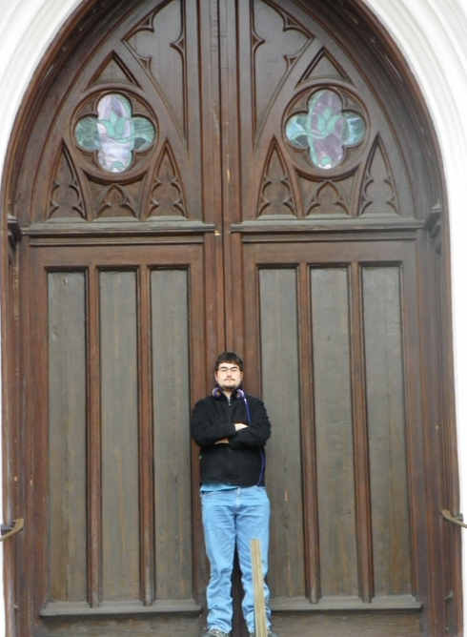


The first picture is from South Korea where a daughter of the Lord God joyfully shows a gigantic door – illustrating the size of the loving heart of Jesus Who bids us to welcome Him into our lives.
The second picture is also of a giant door, in this case the person with the folded arms demonstrates an attitude of reluctance to allow the door to be opened to Jesus, inviting His rebuke and discipline.
The third picture illustrates someone who has been welcomed to, rhetorically, sit upon the throne of the Father.

Faith in Action

Prayer:
Ask the Holy Spirit to assess your life for any evidence of carelessness in your lifestyle, neglect of love for your fellow believers, and/or neglect of evangelism and/or resistance to be discipled or to offer discipleship to others.

Action:
Today I will select an area where I fall short and I will partner with the Holy Spirit, and a prayer partner, as He guides me back onto the right path.
Be Specific ______________________________________________________

All Bible text is from the NET unless otherwise indicated - http://bible.org
Note 1: These Studies often rely upon the guidance of the NET Translators from their associated notes. Careful attention has been given to cite that source where it has been quoted directly or closely paraphrased. Feedback is encouraged where credit has not been sufficiently assigned.
Note 2: When NET text is quoted in commentary and discussion all pronouns referring to God are capitalized, though they are lower-case in the original NET text.
Commentary text is from David M. Colburn, D.Min. unless otherwise noted.
Copyright © 2012 by David M. Colburn. This is a BibleSeven Study – “Revelation” Section - “Rev. 2-3” – prepared by David M. Colburn and edited for bible.org in May of 2012. This text may be used for non-profit educational purposes only, with credit; all other usage requires prior written consent of the author.

