Genesis 6:9 - 11
(Noah, The Flood, Babel)
David M. Colburn
A Chronological Daily Bible Study of the Old Testament
7-Day Sections with a Summary-Commentary, Discussion Questions,
and a Practical Daily Application
Week 3

Sunday (Genesis 6:9 - 7:24)
The Judgment of the Flood
6:9 This is the account of Noah.
Noah was a godly man;
he was blameless among his contemporaries.
He walked with God.
6:10 Noah had three sons: Shem, Ham, and Japheth.
6:11 The earth was ruined in the sight of God; the earth was filled with violence. 6:12 God saw the earth, and indeed it was ruined, for all living creatures on the earth were sinful.
6:13 So God said to Noah, “I have decided that all living creatures must die, for the earth is filled with violence because of them. Now I am about to destroy them and the earth.
6:14 Make for yourself an ark of cypress wood. Make rooms in the ark, and cover it with pitch inside and out.
6:15 This is how you should make it: The ark is to be 450 feet long, 75 feet wide, and 45 feet high. 6:16 Make a roof for the ark and finish it, leaving 18 inches from the top. Put a door in the side of the ark, and make lower, middle, and upper decks.
6:17 I am about to bring floodwaters on the earth to destroy from under the sky all the living creatures that have the breath of life in them. Everything that is on the earth will die,
6:18 but I will confirm my covenant with you. You will enter the ark – you, your sons, your wife, and your sons’ wives with you.
6:19 You must bring into the ark two of every kind of living creature from all flesh, male and female, to keep them alive with you. 6:20 Of the birds after their kinds, and of the cattle after their kinds, and of every creeping thing of the ground after its kind, two of every kind will come to you so you can keep them alive.
6:21 And you must take for yourself every kind of food that is eaten, and gather it together. It will be food for you and for them.
6:22 And Noah did all that God commanded him – he did indeed.

7:1 The Lord said to Noah, “Come into the ark, you and all your household, for I consider you godly among this generation.
7:2 You must take with you seven of every kind of clean animal, the male and its mate, two of every kind of unclean animal, the male and its mate, 7:3 and also seven of every kind of bird in the sky, male and female, to preserve their offspring on the face of the earth.
7:4 For in seven days I will cause it to rain on the earth for forty days and forty nights, and I will wipe from the face of the ground every living thing that I have made.”
7:5 And Noah did all that the Lord commanded him.
7:6 Noah was 600 years old when the floodwaters engulfed the earth. 7:7 Noah entered the ark along with his sons, his wife, and his sons’ wives because of the floodwaters. 7:8 Pairs of clean animals, of unclean animals, of birds, and of everything that creeps along the ground, 7:9 male and female, came into the ark to Noah, just as God had commanded him. 7:10 And after seven days the floodwaters engulfed the earth.
7:11 In the six hundredth year of Noah’s life, in the second month, on the seventeenth day of the month – on that day all the fountains of the great deep burst open and the floodgates of the heavens were opened. 7:12 And the rain fell on the earth forty days and forty nights.
7:13 On that very day Noah entered the ark, accompanied by his sons Shem, Ham, and Japheth, along with his wife and his sons’ three wives. 7:14 They entered, along with every living creature after its kind, every animal after its kind, every creeping thing that creeps on the earth after its kind, and every bird after its kind, everything with wings. 7:15 Pairs of all creatures that have the breath of life came into the ark to Noah. 7:16 Those that entered were male and female, just as God commanded him. Then the Lord shut him in.
7:17 The flood engulfed the earth for forty days. As the waters increased, they lifted the ark and raised it above the earth. 7:18 The waters completely overwhelmed the earth, and the ark floated on the surface of the waters. 7:19 The waters completely inundated the earth so that even all the high mountains under the entire sky were covered. 7:20 The waters rose more than twenty feet above the mountains. 7:21 And all living things that moved on the earth died, including the birds, domestic animals, wild animals, all the creatures that swarm over the earth, and all humankind. 7:22 Everything on dry land that had the breath of life in its nostrils died.
7:23 So the Lord destroyed every living thing that was on the surface of the ground, including people, animals, creatures that creep along the ground, and birds of the sky. They were wiped off the earth. Only Noah and those who were with him in the ark survived.
7:24 The waters prevailed over the earth for 150 days.

Prayer
Lord, may Your Holy Spirit teach me how to be as faithful as Noah so that I too would find favor in your sight, please help me to understand the relationship between my obedient living before you, and the blessings that You give to me, so that they may be poured out into the lives of others. Father, your message is simple, but my chosen path to obedience is sometimes more complicated and cluttered than it should be. Please teach me to be as trusting as Noah; as everything around me seems to be falling into ruin, may I know that You will lift me up above the floodwaters of sin and destruction.

Scripture In Perspective
While others were found unrepentantly-sinful Noah was found by the Lord God to be “a godly man”. This does not imply perfection or sinlessness – else he could have been the Messiah - it meant that he prioritized what the Lord said was important, he was teachable, and was he made an exceptional effort to be obedient.
Enoch “walked with God” and was “taken-up” and, as previously noted without earthly death, Noah was not; therefore, “walked with God” also does not imply sinlessness – but rather intentional and significant obedience.
When the Lord God declared that “... all living creatures on the earth were sinful.” He was making the statement on dual levels; first was the reality of the Fall wherein all of Creation was cursed with the sin of Adam and Eve, second was the volitional sin of humankind – most of it unrepentant.
When the Lord God said that “... all living creatures must die … I am about to destroy them and the earth.” He used His terminology narrowly, referring back to the Creation narrative - because Noah was about to float a remnant of creatures and humankind on the waters. (the waters were, during Creation, specifically defined as separate from “the earth”).
The Lord God then gave Noah very specific instructions as to the construction of the “Ark”, followed by His reaffirmation of intent to purge the earth.
Verse 6:18a “... but I will confirm my covenant with you” appears to be a reference to the dialogue between the Lord and Cain in Genesis 4:3-7 where He acknowledges an implicit quid pro quo between a person's choice to be in right-standing before Him and thus receive His blessing, or to be at-odds with Him and be denied His blessing.
The Lord God extended His covenant with Noah to his sons, his wife, and his sons’ wives. No daughters were specifically mentioned.
The Lord also extended His grace to “... two of every kind of living creature from all flesh, male and female” and he commissioned Noah “... to keep them alive with you.”
He added also “... the birds after their kinds, and of the cattle after their kinds, and of every creeping thing of the ground after its kind, two of every kind will come to you so you can keep them alive.”
Some have suggested that Noah took 100 years to build the ark. That math is predicated upon a literal reading that after Noah turned 500 his three sons were born (5:32), construction began immediately at age 500, then “In the six hundredth year of Noah’s life” 600 - second month, seventeenth day (7:11) came the rains.
The Lord mentions the wives of the sons in verse 6:18 – before the construction was completed (6:22). This could have been a prophesy that by the time that the Ark was complete the sons would have wives – but that stretches the most-simple meaning of the text – therefore Noah and his sons likely completed the Ark in well less than 100 years.
The Lord God instructed Noah to gather food for the many days they would be on the Ark, and food for all of the animals. Once again the Lord was specific as to “... every kind of food that is eaten” because different creatures ate different food.
Once again Noah was found faithful “Noah did all that God commanded him – he did indeed.”
The Lord God's provision was conditional, “... I consider you godly among this generation”, therefore He said “Come into the ark, you and all your household”.
The importance that the Lord placed on the His expectation of sacrifice was affirmed as He required of Noah that he include “... seven of every kind of clean animal, the male and its mate” as opposed to only two each of the “unclean” (therefore He must have communicated this previous to this time and all were aware).
[Note the absence of mention of any children yet born to his sons.]
When all was ready God gave seven days notice prior to the flood-waters. Since He had apparently communicated His expectation of right-sacrifice He presumably also communicated – via Noah – His intentions re. the flood. Of course the construction of the giant ship would have long-since have stimulated questions.
The flood-waters came not only from the sky, as is the common depiction, but also from “the great deep”. The NET translators observe that this is a sort of reversal of Creation as the waters once separated from the earth are now returned to cover it, albeit temporarily.
The waters came up from the ground (springs?) and the rain came down from the heavens (skies) for forty days and nights.
In Matthew 24:36-41 and Luke 17:22-27 Jesus reminded His disciples of Noah and that when He returns there will be little warning, unlike Noah's time when He gave seven days warning to Noah, but the people were not listening to Him - so it was as if they had received none.
When Noah had fulfilled God's instructions as to the construction of the Ark and the assembly of the animals and people they all climbed aboard the great ship.
Then God Himself closed and sealed the door (presumably it was too heavy for humans to close and it was critical that it be perfectly-sealed for the long journey).
Every living thing that breathed the air directly for life was destroyed; it appears that water-bound creatures were not destroyed, as Noah was not instructed to preserve any of them, and also some plant life also survived (thus the birds later finding plants).

Interact with the text

Consider
The Lord God does not expect us to be perfect any more than He expected Noah to be perfect. Only Jesus lived sinlessly. His desire is to bless us, but when we choose rebellion, we create flood-waters of sin between ourselves and His blessings. He provides and He shows us how to provide for ourselves and others. It remains our choice to be wise; to listen, and to obey. If the Lord God's blessings are conditional, how do we learn how to meet His conditions?

Discuss
When you describe “a godly man” or a “godly woman” what are the attributes you highlight which lifts them to that category? (Observe the care the Lord God takes with each discrete species of His Creation “after their kinds”, even after the early ill-affects of the Fall. There are no transitional species or cross-species in His plan.)

Reflect
When Adam and Eve sinned the Lord God administered the consequences required of justice, yet in His mercy and grace He still promised a way back. Once again He finds it necessary to obliterate much of humankind, and the rest of created life, yet He provided a way of survival via the Ark. Had Noah chosen to be like the others all around him what would have happened to his family, not to mention the rest of Creation? Noah tried to be consistently-obedient and therefore the Lord was able to use him in a mighty way; what about us? The Lord God decided to partially roll-back Creation in order to clean up the mess that humankind had made of the world. Does He sometimes roll-back some of the things we have “collected” or given improper value in ours lives – contrary to what should be in the life of a believer? What may have been the thoughts of those on the Ark as they watched the world below them swallowed-up by water and all of those living creatures die, leaving them with nothing but each other and the Lord God to comfort and provide for them? When the Lord God chooses to act He leaves nothing to chance, He raised the waters until they were 20 feet above the tallest mountain so that there was no chance of survival and He kept them there long enough so that not even a bird could survive.

Share
When you are reminded of the Lord God's repeated provision how has that strengthened you during difficult times? When have you observed a clear relationship between your obedient walk before the Lord and His blessings, either direct blessings to you, or blessings poured-out through you into the life of another? When has He directed you toward a task, and showed you the preparation you needed, and then when you were obedient He provided for all of your needs and used you mightily? If not, do you recall a time when He could have (and you should have) but you didn't, so He couldn't? What has the Lord God rolled-back in your life so that He could clean you up?

KTALZ
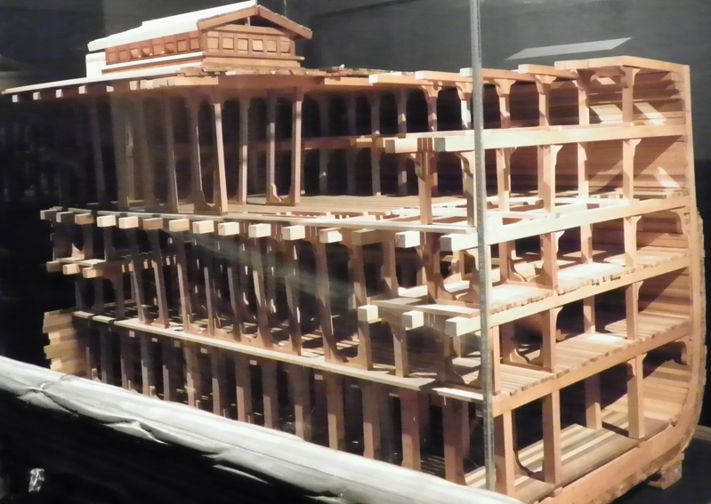
As one may observe from this cutaway-mock-up one concept of what the Biblical Ark may have looked like it was no simple ship.
The Lord God Himself dictated the details of it's design. It was perfectly-suited for the intended task and He closed and sealed the great walkway/door to assure that the voyage would be a safe one.

Faith In Action

Pray
Ask the Holy Spirit to enliven in you these prayers - Lord, when the flood-waters of trouble come into the world all around me, please find me faithfully-trusting You to be my “Ark” of safety and provision. Lord, may your Holy Spirit write this story on my heart so that I will see your consistent message from Noah and up until even now. You give us Yourself and the fellowship of believers and you ask us to recognize that the rest of the world – apart from You – is dead.

Act
Today I will I will ask a fellow believer to pray in agreement with me for a greater sensitivity to the Lord God so that He might find me a little more of an intentionally “godly” person every day. I will pray the same for a fellow believer. In an unconditional prayer, I will welcome the Holy Spirit into my life in a newly powerful way, asking Him to draw me nearer to Him in my daily choices so that I may be used as His means of blessing in the lives of others all around me.

Be Specific ________________________________________________

Monday (Genesis 8:1–14)
8:1 But God remembered Noah and all the wild animals and domestic animals that were with him in the ark.
God caused a wind to blow over the earth and the waters receded.
8:2 The fountains of the deep and the floodgates of heaven were closed, and the rain stopped falling from the sky.
8:3 The waters kept receding steadily from the earth, so that they had gone down by the end of the 150 days.
8:4 On the seventeenth day of the seventh month, the ark came to rest on one of the mountains of Ararat.
8:5 The waters kept on receding until the tenth month. On the first day of the tenth month, the tops of the mountains became visible.
8:6 At the end of forty days, Noah opened the window he had made in the ark 8:7 and sent out a raven; it kept flying back and forth until the waters had dried up on the earth.
8:8 Then Noah sent out a dove to see if the waters had receded from the surface of the ground.
8:9 The dove could not find a resting place for its feet because water still covered the surface of the entire earth, and so it returned to Noah in the ark. He stretched out his hand, took the dove, and brought it back into the ark.
8:10 He waited seven more days and then sent out the dove again from the ark. 8:11 When the dove returned to him in the evening, there was a freshly plucked olive leaf in its beak! Noah knew that the waters had receded from the earth.
8:12 He waited another seven days and sent the dove out again, but it did not return to him this time.
8:13 In Noah’s six hundred and first year, in the first day of the first month, the waters had dried up from the earth, and Noah removed the covering from the ark and saw that the surface of the ground was dry. 8:14 And by the twenty-seventh day of the second month the earth was dry.

Prayer
Lord, remind me often that “God remembers” and that I may never fear that I am alone; reveal to me in this text how You brought Noah and his family through the great flood and how their trust and patience may also be mine.

Scripture In Perspective
150 days passed after God stopped the rains from falling and the waters from rising and forced the waters to retreat to the lakes and seas using “wind”.
The Ark settled on a mountain and for another three months the waters continued to recede.
It appears from the text that another 40 days passed before Noah opened a window and loosed a raven to explore. The raven is a carrion bird and once it found the food of drowned bodies it did not return. We recall that the raven is referenced in Proverbs as a tool of harsh discipline, in Psalms and Job compared to babies abandoned by parents and dependent upon God, in the story of Elijah the Lord God used them to feed His prophet, and later in Luke - Jesus notes that the Lord cares for the ravens.
After the raven's forty days of journeys Noah sent out a dove which returned, unable to find a branch of a tree upon which it could rest, as only the peaks of a lifeless mountains would have been at the water's surface.
Seven days later the dove went out and returned with “... a freshly plucked olive leaf in its beak”, and another seven days later the dove departed and did not return.
The text describes the ground and the earth as dry on different days – the first day of the first month and the twenty-seventh of the second. The “ground” refers to the nearby land whereas the “earth” refers to the entire planet.
Noah waited as long as he did because he did not want to risk doing anything that might offend God, so he awaited His clear signal to open the window and release the birds and then to remove the “cover”..

Interact with the text

Consider
The Lord God remembers, for eternity, those whom He loves; therefore, we who are His children need never worry that He forgets us. God punished rampant sin by purging living things on the earth. He did not purge everything, or everyone, so He clearly had some specific variable(s) in mind.

Discuss
It appears from the text that they may have been aboard the Ark for 300 days. What may it have been like, trapped on an Ark filled with animals, beginning with 40 days and 40 nights of constant rain and floating around for an entire year?

Reflect
The incredible power of the Lord God that opened the water from above and below, then sent it back again, and that very same power continued to do miracle after miracle over history. That power continues to do the miracle of salvation in the hearts of people one-by-one. It was seven days between the olive branch, delivered by the dove - the assurance of life returning to the earth – and the dove's certainty of food and safety apart from the Ark which caused it to not return. There were four men and four women, all adults on the Ark. There is no mention of children.

Share
When have you felt alone and forgotten only to have the Lord God send someone, or do something, that reminded you that He remembered you? When have you been as patient as Noah, waiting on God rather than rushing out after a 'storm' in your life? When have you been alone with a small group of people for more than a few hours? Did you discover the need to 'go deep' because you quickly ran out of shallow things to discuss?

KTALZ


Although this bird is not a dove, nor is it carrying an olive branch, it may help to visualize the joy in Noah's heart when the dove returned – signifying that the terrible judgment of the flood was over.

Faith In Action

Pray
Ask the Holy Spirit to show you how to be intentional about driving the sin out of your life so that He does not have a need to purge your life of sin the hard way.

Act
Today I will I will prayerfully seek out a fellow believer who is feeling alone and forgotten and I will share these verses as an encouragement. If I have not previously done so I will journal an experience of alone-ness in my past, reflecting on the ways that I now recognize the Lord's presence. If I am currently struggling I will journal and pray for an “olive branch” from the Lord God to assure me that both an end to the trouble and a time of safety are near.
Be Specific _____________________________________________

Tuesday (Genesis 8:15-22)
8:15 Then God spoke to Noah and said, 8:16 “Come out of the ark, you, your wife, your sons, and your sons’ wives with you.
8:17 Bring out with you all the living creatures that are with you. Bring out every living thing, including the birds, animals, and every creeping thing that creeps on the earth. Let them increase and be fruitful and multiply on the earth!”
8:18 Noah went out along with his sons, his wife, and his sons’ wives.
8:19 Every living creature, every creeping thing, every bird, and everything that moves on the earth went out of the ark in their groups.
8:20 Noah built an altar to the Lord. He then took some of every kind of clean animal and clean bird and offered burnt offerings on the altar.
8:21 And the Lord smelled the soothing aroma and said to himself, “I will never again curse the ground because of humankind,
even though the inclination of their minds is evil from childhood on.
I will never again destroy everything that lives, as I have just done.
8:22 “While the earth continues to exist,
planting time and harvest,
cold and heat,
summer and winter,
and day and night will not cease.”

Prayer
Lord, You knew that Noah was not perfect, nor was his family, yet You caused them to live in order to preserve humankind. Teach me to trust you like Noah, so that no matter how great your judgment on man – even the troubles of the Great Tribulation – I may be ready to offer myself in worship of You.

Scripture In Perspective
The first thing that Noah did after disembarking from an entire year on the Ark was to build an altar to the Lord. Then he sacrificed some of the seven-each pairs of “clean” animals and birds which the Lord had instructed him to preserve during the flood.
It is said that the same root Hebrew word, depending on the subtleties of context, which is used to describe a “burnt offering to God” is also intended to express humble submission “holocaust” (which has a horrible meaning in modern times).
Oddly, the Great Flood was a sort of holocaust-by-water, as we might term a genocide, and here Noah is offering a burnt offering to the Lord God (whereas the modern “holocaust” often involved gas and fire).
Christians who understand the spiritual battle will recognize that the modern “holocaust” was a “burnt offering” by the Nazi leaders to Satan, even if they did not consciously recognize that fact.
When the Lord God “smelled the soothing aroma” He acknowledged that Noah's descendants were beginning anew with Him once-again central to their lives and for a very brief moment there was peace between God and man.
The Lord then declared that He would never again “curse the ground because of humankind”, not to mean that the curse of the Fall had been lifted, but that no new all-pervasive curse would be imposed.
The Lord God decided to stay His hand despite acknowledging that “... the inclination [not an absolute always-evil but a predisposition from which they were capable of turning] of their [humankind] minds is evil from childhood [specifically not birth but childhood] on”.
The Lord declared a conditional “ While the earth continues to exist ...”, which reminds us that the earth has a limited lifespan in God's plan.
The Lord God then affirmed the cycle of the seasons and what they meant to humankind:
“... planting time and harvest,”
“... cold and heat,”
“... summer and winter,”
“... and day and night”
Finally, He confirmed that it is He who causes it all to continue because it is He who has decided that He will not again interrupt things at a planetary-level until the last days of these end times.
[Note: This appears to mean that nothing in all of Creation will be permitted to cause planetary-level destruction unless the Lord permits it as His instrument of last days destruction.]

Interact With The Text

Consider
Noah wanted to demonstrate his loyalty, his thanks for the Lord God's provision and protection, and his intent to keep Him first.

Discuss
As New Testament Christians we no longer practice literal “burnt sacrifice”. In what ways might our daily lives include elements of the “sweet aroma” of surrender to the Lordship of Christ?

Reflect
Is it encouraging to you to know that the Lord has decided to never curse “the ground” at a planetary-scale until the last days of these end times?

Share
Knowing that the Lord God is aware of the our inclination toward evil from childhood, and knowing that believers are blessed with the indwelling presence of the Holy Spirit, how have you been able to leverage His presence against the sin-inclined tendencies of your imperfect flesh?

KTALZ
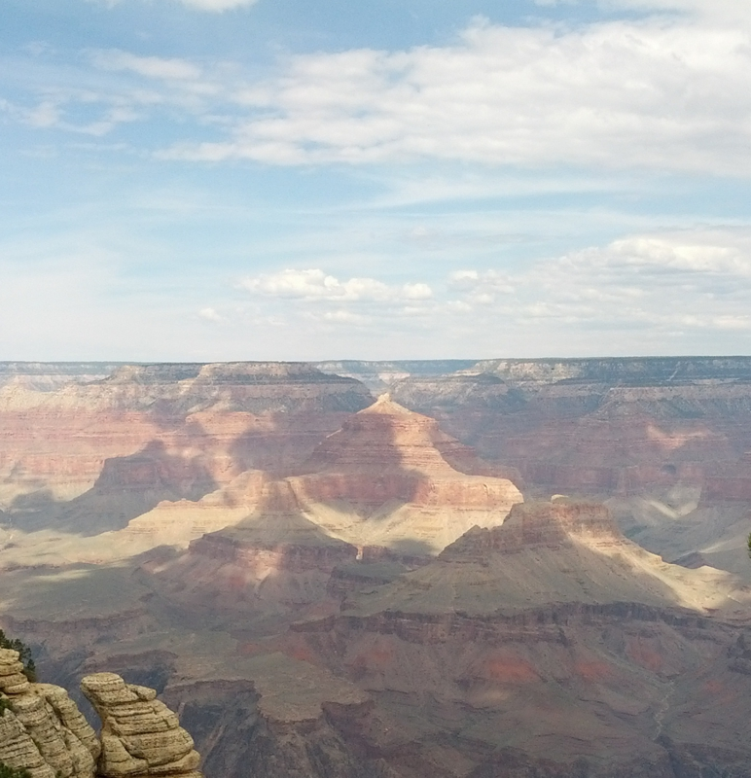
How shocking must it have been for Noah and his family to look out at a world, transformed by the catastrophic flood, devoid of humankind other than their small family?
Imagine how desperately-dependent they had become upon the Lord?

Faith In Action

Pray
Ask the Holy Spirit to find you a willing partner in becoming more and more of a humble and submitted servant of the Lord God, ready to resist the temptations of the flesh to rebel. Also, ask Him to enlighten your understanding of the best use of the limited cycles of the natural seasons of the year, in your walk and of the seasons of your life, before your days come to an end.

Act
I will prayerfully identify a part of my life where I have been neither humble or submitted to the Lord but have rather gone my own way – a way that I am sure has offended God – and I will partner with the Holy Spirit to surrender all of that as a living “burnt offering” for His pleasure in me. I will journal or otherwise record the vision I see of God's priorities worked-out this year and in a more general sense the seasons of the rest of my life. I will share that with a fellow believer for their prayerful reflection and perhaps as a motivation for them to do the same.

Be Specific _________________________________________________

Wednesday (Genesis 9:1-17)
9:1 Then God blessed Noah and his sons and said to them, “Be fruitful and multiply and fill the earth.
9:2 Every living creature of the earth and every bird of the sky will be terrified of you. Everything that creeps on the ground and all the fish of the sea are under your authority.
9:3 You may eat any moving thing that lives. As I gave you the green plants, I now give you everything.
9:4 But you must not eat meat with its life (that is, its blood) in it.
9:5 For your lifeblood I will surely exact punishment, from every living creature I will exact punishment.
From each person I will exact punishment for the life of the individual since the man was his relative.
9:6 “Whoever sheds human blood, by other humans must his blood be shed; for in God’s image God has made humankind.”
9:7 But as for you, be fruitful and multiply; increase abundantly on the earth and multiply on it.”
9:8 God said to Noah and his sons, 9:9 “Look! I now confirm my covenant with you and your descendants after you 9:10 and with every living creature that is with you, including the birds, the domestic animals, and every living creature of the earth with you, all those that came out of the ark with you – every living creature of the earth.
9:11 I confirm my covenant with you: Never again will all living things be wiped out by the waters of a flood; never again will a flood destroy the earth.”
9:12 And God said, “This is the guarantee of the covenant I am making with you and every living creature with you, a covenant for all subsequent generations: 9:13 I will place my rainbow in the clouds, and it will become a guarantee of the covenant between me and the earth.
9:14 Whenever I bring clouds over the earth and the rainbow appears in the clouds, 9:15 then I will remember my covenant with you and with all living creatures of all kinds. Never again will the waters become a flood and destroy all living things.
9:16 When the rainbow is in the clouds, I will notice it and remember the perpetual covenant between God and all living creatures of all kinds that are on the earth.”
9:17 So God said to Noah, “This is the guarantee of the covenant that I am confirming between me and all living things that are on the earth.”

Prayer
Lord, help me to understand the many changes in the relationship of man to the rest of creation, to You, and to one another in this text. Please help me to accept that Your knowledge is perfect and Your instructions to humankind are perfect, even if they challenge generally-accepted notions or traditions of humankind.

Scripture In Perspective
The Lord God reset the standing of humankind before Him “Then God blessed Noah and his sons ...” followed by instructions to get about the business of repopulating the earth.
The creatures of the earth were to “be terrified” of humankind – this is a newly competitive relationship due perhaps to the needs of the growing population for whom the animals represented a useful source of food, labor, clothing, and other resources. The pre-Fall Genesis texts described a more cooperative and peaceful relationship, and one where all need for food had been met and skins for clothing were unnecessary, the post-Fall text described limited competition, here the competition escalates as resources are very thin.
Note: The Lord instructed man to care for the creatures He had created in Gen. 1:26-28, then later, after the Fall, in Gen. 3:21 He made coverings for Adam and Eve from the skins of animals. Abel brought animals for sacrifice in Gen. 4:4. So it became reality that the death of an animal brought a benefit to a human – this was not entirely new in Noah's time.
The text implies that until Noah the Lord had required of His obedient people a purely vegetarian diet. Given their not-too-far-from-Eden genetic 'de-evolution' (from “perfect” to the “less-perfect” bodies), as well as undisclosed changes to the plant life, a purely vegetarian diet may have previously been sufficient to their nutritional needs.
Note: It has been suggested that modern efforts to live a purely vegetarian lifestyle has proved unhealthy for many due to the inability of many or most modern bodies to extract all of the necessary nutrients from only non-meat sources. It would appear to be another symptom of the Fall.
The Lord God did provide a qualifier, one that appears from the following text to be not only health-related but emotional and spiritual as well. He wanted them to not become careless about “life”, because in that primitive time “blood” was associated with life, therefore avoiding the consumption of blood helped to make His point.
The health element of his preparation instructions for meat was so that they cooked meat and thereby reduced illness from bacteria.
The Lord God declared human life valuable and forbade murder.
The Lord reminded humankind that all were related to one-another, especially so for the generations immediately following the Great Flood.
He also reminded them that the life of all humankind had value because we are made in His [partial] image. [Note: Eeven in our Fallen-away state we continue to bear elements of His image to this day.]
The Lord God repeated His command from verse one that they were to “... be fruitful and multiply”

Interact With The Text

Consider
The Lord God chose to “bless” – declaring His partnership in the endeavors of Noah and his family. He now allowed humankind to eat meat rather than be vegetarians. Fish are acceptable to many modern vegetarians; however, a pure 'pure vegan' diet discourages anything from an animal, including fish. The meat broadened their sources of nutrition but it also created a new tension between humankind and the animals. The Lord God declared that life must be valued and that murder was wrong. This was, historically, well-prior to His giving to Moses the Ten Commandments.

Discuss
How does being reminded that humankind was made in the image of the Lord God impact the way that you think of life? God had intentionally cleansed the gene pool of humankind with the Great Flood, given the length of time and the added imperfections in the genetic code since would it be possible today to select one couple, three sons, and three daughters from other families and repopulate the earth without terrible deformities?

Reflect
The population and resource-challenged humankind now needed other creatures for food and clothing, sacrifice and work – despite their closeness on the Ark they were now competing for resources and humankind had the upper hand. There were many side-effects from the Fall, one of them was that the human body became less and less perfect over time; this was illustrated in the continually-shortened lifespans of humankind.

Share
When have you 'used' a creature (not a pet but a work or food animal) such that they would be “terrified” of you (not necessarily directly-so, unless you killed them yourself, but even via a distant butcher working for a grocery store); and not in an abusive way but a generic state of imminent death or service, for food or labor?

KTALZ

God's surrendered-sovereignty in the form of a rainbow?
He chose to surrender His right to again obliterate humanity via a great flood in order to give Noah and his family a sense of predictable-safety from a watery holocaust.

Faith In Action

Pray
Ask the Holy Spirit to show you the difference between the Lord's “go forth and multiply” (reproductively) command to Noah (of course also teaching future generations about Him - thus to multiply spiritually), and His expectation that our primary “go forth and make disciples” multiplication today be of new believers and of matured believers.

Act
Share this verse with a fellow believer and ask them to share for what purpose they believe the Lord God has blessed them. Share the same perspective of God's blessing of you.

Be Specific ________________________________________________

Thursday (Genesis 9:18 -10:32)
9:18 The sons of Noah who came out of the ark were Shem, Ham, and Japheth. (Now Ham was the father of Canaan.) 9:19 These were the sons of Noah, and from them the whole earth was populated.

9:20 Noah, a man of the soil, began to plant a vineyard.
9:21 When he drank some of the wine, he got drunk and uncovered himself inside his tent.
9:22 Ham, the father of Canaan, saw his father’s nakedness and told his two brothers who were outside.
9:23 Shem and Japheth took the garment and placed it on their shoulders. Then they walked in backwards and covered up their father’s nakedness. Their faces were turned the other way so they did not see their father’s nakedness.

9:24 When Noah awoke from his drunken stupor he learned what his youngest son had done to him. 9:25 So he said, “Cursed be Canaan! The lowest of slaves he will be to his brothers.”

9:26 He also said, “Worthy of praise is the Lord, the God of Shem! May Canaan be the slave of Shem!

9:27 May God enlarge Japheth’s territory and numbers! May he live in the tents of Shem and may Canaan be his slave!”

9:28 After the flood Noah lived 350 years. 9:29 The entire lifetime of Noah was 950 years, and then he died.

The Table of Nations
10:1 This is the account of Noah’s sons Shem, Ham, and Japheth. Sons were born to them after the flood.
10:2 The sons of Japheth were Gomer, Magog, Madai, Javan, Tubal, Meshech, and Tiras. 10:3 The sons of Gomer were Askenaz, Riphath, and Togarmah. 10:4 The sons of Javan were Elishah, Tarshish, the Kittim, and the Dodanim.
10:5 From these the coastlands of the nations were separated into their lands, every one according to its language, according to their families, by their nations.
10:6 The sons of Ham were Cush, Mizraim, Put, and Canaan. 10:7 The sons of Cush were Seba, Havilah, Sabtah, Raamah, and Sabteca. The sons of Raamah were Sheba and Dedan.
10:8 Cush was the father of Nimrod; he began to be a valiant warrior on the earth. 10:9 He was a mighty hunter before the Lord. (That is why it is said, “Like Nimrod, a mighty hunter before the Lord.”)
10:10 The primary regions of his kingdom were Babel, Erech, Akkad, and Calneh in the land of Shinar. 10:11 From that land he went to Assyria, where he built Nineveh, Rehoboth-Ir, Calah, 10:12 and Resen, which is between Nineveh and the great city Calah.
10:13 Mizraim was the father of the Ludites, Anamites, Lehabites, Naphtuhites, 10:14 Pathrusites, Casluhites (from whom the Philistines came), and Caphtorites.
10:15 Canaan was the father of Sidon his firstborn, Heth, 10:16 the Jebusites, Amorites, Girgashites, 10:17 Hivites, Arkites, Sinites, 10:18 Arvadites, Zemarites, and Hamathites. Eventually the families of the Canaanites were scattered 10:19 and the borders of Canaan extended from Sidon all the way to Gerar as far as Gaza, and all the way to Sodom, Gomorrah, Admah, and Zeboiim, as far as Lasha.
10:20 These are the sons of Ham, according to their families, according to their languages, by their lands, and by their nations.
10:21 And sons were also born to Shem (the older brother of Japheth), the father of all the sons of Eber.
10:22 The sons of Shem were Elam, Asshur, Arphaxad, Lud, and Aram. 10:23 The sons of Aram were Uz, Hul, Gether, and Mash. 10:24 Arphaxad was the father of Shelah, and Shelah was the father of Eber.
10:25 Two sons were born to Eber: One was named Peleg because in his days the earth was divided, and his brother’s name was Joktan.
10:26 Joktan was the father of Almodad, Sheleph, Hazarmaveth, Jerah, 10:27 Hadoram, Uzal, Diklah, 10:28 Obal, Abimael, Sheba, 10:29 Ophir, Havilah, and Jobab. All these were sons of Joktan.
10:30 Their dwelling place was from Mesha all the way to Sephar in the eastern hills. 10:31 These are the sons of Shem according to their families, according to their languages, by their lands, and according to their nations.
10:32 These are the families of the sons of Noah, according to their genealogies, by their nations, and from these the nations spread over the earth after the flood.

Prayer
Lord, write on my heart the lessons of respect for others that You have illustrated in Your Word, the consequences of disrespect upon oneself and others, and the blessing that respect for others may bring. Thank you that You are not a God of mystery in all things. When you tell Your story You include everything we need to know and then You help us to understand why You chose to included what You included. Lord, thank You for showing us the “big picture” of history along with the more precise stories of Your relationships with individuals and with groups.

Scripture In Perspective
Verse 9:18 includes an emphasis upon Ham's lineage flowing out to the Canaanites – those who would occupy the Promised Land when the Israelites arrived.
The text tells us that Noah was a farmer and among other things he planted and harvested a vineyard, and when he enjoyed some of the fruits of his labor (apparently not accustomed to alcohol) he became 'stupid drunk', shedding his clothes and collapsing in his tent.
Ham, who may have been around 90 years old (his older brother Shem was 98 at the time of the end of the flood), was the youngest son and came upon him in that sorry state. Though not literal it is implied that Ham took Noah's robe to his older brothers telling them about his father's nakedness – a great disrespect (he should have covered him and said nothing).
The older brothers took the robe and respectfully looked away as they covered their father.
When Noah recovered from his drunkenness he was made aware of his son's disrespect and declared a curse [a prophesy perhaps] upon the descendents of Ham, the Canaanites, as their similar lack of respect for God and of self-control would bring trouble.
Noah pronounced a blessing [a prophesy perhaps] on Shem and Japheth's descendants.
Noah was 600 years old before the Flood and lived another 350 years afterward before he died.
Genesis 10 is labeled in the Biblical text “The Table of Nations”
It is strongly recommended that the curious “student” of the Word visit the Bible.org resource: http://net.bible.org/bible.php?book=Gen&chapter=10#n55 . The authors have gone to great lengths to detail the generations and tribes and cities and nations that flowed from each of Noah's children. They also include references for further study.
The translator's note associated with Peleg, a decendant of Shem, reads “The expression “the earth was divided” which may refer to dividing the land with canals, but more likely it anticipates the division of languages at Babel (Gen 11). The verb פָּלָג (palag, “separate, divide”) is used in Ps 55:9 for a division of languages.”
This Genesis 10 text provides further detail of the dispersal of the people as they were obediently “fruitful” and they multiplied. It also reminds the reader that “languages and nations” became unique to groups of families in various regions.
It is worth noting that the text mentions a grandson of Shem and a son of Aram, named Uz. It was from the land of Uz that Abram was called by God.

Interact With The Text

Consider
The Lord God wants us to know that the way that we choose to live before Him, and in our interactions with others, has an impact on our biological, legal, and spiritual descendants. There is nothing in the Word of God without a specific purpose. The several genealogies are there for “credibility”, not that God needs credibility, but to establish the historic credibility of the Word in a transparent and verifiable manner. As the descendants of Noah multiplied they also spread geographically, resulting in changes to their common language and to the creation of local communities or 'nations'.

Discuss
When you observe the disciplined respect for the Lord God, passed down from generation to generation, do you also notice that the predisposition toward rebellion against the Lordship of God was also passed on? Look closely at those who followed Ham, the son who disrespected Noah, and see how Noah's prophesy was fulfilled. Look at your country and see the unique characteristics from region to region (even among people who are biologically and/or legally related) once they gain geological separation from one-another.

Reflect
All three brothers knew the expectations of the Lord God for their treatment of their father yet Ham chose to be disrespectful; we also get to make choices - do we stoop to immaturity with Ham or stand respectful before the Lord with Shem and Japheth? Recall from the story of Jonah that the Lord God's desire was to provide a pathway to forgiveness for the citizens of Ninevah - then remember from whom that cities founder flowed (Ham). Is not the Lord merciful from generation to generation? He is not troubled by our local diversity, His concern is that we share Him in common.

Share
When have you been tempted to disrespect or to shame a parent or other authority figure? What did you choose to do and what was the consequence? Do you know of a family or a community where there has been a long history of bad choices but where the Lord God has found an opportunity to shine the light of forgiveness and truth and that resulted in a break in the “generational curse”? When have you found that diversity has led to disinterest and/or confusion, if not dislike, perhaps even leading to conflict?

KTALZ
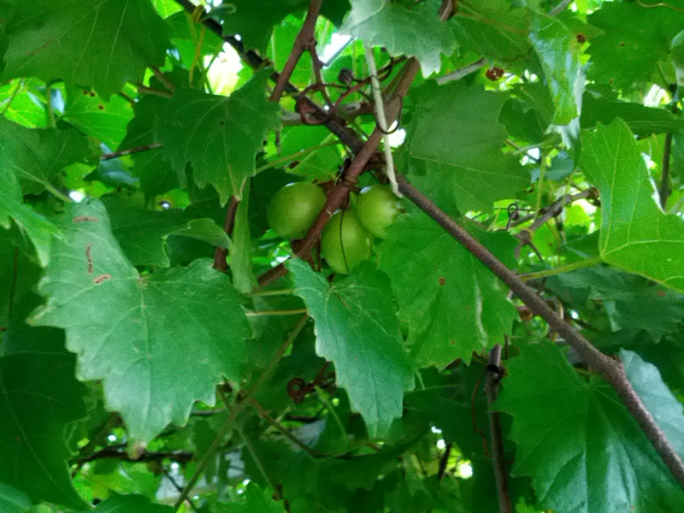

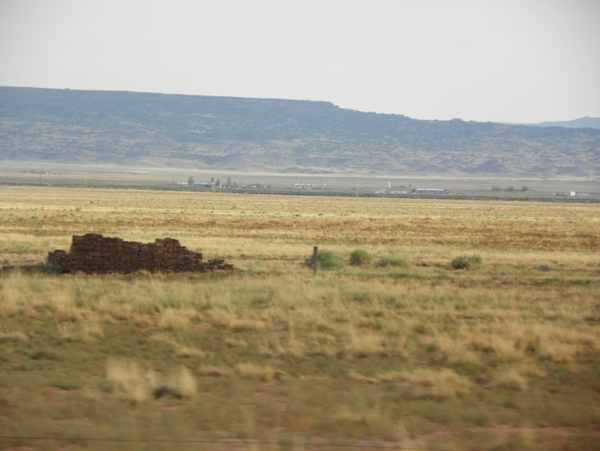
Noah was apparently unaccustomed to the alcohol in fermented grapes. One wonders, after the great Flood and not too far from Creation, how quickly grape vines matured.
After the curses and blessings of his sons, their descendants multiplied, and so did communities of people in every direction.

Faith In Action

Pray
Ask the Holy Spirit to show you where you may have more in common with Ham than with Shem and Japheth. Ask Him to remind you every day of the Lord God's desire to redeem. Ask Him to press into you the same comfort with diversity of color and of language, culture, and geography that He has for all who call Him Lord.

Act
I agree to review my daily life for any patterns of disrespect or shaming toward parents or legitimate authority figures and to prayerfully submit to the Holy Spirit as He helps me to change my attitude and conduct. I agree to spend some quiet time with the Holy Spirit to prayerfully seek awareness of a “generational curse” in my family (or community) which He has either broken or which He is creating an opportunity to break. I will celebrate His blessing where He has already done so (and will share that praise report with a fellow believer) and will make myself available to His liberating work if He is about to enter-into my family or community. I agree to partner with the Holy Spirit, and a prayerful fellow Christian, to search out any place in me where I may hold a bias against a fellow Christian because of differences that the Lord God has demonstrated are unimportant. I will then commit to intentionally purge those wrong thoughts.

Be Specific _____________________________________________

Friday (Genesis 11:1-9)
The Dispersion of the Nations at Babel

11:1 The whole earth had a common language and a common vocabulary.
11:2 When the people moved eastward, they found a plain in Shinar and settled there.
11:3 Then they said to one another, “Come, let’s make bricks and bake them thoroughly.” (They had brick instead of stone and tar instead of mortar.)
11:4 Then they said, “Come, let’s build ourselves a city and a tower with its top in the heavens so that we may make a name for ourselves. Otherwise we will be scattered across the face of the entire earth.”
11:5 But the Lord came down to see the city and the tower that the people had started building.
11:6 And the Lord said, “If as one people all sharing a common language they have begun to do this, then nothing they plan to do will be beyond them.
11:7 Come, let’s go down and confuse their language so they won’t be able to understand each other.”
11:8 So the Lord scattered them from there across the face of the entire earth, and they stopped building the city.
11:9 That is why its name was called Babel – because there the Lord confused the language of the entire world, and from there the Lord scattered them across the face of the entire earth.

Prayer
Lord, how quickly after Your demonstrations of mercy and of power did humankind forget Who You are and drift again into arrogant rebellion. Thank You for the record of this cycle in Your Word which stands as a reminder to us.

Scripture In Perspective
While the end of Chapter 10 spoke of different languages this text refers to a common language and a common vocabulary. It is reasonable to read the difference as Chapter 10 intending to communicate differing dialects rather than entirely different languages – which makes good sense given the relatively brief time from the eight people on the Ark and the time of this text.
However, if one looks more closely at Chapter 10 one discovers that it was not all of the people on earth who are being spoken of here but one stream of descendants; it was Nimrod, son of Cush and grandson of the rebellious Ham - son of Noah - who settled in Shinar. (Gen. 10:8-10)
In their arrogance their rebellion took the form of building a massive tower as a rallying-point and symbol of their ability to get into “the heavens” without the Lord God; removing their perception of a need for God, and condemning them to generations of eternally-lost people.
In His mercy, rather than destroying the city and the people together with their tower, the Lord God confused their language – fragmenting their sense of cohesion and complicating their communications – so that they gave up and dispersed. One of the sub-groups later went on to build the city of Ninevah.

Interact With The Text

Consider
The Bible speaks of the sins of the father (Exo. 20:5, 34:7; Deut 5:8; Num. 14:18), referring to the impact of rebellion, being passed down from generation to generation. We see this with Ham, just as the Lord God had caused Noah to prophesy.

Discuss
Why is it that humankind is so fond of building cathedrals, cities, and towers, most of which are designed to serve as great monuments to man and not to God?

Reflect
God could have wiped-out Shinar, but in His mercy He chose instead to make it so difficult for them that they gave up, preserving an opportunity for some of the people to escape their evil culture and leaders and perhaps choose obedience to their Lord.

Share
When have you rebelled against the Lord God and He found it necessary to make things so difficult that you turned-away from your rebellion? (It could have been the temptation to commit adultery, to cheat, to lie, to steal, etc. You may not have stopped right away but the consequences may have become more than you were willing to bear. It's not unusual that soon after being saved, within the first year, the Enemy brings temptation in ones weakest areas – the same as he did to the generations soon after the Flood.)

KTALZ


The descendants of Ham built a building high into the clouds ...

Faith In Action

Pray
Ask the Holy Spirit to reveal to you something that you need to deal with, that is an act of rebellion against the Lord, however great or small.

Act
I agree to cooperate with the Holy Spirit, and to engage a prayer-partner, as I identify and deal with a place of rebellion in my life - rather than waiting for the Lord God to take sterner measures to separate me from my sin.
Be Specific _____________________________________________

Saturday (Genesis 11:10-32)
The Genealogy of Shem

11:10 This is the account of Shem.
Shem was 100 old when he became the father of Arphaxad, two years after the flood. 11:11 And after becoming the father of Arphaxad, Shem lived 500 years and had other sons and daughters.
11:12 When Arphaxad had lived 35 years, he became the father of Shelah. 11:13 And after he became the father of Shelah, Arphaxad lived 403 years and had other sons and daughters.
11:14 When Shelah had lived 30 years, he became the father of Eber. 11:15 And after he became the father of Eber, Shelah lived 403 years and had other sons and daughters.
11:16 When Eber had lived 34 years, he became the father of Peleg. 11:17 And after he became the father of Peleg, Eber lived 430 years and had other sons and daughters.
11:18 When Peleg had lived 30 years, he became the father of Reu. 11:19 And after he became the father of Reu, Peleg lived 209 years and had other sons and daughters.
11:20 When Reu had lived 32 years, he became the father of Serug. 11:21 And after he became the father of Serug, Reu lived 207 years and had other sons and daughters.
11:22 When Serug had lived 30 years, he became the father of Nahor. 11:23 And after he became the father of Nahor, Serug lived 200 years and had other sons and daughters.
11:24 When Nahor had lived 29 years, he became the father of Terah. 11:25 And after he became the father of Terah, Nahor lived 119 years and had other sons and daughters.
11:26 When Terah had lived 70 years, he became the father of Abram, Nahor, and Haran.

The Record of Terah
11:27 This is the account of Terah.
Terah became the father of Abram, Nahor, and Haran. And Haran became the father of Lot. 11:28 Haran died in the land of his birth, in Ur of the Chaldeans, while his father Terah was still alive. 11:29 And Abram and Nahor took wives for themselves. The name of Abram’s wife was Sarai, and the name of Nahor’s wife was Milcah; she was the daughter of Haran, the father of both Milcah and Iscah. 11:30 But Sarai was barren; she had no children.
11:31 Terah took his son Abram, his grandson Lot (the son of Haran), and his daughter-in-law Sarai, his son Abram’s wife, and with them he set out from Ur of the Chaldeans to go to Canaan. When they came to Haran, they settled there. 11:32 The lifetime of Terah was 205 years, and he died in Haran.

Prayer
Lord, while You allowed sin-consequence of the Fall to have its way with the bodies – indeed the very lifespan – of humankind, Your hand is clear as it guided the sovereign thread of Your perfect plan amidst the chaos and confusion of Fallen Creation.

Scripture In Perspective
The genealogy of the descendants of Shem is remarkable as it demonstrates the rapidly declining life-span of humankind as one evidence of the destructive impact of the Fall; due, of course, to multiple variables.
Seven generations later the genealogy of Terah recorded some better known names, those of Abram, Lot, and Sarai, and regions – those of Ur of the Chaldeans and of Caanan.
The text doesn't explain why but Terah left Ur of the Chaldeans, but he followed the rivers – taking a north-northeast path (rather than directly west across the desert) to go to Canaan. For some unexplained reason he settled in Haran, about half way there.
The genealogy of Abram's wife, Sarai, is not recorded in this section of text. Her story was remarkable as she was “barren”, and given the emphasis of the Lord God upon reproduction at that time, that had to be a very difficult burden for both her and Abram.
Haran's wife is neither named nor is her genealogy cited. Nahor's wife was Haran's daughter and Milcah, was his niece.

Interact With The Text

Consider
In Genesis 11:10-24 the decreasing lifespan of humankind bears plain evidence of the temporal “wages of sin”.

Discuss
Among a people recently commissioned by the Lord God to “go forth and multiply”, and as they were surrounded by the children and grandchildren of Abram's brothers, how must Abram and Sarai have suffered emotionally? How often might they have pleaded to the Lord to give them a child? (Compare this to the New Testament where His emphasis is on salvific-reproduction rather than biological.)

Reflect
The Lord God provided a clear map of the genealogy of Abram and his shared need, together with his wife Sarai, so clearly He was preparing the reader for the story to follow.

Share
When have you desired something that you believed to be the Lord God's will, as would have been Abram and Sarai's expectation of children, only to have roadblocks arise repeatedly to block your path? How did that impact your relationship with the Lord?

KTALZ
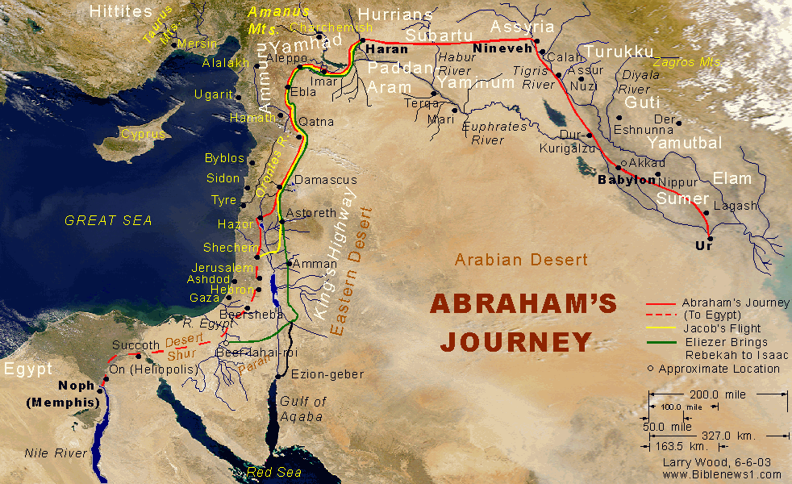
Note some of the interesting places Abram's family passed on the way to Haran?

Faith In Action

Pray
Ask the Holy Spirit to amplify His presence as you seek awareness of current and past occasions where He was teaching you dependence and patience upon the Lord God.

Act
I agree to prayerfully assess my past and present for evidence of the Lord God's hand in my life, holding me back when I was rushing ahead of His timing, testing my faith in His perfect provision and timing – and in the keeping of His promises, and strengthening me along the way.

Be Specific _________________________________________________

All Bible text is from the NET unless otherwise indicated - http://bible.org
Note 1: These Studies often rely upon the guidance of the NET Translators from their associated notes. Careful attention has been given to cite that source where it has been quoted directly or closely paraphrased. Feedback is encouraged where credit has not been sufficiently assigned.
Note 2: When NET text is quoted in commentary and discussion all pronouns referring to God are capitalized, though they are lower-case in the original NET text.
Commentary text is from David M. Colburn, D.Min. unless otherwise noted.
Copyright © 2012, 2013 by David M. Colburn. This is a BibleSeven Study of Genesis plus KTALZ (visual and other study tools). Prepared by David M. Colburn and edited for bible.org in the Fall of 2013. This text may be used for non-profit educational purposes only, with credit; all other usage requires prior written consent of the author.

