1 Exodus 5 – 11
(Plagues Upon Egypt)
David M. Colburn
A Daily Bible Study in 7-Day Sections with a Summary-Commentary, Discussion Questions, and Daily Application
Week 12

Sunday (Exodus 5)
Opposition to the Plan of God

5:1 Afterward Moses and Aaron went to Pharaoh and said, “Thus says the Lord, the God of Israel, ‘Release my people so that they may hold a pilgrim feast to me in the desert.’”
5:2 But Pharaoh said, “Who is the Lord that I should obey him by releasing Israel? I do not know the Lord, and I will not release Israel!”
5:3 And they said, “The God of the Hebrews has met with us. Let us go a three-day journey into the desert so that we may sacrifice to the Lord our God, so that he does not strike us with plague or the sword.”
5:4 The king of Egypt said to them, “Moses and Aaron, why do you cause the people to refrain from their work? Return to your labor!” 5:5 Pharaoh was thinking, “The people of the land are now many, and you are giving them rest from their labor.”
5:6 That same day Pharaoh commanded the slave masters and foremen who were over the people: 5:7 “You must no longer give straw to the people for making bricks as before. Let them go and collect straw for themselves. 5:8 But you must require of them the same quota of bricks that they were making before. Do not reduce it, for they are slackers. That is why they are crying, ‘Let us go sacrifice to our God.’ 5:9 Make the work harder for the men so they will keep at it and pay no attention to lying words!”
5:10 So the slave masters of the people and their foremen went to the Israelites and said, “Thus says Pharaoh: ‘I am not giving you straw. 5:11 You go get straw for yourselves wherever you can find it, because there will be no reduction at all in your workload.’” 5:12 So the people spread out through all the land of Egypt to collect stubble for straw. 5:13 The slave masters were pressuring them, saying, “Complete your work for each day, just like when there was straw!” 5:14 The Israelite foremen whom Pharaoh’s slave masters had set over them were beaten and were asked, “Why did you not complete your requirement for brickmaking as in the past – both yesterday and today?”
5:15 The Israelite foremen went and cried out to Pharaoh, “Why are you treating your servants this way? 5:16 No straw is given to your servants, but we are told, ‘Make bricks!’ Your servants are even being beaten, but the fault is with your people.”
5:17 But Pharaoh replied, “You are slackers! Slackers! That is why you are saying, ‘Let us go sacrifice to the Lord.’ 5:18 So now, get back to work! You will not be given straw, but you must still produce your quota of bricks!” 5:19 The Israelite foremen saw that they were in trouble when they were told, “You must not reduce the daily quota of your bricks.”
5:20 When they went out from Pharaoh, they encountered Moses and Aaron standing there to meet them, 5:21 and they said to them, “May the Lord look on you and judge, because you have made us stink in the opinion of Pharaoh and his servants, so that you have given them an excuse to kill us!”

The Assurance of Deliverance

5:22 Moses returned to the Lord, and said, “Lord, why have you caused trouble for this people? Why did you ever send me? 5:23 From the time I went to speak to Pharaoh in your name, he has caused trouble for this people, and you have certainly not rescued them!”

Prayer
Lord, Your ways are not our ways, please teach me obedience and patience.

Scripture In Perspective
The Lord God had warned Moses that things would not go well initially.
When Moses told Pharaoh that God demanded that he allow the Israelites to go to Canaan to sacrifice to the Lord their God - Pharaoh responded that he didn't know or respect their God, and he refused.
Then Pharaoh decided that the Israelites must not be adequately oppressed that they would even ask such a thing, so he took away the provision of straw – which made the making of bricks easier – and still required them to produce as many bricks. When they failed to meet the quota he had his soldiers beat their foremen and them.
Pharaoh's goal was to turn the Israelites against Moses and Aaron and their “lying words” - he was, for some reason (not stated, but implied in God's promise of protection), unwilling to attack Moses and Aaron directly.
The Hebrew foremen blamed Moses and Aaron.
Moses whined to God, as if God had not previously warned him.

Interact with the text

Consider
The Lord explained what would happen in advance, but at the first sign of opposition Moses whined to God, rather than going to Him and humbly asking what should be their next step together.

Discuss
Moses got in trouble as a young man because he was impatient and impetuous, now he appears to demonstrate some of the same immaturity. Did God choose him – not because he was brave - but because he was mostly-obedient, and he was not one of the Israelites in Egypt who had grown fearfully-compliant after generations in slavery?

Reflect
Why would Moses expect Pharaoh to listen to such a demand when he didn't know the Lord God, had no vested self-interest in the Israelites' religious desires, and was fearful of the huge population of Israelites gaining any sense of independence or self-respect?

Share
When have you set out on a task only to face resistance? How did you respond to the resistance? How has that changed from when you were younger?

KTALZ
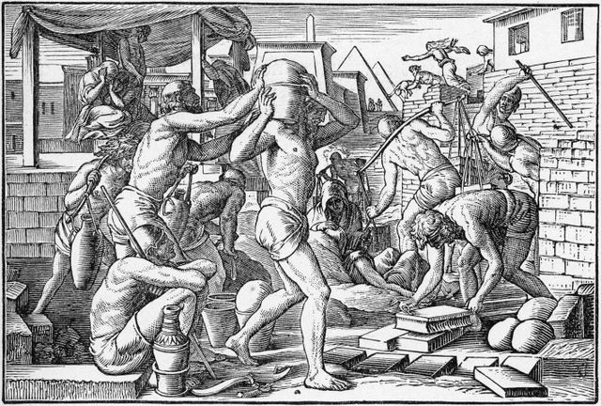

The first reaction to the expression of a desired change, that might reduce the power of tyrants (or would-be tyrants), is always resistance.
Source: Public domain here http://www.lavistachurchofchrist.org/Pictures/Religion%20in%20the%20Home%20%28Part%202%29/images/image_2.jpg

Faith In Action

Pray
Ask the Holy Spirit to reveal to you a place where some resistance in the world, including direct spiritual resistance from the Enemy, has caused you to hesitate in doing God's will.

Act
Today I will partner with the Holy Spirit in overcoming my confusion and fear and will forge ahead, despite resistance, to complete the task which God has placed before me. The task may be freedom from an addiction or a destructive lifestyle, it may be earning the certification, education, or other training I need for the vocation for which He has gifted me, it may be stepping-away from an unhealthy religious affiliation/association, it may be engaging fully in an evangelical/missionary outreach, it may be in a volunteer role in a fellowship, or some other circumstance, opportunity, or task He has placed before me.
Be Specific ________________________________________________

Monday (Exodus 6)
Encouragement of Moses and the People

6:1 Then the Lord said to Moses, “Now you will see what I will do to Pharaoh, for compelled by my strong hand he will release them, and by my strong hand he will drive them out of his land.”
6:2 God spoke to Moses and said to him, “I am the Lord. 6:3 I appeared to Abraham, to Isaac, and to Jacob as God Almighty, but by my name ‘the Lord’ I was not known to them. 6:4 I also established my covenant with them to give them the land of Canaan, where they were living as resident foreigners. 6:5 I have also heard the groaning of the Israelites, whom the Egyptians are enslaving, and I have remembered my covenant. 6:6 Therefore, tell the Israelites, ‘I am the Lord. I will bring you out from your enslavement to the Egyptians, I will rescue you from the hard labor they impose, and I will redeem you with an outstretched arm and with great judgments. 6:7 I will take you to myself for a people, and I will be your God. Then you will know that I am the Lord your God, who brought you out from your enslavement to the Egyptians. 6:8 I will bring you to the land I swore to give to Abraham, to Isaac, and to Jacob – and I will give it to you as a possession. I am the Lord!’”
6:9
Moses told this to the Israelites, but they did not listen to him because of their discouragement and hard labor. 6:10 Then the Lord said to Moses, 6:11 “Go, tell Pharaoh king of Egypt that he must release the Israelites from his land.” 6:12 But Moses replied to the Lord, “If the Israelites did not listen to me, then how will Pharaoh listen to me, since I speak with difficulty?”
6:13 The Lord spoke to Moses and Aaron and gave them a charge for the Israelites and Pharaoh king of Egypt to bring the Israelites out of the land of Egypt.

The Ancestry of the Deliverer

6:14 These are the heads of their fathers’ households:
The sons of Reuben, the firstborn son of Israel, were Hanoch and Pallu, Hezron and Carmi. These were the clans of Reuben.
6:15 The sons of Simeon were Jemuel, Jamin, Ohad, Jakin, Zohar, and Shaul, the son of a Canaanite woman. These were the clans of Simeon.
6:16 Now these are the names of the sons of Levi, according to their records: Gershon, Kohath, and Merari. (The length of Levi’s life was 137 years.)
6:17 The sons of Gershon, by their families, were Libni and Shimei.
6:18 The sons of Kohath were Amram, Izhar, Hebron, and Uzziel. (The length of Kohath’s life was 133 years.)
6:19 The sons of Merari were Mahli and Mushi. These were the clans of Levi, according to their records.
6:20 Amram married his father’s sister Jochebed, and she bore him Aaron and Moses. (The length of Amram’s life was 137 years.)
6:21 The sons of Izhar were Korah, Nepheg, and Zikri.
6:22 The sons of Uzziel were Mishael, Elzaphan, and Sithri.
6:23 Aaron married Elisheba, the daughter of Amminadab and sister of Nahshon, and she bore him Nadab and Abihu, Eleazar and Ithamar.
6:24 The sons of Korah were Assir, Elkanah, and Abiasaph. These were the Korahite clans.
6:25 Now Eleazar son of Aaron married one of the daughters of Putiel and she bore him Phinehas. These are the heads of the fathers’ households of Levi according to their clans.

6:26 It was the same Aaron and Moses to whom the Lord said, “Bring the Israelites out of the land of Egypt by their regiments.” 6:27 They were the men who were speaking to Pharaoh king of Egypt, in order to bring the Israelites out of Egypt. It was the same Moses and Aaron.

Authentication of the Word through Moses

6:28 When the Lord spoke to Moses in the land of Egypt, 6:29 he said to him, “I am the Lord. Tell Pharaoh king of Egypt all that I am telling you.” 6:30 But Moses said before the Lord, “Since I speak with difficulty, why should Pharaoh listen to me?”

Prayer
Lord, may you find me a willing servant – nervous like Moses or bold like Aaron – but still willing.

Scripture In Perspective
Moses had whined to God, but God merely instructed Moses to stay the course and to see what He (the Lord) would do in order to force Pharaoh to obey
[Note: The text “I appeared to Abraham, to Isaac, and to Jacob as God Almighty, but by my name ‘the Lord’ I was not known to them” means that He was known based on His future promises relative to Israel. These promises could not have been realized until Israel became a nation – so they trusted by faith. Also, Yahweh was and is His name, but He was only recognized as the Yahweh-the-Lord-who-is-the-fulfiller-of-promises-to-Israel during the time of Moses – their knowing of Him by His name “the Lord” had been lost in the Garden when Adam and Eve rebelled – despite knowing Him by His presence.]
The Lord God made it clear that He-alone was their redeemer “I will redeem you with an outstretched arm and with great judgments. I will take you to myself for a people, and I will be your God. Then you will know that I am the Lord your God”
The Lord God repeated His instructions to Moses to speak to Pharaoh and again Moses hesitated with fear due to his insecurity about his speaking ability. The Lord once-again authorized Aaron to speak for Moses, repeated what He wanted Moses to do, and detailed how to handle the staff which He had empowered as His sign.

Interact with the text

Consider
The Word contains the history of the generations of man and of the great civilization of Egypt, the accountability-for-credibility built into the Bible gives more cause to people to trust it.

Discuss
The Word tells us of God's desire to use imperfect men as His messengers, and His flexibility to allow the insecure Moses to delegate to Aaron. Why do you think God used such role models?

Reflect
How different are we than Moses? Do we make excuses to avoid doing as God has asked?

Share
When have you seen God clearly demonstrate His power yet some have refused to acknowledge Him, or have acknowledged Him but refuse to respond rightly?

KTALZ
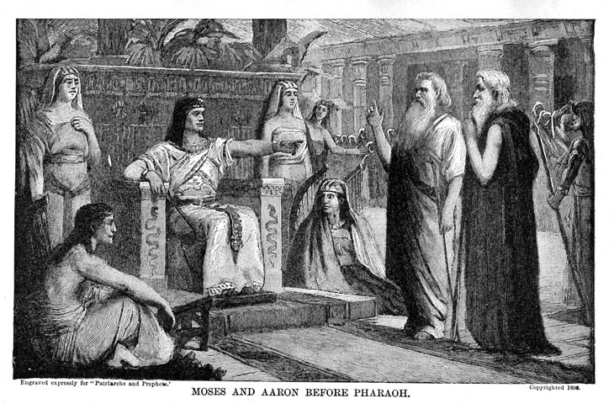

God sent Moses and Aaron to Pharaoh to deliver His message.
Source: Public domain here http://karenswhimsy.com/public-domain-images/free-christian-clipart/images/free-christian-clipart-2.jpg

Faith In Action

Pray
Ask the Holy Spirit to show you something that you can do for Him.

Act
Today I will go and do as the Holy Spirit directs. If needed I will ask a fellow Believer to join me in that ministry.
Be Specific _____________________________________________

Tuesday (Exodus 7)
Moses Returns to Pharaoh

7:1 So the Lord said to Moses, “See, I have made you like God to Pharaoh, and your brother Aaron will be your prophet. 7:2 You are to speak everything I command you, and your brother Aaron is to tell Pharaoh that he must release the Israelites from his land. 7:3 But I will harden Pharaoh’s heart, and although I will multiply my signs and my wonders in the land of Egypt, 7:4 Pharaoh will not listen to you. I will reach into Egypt and bring out my regiments, my people the Israelites, from the land of Egypt with great acts of judgment. 7:5 Then the Egyptians will know that I am the Lord, when I extend my hand over Egypt and bring the Israelites out from among them.
7:6 And Moses and Aaron did so; they did just as the Lord commanded them. 7:7 Now Moses was eighty years old and Aaron was eighty-three years old when they spoke to Pharaoh.
7:8 The Lord said to Moses and Aaron, 7:9 “When Pharaoh says to you, ‘Do a miracle,’ and you say to Aaron, ‘Take your staff and throw it down before Pharaoh,’ it will become a snake.” 7:10 When Moses and Aaron went to Pharaoh, they did so, just as the Lord had commanded them – Aaron threw down his staff before Pharaoh and his servants and it became a snake. 7:11 Then Pharaoh also summoned wise men and sorcerers, and the magicians of Egypt by their secret arts did the same thing. 7:12 Each man threw down his staff, and the staffs became snakes. But Aaron’s staff swallowed up their staffs. 7:13 Yet Pharaoh’s heart became hard, and he did not listen to them, just as the Lord had predicted.

The First Blow: Water to Blood

7:14 The Lord said to Moses, “Pharaoh’s heart is hard; he refuses to release the people. 7:15 Go to Pharaoh in the morning when he goes out to the water. Position yourself to meet him by the edge of the Nile, and take in your hand the staff that was turned into a snake. 7:16 Tell him, ‘The Lord, the God of the Hebrews, has sent me to you to say, “Release my people, that they may serve me in the desert!” But until now you have not listened. 7:17 Thus says the Lord: “By this you will know that I am the Lord: I am going to strike the water of the Nile with the staff that is in my hand, and it will be turned into blood. 7:18 Fish in the Nile will die, the Nile will stink, and the Egyptians will be unable to drink water from the Nile.”’” 7:19 Then the Lord said to Moses, “Tell Aaron, ‘Take your staff and stretch out your hand over Egypt’s waters – over their rivers, over their canals, over their ponds, and over all their reservoirs – so that it becomes blood.’ There will be blood everywhere in the land of Egypt, even in wooden and stone containers.” 7:20 Moses and Aaron did so, just as the Lord had commanded. Moses raised the staff and struck the water that was in the Nile right before the eyes of Pharaoh and his servants, and all the water that was in the Nile was turned to blood. 7:21 When the fish that were in the Nile died, the Nile began to stink, so that the Egyptians could not drink water from the Nile. There was blood everywhere in the land of Egypt! 7:22 But the magicians of Egypt did the same by their secret arts, and so Pharaoh’s heart remained hard, and he refused to listen to Moses and Aaron – just as the Lord had predicted. 7:23 And Pharaoh turned and went into his house. He did not pay any attention to this. 7:24 All the Egyptians dug around the Nile for water to drink, because they could not drink the water of the Nile.

The Second Blow: Frogs
7:25 Seven full days passed after the Lord struck the Nile.

Prayer
Lord, why do we force You to come down so hard? May you find me obedient and teachable and willing rather than hard-hearted, stiff-necked, and stubborn.

Scripture In Perspective
As the Lord prophesied, Pharaoh was resistant, so Aaron cast down the staff which became a snake. The wizards did as Aaron did, then Aarons snake ate theirs and turned back into a staff. Pharaoh, his hard heart further-hardened by God (to escalate the confrontation in His time) refused to act wisely and refused to let the people go.
[Note: “7:13 Yet Pharaoh’s heart became hard” The alternative Hebrew word means stubborn whereas the one used here means more-unyielding – so there was a progression from Pharaoh's stubborn-hard heart to an amplified-state – which the Lord God said He would motivate.]
The Lord God instructed Moses and Aaron to strike the water of the Nile with the staff, in the presence of Pharaoh, and that it - and even the water people had in containers - would turn to blood, the fish would die, and the Nile would stink.
They did so but then Satan empowered Pharaoh's witches, the magicians (7:11 “... wise men and sorcerers, and the magicians of Egypt by their secret arts ”), to duplicate what Moses had done (on a smaller scale), so Pharaoh chose to not believe and not to obey God.
[Note: The witch/magicians only turned a small amount of water red – nothing compared to the massive scale of what God did.]
The people were able to dig new wells near the Nile and find some drinkable water.
Seven days later – the text is unclear - but it appears that the water of the Nile may have remained in the form of blood.

Interact With The Text

Consider
The Nile river is a massive body of water, for anyone to turn all of that to blood – plus the water already in containers throughout Egypt – should have gotten Pharaoh's attention.

Discuss
Have you heard of, or observed, people performing feats that appeared to be beyond the capacity of man? From where do you believe that they acquired that power?

Reflect
Pharaoh cared about himself, and the power that the great nation he ruled gave to him, but he appears to have traded to the Enemy his caring for his people for his power over them – which explains how he ignored the terrible suffering they endured from the first plague of the Nile turned to blood (the hassle and minimal solution that came from their need to dig new wells, plus the loss of fish for food, failed to trouble him) - he just went inside and ignored them.

Share
When have you tried to teach someone about God by telling of His miracles, only to have a highly-resistant person attempt to explain-away those miracles?

KTALZ

Moses and Aaron delivered God's message to Pharaoh, plus two miracles, but the witch/magicians – empowered by the Enemy – counterfeited them and the hardened-to-truth Pharaoh refused to believe.
Source: Public domain here http://karenswhimsy.com/public-domain-images/free-christian-clipart/images/free-christian-clipart-2.jpg

Faith In Action

Pray
Ask the Holy Spirit to reveal to you a place in your life where God has been doing miracles to get your attention.

Act
Today I will recognize the miracles of God all around me, albeit somewhat more subtle than those in today's text, and I will respond to whatever is His call. (God's miracle may be His provision of food or money I didn't expect, a small healing that man's medical knowledge cannot adequately explain, an opportunity to use my gifts at home or school or work that I did not expect, or some other intervention - that a time of prayerful listening and reflecting reveals to me.)
Be Specific _________________________________________________

Wednesday (Exodus 8)
8:1 Then the Lord said to Moses, “Go to Pharaoh and tell him, ‘Thus says the Lord: “Release my people in order that they may serve me! 8:2 But if you refuse to release them, then I am going to plague all your territory with frogs. 8:3 The Nile will swarm with frogs, and they will come up and go into your house, in your bedroom, and on your bed, and into the houses of your servants and your people, and into your ovens and your kneading troughs. 8:4 Frogs will come up against you, your people, and all your servants.”’”
8:5 The Lord spoke to Moses, “Tell Aaron, ‘Extend your hand with your staff over the rivers, over the canals, and over the ponds, and bring the frogs up over the land of Egypt.’” 8:6 So Aaron extended his hand over the waters of Egypt, and frogs came up and covered the land of Egypt.
8:7 The magicians did the same with their secret arts and brought up frogs on the land of Egypt too.
8:8 Then Pharaoh summoned Moses and Aaron and said, “Pray to the Lord that he may take the frogs away from me and my people, and I will release the people that they may sacrifice to the Lord.” 8:9 Moses said to Pharaoh, “You may have the honor over me – when shall I pray for you, your servants, and your people, for the frogs to be removed from you and your houses, so that they will be left only in the Nile?” 8:10 He said, “Tomorrow.” And Moses said, “It will be as you say, so that you may know that there is no one like the Lord our God. 8:11 The frogs will depart from you, your houses, your servants, and your people; they will be left only in the Nile.”
8:12 Then Moses and Aaron went out from Pharaoh, and Moses cried to the Lord because of the frogs that he had brought on Pharaoh. 8:13 The Lord did as Moses asked – the frogs died out of the houses, the villages, and the fields. 8:14 The Egyptians piled them in countless heaps, and the land stank. 8:15 But when Pharaoh saw that there was relief, he hardened his heart and did not listen to them, just as the Lord had predicted.

The Third Blow: Gnats
8:16 The Lord said to Moses, “Tell Aaron, ‘Extend your staff and strike the dust of the ground, and it will become gnats throughout all the land of Egypt.’” 8:17 They did so; Aaron extended his hand with his staff, he struck the dust of the ground, and it became gnats on people and on animals. All the dust of the ground became gnats throughout all the land of Egypt. 8:18 When the magicians attempted to bring forth gnats by their secret arts, they could not. So there were gnats on people and on animals. 8:19 The magicians said to Pharaoh, “It is the finger of God!” But Pharaoh’s heart remained hard, and he did not listen to them, just as the Lord had predicted.

The Fourth Blow: Flies
8:20 The Lord said to Moses, “Get up early in the morning and position yourself before Pharaoh as he goes out to the water, and tell him, ‘Thus says the Lord, “Release my people that they may serve me! 8:21 If you do not release my people, then I am going to send swarms of flies on you and on your servants and on your people and in your houses. The houses of the Egyptians will be full of flies, and even the ground they stand on. 8:22 But on that day I will mark off the land of Goshen, where my people are staying, so that no swarms of flies will be there, that you may know that I am the Lord in the midst of this land. 8:23 I will put a division between my people and your people. This sign will take place tomorrow.”’” 8:24 The Lord did so; a thick swarm of flies came into Pharaoh’s house and into the houses of his servants, and throughout the whole land of Egypt the land was ruined because of the swarms of flies.
8:25 Then Pharaoh summoned Moses and Aaron and said, “Go, sacrifice to your God within the land.” 8:26 But Moses said, “That would not be the right thing to do, for the sacrifices we make to the Lord our God would be an abomination to the Egyptians. If we make sacrifices that are an abomination to the Egyptians right before their eyes, will they not stone us? 8:27 We must go on a three-day journey into the desert and sacrifice to the Lord our God, just as he is telling us.”
8:28 Pharaoh said, “I will release you so that you may sacrifice to the Lord your God in the desert. Only you must not go very far. Do pray for me.”
8:29 Moses said, “I am going to go out from you and pray to the Lord, and the swarms of flies will go away from Pharaoh, from his servants, and from his people tomorrow. Only do not let Pharaoh deal falsely again by not releasing the people to sacrifice to the Lord.” 8:30 So Moses went out from Pharaoh and prayed to the Lord, 8:31 and the Lord did as Moses asked – he removed the swarms of flies from Pharaoh, from his servants, and from his people. Not one remained! 8:32 But Pharaoh hardened his heart this time also and did not release the people.

Prayer
Lord, You taught Your people – and those around them – that You are not to be trifled-with – and that Your sovereign will is never blocked. May I be watchful that I do not arrogantly or carelessly ignore Your action and Your direction in my life.

Scripture In Perspective
Seven days after turning the Nile to blood God sent Moses and Aaron to challenge Pharaoh with a plague of frogs.
Once again Satan used Pharaoh's witches/wizards to draw a token number of frogs out of the Nile, so Pharaoh's heart remained hard.
This time Pharaoh asked Moses to remove the frogs, because unlike the bloodied-water the frogs directly interfered with everything in Egypt – therefore directly impacting him.
He promised to let the Israelites go and sacrifice to their God. The next day Moses responded and the frogs that were on the land all died, resulting in piles of them all over Egypt, rotting in the sun. But once the frogs were dead Pharaoh reneged on his promise.
God then told Moses and Aaron to strike the dust of the earth with the staff and it turned into gnats all over the animals and people of Egypt. The witch/wizards who unable to duplicate this and acknowledged that it was the “finger of God”, but Pharaoh's hard heart would not allow him to submit.
God instructed Moses to warn Pharaoh of the plague of flies, but this time Moses did nothing more than to deliver the message.
One of the other unique elements in this text is that God explained His protection of Goshen, where the Israelites lived, from the plague – “... that you may know that I am the Lord in the midst of this land.”
[Note: This does not mean that the Israelites suffered along with the Egyptians in the first plagues. The Lord had previously promised to protect them.]
Moses negotiated with Pharaoh, who wanted them to worship in Goshen, but Moses said they must do so in Canaan – outside of Egypt. Pharaoh agreed but asked that they not travel far, and he asked Moses to pray to have the flies removed.

Interact With The Text

Consider
The Pharaoh continued to demonstrate his selfishness and his superstition.

Discuss
It is easy to question Pharaoh's sanity here but could someone not find a blind-spot in your life where you have plenty of evidence to cause you to do something differently but you continue in a wrong direction?

Reflect
After the first two plagues Pharaoh's witches/wizards were no longer able to duplicate (or create a token simile of) the miracles of God, once again demonstrating the limitations of the power of Satan's deceptions, and his ability to imitate God.

Share
God twice stuck Egypt and clearly protected the Israelites – how hard could it have been for Pharaoh to recognize the power and precision of God? When should something have been obvious to you but what you wanted to believe or see blinded you to the truth?
KTALZ
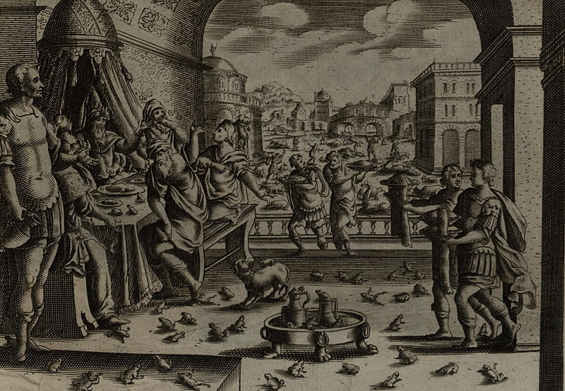

Despite multiple plagues Pharaoh remained stubborn.
Source: Public domain here http://upload.wikimedia.org/wikipedia/commons/thumb/1/10/Jollain_The_Plague_of_Frogs.jpg/800px-Jollain_The_Plague_of_Frogs.jpg

Faith In Action

Pray
Ask the Holy Spirit to reveal to you a blind-spot in your life.

Act
Today I will act on the information the Holy Spirit has revealed, choosing wisdom over stubbornness.
Be Specific ________________________________________________

Thursday (Exodus 9)
The Fifth Blow: Disease
9:1 Then the Lord said to Moses, “Go to Pharaoh and tell him, ‘Thus says the Lord, the God of the Hebrews, “Release my people that they may serve me! 9:2 For if you refuse to release them and continue holding them, 9:3 then the hand of the Lord will surely bring a very terrible plague on your livestock in the field, on the horses, the donkeys, the camels, the herds, and the flocks. 9:4 But the Lord will distinguish between the livestock of Israel and the livestock of Egypt, and nothing will die of all that the Israelites have.”’”
9:5 The Lord set an appointed time, saying, “Tomorrow the Lord will do this in the land.” 9:6 And the Lord did this on the next day; all the livestock of the Egyptians died, but of the Israelites’ livestock not one died. 9:7 Pharaoh sent representatives to investigate, and indeed, not even one of the livestock of Israel had died. But Pharaoh’s heart remained hard, and he did not release the people.

The Sixth Blow: Boils
9:8 Then the Lord said to Moses and Aaron, “Take handfuls of soot from a furnace, and have Moses throw it into the air while Pharaoh is watching. 9:9 It will become fine dust over the whole land of Egypt and will cause boils to break out and fester on both people and animals in all the land of Egypt.” 9:10 So they took soot from a furnace and stood before Pharaoh, Moses threw it into the air, and it caused festering boils to break out on both people and animals.
9:11 The magicians could not stand before Moses because of the boils, for boils were on the magicians and on all the Egyptians. 9:12 But the Lord hardened Pharaoh’s heart, and he did not listen to them, just as the Lord had predicted to Moses.

The Seventh Blow: Hail
9:13 The Lord said to Moses, “Get up early in the morning, stand before Pharaoh, and tell him, ‘Thus says the Lord, the God of the Hebrews: “Release my people so that they may serve me! 9:14 For this time I will send all my plagues on your very self and on your servants and your people, so that you may know that there is no one like me in all the earth. 9:15 For by now I could have stretched out my hand and struck you and your people with plague, and you would have been destroyed from the earth. 9:16 But for this purpose I have caused you to stand: to show you my strength, and so that my name may be declared in all the earth. 9:17 You are still exalting yourself against my people by not releasing them. 9:18 I am going to cause very severe hail to rain down about this time tomorrow, such hail as has never occurred in Egypt from the day it was founded until now. 9:19 So now, send instructions to gather your livestock and all your possessions in the fields to a safe place. Every person or animal caught in the field and not brought into the house – the hail will come down on them, and they will die!”’”
9:20 Those of Pharaoh’s servants who feared the word of the Lord hurried to bring their servants and livestock into the houses, 9:21 but those who did not take the word of the Lord seriously left their servants and their cattle in the field.
9:22 Then the Lord said to Moses, “Extend your hand toward the sky that there may be hail in all the land of Egypt, on people and on animals, and on everything that grows in the field in the land of Egypt.” 9:23 When Moses extended his staff toward the sky, the Lord sent thunder and hail, and fire fell to the earth; so the Lord caused hail to rain down on the land of Egypt. 9:24 Hail fell and fire mingled with the hail; the hail was so severe that there had not been any like it in all the land of Egypt since it had become a nation. 9:25 The hail struck everything in the open fields, both people and animals, throughout all the land of Egypt. The hail struck everything that grows in the field, and it broke all the trees of the field to pieces. 9:26 Only in the land of Goshen, where the Israelites lived, was there no hail.
9:27 So Pharaoh sent and summoned Moses and Aaron and said to them, “I have sinned this time! The Lord is righteous, and I and my people are guilty. 9:28 Pray to the Lord, for the mighty thunderings and hail are too much! I will release you and you will stay no longer.”
9:29 Moses said to him, “When I leave the city I will spread my hands to the Lord, the thunder will cease, and there will be no more hail, so that you may know that the earth belongs to the Lord. 9:30 But as for you and your servants, I know that you do not yet fear the Lord God.”
9:31 (Now the flax and the barley were struck by the hail, for the barley had ripened and the flax was in bud. 9:32 But the wheat and the spelt were not struck, for they are later crops.)
9:33 So Moses left Pharaoh, went out of the city, and spread out his hands to the Lord, and the thunder and the hail ceased, and the rain stopped pouring on the earth. 9:34 When Pharaoh saw that the rain and hail and thunder ceased, he sinned again: both he and his servants hardened their hearts. 9:35 So Pharaoh’s heart remained hard, and he did not release the Israelites, as the Lord had predicted through Moses.

Prayer
Lord, You warn us and You warn us again, but sometimes we are so stubborn that You must increase the loudness of Your message until we listen.

Scripture In Perspective
Moses kept his word but Pharaoh, once again, did not – as God foretold.
The Lord God then struck only the cattle of the Egyptians with a deadly plague and even though Pharaoh verified that the Israelite cattle were unharmed he refused to release them.
The Sixth plague was unmistakably the hand of God through Moses; the boils covered the people and the animals and even the magician/witches, yet Pharaoh still refused to relent.
The Lord God instructed Moses to inform Pharaoh that much worse was to come and to further explained “9:15 For by now I could have stretched out my hand and struck you and your people with plague, and you would have been destroyed from the earth. 9:16 But for this purpose I have caused you to stand: to show you my strength, and so that my name may be declared in all the earth.”
The Lord instructed Moses to warn Pharaoh and his people to protect anything they cared about because He was sending hail and fire from the sky, interestingly there were apparently many who were wiser than Pharaoh as the text reports “9:20 Those of Pharaoh’s servants who feared the word of the Lord hurried to bring their servants and livestock into the houses,” Once again God protected Goshen, the land in Egypt where the Israelites lived.
The destruction was terrible and Pharaoh uttered some new words “I have sinned this time! The Lord is righteous, and I and my people are guilty. “
Even so, when the storm ceased so did Pharaoh's will to do the right thing.

Interact With The Text

Consider
In a new variable the Lord God warned Pharaoh and his people to protect themselves against the coming hail and fire storm. Some had become wise enough to listen to the Lord God and some, despite all of the evidence of the first six plagues, had not.
When God declares that a person or a people belong to Him those so affiliated benefit from His protection and provision. The Pharaoh threatening the life of God's anointed – Moses - after all of the evidence of his close association with the God of power, seems foolish in retrospect.

Discuss
Was it not God's grace which motivated His merciful warning to those who would believe His prophesy and heed His instructions to protect their servants and livestock?

Reflect
The Lord did not simply destroy the Egyptians for their disobedience - He wanted to make His power and presence known through them - to all of the known world.

Share
When have you been warned about something yet refused to pay attention – and the result was bad?

KTALZ
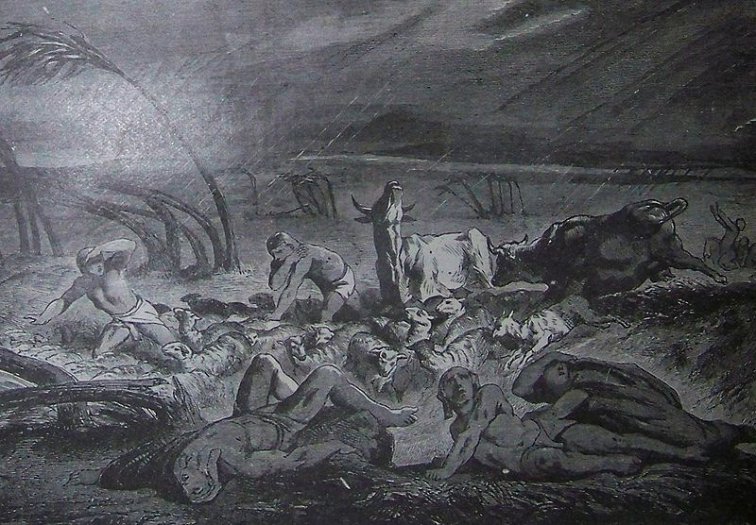

God allowed those who had learned His lesson – that He is God – to protect themselves and their livestock from the plague of hail and fire.
Source: Public domain here http://upload.wikimedia.org/wikipedia/commons/thumb/4/44/Holman_The_Plague_of_Hail.jpg/800px-Holman_The_Plague_of_Hail.jpg

Faith In Action

Pray
Ask the Holy Spirit to remind you of something the Lord God has warned you to avoid or to flee.

Act
Today I will act on God's warning, separating myself from a place of danger, or avoiding it in the first place. It may be a bad attitude, bad associations, bad habits, bad theology, or other bad influences that can rain evil down upon me (sources of entertainment, friends, non-Biblical philosophies and religions, etc.)
Be Specific _____________________________________________

Friday (Exodus 10)
The Eighth Blow: Locusts
10:1 The Lord said to Moses, “Go to Pharaoh, for I have hardened his heart and the heart of his servants, in order to display these signs of mine before him, 10:2 and in order that in the hearing of your son and your grandson you may tell how I made fools of the Egyptians and about my signs that I displayed among them, so that you may know that I am the Lord.”
10:3 So Moses and Aaron came to Pharaoh and told him, “Thus says the Lord, the God of the Hebrews: ‘How long do you refuse to humble yourself before me? Release my people so that they may serve me! 10:4 But if you refuse to release my people, I am going to bring locusts into your territory tomorrow. 10:5 They will cover the surface of the earth, so that you will be unable to see the ground. They will eat the remainder of what escaped – what is left over for you – from the hail, and they will eat every tree that grows for you from the field. 10:6 They will fill your houses, the houses of your servants, and all the houses of Egypt, such as neither your fathers nor your grandfathers have seen since they have been in the land until this day!’” Then Moses turned and went out from Pharaoh.
10:7 Pharaoh’s servants said to him, “How long will this man be a menace to us? Release the people so that they may serve the Lord their God. Do you not know that Egypt is destroyed?”
10:8 So Moses and Aaron were brought back to Pharaoh, and he said to them, “Go, serve the Lord your God. Exactly who is going with you?” 10:9 Moses said, “We will go with our young and our old, with our sons and our daughters, and with our sheep and our cattle we will go, because we are to hold a pilgrim feast for the Lord.”
10:10 He said to them, “The Lord will need to be with you if I release you and your dependents! Watch out! Trouble is right in front of you! 10:11 No! Go, you men only, and serve the Lord, for that is what you want.” Then Moses and Aaron were driven out of Pharaoh’s presence.
10:12 The Lord said to Moses, “Extend your hand over the land of Egypt for the locusts, that they may come up over the land of Egypt and eat everything that grows in the ground, everything that the hail has left.” 10:13 So Moses extended his staff over the land of Egypt, and then the Lord brought an east wind on the land all that day and all night. The morning came, and the east wind had brought up the locusts! 10:14 The locusts went up over all the land of Egypt and settled down in all the territory of Egypt. It was very severe; there had been no locusts like them before, nor will there be such ever again. 10:15 They covered the surface of all the ground, so that the ground became dark with them, and they ate all the vegetation of the ground and all the fruit of the trees that the hail had left. Nothing green remained on the trees or on anything that grew in the fields throughout the whole land of Egypt.
10:16
Then Pharaoh quickly summoned Moses and Aaron and said, “I have sinned against the Lord your God and against you! 10:17 So now, forgive my sin this time only, and pray to the Lord your God that he would only take this death away from me.” 10:18 Moses went out from Pharaoh and prayed to the Lord, 10:19 and the Lord turned a very strong west wind, and it picked up the locusts and blew them into the Red Sea. Not one locust remained in all the territory of Egypt. 10:20 But the Lord hardened Pharaoh’s heart, and he did not release the Israelites.

The Ninth Blow: Darkness
10:21 The Lord said to Moses, “Extend your hand toward heaven so that there may be darkness over the land of Egypt, a darkness so thick it can be felt.”
10:22 So Moses extended his hand toward heaven, and there was absolute darkness throughout the land of Egypt for three days. 10:23 No one could see another person, and no one could rise from his place for three days. But the Israelites had light in the places where they lived.
10:24 Then Pharaoh summoned Moses and said, “Go, serve the Lord – only your flocks and herds will be detained. Even your families may go with you.”
10:25 But Moses said, “Will you also provide us with sacrifices and burnt offerings that we may present them to the Lord our God? 10:26 Our livestock must also go with us! Not a hoof is to be left behind! For we must take these animals to serve the Lord our God. Until we arrive there, we do not know what we must use to serve the Lord.”
10:27 But the Lord hardened Pharaoh’s heart, and he was not willing to release them. 10:28 Pharaoh said to him, “Go from me! Watch out for yourself! Do not appear before me again, for when you see my face you will die!” 10:29 Moses said, “As you wish! I will not see your face again.”

Prayer
Lord, may our hearts not be found hard toward You such that You must bring “a plague of locusts” into our lives to get our attention.

Scripture In Perspective
The Lord God explained that He didn't yet have Pharaoh's full attention and obedience.
He still desired that the children and grandchildren of Moses and Aaron be properly acquainted with His Lordship, and for that purpose Pharaoh's arrogant stubbornness was opportune.
Moses warned Pharaoh about the plague of locusts and Pharaoh's advisers pleaded with him to let the Israelites go because Egypt “is already destroyed” (they were trying to preserve the barley and spelt crops as well as some fruit and nut trees which survived the hail). Pharaoh arrogantly attempted to control the details of Moses' request for the exodus of the Israelites to serve God, but Moses refused to negotiate, so Pharaoh had him run out of the palace.
The plague of the locusts was as God warned Pharaoh through Moses - once again Pharaoh acknowledged that he had sinned against God and asked Moses to pray for the locusts to be gone – then he broke his word again.
God sent three days of utter darkness upon Egypt, yet the part of Egypt occupied by the Israelites remained lighted.
Pharaoh continued to think that he had the power to dictate boundaries for the Israelites. When Moses rejected his limitations Pharaoh threatened to kill him the next time he saw him.

Interact With The Text

Consider
The Lord God always has a perfect purpose, in this case it was to teach the next two generations of Israelites about Himself in contrast to a mere human king, and as a demonstration of His power to protect and to provide. (The latter they should have known from Joseph.)

Discuss
Does it seem absurd to you that Pharaoh would be so obsessed with holding onto the “Hebrew” slaves to build his temples and other structures that he would allow the rest of Egypt to be systematically-destroyed?

Reflect
The expression “But the Lord hardened Pharaoh’s heart ...” is worth revisiting here in the midst of this titanic struggle between Pharaoh, who thinks he is one among many gods, and the Lord God Who is the One and only true God. Pharaoh's heart was hardened against God from the beginning, God didn't cause it to be so, He amplified the hardness to serve as an object lesson to those observing.

Share
When has the Lord overcome what seemed to be insurmountable odds in your life? Did that increase your faith?

KTALZ
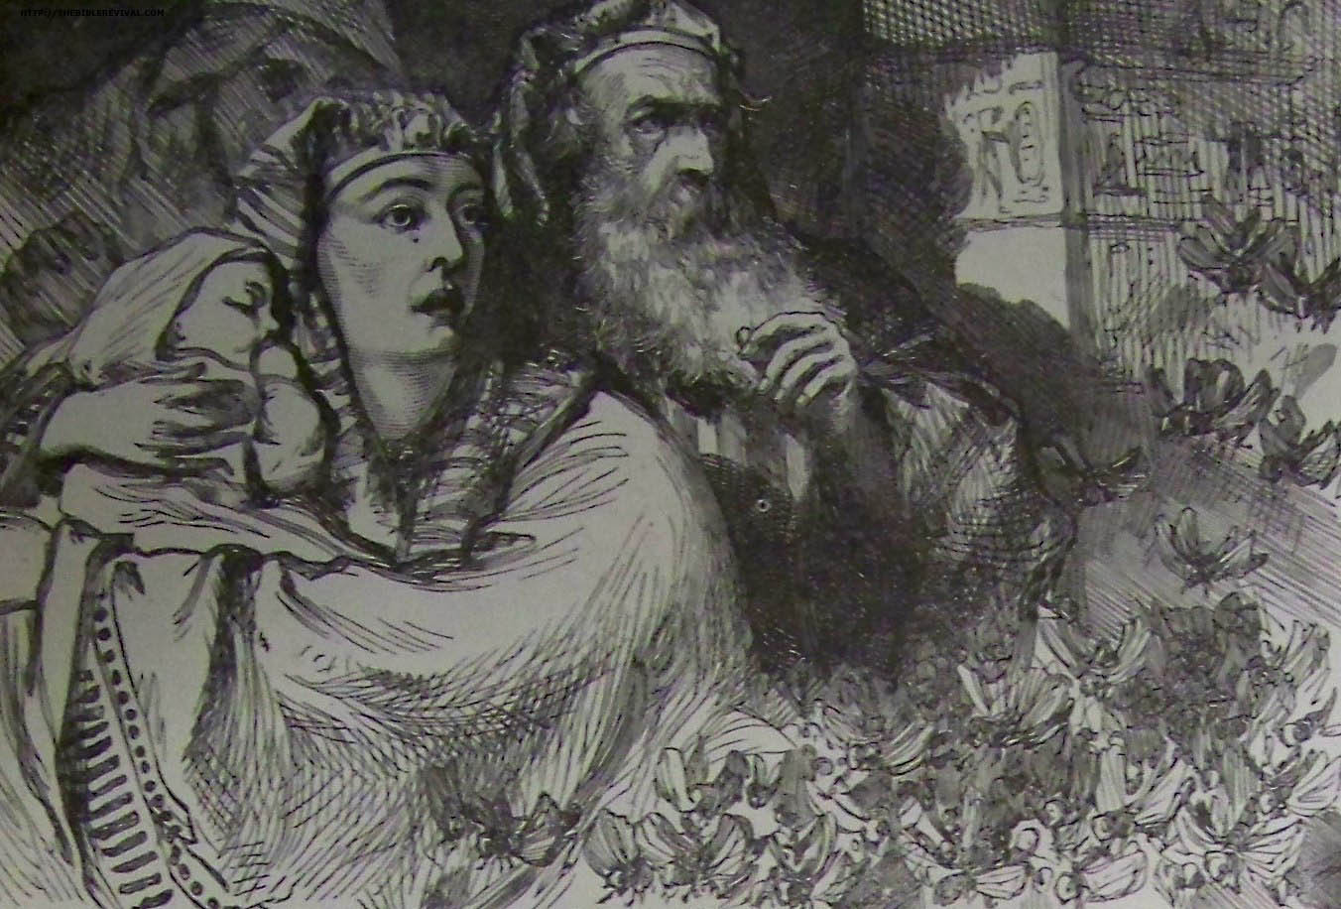

The Eighth plague had decimated Egypt, which was already damaged due to the prior plagues. Pharaoh's advisers risked trouble by challenging him to save what was left of Egypt – but saw no alternative – Pharaoh arrogantly refused.
Source: Public domain here http://thebiblerevival.com/clipart/1890holmanbible/bw/theplagueoflocusts.jpg

Faith In Action

Pray
Ask the Holy Spirit to show you a place in your life where you need to see things more clearly through His eyes.

Act
Today I will accept the leading of the Holy Spirit and repent (turn away from ) those things I value which are blocking my vision of that which God says is most valuable. It may be an obsession with comfort, entertainment, hobby, money, popularity, power, sports, tradition, or anything else that is out of balance in my life and is keeping me from being and doing what Jesus saved me to be and to do.
Be Specific _____________________________________________

Saturday (Exodus 11)
The Tenth Blow: Death
11:1 The Lord said to Moses, “I will bring one more plague on Pharaoh and on Egypt; after that he will release you from this place. When he releases you, he will drive you out completely from this place. 11:2 Instruct the people that each man and each woman is to request from his or her neighbor items of silver and gold.”
11:3 (Now the Lord granted the people favor with the Egyptians. Moreover, the man Moses was very great in the land of Egypt, respected by Pharaoh’s servants and by the Egyptian people.)
11:4 Moses said, “Thus says the Lord: ‘About midnight I will go throughout Egypt, 11:5 and all the firstborn in the land of Egypt will die, from the firstborn son of Pharaoh who sits on his throne, to the firstborn son of the slave girl who is at her hand mill, and all the firstborn of the cattle. 11:6 There will be a great cry throughout the whole land of Egypt, such as there has never been, nor ever will be again.
11:7 But against any of the Israelites not even a dog will bark against either people or animals, so that you may know that the Lord distinguishes between Egypt and Israel.’ 11:8 All these your servants will come down to me and bow down to me, saying, ‘Go, you and all the people who follow you,’ and after that I will go out.” Then Moses went out from Pharaoh in great anger.
11:9 The Lord said to Moses, “Pharaoh will not listen to you, so that my wonders may be multiplied in the land of Egypt.”
11:10 So Moses and Aaron did all these wonders before Pharaoh, but the Lord hardened Pharaoh’s heart, and he did not release the Israelites from his land.

Prayer
Lord, may we not be so stubborn, and our words so violent and ill-conceived, that we bring upon ourselves that which we wish upon others.

Scripture In Perspective
Before Moses left Pharaoh - God gave him one last pronouncement; the death of the firstborns, even of the cattle.
[Note: The text notes that Moses was highly respected throughout Egypt – perhaps the term might be “feared” as they had seen God's power flow through him. They were a people conditioned to respect those who wielded power.]
God reminded Moses of His prophesy, saying “Instruct the people that each man and each woman is to request from his or her neighbor items of silver and gold.”
God declared His intention to leave a lasting impression upon the Egyptians, and any who would hear of what He had done, saying “But against any of the Israelites not even a dog will bark against either people or animals, so that you may know that the Lord distinguishes between Egypt and Israel.”
[Note: Some have taught that there is no difference between the secular and the sacred but this text “the Lord distinguishes between Egypt and Israel.” appears to contradict that teaching.]

Interact With The Text

Consider
When the Lord says that a person or a people belong to Him those so affiliated will benefit from His protection and provision. The Pharaoh threatening the life of God's anointed - Moses, after all of the evidence of his close association with the God of power, seems foolish in retrospect.

Discuss
Why do you think that Moses was so angry? “All these your servants will come down to me and bow down to me, saying, ‘Go, you and all the people who follow you,’ and after that I will go out.” Then Moses went out from Pharaoh in great anger”

Reflect
Egypt had been blessed in many ways due to its association with the Israelites, from the time of Joseph to the time of Moses, including the immoral benefit of their slave-labor. God stripped-away all that they had gained – crops, livestock, health, and valuables (gold and silver) – restoring Egypt to their pre-Israelite condition, perhaps minus something extra for their mistreatment of His people.

Share
When have you you observed a situation where someone who has no power, and who has behaved badly, continued to make demands or to try to dictate terms despite the clear evidence that in so doing they make their situation worse?

KTALZ
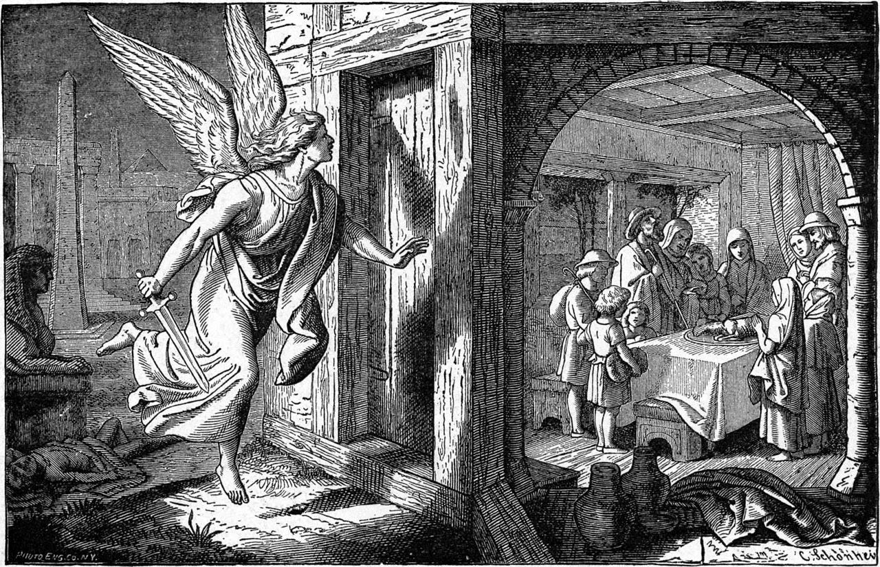

The firstborn of all Egypt, people and animals, would die while – as with the other plagues – the faithful among Israel would be spared.
Source: Public domain here http://eretzsongs.blogspot.com/2014/04/poem-of-day-exodus-13-14-16.html

Faith In Action

Pray
Ask the Holy Spirit to show you where, following a time of trouble, He has 'brought you out' and provided for you.

Act
Today I will share, with a fellow believer, the story of God's restoration and blessing of me. It may be when He saved me from an addiction, a destructive relationship, an ethically-compromising work environment, a sin-promoting lifestyle, or other place of bondage to the world. And, as the Lord provides, I will also share this story with someone who is considering-Christ as an act of evangelistic-missions.
Be Specific _________________________________________________

All Bible text is from the NET unless otherwise indicated - http://bible.org
Note 1: These Studies often rely upon the guidance of the NET Translators from their associated notes. Careful attention has been given to cite that source where it has been quoted directly or closely paraphrased. Feedback is encouraged where credit has not been sufficiently assigned.
Note 2: When NET text is quoted in commentary and discussion all pronouns referring to God are capitalized, though they are lower-case in the original NET text.
Commentary text is from David M. Colburn, D.Min. unless otherwise noted.
Copyright © 2012-2015 by David M. Colburn. This is a BibleSeven Study –“Exodus 5-11. Prepared by David M. Colburn and edited for bible.org in the Fall of 2014. This text may be used for non-profit educational purposes only, with credit; all other usage requires prior written consent of the author.

