Exodus 15:21 - 19
(Journey to the Sinai)
David M. Colburn
A Chronological Daily Bible Study of the Old Testament
7-Day Sections with a Summary-Commentary, Discussion Questions,
and a Practical Daily Application
Week 14

Sunday (Exodus 15:22-27)
The Bitter Water
15:22 Then Moses led Israel to journey away from the Red Sea. They went out to the Desert of Shur, walked for three days into the desert, and found no water. 15:23 Then they came to Marah, but they were not able to drink the waters of Marah, because they were bitter. (That is why its name was Marah.)
15:24 So the people murmured against Moses, saying, “What can we drink?” 15:25 He cried out to the Lord, and the Lord showed him a tree. When Moses threw it into the water, the water became safe to drink. There the Lord made for them a binding ordinance, and there he tested them.
15:26 He said, “If you will diligently obey the Lord your God, and do what is right in his sight, and pay attention to his commandments, and keep all his statutes, then all the diseases that I brought on the Egyptians I will not bring on you, for I, the Lord, am your healer.”
15:27 Then they came to Elim, where there were twelve wells of water and seventy palm trees, and they camped there by the water.

Prayer
Lord, may we recognize that Your desire is to bless us, but that the consequence of rebellion is trouble.

Scripture In Perspective
The huge nation continued their travels but went three days without a source of fresh water. They found water but it was too bitter, unsafe, to drink. Moses asked God and God directed him to a nearby tree which when placed in the water rendered it safe to drink.
God then told them that so long as they were faithful to Him they need not worry about any of the plagues of Egypt being visited upon them.

Interact with the text

Consider
A right expectation in this fallen world is for difficulties, but nothing is too great for the Lord God.

Discuss
Why is it that the Israelites, and we, have such short memories of the Lord's protection and provision – and that His blessings are conditioned upon our obedience?

Reflect
Over a million people and their livestock needed water and were without a fresh source after 3 days of travel in the desert.

Share
When have you felt as though you were in an emotional and/or spiritual desert, without hope of water, and when you thought you had found it you discovered a problem? How did God heal that situation so that you were refreshed?

KTALZ


It's unclear what made the water at Marah too “bitter” to drink such that it would make the people ill, nor what “tree” when placed in the water would make it fit to drink, but then a typical staff could not become a snake without God's intervention.


Elim, on the other hand, was a wonderful oasis of wells and palm trees for the Israelites.
Source: The first image bears a copyright watermark. The second image is public domain here http://upload.wikimedia.org/wikipedia/commons/thumb/8/8f/Palm_Tree.JPG/800px-Palm_Tree.JPG

Faith In Action

Pray
Ask the Holy Spirit to remind you of what He has done in your life and what He is promising to do.

Act
Today I will find time apart for the busyness for prayer and time in the Word. I will be silent before the Lord and will submit to the Holy Spirit as He teaches me. I will be encouraged by remembrances of God's faithfulness and reassured by His promises for my future. I will ask at least one fellow believer to pray for this special time with the Lord and I will share what I learn.
Be Specific ________________________________________________

Monday (Exodus 16)
The Provision of Manna
16:1 When they journeyed from Elim, the entire company of Israelites came to the Desert of Sin, which is between Elim and Sinai, on the fifteenth day of the second month after their exodus from the land of Egypt.
16:2 The entire company of Israelites murmured against Moses and Aaron in the desert.
16:3 The Israelites said to them, “If only we had died by the hand of the Lord in the land of Egypt, when we sat by the pots of meat, when we ate bread to the full, for you have brought us out into this desert to kill this whole assembly with hunger!”
16:4 Then the Lord said to Moses, “I am going to rain bread from heaven for you, and the people will go out and gather the amount for each day, so that I may test them. Will they will walk in my law or not?
16:5 On the sixth day they will prepare what they bring in, and it will be twice as much as they gather every other day.”
16:6 Moses and Aaron said to all the Israelites, “In the evening you will know that the Lord has brought you out of the land of Egypt, 16:7 and in the morning you will see the glory of the Lord, because he has heard your murmurings against the Lord. As for us, what are we, that you should murmur against us?”
16:8 Moses said, “You will know this when the Lord gives you meat to eat in the evening and bread in the morning to satisfy you, because the Lord has heard your murmurings that you are murmuring against him. As for us, what are we? Your murmurings are not against us, but against the Lord.”
16:9 Then Moses said to Aaron, “Tell the whole community of the Israelites, ‘Come before the Lord, because he has heard your murmurings.’”
16:10 As Aaron spoke to the whole community of the Israelites and they looked toward the desert, there the glory of the Lord appeared in the cloud, 16:11 and the Lord spoke to Moses: 16:12 “I have heard the murmurings of the Israelites. Tell them, ‘During the evening you will eat meat, and in the morning you will be satisfied with bread, so that you may know that I am the Lord your God.’”
16:13 In the evening the quail came up and covered the camp, and in the morning a layer of dew was all around the camp. 16:14 When the layer of dew had evaporated, there on the surface of the desert was a thin flaky substance, thin like frost on the earth.
16:15 When the Israelites saw it, they said to one another, “What is it?” because they did not know what it was. Moses said to them, “It is the bread that the Lord has given you for food.
16:16 “This is what the Lord has commanded: ‘Each person is to gather from it what he can eat, an omer per person according to the number of your people; each one will pick it up for whoever lives in his tent.’”
16:17 The Israelites did so, and they gathered – some more, some less.
16:18 When they measured with an omer, the one who gathered much had nothing left over, and the one who gathered little lacked nothing; each one had gathered what he could eat.
16:19 Moses said to them, “No one is to keep any of it until morning.”
16:20 But they did not listen to Moses; some kept part of it until morning, and it was full of worms and began to stink, and Moses was angry with them.
16:21 So they gathered it each morning, each person according to what he could eat, and when the sun got hot, it would melt.
16:22 And on the sixth day they gathered twice as much food, two omers per person; and all the leaders of the community came and told Moses.
16:23 He said to them, “This is what the Lord has said: ‘Tomorrow is a time of cessation from work, a holy Sabbath to the Lord. Whatever you want to bake, bake today; whatever you want to boil, boil today; whatever is left put aside for yourselves to be kept until morning.’”
16:24 So they put it aside until the morning, just as Moses had commanded, and it did not stink, nor were there any worms in it.
16:25 Moses said, “Eat it today, for today is a Sabbath to the Lord; today you will not find it in the area.
16:26 Six days you will gather it, but on the seventh day, the Sabbath, there will not be any.”
16:27 On the seventh day some of the people went out to gather it, but they found nothing. 16:28 So the Lord said to Moses, “How long do you refuse to obey my commandments and my instructions?
16:29 See, because the Lord has given you the Sabbath, that is why he is giving you food for two days on the sixth day. Each of you stay where you are; let no one go out of his place on the seventh day.”
16:30 So the people rested on the seventh day.
16:31 The house of Israel called its name “manna.” It was like coriander seed and was white, and it tasted like wafers with honey.
16:32 Moses said, “This is what the Lord has commanded: ‘Fill an omer with it to be kept for generations to come, so that they may see the food I fed you in the desert when I brought you out from the land of Egypt.’”
16:33 Moses said to Aaron, “Take a jar and put in it an omer full of manna, and place it before the Lord to be kept for generations to come.”
16:34 Just as the Lord commanded Moses, so Aaron placed it before the Testimony for safekeeping.
16:35 Now the Israelites ate manna forty years, until they came to a land that was inhabited; they ate manna until they came to the border of the land of Canaan. 16:36 (Now an omer is one tenth of an ephah.)

Prayer
Lord, we are quick to complain when things are difficult, yet You bear our immature whining and continue to love us. Thank you Lord for Your patience.

Scripture In Perspective
After previously complaining about the lack of water the Israelites complained about the lack of food, even suggesting that Moses had led them to the desert to starve, as they previously accused him of leading them into the desert to die for lack of water. They again declared that it would have been better to die as slaves if only their stomachs were full.
God told Moses that He would send bread and meat, that the people should gather a double-ration on the sixth day (Friday by the ancient Jewish reckoning) and to rest on Saturday. They were also to gather only enough for their family and not to hoard any.
God told Moses that He was doing it this way as a test to see if the people would “walk in My law”.
The people were corrected by Moses who reminded them that he was not the One who brought them out of captivity nor was he the One Who protected them and Who could provide for them – they were complaining about and to God, not him.
Moses told Aaron who told the people. Everyone who gathered discovered that they had just enough, whether they gathered more than their neighbor or less.
Some people disobeyed and hoarded extra and what they had hoarded rotted and Moses was righteously-angry with their disobedience. Then when the Sabbath day came they grumbled that there was no new food – and were reminded that they received a double-portion the day before.
Verses 16:32 to 34 describe God's command that they gather an “omer” (one tenth of an ephah, about 1 or 2 liters) of manna and put it with the “Testimony” for a remembrance. Some have suggested that this is a misplaced text from the end of Exodus when the Ark of the Covenant had been created at God's command (see NET translator's notes). Another possibility is that just as their forefathers had built various memorials of stones to remember intersections with God, so also Moses may have kept a scroll or other article of remembrance as a pre-Ark of the Covenant physical “Testimony”.
God provided manna for all of the forty years of their journey in the desert.

Interact with the text

Consider
Rather than make a humble and polite request for food the Israelites were instead accusatory and demanding, not to mention disrespectful to Moses.

Discuss
Why did God test the people in the way that he did?

Reflect
How different are we from the Israelites? Do we not also hoard, out of fear and/or greed, and forget to rest in God but rather prefer the pursuit of money and pleasure?

Share
When have you had your needs met but when it came time to take time to rest in the Lord God you busied yourself with other things and neglected time alone with Him?

KTALZ
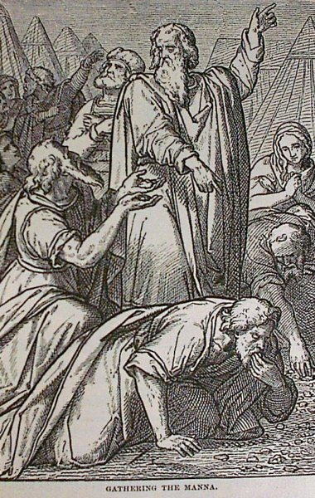

The Israelites grumbled against Moses and Aaron but it was really mistrust of God. In His grace he ignored their insult and provided them with manna and quail.
Source: Public domain here http://www.coolnotions.com/PDImages/StoryOTB047_p115_GatheringTheManna.jpg

Faith In Action

Pray
Ask the Holy Spirit to show you where you have displaced rest in/with the Lord with other things.

Act
Today I will listen to the voice of the Holy Spirit and re-order my priorities. I will set aside significant time for the Lord and will not worry myself with the distractions of other things. It does not need to become a rigid day and time schedule but it does need to be intentional and significant.
Be Specific _____________________________________________

Tuesday (Exodus 17:1-7)
Water at Massa and Meribah
17:1 The whole community of the Israelites traveled on their journey from the Desert of Sin according to the Lord’s instruction, and they pitched camp in Rephidim. Now there was no water for the people to drink.
17:2 So the people contended with Moses, and they said, “Give us water to drink!” Moses said to them, “Why do you contend with me? Why do you test the Lord?”
17:3 But the people were very thirsty there for water, and they murmured against Moses and said, “Why in the world did you bring us up out of Egypt – to kill us and our children and our cattle with thirst?”
17:4 Then Moses cried out to the Lord, “What will I do with this people? – a little more and they will stone me!”
17:5 The Lord said to Moses, “Go over before the people; take with you some of the elders of Israel and take in your hand your staff with which you struck the Nile and go.
17:6 I will be standing before you there on the rock in Horeb, and you will strike the rock, and water will come out of it so that the people may drink.” And Moses did so in plain view of the elders of Israel.
17:7 He called the name of the place Massah and Meribah, because of the contending of the Israelites and because of their testing the Lord, saying, “Is the Lord among us or not?”

Prayer
Lord, just as the people with Moses were desperate for water for temporary earthly life, we are desperate for You for the water of eternal life.

Scripture In Perspective
Once again there was a shortage, this time of water, for the traveling nation and once again instead of asking respectfully they questioned the wisdom of Moses, and by-association, that of God – and Moses again chastised them for that.
The Lord God still provided, instructing Moses to gather the elders and to strike a rock upon which He would 'appear', and Moses did so - and water flowed.
[Note: It is valuable to remember the details of this interaction because something similar occurs later in their travels - which Moses badly mishandled.]

Interact With The Text

Consider
The pattern of distrust of and disrespect toward Moses, whenever they were uncomfortable, had been established by this time. It would rear its ugly head later and result in a terrible consequence for the fearful and rebellious Israelites.

Discuss
Do some imagine themselves in a saving-relationship with the Lord God merely because they are members of a man-made 'church' institution? How many have never truly received the water of eternal life?

Reflect
The Lord God required the presences of the elders, the tribal leaders of Israel, when He appeared at the rock and had Moses strike the rock with the staff to cause water to flow. It was a dramatic demonstration of His power and of His expression of that power through Moses.

Share
When has a group within a fellowship challenged the leadership, in a somewhat disrespectful way, rather than respectfully seeking guidance in meeting their needs - in faithful shared-prayer?

KTALZ
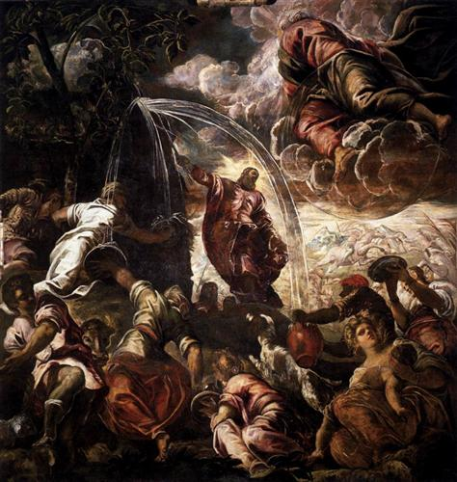

God ignored the rudeness of the people and used the occasion to demonstrate His delegated authority to Moses before the elders.
Source: Public domain here http://uploads1.wikiart.org/images/tintoretto/moses-drawing-water-from-the-rock-1577.jpg!Blog.jpg

Faith In Action

Pray
Ask the Holy Spirit to reveal to you a place in your life where you tend to be demanding rather than respectfully-requesting of the Lord God.

Act
Today I will confess and repent of my disrespectful attitude, request and receive Your forgiveness, and prayerfully bring my requests to You with a humble heart.
Be Specific _________________________________________________

Wednesday (Exodus 17:8-16)
Victory over the Amalekites
17:8 Amalek came and attacked Israel in Rephidim.
17:9 So Moses said to Joshua, “Choose some of our men and go out, fight against Amalek. Tomorrow I will stand on top of the hill with the staff of God in my hand.”
17:10 So Joshua fought against Amalek just as Moses had instructed him; and Moses and Aaron and Hur went up to the top of the hill.
17:11 Whenever Moses would raise his hands, then Israel prevailed, but whenever he would rest his hands, then Amalek prevailed.
17:12 When the hands of Moses became heavy, they took a stone and put it under him, and Aaron and Hur held up his hands, one on one side and one on the other, and so his hands were steady until the sun went down.
17:13 So Joshua destroyed Amalek and his army with the sword.
17:14 The Lord said to Moses, “Write this as a memorial in the book, and rehearse it in Joshua’s hearing; for I will surely wipe out the remembrance of Amalek from under heaven.
17:15 Moses built an altar, and he called it “The Lord is my Banner,” 17:16 for he said, “For a hand was lifted up to the throne of the Lord – that the Lord will have war with Amalek from generation to generation.”

Prayer
Lord, despite our whining and improperly-demanding attitudes You are faithful to us; please find me more faithful to and trusting of You.

Scripture In Perspective
The Amalekites attacked Israel and Moses dispatched Joshua to lead an army against them. The staff of Moses when upheld caused Israel to prevail but when Moses' arms became tired Israel did not prevail. Aaron and Hur brought a stone for Moses to sit on and they each held one side of the staff and Israel destroyed the Amalekites.
God declared that He would wipe the Amalekites from the face of the earth (after a war with them “from generation to generation”) and instructed Moses to “Write this as a memorial in the book, and rehearse it in Joshua’s hearing ...”, which further enhanced the likelihood that the reference to “The Testimony” (in Exo. 16:34) may have been about an ongoing record – which was later added to the artifacts in the Ark of the Covenant.

Interact With The Text

Consider
The Enemy, imagining the Israelites to be vulnerable, used the Amalekites in an attempt to destroy them – his insane rage blinding him to the obvious – that the Lord God would defend His chosen people.

Discuss
God continued to choose the staff as a tool of His expression of power, and He allowed His power to flow only as Moses' arms were raised and the staff was steady (this time eventually requiring the assistance of Aaron and Hur). What message might God have been communicating to the people? To Moses?

Reflect
The transmission of the Lord God's promises from Moses to Joshua was vital to the perpetuation of a right-understanding of the Lord and the reliance His people were to have upon Him.

Share
When have you experienced the power and provision of God, delivered to you through another?

KTALZ
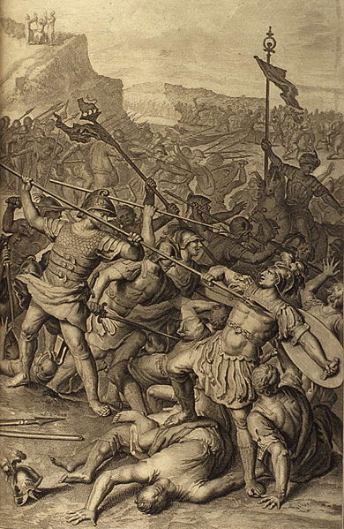

Moses learned that he needed to allow others to assist him with leadership, in this case holding up the staff for a long period of time, and the people learned that victory came from the Lord.
Source: Public domain here http://upload.wikimedia.org/wikipedia/commons/thumb/e/e1/Figures_055_The_Battle_Between_the_Israelites_and_Amalekites.jpg/390px-Figures_055_The_Battle_Between_the_Israelites_and_Amalekites.jpg

Faith In Action

Pray
Ask the Holy Spirit to reveal to you a place where you need to allow Him to minister to you through another, someone whom He has equipped with His power to assist you.

Act
Today I will set aside my pride and allow God to intervene on my behalf through another. It may be someone physically able to complete a task for which my body is not capable, it may be a counselor or mediator or spokesman who can persuade another to favor me, it may be an accountant or doctor or lawyer or other professional acting on my behalf, or it may be someone intervening through intercessory prayer and/or spiritual warfare.
Be Specific ________________________________________________

Thursday (Exodus 18:1-16)
The Advice of Jethro – Part 1
18:1 Jethro, the priest of Midian, Moses’ father-in-law, heard about all that God had done for Moses and for his people Israel, that the Lord had brought Israel out of Egypt.
18:2 Jethro, Moses’ father-in-law, took Moses’ wife Zipporah after he had sent her back, 18:3 and her two sons, one of whom was named Gershom (for Moses had said, “I have been a foreigner in a foreign land”), 18:4 and the other Eliezer (for Moses had said, “The God of my father has been my help and delivered me from the sword of Pharaoh”).
18:5 Jethro, Moses’ father-in-law, together with Moses’ sons and his wife, came to Moses in the desert where he was camping by the mountain of God.
18:6 He said to Moses, “I, your father-in-law Jethro, am coming to you, along with your wife and her two sons with her.”
18:7 Moses went out to meet his father-in-law and bowed down and kissed him; they each asked about the other’s welfare, and then they went into the tent.
18:8 Moses told his father-in-law all that the Lord had done to Pharaoh and to Egypt for Israel’s sake, and all the hardship that had come on them along the way, and how the Lord had delivered them.
18:9 Jethro rejoiced because of all the good that the Lord had done for Israel, whom he had delivered from the hand of Egypt.
18:10 Jethro said, “Blessed be the Lord who has delivered you from the hand of Egypt, and from the hand of Pharaoh, who has delivered the people from the Egyptians’ control!
18:11 Now I know that the Lord is greater than all the gods, for in the thing in which they dealt proudly against them he has destroyed them.”
18:12 Then Jethro, Moses’ father-in-law, brought a burnt offering and sacrifices for God, and Aaron and all the elders of Israel came to eat food with the father-in-law of Moses before God.
18:13 On the next day Moses sat to judge the people, and the people stood around Moses from morning until evening.
18:14 When Moses’ father-in-law saw all that he was doing for the people, he said, “What is this that you are doing for the people? Why are you sitting by yourself, and all the people stand around you from morning until evening?”
18:15 Moses said to his father-in-law, “Because the people come to me to inquire of God.
18:16 When they have a dispute, it comes to me and I decide between a man and his neighbor, and I make known the decrees of God and his laws.”

Prayer
Lord, what You did in and through Moses was a testimony of power and of truth to Jethro “Priest of the Midianites”, as well as Moses' father-in-law. May Your work in and through me also be a testimony to You.

Scripture In Perspective
Jethro had cared for the family of Moses while he served the Lord God in the liberation of His (and his) people in Egypt.
Now that the Israelites were past the liberation and conflict with the Amalekites Jethro brought them to Moses.
Moses treated Jethro with gratefulness and honor and humbly shared what the Lord had done.
Jethro recognized and surrendered to the Lordship of God and brought an offering.
Jethro then observed Moses as he attempted to judge all of the people of Israel, a nation very likely over half of a million people.
Moses explained his reasons.

Interact With The Text

Consider
Up until this point Jethro did not acknowledge the Lordship of God, he was a priest for another religion, and very likely taught the same to his daughter and to Moses' children.

Discuss
Why would Moses think that he could, and should, attempt to judge the entire nation of Israel alone?

Reflect
Jethro, despite his age and title, remained teachable. A role model to Moses.

Share
When have you observed a person who was older and who held a title of some sort learning from someone younger and as a result choose to alter something they believed and/or did?

KTALZ
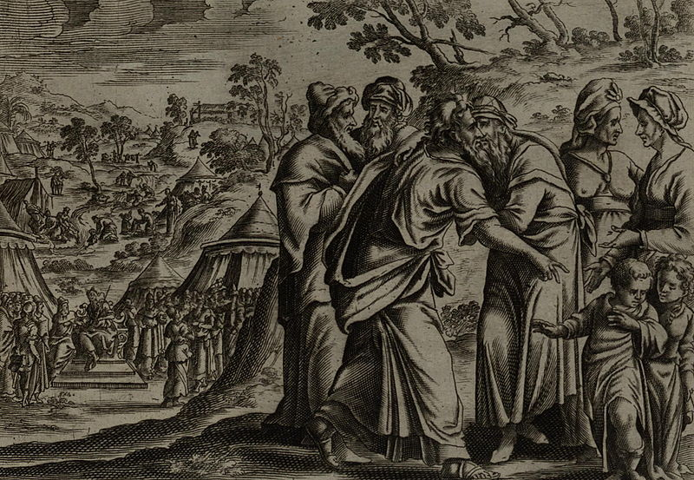

Jethro had cared for and raised the children of Moses, and protected his wife, while Moses was leading the Israelites to freedom and now he was returning them to him.
Source” Public domain here http://upload.wikimedia.org/wikipedia/commons/thumb/9/98/Jollain_Jethro%27s_visit.jpg/800px-Jollain_Jethro%27s_visit.jpg

Faith In Action

Pray
Ask the Holy Spirit to reveal to you something that He wants to change in your thinking.

Act
I will humble myself and be teachable so that the lesson the Lord God has for me may make me a wiser and a more valuable instrument in His great work.
Be Specific _____________________________________________

Friday (Exodus 18:17-27)
The Advice of Jethro – Part 2
18:17 Moses’ father-in-law said to him, “What you are doing is not good! 18:18 You will surely wear out, both you and these people who are with you, for this is too heavy a burden for you; you are not able to do it by yourself.
18:19 Now listen to me, I will give you advice, and may God be with you: You be a representative for the people to God, and you bring their disputes to God; 18:20 warn them of the statutes and the laws, and make known to them the way in which they must walk and the work they must do.
18:21 But you choose from the people capable men, God-fearing, men of truth, those who hate bribes, and put them over the people as rulers of thousands, rulers of hundreds, rulers of fifties, and rulers of tens.
18:22 They will judge the people under normal circumstances, and every difficult case they will bring to you, but every small case they themselves will judge, so that you may make it easier for yourself, and they will bear the burden with you.
18:23 If you do this thing, and God so commands you, then you will be able to endure, and all these people will be able to go home satisfied.”
18:24 Moses listened to his father-in-law and did everything he had said. 18:25 Moses chose capable men from all Israel, and he made them heads over the people, rulers of thousands, rulers of hundreds, rulers of fifties, and rulers of tens.
18:26 They judged the people under normal circumstances; the difficult cases they would bring to Moses, but every small case they would judge themselves.
18:27 Then Moses sent his father-in-law on his way, and so Jethro went to his own land.

Prayer
Lord, may leaders be humble and trusting enough to delegate, and may those to whom they delegate be faithful, and in whichever role You place me may I give my best.

Scripture In Perspective
Jethro observed Moses carrying the weight of resolving every small and great legal conflict among the Israelite nation of over a million people.
He advised Moses to recruit men of maturity to handle the small matters so that he would only have to handle the major ones.
Moses was humble enough to hear and heed the counsel of Jethro.
[Note: The NET translators notes remark that this is a role model for all leaders. One might also observe that much of the modern court system owes its roots to this wise counsel, presumably instigated in Jethro by God.]

Interact With The Text

Consider
Moses made a decision to submit as the Lord God's chosen instrument in leading the Israelites out of Egyptian captivity and he left his family in the safekeeping of Jethro.

Discuss
Do you agree with the NET translators that Jethro was in a strong position to have his advice heard by Moses because of - his age, his relationship, and that he had no plans to remain and be one of those to whom Moses delegated, nor to continue to give additional advice?

Reflect
Moses was advised to choose men who were respected in the community, much as the apostle Paul later counseled Timothy to do the same when choosing elders. Moses would also need to instruct them as to the dividing line between minor cases, which they would handle, and major cases, which they were to escalate-up to him.

Share
When have you experienced or observed a leader who became overwhelmed by too many responsibilities? Was that leader able to receive the wisdom of taking the risk to delegate?

KTALZ

After Jethro delivered Moses' family to him he observed Moses trying to judge all of the conflicts for the huge crowd of Israelites & he suggested that Moses delegate.
Source” Public domain here http://upload.wikimedia.org/wikipedia/commons/thumb/9/98/Jollain_Jethro%27s_visit.jpg/800px-Jollain_Jethro%27s_visit.jpg

Faith In Action

Pray
Ask the Holy Spirit to send you a Jethro, and to give you the humility to receive what he or she says.

Act
Today I will humbly delegate where I need to delegate, respectfully counsel where I need to counsel a leader to delegate, or humbly make myself available to answer the call to fill a gap where there is a gap for which God has equipped and prepared me.
Be Specific _____________________________________________

Saturday (Exodus 19)
Israel at Sinai
19:1 In the third month after the Israelites went out from the land of Egypt, on the very day, they came to the Desert of Sinai. 19:2 After they journeyed from Rephidim, they came to the Desert of Sinai, and they camped in the desert; Israel camped there in front of the mountain.
19:3 Moses went up to God, and the Lord called to him from the mountain, “Thus you will tell the house of Jacob, and declare to the people of Israel: 19:4 ‘You yourselves have seen what I did to Egypt and how I lifted you on eagles’ wings and brought you to myself. 19:5 And now, if you will diligently listen to me and keep my covenant, then you will be my special possession out of all the nations, for all the earth is mine, 19:6 and you will be to me a kingdom of priests and a holy nation.’ These are the words that you will speak to the Israelites.”
19:7 So Moses came and summoned the elders of Israel. He set before them all these words that the Lord had commanded him, 19:8 and all the people answered together, “All that the Lord has commanded we will do!” So Moses brought the words of the people back to the Lord.
19:9 The Lord said to Moses, “I am going to come to you in a dense cloud, so that the people may hear when I speak with you and so that they will always believe in you.” And Moses told the words of the people to the Lord.
19:10 The Lord said to Moses, “Go to the people and sanctify them today and tomorrow, and make them wash their clothes 19:11 and be ready for the third day, for on the third day the Lord will come down on Mount Sinai in the sight of all the people. 19:12 You must set boundaries for the people all around, saying, ‘Take heed to yourselves not to go up on the mountain nor touch its edge. Whoever touches the mountain will surely be put to death! 19:13 No hand will touch him – but he will surely be stoned or shot through, whether a beast or a human being; he must not live.’ When the ram’s horn sounds a long blast they may go up on the mountain.”
19:14 Then Moses went down from the mountain to the people and sanctified the people, and they washed their clothes. 19:15 He said to the people, “Be ready for the third day. Do not go near your wives.”
19:16 On the third day in the morning there was thunder and lightning and a dense cloud on the mountain, and the sound of a very loud horn; all the people who were in the camp trembled. 19:17 Moses brought the people out of the camp to meet God, and they took their place at the foot of the mountain. 19:18 Now Mount Sinai was completely covered with smoke because the Lord had descended on it in fire, and its smoke went up like the smoke of a great furnace, and the whole mountain shook violently. 19:19 When the sound of the horn grew louder and louder, Moses was speaking and God was answering him with a voice.
19:20 The Lord came down on Mount Sinai, on the top of the mountain, and the Lord summoned Moses to the top of the mountain, and Moses went up. 19:21 The Lord said to Moses, “Go down and solemnly warn the people, lest they force their way through to the Lord to look, and many of them perish. 19:22 Let the priests also, who approach the Lord, sanctify themselves, lest the Lord break through against them.”
19:23 Moses said to the Lord, “The people are not able to come up to Mount Sinai, because you solemnly warned us, ‘Set boundaries for the mountain and set it apart.’” 19:24 The Lord said to him, “Go, get down, and come up, and Aaron with you, but do not let the priests and the people force their way through to come up to the Lord, lest he break through against them.” 19:25 So Moses went down to the people and spoke to them.

Prayer
Lord, Your presence of perfection is like fire to the dross that is a fallen creature (man or beast) here on Earth. May I remember that while You love me, You are still a holy and perfect Lord God and I am only worthy to call you Abba Father because of Jesus. Please find me humble.

Scripture In Perspective
90 days after they left Egypt the Israelites arrived at the base of Mount Sinai. The precise location of Mount Sinai has been debated based upon archeology and differing interpretations of Biblical mention of specific features and stopping points along the way there.
Moses climbed the mountain and the Lord God instructed him to tell the people that He desired them to be a nation guided by priests, as they were obedient they would become a holy nation - worthy of His blessing - as a nation set apart from all others by Him.
Moses traveled back down and delivered God's message to elders who on behalf of the people agreed to His terms. Moses then returned to the mountain to deliver the message to God that the elders had agreed.
[Note: God, of course, already knew – the exercise was a formality for the sake of Moses and the people.]
The Lord was pleased and instructed Moses to have the people ceremonially prepare themselves for three days and to warn them to keep themselves, and their animals, from touching any part of the mountain or else they would die.

Interact With The Text

Consider
Israel had a simple, indeed primitive, national relationship with (and an understanding of) God. They had suffered a lot of distracting influences from their days in Egypt, as well as other influences from their national past.

Discuss
Over a million strong, generations accustomed to the predictability of life in Egypt, challenged by the Egyptian charioteers at the Red Sea, attacked by the Amorites along the way, twice running out of water and once out of food, and now confronted with a mountain that rumbled and roared with clouds and smoke – all in the brief span of 90 days (during a period when they were constantly moving). How confused, disoriented, exhausted, and frightened must they have been?

Reflect
God used what was probably a volcanic mountain to stage His meeting with Moses, on behalf of the Israelites, to establish Himself as their Lord God – it was designed to be a profoundly visual manifestation.

Share
When have you found yourself in the midst of many changes and discovered that things you had previously found easy to manage, and to understand, somehow became more challenging?

KTALZ
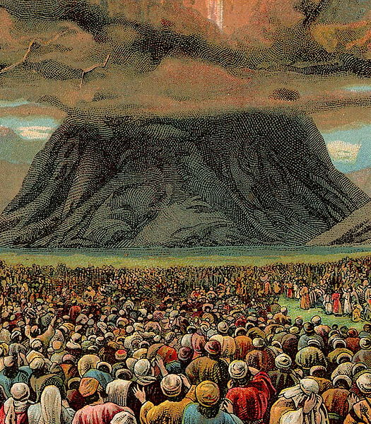

God made His presence known on the mountain as the people sent word through their elders that they agreed to the terms of God's covenant.
Source: Public domain here http://upload.wikimedia.org/wikipedia/commons/thumb/6/6a/The_Ten_Commandments_%28Bible_Card%29.jpg/525px-The_Ten_Commandments_%28Bible_Card%29.jpg

Faith In Action

Pray
Ask the Holy Spirit to show you where you may need some work on your walk before the Lord.

Act
Today I will humbly and prayerfully accept the guidance of the Holy Spirit as to areas in my walk that are not guided by the new covenant Biblical expectations of the “priesthood of all believers” so that I may be more-intimately and profoundly part of the “righteous nation” that is Christ's church.
Be Specific _________________________________________________

All Bible text is from the NET unless otherwise indicated - http://bible.org
Note 1: These Studies often rely upon the guidance of the NET Translators from their associated notes. Careful attention has been given to cite that source where it has been quoted directly or closely paraphrased. Feedback is encouraged where credit has not been sufficiently assigned.
Note 2: When NET text is quoted in commentary and discussion all pronouns referring to God are capitalized, though they are lower-case in the original NET text.
Commentary text is from David M. Colburn, D.Min. unless otherwise noted.
Copyright © 2012 by David M. Colburn. This is a BibleSeven Study –“Genesis 3. Prepared by David M. Colburn and edited for bible.org in August of 2012. This text may be used for non-profit educational purposes only, with credit; all other usage requires prior written consent of the author.

