Exodus 12 – 15:21
(Passover & Escape from Egypt)
David M. Colburn
A Chronological Daily Bible Study of the Old Testament
7-Day Sections with a Summary-Commentary, Discussion Questions,
and a Practical Daily Application
Week 13

Sunday (Exodus 12:1-28)
The Institution of the Passover
12:1 The Lord said to Moses and Aaron in the land of Egypt, 12:2 “This month is to be your beginning of months; it will be your first month of the year. 12:3 Tell the whole community of Israel, ‘In the tenth day of this month they each must take a lamb for themselves according to their families – a lamb for each household. 12:4 If any household is too small for a lamb, the man and his next-door neighbor are to take a lamb according to the number of people – you will make your count for the lamb according to how much each one can eat. 12:5 Your lamb must be perfect, a male, one year old; you may take it from the sheep or from the goats. 12:6 You must care for it until the fourteenth day of this month, and then the whole community of Israel will kill it around sundown. 12:7 They will take some of the blood and put it on the two side posts and top of the doorframe of the houses where they will eat it. 12:8 They will eat the meat the same night; they will eat it roasted over the fire with bread made without yeast and with bitter herbs. 12:9 Do not eat it raw or boiled in water, but roast it over the fire with its head, its legs, and its entrails. 12:10 You must leave nothing until morning, but you must burn with fire whatever remains of it until morning. 12:11 This is how you are to eat it – dressed to travel, your sandals on your feet, and your staff in your hand. You are to eat it in haste. It is the Lord’s Passover.
12:12 I will pass through the land of Egypt in the same night, and I will attack all the firstborn in the land of Egypt, both of humans and of animals, and on all the gods of Egypt I will execute judgment. I am the Lord. 12:13 The blood will be a sign for you on the houses where you are, so that when I see the blood I will pass over you, and this plague will not fall on you to destroy you when I attack the land of Egypt.
12:14 This day will become a memorial for you, and you will celebrate it as a festival to the Lord – you will celebrate it perpetually as a lasting ordinance. 12:15 For seven days you must eat bread made without yeast. Surely on the first day you must put away yeast from your houses because anyone who eats bread made with yeast from the first day to the seventh day will be cut off from Israel.
12:16 On the first day there will be a holy convocation, and on the seventh day there will be a holy convocation for you. You must do no work of any kind on them, only what every person will eat – that alone may be prepared for you. 12:17 So you will keep the Feast of Unleavened Bread, because on this very day I brought your regiments out from the land of Egypt, and so you must keep this day perpetually as a lasting ordinance. 12:18 In the first month, from the fourteenth day of the month, in the evening, you will eat bread made without yeast until the twenty-first day of the month in the evening. 12:19 For seven days yeast must not be found in your houses, for whoever eats what is made with yeast – that person will be cut off from the community of Israel, whether a foreigner or one born in the land. 12:20 You will not eat anything made with yeast; in all the places where you live you must eat bread made without yeast.’”
12:21 Then Moses summoned all the elders of Israel, and told them, “Go and select for yourselves a lamb or young goat for your families, and kill the Passover animals. 12:22 Take a branch of hyssop, dip it in the blood that is in the basin, and apply to the top of the doorframe and the two side posts some of the blood that is in the basin. Not one of you is to go out the door of his house until morning. 12:23 For the Lord will pass through to strike Egypt, and when he sees the blood on the top of the doorframe and the two side posts, then the Lord will pass over the door, and he will not permit the destroyer to enter your houses to strike you. 12:24 You must observe this event as an ordinance for you and for your children forever. 12:25 When you enter the land that the Lord will give to you, just as he said, you must observe this ceremony. 12:26 When your children ask you, ‘What does this ceremony mean to you?’ – 12:27 then you will say, ‘It is the sacrifice of the Lord’s Passover, when he passed over the houses of the Israelites in Egypt, when he struck Egypt and delivered our households.’” The people bowed down low to the ground, 12:28 and the Israelites went away and did exactly as the Lord had commanded Moses and Aaron.

Prayer
Lord, the initiation of the Passover rite was significant step-up in the commitment of Your people to recognize Your Lordship, may we Christians remember that what we call “Communion” is an equally powerful symbol of Your Lordship. Although the old festival and sacrificial system has passed away, may we never forget all that You did because of Your faithful love for Israel – so that it remains a constant reminder that You are equally faithful to us.

Scripture In Perspective
The Lord God instructed the Israelites as to how they might protect themselves against the coming final judgment of the Egyptians who had held them in captivity and who had rejected God's demand to set them free.
The Israelites, at least the obedient among them, were to sacrifice a “perfect” lamb (goat or sheep).
[Note: This text refers only in the generic to “firstborn”, but the prior Chapter Verse 11:5 is rendered “... and all the firstborn in the land of Egypt will die, from the firstborn son of Pharaoh who sits on his throne, to the firstborn son of the slave girl who is at her hand mill, and all the firstborn of the cattle.”, implying that it was the firstborn males who were to be targeted. Psalm 135:8 offers clarification “He struck down the firstborn of Egypt, including both men and animals.” In both cases the Net Bible - Word Analysis shows the intended meaning to be gender-specific: male.]
[Note: In verses 12:12-13 the Lord uses the phrase “I will” to describe His direct and indirect, via an angel, actions. It is important to remember this phraseology elsewhere in the Word – sometimes actions are a delegated-extension rather than a direct action of the Lord.]
The Lord explained how they would keep this new rite as a reminder of His protection, provision, and His Lordship.
He warned that the failure to obey His detailed instructions closely would result in tragedy.
Celebration, convocation, feast, festival, memorial, passover, and sacrifice are all terms the text uses to define the rite of remembrance of the plague which brought the exodus from Egypt.
God explained the reason for the perpetual (for the generations of Israelites) requirement “... because on this very day I brought your regiments out from the land of Egypt”.
[Note: The terms “eternal” and “perpetual” are sometimes misapplied due to misunderstanding of the context. Generally, the context is limited by the terms of a covenant which, when broken, may end the time period. Even post-judgment events may be tied to the temporary context of that which is being described. e.g. The lost are bound to the temporary fallen creation for which time itself was created. If that creation is ultimately obliterated are not also those things bound to it obliterated?]
God described in general, and with some specificity, what was to be done and not done. (Additional detail would come later in the life of Israel.)
[Note: According to the Net translators the hyssop was a common plant whose shape and texture was well-suited for painting blood on the door frame and for use by priests in rituals that involved blood. It may also have been an aromatic herb.]

Interact with the text

Consider
The Lord God destroyed the last and most valued thing of all, the firstborn male of both humans and livestock – the final step in getting the Pharaoh's attention (and that of the Egyptians whose cooperation allowed Pharaoh to enslave God's people). He only offered protection to the people of Israel “Tell the whole community of Israel”. Just as the blood of the “perfect” lamb protected the Israelites against the “destroyer” in Egypt the blood of The Lamb, Jesus, will protect us in the last days of these end times when God comes in final judgment.

Discuss
This is the first time that God told the people to dress to travel and that what was about to happen was to be remembered in a rite to be repeated annually. How must the people have felt, after several false-starts, to finally be told that this was at last the time of their exodus from Egypt? After all of the plagues visited upon Egypt, how frightening must it have been to hear that the very angel of death “the destroyer” would be passing through all of Egypt – including Goshen – which had previously been spared?

Reflect
Note how sensitive the Lord God in the detail - where He allowed that a small family, or one with small children who did not eat much, might join with another family, as they were required to eat the entire lamb and to burn the leftovers. God knew how quickly people would forget His liberation of them from bondage in Egypt, so not only did He require an annual remembrance, He placed strict limits to prevent them from being distracted from remembrance by the busyness of their usual work.

Share
When have you anticipated a change for a while but circumstances forced you to wait, even after more than one false-start? How did you feel when the time finally arrived? When have you made the time to pause and to remember how and when God set you free from the bondage of an otherwise eternally-unforgiven sin?

KTALZ
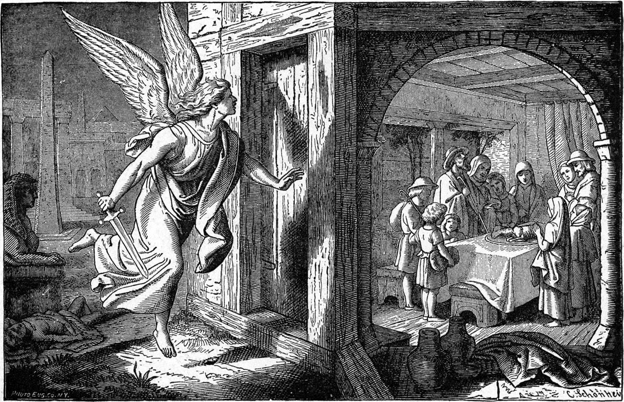

The blood that protected the Israelites from the angel of death would later be the grace-blood of Jesus which saves us all from the law at the Great White Throne Judgment.
Source: Public domain here http://eretzsongs.blogspot.com/2014/04/poem-of-day-exodus-13-14-16.html

Faith In Action

Pray
Ask the Holy Spirit to show you somewhere in your life where He has provided a way out (1 Corinthians 10:13) and to bring to your remembrance how and when He actually set you free.

Act
Today I will share with a fellow Christian God's provision of a way out – an 'exodus' in my life. We will celebrate His faithfulness together. I also will make plans for an annual celebration of my salvation. I will not make it about me, or about the sin from which I was set free, but rather about the One Who set me free - and to celebrate His victory.
Be Specific ________________________________________________

Monday (Exodus 12:29 – 12:42)
The Deliverance from Egypt
12:28 It happened at midnight – the Lord attacked all the firstborn in the land of Egypt, from the firstborn of Pharaoh who sat on his throne to the firstborn of the captive who was in the prison, and all the firstborn of the cattle. 12:30 Pharaoh got up in the night, along with all his servants and all Egypt, and there was a great cry in Egypt, for there was no house in which there was not someone dead. 12:31 Pharaoh summoned Moses and Aaron in the night and said, “Get up, get out from among my people, both you and the Israelites! Go, serve the Lord as you have requested! 12:32 Also, take your flocks and your herds, just as you have requested, and leave. But bless me also.”
12:33 The Egyptians were urging the people on, in order to send them out of the land quickly, for they were saying, “We are all dead!” 12:34 So the people took their dough before the yeast was added, with their kneading troughs bound up in their clothing on their shoulders. 12:35 Now the Israelites had done as Moses told them – they had requested from the Egyptians silver and gold items and clothing. 12:36 The Lord gave the people favor in the sight of the Egyptians, and they gave them whatever they wanted, and so they plundered Egypt.
12:37 The Israelites journeyed from Rameses to Sukkoth. There were about 600,000 men on foot, plus their dependants. 12:38 A mixed multitude also went up with them, and flocks and herds – a very large number of cattle. 12:39 They baked cakes of bread without yeast using the dough they had brought from Egypt, for it was made without yeast – because they were thrust out of Egypt and were not able to delay, they could not prepare food for themselves either.
12:40 Now the length of time the Israelites lived in Egypt was 430 years. 12:41 At the end of the 430 years, on the very day, all the regiments of the Lord went out of the land of Egypt. 12:42 It was a night of vigil for the Lord to bring them out from the land of Egypt, and so on this night all Israel is to keep the vigil to the Lord for generations to come.

Prayer
Lord, when You sovereignly decide that the moment has come there is no power in all of existence that can resist You.

Scripture In Perspective
Pharaoh finally got God's message and joined the rest of Egypt in pressing the Israelites to leave Egypt – before anything else awful happened to them.
[Note: As would later be the method for counting the population in some New Testament texts, e.g. the “Feeding of the Four Thousand”, only the men with dependents are numbered. In this case that is given as 600,000. One is left to extrapolate the wives and children and other dependents to gather a sense of the huge community that was suddenly on the move.]
The unleavened bread was first part of the first Passover meal, later a necessity of the sudden migration, and thereafter part of both the religious rites - as well as a frequent rhetorical tool in God's teaching.
Just as God prophesied before the exodus-ministry of Moses started, because the Egyptians were glad to see them go, God was free to cause them to “favor” the departing Israelites - with gold and silver and clothing “.. they plundered Egypt.”
As was the prophesy of the Messiah, not a bone broken, so also was God's instruction for the Passover lamb. God additionally linked circumcision with the eating of the Passover.

Interact with the text

Consider
Imagine the Egyptians, devastated by plague after plague, helping the Israelites to load their wagons, pressing gold and silver and clothing into their hands, pleading with them to leave while there was something left of Egypt and of their families.

Discuss
Even in these early days of the nation of Israel the Lord God was writing His prophesy of Jesus on the Cross. How does reading “ … you must not break a bone of it” (the Passover lamb) encourage your trust in Him?

Reflect
The Israelites had lived for 430 years in Egypt, multiple generations had known no other home. While slavery was troubling, and traditional stories reminded them of their tribal history, leaving Egypt had to have been very emotionally-conflicting.

Share
When have you had to make a sudden and significant change in your life? How did that continue to imbalance you for a while? Did you sometimes long to return to the past, even though it was unpleasant?

KTALZ
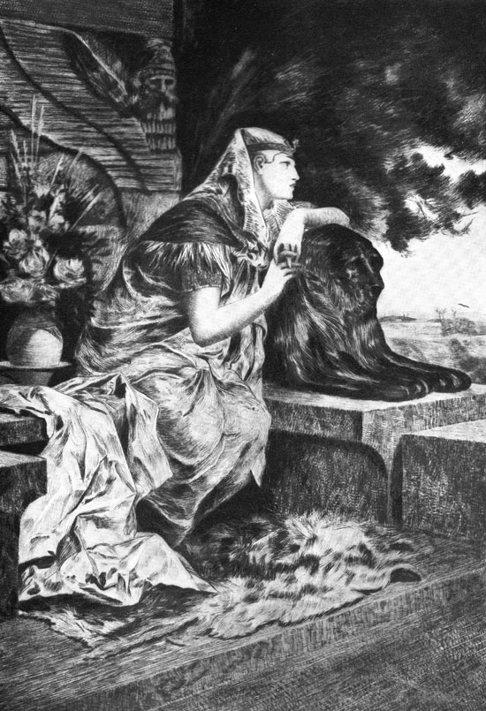

As recorded in previous text Pharaoh's advisers had pleaded with him to let the Israelites go, due to the devastating damage the Lord had brought to their land, but he was too stiff-necked to listen.
Source:Public domain here http://karenswhimsy.com/public-domain-images/ancient-egypt-clothing/images/ancient-egypt-clothing-2.jpg

Faith In Action

Pray
Ask the Holy Spirit to show you where change is coming in your life.

Act
Today I will step out in faith, making whatever change the Lord asks of me, not looking back longingly on what I am leaving but looking ahead to what He has prepared.
Be Specific _____________________________________________

Tuesday (Exodus 12:43 – 13:16)
Participation in the Passover
12:43 The Lord said to Moses and Aaron, “This is the ordinance of the Passover. No foreigner may share in eating it. 12:44 But everyone’s servant who is bought for money, after you have circumcised him, may eat it. 12:45 A foreigner and a hired worker must not eat it. 12:46 It must be eaten in one house; you must not bring any of the meat outside the house, and you must not break a bone of it. 12:47 The whole community of Israel must observe it.
12:48 “When a foreigner lives with you and wants to observe the Passover to the Lord, all his males must be circumcised, and then he may approach and observe it, and he will be like one who is born in the land – but no uncircumcised person may eat of it. 12:49 The same law will apply to the person who is native-born and to the foreigner who lives among you.”
12:50 So all the Israelites did exactly as the Lord commanded Moses and Aaron. 12:51 And on this very day the Lord brought the Israelites out of the land of Egypt by their regiments.

The Law of the Firstborn
13:1 The Lord spoke to Moses: 13:2 “Set apart to me every firstborn male – the first offspring of every womb among the Israelites, whether human or animal; it is mine.”
13:3 Moses said to the people, “Remember this day on which you came out from Egypt, from the place where you were enslaved, for the Lord brought you out of there with a mighty hand – and no bread made with yeast may be eaten. 13:4 On this day, in the month of Abib, you are going out.
13:5 When the Lord brings you to the land of the Canaanites, Hittites, Amorites, Hivites, and Jebusites, which he swore to your fathers to give you, a land flowing with milk and honey, then you will keep this ceremony in this month. 13:6 For seven days you must eat bread made without yeast, and on the seventh day there is to be a festival to the Lord. 13:7 Bread made without yeast must be eaten for seven days; no bread made with yeast shall be seen among you, and you must have no yeast among you within any of your borders.
13:8 You are to tell your son on that day, ‘It is because of what the Lord did for me when I came out of Egypt.’ 13:9 It will be a sign for you on your hand and a memorial on your forehead, so that the law of the Lord may be in your mouth, for with a mighty hand the Lord brought you out of Egypt. 13:10 So you must keep this ordinance at its appointed time from year to year.
13:11 When the Lord brings you into the land of the Canaanites, as he swore to you and to your fathers, and gives it to you, 13:12 then you must give over to the Lord the first offspring of every womb. Every firstling of a beast that you have – the males will be the Lord’s. 13:13 Every firstling of a donkey you must redeem with a lamb, and if you do not redeem it, then you must break its neck. Every firstborn of your sons you must redeem.
13:14
In the future, when your son asks you ‘What is this?’ you are to tell him, ‘With a mighty hand the Lord brought us out from Egypt, from the land of slavery. 13:15 When Pharaoh stubbornly refused to release us, the Lord killed all the firstborn in the land of Egypt, from the firstborn of people to the firstborn of animals. That is why I am sacrificing to the Lord the first male offspring of every womb, but all my firstborn sons I redeem.’ 13:16 It will be for a sign on your hand and for frontlets on your forehead, for with a mighty hand the Lord brought us out of Egypt.”

Prayer
Lord, You set them free, guided them, and protected them – You are a truly loving God.

Scripture In Perspective
God required of the Israelites the firstborn animals as sacrifices of remembrance and the firstborn children as ones dedicated to His service.
God explained that this would be an assurance they they never forgot what He did for them in Egypt.
These rituals were assigned to Israelites and their slaves. Others were allowed to observe or to participate if they were circumcised.
[Note: As with all of the pre-Christ rituals, fulfilled in Him, this dos not apply to Christians - other than as a purely-symbolic volunteer activity. Part of the “My burden is light” message of Jesus was relief from the many Jewish ceremonies and rituals, in addition to the layers of regulations added by the religious leaders, and the crushing burden of impossible works-righteousness under the Law.]

Interact With The Text

Consider
While the Egyptians would not soon forget the God Who tore His people free of their selfish clutches, the Israelites, facing danger and trial, might have more readily forgotten – so the Lord required of them several elements of sacrificial-remembrance.

Discuss
Over a million people traveling together, something rarely seen in the history of the world, what must it have been like to deal with all of the needs?

Reflect
The Lord God made it clear that He would be guiding them to the Promised Land.

Share
When have you been through a time of change and the Lord provided clear guidance to you?

KTALZ
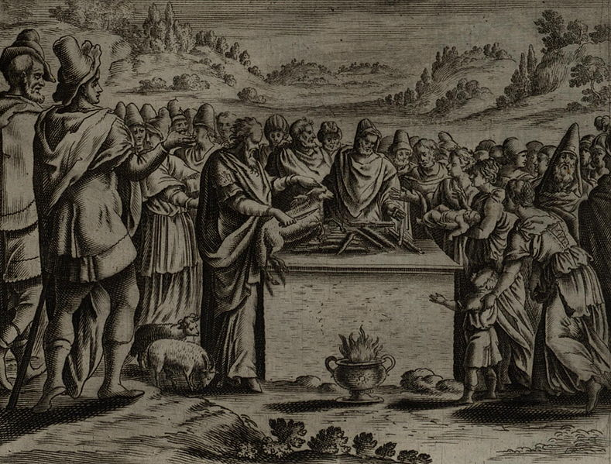

The Passover was a ritual of remembrance, somewhat of a burden, but one designed to keep the Israelites focused on Who was their God and what He had done for them.
Source: Public domain here http://upload.wikimedia.org/wikipedia/commons/thumb/0/00/Jollain_Passover.jpg/789px-Jollain_Passover.jpg

Faith In Action

Pray
Ask the Holy Spirit to show you a path around conflict so that you will not be distracted from the task He has set before you.

Act
Today I will pray and study, and I will ask a fellow Believer to pray in-agreement, that I hear rightly from the Holy Spirit how I might avoid a looming conflict. This is not because I should fear conflict, indeed sometimes it is unavoidable, but this is about avoidable conflict that might distract me from His mission. I will act according to lead of the Holy Spirit and I will share the results with a fellow Believer as an encouragement to them.
Be Specific _________________________________________________

Wednesday (Exodus 13:17-22)
The Leading of God
13:17 When Pharaoh released the people, God did not lead them by the way to the land of the Philistines, although that was nearby, for God said, “Lest the people change their minds and return to Egypt when they experience war.”
13:18 So God brought the people around by the way of the desert to the Red Sea, and the Israelites went up from the land of Egypt prepared for battle.
13:19 Moses took the bones of Joseph with him, for Joseph had made the Israelites solemnly swear, “God will surely attend to you, and you will carry my bones up from this place with you.”
13:20 They journeyed from Sukkoth and camped in Etham, on the edge of the desert.
13:21 Now the Lord was going before them by day in a pillar of cloud to lead them in the way, and by night in a pillar of fire to give them light, so that they could travel day or night.
13:22 He did not remove the pillar of cloud by day nor the pillar of fire by night from before the people.

Prayer
Lord, You know how fickle fallen humankind can be, our bravery turns to cowardice in a moment. May I be attentive to Your directions; what to avoid and how to stand my ground - so that I never retreat or wander from the right path.

Scripture In Perspective
As the people left Egypt - great in number - they left after generations as slaves, they were ill-equipped for a nomadic life nor were they prepared for military conflict, so God directed them away from the land of the battle-hardened Philistines.
God could have easily protected them against the Philistines but He knew that their faith was weak and their hearts fickle and He did not want them retreating to Egypt out of fear.
He took used the extra time of travel to prepare them for a more controlled potential battle, with the decimated-Egyptians, rather than the embedded-Philistines.
Moses kept the word that had been given to Joseph and brought his bones with them. There was no spiritual power in them – it was a matter of integrity and of symbolism of the return home.
God guided this huge populace, over a million people “Now the Lord was going before them by day in a pillar of cloud to lead them in the way, and by night in a pillar of fire to give them light, so that they could travel day or night. He did not remove the pillar of cloud by day nor the pillar of fire by night from before the people.”
He guided them continuously so that they were completely dependent upon His obvious presence.

Interact With The Text

Consider
The Lord God was completely familiar with the nature of the Israelites and guided them accordingly.

Discuss
Had the Israelites been immediately confronted in battle by the Philistines, as they attempted to pass through their lands, how likely is it that they would have fled back to Egypt?

Reflect
Even though the Lord God was constantly present in the cloud and the fire he knew that the moment the Israelites were confronted by force they'd wither – slavery can have that impact. He made it possible for everyone to see Him leading, a “... pillar of cloud by day nor the pillar of fire by night” He kept them from getting lost along the way and allowed them to travel as was best due to the weather.

Share
When have you been guided away from a conflict – and in retrospect you recognized that you were not prepared to deal with it at the time?

KTALZ
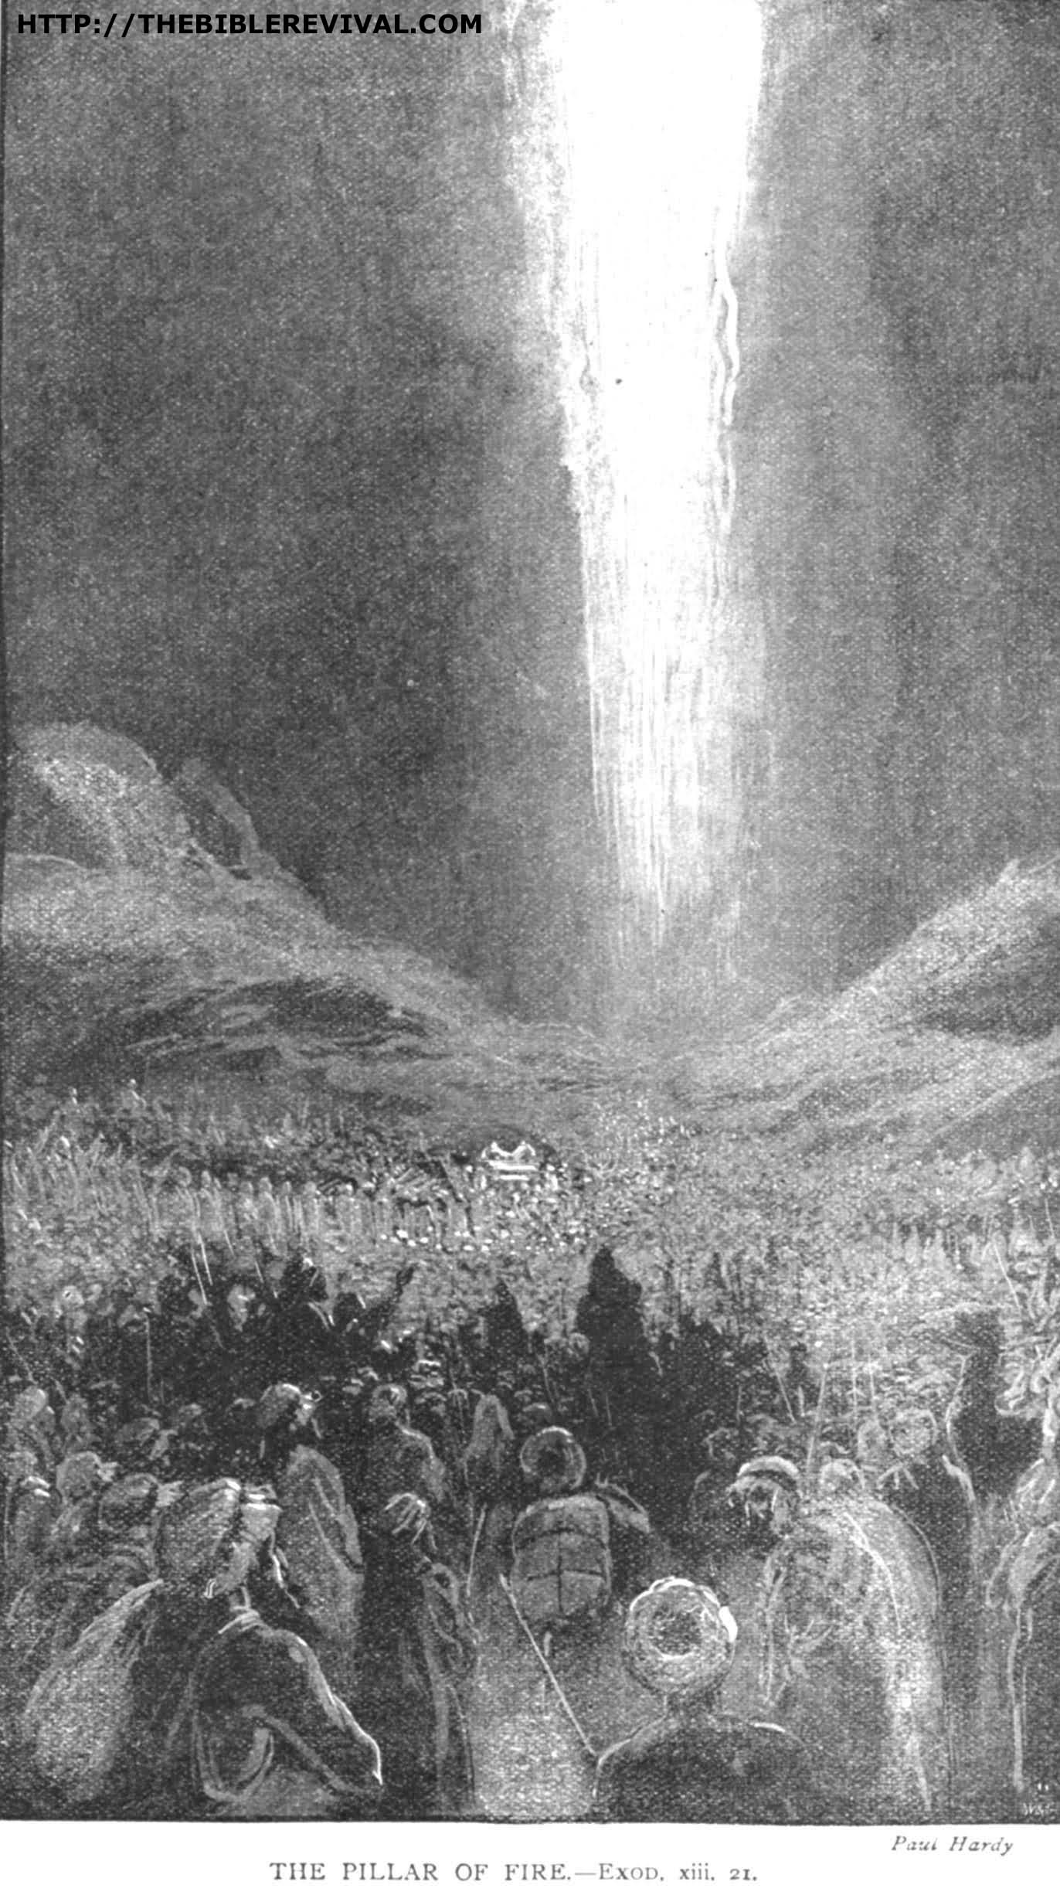

The Lord makes His presence known in special ways when He needs us to pay special attention to His guidance and protection.
Source: Public domain here http://thebiblerevival.com/clipart/exod%208%20-%20the%20pillar%20of%20fire.jpg

Faith In Action

Pray
Ask the Holy Spirit to reveal to you a place in your life where you need to surrender more fully to the Lord God so that He may guide you and prepare you.

Act
I agree to prayerfully listen for the voice of the Lord through His Holy Spirit, engaging where He tells me to engage, and diverting away from engagement where He so directs. When I am uncertain I will ask a fellow Believer to pray in-agreement for clarity, and as-appropriate I will consult one who meets the Biblical definition of an “elder”.
Be Specific ________________________________________________

Thursday (Exodus 14:1-18)
The Victory at the Red Sea – Part 1
14:1 The Lord spoke to Moses: 14:2 “Tell the Israelites that they must turn and camp before Pi-hahiroth, between Migdol and the sea; you are to camp by the sea before Baal Zephon opposite it. 14:3 Pharaoh will think regarding the Israelites, ‘They are wandering around confused in the land – the desert has closed in on them.’ 14:4 I will harden Pharaoh’s heart, and he will chase after them. I will gain honor because of Pharaoh and because of all his army, and the Egyptians will know that I am the Lord.” So this is what they did.
14:5 When it was reported to the king of Egypt that the people had fled, the heart of Pharaoh and his servants was turned against the people, and the king and his servants said, “What in the world have we done? For we have released the people of Israel from serving us!” 14:6 Then he prepared his chariots and took his army with him. 14:7 He took six hundred select chariots, and all the rest of the chariots of Egypt, and officers on all of them.
14:8 But the Lord hardened the heart of Pharaoh king of Egypt, and he chased after the Israelites. Now the Israelites were going out defiantly. 14:9 The Egyptians chased after them, and all the horses and chariots of Pharaoh and his horsemen and his army overtook them camping by the sea, beside Pi-hahiroth, before Baal-Zephon. 14:10 When Pharaoh got closer, the Israelites looked up, and there were the Egyptians marching after them, and they were terrified. The Israelites cried out to the Lord, 14:11 and they said to Moses, “Is it because there are no graves in Egypt that you have taken us away to die in the desert? What in the world have you done to us by bringing us out of Egypt? 14:12 Isn’t this what we told you in Egypt, ‘Leave us alone so that we can serve the Egyptians, because it is better for us to serve the Egyptians than to die in the desert!’”
14:13 Moses said to the people, “Do not fear! Stand firm and see the salvation of the Lord that he will provide for you today; for the Egyptians that you see today you will never, ever see again. 14:14 The Lord will fight for you, and you can be still.”
14:15 The Lord said to Moses, “Why do you cry out to me? Tell the Israelites to move on. 14:16 And as for you, lift up your staff and extend your hand toward the sea and divide it, so that the Israelites may go through the middle of the sea on dry ground. 14:17 And as for me, I am going to harden the hearts of the Egyptians so that they will come after them, that I may be honored because of Pharaoh and his army and his chariots and his horsemen. 14:18 And the Egyptians will know that I am the Lord when I have gained my honor because of Pharaoh, his chariots, and his horsemen.”

Prayer
Lord, You are my Lord and my defender, Who can march against the Lord God and live?

Scripture In Perspective
The Lord instructed Moses to divide the camp into two locations near the Red Sea in order to convince Pharaoh that they were in disarray.
Pharaoh, meanwhile, once-again changed his mind about the Israelites and decided to retrieve them – and he committed not only his most elite chariots but also all of the others – each of them carrying an officer.
The people saw the approach and immediately questioned the wisdom of Moses in taking them from relative safety-in-slavery into an expected slaughter in the desert.
Moses instructed them to stand their ground “The Lord will fight for you, and you can be still.” but the Lord God corrected Moses “Why do you cry out to me?” and He again directed him to tell the Israelites to march to the sea and for him (Moses) to extend his staff over sea, just as he had over the Nile and the land of Egypt (during the plagues) – but this time God would cause the waters of the Red Sea to part and the sea bed to become dry and hard.

Interact With The Text

Consider
Pharaoh seemed to have had a very short memory. Every time he opposed the freedom of the Israelites Egypt suffered terribly.

Discuss
After all of the plagues and the great power God had applied (through Moses), in order to set the Israelites free from Egyptian bondage, why would they immediately doubt Moses the moment that they saw Pharaoh's army?

Reflect
All of the mere humans involved had lots of their own agendas, but God's sovereign plan was to get everyone's attention focused upon Him – in order that they would believe in Him and trust in His anointed leader, Moses.

Share
When have you made it necessary for God to get your attention?

KTALZ
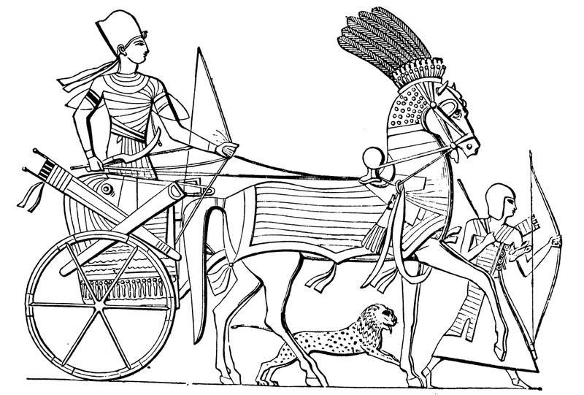

Imagine hundreds of Egyptian battle-chariots bearing-down on the Israelites – a people whom they had intimidated and subjugated for 430 years – little wonder that they were frightened. Their reaction is why God took them the long way around the Philistine territory.
Source: Public domain here http://upload.wikimedia.org/wikipedia/commons/thumb/1/16/Egyptian-Chariot.png/800px-Egyptian-Chariot.png

Faith In Action

Pray
Ask the Holy Spirit to show you how He has protected you against danger and trouble.

Act
Today I will remember what the Lord has done for me and I will celebrate it with at least one fellow Believer.
Be Specific _____________________________________________

Friday (Exodus 14:19-31)
The Victory at the Red Sea – Part 2
14:19 The angel of God, who was going before the camp of Israel, moved and went behind them, and the pillar of cloud moved from before them and stood behind them. 14:20 It came between the Egyptian camp and the Israelite camp; it was a dark cloud and it lit up the night so that one camp did not come near the other the whole night.
14:21 Moses stretched out his hand toward the sea, and the Lord drove the sea apart by a strong east wind all that night, and he made the sea into dry land, and the water was divided.
14:22 So the Israelites went through the middle of the sea on dry ground, the water forming a wall for them on their right and on their left.
14:23 The Egyptians chased them and followed them into the middle of the sea – all the horses of Pharaoh, his chariots, and his horsemen.
14:24 In the morning watch the Lord looked down on the Egyptian army through the pillar of fire and cloud, and he threw the Egyptian army into a panic. 14:25 He jammed the wheels of their chariots so that they had difficulty driving, and the Egyptians said, “Let’s flee from Israel, for the Lord fights for them against Egypt!”
14:26 The Lord said to Moses, “Extend your hand toward the sea, so that the waters may flow back on the Egyptians, on their chariots, and on their horsemen!”
14:27 So Moses extended his hand toward the sea, and the sea returned to its normal state when the sun began to rise. Now the Egyptians were fleeing before it, but the Lord overthrew the Egyptians in the middle of the sea.
14:28 The water returned and covered the chariots and the horsemen and all the army of Pharaoh that was coming after the Israelites into the sea – not so much as one of them survived!
14:29 But the Israelites walked on dry ground in the middle of the sea, the water forming a wall for them on their right and on their left.
14:30 So the Lord saved Israel on that day from the power of the Egyptians, and Israel saw the Egyptians dead on the shore of the sea.
14:31 When Israel saw the great power that the Lord had exercised over the Egyptians, they feared the Lord, and they believed in the Lord and in his servant Moses.

Prayer
Lord, Your have always been consistent, protecting Your people from punishment meant only for their enemies. May I trust You – since You can control the elements, and everything else in Creation, for your sovereign purposes.

Scripture In Perspective
The Lord God blocked the Egyptians from attacking the Israelites throughout the night - He placed the columns of fire and cloud between the Israelites and Egyptians
He then used Moses as His instrument of power, parting the sea and drying the seabed for their ease of travel.
The Lord continued to protect the Israelites as they crossed the dry sea bed.
God again “hardened the heart of Pharaoh”, that is He amplified the already hard and stubborn heart of Pharaoh - so that he would again act rashly - and thus Pharaoh ordered his chariots to charge after the Israelites.
In their arrogance, and despite their past experiences – and the immediate evidence of the power of the Lord on behalf of the Israelites – the Egyptians charged after them.
The Lord God stalled the Egyptian attack, they became disorganized when they finally recognized His presence, the charioteers to panicked and their wheels became stuck, and then he brought the waters down upon them - Pharaoh's entire army of chariots and horses and horsemen were drowned.
[Note: The Israelites were still crossing the God-created pathway through sea; one half remained dry while the other flooded – this could never be a natural occurrence, as some have postulated.]
God's stated purpose was then achieved “When Israel saw the great power that the Lord had exercised over the Egyptians, they feared the Lord, and they believed in the Lord and in his servant Moses.”
The Israelites had complained and grumbled against the Lord and Moses when they felt threatened by their former captors.
He accomplished His multiple goals, protecting the Israelites from the Egyptians, punishing the Egyptians, causing the Israelites to return to a right-recognition of Himself, and to cause the Israelites to recognize Moses as His chosen instrument.

Interact With The Text

Consider
The Lord God could easily have struck the Egyptians dead but He chose another process so as to accomplish more.

Discuss
Watching this from his vantage-point on the high ground of the shore behind his charioteers what might have been going through the mind of Pharaoh?

Reflect
The pattern of this was consistent with most of the plagues - where only the Egyptians were harmed.

Share
When have you been faced with a challenge only to recognize that the Lord God had protected you as He punished those who sought to harm you?

KTALZ
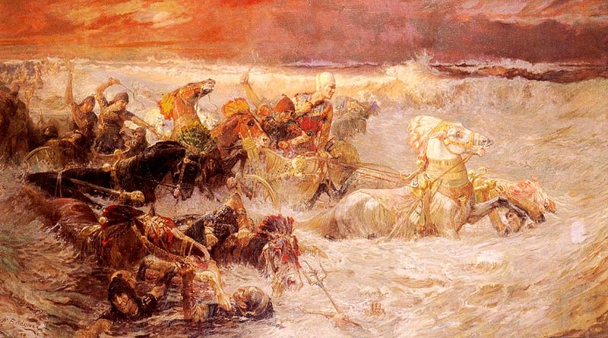

The hard-heart (false gods) and stubborn-selfishness (fallen flesh) of Pharaoh led a double-defeat; first the damage from the plagues, then the destruction of his war chariots and their associated soldiers.
Source: Public domain here https://upload.wikimedia.org/wikipedia/commons/thumb/9/97/Bridgman_Pharaoh%27s_Army_Engulfed_by_the_Red_Sea.jpg

Faith In Action

Pray
Ask the Holy Spirit to reveal to you a place where you are doubting Him, or refusing to be led by His chosen leader, and you may be creating the need for Him to educate you.

Act
I agree to be still so that I may listen to the Holy Spirit, humbly receiving His correction, trusting in Him to be my Guide - teachable by His chosen human leader (while always remaining a good Berean, testing everything against the Word).
Be Specific _____________________________________________

Saturday (Exodus 15:1-21)
The Song of Triumph
15:1 Then Moses and the Israelites sang this song to the Lord. They said, “I will sing to the Lord, for he has triumphed gloriously, the horse and its rider he has thrown into the sea.
15:2 The Lord is my strength and my song, and he has become my salvation. This is my God, and I will praise him, my father’s God, and I will exalt him.
15:3 The Lord is a warrior, the Lord is his name.
15:4 The chariots of Pharaoh and his army he has thrown into the sea, and his chosen officers were drowned in the Red Sea.
15:5 The depths have covered them, they went down to the bottom like a stone.
15:6 Your right hand, O Lord, was majestic in power, your right hand, O Lord, shattered the enemy.
15:7 In the abundance of your majesty you have overthrown those who rise up against you. You sent forth your wrath; it consumed them like stubble.
15:8 By the blast of your nostrils the waters were piled up, the flowing water stood upright like a heap, and the deep waters were solidified in the heart of the sea.
15:9 The enemy said, ‘I will chase, I will overtake, I will divide the spoil; my desire will be satisfied on them. I will draw my sword, my hand will destroy them.’
15:10 But you blew with your breath, and the sea covered them. They sank like lead in the mighty waters.
15:11 Who is like you, O Lord, among the gods? Who is like you? – majestic in holiness, fearful in praises, working wonders?
15:12 You stretched out your right hand, the earth swallowed them.
15:13 By your loyal love you will lead the people whom you have redeemed; you will guide them by your strength to your holy dwelling place.
15:14 The nations will hear and tremble; anguish will seize the inhabitants of Philistia.
15:15 Then the chiefs of Edom will be terrified, trembling will seize the leaders of Moab, and the inhabitants of Canaan will shake.
15:16 Fear and dread will fall on them; by the greatness of your arm they will be as still as stone until your people pass by, O Lord, until the people whom you have bought pass by.
15:17 You will bring them in and plant them in the mountain of your inheritance, in the place you made for your residence, O Lord, the sanctuary, O Lord, that your hands have established.
15:18 The Lord will reign forever and ever!
15:19 For the horses of Pharaoh came with his chariots and his footmen into the sea, and the Lord brought back the waters of the sea on them, but the Israelites walked on dry land in the middle of the sea.”
15:20 Miriam the prophetess, the sister of Aaron, took a hand-drum in her hand, and all the women went out after her with hand-drums and with dances. 15:21 Miriam sang in response to them, “Sing to the Lord, for he has triumphed gloriously; the horse and its rider he has thrown into the sea.”

Prayer
Lord, may we be as excited in our celebration of Your great deeds as were Moses and the Israelites.

Scripture In Perspective
Moses and the Israelites created a song of celebration of God's liberation and protection. Songs were a common means of remembering history.
Their song also looked ahead to God's prophesy of their conquest and occupation of the promised lands currently occupied but other people.

Interact With The Text

Consider
The Israelite method of celebrating and remembering history through the use of songs has also been used in other cultures.

Discuss
How important is the linkage between the remembrance of what God has done and what He has promised to do?

Reflect
Do we take the time to properly celebrate the joy of life in God's hands?

Share
When have your fellowship's leaders called the people to a time of joyful thanksgiving? How did that refresh the hearts of the people?

KTALZ
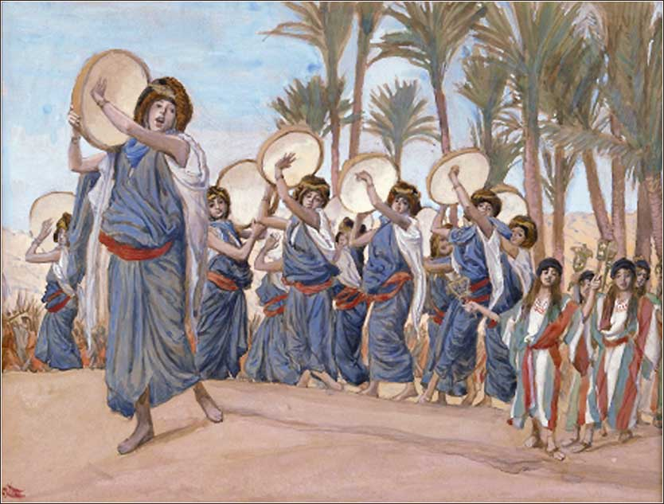

The Israelites took time to celebrate what God had done to liberate them.
Source: Public domain here http://dailyprayer.us/photos820/Tissot_The_Songs_of_Joy.jpg

Faith In Action

Pray
Ask the Holy Spirit to remind you of what He has done in your life and what He is promising to do.

Act
Today I will find time apart from my busyness for prayer and time in the Word. I will be silent before the Lord and will submit to the Holy Spirit as He teaches me. I will be encouraged by remembrances of God's faithfulness and reassured by His promises for my future. I will ask at least one fellow Believer to pray for this special time with the Lord and I will share what I learn.
Be Specific _________________________________________________

All Bible text is from the NET unless otherwise indicated - http://bible.org
Note 1: These Studies often rely upon the guidance of the NET Translators from their associated notes. Careful attention has been given to cite that source where it has been quoted directly or closely paraphrased. Feedback is encouraged where credit has not been sufficiently assigned.
Note 2: When NET text is quoted in commentary and discussion all pronouns referring to God are capitalized, though they are lower-case in the original NET text.
Commentary text is from David M. Colburn, D.Min. unless otherwise noted.
Copyright © 2012-2015 by David M. Colburn. This is BibleSeven Study –“Exodus 12-15:21. Originally prepared by David M. Colburn and edited for bible.org in August of 2012. This text may be used for non-profit educational purposes only, with credit; all other usage requires prior written consent of the author.

