Ephesians 5
David M. Colburn
A Daily Bible Study in 7-Day Sections with a Summary-Commentary, Discussion Questions, and Daily Application

Book Introduction
The Apostle Paul, having reminded his readers of the glory and promise of God, our need for His grace and provision, our new standing before God, as both individuals and as a family of believers, the magnificence of God, a healthy perspective of suffering in the life of a believer, the love, power and provision of God, and His calling to a life of holiness, now described with greater specificity how one could live a life of holiness.
Ephesians Chapter 5 may be subdivided into seven subsections: 5:1-2 which describes what is to follow based on what Paul has just shared in the prior chapter, 5:3-5 where he provides a summary of some concerns, 5:6-14 includes a warning as to negative consequences, 5:15-17 promotes wisdom, 5:18-21 how we are to interact one to another, 5:22-31 Paul uses marriage as an illustration, 5:32-33 he closes with a clarification of the prior section.

Sunday (Ephesians 5:1-2)
Live in Love
5:1 Therefore, be imitators of God as dearly loved children
5:2 and live in love, just as Christ also loved us and gave himself for us, a sacrificial and fragrant offering to God.

Prayer
Lord, Your love transforms. May I be teachable so that You may love others through me.

Summary & Commentary
“Therefore” ... Paul described what was like to follow based on what he had just shared in the prior chapter; because we are called to lives of holiness (see Ephesians chapter 4) we are to “be imitators of God as dearly beloved children”, we are to live (walk) “in love” (out of hearts informed by Christ in us through the Holy Spirit of God).
It is generally easier to talk about theoretical holiness than it is to address the details of what that looks like in daily living. The Apostle Paul had to strike a balance between “legalism” and “license”, the error of his former thought-patterns as a legalistic “pharisee of pharisee’s” versus the devious efforts of the Enemy to constantly lure people back into immorality.
As was typical of Paul he again reminded his readers of their love-debt to Christ for His sacrifice before he brought the hard-Word of the Lord God’s challenge that they live as-Christ, rather than as as-worldly.

Interaction

Consider
The sacrifice of Jesus, and the love-debt we owe Him, motivates us to live a life dedicated to increasing holiness.

Discuss
What is the practical meaning of “... live in love”, as Paul described God’s desire for His children, in your life?

Reflect
The amazing and incredible truth is that the Lord God, through Paul, has said that we are His “dearly loved children”.

Share
When have you, or someone you know, been a successful-imitator of the Lord God (not continually or perfectly)—as expressed through a life that demonstrates an intentionally- sacrificial giving of self—to other believers—in love?

KTALZ
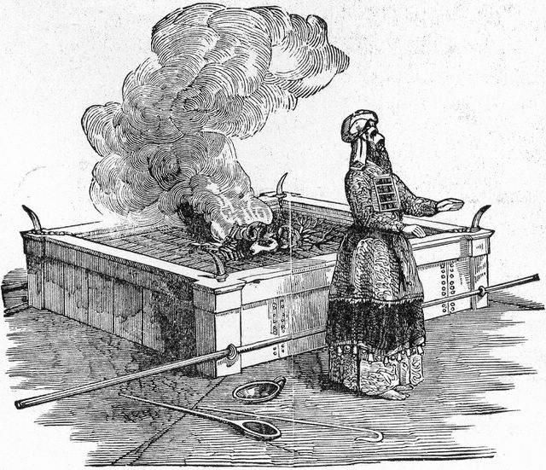

In the old testament God honored sacrifices conducted according to the Law and presented with hearts of repentance. Jesus satisfied the ultimate demand of the Law in order to redeem us.
Source: Public domain here http://www.lavistachurchofchrist.org/Pictures/Treasures%20of%20the%20Bible%20%28Illustrated%20Passages%29/images/scan0014-1.jpg

Faith in Action

Prayer
Ask the Holy Spirit to reveal to you one sin, one obsession, or one act of rebellion which is blocking your progress toward more-holy living.

Action
Today I will confess and repent, seek and accept the Lord God’s forgiveness, and surrender to the Holy Spirit as He leads me toward holiness. I will welcome a fellow believer, whom He may bring to walk alongside me, to minister to me through prayer and encouragement.

Be Specific ______________________________________________________

Monday (Ephesians 5:3-5)
5:3 But among you there must not be either sexual immorality, impurity of any kind, or greed, as these are not fitting for the saints.
5:4 Neither should there be vulgar speech, foolish talk, or coarse jesting—all of which are out of character—but rather thanksgiving.
5:5 For you can be confident of this one thing: that no person who is immoral, impure, or greedy (such a person is an idolater) has any inheritance in the kingdom of Christ and God.

Prayer
Lord, You are holy and You are our model of perfection, the goal of our discipleship. May I keep my eyes on You, rather than doctrines and traditions, expectations and standards, created by mere humans.

Summary & Commentary
The Apostle Paul provided a summary of concerns; “sexual immorality, impurity of any kind, ... greed ... vulgar speech, foolish talk, ... coarse jesting ...”
He reminded his readers that who they were was because of who they had become because of Whose they were. He chose his phrases, contrasting the things of the world with the things of the faithful carefully “not fitting for the saints” and “all of which are out of character”.
As a visiting professor to a seminary once put it, “We are saints, children of God, viewed by God through the filter of Christ as cleansed, clothed in pure white, so we press away those things that would bring a stain.”
Paul provided an alternative mindset to the selfish obsessions of flesh and of the world, for the faithful believer—instead of all of those things “... rather thanksgiving”.

Interaction

Consider
Some of us are more fussy about matters of cleanliness and organization than others. We all have places in our lives where we prefer clean over dirty and order over chaos; it may be in the food we eat, the tools we use, or the clothes we wear. God asks that we be as attentive to “.. the temple of His Holy Spirit” as we are to these other things.

Discuss
Does the perspective that “We are saints, children of God, viewed by God through the filter of Christ as cleansed, clothed in pure white, so we press away those things that would bring a stain.” encourage you to take a stronger stand against sin in your life?

Reflect
There are many places and ways that the Enemy tries to draw us into “sexual immorality, impurity of any kind, ... greed ... vulgar speech, foolish talk, ... coarse jesting ...”

Share
When have you experienced the power of knowing your identity in God’s eyes and that empowered you to resist being drawn into “sexual immorality, impurity of any kind, ... greed ... vulgar speech, foolish talk, ... coarse jesting …”?

KTALZ
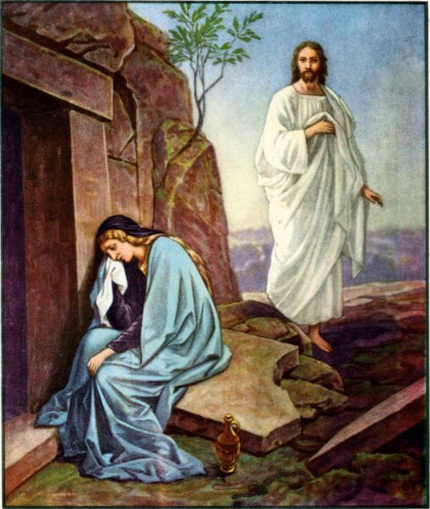

Like Jesus we also will one day be clothed in the white of cleansed-righteousness.
Source: Public domain here http://www.lavistachurchofchrist.org/Pictures/Jesus%27%20Death,%20Resurrection%20and%20Ascention/images/the_resurrection_day.jpg

Faith in Action

Prayer
Ask the Holy Spirit to reveal to you an influence that threatens your purity before the Lord God.

Action
Today I am choosing to have a heart of thanksgiving for the many gifts of the Lord God and I commit to partner with the Holy Spirit for victory in the test – to avoid temptation - and if I've already allowed it to become a temptation, victory in resisting sin and in rolling-back the temptation to a test.

Be Specific ______________________________________________________

Tuesday (Ephesians 5:6-14)
Live in the Light
5:6 Let nobody deceive you with empty words, for because of these things God’s wrath comes on the sons of disobedience.
5:7 Therefore do not be partakers with them,
5:8 for you were at one time darkness, but now you are light in the Lord. Walk as children of the light—
5:9 for the fruit of the light consists in all goodness, righteousness, and truth—
5:10 trying to learn what is pleasing to the Lord.
5:11 Do not participate in the unfruitful deeds of darkness, but rather expose them.
5:12 For the things they do in secret are shameful even to mention.
5:13 But all things being exposed by the light are made evident.
5:14 For everything made evident is light, and for this reason it says:
“Awake, O sleeper!
Rise from the dead, and Christ will shine on you!”

Prayer
Lord, You rescued us from darkness, and You shine Your light in and through us. May I be faithfully-alert to avoid drifting back into darkness and faithful in making myself available to be Your light in this dark and dying world.

Summary & Commentary
Paul offered a clear and chilling warning as to the negative consequences for those who fail to intentionally seek lives of holiness; “... no person who is immoral, impure, or greedy ... has any inheritance in the kingdom of Christ and God.”
His descriptive phrases included “disobedience ... darkness ... unfruitful deeds ... shameful even to mention …”, which described every Ephesian at one moment of their lives or another.
All was not hopeless because their hope was not in their purity but in that of Christ.
Their means to overcome those disqualifying attributes was the post-salvation “first downpayment” gift of the indwelling Holy Spirit.
Their perfected-purity would not come until the threshold of Heaven where they would receive a “new body” .
Paul’s choice of words was intentional “... such a person is an idolater”. An idolater is one who places something in their life in a higher position than God; the prohibition of such was the root of the first rebellion in Heaven, the rebellion in Eden; it was also the first of the Ten Commandments of God “You shall have no Gods before Me” (Exodus 20:3).
He warned the Ephesians to be discerning “Let nobody deceive you with empty words ...”, echoing his plea for discernment in Eph. 4.
Paul, in vs 5:8-10, contrasted all of this with hope “... for you were at one time darkness, but now you are light in the Lord. Walk as children of the light—for the fruit of the light consists in all goodness, righteousness, and truth—trying to learn what is pleasing to the Lord.”
He spoke of a process “trying to learn” rather than an expectation of instant holiness in this fallen world.
Paul also appeared to paraphrase from Isaiah “Awake, O sleeper! Rise from the dead, and Christ will shine on you!” (Isa. 26:19, 51:17, 52:1, 60:1) Note here that we are “dead” IF we are without Christ and that we “Arise” with Him. Paul harkened back to Eph. 4:21 where he qualified his message to the church (believers) as intended for those who were listening but not yet saved “... if indeed you heard about Him [Christ] and were taught in Him [Christ], just as the truth is in Jesus.”

Interaction

Consider
There is an old saying "Be afraid, be very afraid!" Choices have consequences, the most important being our very salvation, all else orbits that one most-meaningful exercise of free will. A truly saved person shows "fruit" of the presence of the Holy Spirit of God and that fruit is multiplied in an intentionally obedient child of God.

Discuss
What are some practical ways to practice the Eph. 5:10 command that we be "... trying to learn"? (The phrase indicates that it will be challenging and that it must be an intentional commitment—we make an investment in partnership with Christ to read His Book, to study His Book for understanding, to share His Book with others, and then to live-intentionally in accountability with others to better assure that our lives reflect His truth.)

Reflect
Once again comes the Lord God's warning to resist temptation (don't fail the test), to avoid drifting back into the old ways (so that you are source of purity), and the encouragement that His Holy Spirit walks with us throughout the process of our journey toward holiness.

Share
When have you, knowing the consequences and the powerful presence of the Holy Spirit within, been successful in passing the test and so that you resisted temptation, or that if already tempted you resisted acting upon it?

KTALZ
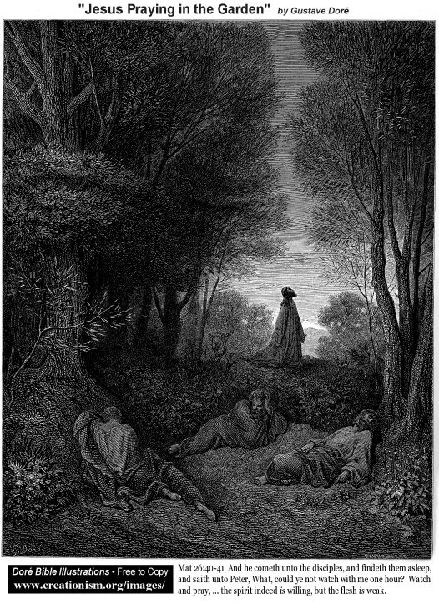

Just as the apostles slept, despite Jesus instructing them to be awake and in prayer, so Paul also instructed the Ephesians (and other readers of his letter) – whom he knew would be less than alert.
Source: Public domain as noted in the image.

Faith in Action

Prayer
Ask the Holy Spirit to reveal to you a specific test, which could become a specific temptation for you, or a specific temptation which threatens to become an act of sin.

Action
Today I am choosing to resist and to partner with the Holy Spirit in discerning and resisting the deceit of the Enemy who tries to drag me down.

Be Specific ______________________________________________________

Wednesday (Ephesians 5:15-17)
Live Wisely
5:15 Therefore be very careful how you live—not as unwise but as wise,
5:16 taking advantage of every opportunity, because the days are evil.
5:17 For this reason do not be foolish, but be wise by understanding what the Lord’s will is.

Prayer
Lord, You do not promise us more than today, and you instruct us to be wise in living according to Your perfect will. May I take the time and make the effort to study and apply Your Word to my life.

Summary & Commentary
The Apostle Paul promoted the importance of wisdom; at that time he would have been cognizant that Proverbs 8:22-31 taught the Ephesians that wisdom existed prior to Creation, it was not a new concept and was sometimes personalized as “she” by Old Testament authors who led their listeners and readers to appreciate the personhood of the Godhead in every attribute.
He confronted the Ephesians with good and bad choices, alternatives and consequences, “... be very careful how you live—not as unwise but as wise ... taking advantage of every opportunity ... do not be foolish, but be wise ...”
Paul explained the importance of good stewardship of time “... for the days are evil.” meaning that one could never reclaim a day that had passed, once used unwisely it had been lost to the best service for God.
He instructed his readers how to “... become wise ...” which is “... by understanding what the Lord’s will is.” This brought-forward what he had previously been discussing about their relationship with God, and with one-another, and it foreshadows the text to follow.

Interaction

Consider
Every morning we awaken with choices to make about the usage of our physical resources and of our time; at the end of every day the wise person will reflect on the quality of their choices in order to improve the next day.

Discuss
How has the leading of the Holy Spirit, Who guides us in the way of wisdom through the Bible and who challenges us to understand what is the will of God, made a difference in your life?

Reflect
Wisdom is bringing the knowledge we have of the Word of God to bear upon our choices. We continually seek greater understanding, as well as partnership with others, for accountability, caring, prayer, and support.

Share
When has Biblical wisdom led you to make a better decision than you typically made prior to your salvation and discipleship?

KTALZ


We use a clock or sundial to track the time, often to organize our days, but a properly-operating time-device never runs in reverse – once passed time may never be recovered.
Source: Public domain here http://www.wpclipart.com/time/sundial.jpg

Faith in Action

Prayer
Ask the Holy Spirit to reveal to you a place in your life where He wants to help you to resist the distractions of the Enemy which are keeping you from your Bible study and application.

Action
Today I commit to set aside time every day for you, Lord God, and I will follow the leading of Your Holy Spirit in removing and resisting the many schemes of the enemy to interfere.

Be Specific ______________________________________________________

Thursday (Ephesians 5:18-21)
5:18 And do not get drunk with wine, which is debauchery, but be filled by the Spirit,
5:19 speaking to one another in psalms, hymns, and spiritual songs, singing and making music in your hearts to the Lord,
5:20 always giving thanks to God the Father for each other in the name of our Lord Jesus Christ,
5:21 and submitting to one another out of reverence for Christ.

Prayer
Lord, You have given us words and music to fill and to guide our hearts with Your love, that we might drown-out the worldly intoxicants of temptation to sin. May I fill my life with Your music and words.

Summary & Commentary
Paul described for the Ephesians how they were to interact with one-another; beginning first with a warning to not “get drunk with wine”. (This was not necessarily exclusively a literal reference to alcohol-caused intoxication but another reminder of clear-thinking and good stewardship.)
He warned them against this “debauchery”. (The modern definition of debauchery refers to “sensual pleasures” but an archaic definition may be more on-target “seduction from duty” the fine art of manipulating one away from duty—the work of the Enemy to draw us away from faithful service to God.)
As always Paul offered a healthier and more God-honoring alternative to that debauchery, “... but be filled by the Spirit”. The context here makes it clear that he was continuing his theme of knowing and obeying God, the text does not indicate that he spoke of so-called 'charismatic gifts’.
Note the text following “... speaking to one another in psalms” which are primarily wisdom literature, “... hymns” which are generally methodologies for memorization with the dual benefit of value in comfort and worship, and “... spiritual songs” (songs that are faithful to the Word of God but not literal repetitions which could easily degrade into the “vain repetitions of the pagans” (Mat. 6:7), or become ritualistic ranting).
Paul then switched mid-sentence from addressing corporate/interpersonal interactions to the heart-preparation of each of the individuals as they approach those interactions “... singing and making music in your hearts to the Lord.” He then added one more heart-condition qualifier “... always giving thanks to God the Father for each other in the name of our Lord Jesus Christ”, again placing God first in authority and humility toward others in the forefront of motivation.

Interaction

Consider
The Lord God prepares us to speak love to one another by us first preparing ourselves "... singing and making music" in our hearts to You "... always giving thanks to God ...” then “... for each other in the name of our Lord Jesus Christ".

Discuss
How easy is it to get caught up in manipulating or being manipulated by the environment of a corporate gathering, be it a charismatic or otherwise-gifted speaker (1 Cor. 1:12-17), a talented dramatic and/or musical performer, a controversial or risk-taking leader or peer, or a cleverly sequenced series of activities, songs, and emotional appeals?

Reflect
When was there a time when you were desperate for relief from a troubling situation such as loneliness, depression, hopelessness, fear, and even boredom, and you looked for a 'magical' solution and you found it—only to later realize that it was not genuine.

Share
When have you experienced genuine worship which began with a thankful surrender to God, followed by placing others before yourself, and concluded in a desire for pure and undistracted worship. (If you cannot do this then you need to reconsider your understanding and practice of corporate, individual, and whole-life Biblical worship.)

KTALZ
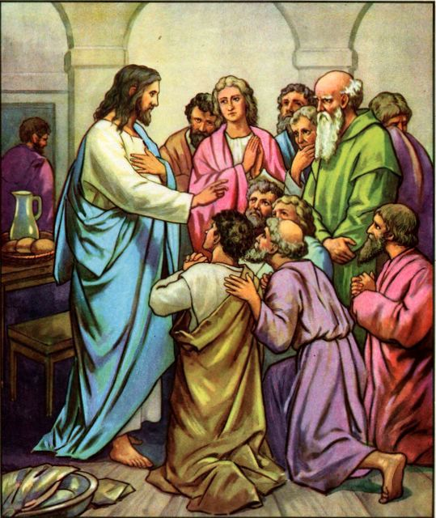

Just as the disciples praised Him when He appeared to them so should we.
Source: Public domain here http://www.lavistachurchofchrist.org/Pictures/Jesus%27%20Death,%20Resurrection%20and%20Ascention/images/jesus_teaching_a_new_commandment.jpg

Faith in Action

Prayer
Ask the Holy Spirit to reveal to you a brother or sister in-Christ for whom it will be difficult for you to pray but for whom He desires that you do so just the same.

Action
Today I am choosing to pray for at least one brother or sister and to also encourage at least one brother or sister by sharing Your Word or a song of praise.

Be Specific ______________________________________________________

Friday (Ephesians 5:22-31)
Exhortations to Households
5:22 Wives, submit to your husbands as to the Lord,
5:23 because the husband is the head of the wife as also Christ is the head of the church—he himself being the savior of the body.
5:24 But as the church submits to Christ, so also wives should submit to their husbands in everything.
5:25 Husbands, love your wives just as Christ loved the church and gave himself for her
5:26 to sanctify her by cleansing her with the washing of the water by the word,
5:27 so that he may present the church to himself as glorious—not having a stain or wrinkle, or any such blemish, but holy and blameless.
5:28 In the same way husbands ought to love their wives as their own bodies. He who loves his wife loves himself.
5:29 For no one has ever hated his own body but he feeds it and takes care of it, just as Christ also does the church,
5:30 for we are members of his body.
5:31 For this reason a man will leave his father and mother and will be joined to his wife, and the two will become one flesh.

Prayer
Lord, You created and blessed, guide and love Your Church (believers) and You sacrificed for it so that You may one day gathering it (all believers) into intimate and eternal relationship with You. May I study what you have done for the Church as I apply and teach what that means to a couple's relationship with one-another in marriage.

Summary & Commentary
Paul used marriage as an illustration; he began with a reminder that Christ is the savior of the body (he taught elsewhere that every part of the body is equally important and valuable) thus competent scholarship does not allow one to read-in a greater value for a male over a female or a husband over a wife. This text is primarily about the responsibilities of the husband—whose role model must be Christ.
Read carefully Paul’s clarification of his primary purpose in Eph. 5:32b “... I am actually speaking with reference to Christ and the church.” He goes on in 5:33 to acknowledge that he has a dual-purpose for the understanding of marriage but the clarification of 5:32b should be a warning to those who attempt to proof-text in the defense of thuggish husbands.
Paul intentionally modified everything in his letter that preceded when he wrote “... --He Himself [Christ] being the savior of the body.”; therefore, when the Ephesians read “Wives submit to your husbands as to the Lord” they were compelled to reflect upon why they had choosen to submit to the Lord. (He was asking for the wife to make an obedient choice, but not an unconditional one, as her husband had obligations as well.) Some translations render the text “your husbands in the Lord”.
In Eph. 5:25-26 he amplified his qualification “Husbands, love your wives just as Christ loved the church and gave Himself for her to sanctify her by cleansing her with the washing of the water by the Word.”
[Note: There are several important elements; “loved” and “gave” are past-tense to emphasize that His work as “the Word” was predicated on His first loving the Church (Believers) and that His work of giving Himself “for her” was finished. This is equivalent to the act of marriage where the husband, motivated by love, gives Himself to his wife—sacrificing his non-married lifestyle (everything related to his pre-marriage relational lifestyle must be surrendered). The wife “is sanctified”, set apart from single women, so that her husband may then be used of God to “cleanse her with the washing of the Word”. A husband serves his wife at the behest of the Lord.]
Eph. 5:27 refined the ultimate purpose of Christ’s investment in the church “... so that He may present the church to Himself as glorious -- not having a stain or wrinkle, or other such blemish, but holy and blameless.” Jesus the Christ was to present The Church to Himself, our Lord God.
[Note: There have been sick men who have mistaken this to mean that their obsession should be the forced-legalistic perfection of their wives. In full-context this is clearly neither within the capacity nor responsibility of the husband -- holiness is less taught than caught, never imposed but always freely-chosen.]
Returning to 5:24 “But as the church [a gathering of Believers] submits to Christ, so also wives should submit to their husbands in everything.”
[Note: We have already learned in the prior text that the husband is an agent of the Lord in his wife’s life, we know that nothing is of value to the Christian that is not of the Lord, therefore “everything” refers to the purpose for which the Lord called the two into marriage and the process of holiness that follows—sanctification—there is nothing in the text about only women washing dishes or wifely-obligations to submit to sinful-orders from a husband in rebellion against the Lord (such a man is spiritually-impotent and an enemy of God).]
Paul promoted the fullest-stewardship of the gifts of the wife, as found in Proverbs 31:10-31, and he would have had that in-mind, together with the esteem of her husband “at the city gates” where the elders provided spiritual guidance to the people.
[Note: In 5:27 the church is a kind of extension of Christ; in 5:28 “In the same way husbands ought to love their wives as their own bodies. He who loves his wife loves himself.” “Loves” is an action word, the action of giving himself for her in the process of holiness that follows her sanctification in marriage.]
5:29a “For no one has ever hated his own body but feeds it and takes care of it ...”, Paul here addressed healthy people—not troubled ones who self-mutilate or who dwell in lies of the Enemy that they are somehow worthless—Jesus died on the Cross as the absolute and unchallengeable-in-all-of-Creation declaration of our value to God. Just as we eat and drink and wash and exercise and clothe and care for our bodies, Christ does this for “the body of Christ” the church (Believers) - the husband is to do the same for his wife.
5:29b “... just as Christ also did for the church, for we are members of His body.” Paul reaffirmed the context of this discussion, we are all (male and female) members of the spiritual body of Christ, therefore we must seek after the same things for one another as He seeks for every member of His body.
Paul concluded by reminding his readers that this teaching was mostly about the duties of the husband and his sacrifice to facilitate the holiness of his wife. “The man will leave ...” and “... be joined to his wife ...” and “... the two will become one flesh.”; linking to the prior text Paul intended that the Ephesians would understand him to mean “... as Christ is joined to His church.”

Interaction

Consider
A Christian woman must never marry a non-Christian man, nor may a Christian man marry a non-Christian woman, such is contrary to the clear teaching of the Bible and is an act of rebellion of which neither should not expect the Lord God's blessing. There is no such thing as dating (the common concept of "dating" is itself fraught with fraud and temptation) or marriage for the purpose of evangelism (sometimes called "missionary dating or missionary marriage). It is even dubious if there is any wisdom in marrying anyone who is not somewhat close to oneself in spiritual maturity.

Discuss
What are some circumstances where some people become Christians after marriage (where they were both previously unsaved) and find themselves in the same conflict as a first century married Jew who was saved (“completed”)? Must they not consult the teaching of the Bible, to neither force the unsaved mate to leave or force them to remain, as the preferred goal is to be such a God-honoring witness that the spouse will also be saved (1 Cor. 7:12-16)?

Reflect
A woman must clearly understand that her decision (when entering into marriage) is to follow the spiritual leadership of her husband, trusting him to be a faithful servant of God. The man must understand that he is making a solemn pledge, before the Lord God, to bless his wife as the Lord's agent in her process toward holiness – leading first by humble example.

Share
When have you been aware of someone making a romantic-decision, based on God's teaching, rather than based on lesser human tradition or on the lust of the flesh? Have you had the opportunity in a counseling/encouraging/mentoring context to encourage someone to slow down, reflect, and to do so?

KTALZ
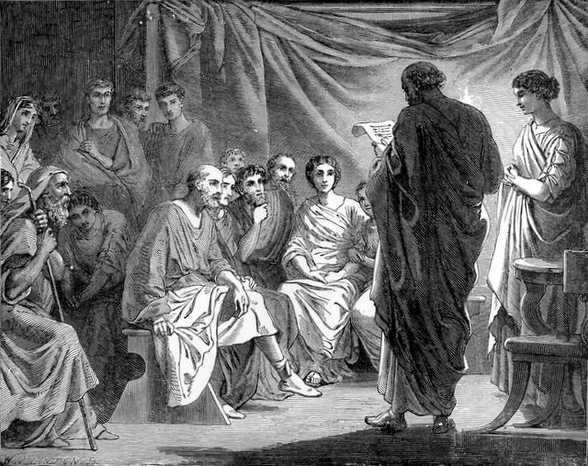

Gathered Believers are “the Church” and as such are to be as-Christ to one-another just as are husband and wife.
Source: Public domain here http://lavistachurchofchrist.org/Pictures/Treasures%20of%20the%20Bible%20%28Church%20Age%29/images/scan0016.jpg

Faith in Action

Prayer
Ask the Holy Spirit to remind you of His love and sacrifice for you as you are part of ("the Church") and that marriage is your opportunity (if married) to emulate Him. Thank the Lord God also for teaching you how to serve on-another in marriage, expressing grace and humility as you build up your mate to God's glory and in God's service.

Action
Today I am choosing to pray for truly-Biblical marriages among Believers. I also pray that, should the Lord lead me to marriage, that I will be fully-faithful to His priorities from the first moment of the process leading to marriage and throughout my marriage. I commit to encourage and to lift up in prayer at least one specific married person right now.

Be Specific ______________________________________________________

Saturday (Ephesians 5:32-33)
5:32 This mystery is great—but I am actually speaking with reference to Christ and the church.
5:33 Nevertheless, each one of you must also love his own wife as he loves himself, and the wife must respect her husband.

Prayer
Lord, You gave Yourself in order to enable Believers "The Church" to become "one flesh" with You. May I invest myself in the same way in my marriage, if I am married; may I pray for all Christian marriages (whether I am married or not); and, may I understand-fully the commitment I am making if I am single and considering marriage.

Summary & Commentary
Paul began this part of his letter to the Ephesians with a clarification of the prior section, using the phrase “This mystery ...”, because he was teaching them—using the illustration of human marriage—about the relationship between Christ and His Church (all Believers).
The way that man and woman become “one flesh” was to be understood as the way that the Lord God was creating a one-flesh relationship with His “bride, The Church.
[Note: The term mystery generally refers to something that occurs in the unseen spiritual, rather in than the visible realm, yet it also may refer to something that is difficult to comprehend.]
Paul’s term “is great” acknowledged that humans will have to expend some time in prayerful study if they are to comprehend and honor it.
He made certain that he was not misunderstood, reemphasizing his primary purpose in Eph. 5:32b “... I am actually speaking with reference to Christ and the church.” As already stated earlier Paul emphasized in 5:33 the acknowledgment that he had a dual-purpose for his perspective on marriage, but he offered the clarification of 5:32b as a warning to those who might attempt to proof-text his words in the defense of thuggish husbands.
Paul’s theme was that it was time for married Christians to step-up. Marriage was (and is) an act of sanctification—agreeing to be set apart for a special partnership in the process of holiness. Marriage is not for everyone because, as Paul remarks elsewhere, many practical aspects of marriage (and raising children) represent a distraction from the things of the Lord - and they provided a pressure-point for the Enemy to extort cooperation.
Those who are contemplating marriage need to better understand the nature of Biblical marriage before they enter into courtship. This is one of many gross failures of church leaders for 2,000+ years and the evidence of that failure is in the broken homes all around us.
[Note: This Web under-renovation site contains excerpts from a doctorate thesis which documents these practical matters http://bibleseven.com/thesis.html ]
Paul's last word to the Ephesians “... each one of you must also love his own wife as he loves himself, and the wife must respect her husband.” bears careful contextual reflection. Paul was speaking to Believers, not unbelievers; obedient Believers, not Believers in rebellion (the definition of rebellion requiring discipline is addressed elsewhere but would include volitional and unrepentant sin both physical and theological). He addressed the critical need for church discipline—and he was not addressing spiritually-divided households.
[Note: Paul was always precise in defining his audience and we know from the first chapter of Ephesians that he was addressing Believers. Were he to have changed audiences to address divided households, or unbelievers, in chapter 5 he would have stated such clearly.)

Interaction

Consider
The Lord God's challenge is that married Christians need to step-up to a standard of sacrificial-investment in one-another equal to that of His sacrificial investment in His Church.

Discuss
What are some ways that every Christian may support the "holy estate" of marriage? How might we do a better job of teaching this to children, youth, young adults and adult singles?

Reflect
The Lord God has sanctified the value of marriage and provided a stern warning that marriage is not something into which a Christian should enter lightly.

Share
When have you observed a couple, both believers who desired to intentionally honor God in their marriage, demonstrate the fruits of their faith-walk in the way that they encouraged and served one-another?

KTALZ
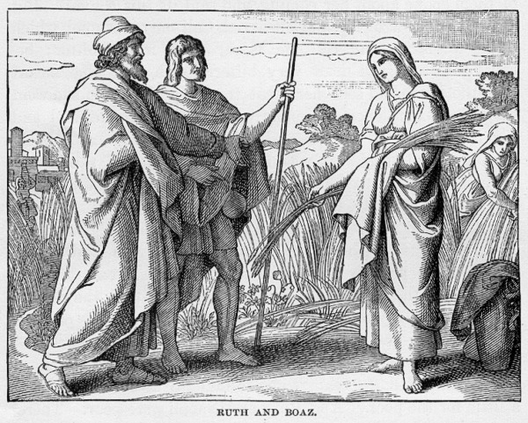

Just as Ruth and Boaz had to meet certain standards prior to marriage they also loved God first and loved, honored, respected, and served one-another.
Source: Public domain here http://www.coolnotions.com/PDImages/StoryOTB089_p223_RuthAndBoaz.jpg

Faith in Action

Prayer
Ask the Holy Spirit to reveal to you at least one person who may benefit from this teaching.

Action
Today I am choosing to pray that marriage will be seen through Your eyes rather than the silly and shallow eyes of the secular entertainment world, and I will pray for the health and protection of a specific marriage; if married I will add my own to those prayers.

Be Specific ______________________________________________________
All Bible text is from the NET unless otherwise indicated—http://bible.org
Note 1: These Studies often rely upon the guidance of the NET Translators from their associated notes. Careful attention has been given to cite that source where it has been quoted directly or closely paraphrased. Feedback is encouraged where credit has not been sufficiently assigned.
Note 2: When NET text is quoted in commentary and discussion all pronouns referring to God are capitalized, though they are lower-case in the original NET text.
Commentary text is from David M. Colburn, D.Min. unless otherwise noted.
Copyright © 2011-2014 by David M. Colburn. This is a BibleSeven Study—in the series, “Ephesians”—prepared by David M. Colburn and edited for bible.org in 2014. This text may be used for non-profit educational purposes only, with credit; all other usage requires prior written consent of the author.

