Ephesians 3
David M. Colburn
A Daily Bible Study in 7-Day Sections with a Summary-Commentary, Discussion Questions, and Daily Application

Chapter Introduction

Context from Ephesians 1 and 2
The Apostle Paul reminded his readers of the glory and promise of God, our need for His grace and provision, and our new standing before God, as both individuals and as a family of believers.

Overview of Ephesians 3
Paul revisited the magnificence of God, the plan for Christ to create a Church of all believers, that the fruits of grace are to be shared, that discouragement due to suffering may be evidence of doubts about God’s sovereignty, that faithfulness in suffering may be strong evidence of true salvation, and that we need to be in constant awe of the love and power and provision of God.

Sunday (Ephesians 3:1-4)
Paul’s Relationship to the Divine Mystery
3:1 For this reason I, Paul, the prisoner of Christ Jesus for the sake of you Gentiles—
3:2 if indeed you have heard of the stewardship of God’s grace that was given to me for you,
3:3 that by revelation the divine secret was made known to me, as I wrote before briefly.
3:4 When reading this, you will be able to understand my insight into this secret of Christ.

Prayer
Lord, Your revelation through Paul announced Your fulfillment of Your consistent promise to Adam and Eve, Abraham, and Moses. May I be faithful to tell others.

Summary & Commentary
Paul reminded his readers that he was a prisoner because of his obedience in telling them the good news of Jesus Christ.
Paul’s revelation was that who you were is no longer who you are “in Christ”.”
He reminded his readers that his insight was a result of God’s calling and equipping—so that there was no confusion with the false teachers whose claim was to be wise in and of themselves.
Paul also wanted to be sure that his readers understood that unless they were “in Christ”, saved plus the indwelling Holy Spirit of God, they would be unable to understand his message.
God forgives every sin that we (Christians) confess, and for which we are truly repentant (desire to turn away from), and He sets us free from judgment for that/those sins; God makes us new every morning.

Interaction

Consider
The Lord God called and equipped Paul, once a “Jew of Jews”, a Pharisee who had no time for Gentiles and who attacked Christians, to be His emissary to Gentile-Christians.

Discuss
Why might a non-Christian have trouble understanding what Paul was teaching? Why was it important for Paul to remind the Gentile believers of the source of his authority versus that of some other preacher-teachers who had not been sent by God?

Reflect
The meaning of “Who you were is no longer who you are in-Christ” is important.

Share
When were you unable to comprehend a Biblical teaching prior to your salvation, but once indwelt by the Holy Spirit of God, you could understand?

KTALZ


Paul willingly suffered abuse, imprisonment, and eventually death so that he could be God's instrument to bring the good news of salvation to the Gentiles.
Source: Public domain here http://en.wikipedia.org/wiki/Rembrandt

Faith in Action

Prayer
Ask the Holy Spirit to show you something new in the Bible to both equip and mature you and to remind you of His power to transform.

Action
Today I will thank the Lord God that He forgives every sin that we confess, and for which we are truly repentant (desire to turn away from), and that He sets us free from judgment for that sin (makes us new every morning).

Be Specific ______________________________________________________

Monday (Ephesians 3:5-6)
3:5 Now this secret was not disclosed to people in former generations as it has now been revealed to his holy apostles and prophets by the Spirit,
3:6 namely, that through the gospel the Gentiles are fellow heirs, fellow members of the body, and fellow partakers of the promise in Christ Jesus.

Prayer
Lord, You had a perfect plan from the beginning, and in Your perfect timing—following the work of Jesus the Christ on the Cross and Resurrection—You made it known through Your chosen spokesmen. May I worship Your perfection and share Your story.

Summary & Commentary
There was little point to revealing this “secret” until after the Gospel had been actualized through the events of the Cross and the Resurrection.
The Lord God’s timing was perfect as the Romans had created an exceptional system for travel which equipped His messengers to spread the Word quickly and effectively—before the enemies of truth could prevent it.
When Jesus was crucified the veil between man and God was torn away forever and with the resurrection of Christ all who accept His Lordship, and reject everything that is not of Him, are welcomed into His eternal family regardless of gender, race, or social status. (Galatians 3:28)
Recalling our discussion of Ephesians 1; the New Testament chronology tells us that Ephesians is preceded chronologically by Matthew, Mark, Luke, John, Acts, James, Galatians, Thessalonians, Corinthians, Romans, Philemon, and Colossians. Thus the members of the church (Believers) at Ephesus would have been taught this concept.
(Note: There are 24 cross references to this same concept from those Letters/Books http://net.bible.org/verse.php?book=Gal&chapter=3&verse=28&tab=commentaries )

Interaction

Consider
The Lord God abolished all of the worldly castes and classes, artificial social hierarchies, and racial distinctions. All are equal in His family.

Discuss
What are some of the reason(s) why we must surrender our claims to everything in this fallen world, including our free will, in order to truly be saved?

Reflect
“... the veil between man and God was torn away forever.” Craig Keener writes “An Ethiopian “eunuch” in the OT turns out to be one of Jeremiah’s few allies and saves his life (Jer. 38:7-13). This African court official was the first non-Jewish Christian.” http://www.craigkeener.com/philip-preaches-to-the-ethiopian-eunuch-in-acts-826-27/

Share
When have you experienced or observed the way that an absence of artificial man-made walls, separating people into unequal sub-groups, impacted witnessing for Christ and/or encouraging fellow believers?

KTALZ
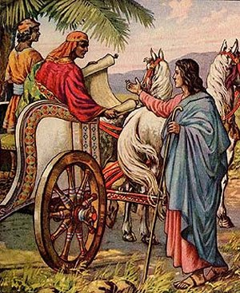

In the old testament an Ethiopian eunuch befriended and saved Jeremiah. In the new testament is it believed that the first Gentile, non-Jewish, Believer was also an Ethiopian eunuch. God's reward and another reminder that He is no respecter of mere human labels?
Source: Public domain here http://breadsite.org/

Faith in Action

Prayer
Ask the Holy Spirit to reveal to you someone “considering Christ”, and/or a fellow believer who has not been well-discipled, with whom He desires you to share His revealed secret.

Action
Today I will share these truths with someone "considering Christ", and/or with a fellow believer, who would be blessed and encouraged to recognize and live in the freedom-from-man-made-walls that comes from being a member of the family of God.

Be Specific ______________________________________________________

Tuesday (Ephesians 3:7–9)
3:7 I became a servant of this gospel according to the gift of God’s grace that was given to me by the exercise of his power.
3:8 To me—less than the least of all the saints—this grace was given, to proclaim to the Gentiles the unfathomable riches of Christ
3:9 and to enlighten everyone about God’s secret plan—a secret that has been hidden for ages in God who has created all things.

Prayer
Lord, You made salvation possible, and You have caused Your Gospel to be known far and wide. May I be faithful in gratefulness and bold in sharing Your story.

Summary & Commentary
The power of the Lord God was in His provision of salvation through Jesus the Christ.
The Lord God called Paul by appearing to him, challenging him “Why do you persecute me?” (to which Paul responded “Lord?” - indicating a teachable heart), accepted his repentance and submission, then empowered him by bringing others alongside to disciple him in order that Paul might effectively challenge the religious elite (as a former peer).
Paul became a “... servant of this gospel” because of the Lord God's calling and empowering and his right-response to tell others.
Paul wrote much of the New Testament so that we might better know God and what He asks of us.
Paul reminded his readers again that God’s saving grace is for all, regardless of gender, race, or social status.

Interaction

Consider
Paul, despite his history, was teachable in spirit and willing to go and to do whatever the Lord God asked, no matter the cost. He could have been like other Pharisees and rejected God in favor of their idolatry of position and tradition.

Discuss
What are some of the things that you have learned about the Lord God, and what He expects of you, as a result of reading the writings of Paul?

Reflect
Those whom God called to serve alongside of Paul, and those whom God calls today, have been used to faithfully teach His truths to generation after generation of new believers.

Share
When have you experienced a faithful teacher, rightly teaching the unchanging Word of God, helping you to grow in the knowledge of God and in your maturing personal walk with Him?

KTALZ
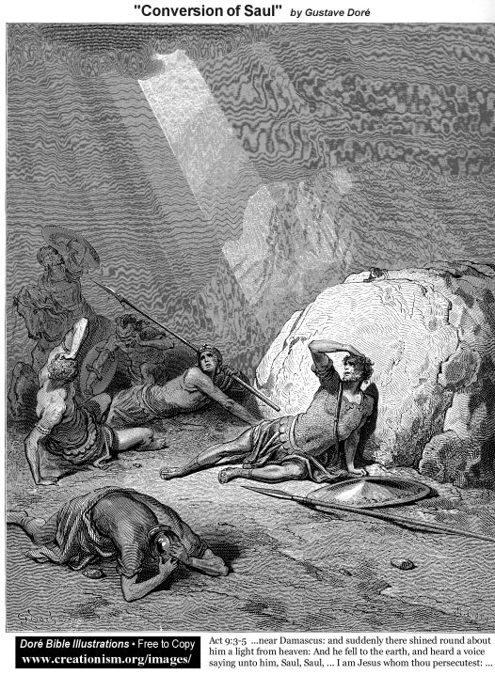

Paul because a useful instrument of God in outreach to the Gentiles because he chose to be willing and made himself available – he's our role model.
Source: Public domain as stated in the image.

Faith in Action

Prayer
Ask the Holy Spirit to remind you of a faithful teacher of His Word for whom He wants you to pray.

Action
Today I will thank the Lord God for empowering Paul to challenge the religious elite and to write so much of the New Testament that we might better know Him and what He asks of us.

Be Specific ______________________________________________________

Wednesday (Ephesians 10–12)
3:10 The purpose of this enlightenment is that through the church the multifaceted wisdom of God should now be disclosed to the rulers and the authorities in the heavenly realms.
3:11 This was according to the eternal purpose that he accomplished in Christ Jesus our Lord, 3:12 in whom we have boldness and confident access to God because of Christ’s faithfulness.

Prayer
Lord, You have allowed angels, demons, and humankind alike to make choices and to choose sides, and over history You promised a redeemer—while You kept the details to Yourself. As I learn from the apostles the Gospel story, and am enlightened, may I unselfishly share Your story with others.

Summary & Commentary
Angels and demons alike were made aware of the complete meaning and purpose of the Gospel, and especially the role of The Church (the assembly of believers, physical and/or spiritual, as an eternal family), in the great plan of the Lord God’s redemption of humankind.
Through the work of Christ we may approach the Creator and all-powerful God of everything with the confidence of a dearly loved child – knowing that we will receive all of the needed affection and provision and training from the most-perfect One.

Interaction

Consider
“The Church”, the body of believers, “has become the revelation of the plan of redemption from the Lord God.

Discuss
How has the “enlightenment” of the Lord God, through His Bible, His Holy Spirit, and those whom He has sent to teach you, increased your maturity and your relationship with Him?

Reflect
How incredible is the love of the Lord God that we may approach Him with “... boldness and confident access”.

Share
When have you have approached the Lord God with “... boldness and confident access” and He has responded to you with comfort, encouragement, enlightenment, equipping, and/or healing?

KTALZ
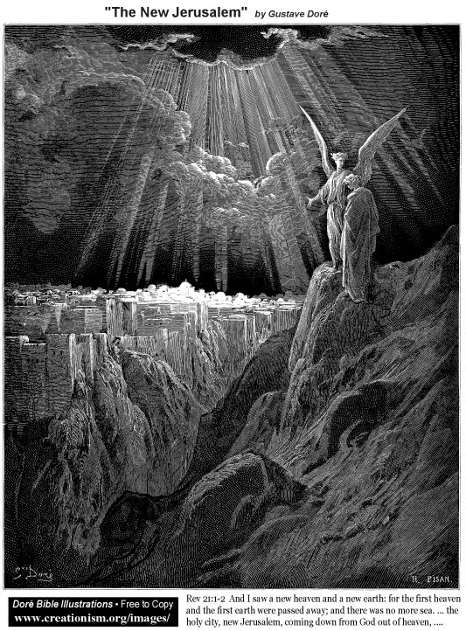

Today the term “heavenly realms” includes all of the spiritual beings, good and evil, but after the “Great White Throne Judgment” Heaven will never again host a thought, let alone a visit, from anything impure.
Source: Public domain as defined in the image.

Faith in Action

Prayer
Ask the Holy Spirit to reveal to you a place in your life where you have not been bringing a challenge to the Lord, rather attempting to solve it in your own fleshy strength.

Action
Today I will approach the Creator and all-powerful God of everything with the confidence of a dearly loved child in order to receive all of the needed affection and comfort and provision and training and wisdom from the most-perfect One.

Be Specific ______________________________________________________

Thursday (Ephesians 3:13)
3:13 For this reason I ask you not to lose heart because of what I am suffering for you, which is your glory.

Prayer
Lord, You allowed Paul to demonstrate the depth of commitment that You ask of a true follower, just as You asked Your prophets of the OT to sometimes suffer to make a point. May I be a willing instrument, even when it is inconvenient, and even when it hurts.

Summary & Commentary
Because the Lord God has chosen to use the Church (Believers) as His instrument of redemption in the world, we are not to “lose heart”.
No matter what happens in our time here in this fallen and foreign world God is our sufficiency, He is our comfort, He is our purpose, and He is never far from us. We must never lose hope!
Paul wanted them to understand that his suffering triggered two events in the lives of his readers; the first was that once he brought them the Word of salvation— he prayed that they would trust it - therefore resulting in the glory of their salvation; the second, that they would remain strong “not to lose heart”, and thereby their faith and trust in the Lord God’s greater purpose would serve as both an evidence of their salvation and as an evidence of them “working out their salvation” in an intentionally “ultrafidian” (beyond faith) manner; itself also an expression of their “glory”—a beauty because of Him and reflected back to Him.

Interaction

Consider
The Lord God provided the voluntary sacrifice of Christ which served as a model for that of the apostles.

Discuss
What does “... our time here in this fallen and foreign world” mean to you?

Reflect
The powerful truth is that the Lord God is our sufficiency, He is our comfort, He is our purpose, and He is never far from us.

Share
When have you experienced, in a certain circumstance, that trusting the Lord God brought you hope when all of the worldly evidence suggested that you were without hope?

KTALZ

Just as Paul had caused Believers to suffer for their faith he now suffered to bring the Good News to the Gentiles.
Source: Public domain here http://en.wikipedia.org/wiki/Rembrandt

Faith in Action

Prayer
Ask the Holy Spirit to remind you in His own special way that no matter what happens in our time here in this fallen and foreign world He is our sufficiency, He is our comfort, He is our purpose, and He is never far from us.

Action
Today I will thank the Lord God and I will share that Biblical perspective with a fellow believer whom I believe will be blessed by that Word of encouragement.

Be Specific ______________________________________________________

Friday (Ephesians 3:14-19)
Prayer for Strengthened Love
3:14 For this reason I kneel before the Father,
3:15 from whom every family in heaven and on the earth is named.
3:16 I pray that according to the wealth of his glory he may grant you to be strengthened with power through his Spirit in the inner person,
3:17 that Christ may dwell in your hearts through faith, so that, because you have been rooted and grounded in love,
3:18 you may be able to comprehend with all the saints what is the breadth and length and height and depth,
3:19 and thus to know the love of Christ that surpasses knowledge, so that you may be filled up to all the fullness of God.

Prayer
Lord, You made it possible for me to be in Your eternal family, and You then fill me with Christ so that I may mature in-You. May I seek Your wisdom, surrender to Your Lordship, and be available as Your instrument.

Summary & Commentary
“For this reason I kneel”
[“this reason” referred to salvation and their continued maturity] before the Father [We are called “the children of the Father”]
“from whom every family ... is named”
[historically, naming implied ownership, or at least a position of superiority. In the early Genesis account Adam named the animals over whom God gave him dominion.]
“according to the wealth of His glory He may grant”
[God’s glory is endless. God chooses to give from His resources, none may compel Him.]
“be strengthened”
[We acknowledge our weakness and then we set aside our pride and allow God to be our strength.]
“Christ may dwell in your hearts through faith”
[Christ “dwells” in a rhetorical sense through our attitudes, and God is more literally represented in us via his indwelling Holy Spirit. Faith is the means through which we trust the truth of Christ, follow the leading of the Holy Spirit, and go beyond the essentials of salvation into “ultrafidian” beyond-faith surrender and service.]
“rooted and grounded in love ... able to comprehend ... the love of Christ”
[A tree draws nutrition from and is strengthened against uprooting in storms by it’s roots, so it should be for us through the love of Christ. He also gives to we selfish and stubborn people the capacity to comprehend His unique love.]
“be filled up to all the fullness of God”
[It is God’s desire that we be filled to overflowing so that the overflow may bless others.]

Interaction

Consider
Incredible is the gift that we are claimed by the Lord God as His eternal-children.

Discuss
What are some of the blessings that the Lord God pours out to His children, and through them, overflowing to others?

Reflect
What is the impact of being “... rooted and grounded in ... the love of Christ”?

Share
When have you experienced the Lord God causing an overflow of His love in you so that you could then share the overflow with others?

KTALZ
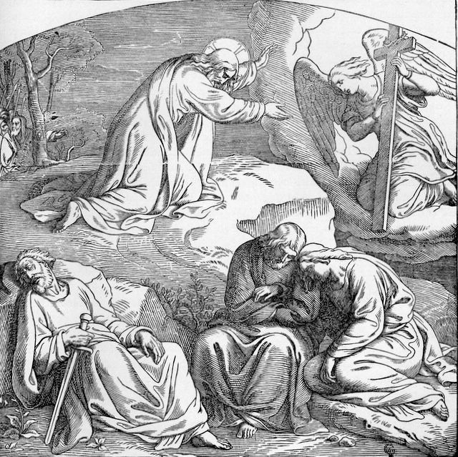

Just as Jesus prayed earnestly yet His disciples slept Paul imitated Him in prayer even as many new Believers also lacked the discipline to earnestly-pray.
Source: Public domain here http://www.lavistachurchofchrist.org/Pictures/Treasures%20of%20the%20Bible%20%28Jesus%27%20Death,%20Burial,%20Resurrection,%20and%20Ascension%29/images/scan0001.jpg

Faith in Action

Prayer
Ask the Holy Spirit to remind you several times this day to reread and to reflect upon the prayer of Paul.

Action
Today, as I read and reflect upon this prayer of Paul I will thank the Lord God for placing it upon his heart and for pouring it out through his letter to the Ephesians and others.

Be Specific ______________________________________________________

Saturday (Ephesians 3:20-21)
3:20 Now to him who by the power that is working within us is able to do far beyond all that we ask or think,
3:21 to him be the glory in the church and in Christ Jesus to all generations, forever and ever. Amen.

Prayer
Lord, You are the power for change - for good, and You have chosen to work through Your children—The Church. May I be available and engaged as You disciple and equip me to be one of Your instruments of reconciliation to humankind in the world.

Summary & Commentary
The power of Him that is working in us is both our faith, which He is growing, and is the Holy Spirit—through Whom He is growing it.
The Lord God is without-limit, something that we finite humans are cannot fully comprehend.
Paul challenged the Ephesian believers, and Believers everywhere, to be honest in their prayers to the Lord God—because He is able “...to do far beyond all that we ask or think”
The phrase “... in the church” refers to the Believers—which is the only place on earth that the Lord God chooses to display His glory and through whom His glory is reflected—”... the church” existed before buildings and denominations and programs and it continues to exist apart from those things.
“... in Christ Jesus the glory of God is displayed generation after generation and forever.

Interaction

Consider
A familial relationship with the God of endless power and timeless existence is hard, yet exciting, to imagine.

Discuss
What are some ways that we may partner with the Lord God in-faith to be conduits of His glory to others?

Reflect
Celebrate the Lord God’s reassurance, through Paul, that we need hold nothing back as He can and will do far more than “... all that we ask or think” (keeping in mind that it's about what He says is important, not the world).

Share
When have you experienced and/or observed the Lord God going far beyond your prayer-request(s) of Him?

KTALZ
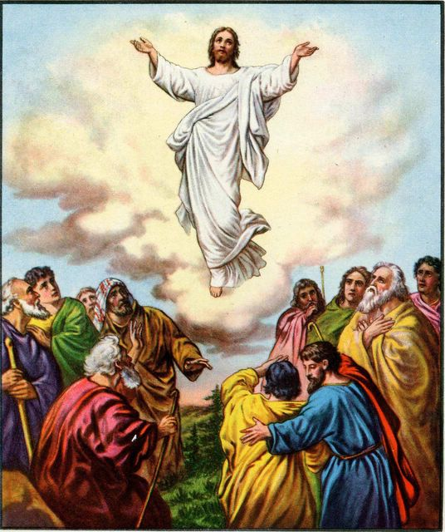

Jesus' glory was returned to Him as He ascended back home to Heaven. We honor His glory through our obedient service here.
Source: Public domain here http://www.lavistachurchofchrist.org/Pictures/Jesus%27%20Death,%20Resurrection%20and%20Ascention/images/jesus_returns_to_the_father.jpg

Faith in Action

Prayer
Ask the Holy Spirit to remind you to read Paul's prayer several times today.

Action
Today I will say Amen & Amen! To Paul's prayer and I will share it with a fellow believer and together will celebrate the Lord God's loving-perfection.

Be Specific ______________________________________________________
All Bible text is from the NET unless otherwise indicated—http://bible.org
Note 1: These Studies often rely upon the guidance of the NET Translators from their associated notes. Careful attention has been given to cite that source where it has been quoted directly or closely paraphrased. Feedback is encouraged where credit has not been sufficiently assigned.
Note 2: When NET text is quoted in commentary and discussion all pronouns referring to God are capitalized, though they are lower-case in the original NET text.
Commentary text is from David M. Colburn, D.Min. unless otherwise noted.
Copyright © 2011 by David M. Colburn. This is a BibleSeven Study—in the series, “Ephesians”—prepared by David M. Colburn and edited for bible.org in October of 2011. This text may be used for non-profit educational purposes only, with credit; all other usage requires prior written consent of the author.

