Ephesians 2
David M. Colburn
A Daily Bible Study in 7-Day Sections with a Summary-Commentary, Discussion Questions, and Daily Application

Chapter Introduction
The Apostle Paul, having reminded his readers of the glory and promises of God, as well as our need for His grace and provision, moves on to our new standing before God, both as individuals and, corporately, as a family of Believers.
When the daily challenges of life confront us, our fleshy nature tends to move us to anger or depression in response to fear.
In books and movies like Harry Potter, young people turn to witchcraft for magical powers. In the crass movie Wanted a young man, trapped in what he sees as a dead-end job as an “account manager” under the tyrannical supervision of an arbitrary and demanding boss, invents a persona of rebellion and re-creates the story of his life. In his fantasy he is the heir to the “magical” powers of his murdered father, is recruited by an organization supposedly directed by fate to execute bad people, is befriended by a beautiful and deadly woman, endures severe injuries as part of his training, is “magically” cured, and goes on to be the hero of the story. He then returns to his job, where he righteously exacts revenge on all who “deserve it.”
Which of us has not dreamed of such glorious “get-evens”? Of what are we afraid: Failure, pain, insignificance? In what or whom shall we trust: Government, magic, money, power, or the one true Lord God of the Bible?
In Wanted a gang of mercenaries is presented as a family with a home that looked like a castle. Each had power, privilege, and purpose. They were never alone, backed up one another, were provided with the best of everything, and acted in ways designed to change the world.
Are we not who we are as a result of Whose we are? Do we not therefore have exceptional power, privilege, and purpose? And are we ever really alone? Do we back up one another? Are we provided with what we truly need? Do we act in ways that change our world?

Sunday (Ephesians 2:1-3)
New Life Individually
2:1 And although you were dead in your transgressions and sins,
2:2 in which you formerly lived according to this world’s present path, according to the ruler of the kingdom of the air, the ruler of the spirit that is now energizing the sons of disobedience,
2:3 among whom all of us also formerly lived out our lives in the cravings of our flesh, indulging the desires of the flesh and the mind, and were by nature children of wrath even as the rest…

Prayer
Lord, You have offered us rescue from destruction, because the Enemy's deception constantly leads humankind into sin. May I be careful to test every influence to be certain that it is of-You and not of-the Enemy.

Summary & Commentary
Who we were is no longer who we are “in Christ”.
Paul began by setting up the context “... you were dead in your transgressions and sins ...”, then he paused a moment to let that sink in.
Paul continued with a checklist of their circumstances:
1. “... in which you formally [or previously] lived ...”
2. “... according to this world’s present path ...”
3. “... according to the ruler of the kingdom of the air ...” [Air is created, Satan temporarily rules due to the Fall.]
4. “... according to the ruler of the spirit ...” [Pre-salvation our spirit is accessible by Satan, our flesh remains accessible to him after salvation.]
5. “... that is now energizing the sons of disobedience ...” [From Adam and Eve on, all are sons—and daughters—of disobedience; absent salvation.]
6. “... among whom all of us also formerly lived out our lives ...”
7. “... in the cravings of our flesh ...”
8. “... indulging the desires of the flesh and the mind ...”
9. “... and were by nature children of wrath ...” [God’s wrath for rebellion against Him.]
10. “... even as the rest ...” [the same as others – we were not special pre-salvation]

Interaction

Consider
The nature of our pre-salvation selves was, eternally-spiritually dead.

Discuss
How enlightening is it for you to personalize the checklist of Paul with your life story?

Reflect
What are some obvious evidences of evil in modern society as listed by Paul?

Share
When have you been confronted by an unsaved person who is unwittingly enslaved as Paul described?

KTALZ
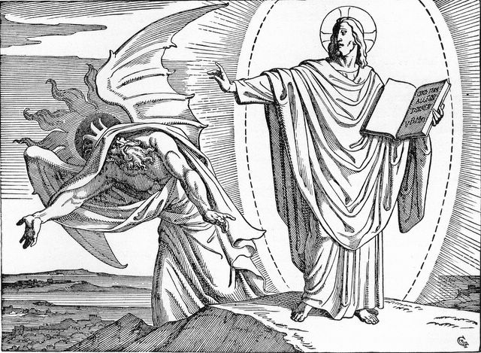

“the ruler of the kingdom of the air”, the devil, tried to temp Jesus via His flesh but our Lord rebuked him using the whole Word of God – we should do the same.
Source: Public domain here http://www.lavistachurchofchrist.org/Pictures/Treasures%20of%20the%20Bible%20%28Jesus%27%20Ministry%29/images/scan0016.jpg

Faith in Action

Prayer
Ask the Holy Spirit to give you the opportunity to gently show these verses to an unsaved person whose respect and trust you have previously earned.

Action
Today I will share, as the Holy Spirit guides, and ask if the person sees any parallels between their lives and what Paul described. I will do so humbly and respectfully, I will not condemn or pressure them, and I will merely engage a conversation and allow the Holy Spirit to be in control.

Be Specific ______________________________________________________

Monday (Ephesians 2:4-9)
2:4 But God, being rich in mercy, because of his great love with which he loved us,
2:5 even though we were dead in transgressions, made us alive together with Christ—by grace you are saved!—
2:6 and he raised us up with him and seated us with him in the heavenly realms in Christ Jesus, 2:7 to demonstrate in the coming ages the surpassing wealth of his grace in kindness toward us in Christ Jesus.
2:8 For by grace you are saved through faith, and this is not from yourselves, it is the gift of God;
2:9 it is not from works, so that no one can boast.

Prayer
Lord, You provided for our salvation even when not one was fit to be saved (due to the Fall), and You ask for nothing but surrender-through-faith in return.

Summary & Commentary
We are “saved by grace” because we could never have been saved through Works alone. The Lord God “sees” us through eyes of grace—the eyes of Jesus Christ.
Paul continued his explanation of how and why God has acted to redeem us:
- God is “... rich in mercy ...”
- “... because of His great love ...”
- “... with which He loved us ...”
- “... even though we were dead in transgressions ...”
- “... made us alive together with Christ ...”
- “... by grace you are saved!”
- “... and He raised us up with Him ...”
- “... and seated us with Him ...”
- “... in the Heavenly realms ...”
- “... in Christ Jesus ...”
- “... to demonstrate in the coming ages ...” [God allows imperfection, the result of rebellion, to continue because He knows that there remain many who can and will make a choice for faith and wants to give them that chance—He does not force the choice because then it is not genuine.]
- “... the surpassing wealth of His grace in kindness toward us in Christ Jesus.”
- Paul continued with a clarification of how saving faith is actualized:
- “For by grace you are saved though faith ...” [Faith is an act of the will, a 100% surrender of free will.]
- “... and this is not from yourselves ...”
- “... it is the gift of God ...”
- “... it is not from works ...”
- “... so that no one can boast.”

Interaction

Consider
It is an amazing truth that the Lord God chooses to love us and He chooses to show His love through the gift of grace that is our salvation.

Discuss
What does each element of Paul’s summary mean to you? Can you recall a parallel passage elsewhere in the Bible?

Reflect
“Works” cannot earn salvation, salvation was only made possible by the gift of God and may only be received by accepting the Lordship of Christ—surrendering everything else, the entire world and our free will.

Share
How did the absence of a demand for works-righteousness, by the Lord God, help to lead you to choose to surrender in faith?

KTALZ
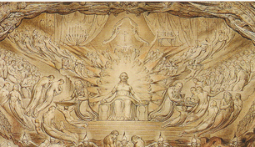

Jesus in His rightful place upon His heavenly throne.
Source: Public domain (image presented is an excerpt from original) here http://en.wikipedia.org/wiki/File:The_Vision_of_the_Last_Judgment.png

Faith in Action

Prayer
Ask the Holy Spirit to reveal to you someone whom He has found teachable and whom He has prepared to hear His Gospel.

Action
Today I will share the truths of these verses with someone “considering Christ” and/or with a fellow believer who would be blessed and encouraged to revisit the exciting moment of their salvation – celebrating the freedom which it brought.

Be Specific ______________________________________________________

Tuesday (Ephesians 2:10)
2:10 For we are his workmanship, having been created in Christ Jesus for good works that God prepared beforehand so we may do them.

Prayer
Lord, You rescued us from the eternal spiritual junkyard to which we were condemned by our first ancestors, Adam and Eve. May we, as Believers, celebrate Your rescue through lives sold-out to You.

Summary & Commentary
God has a purpose and a plan for each of us: We are to “partner” with Him and invite Him to do whatever He has to do to shape us into useful servants of His perfect will.
“For we are His workmanship ...” [God does not make anything imperfect—Adam and Eve made us into junk—Jesus will restore us to “design specs” in Heaven. Rom 5:15]
“... having been created in Christ Jesus ...” [Or, re-created, “made new”. 1Cor. 15:22]
“... for good works ...” [This is post-salvation.]
“... that God prepared beforehand ...” [He wanted Adam & Eve to stay clean and do this. Rom. 5:12]
“... so that we may do them.” [We are allowed to choose to serve God well or poorly.]

Interaction

Consider
Despite the failure of Adam & Eve the Lord God provided a way that we might return to what He had planned for them before the Fall and to begin-again that relationship, this time “farming” and “fishing” for a spiritual harvest and catch.

Discuss
What are some teachings elsewhere in the Bible as to what “works” God expects of His children? (Hint: Fruits of the spirit, telling His-story, loving fellow believers, using our gifts fully.)

Reflect
There has been an amazing change in you before and after salvation, how your self-image was transformed (or should have been) from a slave to the world to a child of God in a love-relationship with the Creator-God of everything.

Share
What is an example of serving the Lord God through good works, as a believer, in your life?

KTALZ


While God's workmanship is always perfect, everything since the Fall – even the pretty things - bears the evidences of imperfection implicit in a world separated from Him by sin.

Faith in Action

Prayer
Ask the Holy Spirit to reveal to you someone whom He has led to ‘consider-Christ’.

Action
Today I will tell someone who is “considering Christ” my story of before and after salvation minimizing the before as wasted and the after as worthwhile. I will not pressure them to make any sort of decision but will pray for them to choose Christ.

Be Specific ______________________________________________________

Wednesday (Ephesians 2:11–13)
New Life Corporately
2:11 Therefore remember that formerly you, the Gentiles in the flesh—who are called “uncircumcision” by the so-called “circumcision” that is performed on the body by human hands—
2:12 that you were at that time without the Messiah, alienated from the citizenship of Israel and strangers to the covenants of promise, having no hope and without God in the world.
2:13 But now in Christ Jesus you who used to be far away have been brought near by the blood of Christ.

Prayer
Lord, You have made Your redemption of humankind available to anyone who surrenders to the Lordship of Christ, regardless of age, gender, national origin, or race. May I remember to refuse to treat people differently based on anything—other than the only thing that matters—their relationship with You.

Summary & Commentary
We have now become “aliens” in this fallen world, whose prince is Satan. We are instead guaranteed eternal citizenship in Heaven with our Lord and King!
Paul began by speaking to the Gentiles, reminding them that they lacked the Jewish hope of a Messiah, and were labeled “uncircumcised” by those who associated ritual circumcision with works-salvation.
Paul then reminded them that they also were strangers to the knowledge of God, something the Jews did possess.
Then Paul concluded that although they had been “far away” they “... had now been brought near by the blood of Christ” and were “in Christ Jesus”—peers with all believers, Jew and Gentile alike.

Interaction

Consider
The double-gift of Christ to Gentiles, they (mostly “we”), not only gained the knowledge that a Messiah was needed and was coming, but the knowledge that He has come and He welcomes us now to His salvation-party as an honored guest—if we will but come in faith.

Discuss
What are some ways that you were clueless and hopeless, in your life, as a result of unawareness of the promise of a Messiah?

Reflect
What impact does the meaning of the Biblical phrases “brought near by the blood of Christ” and “in Christ Jesus” have upon you?

Share
How would you explain the Biblical phrases “brought near by the blood of Christ” and “in Christ Jesus” with someone to whom they would be very foreign expressions and perhaps even unpleasant-sounding expressions?

KTALZ


We are all familiar with the notion of something a long ways off as we travel; so also is humankind far from God without Jesus, even more so with no knowledge of Him at all.
Source: Copyright as watermarked – authorized for educational use together with this Bible study in unaltered (except for language-translation) form – no re-publication of other use without prior written permission.

Faith in Action

Prayer
Ask the Holy Spirit to lead you to a Biblically-accurate but less religious-sounding explanation of the Biblical phrases “brought near by the blood of Christ” and “in Christ Jesus”.

Action
Today I will share my less “religious-sounding” explanation with someone who has not yet chosen Christ. I will ask a fellow believer to pray in agreement with me for wisdom and will share with that prayer-partner the outcome of my sharing.

Be Specific ______________________________________________________

Thursday (Ephesians 2:14-16)
2:14 For he is our peace, the one who made both groups into one and who destroyed the middle wall of partition, the hostility,
2:15 when he nullified in his flesh the law of commandments in decrees.
He did this to create in himself one new man out of two, thus making peace,
2:16 and to reconcile them both in one body to God through the cross, by which the hostility has been killed.

Prayer
Lord, You chose in the Garden of Eden to make a way to reconcile Your creation to you—and despite our continued rebellion ever since You have never waivered. May I be more like You every day, resolute in placing You first, resolved to draw nearer to You.

Summary & Commentary
Through Jesus the Christ, the Lord God abolished the demands of the Law upon man and has instead taken them upon Himself. The “people of the Law” (Jews) and those not of the formerly “chosen tribe” are now forever one in Christ.
Paul described Christ as “our peace” because He “... made both groups [Gentiles and Jews] into one ...”
“... He nullified in His flesh the law of commandments in decrees.” [Jesus took away the requirement of the Law that every person who ever sinned be condemned and replaced it with grace—which makes Him our righteousness instead of perfect Law-keeping.]
“He did this to create in Himself ...” [the body of believers; “The Church”, exists as an adopted part of the Lord’s family—a unique intimacy of ‘being’.]
“... one new man out of two ...” [Jew and Gentile, Law-keeper and Law-stranger.]
“... to reconcile them both in one body to God ...” [the body of believers; “The Church”.]
“... through the Cross ...” [Where the power of death was broken for all who surrendered in faith, dying to the world and the dominion of Satan, being born anew in Christ.]
“... by which the hostility has been killed.” [the curse at the Fall as recorded in Genesis.]
[Note: When God-the-Son joined with human flesh through Eve He created a unique new Adam – One Who in-Himself first became a joined-being – fully-God & fully-man - so that He could save and join-together Jews and non-Jews in His “Church”.]

Interaction

Consider
The Lord God has given the incredible gift and sacrifice of Christ, taking our sins to the Cross and leaving them there—powerless—so that He might then offer us the perfect hope of salvation.

Discuss
How do you express the proper Biblical definition of “The Church” as the community of believers? How might you use that clarification to draw fellow Christians away from an obsession with buildings and organizations and instead to relationship (with God) and purpose (in Christ)?

Reflect
The dominion of Satan in the lives of the unsaved is broken and there is a new-found freedom experienced by children of God.

Share
What is an example of the way Jesus bridges the gap of Jew and Gentile, old and young, male and female, as all recognize that their common definition, purpose, and value comes from a common source?

KTALZ


Jesus is the rock and in Him the tree (Jews) and the grass (non-Jews/Gentiles) are drawn together.
Source: Copyright as watermarked – authorized for educational use together with this Bible study in unaltered (except for language-translation) form – no re-publication of other use without prior written permission.

Faith in Action

Prayer
Ask the Holy Spirit to reveal to you a fellow believer who will be edified and encouraged to learn of the most-Biblical definition of “The Church”.

Action
Today I will encourage a fellow believer to reconsider the Biblical meaning of “The Church” and ask them to then prayerfully consider where the Enemy may have caused distraction and diversion in their relationship with God as the result of a non-Biblical definition of “The Church”. I will commit to pray in agreement with them for wisdom as they walk through the process of adjusting their perspectives and priorities.

Be Specific ______________________________________________________

Friday (Ephesians 2:17-20)
2:17 And he came and preached peace to you who were far off and peace to those who were near,
2:18 so that through him we both have access in one Spirit to the Father.
2:19 So then you are no longer foreigners and noncitizens, but you are fellow citizens with the saints and members of God’s household,
2:20 because you have been built on the foundation of the apostles and prophets, with Christ Jesus himself as the cornerstone.

Prayer
Lord, You made a way for us to benefit from Your 'cross of grace'. May I celebrate Your gift with a life sold-out to You.

Summary & Commentary
Paul reminded the people that Jesus arose and “preached peace” so that all are welcomed to accept His gift through the Holy Spirit. He is the cornerstone upon which the apostles and the prophets built His Church.
He also reminded them that Jesus came and “preached peace” to both Jew and Gentile in order to bring them together in faith and together in the Holy Spirit.
Paul used again the term “saints” to describe “fellow citizens” and “members of God’s household.”
He further explained that who they were as Believers was because they “have been built on the foundations of the apostles and prophets ... with Christ Jesus Himself as the cornerstone.”

Interaction

Consider
The strong desire of Christ is that His children be unified (based on Biblical Christian principles, not the invented parameters of man, such as "political correctness" or "speech censorship", which are intended to restrict the condemnation of sin).

Discuss
The apostles and the prophets taught what was necessary to an adequate Believer knowledge-base, and they demonstrated the power of the Holy Spirit to equip Believers to be unified in the love of Christ; how is that explained and practiced in your fellowship?

Reflect
Believers are blessed by a powerful sense of 'belonging' that comes from the Lord God calling us "saints" and "fellow citizens" and "members of God's household."

Share
When have you observed genuine unity among believers that overcame, and or is overcoming, worldly divisions and fears – without selling-out the Word of God?

KTALZ
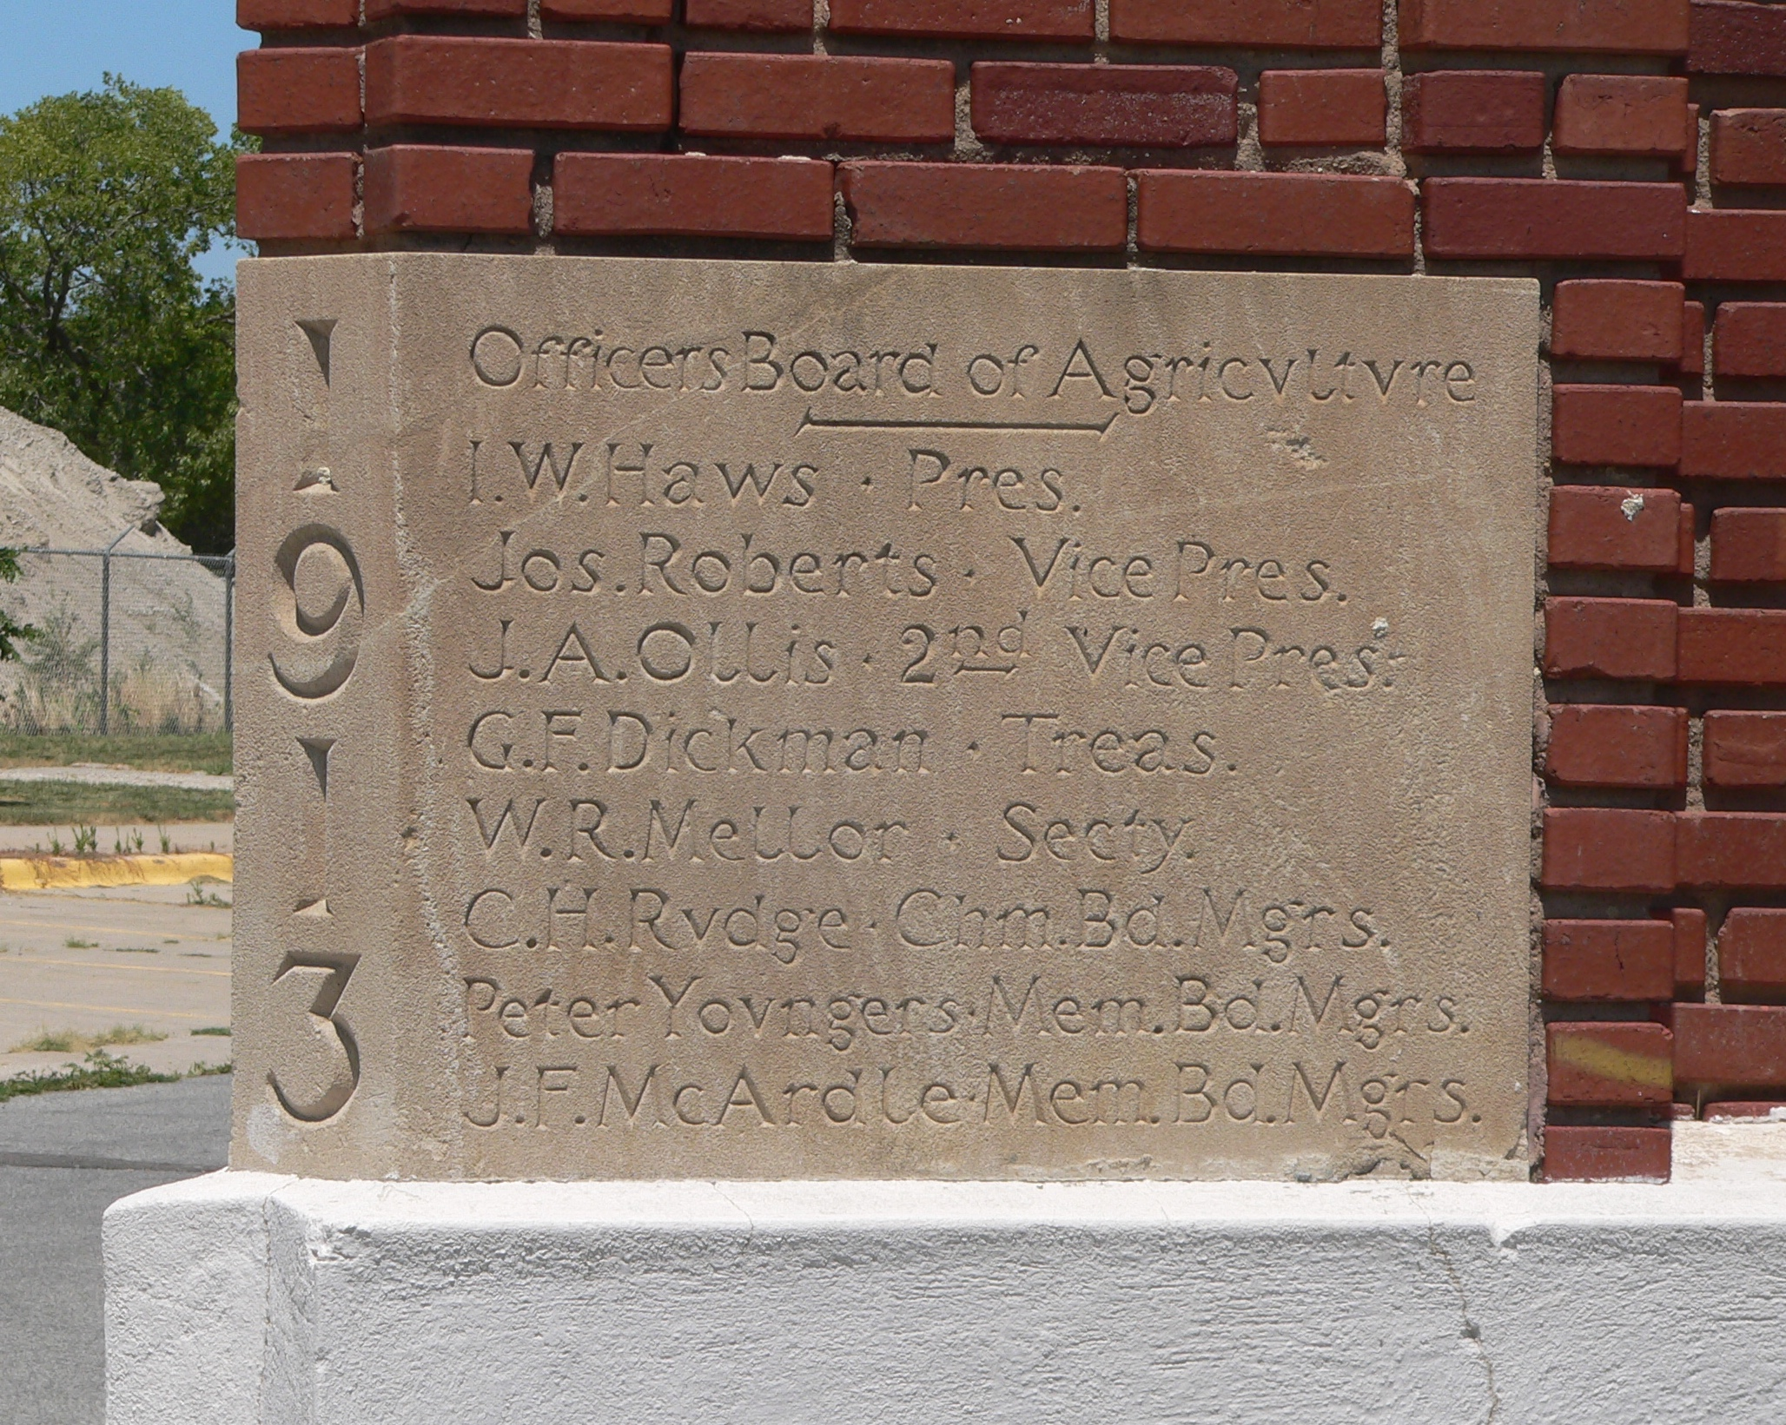

Just as a cornerstone is the reference point to balance and 'square' for the rest of a building, it may also contain valuable information, so is Christ to His church – in both cases without the cornerstone the rest fails.
Source: Public domain here http://upload.wikimedia.org/wikipedia/commons/3/39/Industrial_Arts_bldg_%28Lincoln%2C_NE%29_cornerstone_2.JPG

Faith in Action

Prayer
Ask the Holy Spirit to reveal to you a new or troubled believer whom He desires to reach using you as His instrument of blessing.

Action
Today I will share the Lord God's priority that we be united in the love of Christ. I agree to pray in-agreement that they will partner with the Holy Spirit to purge any fear or misunderstandings that may stand in opposition to their full fellowship with their fellow believers.

Be Specific ______________________________________________________

Saturday (Ephesians 2:21-22)
2:21 In him the whole building, being joined together, grows into a holy temple in the Lord, 2:22 in whom you also are being built together into a dwelling place of God in the Spirit.

Prayer
Lord, You have made every Believer, and every fellowship of faithful Believers, a dwelling place where You make Your presence and Your plan known. May I seize every opportunity to “grow together” with like-minded intentional Biblical-Christians.

Summary & Commentary
The Lord God draws together those who are His, building us into a “holy temple” and a “dwelling place of God in the Spirit”.
Paul wrote “In Him ...”, reminding them of the centrality of Christ to everything in the world of the believer.
He continued his construction metaphor “... the whole building ...” [The corporate commonality of believers.]
“... being joined together ..” [Causing believers to live in Biblical unity is a process, not an event.]
“... grows into a holy temple ...” [Believers are purposed to worship God in everything that we think, say, and do.]
“... in the Lord ...” [The centrality of Christ again.]
“... in whom you are also being built together ...” [It is a community process.]
“... into a dwelling place of God in the Spirit.” [The Holy Spirit is our common bond.]

Interaction

Consider
It is critical to remember that Christ is in all and defines all and brings to all perspective and purpose and nothing we do as believers must ever be apart from Him as our center.

Discuss
Why is there such a major problem with worldly things displacing Christ in our gatherings and in our separate daily walks?

Reflect
There are many ways we can choose to enhance the centrality of Christ and to resist the distractions of the enemy.

Share
When have you experienced or observed a community of believers either emphasizing Christ or allowing themselves to be distracted by something else? What was the result?

KTALZ
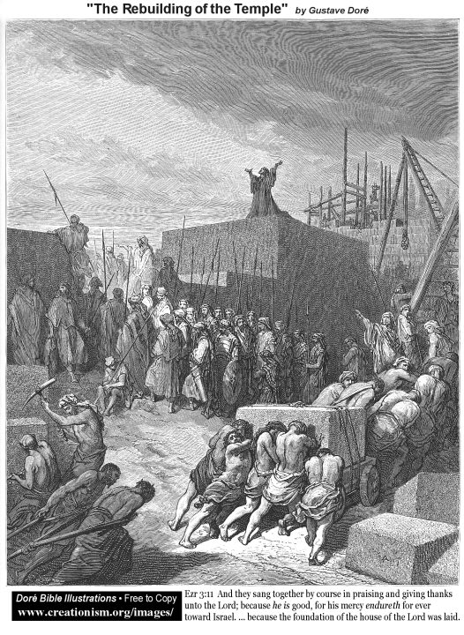

Just as Ezra, at the behest of the Lord God, rebuilt the Temple – He now calls us to build a new temple with Him.
Source: Public domain as labeled in the image.

Faith in Action

Prayer
Ask the Holy Spirit to show you a place in your walk, alone and/or in community, where you have allowed other things to displace Christ as the indispensable and irreplaceable center.

Action
Today I will cooperate with the Holy Spirit as He leads me back to a right place with Christ.

Be Specific ______________________________________________________
All Bible text is from the NET unless otherwise indicated—http://bible.org
Note 1: These Studies often rely upon the guidance of the NET Translators from their associated notes. Careful attention has been given to cite that source where it has been quoted directly or closely paraphrased. Feedback is encouraged where credit has not been sufficiently assigned.
Note 2: When NET text is quoted in commentary and discussion all pronouns referring to God are capitalized, though they are lower-case in the original NET text.
Commentary text is from David M. Colburn, D.Min. unless otherwise noted.
Copyright © 2011-2014 by David M. Colburn. This is a BibleSeven Study—in the series, “Ephesians”—prepared by David M. Colburn and edited for bible.org in 2014. This text may be used for non-profit educational purposes only, with credit; all other usage requires prior written consent of the author.

