Ephesians 1
A Daily Bible Study in 7-Day Sections with a Summary-Commentary, Discussion Questions, and Daily Application
David M. Colburn

Book Introduction
According to one chronological list of New Testament books Ephesians appears between Matthew, Mark, Luke, John, Acts, James, Galatians, Thessalonians, Corinthians, Romans, Philemon, and Colossians; and 1Timothy, Titus, 1 Peter, Hebrews, 2 Timothy, Jude, 2, Peter, 1-3 John, and Revelation.
This is relevant because prior to the church in Ephesus receiving Paul’s letter there was significant awareness of texts preceding Ephesians, texts circulated by taking advantage of the Roman mails and traveling routes, and frequently passed from “church” (a gathering of Believers) to church, and read aloud. The texts following Ephesians, yet to be authored and distributed, were built upon Old Testament prophesies, those of Jesus while in the flesh, and the pre-Ephesian and Ephesians “newer Testament” texts.
According to many Biblical scholars, the book of Ephesians appears not to have been uniquely written to the church in Ephesus. Ephesians gained it’s identification with Ephesus because theirs is believed to be the first church to receive this letter and because there were multiple copies found there (which indicates the intent of the church in Ephesus to distribute the letter). The intended audience is clearly that of all believers everywhere.
Understanding some key definitions in the Bible helps in understanding the book of Ephesians:
- Creation- bara (Heb.) ‘make something out of nothing’
- Delegation- God’s contract with His created to manage His creation
- Rebellion- Adam & Eve’s breach of contract
- Curse- the consequences for breach of contract
- Promise- “Christ” to come, providing redemption from the consequences
- CHRISTmas- Jesus the Christ born in the flesh, first step in His provision realized
- Easter- the culmination of propitiation, substitution, resurrection, ascension, intercession
Understanding key descriptive Biblical names and terms helps to understand Ephesians:
- Trinity (Triune God) - God the Father, God the Son, God the Holy Spirit
- God the Father - Creator, Lord, and never-corporeal keeper of glory
- God the Son - Jesus the man, sinless human of immaculate conception
- Jesus the Christ, God’s son in the flesh, anointed as Savior (Acts 2:22-24)
- Jesus our Lord, His God-glory restored, He Whom we worship and obey
- God the Holy Spirit - Comforter of the living, restorer of the dead, empowerer of holiness
- Spirit (human) - God’s unique essence placed in man to engage Him at the spiritual level

Sunday (Ephesians 1:1-2)
Salutation
1:1 From Paul, an apostle of Christ Jesus by the will of God, to the saints [in Ephesus], the faithful in Christ Jesus. 1:2 Grace and peace to you from God our Father and the Lord Jesus Christ!

Prayer
Lord, Your Word affirms itself, clarifying important concepts, reminding us of the reality of and reason for Your Gospel. May I never forget that You are the Lord God, that You call me a “saint” because You have redeemed me and will make me holy prior to Heaven, and that I owe it all to You.

Summary & Commentary
In the first chapter of Ephesians, the Apostle Paul reminded the Church of the glory and promises of God and what that means to all Believers
Paul began by identifying himself as an “apostle of Jesus Christ by the will of God” then reminded his readers that they also are “saints ... the faithful” through the same blessing of God. [Note: His readers would have known the story of how Paul was converted from a destroyer of Christians to their most zealous advocate (Acts 9:-18), so the model of turning away from one belief system and accepting a new one unconditionally was not entirely new to them.]
Paul communicated a couple of interesting points that are easily overlooked; when he wrote “Grace and peace to you from God our Father and [God] the Lord Jesus Christ.”
He intentionally wrote “grace” to remind the believers that they were no longer under the law as to eternal judgment and “peace” in order to clarify further that the war between their former rebellious selves and the Holy God was over.
Paul also added “... and the Lord Jesus Christ” in an apparent reminder of our subjection and debt to Jesus to make the “Grace and peace” possible. [Note: In the deception of Eve in the Garden, a critical element of the deception occurred when the serpent got her to drop “Lord” from “Lord God”.]

Interaction

Consider
The Lord God’s incredible gift—the truth that accepting God’s grace in the places of our lives where we’d be most ashamed to have Jesus in-the-flesh present is a first step to understanding grace—He already knows, and although we must never imagine that He endorses our sin, grace means that He still loves us!

Discuss
How do we meet the challenge of living here in our still-fallen flesh, assured of Heaven with bodies and minds made pure, yet struggling daily to press away the things that would drag us down?

Reflect
The Lord God’s love-name for us is “saints”, because we have chosen to be among the faithful, trusting His truth, and surrendering to His perfectly-loving Lordship.

Share
What is one example of the chasm of the person you were before Christ and the person you are now?

KTALZ
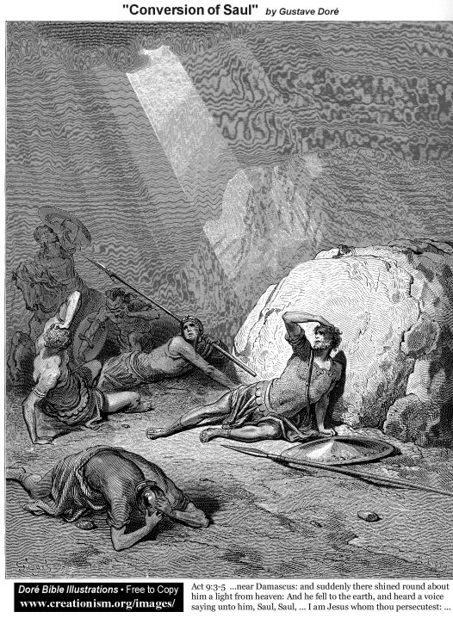

Paul used the moment of the Lord God offering him a chance to redeem himself, via surrender, from the angry legalistic anti-Christian zealot he was as an illustration of the powerful transformation at-salvation of every believer.
Source: Public domain as noted in picture.

Faith in Action

Prayer:
Ask the Holy Spirit to remind you of one specific example where knowing that His truth empowered you to resist a former pattern of cycling down into depression or escalating up to worse sin—choosing instead confession, repentance (turning away), forgiveness, and restoration—freedom!

Action:
Today I will I will share with a fellow Believer the amazing freedom that comes from knowing that despite my imperfections in the flesh I am loved by God and guaranteed freedom from imperfection and sin for eternity with Him in Heaven.

Be Specific ______________________________________________________

Monday (Ephesians 1:3-6)
Spiritual Blessings in Christ
1:3 Blessed is the God and Father of our Lord Jesus Christ, who has blessed us with every spiritual blessing in the heavenly realms in Christ.
1:4 For he chose us in Christ before the foundation of the world that we may be holy and unblemished in his sight in love.
1:5 He did this by predestining us to adoption as his sons through Jesus Christ, according to the pleasure of his will—1:6 to the praise of the glory of his grace that he has freely bestowed on us in his dearly loved Son.

Prayer
Lord, You promised Adam and Eve, and later Abraham, that You would send a redeemer. You said that the Redeemer would make salvation possible for everyone. You taught through the Law that Your standard was a high one—absolute surrender—and Jesus taught that salvation through grace was an offered-gift to those who chose to accept it. May I never imagine that I have earned my salvation, nor that it has been imposed-upon me [there is no Biblical teaching that anyone is “born saved”], but that You reveal Yourself to every member of humankind and each must make an eternal choice.

Summary & Commentary
God blesses us by predestining (creating the conditions for) all who surrender this world and who accept the gift of Heaven through Christ—to an eternity freed from imperfection and restoration to the Edenic condition.
The phrase “He chose us in-Christ before the foundations of the world” requires a careful look at the intent of the phrase versus the less-than-concise word “predestination” all alone. To be “in-Christ” flows from a process [see text further down] rather than a simple event, choosing “us” then refers to choosing those who choose to be “in-Christ”.
Before the “foundations of the world” “The Christ” had not yet come nor had Adam and Eve rebelled, triggering The Fall.
Paul emphasized that our standing before God in an “unblemished” state is a result of His loving provision through Christ whose sacrifice for us removed our imperfections.
A little further down the text [addressed on Wednesday] he walked his readers through the following steps of salvation and blessing:
1:13a We hear the Word of God.
1:13b We choose to believe.
1:13c We are then saved.
1:13d We are given the indwelling Holy Spirit as Jesus promised (John 16)
vs. 1:4 He (the Lord God) chose us based on a pre-established set of conditions, “...in Christ”.
vs. 1:5 He (the Lord God) predestined us to adoption as His (God’s) “sons”—if we meet the conditions referenced in 1:4. [Note: This is more than legal standing as in His (God’s) family but would have been understood to mean for both male and female alike the full rights of a loved child and one who benefits from all of the blessings and rights thereof.]
Notes:
The sequence of events described by Paul were “
Fellowship between God and man is not described here, nor even in pre-Fall Eden (Gen. 1-3), all that is described is the provision of a redeemer and the boundaries for redemption set by Him.
Even as some New Testament texts address fellowship between God and man (e.g. 1 Cor. 1:9, 1 John 1:3) it is moreso of our fellowship with Christ via His provision of salvation and therefore certainty of joining Him in Heaven.
Even Eph. 1:5 where Paul described our status as “inheritors” he still did not mention affection or casual fellowship between man and God in Heaven.
When we look for a sense of how God loves us, and the intimacy which He seeks, we must look elsewher in the Word for “Father” used in the “Abba” (daddy) context rather than here in the ‘God the keeper of order’ context.
We will also want to look at the fellowship between Jesus and God the Father because we inherit that relationship through Jesus as our promised and fulfilled Christ.
The traditional interpretation of Gen. 3:8 is post-sin and pre-curse, but Adam and Eve are already in a state of rebellion and their standing before God has changed. Instead of implying a friendly “walking together in the cool of the day” this verse appears to describe the highly- offended Lord God looking to Adam and Eve like an approaching storm (an experience something foreign to them but something that we readily recognize in this fallen world) - near where they were hiding.

Interaction

Consider
It was God’s pleasure to create a way to overcome “the sin of Adam” through the work of Jesus the Christ. Because the cost of creating “a way home” to Heaven for us was impossible through “works” He paid the price for us and only asks that we reject the things of this world-in- rebellion and surrender eternal allegiance (our free will) to our Lord the Perfect One, Jesus.

Discuss
Why is a clear understanding of the “steps” or “elements” of “predestination” so important?
First, He created the conditions for all who surrender this world and who accept the gift of Heaven through Christ,
Then, Second, He granted us adoption as His (God’s) “sons”, all of the blessings and rights as “family” in Christ.

Reflect
Our standing before God in an “unblemished” state is a result of His loving provision through Jesus the Christ whose sacrifice for us removed our imperfections.

Share
When have you heard “predestination” described? Compare and contrast that with the Word of God.

KTALZ


Before the earth had even been created, an event that occurred along a timeline – in sequential time that He created for us - by God He [not bound by created-time] envisioned our need for salvation – and thus He provided a way through grace that also met the requirements of justice.
Source: Public domain image sent from the International Space Station in 2013.

Faith in Action

Prayer
Ask the Holy Spirit to reveal to you one unsaved person for whom He would like you to pray.

Action
Today I will pray for the person He has revealed to me and, if I have to earned the opportunity to do so, I will tell them about the incredible gift of Heaven through Jesus.

Be Specific ______________________________________________________

Tuesday (Ephesians 1:7-11)
1:7 In him we have redemption through his blood, the forgiveness of our trespasses, according to the riches of his grace
1:8 that he lavished on us in all wisdom and insight.
1:9 He did this when he revealed to us the secret of his will, according to his good pleasure that he set forth in Christ,
1:10 toward the administration of the fullness of the times, to head up all things in Christ—the things in heaven and the things on earth.
1:11 In Christ we too have been claimed as God’s own possession, since we were predestined according to the one purpose of him who accomplishes all things according to the counsel of his will

Prayer
Lord, You provided the way of freedom for us in Christ, and You provided us Your Gospel so that we would understand. May I receive Your gift of “all wisdom and insight” with a teachable heart.

Summary & Commentary
We have eternal redemption and daily forgiveness, as promised by God (Gen. 3:15), and because of the propitiation of Christ.
[Note: Propitiation is theologian’s shorthand for the work of Christ on the Cross where He, the only God-man, One without sin, took upon Himself our sin and through His sacrifice of death and His miracle of resurrection destroyed the power of death-for-sin for all who accept His Lordship.]
Paul refers to “the secret” of Christ, His salvation available to all and not only the Jew, and His plan to rescue man through Christ.
[Note: The coming of a Messiah was not a secret, the Messiah was prophesied at the Fall (Gen. 3:15) in the Abrahamic Covenant (Gen 12:1-3), John 3:56 observed that “Abraham rejoiced for the day Messiah would come” the unique individual “one seed” (Gen. 13:15; 22:18, Gal. 3:16), “... until Shiloh comes” (Gen. 49:10-12), the sacrificial system was temporary (Rom. 3:25), the serpent of Numbers 21 is identified in John 3:14; 12:32 as an image of the Messiah, Moses was a type of Messiah (Deut. 18:15), in the Book of Ruth the kinsman redeemer/guardian was a type of Messiah (Ruth 4:14, Psa. 78:35, Deut. 25:5-10), in 1 Sam. 8:4-5 Israel was too obsessed with other nations and mis-applied Messiah as their demand a human king—a failure of understanding that followed them all of the way to time of Jesus, in 2 Sam. 7:11b-16 Messiah was clarified/restated, Messiah was often described generationally and rhetorically as “the son of David (Luke 1:32l 2:4; 18:38), all of the following describe the coming Messiah ﻿(Isa. 7:14-16; 9:6-7; 11:1-5; 49:5-7; 52, 53, Dan. 7:13-14, Zech. 3:8; 9:9, Mal. 3:1), “Out of Egypt I called My son,” -- Hos. 11:1 is misunderstood if taken to mean that the Messiah was an Egyptian. “called out” does not necessarily mean that He was an Egyptian but that He was a descendant of those called out of bondage—or that He fled persecution to Egypt (Mary & Joseph took him as a baby) then was “called out” to return home to grow up and do His work—Matthew (2:15) clarifies this, and finally one Bible scholar provided the following Messiah excerpts from Psalms:
Psalm 2 speaks of the Messiah as the One whom God will install as His King over Israel (v. 7). Messiah will be given the nations as His inheritance, and He will rule over those who seek to oppose Him (vss. 1-3, 8-9). The nations are thus urged to worship God now, or face the wrath of His coming King. In contrast, Psalm 22 portrays the suffering of Messiah on the cross of Calvary. It begins with the words which our Lord quoted upon the cross, “My God, my God, why has Thou forsaken me?” thus identifying the Savior with the One whose sufferings are described in this Psalm.
Psalm 45 is written for the celebration of the king’s marriage. It therefore focuses on the splendor and majesty of the coming King (vss. 3-6), and upon the fact that His throne is eternal (v. 6). The bride of the king loves righteousness and hates wickedness (the church?) and has been chosen by Him as His bride. The splendor and beauty of the bride is described as she has been prepared for her presentation to the King.
Psalm 72 depicts the reign of the Righteous King of Israel, who judges the people with righteousness and justice, and who vindicates the afflicted. He is the One who will answer the cries of the afflicted and will bring them deliverance.
Psalm 110 speaks of the installation of the Messiah at the right hand of God, who will rule over His enemies. Not only is He to rule as king, but He is also an eternal priest after the order of Melchizedek (v. 4). He will come to the earth to destroy His enemies.
“The Nestlé edition of the Greek NT lists “passages in bold which are direct quotations from the Old Testament.”
The list shows the NT as borrowing 224 separate passages from 103 different psalms, and with the same passages appearing in different places this gives a total of 280 psalm quotations in the NT. Approximately 50 of these deal with the sufferings, resurrection, ascension of Christ, and the spreading of the gospel to all nations.
The other quotations are more of a teaching or comforting nature.” Source: http://www.ristosantala.com/rsla/OT/OT13.html]
Walking through the steps (second part):
1:9-10 He (the Lord God) made known to us His (God’s) will ... which He purposed in Him (God) ... with a view to the summing up of all things in Christ—this is the fulfillment of the promise of God after the Fall in the Garden (Gen. 3:15)
1:11 We are predestined according to His (God’s) purpose—when we meet the qualifications for predestination He (God) has a perfect plan for us (unlike the imperfect ones we invent every day) and upon our ‘qualification’ He initiates that plan.
[Note: “ we were predestined according to the one purpose of him” - the “one purpose” is to undo the damage of rebellion that led to the Fall “that none may be lost” among those who surrender to Christ – same formula as the Garden – choose your future. An imposed affiliation isn't a love-relationship it's an imposition – God wants us to choose Him then to obey Him from hearts of loving gratefulness.]

Interaction

Consider
Dealing with sin in our lives is a challenge, we are much better at cover-ups and denials than we are at confession and repentance, and we lie to ourselves even better than we lie to others.

Discuss
How does the clear linkage between the Old Testament Psalms, and the New Testament text that quotes from it, encourage your assurance of the integrity of God’s Word?

Reflect
Thank the Lord God that through Jesus the Christ He took our punishment on the Cross, that He as God-man was resurrected from the formerly inescapable bonds of death, that He walked and taught His-story and His promise, and that He sent His apostles to teach and write it to the new church (believers) that we might have His Word today. Thank Him also for daily forgiveness.

Share
When have you read something in the New Testament and realized that the writer was quoting from, of building upon, the OT?

KTALZ


The Bible is inspired and is self-affirming/correcting – it all works together.
Source: Public domain from the internet (specific source unknown.).

Faith in Action

Prayer
Ask the Holy Spirit to reveal to you a piece of His plan for your life.

Action
Today I will praise the Lord God for His perfect plan for my life and I will humbly and trustingly follow where he leads.

Be Specific ______________________________________________________

Wednesday (Ephesians 1:12-14)
1:12 so that we, who were the first to set our hope on Christ, would be to the praise of his glory.
1:13 And when you heard the word of truth (the gospel of your salvation)—when you believed in Christ—you were marked with the seal of the promised Holy Spirit,
1:14 who is the down payment of our inheritance, until the redemption of God’s own possession, to the praise of his glory.

Prayer
Lord, You saved us and although we are already with You in your timeless-reality, we remain here for a while as we endure the time-bound reality of creation. May I keep my eyes always on You so that I never forget that I no longer belong here but rather with You in Heaven.

Summary & Commentary
We first set our hopes upon Christ when we “heard the Word of truth” and “believed in Christ.” Then we were “marked with the seal of the promised Holy Spirit.”
Walking through the steps (third part):
1:13a We hear the Word of God, HIS-story.
1:13b We choose to believe.
1:13c We are then saved.
1:13d We are given the indwelling Holy Spirit as Jesus promised (John 16)
There is a theological construct called “already, not yet”. This refers to the sovereign and unalterable declarations of God relative to His promises to His children; we are already seen as redeemed from the penalty of sin but we are not yet directly experiencing the fullness of the results of that redemption (Heaven), or as Jesus said to the repentant thief on the Cross “... today you will be with me in paradise”—Jesus was in the grave for three days and after His resurrection walked the earth for another forty, so, clearly he was speaking in the “already, not yet” linear time versus the timelessness of God and Heavenly/spiritual reality (Luke 23:39-43).
Thank God that the resurrected and glorified Jesus, Christ in the flesh, is our perfect hope and, like Him and because of Him, we also have been claimed by God as His! We first set our hopes upon Christ when we “heard the Word of truth” and “believed in Christ.” Then we were “marked with the seal of the promised Holy Spirit.”

Interaction

Consider
The amazing, incredible, surreal fact is that you have the indwelling Holy Spirit of God! What are you doing as a result of that incomparable gift? Are we, the body of Christ, partnering with Him to heal and mature emotionally, intellectually, physically, and spiritually?

Discuss
How does the concept of “already, not yet,” help you to understand the difference between a human perspective of time-bound events and that of an outside-of-time God?

Reflect
The resurrected and glorified Jesus, Christ in the flesh, is our perfect hope and, like Him and because of Him, we also have been claimed by God as His! We first set our hopes upon Christ when we “heard the Word of truth” and “believed in Christ.” Then we were “marked with the seal of the promised Holy Spirit.”

Share
Share an example of how the Holy Spirit of God, working from within you, caused you to be used by God in a meaningful and positive way.

KTALZ
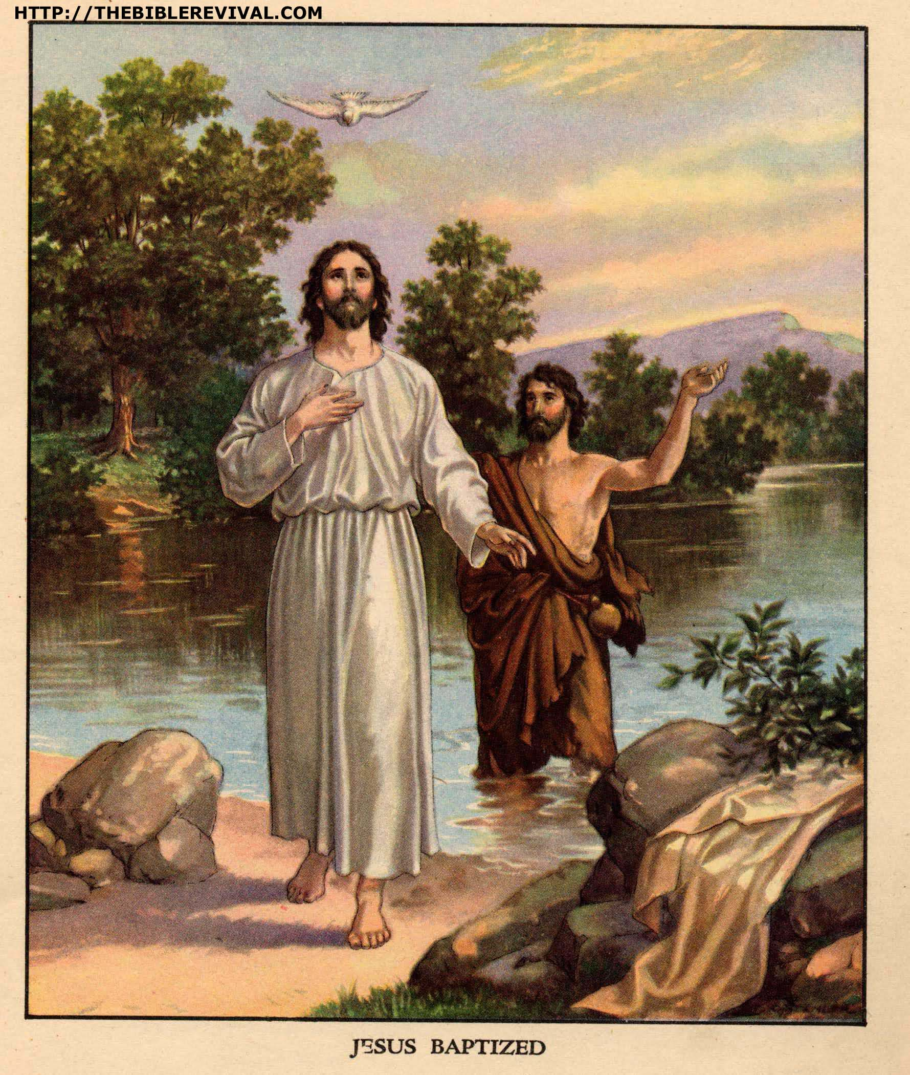

Just as Jesus-Himself was “marked with the seal of the promised Holy Spirit”, emphasized via a dove and audible heavenly voice, so is every believer.
Source: Public domain here https://images.duckduckgo.com/iu/?u=http%3A%2F%2Fthebiblerevival.com%2Fclipart%2Fjesus%2520baptized.jpg&f=1

Faith in Action

Prayer
Ask the Holy Spirit to reveal how He wants to work in your life to heal and mature you.

Action
Today I choose to prayerfully partner with Him in His work so that while I am “not yet” in my new perfected body in Heaven I am “already” worshiping Him with my life.

Be Specific ______________________________________________________

Thursday (Ephesians 1:15-16)
Prayer for Wisdom and Revelation
1:15 For this reason, because I have heard of your faith in the Lord Jesus and your love for all the saints,
1:16 I do not cease to give thanks for you when I remember you in my prayers.

Prayer
Lord, You have given to us a right-model for obedient Biblical-Christian living. May I remember to reflect often upon this teaching, comparing and contrasting my walk with the guidance found here, and seeking to mature so that I may be-improved by Your Holy Spirit.

Summary & Commentary
Paul stated his motivation for offering up prayers on the Saints behalf: “For this reason, because I have heard of your faith in the Lord Jesus and your love for all the saints.” Because they are Believers “in the Lord,” and because the witness of their lives as well as their words told HIS-story, Paul celebrated with, “I do not cease to give thanks for you when I remember you in my prayers.”
Following the sequence:
They were believers in the Lord.
They “ultrafidian” went beyond faith and ...
... obediently loved one another.
... obediently shared the Good News (like the Thessalonians 1:7-10)
therefore, Paul remembered them to God in his prayers.

Interaction

Consider
As you contemplate becoming an ultrafidian-Christian; do you find that exciting and scary at the same moment? (Loving those sometimes hard-to-love brothers and sisters in Christ, even the one in the mirror right after doing something really dumb, can be an exciting challenge.)

Discuss
In what ways can we be ultrafidian-Christians and go beyond faith to obediently love one another and obediently share the Good News because the Holy Spirit of God dwells in every one of us?

Reflect
We may call upon the Lord God Who blessed through the prayers of Apostles then and the intercession of Jesus in Heaven now.

Share
When have you been an ultrafidian-Christian and done something in-faith that you never thought you could do?

KTALZ
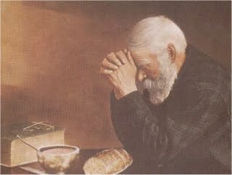

Paul prayed, as should we, for those who live obediently before the Lord.
Source: Public domain here http://payingattentiontothesky.com/2009/09/

Faith in Action

Prayer
Ask the Holy Spirit to reveal to you a brother or sister whom you may encourage with, and one unsaved person you can tell about, the Gospel of Jesus the Christ.

Action
Today I am choosing to be an ultrafidian-Christian, loving my Christian brothers and sisters and obediently sharing the Good News every chance I get.

Be Specific ______________________________________________________

Friday (Ephesians 1:17-21)
1:17 I pray that the God of our Lord Jesus Christ, the Father of glory, may give you spiritual wisdom and revelation in your growing knowledge of him,
1:18—since the eyes of your heart have been enlightened—so that you may know what is the hope of his calling, what is the wealth of his glorious inheritance in the saints,
1:19 and what is the incomparable greatness of his power toward us who believe, as displayed in the exercise of his immense strength.
1:20 This power he exercised in Christ when he raised him from the dead and seated him at his right hand in the heavenly realms 1:21 far above every rule and authority and power and dominion and every name that is named, not only in this age but also in the one to come.

Prayer
Lord, You are sovereign over life and death, even time itself. May I live in a proper awe of You Lord, an awe that produces an increased desire for growing spiritual maturity in my life.

Summary & Commentary
Paul strongly encouraged his readers to seek after knowledge of the Lord God and prayed that He would bless their willingness to learn with “spiritual wisdom and revelation.”
Wisdom was an attribute spoken of frequently in the Old Testament: “With God are wisdom and power; counsel and understanding are his” (Job 12:13); “Fearing the Lord is the beginning of moral knowledge, but fools despise wisdom and instruction” (Prov. 1:7); “For the Lord gives wisdom, and from his mouth comes knowledge and understanding” (Prov. 2:6); “I will guide you in the way of wisdom and I will lead you in upright paths” (Prov. 4:11); “When pride comes, then comes disgrace, but with humility comes wisdom” (Prov. 11:2). Reflecting on these verses, it is clear we should desire wisdom as much as God desires it for us.
“Revelation” may have more than one meaning. In 1 Corinthians 1:7 the context refers to ‘knowledge’: at one level certainty of the revelation of Christ’s return in His full glory (“so that you do not lack any spiritual gift as you wait for the revelation of our Lord Jesus Christ”) and, at another level, to insight or the discernment of truth from lies.
Some take Paul’s use of “spiritual” to refer to a Charismatic gift or experiential event but there is nothing in the larger context to support such an interpretation.
In the use of “revelation” an apparent iconicity has been noted between our “being enlightened to know” compared to “the working of His strength and might.”
Since Genesis, the Lord God variously described the gift of “revelation” as about the promised “hope of His calling” ... He “raised Him from the dead” He celebrated the “glory of His inheritance” ... He “seated Him in the Heavenly places” He described the “greatness of His power” ... and that He was “far above all rule and authority and power”

Interaction

Consider
It is not necessary for everyone to go to a Bible College or a seminary, some of those who have done so were not ready when they did, and others attended where they were taught bad doctrine; but somewhere—preferably in our fellowships, large or small—we all need to get more clued-in as to spiritual wisdom and revelation.

Discuss
What are some examples of the value of wisdom, acquired through the indwelling Holy Spirit, to equip us to discern and thereby to reject the many deceptions that the Enemy brings against us?

Reflect
How have you responded to the Lord God’s strong encouragement of us to seek after knowledge of Him, with the promise that He will bless our willingness to learn; specifically learning about spiritual wisdom and revelation?

Share
When have you experienced or observed an example where knowledge of the Word of God, and possession of discernment of the Holy Spirit, equipped you to discern and reject a deception, or to assist another believer in so doing?

KTALZ
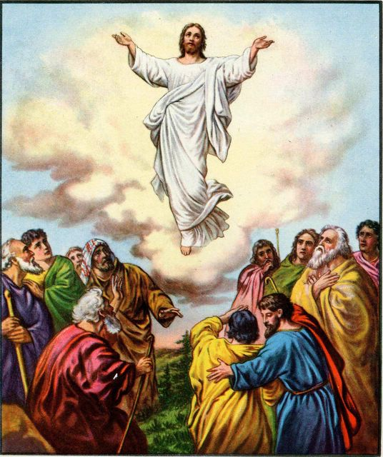

One piece of the Lord God's revelation was of Jesus ascending to assure His followers that He was indeed returning to Heaven and that He would return in the same highly-visible (even much more so according to prophesy) way.
Source: Public domain here http://www.lavistachurchofchrist.org/Pictures/Jesus%27%20Death,%20Resurrection%20and%20Ascention/images/jesus_returns_to_the_father.jpg

Faith in Action

Prayer
Ask the Holy Spirit to reveal to you an area of your knowledge of spiritual wisdom or revelation that wants you to explore.

Action
Today I will invest more time in my knowledge of spiritual wisdom and revelation. I will consult one Biblically-qualified as an elder to assist as needed.

Be Specific ______________________________________________________

Saturday (Ephesians 1:22-23)
1:22 And God put all things under Christ’s feet, and he gave him to the church as head over all things.
1:23 Now the church is his body, the fullness of him who fills all in all.

Prayer
Lord, You have called us together in-You, and You have equipped us through Your Word. May I be faithful in encouraging fellowship that is centered upon You my Lord God.

Summary & Commentary
Paul reminded the church that everything, and every Believer, is “under Christ’s feet” and that “the church is his body”.
With “God put all things under Christ’s feet” Paul penned an interesting parallel to Psalm 8, where David praised the Lord God for giving His Creation to man. Adam and Eve rebelled, everything and everybody created was cursed because of them, and consequently Satan became the ruler or prince of the fallen world (see John 16:11). Yet we read in Daniel 12:1, “Michael the great prince [a type of Jesus the Christ] who protects your people will arise.”
Then Paul wrote, “He gave him to the church as head over all things.” [All Believers must choose to be, as they inherently are already, eternally submitted to Christ, as will also be “the new heaven and new earth” (Rev. 21:1).]
“Now the church is his body” reminds us that Believers, wherever they are, are a spiritual extension or physical representation on earth of Christ and that every member is obligated to Him for their salvation - and therefore owes Him a love-debt of service.
Paul then declared how great is the reach of the presence of Christ, “the fullness of him who fills all in all.” He reminded his readers again that He is God, that He holds together all of creation (see Col. 1:15), and that He – through His Holy Spirit - is in every Believer.

Interaction

Consider
The Lord God is not pleased with careless Christians who attend a fellowship out of guilt or social obligation or superstition, or for entertainment or business or social networking. Believers must get serious about being teachable, about setting new God-directed priorities, and about making choices that are more intentionally-Biblical.

Discuss
What would you offer as an illustration of “submission to Christ”, something that expresses His love and value, within which we live - and a sense of protection and purpose - because He is our One true and perfect King?

Reflect
The wonderful truth that Jesus is in charge and not mere humans, that “The Church” (Believers) report to Him and not to mere man, and the true “Church” is His earthly expression - through us through the power and wisdom of the Holy Spirit - and that every member has the privilege of returning to Him a love-debt of service.

Share
When have you made a decision about a fellowship, or a level of participation in that fellowship, that was not based on your own discipleship, serving others, or shared worship but was instead due to some lesser flesh-motivated purpose: seeking clients, seeking a mate, seeking access to someone with money or power or prestige, seeking entertainment, seeking recognition, or other purpose? How did God show you your error? Or is He challenging your your heart-motivation right now?

KTALZ
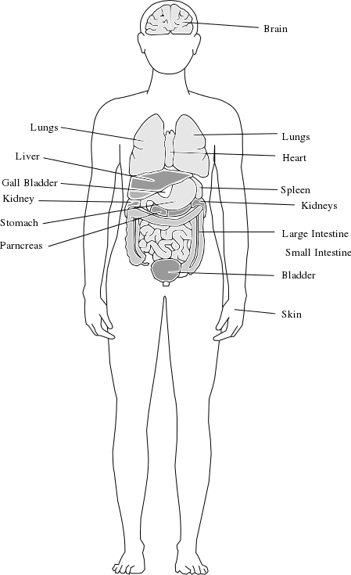

The “church” is the body of Christ; Believers are intimately integrated with God.
Source: Public domain here http://www.wpclipart.com/medical/anatomy/organs_various/body_organs.png

Faith in Action

Prayer
Ask the Holy Spirit to reveal to you something in your calendar and/or checkbook that He wants you to submit more-intentionally to His priorities.

Action
Today I will partner with His Holy Spirit in becoming more teachable in heart and in mind and I will be a more-intentional member of the community of Believers which is His Church (an organized corporate church or a loosely-affiliated network of Believers).

Be Specific ______________________________________________________

Additional Resources: “Messiah” http://www.bible.org/page.php?page_id=660 {1}
All Bible text is from the NET unless otherwise indicated—http://bible.org
Note 1: These Studies often rely upon the guidance of the NET Translators from their associated notes. Careful attention has been given to cite that source where it has been quoted directly or closely paraphrased. Feedback is encouraged where credit has not been sufficiently assigned.
Note 2: When NET text is quoted in commentary and discussion all pronouns referring to God are capitalized, though they are lower-case in the original NET text.
Commentary text is from David M. Colburn, D.Min. unless otherwise noted.
Copyright © 2011-2014 by David M. Colburn. This is a BibleSeven Study—in the series, “Ephesians”—prepared by David M. Colburn and edited for bible.org in Spring 2014. This text may be used for non-profit educational purposes only, with credit; all other usage requires prior written consent of the author.

