Daily Devotional
Week 1 Day 1
OT (chronological)
Sunday (Genesis 1:1-5)
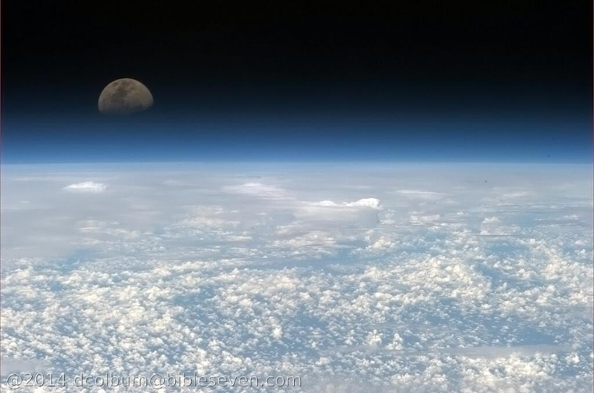
The Creation of the World

“In the beginning God created the heavens and the earth.
Now the earth was without shape and empty,
and darkness was over the surface of the watery deep,
but the Spirit of God was moving over the surface of the water.
God said, “Let there be light.” And there was light!
God saw that the light was good, so God separated the light from the darkness.
God called the light “day” and the darkness “night.”
There was evening, and there was morning, marking the first day.”

For two months before a puppy is born it lives and grows inside the mother dog.
Prior to that two months the puppy simply did not exist, anywhere.
That is what things were like before “God said”.

When you consider this day who or what is important
and you decide who or what will guide your decisions,
try to remember that before anything - was God.
Should He not be our everything?

Dear Lord, I want You to be first, last, and everything. Amen. dmc2016
[Image source: International Space Station, 2013, public domain]
Daily Devotional
Week 1 Day 2
OT (chronological)
Monday (Genesis 1:6-25)
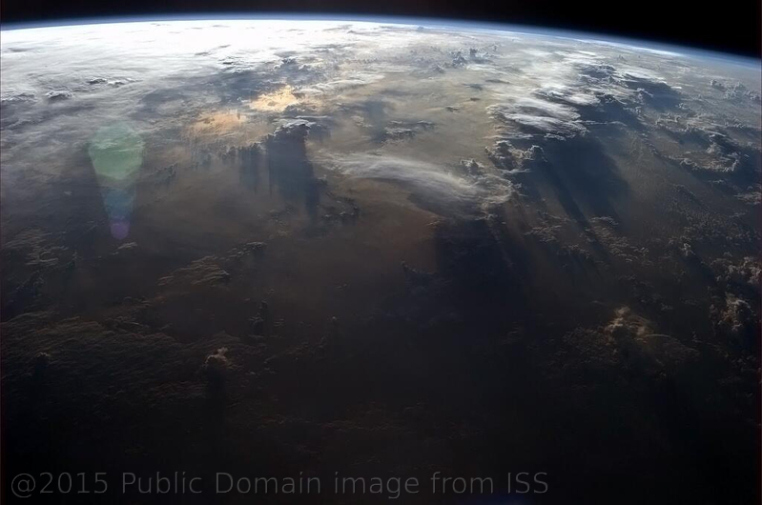

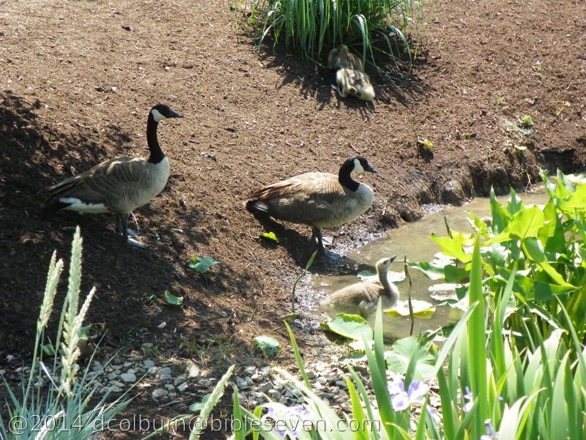

“God said, “Let there be an expanse in the midst of the waters and let it separate water from water.
So God made the expanse and separated the water under the expanse from the water above it. It was so.
God called the expanse “sky.” There was evening, and there was morning, a second day.
God said, “Let the water under the sky be gathered to one place and let dry ground appear.” It was so.
God called the dry ground “land” and the gathered waters he called “seas.” God saw that it was good.
God said, “Let the land produce vegetation: plants yielding seeds according to their kinds, and trees bearing fruit with seed in it according to their kinds.” It was so.
The land produced vegetation – plants yielding seeds according to their kinds, and trees bearing fruit with seed in it according to their kinds. God saw that it was good.
There was evening, and there was morning, a third day.
God said, “Let there be lights in the expanse of the sky to separate the day from the night,
and let them be signs to indicate seasons and days and years,
and let them serve as lights in the expanse of the sky to give light on the earth.” It was so.
God made two great lights – the greater light to rule over the day and the lesser light to rule over the night. He made the stars also.
God placed the lights in the expanse of the sky to shine on the earth, to preside over the day and the night, and to separate the light from the darkness. God saw that it was good.
There was evening, and there was morning, a fourth day.
God said, “Let the water swarm with swarms of living creatures and let birds fly above the earth across the expanse of the sky.”
God created the great sea creatures and every living and moving thing with which the water swarmed, according to their kinds, and every winged bird according to its kind. God saw that it was good.
God blessed them and said, “Be fruitful and multiply and fill the water in the seas, and let the birds multiply on the earth.”
There was evening, and there was morning, a fifth day.
God said, “Let the land produce living creatures according to their kinds: cattle, creeping things, and wild animals, each according to its kind.” It was so.
God made the wild animals according to their kinds, the cattle according to their kinds,
and all the creatures that creep along the ground according to their kinds. God saw that it was good.”

A person built a house inside a bubble.
Between the house and the space inside the bubble every need was met for human and non-human life.
There was fresh air, water, food, and shelter and lots of room to move about.
Everything was in perfect balance – but was it a home?
Not without people living in it - it was not.

Up until this moment in Creation God had not yet added man to the world, but it was a perfect place for humans to live.
The Holy Spirit Who lives in us, Believers, is perfect – just like God's Creation.
When it's time to decide between the world and the wisdom of God,
isn't it best to go to the perfect place for wisdom – God in us?

Dear Lord, please help us to make you our perfect home. Amen. dmc2016
Image Source: Copyright as in image watermark

Daily Devotional
Week 1 Day 3
OT (chronological)
Tuesday (Genesis 1:26-2:4)

“Then God said, “Let us make humankind in our image, after our likeness, so they may rule over the fish of the sea and the birds of the air, over the cattle, and over all the earth, and over all the creatures that move on the earth.”
God created humankind in his own image, in the image of God he created them, male and female he created them.
God blessed them and said to them, “Be fruitful and multiply! Fill the earth and subdue it! Rule over the fish of the sea and the birds of the air and every creature that moves on the ground.”
Then God said, “I now give you every seed-bearing plant on the face of the entire earth and every tree that has fruit with seed in it. They will be yours for food.
And to all the animals of the earth, and to every bird of the air, and to all the creatures that move on the ground – everything that has the breath of life in it – I give every green plant for food.” It was so.
God saw all that he had made – and it was very good! There was evening, and there was morning, the sixth day.
The heavens and the earth were completed with everything that was in them. By the seventh day God finished the work that he had been doing, and he ceased on the seventh day all the work that he had been doing. God blessed the seventh day and made it holy because on it he ceased all the work that he had been doing in creation.
This is the account of the heavens and the earth when they were created – when the Lord God made the earth and heavens.”

The farmer and his wife were getting older and decided they needed some help.
They hired a person to manage their property for them; the cattle, the planting and sowing of the fields, and the maintenance of the barns, equipment, and fences.
They gave to their manager money and power to act in their name.
The manager was not them - but the manager now had purpose and responsibilities, like them.

The first man and woman were expressly created for the purpose of caring for God's new Creation.
Although we are far from that perfect place, and their perfect innocence, we also need His purpose.
When we rise in the morning we are blessed with a purpose from God.
Dear Lord, Please keep me mindful that I live and breathe to serve You, and please help me to know, and to fulfill, Your purpose for my life. Amen. dmc2016
Image Source: Copyright as in image watermark
Daily Devotional
Week 1 Day 4
OT (chronological)
Wednesday (Genesis 2:5-17)
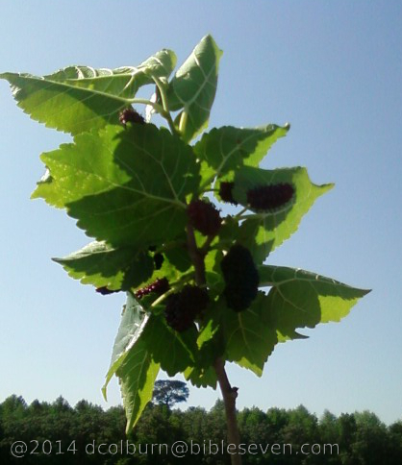
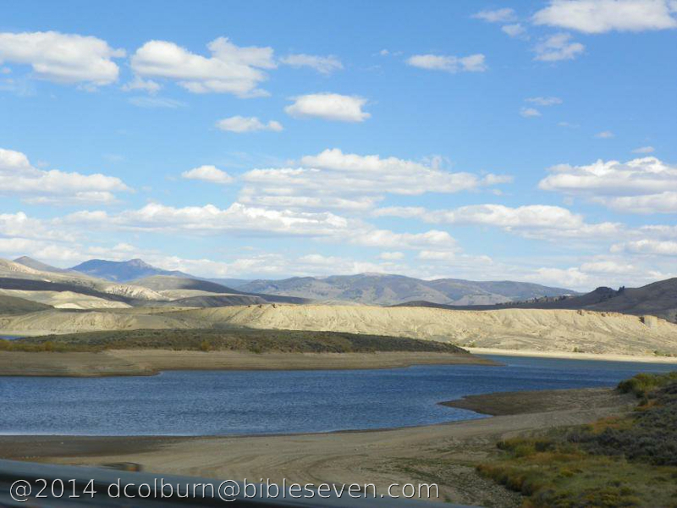
“Now no shrub of the field had yet grown on the earth, and no plant of the field had yet sprouted, for the Lord God had not caused it to rain on the earth, and there was no man to cultivate the ground. Springs would well up from the earth and water the whole surface of the ground. The Lord God formed the man from the soil of the ground and breathed into his nostrils the breath of life, and the man became a living being.
The Lord God planted an orchard in the east, in Eden; and there he placed the man he had formed.
The Lord God made all kinds of trees grow from the soil, every tree that was pleasing to look at and good for food. (Now the tree of life and the tree of the knowledge of good and evil were in the middle of the orchard.)
Now a river flows from Eden to water the orchard, and from there it divides into four headstreams. The name of the first is Pishon; it runs through the entire land of Havilah, where there is gold.
(The gold of that land is pure; pearls and lapis lazuli are also there). The name of the second river is Gihon; it runs through the entire land of Cush. The name of the third river is Tigris; it runs along the east side of Assyria. The fourth river is the Euphrates.
The Lord God took the man and placed him in the orchard in Eden to care for it and to maintain it.
Then the Lord God commanded the man, “You may freely eat fruit from every tree of the orchard, but you must not eat from the tree of the knowledge of good and evil, for when you eat from it you will surely die.”

They arrived in a distant land in hopes of finding the rumored spring of eternal youth. There was indeed a very special spring - and a beautiful tree bearing sweet hanging fruit stood next to it.
A unique combination of the spring, the fruit, and the person - resulted in forever young, or aging quickly. Neither the spring nor the fruit was of any benefit without the other.
The local belief was that the integrity of the person determined the reaction. So far no-one who had dared to test the spring and the fruit had possessed the integrity to earn eternal youth.
Adam and Eve had been informed of the potential for death. They had observed that when they picked and ate them - the berries, fruits, and greens were separated from their own source of life (the bush, the tree, or the plant) – which represented a primitive form of death.
In our day-to-day lives our inconsistent-integrity reveals something of our standing, with or without God. Fortunately, it's not our integrity, but rather that of Jesus the Christ - that earns us eternal life.

Dear Lord, I need Your integrity to be my integrity, all of the day and all of the night. Amen. dmc2016
Image Source: Copyright as in image watermark
Daily Devotional
Week 1 Day 5
OT (chronological)
Thursday (Genesis 2:18-25)
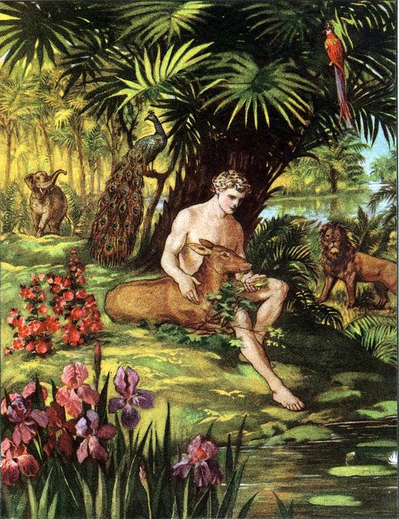
“2:19 The Lord God formed out of the ground every living animal of the field and every bird of the air. He brought them to the man to see what he would name them, and whatever the man called each living creature, that was its name.
2:20 So the man named all the animals, the birds of the air, and the living creatures of the field.
2:18 The Lord God said, “It is not good for the man to be alone. I will make a companion for him who corresponds to him.”
20b … but for Adam no companion who corresponded to him was found. 2:21 So the Lord God caused the man to fall into a deep sleep, and while he was asleep, he took part of the man’s side and closed up the place with flesh.
2:22 Then the Lord God made a woman from the part he had taken out of the man, and he brought her to the man. 2:23 Then the man said,
“This one at last is bone of my bones
and flesh of my flesh;
this one will be called ‘woman,’
for she was taken out of man.”
2:24 That is why a man leaves his father and mother and unites with his wife, and they become a new family.
2:25 The man and his wife were both naked, but they were not ashamed.”
Three young scientists had grown frustrated because no matter how they manipulated the microbes and other resources they found in the dirt - they simply could not coax it into growing human tissue.
An older scientist, watching them struggle, one day invited them to his lab – where he showed them a successful effort.
Shocked, they asked him how he had done what they could not, he explained “Human tissue is unique and unless you begin with a uniquely-human source – in this case adult stem cells – you can never succeed.”

In our lives we often struggle to find ways of doing things our own way, despite God's clear instruction that His way is the only healthy and wise way - so we become frustrated.
Humankind was invented by God, then distorted by sin, but God still understands us best.
When we choose our paths why not ask our inventor, Who loves us dearly, which way shall we go?

Dear Lord, I know that my flesh resists Your direction and discipline, please help me to choose You over everyone and everything else. Amen. dmc2016
Image Source: Public domain here http://biblelessonsite.org/images/creation.jpg
Daily Devotional
Week 1 Day 6
OT (chronological)
Friday (Genesis 3:1-13)

The Temptation and the Fall

“Now the serpent was more shrewd than any of the wild animals that the Lord God had made. He said to the woman, “Is it really true that God said, ‘You must not eat from any tree of the orchard’?”
The woman said to the serpent, “We may eat of the fruit from the trees of the orchard;
but concerning the fruit of the tree that is in the middle of the orchard God said, ‘You must not eat from it, and you must not touch it, or else you will die.’” The serpent said to the woman, “Surely you will not die,
for God knows that when you eat from it your eyes will open and you will be like divine beings who know good and evil.”

When the woman saw that the tree produced fruit that was good for food, was attractive to the eye, and was desirable for making one wise, she took some of its fruit and ate it.
She also gave some of it to her husband who was with her, and he ate it.
Then the eyes of both of them opened, and they knew they were naked;
so they sewed fig leaves together and made coverings for themselves.

Then the man and his wife heard the sound of the Lord God moving about in the orchard at the breezy time of the day, and they hid from the Lord God among the trees of the orchard.
But the Lord God called to the man and said to him, “Where are you?”
The man replied, “I heard you moving about in the orchard, and I was afraid because I was naked, so I hid.”
And the Lord God said, “Who told you that you were naked?
Did you eat from the tree that I commanded you not to eat from?”
The man said, “The woman whom you gave me, she gave me some fruit from the tree and I ate it.”
So the Lord God said to the woman, “What is this you have done?”
And the woman replied, “The serpent tricked me, and I ate.”

The mom and dad told their children that while the painting project in the bedrooms was completed they needed to wait in the kitchen.
They told their 7 year old son to ask his 12 year old sister if he needed any help with anything - and for them both to eat nothing until dinner time.
The sister sat and read her favorite part of her science book, the page that described how to make desserts, while her younger brother laid on the floor and read a magazine about dogs.
The pictures of the desserts made the sister hungry. When she looked into the kitchen she saw chocolate chip cookies in the glass cookie jar. She got up, walked into kitchen, took one, and ate it.
Feeling guilty she called her brother in and had him eat one as well.
Just about then their parents walked into the room and caught them with the cookie jar.
The girl said “I couldn't help myself, it was that school book”, and her brother said “You told me to I was supposed to listen to her”.

When we make our choices is it based on the boundaries that God has set or do we make excuses to satisfy the immediate desires of our flesh?

Dear Lord, Please gather about me – and those whom I love – people who obey You, so that we are not so easily led astray. Amen. dmc2016
Image Source: Copyright as in image watermark

Daily Devotional
Week 1 Day 7
OT (chronological)
Saturday (Genesis 3:14-24)
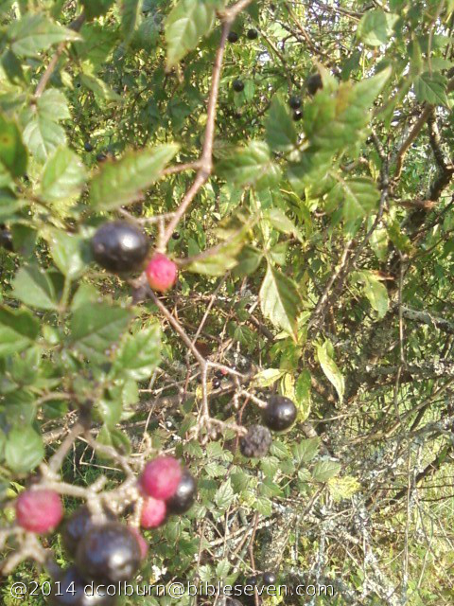
The Judgment Oracles of God at the Fall

“The Lord God said to the serpent,
“Because you have done this,
cursed are you above all the wild beasts
and all the living creatures of the field!
On your belly you will crawl
and dust you will eat all the days of your life.
And I will put hostility between you and the woman
and between your offspring and her offspring;
her offspring will attack your head,
and you will attack her offspring’s heel.”
To the woman he said,
“I will greatly increase your labor pains;
with pain you will give birth to children.
You will want to control your husband,
but he will dominate you.”
But to Adam he said,
“Because you obeyed your wife
and ate from the tree about which I commanded you,
‘You must not eat from it,’
cursed is the ground thanks to you;
in painful toil you will eat of it all the days of your life.
It will produce thorns and thistles for you,
but you will eat the grain of the field.
By the sweat of your brow you will eat food
until you return to the ground,
for out of it you were taken;
for you are dust, and to dust you will return.”
The man named his wife Eve,
because she was the mother of all the living.
The Lord God made garments from skin for Adam and his wife,
and clothed them.
And the Lord God said, “Now that the man has become like one of us, knowing good and evil,
he must not be allowed to stretch out his hand and take also from the tree of life and eat, and live forever.”
So the Lord God expelled him from the orchard in Eden to cultivate the ground from which he had been taken.
When he drove the man out,
he placed on the eastern side of the orchard in Eden
angelic sentries who used the flame of a whirling sword to guard the way to the tree of life.”

For years, every day at dark, the children were allowed to light one small rocket - it would fly up straight over the yard, then make colorful bright sparkles – after which they'd have a small treat.
There were many different size and color rockets from which to choose - and all were pretty.
On a shelf above them were two that looked just a little more special, one they were told to never light – even though the display would be magnificent – because if they did they'd have to move away. The other would be be beautiful as well - and it would mean they'd always have everything they needed.
It seemed to them that they would always have all they needed, so the second didn't seem so special, but when a note was found one evening on her door – saying “Fire that rocket and you'll get extra treats and nothing will change.” It was signed “A Friend” She decided to light it with her brother.
They did so and suddenly after the bright display a terrible cloud appeared in the sky and lightning started striking everywhere, burning the trees and setting the house on fire – so they ran from the house and the property – never to return.

There are people, places, things, and value-systems in this world which the Bible tells us to avoid.
They may seem exciting at first, and we may tell ourselves that we won't be harmed, but He is right.
Every sin leaves a scar on our hearts and minds and sometimes even on our physical body.
If we confess and repent He will forgive and restore us to His fellowship but we will bear the marks of our sin until we receive our new bodies in Heaven.

Dear Lord, It's so easy for us to imagine that “We got this” when the truth is “It's got us”. The enemy leaves a mark to celebrate where we once chose him over You, and to which he points when he's trying to trick us again. Humble us, discipline us, guide us away from that which separates us from You. Amen. dmc2016
Image Source: Copyright as in image watermark

All Bible text is from the NET unless otherwise indicated - http://bible.org
Devotional copyright © 2016 by David M. Colburn. This is associated with the BibleSeven Study – “Genesis 1-3 – OT Chronological”. This text may be used for non-profit educational purposes only, with credit; all other usage requires prior written consent of the author.

