Song of Songs 1 - 8
(Solomon Reflects Upon Love and Wisdom)
David M. Colburn
A Chronological Daily Bible Study of the Old Testament
7-Day Sections with a Summary-Commentary, Discussion Questions,
and a Practical Daily Application
Week 33

Sunday (Song of Songs 1)
Title/Superscription
1:1 Solomon’s Most Excellent Love Song.
The Desire for Love
1:2 The Beloved to Her Lover:
Oh, how I wish you would kiss me passionately!
For your lovemaking is more delightful than wine.
1:3 The fragrance of your colognes is delightful; your name is like the finest perfume. No wonder the young women adore you!
1:4 Draw me after you; let us hurry!
May the king bring me into his bedroom chambers!

The Maidens to the Lover:
We will rejoice and delight in you; we will praise your love more than wine.
The Beloved to Her Lover: How rightly the young women adore you!

The Country Maiden and the Daughters of Jerusalem
1:5 The Beloved to the Maidens:
I am dark but lovely, O maidens of Jerusalem, dark like the tents of Qedar, lovely like the tent curtains of Salmah.
1:6 Do not stare at me because I am dark, for the sun has burned my skin.
My brothers were angry with me; they made me the keeper of the vineyards.
Alas, my own vineyard I could not keep!

The Shepherd and the Shepherdess
1:7 The Beloved to Her Lover:
Tell me, O you whom my heart loves, where do you pasture your sheep?
Where do you rest your sheep during the midday heat?
Tell me lest I wander around beside the flocks of your companions!

1:8 The Lover to His Beloved:
If you do not know, O most beautiful of women, simply follow the tracks of my flock, and pasture your little lambs beside the tents of the shepherds.

The Beautiful Mare and the Fragrant Myrrh
1:9 The Lover to His Beloved:
O my beloved, you are like a mare among Pharaoh’s stallions.
1:10 Your cheeks are beautiful with ornaments; your neck is lovely with strings of jewels.
1:11 We will make for you gold ornaments studded with silver.

1:12 The Beloved about Her Lover:
While the king was at his banqueting table, my nard gave forth its fragrance.
1:13 My beloved is like a fragrant pouch of myrrh spending the night between my breasts.
1:14 My beloved is like a cluster of henna blossoms in the vineyards of En-Gedi.

Mutual Praise and Admiration
1:15 The Lover to His Beloved:
Oh, how beautiful you are, my beloved!
Oh, how beautiful you are!
Your eyes are like doves!

1:16 The Beloved to Her Lover:
Oh, how handsome you are, my lover!
Oh, how delightful you are!
The lush foliage is our canopied bed; 1:17 the cedars are the beams of our bedroom chamber; the pines are the rafters of our bedroom.

Prayer
Lord, Your love for those who have accepted Jesus as Lord is beyond any mere human comparison, but that is the best we can do as we attempt to comprehend it. May I praise You and rest in the encouragement and peace that comes from knowing that you love me with a passion unmatched anywhere in this world.

Scripture In Perspective
There is scholarly debate as to authorship; if the texts are written by Solomon or were they written about Solomon, and if are they purely about romantic passion or if there are embedded meanings beyond that.
[Note: There is nothing in this section of text about actual physical romantic contact, only the hyper-romanticized words of two infatuated young people. King David's Psalms were often filled with inflated rhetoric about God - Solomon was even more a man of artistic temperament and leisure.]
Solomon began with a description of the passion of one of the maidens – she had compared his lovemaking (the rest of this section of text implies her imagination versus realized passion) to the intoxicating effects of wine, then she apologized for her dark skin due to labor in the sun. The other maidens were all as smitten with him as she but she pleaded with him to be invited into his king's chambers (adding to the sense that nothing has yet occurred).
[Note: Ruth's skin would have been dark for the same reason, many hours in the sun (any skin tone impact from her non-Hebrew nationality is unclear), yet Boaz loved her and she was in the line of David and Jesus.]
Then he described himself as a shepherd and she as a shepherdess, she asked where he would be with his sheep, so that she would not be following around some other shepherd's flock. He instructed her to follow closely the path of his sheep and thus be near to him.
[Note: As Christians others, fellow Believers as well as those considering-Chris, should be able to sense the presence of God when they are near to us. This is part of us being His “salt and light” in this dark and dying world. Knowing how to identify God and His people helps one to avoid apostates and cults.]
He compared her to a mare among Pharaoh's stallions.
[Note: The NET Translator's Notes explain that this was drawn from a story where an enemy of Pharaoh sent a mare among his chariot-pulling stallions to cause them to go wild, but a soldier killed it before the stallions could react – it was intended as a compliment to her beauty.]
She responded that he was like myrrh between her breasts as she slept or like henna blossoms in the desert oasis.
[Note: She was not allowed, by her brothers, to own her own sheep so myrrh - a perfume or serving some sort of medicinal purpose – would have been difficult for her to afford (perhaps only something she imagined owning).]
They concluded by exchanging compliments and her final words described a fantasy place of passions “The lush foliage is our canopied bed; the cedars are the beams of our bedroom chamber; the pines are the rafters of our bedroom.”

Interact with the text

Consider
One might draw from the discussion of her following him with his sheep that a parallel-meaning could be the call of Jesus to His “bride” (the church) to do likewise.

Discuss
Does it fit with the rest of the Biblical text for the Song of Songs be merely about romantic passion? What might be the alternative purpose of this emotionally-powerful imagery?

Reflect
The author's knowledge of Egyptian history was remarkably detailed.

Share
When have you experienced or observed someone as smitten with Jesus, as the woman in the text was by Solomon, and as his father David often appeared to be (in his Psalms) with God?

KTALZ
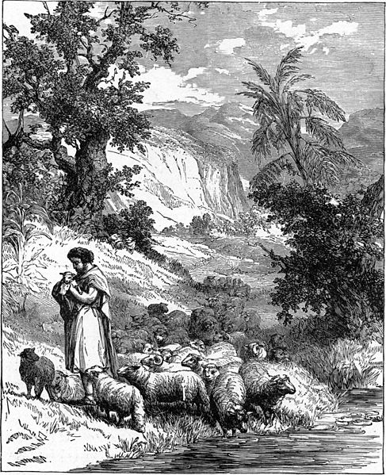

Just as Solomon told the young woman – if she wanted to be near him then follow his sheep, so also it should be said of God and His followers.
Source: Public domain here http://upload.wikimedia.org/wikipedia/commons/thumb/8/83/Foster_Bible_Pictures_0045-1_A_Shepherd.jpg/487px-Foster_Bible_Pictures_0045-1_A_Shepherd.jpg

Faith In Action

Pray
Ask the Holy Spirit to reveal to you the deep and passionate love He has for you, and also to show you how to be His “sheep” to such a degree of faithfulness that those considering Christ will be drawn nearer to Him when they are near to you.

Act
Today I will praise the Lord God and rest in the image of Him welcoming me, with open arms and a smile like the sun, into Heaven. I will also make the adjustments to my faith life and walk so as to be useful as His instrument in drawing others near – that those considering Christ will find His reflection in me appealing.
Be Specific ________________________________________________

Monday (Song of Songs 2)
The Lily among the Thorns and the Apple Tree in the Forest
2:1 The Beloved to Her Lover:
I am a meadow flower from Sharon, a lily from the valleys.
2:2 The Lover to His Beloved:
Like a lily among the thorns, so is my darling among the maidens.
2:3 The Beloved about Her Lover:
Like an apple tree among the trees of the forest, so is my beloved among the young men. I delight to sit in his shade, and his fruit is sweet to my taste.

The Banquet Hall for the Love-Sick
2:4 The Beloved about Her Lover:
He brought me into the banquet hall, and he looked at me lovingly.
2:5 Sustain me with raisin cakes, refresh me with apples, for I am faint with love.

The Double Refrain: Embracing and Adjuration
2:6 His left hand caresses my head, and his right hand stimulates me.
2:7 The Beloved to the Maidens:
I adjure you, O maidens of Jerusalem, by the gazelles and by the young does of the open fields:
Do not awaken or arouse love until it pleases!

The Arrival of the Lover
2:8 The Beloved about Her Lover:
Listen! My lover is approaching!
Look! Here he comes, leaping over the mountains, bounding over the hills!
2:9 My lover is like a gazelle or a young stag. Look! There he stands behind our wall, gazing through the window, peering through the lattice.

The Season of Love and the Song of the Turtle-Dove
2:10 The Lover to His Beloved:
My lover spoke to me, saying: “Arise, my darling;
My beautiful one, come away with me!
2:11 Look! The winter has passed, the winter rains are over and gone.
2:12 The pomegranates have appeared in the land, the time for pruning and singing has come; the voice of the turtledove is heard in our land.
2:13 The fig tree has budded, the vines have blossomed and give off their fragrance.
Arise, come away my darling; my beautiful one, come away with me!”

The Dove in the Clefts of En-Gedi
2:14 The Lover to His Beloved:
O my dove, in the clefts of the rock, in the hiding places of the mountain crags, let me see your face, let me hear your voice; for your voice is sweet, and your face is lovely.

The Foxes in the Vineyard
2:15 The Beloved to Her Lover:
Catch the foxes for us, the little foxes, that ruin the vineyards – for our vineyard is in bloom.

Poetic Refrain: Mutual Possession
2:16 The Beloved about Her Lover:
My lover is mine and I am his; he grazes among the lilies.

The Gazelle and the Rugged Mountains
2:17 The Beloved to Her Lover:
Until the dawn arrives and the shadows flee, turn, my beloved – be like a gazelle or a young stag on the mountain gorges.

Prayer
Lord, Your relationship with us is much like that described between Solomon and the woman, You love us passionately yet we are often fearful, timid, and wandering. May I accept Your love and seek-after only You.

Scripture In Perspective
The woman described herself humbly as a common flower of the region of Sharon, perhaps a crocus, and a chamomile lily of the valley.
Solomon responded, accepting her self-description, that she was therefore “a lily among the thorns”.
The woman replied that he was like an apple tree among the common trees of the field, continuing the analogy to describe his attention as like the sweet fruit, even as “a banquet hall.”
As she explained that when he held her she felt loved (but it remains unclear if the contact was in her imagination or real as the rest of the text describes him at some distance).
She warned other “maidens” to not engage in mere physical passion without a genuine love relationship.
[Note: It's unclear if she refers to “love relationship” meaning standing as a concubine or as a wife or apart from that. Also, depending on the time-period in Solomon's life as king, she could have been one of hundreds of wives and concubines and is writing of her longing for his attention. It's also important to note that Solomon was a king consumed with leisure, perhaps traveling from place to place and from one concubine/wife to another.]
She exclaimed with delight that he had arrived and was gazing at the women through the fence.
Solomon declared that it was Spring and therefore time for her to come away with him. He compared her to a timid dove, hiding in the protective clefts of the stony hills, and implored her to come out.
The woman replied that he should be careful of trouble, that she knows him to have multiple female interests, and that she had searched for him.

Interact with the text

Consider
The woman accepted that the man has other physical interests, which did not mean that such was appropriate – merely an acknowledgment of reality (Solomon had many concubines and wives), but she believed that her relationship with him was a unique true-love relationship.

Discuss
Why would Solomon express special love for this woman yet continue to “graze among the lily's”, likely a euphemism for sexual interaction with other “maidens”?

Reflect
The woman warned him that there was trouble ahead for their relationship if he continued his wandering ways, or if he was not careful to avoid a temptation designed to subvert their relationship.

Share
When have you experienced or observed someone who was in a relationship, one that they supposedly valued, yet they flirted (or worse) with other people?
KTALZ
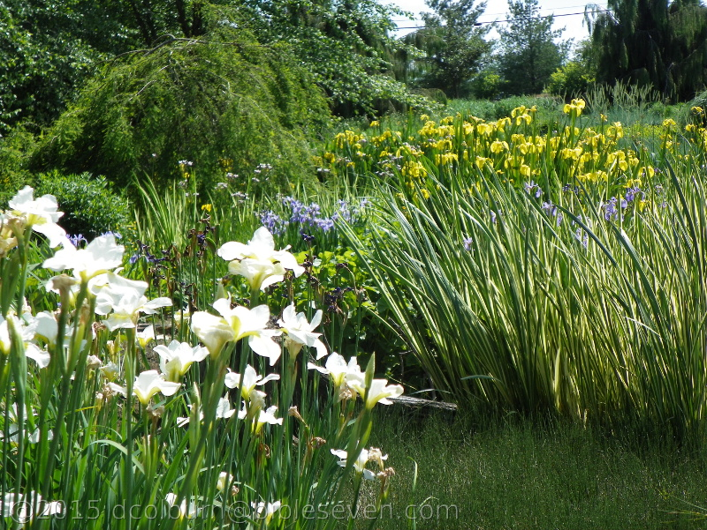

Lillies are both beautiful and delicate, as it the quality and righteousness-sensitive nature of our relationship with the Lord God.
Source: Copyright as watermarked on the image and noted in the weekly B7 study footnote.

Faith In Action

Pray
Ask the Holy Spirit to reveal to you a place in your walk where you are being relationally-careless.

Act
Today I will carefully, intentionally, and prayerfully seek the Holy Spirit's guidance as to any relationship-carelessness in my life and will repent of it (turn away and not return to it). It could be thoughtless flirting, inappropriate online conversations that belong solely to a spouse (whether married or single, some discussions are Biblically-restricted to a marriage relationship), or something more extreme.
Be Specific _____________________________________________

Tuesday (Song of Songs 3 - 4)
The Lost Lover is Found
3:1 The Beloved about Her Lover:
All night long on my bed I longed for my lover. I longed for him but he never appeared.
3:2 “I will arise and look all around throughout the town, and throughout the streets and squares; I will search for my beloved.” I searched for him but I did not find him.
3:3 The night watchmen found me – the ones who guard the city walls. “Have you seen my beloved?”
3:4 Scarcely had I passed them by when I found my beloved!
I held onto him tightly and would not let him go until I brought him to my mother’s house, to the bedroom chamber of the one who conceived me.

3:5 The Adjuration Refrain
The Beloved to the Maidens:
I admonish you, O maidens of Jerusalem, by the gazelles and by the young does of the open fields: “Do not awake or arouse love until it pleases!”

The Royal Wedding Procession
3:6 The Speaker:
Who is this coming up from the desert like a column of smoke, like a fragrant billow of myrrh and frankincense, every kind of fragrant powder of the traveling merchants?
3:7 Look! It is Solomon’s portable couch!
It is surrounded by sixty warriors, some of Israel’s mightiest warriors.
3:8 All of them are skilled with a sword, well-trained in the art of warfare. Each has his sword at his side, to guard against the terrors of the night.
3:9 King Solomon made a sedan chair for himself of wood imported from Lebanon.
3:10 Its posts were made of silver; its back was made of gold. Its seat was upholstered with purple wool; its interior was inlaid with leather by the maidens of Jerusalem.
3:11 Come out, O maidens of Zion, and gaze upon King Solomon!
He is wearing the crown with which his mother crowned him on his wedding day, on the most joyous day of his life!

The Wedding Night: Praise of the Bride
4:1 The Lover to His Beloved:
Oh, you are beautiful, my darling!
Oh, you are beautiful!
Your eyes behind your veil are like doves. Your hair is like a flock of female goats descending from Mount Gilead.
4:2 Your teeth are like a flock of newly-shorn sheep coming up from the washing place; each of them has a twin, and not one of them is missing.
4:3 Your lips are like a scarlet thread; your mouth is lovely.
Your forehead behind your veil is like a slice of pomegranate.
4:4 Your neck is like the tower of David built with courses of stones; one thousand shields are hung on it – all shields of valiant warriors.
4:5 Your two breasts are like two fawns, twins of the gazelle grazing among the lilies.
4:6 Until the dawn arrives and the shadows flee, I will go up to the mountain of myrrh, and to the hill of frankincense.
4:7 You are altogether beautiful, my darling!
There is no blemish in you!

The Wedding Night: Beautiful as Lebanon
4:8 Come with me from Lebanon, my bride, come with me from Lebanon. Descend from the crest of Amana, from the top of Senir, the summit of Hermon, from the lions’ dens and the mountain haunts of the leopards.
4:9 You have stolen my heart, my sister, my bride!
You have stolen my heart with one glance of your eyes, with one jewel of your necklace.
4:10 How delightful is your love, my sister, my bride!
How much better is your love than wine; the fragrance of your perfume is better than any spice!
4:11 Your lips drip sweetness like the honeycomb, my bride, honey and milk are under your tongue. The fragrance of your garments is like the fragrance of Lebanon.

The Wedding Night: The Delightful Garden
4:12 The Lover to His Beloved:
You are a locked garden, my sister, my bride; you are an enclosed spring, a sealed-up fountain.
4:13 Your shoots are a royal garden full of pomegranates with choice fruits: henna with nard,
4:14 nard and saffron; calamus and cinnamon with every kind of spice, myrrh and aloes with all the finest spices.
4:15 You are a garden spring, a well of fresh water flowing down from Lebanon.

4:16 The Beloved to Her Lover:
Awake, O north wind; come, O south wind!
Blow on my garden so that its fragrant spices may send out their sweet smell. May my beloved come into his garden and eat its delightful fruit!

Prayer
Lord, when we become Yours our relationship is “family” and we become exclusively Yours like the “locked garden” of ancient royalty. May I rest in the assurance of Your amazing love for me.

Scripture In Perspective
While the woman searched for Solomon she was found by the night watchmen, the guards of the walls.
[Note: Her search sounds a little like a person on the threshold of surrendering to the Lordship of Christ but who is clinging to worldly things, having trouble “finding” the Lord, but is “found” by those who already belong to the Lord.]
The woman announced that she finally found him and brought him to her mother's home.
[Note: There is discussion in the NET Translator's Notes that she wanted to make love in the same room as she was conceived because they had previously made love where he had been conceived – but the text doesn't require that (nor, as has been observed in the studies of chapters 1-3, do those prior text require an interpretation that they had previously “made love” at all; rather, this text seems to imply that she merely wanted him to meet her mother.]
Solomon's approach was heralded as he traveled in conspicuous luxury to the location of his impending wedding.
Solomon then heaped compliments upon the appearance of his bride.
[Note: His use of “sister” is explained in the NET Translator's Notes as a common ancient phrase in love-literature, generally to elevate the level of commitment to ones wife beyond marriage.]
Solomon described her using a term “locked garden” which meaning parallels an ancient custom of private gardens used by royalty – again amplifying her exclusive relationship with him – and could also imply that she was a virgin.
[Note: Some have suggested that the woman in the Song of Songs was his father's deathbed companion, the very beautiful and young virgin Shulamite woman.]

Interact With The Text

Consider
When a person is at the place in their journey where they are responding to the Lord's calling they “seek” and then are “found” by Him.

Discuss
Given Solomon's propensity to add women to his collection of wives and concubines how or why might this woman have earned such a special place that he wrote of her?

Reflect
Solomon, despite the gift of wisdom, seemed to have no comprehension of monogamy and a predisposition to wild flights of romantic fantasy.

Share
When have you been seeking an answer to a challenge and wondered where the Lord God was, only to have Him “find” you where you had not looked – but should have?
KTALZ
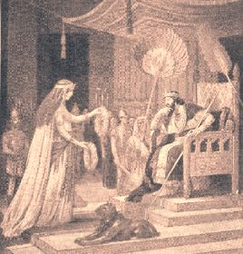

The identity of the object of Solomon's romantic interest is debated but one school of thought takes her to be David's deathbed companion, a young Shunammite virgin whose hand Adonijah sought – which got him killed – and whose beauty was renoun.
Source: Public domain here https://duckduckgo.com/l/?kh=-1&uddg=http%3A%2F%2Ftvsd.com.br%2Fpublicidade_bkp%2Fabishag-the-shunammite-for-adonijah

Faith In Action

Pray
Ask the Holy Spirit to reveal to you a blind-spot in your lifestyle where, like Solomon, you have been missing God's wisdom.

Act
Today I will confess and repent, seek and accept the Lord God's forgiveness, and replace that place of sin with something devoted to intentional righteousness. It may be some form of entertainment, a manner of dress, a way of speaking to others, uncontrolled anger, substance abuse/misuse, or other offense to the Holy Spirit within. I will ask a fellow Believer to pray in-agreement, and as is appropriate to be my accountability-partner, to challenge and encourage.
Be Specific _________________________________________________

Wednesday (Song of Songs 5)
5:1 The Lover to His Beloved:
I have entered my garden, O my sister, my bride; I have gathered my myrrh with my balsam spice.
I have eaten my honeycomb and my honey; I have drunk my wine and my milk!

The Poet to the Couple: Eat, friends, and drink!
Drink freely, O lovers!

The Trials of Love: The Beloved’s Dream of Losing Her Lover
5:2 The Beloved about Her Lover:
I was asleep, but my mind was dreaming. Listen! My lover is knocking at the door!
The Lover to His Beloved: “Open for me, my sister, my darling, my dove, my flawless one!
My head is drenched with dew, my hair with the dampness of the night.”

5:3 The Beloved to Her Lover:
“I have already taken off my robe – must I put it on again?
I have already washed my feet – must I soil them again?”
5:4 My lover thrust his hand through the hole, and my feelings were stirred for him.
5:5 I arose to open for my beloved; my hands dripped with myrrh – my fingers flowed with myrrh on the handles of the lock.
5:6 I opened for my beloved, but my lover had already turned and gone away. I fell into despair when he departed. I looked for him but did not find him; I called him but he did not answer me.
5:7 The watchmen found me as they made their rounds in the city. They beat me, they bruised me; they took away my cloak, those watchmen on the walls!

The Triumph of Love: The Beloved Praises Her Lover
5:8 The Beloved to the Maidens:
O maidens of Jerusalem, I command you – If you find my beloved, what will you tell him?
Tell him that I am lovesick!

5:9 The Maidens to The Beloved:
Why is your beloved better than others, O most beautiful of women?
Why is your beloved better than others, that you would command us in this manner?

5:10 The Beloved to the Maidens:
My beloved is dazzling and ruddy; he stands out in comparison to all other men.
5:11 His head is like the most pure gold. His hair is curly – black like a raven.
5:12 His eyes are like doves by streams of water, washed in milk, mounted like jewels.
5:13 His cheeks are like garden beds full of balsam trees yielding perfume. His lips are like lilies dripping with drops of myrrh.
5:14 His arms are like rods of gold set with chrysolite. His abdomen is like polished ivory inlaid with sapphires.
5:15 His legs are like pillars of marble set on bases of pure gold. His appearance is like Lebanon, choice as its cedars.
5:16 His mouth is very sweet; he is totally desirable.
This is my beloved!
This is my companion, O maidens of Jerusalem!

Prayer
Lord, You love us and have many times declared Your love. You, in the person of Jesus, have suffered mistreatment at the hands of those (the religious leaders - who should have supported You) as You sought us out. May I return as much of Your love as I am capable. May I also seek-after what You call me to be and to do, during my brief time in this world, no matter the resistance from those who simply do not understand.

Scripture In Perspective
Solomon declared his love for his bride.
He then added an editorial insertion “The Poet to the Couple: Eat, friends, and drink!”.
The rest of the text is the description of a nightmare-dream of the woman of him passing by, stopping briefly, and when she didn't get to the door immediately he moved on.
[Note: She knew it was him, in her dream, but hesitated because she didn't want to get her feet dirty. Given the many women in his life it may not have been unusual for him to be impatient.]
The woman searched for him again and was accosted, even her robe pulled away from her by the city watchmen, yet she continued her search.
[Note: In her dream, the watchmen may have taken her for a drunkard or a prostitute and attempted to arrest her but she was so desperate she broke-away from their grasp, leaving her robe behind.]
She pleaded with the maidens to help her to find him, but they asked her why they should do so, to which she responded that he was a most-unique man and she loved him.

Interact With The Text

Consider
Solomon switched from an 'actor' in his love story, to editor/poet, and back again.

Discuss
Why might his “bride” have had such a nightmare-dream?

Reflect
The woman was so desperate for Solomon that she endured mistreatment and still continued her search for him in the danger of night.

Share
When have you been so desperate for the attention of a person, or a heightened-level of interaction with the Lord God, that your pursuit continued despite the incredulity or even the mocking of others?

KTALZ
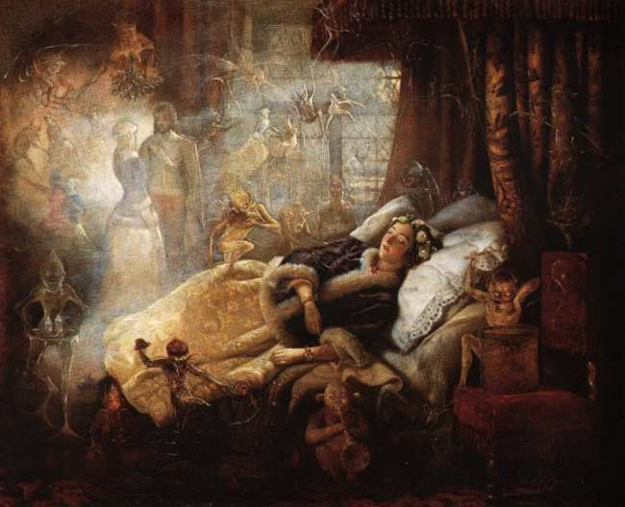

It is sad that one of Solomon's wives would have such a dream but perhaps it represented elements of her real-life circumstances.
Source: Public domain here http://www.twilighttimes.com/jan03/images/jaf_Dreams3.jpg

Faith In Action

Pray
Ask the Holy Spirit to reveal to you an element of your relationship, or a task He has assigned to you, in which He desires you to pursue - despite resistance from mere humans.

Act
Today I will prayerfully confirm the call of the Holy Spirit and go where He has directed. I will ask more than one fellow-Believer to pray in-agreement with me, both for verification of my initial right-discernment and for courage and wisdom, as I persevere.
Be Specific ________________________________________________

Thursday (Song of Songs 6)
The Lost Lover Found
6:1 The Maidens to the Beloved:
Where has your beloved gone, O most beautiful among women?
Where has your beloved turned?
Tell us, that we may seek him with you.

6:2 The Beloved to the Maidens:
My beloved has gone down to his garden, to the flowerbeds of balsam spices, to graze in the gardens, and to gather lilies.

Poetic Refrain: Mutual Possession
6:3 The Beloved about Her Lover:
I am my lover’s and my lover is mine; he grazes among the lilies.

The Renewal of Love
6:4 The Lover to His Beloved:
My darling, you are as beautiful as Tirzah, as lovely as Jerusalem, as awe-inspiring as bannered armies!
6:5 Turn your eyes away from me – they overwhelm me!
Your hair is like a flock of goats descending from Mount Gilead.
6:6 Your teeth are like a flock of sheep coming up from the washing; each has its twin; not one of them is missing.
6:7 Like a slice of pomegranate is your forehead behind your veil.
6:8 There may be sixty queens, and eighty concubines, and young women without number.
6:9 But she is unique!
My dove, my perfect one!
She is the special daughter of her mother, she is the favorite of the one who bore her.
The maidens saw her and complimented her; the queens and concubines praised her:
6:10 “Who is this who appears like the dawn?
Beautiful as the moon, bright as the sun, awe-inspiring as the stars in procession?”

The Return to the Vineyards
6:11 The Lover to His Beloved:
I went down to the orchard of walnut trees, to look for the blossoms of the valley, to see if the vines had budded or if the pomegranates were in bloom.
6:12 I was beside myself with joy!
There please give me your myrrh, O daughter of my princely people.

The Love Song and Dance
6:13 The Lover to His Beloved:
Turn, turn, O Perfect One!
Turn, turn, that I may stare at you!

The Beloved to Her Lover:
Why do you gaze upon the Perfect One like the dance of the Mahanaim?

Prayer
Lord, Solomon was a man of many earthly lusts; not initially, but soon after he settled into his life of leisure as king he began to seek greater fame and greater wealth, more luxuries and more women. He stumbled into a functional-idolatry of them and it harmed everyone involved. May I grow in Your wisdom to appreciate the things of beauty and value in this world without allowing myself to become captive to them.

Scripture In Perspective
The maidens inquired of the troubled woman as to the whereabouts of Solomon, adding that they'd like to go and find him as well.
[Note: The text is unclear as to their intent; if they were intending to assist her, or they also sought his attention.]
The woman declared “I am my lover’s and my lover is mine; he grazes among the lilies.”.
[Note: This may have been her assertion that even though Solomon was physically-with other women his heart still belonged to her. To “graze” and to “gather lilies” are terms previously used to imply interactions with other women. The NET Translator's Notes explain that there is some debate about the meaning, among which include Solomon visiting with his concubines, him fleeing to the safety of his gardens to escape the powerful emotions elicited by this woman, or that he was somehow with her, yet not – daydreaming or preoccupied with other matters.]
Solomon then reappeared, repeating his flowery description of his affection for her, and reinforcing the sense that he had temporarily fled (due to the overwhelming emotions), he said “Turn your eyes away from me – they overwhelm me!”
He continued, saying that he had been to the valley to see how the blooms were coming during the Spring and was overjoyed with them, and so he pleaded with her to return with him there to be together. And, reversing his prior request that she not look at him, he begged her to do so – referring to her as “Perfect One”.
She responded to his, asking why he would “... gaze upon the Perfect One like the dance of the Mahanaim?”.
[Note: The NET Translator's Text discusses the various possible meanings of the terms “Perfect One” and “dance of the Mahanaim”. The most-simple explanation, and the one flowing consistently with the rest of the text, is most likely to be correct; he had previously pontificated upon her physical perfection and her exceptional emotional connection with him – to the threshold of idol worship. His open-mouth staring at her would be parallel to one's reaction to an exceptionally passionate and powerful dance performed by young and talented female dancers – appealing to both his (and other male spectator's) awe and lust.]
If taken as symbolism this emphasizes that we are to have our constant attention focused on the The Perfect One, the Lord God. Even though we pollute that preferred singular focus with our impulsive worldly-lusts, He continues to desire and pursue us.

Interact With The Text

Consider
Despite the gift of wisdom, great wealth and power, and the blessing of the Lord God – Solomon was still a mere man of mere flesh and just as vulnerable to temptation as any man.

Discuss
Why would the woman want to be in a relationship with a man, king or not, who already had so many other women in his life?

Reflect
The lust of the eyes is among the greatest enemies of our relationship with the Lord God, from the first failure of Eve and Adam in the Garden, though the present.

Share
When have you been frightened by the adulation of others, fearing that you could not live up to it, or fearing that it might overwhelm your self-perspective?

KTALZ
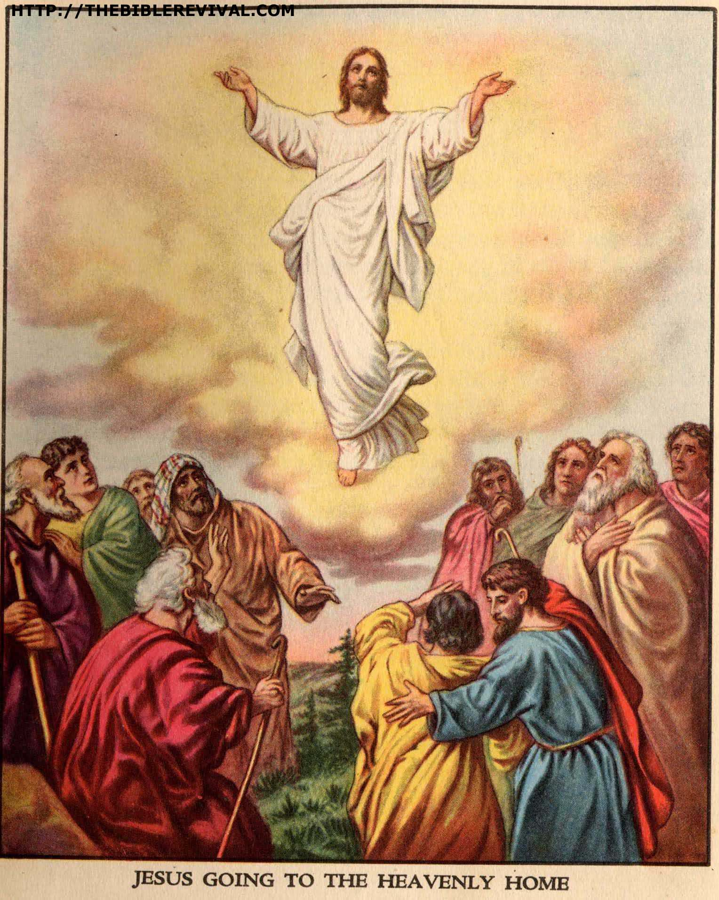

Jesus is The Perfect One on Whom our eyes should be focused and to Whom our greatest affection belongs.
Source: Public domain here http://thebiblerevival.com/clipart/jesus%20going%20to%20the%20heavenly%20home.jpg

Faith In Action

Pray
Ask the Holy Spirit to teach you how to be your own second-greatest fan, and greatest critic, second only to Him.

Act
Today I will accept God's teaching that I have value because of my relationship with Him, and that means that I am exceptionally-special. I will also partner with Him to search-out those places where I fall-short, and I will intentionally and prayerfully move toward greater maturity.
Be Specific _____________________________________________

Friday (Song of Songs 7)
7:1 The Lover to His Beloved:
How beautiful are your sandaled feet, O nobleman’s daughter!
The curves of your thighs are like jewels, the work of the hands of a master craftsman.
7:2 Your navel is a round mixing bowl – may it never lack mixed wine!
Your belly is a mound of wheat, encircled by lilies.
7:3 Your two breasts are like two fawns, twins of a gazelle.
7:4 Your neck is like a tower made of ivory.
Your eyes are the pools in Heshbon by the gate of Bath-Rabbim.
Your nose is like the tower of Lebanon overlooking Damascus.
7:5 Your head crowns you like Mount Carmel.
The locks of your hair are like royal tapestries – the king is held captive in its tresses!
7:6 How beautiful you are! How lovely, O love, with your delights!

The Palm Tree and the Palm Tree Climber
7:7 The Lover to His Beloved:
Your stature is like a palm tree, and your breasts are like clusters of grapes.
7:8 I want to climb the palm tree, and take hold of its fruit stalks.
May your breasts be like the clusters of grapes, and may the fragrance of your breath be like apricots!
7:9 May your mouth be like the best wine, flowing smoothly for my beloved, gliding gently over our lips as we sleep together.

Poetic Refrain: Mutual Possession
7:10 The Beloved about Her Lover:
I am my beloved’s, and he desires me!

The Journey to the Countryside
7:11 The Beloved to Her Lover:
Come, my beloved, let us go to the countryside; let us spend the night in the villages.
7:12 Let us rise early to go to the vineyards, to see if the vines have budded, to see if their blossoms have opened, if the pomegranates are in bloom – there I will give you my love.
7:13 The mandrakes send out their fragrance; over our door is every delicacy, both new and old, which I have stored up for you, my lover.

Prayer
Lord, You have often declared Your love for us; Jesus said “How I have longed to gather you to Myself.” May I be certain of Your love and respond in-kind.

Scripture In Perspective
Solomon, like his father David, was given to penning reams of flowery phraseology – in this case complimentary.
Solomon described the physical details of his young wife's body using comparative images which could defy the ability of a reader to comprehend.
[Note: do twin 4-legged gazelles and a woman's breasts have in common, other than the numeric similarity?]
Solomon returned to a reference to intoxication.
[Note: Perhaps literal intoxication (plus emotional intoxication) may explain his poetic excesses, e.g. describing kissing her lips as like wine to his senses.]
After her prior expression of concern for his commitment, followed by her hopeful declaration that his love would bring him back to her, she heard his praise and declared again her certainty of his commitment “I am my beloved’s, and he desires me!”
Solomon concluded by inviting her to the countryside, saying that if things are in bloom he would make love to her in the gardens.

Interact With The Text

Consider
The woman emphasized relationship, though she echoed Solomon's emphasis upon physical attributes, whereas Solomon mostly spoke of the physical.

Discuss
Might Solomon have been trying to assure the woman, using extreme flowery language, given his growing bevy of young and beautiful wives and concubines from across the known world?

Reflect
Solomon, living a life of luxurious ease, seemed to have a need to seek-out unusual experiences in unusual locations.

Share
When have you read a poem or story wherein which the language was so extreme and flowery that it became difficult to follow?

KTALZ
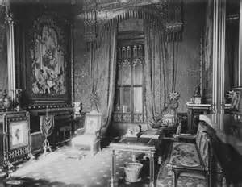

This image is of the royal window tapestry at Windsor Castle in the UK – the length and thickness may have been what Solomon was paralleling with his young wife's hair.
https://www.royalcollection.org.uk/collection/the-tapestry-room-windsor-castle

Faith In Action

Pray
Ask the Holy Spirit to reveal a place where He likes to meet you. Some place where you break-away from the world and where you are the least distracted by the things of the world.

Act
Today I will make time to be where the Lord God most effectively touches my heart and mind. It may be a certain room in my home at a certain time of day, it may be a place in my back yard or a park, it may be in a place Where believers gather, or somewhere else. The key will be to try and find a place that makes intimate communion with Him most-possible.
Be Specific _____________________________________________

Saturday (Song of Songs 8)
The Beloved’s Wish Song
8:1 The Beloved to Her Lover:
Oh, how I wish you were my little brother, nursing at my mother’s breasts; if I saw you outside, I could kiss you – surely no one would despise me!
8:2 I would lead you and bring you to my mother’s house, the one who taught me. I would give you spiced wine to drink, the nectar of my pomegranates.

Double Refrain: Embracing and Adjuration
8:3 The Beloved about Her Lover:
His left hand caresses my head, and his right hand stimulates me.

8:4 The Beloved to the Maidens:
I admonish you, O maidens of Jerusalem: “Do not arouse or awaken love until it pleases!”

The Awakening of Love
8:5 The Maidens about His Beloved:
Who is this coming up from the desert, leaning on her beloved?

The Beloved to Her Lover: Under the apple tree I aroused you; there your mother conceived you, there she who bore you was in labor of childbirth.

The Nature of True Love
8:6 The Beloved to Her Lover:
Set me like a cylinder seal over your heart, like a signet on your arm. For love is as strong as death, passion is as unrelenting as Sheol. Its flames burst forth, it is a blazing flame.
8:7 Surging waters cannot quench love; floodwaters cannot overflow it. If someone were to offer all his possessions to buy love, the offer would be utterly despised.

The Brother’s Plan and the Sister’s Reward
8:8 The Beloved’s Brothers:
We have a little sister, and as yet she has no breasts. What shall we do for our sister on the day when she is spoken for?
8:9 If she is a wall, we will build on her a battlement of silver; but if she is a door, we will barricade her with boards of cedar.

8:10 The Beloved:
I was a wall, and my breasts were like fortress towers. Then I found favor in his eyes.

Solomon’s Vineyard and the Beloved’s Vineyard
8:11 The Beloved to Her Lover:
Solomon had a vineyard at Baal-Hamon; he leased out the vineyard to those who maintained it. Each was to bring a thousand shekels of silver for its fruit.
8:12 My vineyard, which belongs to me, is at my disposal alone. The thousand shekels belong to you, O Solomon, and two hundred shekels belong to those who maintain it for its fruit.

Epilogue: The Lover’s Request and His Beloved’s Invitation
8:13 The Lover to His Beloved:
O you who stay in the gardens, my companions are listening attentively for your voice; let me be the one to hear it!

8:14 The Beloved to Her Lover:
Make haste, my beloved! Be like a gazelle or a young stag on the mountains of spices.

Prayer
Lord, You desire that we be wholeheartedly committed to You, and that we freely give all that we are and all that we possess in this world over to You. May I remain fully surrendered to the Lord God in everything.

Scripture In Perspective
The woman wished that Solomon were her very little brother so that when they met in public they could kiss.
[Note: The NET Translator's Notes explain that public displays of affection were discouraged but among family members were permitted. The age-hint in her daydream was so no one could question the appropriateness of her kissing her baby brother. The woman expanded her parallel illustration; she wanted to bring Solomon to the place where she was conceived (and where her mother nursed her little brother).]
She repeated her description of the touch of Solomon upon her head with one hand and her body with the other.
[Note: Scholars debate the precise meaning, as in vs 2:6. This could refer to his impact upon her mind and her body, could refer to his caring and his passion, or could mean literally what it appears to say. Solomon's predisposition to poetic license is nowhere as imprecise as in these love texts.
She again warned her fellow maidens to avoid physical involvement prior to knowing that the man is truly their beloved.
The maidens chronicled the arrival of the couple.
The woman challenged Solomon for a commitment of love to mark his heart as belonging to her.
The woman's brothers, still thinking of her as a figure-less little girl, declared their intent to defend her from harm.
The woman reminded them that she was no longer a little girl (her transition from girl to woman may have been celebrated in the earlier Spring-associated text of Solomon), that she was well-defended, and that she had found both love and passion with Solomon.
[Note: Several elements of this chapter repeat earlier texts and thus appear to be out of time-sequence - some earlier sections of the text referred to their wedding.]
The woman compared Solomon's vineyard (affections/possessions) to hers, his freely offered to her, and hers freely offered to him.
Solomon called out to her, observing that the others with him listened for her voice, but desired that he be the one to hear her first.
She responded, calling out “Make haste, my beloved! Be like a gazelle or a young stag on the mountains of spices.”

Interact With The Text

Consider
The woman placed a high value on genuine love, on deep commitment, and on sharing all things in common.

Discuss
Given his tendency to wander from woman to woman might Solomon's desire that he be first among his companions, to hear her voice, be a concern that she might be as promiscuous as he – and go to the first man she met?

Reflect
It appears that even the king, and one of his wives, needed to honor the cultural prohibition against public displays of affection.

Share
When have you longed for the innocence, and associated freedom, of childhood?
KTALZ
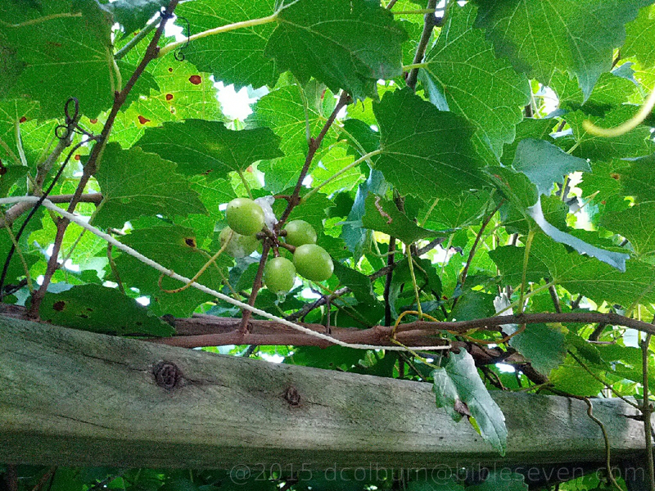

They offered one of their prized possessions, their vineyards, to one-another as a symbol of sacrifice and sharing.
Source: As labeled on photo and described in the bible study footnote.

Faith In Action

Pray
Ask the Holy Spirit to reveal to you a place in your relationship with the Lord God where you need to make a more complete commitment and surrender. It will be one of the many moments in your journey intended for maturity and will be an exercise that you will repeat.

Act
Today I will joyfully and prayerfully commit and surrender, where the Holy Spirit directs, separating myself from the bondage of the worldly values – in which I had previously either not recognized or had resisted surrendering to Him.
Be Specific _________________________________________________

All Bible text is from the NET unless otherwise indicated - http://bible.org
Note 1: These Studies often rely upon the guidance of the NET Translators from their associated notes. Careful attention has been given to cite that source where it has been quoted directly or closely paraphrased. Feedback is encouraged where credit has not been sufficiently assigned.
Note 2: When NET text is quoted in commentary and discussion all pronouns referring to God are capitalized, though they are lower-case in the original NET text.
Commentary text is from David M. Colburn, D.Min. unless otherwise noted.
Copyright © 2012-2015 by David M. Colburn. This is a BibleSeven Study –“Song of Songs”. Prepared by David M. Colburn and edited for bible.org in Spring 2015. This text may be used for non-profit educational purposes only, with credit; all other usage requires prior written consent of the author.

