Romans 11-16
David M. Colburn
A Daily Bible Study in 7-Day Sections with a Summary-Commentary, Discussion Questions, and Daily Application

Sunday (Romans 11)
Israel’s Rejection not Complete nor Final
11:1 So I ask, God has not rejected his people, has he? Absolutely not! For I too am an Israelite, a descendant of Abraham, from the tribe of Benjamin.
11:2 God has not rejected his people whom he foreknew! Do you not know what the scripture says about Elijah, how he pleads with God against Israel? 11:3 “Lord, they have killed your prophets, they have demolished your altars; I alone am left and they are seeking my life!”
11:4 But what was the divine response to him? “I have kept for myself seven thousand people who have not bent the knee to Baal.”
11:5 So in the same way at the present time there is a remnant chosen by grace. 11:6 And if it is by grace, it is no longer by works, otherwise grace would no longer be grace.
11:7 What then? Israel failed to obtain what it was diligently seeking, but the elect obtained it. The rest were hardened, 11:8 as it is written,
“God gave them a spirit of stupor, eyes that would not see and ears that would not hear, to this very day.”
11:9 And David says,
“Let their table become a snare and trap, a stumbling block and a retribution for them;
11:10 let their eyes be darkened so that they may not see, and make their backs bend continually.”
11:11 I ask then, they did not stumble into an irrevocable fall, did they? Absolutely not! But by their transgression salvation has come to the Gentiles, to make Israel jealous. 11:12 Now if their transgression means riches for the world and their defeat means riches for the Gentiles, how much more will their full restoration bring?
11:13 Now I am speaking to you Gentiles. Seeing that I am an apostle to the Gentiles, I magnify my ministry, 11:14 if somehow I could provoke my people to jealousy and save some of them. 11:15 For if their rejection is the reconciliation of the world, what will their acceptance be but life from the dead? 11:16 If the first portion of the dough offered is holy, then the whole batch is holy, and if the root is holy, so too are the branches.
11:17 Now if some of the branches were broken off, and you, a wild olive shoot, were grafted in among them and participated in the richness of the olive root, 11:18 do not boast over the branches. But if you boast, remember that you do not support the root, but the root supports you.
11:19 Then you will say, “The branches were broken off so that I could be grafted in.” 11:20 Granted! They were broken off because of their unbelief, but you stand by faith. Do not be arrogant, but fear! 11:21 For if God did not spare the natural branches, perhaps he will not spare you.
11:22 Notice therefore the kindness and harshness of God—harshness toward those who have fallen, but God’s kindness toward you, provided you continue in his kindness; otherwise you also will be cut off.
11:23 And even they—if they do not continue in their unbelief—will be grafted in, for God is able to graft them in again. 11:24 For if you were cut off from what is by nature a wild olive tree, and grafted, contrary to nature, into a cultivated olive tree, how much more will these natural branches be grafted back into their own olive tree?
11:25 For I do not want you to be ignorant of this mystery, brothers and sisters, so that you may not be conceited: A partial hardening has happened to Israel until the full number of the Gentiles has come in. 11:26 And so all Israel will be saved, as it is written:
“The Deliverer will come out of Zion; he will remove ungodliness from Jacob.
11:27 And this is my covenant with them, when I take away their sins.”
11:28 In regard to the gospel they are enemies for your sake, but in regard to election they are dearly loved for the sake of the fathers. 11:29 For the gifts and the call of God are irrevocable. 11:30 Just as you were formerly disobedient to God, but have now received mercy due to their disobedience, 11:31 so they too have now been disobedient in order that, by the mercy shown to you, they too may now receive mercy. 11:32 For God has consigned all people to disobedience so that he may show mercy to them all.
11:33 Oh, the depth of the riches and wisdom and knowledge of God! How unsearchable are his judgments and how fathomless his ways!
11:34 For who has known the mind of the Lord, or who has been his counselor?
11:35 Or who has first given to God, that God needs to repay him?
11:36 For from him and through him and to him are all things. To him be glory forever! Amen.

Prayer
Lord, Your plan is unfolding, we need to honor and obey and to pray for those who still need to repent and surrender to You. May I be faithful in telling Your story to those who are still strangers to You and to disciple fellow-believers who need to become better servants of yours.

Summary & Commentary
“Israel ... 7,000 people who have not bent the knee to Baal… a remnant…” preserved by the Lord God because they did not rebel by worshiping the false god.
“... chosen by grace ... salvation has come to the Gentiles, to make Israel jealous ...” [Note: Disobedience is against the Law, first the Jews and then the Gentiles are convicted by it, this then creates the opportunity for grace to bring unmerited mercy.]
Paul used the term “grace” as he had described earlier, a response to faith, not to works, and the “elect” as he previously described to be those who met the Roman 10 standard of belief and confession to receive salvation.
[Note: The English language term “elect”, as in to-elect or to be-elected, is the result of a process and not a foregone arbitrary conclusion. “The elect” is also the result of a process. To claim otherwise, choosing a hyper-narrow literalist-interpretation obligates one (based on this section of text) to declare that every Israelite is also “elect”. No eternal consequences for rebellion, no matter how gross.]
Paul noted that rebellious Israel had been further-hardened by God for a time so that the Gentiles could be “grafted in” but that later on Jews - who repented of their rebellion - would be “grafted back in”.
The Lord God did not cause them to be hardened, they chose to worship Baal, that was their initial “hardening”. Israel had, for a time, lost its status as a favored-nation.
The Lord God used Israel as His instrument to fulfill His prophesy (made at the time of the Fall in the Garden of Eden), so as-such, Israel was a necessary prior-step to the Gentile’s salvation—Paul warned the Gentiles understand the full historical context and to not disrespect the Israelites.
Those among the Israelites who would repent of their rebellion, and return to the Lord God (like the Prodigal Son), would be welcomed back into the His family for eternity.
The grace-through-mercy of God, made possible by Jesus the Christ, cannot ever be earned or deserved by fallen man but is offered in exchange for our surrender of the hopelessness of slavery to a sin-controlled existence in this fallen world.

Interaction

Consider
The Israelites had a long and rocky relationship with the Lord God, often blessed, and often punished due to terrible rebellion, yet the Lord God still loved them—the same as He did the very first man and woman - and everything else in His creation.

Discuss
Does the pattern of options and choices give you confidence in the Lord God's promise to allow humankind free will, even though it pains Him greatly to see us fail and to suffer, and even though it cost excruciating-suffering for His only Son in the flesh?

Reflect
The sequence of events in God’s redemption of rebellious man:
- God permits free will and man rebels in the Garden.
- God “corrects the course” of man at the Tower of Babel, via the Flood, through the Exodus, and in and out of captivity as a result of continued rebellion.
- God comes in the form of the man Jesus to be The Christ to provide a way home.
- God calls preachers and teachers via disciples and apostles.
- God causes His Holy Bible to be written and distributed that all may know and grow.
- God returns, takes His own home and obliterates the rest.
- God shares eternity with His family.

Share
When have you been reading your Bible and paused in amazement at the consistency and the persistent-patience and unending love of the Lord God?

KTALZ


Grafting a branch can cause some disruption of the flow of life in the host but if done correctly it heals fine. Some fruit trees have successfully hosted grafts from several other different fruit trees.
Source: Public domain here http://extension.missouri.edu/explore/images/g06971art04c.jpg

Faith in Action

Prayer:
Ask the Holy Spirit to remind you of the one most-appealing thing that drew you to Him.

Action:
Today I will reflect, with a fellow believer, upon the incredible expanse of HIS-story—a story where God has not allowed His children to all be destroyed, a story within which He has made corrections to the flow of human history - without violating the individual free will choice of everyone to chose Him or not.

Be Specific ______________________________________________________

Monday (Romans 12)
Consecration of the Believer’s Life
12:1 Therefore I exhort you, brothers and sisters, by the mercies of God, to present your bodies as a sacrifice—alive, holy, and pleasing to God—which is your reasonable service.
12:2 Do not be conformed to this present world, but be transformed by the renewing of your mind, so that you may test and approve what is the will of God—what is good and well-pleasing and perfect.
Conduct in Humility
12:3 For by the grace given to me I say to every one of you not to think more highly of yourself than you ought to think, but to think with sober discernment, as God has distributed to each of you a measure of faith.
12:4 For just as in one body we have many members, and not all the members serve the same function, 12:5 so we who are many are one body in Christ, and individually we are members who belong to one another.
12:6 And we have different gifts according to the grace given to us. If the gift is prophecy, that individual must use it in proportion to his faith. 12:7 If it is service, he must serve; if it is teaching, he must teach; 12:8 if it is exhortation, he must exhort; if it is contributing, he must do so with sincerity; if it is leadership, he must do so with diligence; if it is showing mercy, he must do so with cheerfulness.
Conduct in Love
12:9 Love must be without hypocrisy. Abhor what is evil, cling to what is good.
12:10 Be devoted to one another with mutual love, showing eagerness in honoring one another.
12:11 Do not lag in zeal, be enthusiastic in spirit, serve the Lord. 12:12 Rejoice in hope, endure in suffering, persist in prayer.
12:13 Contribute to the needs of the saints, pursue hospitality.
12:14 Bless those who persecute you, bless and do not curse.
12:15 Rejoice with those who rejoice, weep with those who weep.
12:16 Live in harmony with one another; do not be haughty but associate with the lowly. Do not be conceited.
12:17 Do not repay anyone evil for evil; consider what is good before all people.
12:18 If possible, so far as it depends on you, live peaceably with all people.
12:19 Do not avenge yourselves, dear friends, but give place to God’s wrath, for it is written, “Vengeance is mine, I will repay,” says the Lord. 12:20 Rather, if your enemy is hungry, feed him; if he is thirsty, give him a drink; for in doing this you will be heaping burning coals on his head.
12:21 Do not be overcome by evil, but overcome evil with good.

Prayer
Lord, You teach us to not attempt to overcome evil with more evil (because we will then be overcome by evil and the enemy will have a double-victory) but rather to overcome evil with good. May I be faithful in that, even though it is contrary to my flesh, and very difficult to do—with Your indwelling Holy Spirit I am able—in Your righteous-strength.

Summary & Commentary
It “... is your reasonable service. Do not be conformed to this present world.” Be humble, honor one another through mutual love. “Rejoice in hope, endure in suffering, persist in prayer ... Do not be overcome by evil, but overcome evil with good.”
Paul implored “... present your bodies as a sacrifice ... be transformed by the renewing of your mind” so that in knowing and applying the will [known via the Word] of God one may mature as a Christian.
Paul linked back to his discussion of “judging” to make the point that humility prevents sin “... think more highly of yourself than you ought to think”. He then goes on to note that the exercise of “gifts” are to be in proportion to “humility”, not to show off and not ritualistically. He specifically lists prophesy, service, teaching, exhortation, contributing, leadership, and mercy.
Paul qualifies each to show the linkage between humility (as modeled by Jesus and Paul) and the exercise of gifts:
Gift Description | Humility-Qualifier
Prophesy (mostly re-telling, rarely fore-telling) | In proportion to faith (not faked)
Service (assisting others in need) | Serve (remember foot-washing)
Teaching (the Word of God w/o changes) | Teach (tell HIS-story, not yours)
Exhortation (plead for salvation and righteousness) | Exhort (not manipulate, motivate)
Contributing (give from God’s bounty) | Sincerely (not Ananias & Sapphira)
Leadership (intentionally show the way) | Diligence (integrity & persistence)
Mercy (comfort, encourage, & forgive) | Cheerfully (not reluctantly)

Paul checked-off a list of what true Biblical love “looks like”:
- Without hypocrisy
- Abhorring what is evil
- Clinging to what is good
- Devoted to one another with mutual love
- Eagerly honoring one another
- Zealous & enthusiastic in spirit serving the Lord
- Rejoicing in hope
- Enduring in suffering
- Persisting in prayer
- Contributing to the needs of the saints
- Pursuing hospitality
- Blessing those who persecute you (not cursing them)
- Rejoicing with those who rejoice
- Weeping with those who weep
- Living on harmony with one another
- Playing no favorites for the rich over poor, pretty over ugly, easy over difficult
- Never conceited
- Never repaying evil with evil
- Look for the good rather than the bad as people are watching
- When you control relational circumstances choose to live peaceably with others
- Never seek revenge, “‘Vengeance is mine” says the Lord’”
- Feed a hungry enemy & give a thirsty enemy drink, heap the burning coals of warmth on his head [and conviction that you are a child of the one true Lord].

Interaction

Consider
Whenever we think of ourselves more-highly than we should we are then prone to “judge” others, but when we are humble we may be discerning about others without judging them.

Discuss
How do the items on the chart and the checklist from Paul and reflect upon your life and how do they apply to your walk?

Reflect
It is the righteousness of the Lord God that His Holy Spirit pours-out through us which accomplishes the things Paul listed.

Share
When have you experienced or observed a struggle with humility which then was reflected in the right application of and attitude toward gifts?

KTALZ
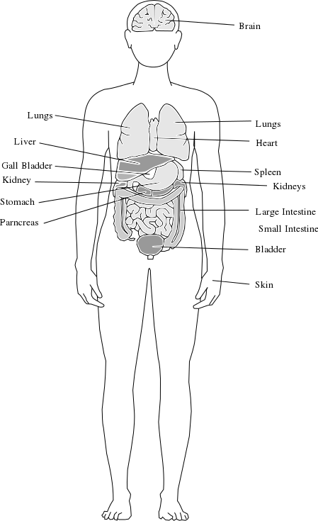

Members of a fellowship are interdependent and unique as in the human body.
Source: Public domain here http://www.wpclipart.com/medical/anatomy/organs_various/body_organs.png

Faith in Action

Prayer:
Ask the Holy Spirit reveal to you at least one item on Paul’s list where you need to partner with Him in order to grow.

Action:
Today I will ask a fellow believer to pray in agreement with me for perseverance in that effort.

Be Specific ______________________________________________________

Tuesday (Romans 13)
Submission to Civil Government
13:1 Let every person be subject to the governing authorities. For there is no authority except by God’s appointment, and the authorities that exist have been instituted by God. 13:2 So the person who resists such authority resists the ordinance of God, and those who resist will incur judgment 13:3 (for rulers cause no fear for good conduct but for bad). Do you desire not to fear authority? Do good and you will receive its commendation, 13:4 for it is God’s servant for your good. But if you do wrong, be in fear, for it does not bear the sword in vain. It is God’s servant to administer retribution on the wrongdoer. 13:5 Therefore it is necessary to be in subjection, not only because of the wrath of the authorities but also because of your conscience. 13:6 For this reason you also pay taxes, for the authorities are God’s servants devoted to governing. 13:7 Pay everyone what is owed: taxes to whom taxes are due, revenue to whom revenue is due, respect to whom respect is due, honor to whom honor is due.
Exhortation to Love Neighbors
13:8 Owe no one anything, except to love one another, for the one who loves his neighbor has fulfilled the law. 13:9 For the commandments, “Do not commit adultery, do not murder, do not steal, do not covet,” (and if there is any other commandment) are summed up in this, “Love your neighbor as yourself.” 13:10 Love does no wrong to a neighbor. Therefore love is the fulfillment of the law.
Motivation to Godly Conduct
13:11 And do this because we know the time, that it is already the hour for us to awake from sleep, for our salvation is now nearer than when we became believers. 13:12 The night has advanced toward dawn; the day is near. So then we must lay aside the works of darkness, and put on the weapons of light. 13:13 Let us live decently as in the daytime, not in carousing and drunkenness, not in sexual immorality and sensuality, not in discord and jealousy. 13:14 Instead, put on the Lord Jesus Christ, and make no provision for the flesh to arouse its desires.

Prayer
Lord, You teach us about our human nature and our spiritual nature in-You, then You teach us how to manage both. May I be a humble and teachable student.

Summary & Commentary
Jesus taught: “Then give to Caesar the things that are Caesar’s, and to God the things that are God’s.” Matthew 22:21 [Paul was expanding on the practical application of that principle.]
Fallen humans, even believers, require the “container” or boundaries of organized systems for civilization lest we drift into Sodom and Gomorrah-like anarchy “Let every person be subject to the governing authorities. For there is no authority except by God’s appointment ... if you do wrong, be in fear ...”
Paul was not teaching Christians to be debt-free, but to be balanced (because elsewhere the management of debt is discussed) “Pay everyone what is owed ... Owe no one anything ...” describes both immediate payments in-full and debt payments on-time.
He challenged Christians whose human nature caused them to seek their own best-interest and to think of themselves as valuable to look outside of themselves and to “Love your neighbor as yourself ...”
Paul echoed the call of Jesus to live righteously – even when no one is watching “Let us live decently as in the daytime ... put on the Lord Jesus Christ, and make no provision for the flesh to arouse its desires.”
Paul reminded that authority “... does not bear the sword in vain.”, because authority by-definition includes the power to enforce boundaries and rules.
He provided a list of expectations for Christians in-community as guidance:
- “... pay taxes, for the authorities are God’s servants devoted to governing.”
- “Pay everyone what is owed: taxes ... revenue ... respect ... honor.
- “Owe no one anything, except to love one another
[Note: Paul is not instructing believers to affirm or practice unrighteous deeds, even if “rulers” demand such, as in an Islamist country where slavery, brutality, and death are threatened if one does not deny Christ and accept their false teaching. In a free country Christians are expected to participate in the political process so as to remove laws that impose sin. There have been many discussions about the obligation of Christians to evil rulers.]
Paul provided another list for us to successfully “... live decently as in the daytime” putting “... on the Lord Jesus Christ” making “... no provision for the flesh to arouse its desires.”
- “... not in carousing”
- “... not in ... drunkeness”
- “... not in sexual immorality”
- “... not in ... sensuality”
- “... not in discord”
- “... not in ... jealousy”

Interaction

Consider
The fallen nature of man results in a typical outcome when fallen humans are separated from a civilizing "container" for long.

Discuss
What is your understanding of the dividing line between “that which is Caesar’s” and “that which is God’s”?

Reflect
Paul’s list for putting on the Lord Jesus Christ (righteous living) is reflected elsewhere in the direct teaching of Jesus, that of other Biblical authors, and in the Old Testament. The Lord God is perfectly-consistent.

Share
When have you experienced or observed the consequence of the absence of authority as a “container for civilization”?

KTALZ


Just like the sunlight breaking free of an eclipse so also are Believers to break free of the darkness and be instruments for the light of God's truth to shine into a dark world.

Faith in Action

Prayer:
Ask the Holy Spirit to reveal to you a place in Paul's list, for putting on the Lord Jesus Christ (righteous living), and identify at least one area where you need to partner with the Holy Spirit to move toward greater maturity.

Action:
Today I will ask a fellow believer to pray in agreement with me for perseverance in my effort, with the Holy Spirit, to move toward greater maturity. I will share the result of that effort with that prayer-partner and we will celebrate and praise the Lord together.

Be Specific ______________________________________________________

Wednesday (Romans 14)
Exhortation to Mutual Forbearance
14:1 Now receive the one who is weak in the faith, and do not have disputes over differing opinions.
14:2 One person believes in eating everything, but the weak person eats only vegetables. 14:3 The one who eats everything must not despise the one who does not, and the one who abstains must not judge the one who eats everything, for God has accepted him.
14:4 Who are you to pass judgment on another’s servant? Before his own master he stands or falls. And he will stand, for the Lord is able to make him stand.
14:5 One person regards one day holier than other days, and another regards them all alike. Each must be fully convinced in his own mind.
14:6 The one who observes the day does it for the Lord. The one who eats, eats for the Lord because he gives thanks to God, and the one who abstains from eating abstains for the Lord, and he gives thanks to God.
14:7 For none of us lives for himself and none dies for himself.
14:8 If we live, we live for the Lord; if we die, we die for the Lord. Therefore, whether we live or die, we are the Lord’s.
14:9 For this reason Christ died and returned to life, so that he may be the Lord of both the dead and the living.
14:10 But you who eat vegetables only—why do you judge your brother or sister? And you who eat everything—why do you despise your brother or sister? For we will all stand before the judgment seat of God.
14:11 For it is written, “As I live, says the Lord, every knee will bow to me, and every tongue will give praise to God.”
14:12 Therefore, each of us will give an account of himself to God.
Exhortation for the Strong not to Destroy the Weak
14:13 Therefore we must not pass judgment on one another, but rather determine never to place an obstacle or a trap before a brother or sister.
14:14 I know and am convinced in the Lord Jesus that there is nothing unclean in itself; still, it is unclean to the one who considers it unclean.
14:15 For if your brother or sister is distressed because of what you eat, you are no longer walking in love. Do not destroy by your food someone for whom Christ died. 14:16 Therefore do not let what you consider good be spoken of as evil. 14:17 For the kingdom of God does not consist of food and drink, but righteousness, peace, and joy in the Holy Spirit. 14:18 For the one who serves Christ in this way is pleasing to God and approved by people.
14:19 So then, let us pursue what makes for peace and for building up one another. 14:20 Do not destroy the work of God for the sake of food. For although all things are clean, it is wrong to cause anyone to stumble by what you eat. 14:21 It is good not to eat meat or drink wine or to do anything that causes your brother to stumble.
14:22 The faith you have, keep to yourself before God. Blessed is the one who does not judge himself by what he approves.
14:23 But the man who doubts is condemned if he eats, because he does not do so from faith, and whatever is not from faith is sin.

Prayer
Lord, You give us freedoms in our faith but we are expected to be careful that we do not exercise them selfishly so as to cause our brother to stumble. May I be intentional in all that I do—bring attention and honor and glory to You.

Summary & Commentary
“Now receive the one who is weak in the faith ...”
Among truly-saved believers whether one treats one day as “holier” than another or all the same, eats or fasts, lives or dies, because he or she belongs to the Lord all they do—and how they do it is also for the Lord and answers only to the Lord. The only things that are unclean are those which compromise ones relationship with God. “... whatever is not from faith is sin.”
Paul used the still-confused, spiritually immature, behavior of those who were “... weak in the faith” to demonstrate living-out grace toward fellow believers.
Some still harbored superstitious beliefs about meat sacrificed to idols by pagans or sacrificed to God by Law-bound incomplete Jews which prevented them from eating meat “.. the weak person eats only vegetables”, He instructed the more mature - who would have been free to eat anything - to be patient with the weaker—allowing (the weak believer) to do what best-honored God in their heart.

Interaction

Consider
Condemnation of a “weak” believer, about things not essential to salvation or righteous living, may drive them out of fellowship, slow their spiritual growth, or even cause them to reject Christ (even though—if their confession-conversion was genuine—their salvation cannot be “lost” - they may choose to live for a long time as if it were).

Discuss
List examples where a wrongful attitude toward a “weak” believer was confronted and corrected. What was the outcome?

Reflect
Paul used the still-confused, spiritually immature, behavior of those who were “... weak in the faith” to demonstrate living-out grace toward fellow believers.

Share
When have you experienced confusion because someone was making choices, that you did not understand as a new believer, but which you later came to understand? [Note: This is why the Bible discourages being “unequally-yoked” in business or marriage. Not only are linkages between Believers and non-Believers discouraged but also between mature and immature – decisions must be made and the two understand differently due to relative maturity.]

KTALZ


God created plants and animals alike and directly warned Peter, based on religious tradition, to not call unclean what He had said was clean. God's priority, applied by Paul, was that we must be sensitive to the impact of our choices on easily confused immature Believers.

Faith in Action

Prayer:
Ask the Holy Spirit to reveal to you a place where I harbor any beliefs which limit my freedom where God has not limited it (not necessarily specific to ritualistically “clean” of “unclean” foods but perhaps denominations, human religious traditions, Bible translations, styles of music, styles of clothing, buildings, gender roles in leadership, race, etc.).

Action:
Today I will ask a fellow believer to pray in agreement with me as I partner with the Holy Spirit to purge that immature belief from my life.

Be Specific ______________________________________________________

Thursday (Romans 15:1-13)
Exhortation for the Strong to Help the Weak
15:1 But we who are strong ought to bear with the failings of the weak, and not just please ourselves.
15:2 Let each of us please his neighbor for his good to build him up. 15:3 For even Christ did not please himself, but just as it is written, “The insults of those who insult you have fallen on me.”
15:4 For everything that was written in former times was written for our instruction, so that through endurance and through encouragement of the scriptures we may have hope.
15:5 Now may the God of endurance and comfort give you unity with one another in accordance with Christ Jesus, 15:6 so that together you may with one voice glorify the God and Father of our Lord Jesus Christ.
Exhortation to Mutual Acceptance
15:7 Receive one another, then, just as Christ also received you, to God’s glory.
15:8 For I tell you that Christ has become a servant of the circumcised on behalf of God’s truth to confirm the promises made to the fathers, 15:9 and thus the Gentiles glorify God for his mercy. As it is written, “Because of this I will confess you among the Gentiles, and I will sing praises to your name.”
15:10 And again it says: “Rejoice, O Gentiles, with his people.”
15:11 And again, “Praise the Lord all you Gentiles, and let all the peoples praise him.”
15:12 And again Isaiah says, “The root of Jesse will come, and the one who rises to rule over the Gentiles, in him will the Gentiles hope.”
15:13 Now may the God of hope fill you with all joy and peace as you believe in him, so that you may abound in hope by the power of the Holy Spirit.

Prayer
Lord, You reminded us that we have responsibilities to others—especially fellow-believers—to be caring and considerate, sacrificing some of our comfort and convenience for their sakes. May I be careful to not impose personal preferences of style and personal freedoms of expression where such might discourage those considering-Christ or may confuse or discourage new and/or less-mature fellow believers.

Summary & Commentary
“... bear with the failings of the weak ... Let each of us please his neighbor for his good to build him up ... may the God of encouragement and comfort give you unity with one another ... abound in hope by the power of the Holy Spirit …”
Paul continued his exhortation that we “make room for” the weaker believer, that the more mature not create an environment that was unnecessarily confusing and/or uncomfortable for newer and/or weaker believers (and those considering-Christ).
He quoted “The insults of those who insult you have fallen on me.” echoing the challenge of Jesus to Paul on the road to Damascus “Why do you persecute Me?”; everything that matters is ultimately always about Him.
He reminded that Psalms 69:9 described the provision of Christ, explaining that “... everything that was written in former times was written for our instruction, so that through endurance and through encouragement of the scriptures we may have hope.”
Paul called for unity among believers, Jew and Gentile alike, “... to God’s glory.”
Paul reminded his Roman audience that the OT foretold salvation for the Gentiles through the Messiah and that he was “... a minister of Christ Jesus to the Gentiles ... to bring about the obedience of the Gentiles” so that “... those who have not [yet] heard will understand.”
And he reiterated that our hope must be found in the Lord God through the Holy Spirit.

Interaction

Consider
The Lord God demonstrates an amazing continuity of the Bible over thousands of years and across nations and continents. God foretold and God accomplished. We merely acknowledge.

Discuss
Do we have essential unity based on what the Bible says is important or are we rebellious—dividing over that which is not essential and which God says to not divide?

Reflect
There is amazing diversity within the body of Christ, old and young, male and female, across cultures and nationalities and race. New believers, stuck believers, and maturing believers.

Share
When have you observed older believers, not necessarily more-mature (though they may think so), imposing preferences for a Bible translation, music, order of worship, style of building decoration, etc. on others—without regard for consequences?

KTALZ
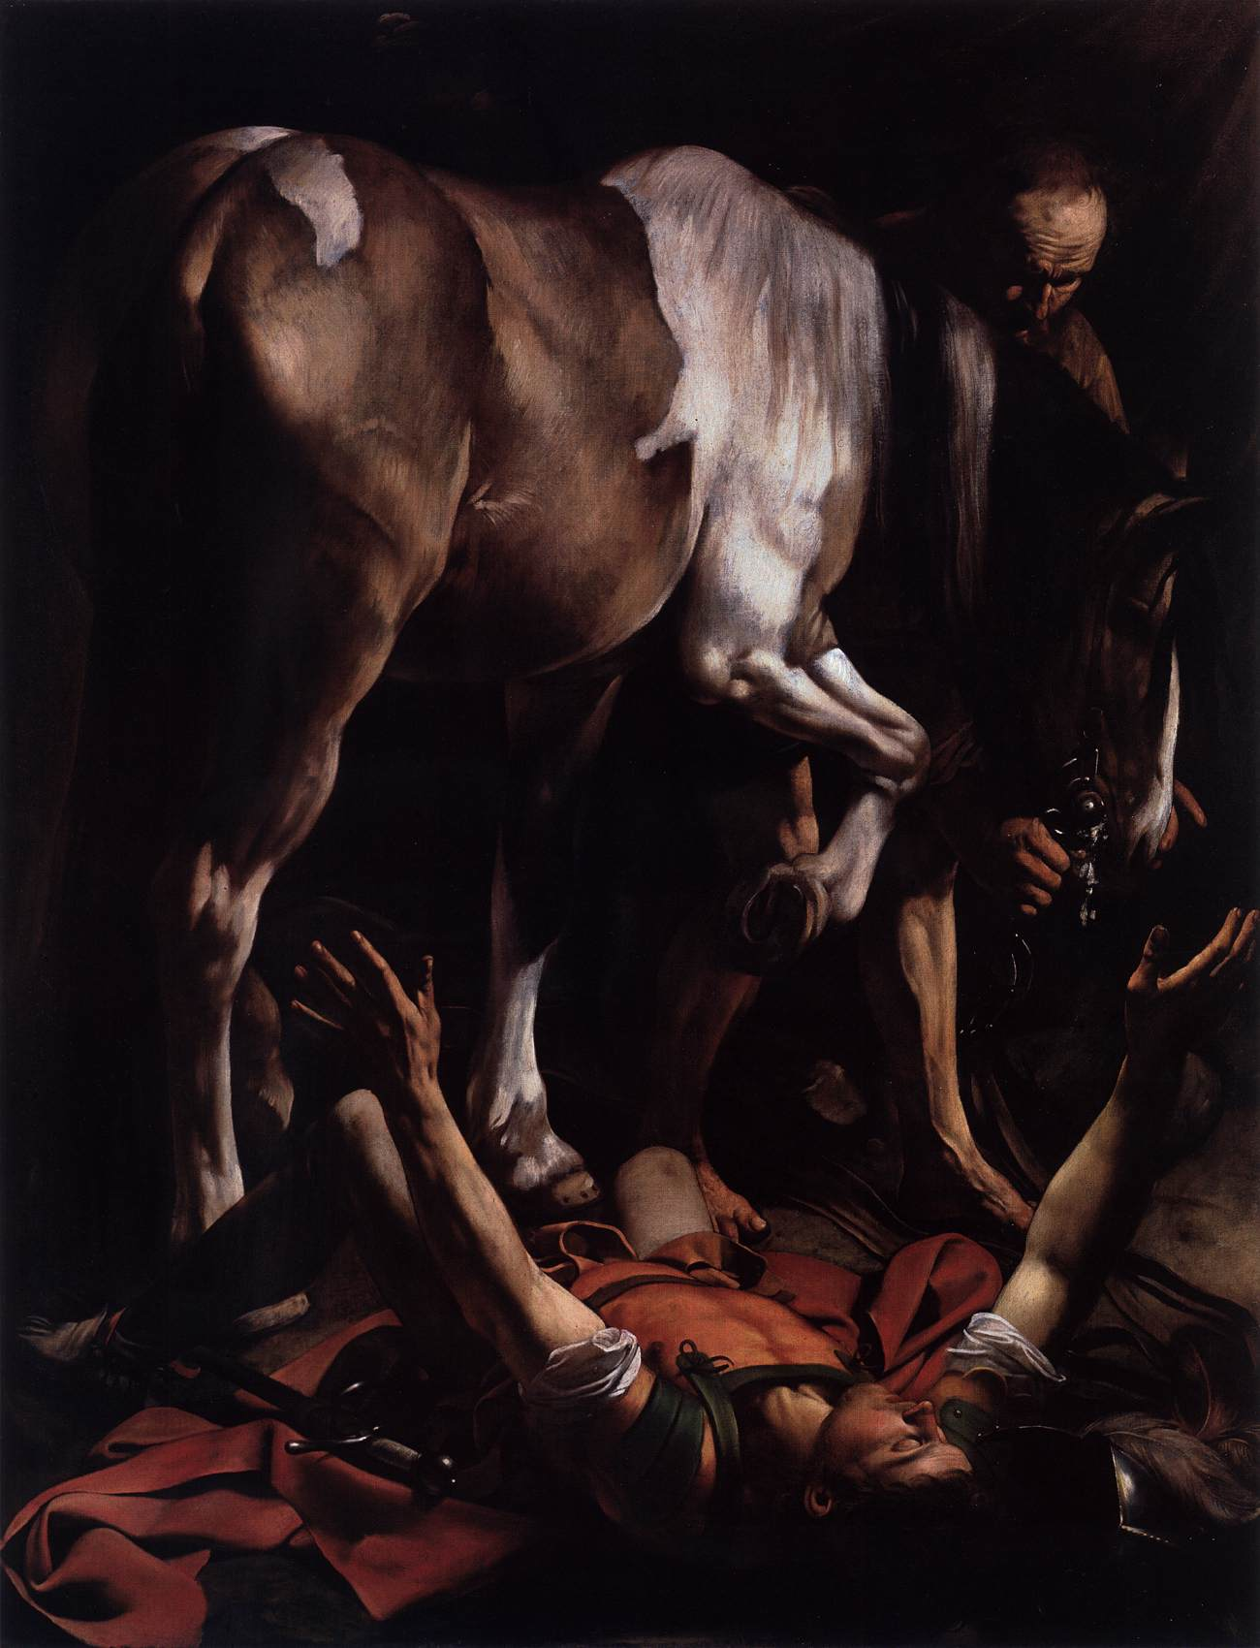

Just as Jesus challenged Paul “Why do you persecute Me?” on the road to Damascus, once again He re-frames the attacks on Believers as truly upon Him “The insults of those who insult you have fallen on me.”
Source: Public domain here http://www.wga.hu/art/c/caravagg/05/29ceras.jpg

Faith in Action

Prayer:
Ask the Holy Spirit to reveal to you a place where you may have contributed to division based upon a wrong priority or prreference.

Action:
Today I will repent of what the Holy Spirit has revealed to me, I will seek forgiveness and reconciliation, or I will come along side someone who needs to do so and walk with them through the process. In either case I will ask a fellow believer to pray in agreement that all involved will accept the comfort, strength, and wisdom of the Holy Spirit.

Be Specific ______________________________________________________

Friday (Romans 15:14-30)
Paul’s Motivation for Writing the Letter
15:14 But I myself am fully convinced about you, my brothers and sisters, that you yourselves are full of goodness, filled with all knowledge, and able to instruct one another.
15:15 But I have written more boldly to you on some points so as to remind you, because of the grace given to me by God 15:16 to be a minister of Christ Jesus to the Gentiles. I serve the gospel of God like a priest, so that the Gentiles may become an acceptable offering, sanctified by the Holy Spirit.
15:17 So I boast in Christ Jesus about the things that pertain to God.
15:18 For I will not dare to speak of anything except what Christ has accomplished through me in order to bring about the obedience of the Gentiles, by word and deed, 15:19 in the power of signs and wonders, in the power of the Spirit of God. So from Jerusalem even as far as Illyricum I have fully preached the gospel of Christ. 15:20 And in this way I desire to preach where Christ has not been named, so as not to build on another person’s foundation, 15:21 but as it is written: “Those who were not told about him will see, and those who have not heard will understand.”
Paul’s Intention of Visiting the Romans
15:22 This is the reason I was often hindered from coming to you. 15:23 But now there is nothing more to keep me in these regions, and I have for many years desired to come to you 15:24 when I go to Spain. For I hope to visit you when I pass through and that you will help me on my journey there, after I have enjoyed your company for a while.
15:25 But now I go to Jerusalem to minister to the saints. 15:26 For Macedonia and Achaia are pleased to make some contribution for the poor among the saints in Jerusalem.
15:27 For they were pleased to do this, and indeed they are indebted to the Jerusalem saints. For if the Gentiles have shared in their spiritual things, they are obligated also to minister to them in material things.
15:28 Therefore after I have completed this and have safely delivered this bounty to them, I will set out for Spain by way of you, 15:29 and I know that when I come to you I will come in the fullness of Christ’s blessing.
15:30 Now I urge you, brothers and sisters, through our Lord Jesus Christ and through the love of the Spirit, to join fervently with me in prayer to God on my behalf.
15:31 Pray that I may be rescued from those who are disobedient in Judea and that my ministry in Jerusalem may be acceptable to the saints, 15:32 so that by God’s will I may come to you with joy and be refreshed in your company.
15:33 Now may the God of peace be with all of you. Amen.

Prayer
Lord, you equipped and sent the apostle Paul on Your mission to the Gentiles, and he completed it despite terrible challenges. May I discover You mission or missions for me, and may I follow his example and persevere despite opposition.

Summary & Commentary
Paul encouraged the believers “... that you yourselves are full of [the Lord God's] goodness [through His indwelling Holy Spirit], filled with all [Word-imparted and spiritually-discerned] knowledge, and able to instruct one another.”
Paul's use of “priest” referred only to the Believing-Gentiles, to be presented to the Lord as his offering – the work of his sacrificial ministry “I serve the gospel of God like a priest, so that the Gentiles may become an acceptable offering, sanctified by the Holy Spirit.”
Paul, once again, spoke of salvation as a process – from someone preaching/teaching to others hearing/understanding with the purpose of equipping them to make an informed choice for Christ – and so he quoted Isaiah 52:15 as a motivation for his ministry to new groups “Those who were not told about him will see, and those who have not heard will understand.”
Paul asked for prayers for protection from “... those who are disobedient in Judea and that my ministry in Jerusalem may be acceptable to the saints.” He was speaking of the Judaisers, those attempting to impose Jewish rituals and traditions on saved-Gentiles, and the religious leaders who rejected Jesus as The Christ.
He said that he was finally free to come to the Romans because he had faithfully shared the Word with those elsewhere, to whom no one else has previously spoken, whom the Lord God sent him to share His good news.

Interaction

Consider
After salvation the Holy Spirit brings to the believer “goodness”, “knowledge” and wisdom, and the capacity to share all of that with others.

Discuss
With all of the evidence of the Lord God’s work in and through Paul why would “the saints in Jerusalem” still have any doubts about his ministry?

Reflect
Paul wanted to do the most-difficult work (perhaps partially motivated by his prior persecution of Believers), confronting religious leaders who felt threatened by Christianity (as he had also felt threatened when he was one of them), and to reach-out to the unsaved Gentiles (whom some others, e.g. Peter, had been initially resistant to reaching).

Share
When have you experienced or observed believers questioning the ministry of someone who was clearly doing the Lord's work?

KTALZ
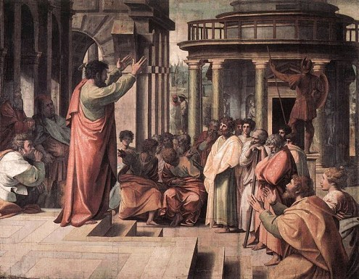

Paul preached to the philosophers in Athens, Greece.
Source: Public domain here http://gardenofpraise.com/images2/paul9.jpg

Faith in Action

Prayer:
Ask the Holy Spirit to reveal to you a challenging new ministry.

Action:
Today I will courageously, humbly, and prayerfully go where the Lord leads and do as He directs.

Be Specific ______________________________________________________

Saturday (Romans 16)
Personal Greetings
16:1 Now I commend to you our sister Phoebe, who is a servant of the church in Cenchrea, 16:2 so that you may welcome her in the Lord in a way worthy of the saints and provide her with whatever help she may need from you, for she has been a great help to many, including me.
16:3 Greet Prisca and Aquila, my fellow workers in Christ Jesus, 16:4 who risked their own necks for my life. Not only I, but all the churches of the Gentiles are grateful to them. 16:5 Also greet the church in their house. Greet my dear friend Epenetus, who was the first convert to Christ in the province of Asia. 16:6 Greet Mary, who has worked very hard for you. 16:7 Greet Andronicus and Junia, my compatriots and my fellow prisoners. They are well known to the apostles, and they were in Christ before me. 16:8 Greet Ampliatus, my dear friend in the Lord. 16:9 Greet Urbanus, our fellow worker in Christ, and my good friend Stachys. 16:10 Greet Apelles, who is approved in Christ. Greet those who belong to the household of Aristobulus. 16:11 Greet Herodion, my compatriot. Greet those in the household of Narcissus who are in the Lord. 16:12 Greet Tryphena and Tryphosa, laborers in the Lord. Greet my dear friend Persis, who has worked hard in the Lord.
16:13 Greet Rufus, chosen in the Lord, and his mother who was also a mother to me.
16:14 Greet Asyncritus, Phlegon, Hermes, Patrobas, Hermas, and the brothers and sisters with them. 16:15 Greet Philologus and Julia, Nereus and his sister, and Olympas, and all the believers who are with them.
16:16 Greet one another with a holy kiss. All the churches of Christ greet you.
16:17 Now I urge you, brothers and sisters, to watch out for those who create dissensions and obstacles contrary to the teaching that you learned. Avoid them! 16:18 For these are the kind who do not serve our Lord Christ, but their own appetites. By their smooth talk and flattery they deceive the minds of the naive.
16:19 Your obedience is known to all and thus I rejoice over you. But I want you to be wise in what is good and innocent in what is evil.
16:20 The God of peace will quickly crush Satan under your feet. The grace of our Lord Jesus be with you.
16:21 Timothy, my fellow worker, greets you; so do Lucius, Jason, and Sosipater, my compatriots. 16:22 I, Tertius, who am writing this letter, greet you in the Lord. 16:23 Gaius, who is host to me and to the whole church, greets you. Erastus the city treasurer and our brother Quartus greet you.
16:24 [[EMPTY]] 16:25
Now to him who is able to strengthen you according to my gospel and the proclamation of Jesus Christ, according to the revelation of the mystery that had been kept secret for long ages, 16:26 but now is disclosed, and through the prophetic scriptures has been made known to all the nations, according to the command of the eternal God, to bring about the obedience of faith—16:27 to the only wise God, through Jesus Christ, be glory forever! Amen.

Prayer
Lord, You drew both men and women into fellowship and many went beyond mere membership to active and sacrificial service to one-another and to the cause of spreading Your gospel. May I be counted among their number.

Summary & Commentary
Paul shared a lengthy list of men and women whom he respected as faithful and mature servants of Christ and commended them to the believers in Rome.
In the case of Phoebe he identified her as serving a ministry role in the fellowship at Cenchrea. [Note: There is some debate as to if her role was that of a Biblically defined “deacon”(ess) or some other significant role other than deacon(ess). In either case God decided that her ministry role was significant enough to be recorded in His Bible.]
From the Bible.org Greek/Hebrew translation notes Paul’s reference to Rufus as “chosen of God ...” 16:13 is worth a pause:
Εκλεκτον 1) picked out, chosen 1a) chosen by God, 1a1) to obtain salvation through Christ 1a1a) Christians are called “chosen or elect” of God 1a2) the Messiah in called “elect”, as appointed by God to the most exalted office conceivable 1a3) choice, select, i.e. the best of its kind or class, excellence preeminent: applied to certain individual Christians
This text and translation suggests that the term “chosen” or “elect”, the same in Greek, does not mean predestined but one of many who are saved who are for reasons of the Lord God elevated somehow within the family.
Paul warned “... watch out for those who create dissensions and obstacles contrary to the teaching that you have learned ... I want you to be wise in what is good and innocent in what is evil.”
Paul noted that such people “... do not serve our Lord Jesus Christ, but their own appetites. By their smooth talk and flattery they deceive the minds of the naive.
The name Tertius was that of the scribe whom Paul used to record his words. It is probable that due to the many physical assaults endured by Paul, and/or perhaps some form of arthritis, he was unable to write at-length at the time himself.
Paul concluded this chapter, and the Book of Romans, with a word of encouragement in the spiritual battle; “The God of grace will quickly crush Satan under your feet. The grace of our Lord Jesus be with you.”

Interaction

Consider
Paul re-emphasized the parity between Jew and Gentile, a very touchy subject in his day.

Discuss
Could Paul’s warnings against smooth talkers, flatterers, those who create dissension and obstacles—defined as selfish and self-serving—to be resisted and avoided—apply to some in the fellowship of Believers today?

Reflect
Observe the consistency of the message of God—here Paul, in the service of God, paralleled the writing of Luke in intentionally citing the ministry role of a woman; thereby reinforcing again the teaching of Jesus that in His family there is no division between Jew or Gentile, male or female.

Share
When have you observed that the importance of grace to the Lord God resulted in His intervention to “crush Satan” when prayer was raised against his evil attacks?

KTALZ
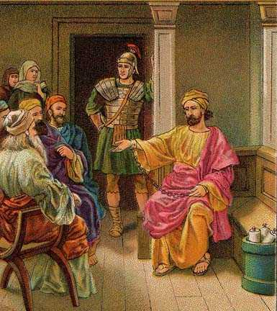

Although under house arrest in Rome Paul continued to disciple and evangelize in person and via letters.
Source: Public domain here http://gardenofpraise.com/images/acts18b.jpg

Faith in Action

Prayer:
Ask the Holy Spirit to reveal to you a circumstance where “... smooth talkers, flatterers, those who create dissension and obstacles” may be harming a fellowship in your area.

Action:
Today I will pray for protection of the fellowship under siege and that the leadership will respond Biblically—in prayer and action.

Be Specific ______________________________________________________
All Bible text is from the NET unless otherwise indicated—http://bible.org
Note 1: These Studies often rely upon the guidance of the NET Translators from their associated notes. Careful attention has been given to cite that source where it has been quoted directly or closely paraphrased. Feedback is encouraged where credit has not been sufficiently assigned.
Note 2: When NET text is quoted in commentary and discussion all pronouns referring to God are capitalized, though they are lower-case in the original NET text.
Commentary text is from David M. Colburn, D.Min. unless otherwise noted.
Copyright © 2011 by David M. Colburn. This is a BibleSeven Study—Section 3 of the series, “Romans”—prepared by David M. Colburn and edited for bible.org in October of 2011. This text may be used for non-profit educational purposes only, with credit; all other usage requires prior written consent of the author.

