Numbers 13 – 25 & Psalm 90
(Promised Land, Rebellion, Wilderness, Balaam)
David M. Colburn
A Chronological Daily Bible Study of the Old Testament
7-Day Sections with a Summary-Commentary, Discussion Questions,
and a Practical Daily Application
Week 19

Sunday (Numbers 13)
Spies Sent Out
13:1 The Lord spoke to Moses: 13:2 “Send out men to investigate the land of Canaan, which I am giving to the Israelites. You are to send one man from each ancestral tribe, each one a leader among them.” 13:3 So Moses sent them from the wilderness of Paran at the command of the Lord. All of them were leaders of the Israelites.
13:4 Now these were their names: from the tribe of Reuben, Shammua son of Zaccur; 13:5 from the tribe of Simeon, Shaphat son of Hori; 13:6 from the tribe of Judah, Caleb son of Jephunneh; 13:7 from the tribe of Issachar, Igal son of Joseph; 13:8 from the tribe of Ephraim, Hoshea son of Nun; 13:9 from the tribe of Benjamin, Palti son of Raphu; 13:10 from the tribe of Zebulun, Gaddiel son of Sodi; 13:11 from the tribe of Joseph, namely, the tribe of Manasseh, Gaddi son of Susi; 13:12 from the tribe of Dan, Ammiel son of Gemalli; 13:13 from the tribe of Asher, Sethur son of Michael; 13:14 from the tribe of Naphtali, Nahbi son of Vopshi; 13:15 from the tribe of Gad, Geuel son of Maki. 13:16 These are the names of the men whom Moses sent to investigate the land. And Moses gave Hoshea son of Nun the name Joshua.
The Spies’ Instructions
13:17 When Moses sent them to investigate the land of Canaan, he told them, “Go up through the Negev, and then go up into the hill country 13:18 and see what the land is like, and whether the people who live in it are strong or weak, few or many, 13:19 and whether the land they live in is good or bad, and whether the cities they inhabit are like camps or fortified cities, 13:20 and whether the land is rich or poor, and whether or not there are forests in it. And be brave, and bring back some of the fruit of the land.” Now it was the time of year for the first ripe grapes.
The Spies’ Activities
13:21 So they went up and investigated the land from the wilderness of Zin to Rehob, at the entrance of Hamath. 13:22 When they went up through the Negev, they came to Hebron where Ahiman, Sheshai, and Talmai, descendants of Anak, were living. (Now Hebron had been built seven years before Zoan in Egypt.) 13:23 When they came to the valley of Eshcol, they cut down from there a branch with one cluster of grapes, and they carried it on a staff between two men, as well as some of the pomegranates and the figs. 13:24 That place was called the Eshcol Valley, because of the cluster of grapes that the Israelites cut from there. 13:25 They returned from investigating the land after forty days.
The Spies’ Reports
13:26 They came back to Moses and Aaron and to the whole community of the Israelites in the wilderness of Paran at Kadesh. They reported to the whole community and showed the fruit of the land. 13:27 They told Moses, “We went to the land where you sent us. It is indeed flowing with milk and honey, and this is its fruit. 13:28 But the inhabitants are strong, and the cities are fortified and very large. Moreover we saw the descendants of Anak there. 13:29 The Amalekites live in the land of the Negev; the Hittites, Jebusites, and Amorites live in the hill country; and the Canaanites live by the sea and along the banks of the Jordan.”
13:30 Then Caleb silenced the people before Moses, saying, “Let us go up and occupy it, for we are well able to conquer it.” 13:31 But the men who had gone up with him said, “We are not able to go up against these people, because they are stronger than we are!” 13:32 Then they presented the Israelites with a discouraging report of the land they had investigated, saying, “The land that we passed through to investigate is a land that devours its inhabitants. All the people we saw there are of great stature. 13:33 We even saw the Nephilim there (the descendants of Anak came from the Nephilim), and we seemed liked grasshoppers both to ourselves and to them.”

Prayer
Lord, You never make a promise that You fail to keep, and You never send us where we cannot – in Your power – prevail. No matter the challenge may I never doubt Your promises.

Scripture In Perspective
The Lord God gave Moses instructions to send leaders from all of the tribes to investigate the land of Canaan, the land that He was - as promised - giving to Israel.
Moses instructed them as to how they should approach the land, what to look for, and to bring back some of the produce of the land.
They were gone for 40 days and returned with a great deal of produce which they showed the people and brought to Moses.
They reported that the land was filled with large and strong people and that it was fortified.
Caleb called them to silence and declared that they should enter and take the land.
They replied with a discouraging report that the land was one of conflict and the people labored mightily to develop and farm it. They described the men as large and strong, even making reference to the fables of old of Nephalim “giants”, declaring that it was impossible to Israel to prevail.

Interact with the text

Consider
The Lord God never suggested that the ones He had sent were to return with an opinion as to whether the land was theirs, nor whether they could take the land, He had already promised it to them.

Discuss
How often had the people of Israel previously doubted God? Why had they not yet learned?

Reflect
God had overwhelmed the entire empire of Egypt and now the Israelites doubted that He could deliver this land to them?

Share
When have you been wrestled with your own uncertainty, or that of others, in doing what God asked of you? Did you hesitate? Why?

KTALZ
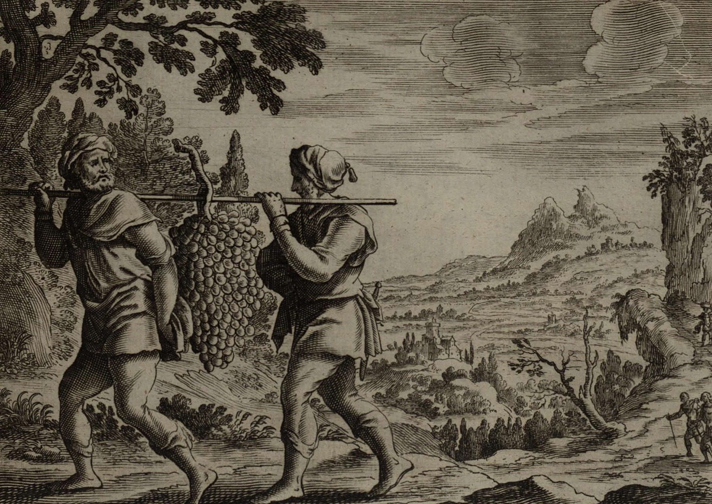

The spies returned with evidence of the promised fertility of the Promised Land but then cowardly lobbied the people to fear taking the land – despite God's promise to deliver it to them. Caleb was the brave and faithful exception.
Source: Public domain here http://upload.wikimedia.org/wikipedia/commons/c/cc/Jollain_The_Spies_Return_from_Canaan.jpg

Faith In Action

Pray
Ask the Holy Spirit to show you where you are seeing a challenge though your human eyes and not the eyes of the almighty God.

Act
Today I will prayerfully submit to the Holy Spirit's vision of my world. I will bring any doubts and fears I have to Him. I will accept whatever challenge He places before me without any doubts that He is able. I agree to step-out in faith and will ask a fellow believer to pray in-agreement with me for courage and trust and wisdom.
Be Specific ________________________________________________

Monday (Numbers 14)
The Israelites Respond in Unbelief
14:1 Then all the community raised a loud cry, and the people wept that night. 14:2 And all the Israelites murmured against Moses and Aaron, and the whole congregation said to them, “If only we had died in the land of Egypt, or if only we had perished in this wilderness!
14:3 Why has the Lord brought us into this land only to be killed by the sword, that our wives and our children should become plunder? Wouldn’t it be better for us to return to Egypt?”
14:4 So they said to one another, “Let’s appoint a leader and return to Egypt.”
14:5 Then Moses and Aaron fell down with their faces to the ground before the whole assembled community of the Israelites.
14:6 And Joshua son of Nun and Caleb son of Jephunneh, two of those who had investigated the land, tore their garments.
14:7 They said to the whole community of the Israelites, “The land we passed through to investigate is an exceedingly good land. 14:8 If the Lord delights in us, then he will bring us into this land and give it to us – a land that is flowing with milk and honey. 14:9 Only do not rebel against the Lord, and do not fear the people of the land, for they are bread for us. Their protection has turned aside from them, but the Lord is with us. Do not fear them!”
14:10 However, the whole community threatened to stone them. But the glory of the Lord appeared to all the Israelites at the tent of meeting.
The Punishment from God
14:11 The Lord said to Moses, “How long will this people despise me, and how long will they not believe in me, in spite of the signs that I have done among them?
14:12 I will strike them with the pestilence, and I will disinherit them; I will make you into a nation that is greater and mightier than they!”
14:13 Moses said to the Lord, “When the Egyptians hear it – for you brought up this people by your power from among them – 14:14 then they will tell it to the inhabitants of this land. They have heard that you, Lord, are among this people, that you, Lord, are seen face to face, that your cloud stands over them, and that you go before them by day in a pillar of cloud and in a pillar of fire by night. 14:15 If you kill this entire people at once, then the nations that have heard of your fame will say, 14:16 ‘Because the Lord was not able to bring this people into the land that he swore to them, he killed them in the wilderness.’
14:17 So now, let the power of my Lord be great, just as you have said, 14:18 ‘The Lord is slow to anger and abounding in loyal love, forgiving iniquity and transgression, but by no means clearing the guilty, visiting the iniquity of the fathers on the children until the third and fourth generations.’
14:19 Please forgive the iniquity of this people according to your great loyal love, just as you have forgiven this people from Egypt even until now.”
14:20 Then the Lord said, “I have forgiven them as you asked.
14:21 But truly, as I live, all the earth will be filled with the glory of the Lord. 14:22 For all the people have seen my glory and my signs that I did in Egypt and in the wilderness, and yet have tempted me now these ten times, and have not obeyed me, 14:23 they will by no means see the land that I swore to their fathers, nor will any of them who despised me see it.
14:24 Only my servant Caleb, because he had a different spirit and has followed me fully – I will bring him into the land where he had gone, and his descendants will possess it.
14:25 (Now the Amalekites and the Canaanites were living in the valleys.) Tomorrow, turn and journey into the wilderness by the way of the Red Sea.”
14:26 The Lord spoke to Moses and Aaron: 14:27 “How long must I bear with this evil congregation that murmurs against me? I have heard the complaints of the Israelites that they murmured against me.
14:28 Say to them, ‘As I live, says the Lord, I will surely do to you just what you have spoken in my hearing. 14:29 Your dead bodies will fall in this wilderness – all those of you who were numbered, according to your full number, from twenty years old and upward, who have murmured against me. 14:30 You will by no means enter into the land where I swore to settle you. The only exceptions are Caleb son of Jephunneh and Joshua son of Nun.
14:31 But I will bring in your little ones, whom you said would become victims of war, and they will enjoy the land that you have despised.
14:32 But as for you, your dead bodies will fall in this wilderness, 14:33 and your children will wander in the wilderness forty years and suffer for your unfaithfulness, until your dead bodies lie finished in the wilderness.
14:34 According to the number of the days you have investigated this land, forty days – one day for a year – you will suffer for your iniquities, forty years, and you will know what it means to thwart me.
14:35 I, the Lord, have said, “I will surely do so to all this evil congregation that has gathered together against me. In this wilderness they will be finished, and there they will die!”’”
14:36 The men whom Moses sent to investigate the land, who returned and made the whole community murmur against him by producing an evil report about the land, 14:37 those men who produced the evil report about the land, died by the plague before the Lord.
14:38 But Joshua son of Nun and Caleb son of Jephunneh, who were among the men who went to investigate the land, lived.
14:39 When Moses told these things to all the Israelites, the people mourned greatly.
14:40 And early in the morning they went up to the crest of the hill country, saying, “Here we are, and we will go up to the place that the Lord commanded, for we have sinned.”
14:41 But Moses said, “Why are you now transgressing the commandment of the Lord? It will not succeed! 14:42 Do not go up, for the Lord is not among you, and you will be defeated before your enemies. 14:43 For the Amalekites and the Canaanites are there before you, and you will fall by the sword. Because you have turned away from the Lord, the Lord will not be with you.”
14:44 But they dared to go up to the crest of the hill, although neither the ark of the covenant of the Lord nor Moses departed from the camp.
14:45 So the Amalekites and the Canaanites who lived in that hill country swooped down and attacked them as far as Hormah.

Prayer
Lord, it is painful to read about Israel's rebellion as they stood at the threshold of the promised land. May I learn to never doubt Your promises and to never rebel against Your leading.

Scripture In Perspective
The tribal leaders, whose fear had overcome their faith and whose spirit of rebellion overwhelmed their good sense, turned the people against Moses and Aaron and God – they became partners with the enemy in deception and rebellion.
They whined that they would fall in battle and that their children would become victims of the inhabitants.
Moses and Aaron and Caleb and Joshua pleaded with them to repent and to trust God, since He had repeatedly proved Himself able, but they instead threatened to stone them to death.
God intervened and just as He had used Pharaoh's words against him He used theirs against them – declaring than none over the age of 20 would live to see the promised land and that their wives and children would be victims of their rebellion and suffer 40 years in the wilderness with them – then the children would inherit the land of promise.
Only Joshua and Caleb would live to enter the promised land as they had trusted the Lord God.
The people mourned the news then some decided to enter the land, even though the Ark and Moses did not join them, and without the protection of God they were killed by the inhabitants.

Interact with the text

Consider
Just as Eve partnered with the serpent to deceive Adam into disbelieving and disobeying God, the tribal leaders likewise conspired in the spreading of the lie that God was not telling the truth and/or that He was not able to keep His promise.

Discuss
Why would the people attack the residents of the promised land without the Ark or Moses, and therefore without the support of God?

Reflect
God knows our hearts, and in those time and places in which we rebel, we are chastised.

Share
When have you mistrusted God and gone your own way only to discover that without His blessing your schemes were destroyed?

KTALZ
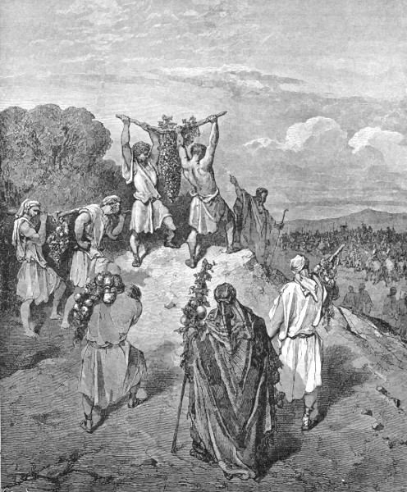

The spies who encouraged rebellion against God, Who had promised them the Promised Land, we destroyed by God via a plague.
Source: Public domain here http://www.wpclipart.com/religion_mythology/bible/Childs_story_of_Bible_2/return_of_the_spies.jpg

Faith In Action

Pray
Ask the Holy Spirit to show you where you may be harboring doubt, due to fear, because you are looking at the world through the eyes of man and not the Lord God - and to remind you why you should trust Him.

Act
Today I will confess my doubts and surrender to the Holy Spirit. I will trust that He has already gone ahead of me in a situation where the enemy has had me believing a lie. I will ask a fellow Believer to pray in-agreement with me for courage and faith, trust and wisdom.
Be Specific _____________________________________________

Tuesday (Numbers 15-16)
Please read Numbers 15 in your Bible or at this link:
http://net.bible.org/bible.php?book=Num&chapter=15&mode=text

The Rebellion of Korah
16:1 Now Korah son of Izhar, the son of Kohath, the son of Levi, and Dathan and Abiram, the sons of Eliab, and On son of Peleth, who were Reubenites, took men 16:2 and rebelled against Moses, along with some of the Israelites, 250 leaders of the community, chosen from the assembly, famous men. 16:3 And they assembled against Moses and Aaron, saying to them, “You take too much upon yourselves, seeing that the whole community is holy, every one of them, and the Lord is among them. Why then do you exalt yourselves above the community of the Lord?”
16:4 When Moses heard it he fell down with his face to the ground. 16:5 Then he said to Korah and to all his company, “In the morning the Lord will make known who are his, and who is holy. He will cause that person to approach him; the person he has chosen he will cause to approach him. 16:6 Do this, Korah, you and all your company: Take censers, 16:7 put fire in them, and set incense on them before the Lord tomorrow, and the man whom the Lord chooses will be holy. You take too much upon yourselves, you sons of Levi!” 16:8 Moses said to Korah, “Listen now, you sons of Levi! 16:9 Does it seem too small a thing to you that the God of Israel has separated you from the community of Israel to bring you near to himself, to perform the service of the tabernacle of the Lord, and to stand before the community to minister to them? 16:10 He has brought you near and all your brothers, the sons of Levi, with you. Do you now seek the priesthood also? 16:11 Therefore you and all your company have assembled together against the Lord! And Aaron – what is he that you murmur against him?” 16:12 Then Moses summoned Dathan and Abiram, the sons of Eliab, but they said, “We will not come up. 16:13 Is it a small thing that you have brought us up out of the land that flows with milk and honey, to kill us in the wilderness? Now do you want to make yourself a prince over us? 16:14 Moreover, you have not brought us into a land that flows with milk and honey, nor given us an inheritance of fields and vineyards. Do you think you can blind these men? We will not come up.”
16:15 Moses was very angry, and he said to the Lord, “Have no respect for their offering! I have not taken so much as one donkey from them, nor have I harmed any one of them!”
16:16 Then Moses said to Korah, “You and all your company present yourselves before the Lord – you and they, and Aaron – tomorrow. 16:17 And each of you take his censer, put incense in it, and then each of you present his censer before the Lord: 250 censers, along with you, and Aaron – each of you with his censer.” 16:18 So everyone took his censer, put fire in it, and set incense on it, and stood at the entrance of the tent of meeting, with Moses and Aaron. 16:19 When Korah assembled the whole community against them at the entrance of the tent of meeting, then the glory of the Lord appeared to the whole community.
The Judgment on the Rebels
16:20 The Lord spoke to Moses and Aaron: 16:21 “Separate yourselves from among this community, that I may consume them in an instant.” 16:22 Then they threw themselves down with their faces to the ground and said, “O God, the God of the spirits of all people, will you be angry with the whole community when only one man sins?”
16:23 So the Lord spoke to Moses: 16:24 “Tell the community: ‘Get away from around the homes of Korah, Dathan, and Abiram.’” 16:25 Then Moses got up and went to Dathan and Abiram; and the elders of Israel went after him. 16:26 And he said to the community, “Move away from the tents of these wicked men, and do not touch anything they have, lest you be destroyed because of all their sins.” 16:27 So they got away from the homes of Korah, Dathan, and Abiram on every side, and Dathan and Abiram came out and stationed themselves in the entrances of their tents with their wives, their children, and their toddlers. 16:28 Then Moses said, “This is how you will know that the Lord has sent me to do all these works, for I have not done them of my own will. 16:29 If these men die a natural death, or if they share the fate of all men, then the Lord has not sent me. 16:30 But if the Lord does something entirely new, and the earth opens its mouth and swallows them up along with all that they have, and they go down alive to the grave, then you will know that these men have despised the Lord!”
16:31 When he had finished speaking all these words, the ground that was under them split open, 16:32 and the earth opened its mouth and swallowed them, along with their households, and all Korah’s men, and all their goods. 16:33 They and all that they had went down alive into the pit, and the earth closed over them. So they perished from among the community. 16:34 All the Israelites who were around them fled at their cry, for they said, “What if the earth swallows us too?” 16:35 Then a fire went out from the Lord and devoured the 250 men who offered incense.
The Atonement for the Rebellion
16:36 (17:1) The Lord spoke to Moses: 16:37 “Tell Eleazar son of Aaron the priest to pick up the censers out of the flame, for they are holy, and then scatter the coals of fire at a distance. 16:38 As for the censers of these men who sinned at the cost of their lives, they must be made into hammered sheets for covering the altar, because they presented them before the Lord and sanctified them. They will become a sign to the Israelites.” 16:39 So Eleazar the priest took the bronze censers presented by those who had been burned up, and they were hammered out as a covering for the altar. 16:40 It was a memorial for the Israelites, that no outsider who is not a descendant of Aaron should approach to burn incense before the Lord, that he might not become like Korah and his company – just as the Lord had spoken by the authority of Moses. 16:41 But on the next day the whole community of Israelites murmured against Moses and Aaron, saying, “You have killed the Lord’s people!” 16:42 When the community assembled against Moses and Aaron, they turned toward the tent of meeting – and the cloud covered it, and the glory of the Lord appeared. 16:43 Then Moses and Aaron stood before the tent of meeting.
16:44 The Lord spoke to Moses: 16:45 “Get away from this community, so that I can consume them in an instant!” But they threw themselves down with their faces to the ground. 16:46 Then Moses said to Aaron, “Take the censer, put burning coals from the altar in it, place incense on it, and go quickly into the assembly and make atonement for them, for wrath has gone out from the Lord – the plague has begun!” 16:47 So Aaron did as Moses commanded and ran into the middle of the assembly, where the plague was just beginning among the people. So he placed incense on the coals and made atonement for the people. 16:48 He stood between the dead and the living, and the plague was stopped. 16:49 Now 14,700 people died in the plague, in addition to those who died in the event with Korah. 16:50 Then Aaron returned to Moses at the entrance of the tent of meeting, and the plague was stopped.

Prayer
Lord, the attacks on Moses and Aaron were precursors to the attack upon Jesus. May I not challenge the authority of Jesus, nor of the indwelling Holy Spirit, through overt disobedience and/or subtle disrespect for the clear and life-changing meaning found in Your teaching.

Scripture In Perspective
The Lord God repeated some of the details of sacrificial practices to Moses.
Korath, of the tribe of Levi, among those who had been called to serve the Lord gathered 250 men and challenged the authority of Moses, to which Moses replied that they come before the Lord in the morning to see whom the Lord selected to come forward near to Him.
They accused Moses and Aaron of taking too much authority, saying that “You take too much upon yourself ...”, and Moses turned the same phrase back on them. They took their censors of incense and waved them before the Lord.
Moses was angry and asked the Lord to intervene, specifically uttering an 'imprecatory prayer' against them, that the Lord not accept their offering and therefore withhold forgiveness and rather cause them to receive the full punishment of the law for their sin.
God separated-out the tents of Korah, Dathan, and Abiram and Moses declared that his authority from God would be known because those who challenged him would die a sudden and unnatural death. God opened the ground and it swallowed them - and then He sent flames like fire out to kill all of the 250 who had rebelled.
Because the Lord had sanctified the brass censors they were hammered into a sheet which was thereafter used to cover the altar as a reminder to the people.
But the people accused Moses of killing the men and spoke disrespectfully and rebelliously against Moses and Aaron. God instructed Moses to move away from the people so that He could strike them all dead.
Moses sent Aaron to make atonement for them, while he pleaded with the Lord, as a plague from the Lord had already begun. 14,700 people died before Aaron could place the incense upon the coals in their midst.

Interact With The Text

Consider
Once again, despite the impossible-to-miss anointing of the Lord upon Moses and the clear calling of Aaron, the people rebelled - first a small group and then the whole community.

Discuss
How many times and in how many ways did the Lord God have to affirm His anointing of Moses as their human emissary-leader for the people to accept that?

Reflect
The punishment of God matched the rebellion, first directed at the 250 and their leaders, then at the congregation as a whole (the plague).

Share
When have you observed people in rebellion against legitimate authority because they did not want to hear the truth they were being told and/or they simply did not want to submit to authority?

KTALZ
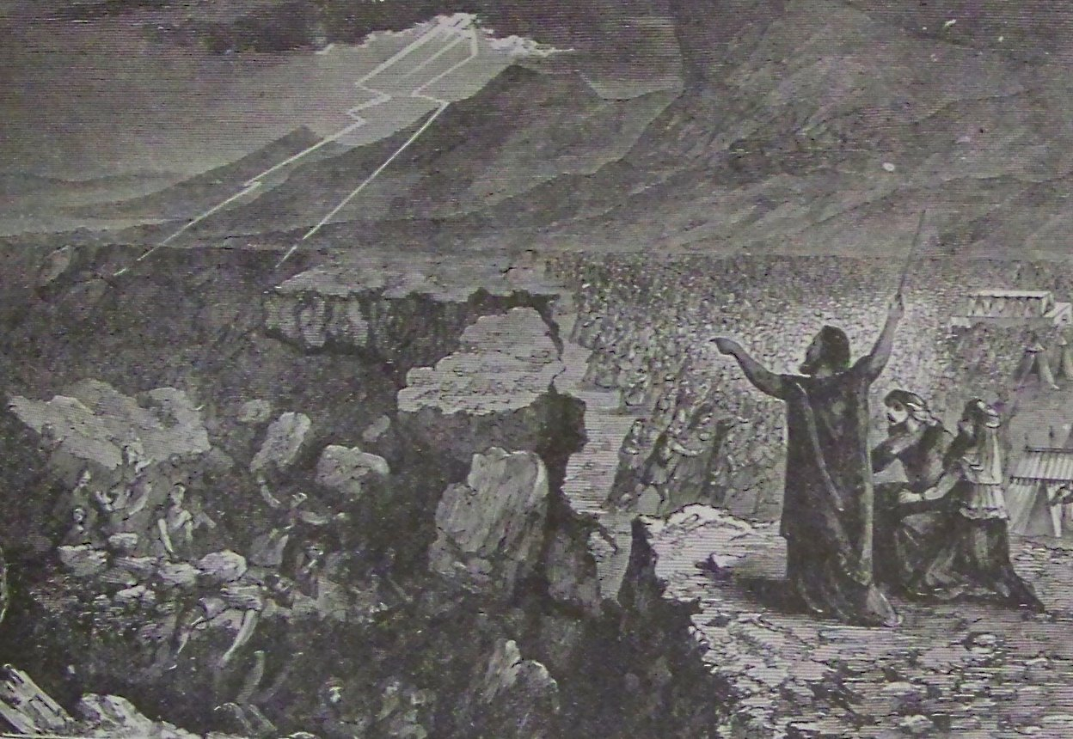

Rebellion against Moses was rebellion against God's authority and those leading the rebellion, and their families and associates, had to be removed from the population – and after that many others who unwisely continued the rebellion.
Source: Public domain here http://upload.wikimedia.org/wikipedia/commons/c/c0/Holman_Destruction_of_Korah_Dathan_and_Abiram.jpg

Faith In Action

Pray
Ask the Holy Spirit to show you where you have rebelled against legitimate authority - because they were holding you accountable for the consequences of your choices. (Perhaps it was (is) a boss, a business, a law enforcement person, a parent, a politician, a regulator, a pastor/elder, or a teacher?)

Act
Today I will confess my sin and repent. I will humbly submit to the legitimate authority which is delivering chastisement for my sin. Perhaps a bosses-sanction for carelessness or laziness, a business assessing a fine or penalty for some element of a contract, a law enforcement officer enforcing the law (e.g. a traffic offense), a parent punishing a child for disrespect or disobedience, a politician challenging those who misuse power for selfish ends, a regulator enforcing rules, a pastor/elder holding you accountable to the Bible, or a teacher punishing cheating or misbehavior or sloth.
Be Specific _________________________________________________

Wednesday (Numbers 17-19)
The Budding of Aaron’s Staff
17:1 The Lord spoke to Moses: 17:2 “Speak to the Israelites, and receive from them a staff from each tribe, one from every tribal leader, twelve staffs; you must write each man’s name on his staff.
17:3 You must write Aaron’s name on the staff of Levi; for one staff is for the head of every tribe.
17:4 You must place them in the tent of meeting before the ark of the covenant where I meet with you.
17:5 And the staff of the man whom I choose will blossom; so I will rid myself of the complaints of the Israelites, which they murmur against you.”
17:6 So Moses spoke to the Israelites, and each of their leaders gave him a staff, one for each leader, according to their tribes – twelve staffs; the staff of Aaron was among their staffs. 17:7 Then Moses placed the staffs before the Lord in the tent of the testimony.
17:8 On the next day Moses went into the tent of the testimony – and the staff of Aaron for the house of Levi had sprouted, and brought forth buds, and produced blossoms, and yielded almonds!
17:9 So Moses brought out all the staffs from before the Lord to all the Israelites. They looked at them, and each man took his staff.
The Memorial
17:10 The Lord said to Moses, “Bring Aaron’s staff back before the testimony to be preserved for a sign to the rebels, so that you may bring their murmurings to an end before me, that they will not die.” 17:11 So Moses did as the Lord commanded him – this is what he did.
17:12 The Israelites said to Moses, “We are bound to die! We perish, we all perish! 17:13 (17:28) Anyone who even comes close to the tabernacle of the Lord will die! Are we all to die?”

Please read Numbers 18 & 19 in your Bible or at these links:
http://net.bible.org/bible.php?book=Num&chapter=18

http://net.bible.org/bible.php?book=Num&chapter=19

Prayer
Lord, You choose our spiritual leaders, and You have declared that as long as they obey You we are to obey and respect them. May I be humble before those whom You have called to leadership, and “a good Berean” (one who verifies all teaching in Your Word), so that I know whether a leader is being faithful to You.

Scripture In Perspective
The Lord God instructed Moses to require each tribal leader to present a staff at the tabernacle.
Each staff was to be labeled with the name of the elder. Aaron's staff was to be among them.
The staffs were presented to the Lord at the entrance to the tent of testimony. God said that He would cause the staff of the one He chose to bud so that the elders would clearly know who was His chosen priest and stop complaining.
God caused the staff of Aaron to bud and produce almonds while the others remained dead. The elder's staffs were returned to them after they saw all of them.
Aaron's staff, at the direction of God, was returned to the tent of testimony as a remembrance of God's miracle and to finally quell any doubts about the divine calling of Moses and Aaron so that He would not have to strike them down.
The Israelites cried in fear that they could not approach God's tabernacle of presence without dying. Aaron, his sons, and the tribe of Levi were charged with responsibility to represent the people at the Tabernacle.
The Lord provided some additional details for the ordinances and sacrifices.

Interact With The Text

Consider
God again clarified His calling of Aaron and Moses using a clear symbolic gesture and He drove the chronically-rebellious people away from His Holy Tabernacle.

Discuss
Why would the people be afraid of death because they could not approach the tabernacle?

Reflect
In an agricultural society the life in Aaron's staff and death in the staff's of the elders was a powerful imagery. The Lord God created a structure that was more “representative” than “democratic” as He increased the degree to which the people were dependent upon the priests for access to Him.

Share
When have you observed a challenge to leadership where the Lord God powerfully intervened to affirm His leader?

KTALZ
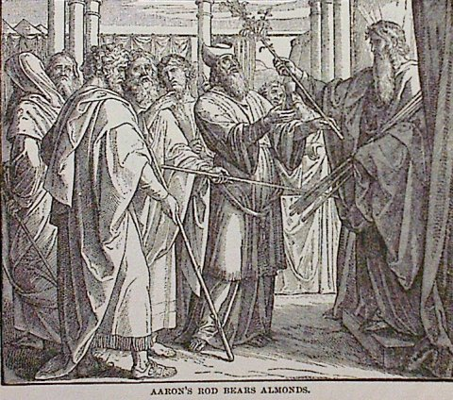

The buds of life, plus almonds, from a dead wood staff was clear evidence of God's hand and His anointing of Aaron and Moses with authority over the dead staffs of the elders.
Source: Public domain here http://www.coolnotions.com/PDImages/StoryOTB064_p158_AaronsRodBearsAlmonds.jpg

Faith In Action

Pray
Ask the Holy Spirit to show you where you have authority, and together with it, responsibility.

Act
Today I will accept the Lord's calling in my life to lead; it may be as a coach, a counselor, a mentor, a parent, a teacher, or some other role, but I will speak His truth in love but without fear. If my leadership is challenged I will prayerfully request that the Lord intervene for His sake. I will share my call to leadership with a fellow Believer and ask them to pray in-agreement for confirmation and protection.
Be Specific ________________________________________________

Thursday (Numbers 20-21)
The Israelites Complain Again
20:1 Then the entire community of Israel entered the wilderness of Zin in the first month, and the people stayed in Kadesh. Miriam died and was buried there.
20:2 And there was no water for the community, and so they gathered themselves together against Moses and Aaron. 20:3 The people contended with Moses, saying, “If only we had died when our brothers died before the Lord! 20:4 Why have you brought up the Lord’s community into this wilderness? So that we and our cattle should die here? 20:5 Why have you brought us up from Egypt only to bring us to this dreadful place? It is no place for grain, or figs, or vines, or pomegranates; nor is there any water to drink!”
Moses Responds
20:6 So Moses and Aaron went from the presence of the assembly to the entrance to the tent of meeting. They then threw themselves down with their faces to the ground, and the glory of the Lord appeared to them. 20:7 Then the Lord spoke to Moses: 20:8 “Take the staff and assemble the community, you and Aaron your brother, and then speak to the rock before their eyes. It will pour forth its water, and you will bring water out of the rock for them, and so you will give the community and their beasts water to drink.”
20:9 So Moses took the staff from before the Lord, just as he commanded him. 20:10 Then Moses and Aaron gathered the community together in front of the rock, and he said to them, “Listen, you rebels, must we bring water out of this rock for you?” 20:11 Then Moses raised his hand, and struck the rock twice with his staff. And water came out abundantly. So the community drank, and their beasts drank too.
The Lord’s Judgment
20:12 Then the Lord spoke to Moses and Aaron, “Because you did not trust me enough to show me as holy before the Israelites, therefore you will not bring this community into the land I have given them.”
20:13 These are the waters of Meribah, because the Israelites contended with the Lord, and his holiness was maintained among them.
Rejection by the Edomites
20:14 Moses sent messengers from Kadesh to the king of Edom: “Thus says your brother Israel: ‘You know all the hardships we have experienced, 20:15 how our ancestors went down into Egypt, and we lived in Egypt a long time, and the Egyptians treated us and our ancestors badly. 20:16 So when we cried to the Lord, he heard our voice and sent a messenger, and has brought us up out of Egypt. Now we are here in Kadesh, a town on the edge of your country. 20:17 Please let us pass through your country. We will not pass through the fields or through the vineyards, nor will we drink water from any well. We will go by the King’s Highway; we will not turn to the right or the left until we have passed through your region.’”
20:18 But Edom said to him, “You will not pass through me, or I will come out against you with the sword.” 20:19 Then the Israelites said to him, “We will go along the highway, and if we or our cattle drink any of your water, we will pay for it. We will only pass through on our feet, without doing anything else.”
20:20 But he said, “You may not pass through.” Then Edom came out against them with a large and powerful force. 20:21 So Edom refused to give Israel passage through his border; therefore Israel turned away from him.
Aaron’s Death
20:22 So the entire company of Israelites traveled from Kadesh and came to Mount Hor. 20:23 And the Lord spoke to Moses and Aaron in Mount Hor, by the border of the land of Edom. He said: 20:24 “Aaron will be gathered to his ancestors, for he will not enter into the land I have given to the Israelites because both of you rebelled against my word at the waters of Meribah. 20:25 Take Aaron and Eleazar his son, and bring them up on Mount Hor. 20:26 Remove Aaron’s priestly garments and put them on Eleazar his son, and Aaron will be gathered to his ancestors and will die there.”
20:27 So Moses did as the Lord commanded; and they went up Mount Hor in the sight of the whole community. 20:28 And Moses removed Aaron’s garments and put them on his son Eleazar. So Aaron died there on the top of the mountain. And Moses and Eleazar came down from the mountain. 20:29 When all the community saw that Aaron was dead, the whole house of Israel mourned for Aaron thirty days.

Victory at Hormah
21:1 When the Canaanite king of Arad who lived in the Negev heard that Israel was approaching along the road to Atharim, he fought against Israel and took some of them prisoner.
21:2 So Israel made a vow to the Lord and said, “If you will indeed deliver this people into our hand, then we will utterly destroy their cities.” 21:3 The Lord listened to the voice of Israel and delivered up the Canaanites, and they utterly destroyed them and their cities. So the name of the place was called Hormah.
Fiery Serpents
21:4 Then they traveled from Mount Hor by the road to the Red Sea, to go around the land of Edom, but the people became impatient along the way. 21:5 And the people spoke against God and against Moses, “Why have you brought us up out of Egypt to die in the wilderness, for there is no bread or water, and we detest this worthless food.”
21:6 So the Lord sent poisonous snakes among the people, and they bit the people; many people of Israel died. 21:7 Then the people came to Moses and said, “We have sinned, for we have spoken against the Lord and against you. Pray to the Lord that he would take away the snakes from us.” So Moses prayed for the people.
21:8 The Lord said to Moses, “Make a poisonous snake and set it on a pole. When anyone who is bitten looks at it, he will live.” 21:9 So Moses made a bronze snake and put it on a pole, so that if a snake had bitten someone, when he looked at the bronze snake he lived.
The Approach to Moab
21:10 The Israelites traveled on and camped in Oboth. 21:11 Then they traveled on from Oboth and camped at Iye Abarim, in the wilderness that is before Moab, on the eastern side. 21:12 From there they moved on and camped in the valley of Zered. 21:13 From there they moved on and camped on the other side of the Arnon, in the wilderness that extends from the regions of the Amorites, for Arnon is the border of Moab, between Moab and the Amorites. 21:14 This is why it is said in the Book of the Wars of the Lord,
“Waheb in Suphah and the wadis, the Arnon 21:15 and the slope of the valleys that extends to the dwelling of Ar, and falls off at the border of Moab.”
21:16 And from there they traveled to Beer; that is the well where the Lord spoke to Moses, “Gather the people and I will give them water.” 21:17 Then Israel sang this song:
“Spring up, O well, sing to it!
21:18 The well which the princes dug, which the leaders of the people opened with their scepters and their staffs.”
And from the wilderness they traveled to Mattanah; 21:19 and from Mattanah to Nahaliel; and from Nahaliel to Bamoth; 21:20 and from Bamoth to the valley that is in the country of Moab, near the top of Pisgah, which overlooks the wilderness.
The Victory over Sihon and Og
21:21 Then Israel sent messengers to King Sihon of the Amorites, saying,
21:22 “Let us pass through your land; we will not turn aside into the fields or into the vineyards, nor will we drink water from any well, but we will go along the King’s Highway until we pass your borders.” 21:23 But Sihon did not permit Israel to pass through his border; he gathered all his forces together and went out against Israel into the wilderness. When he came to Jahaz, he fought against Israel. 21:24 But the Israelites defeated him in battle and took possession of his land from the Arnon to the Jabbok, as far as the Ammonites, for the border of the Ammonites was strongly defended. 21:25 So Israel took all these cities; and Israel settled in all the cities of the Amorites, in Heshbon, and in all its villages. 21:26 For Heshbon was the city of King Sihon of the Amorites. Now he had fought against the former king of Moab and had taken all of his land from his control, as far as the Arnon. 21:27 That is why those who speak in proverbs say,
“Come to Heshbon, let it be built. Let the city of Sihon be established! 21:28 For fire went out from Heshbon, a flame from the city of Sihon. It has consumed Ar of Moab and the lords of the high places of Arnon.
21:29 Woe to you, Moab. You are ruined, O people of Chemosh! He has made his sons fugitives, and his daughters the prisoners of King Sihon of the Amorites. 21:30 We have overpowered them; Heshbon has perished as far as Dibon. We have shattered them as far as Nophah, which reaches to Medeba.”
21:31 So the Israelites lived in the land of the Amorites. 21:32 Moses sent spies to reconnoiter Jaazer, and they captured its villages and dispossessed the Amorites who were there.
21:33 Then they turned and went up by the road to Bashan. And King Og of Bashan and all his forces marched out against them to do battle at Edrei. 21:34 And the Lord said to Moses, “Do not fear him, for I have delivered him and all his people and his land into your hand. You will do to him what you did to King Sihon of the Amorites, who lived in Heshbon. 21:35 So they defeated Og, his sons, and all his people, until there were no survivors, and they possessed his land.

Prayer
Lord, please find me obedient in action and in teaching, adding nothing to Your Word. You have shown us Your faithfulness and power, You ask only that we trust and obey. May I always trust in You and obey Your Word.

Scripture In Perspective
There is again a shortage of water and the people complain to Moses, again whining that he and Aaron have led them astray.
Moses and Aaron went to the Lord God and He instructed them to come before the nearby rock with the staff and to speak (as His representative) and water would come out.
Moses gathered the people and did far more than speak to the rock (as God's representative) he asked the people if he and Aaron were supposed to bring water from the rock - he then struck it twice and water did come out – sufficient for the people and their animals.
Because Moses made it about himself, and Aaron, God told him that they would not lead His people into the promised land – once the 40 years in the wilderness had passed.
Moses asked the king of the Edomites to allow them to cross their territory, and even offered to pay for any resources – e.g. water – that they consumed, but he refused and brought a large army forward to keep them out - so they traveled a different route and stopped at Mount Hor.
At God's instruction Aaron's robes and responsibilities were transferred to his son, while on the mountain – in the sight of the people - then God called Aaron home.
Israel had a new head priest, and after 30 days or mourning, they continued their travels.
The Canaanites attacked them and took some captive so they cried out to God – He intervened and they were empowered to defeat them and to destroy their cities.
They continued their travels and once again complained, criticizing Moses and God, so God sent snakes among them. They cried out in repentance so God had Moses mount a brass snake on a pole and if they were bitten and looked to that symbol of God they were healed.
The Amorites, and then the King of Og, both attacked them and God gave the Israelites victory and possession of their lands.
[Note: In each battle Israel was expected to obliterate their enemy – none would be left to pollute the people with their false religion.]

Interact With The Text

Consider
From his days as a young man in Egypt Moses had evidenced an impetuous nature. Because he was angry Moses did not follow God's instruction, but rather made it appear that it was he and Aaron who brought the water from the rock, thus he was disobedient – and as God's anointed he was held to a higher-standard.
The Israelites promised God that they would not compromise with the local inhabitants, and if God gave them victory in battle, they would utterly destroy them. He did and they did.

Discuss
Why did the people keep challenging Moses and continually-question the wisdom of the exodus from slavery in Egypt every time things got uncomfortable? After all that had happened how could the people repeat the error of rebellion?

Reflect
God could have moved the Edomites but chose not to since the people continued to be rebellious. God leads and provides and protects and empowers – and He wants to bless - but He does not bless disobedience.

Share
When have you done or said something to cause the appearance that you had more authority and/or power than you actually did? When have you doubted God, despite repeated evidences of His loving care in your life, and perhaps in that of others?

KTALZ
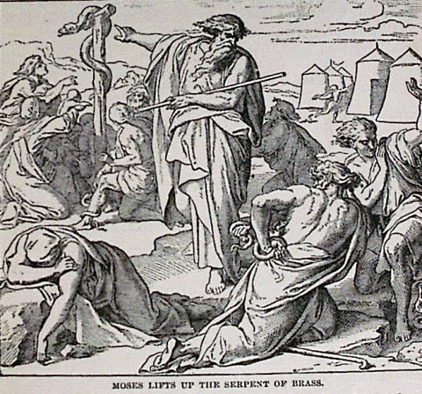

The cure for the avenging serpent-bite from the Lord was looking up at a brass serpent – a symbolic gesture of surrender to the Lord.
Source: Public domain here http://www.coolnotions.com/PDImages/StoryOTB065_p161_MosesLiftsUpTheSerpantOfBrass.jpg

Faith In Action

Pray
Ask the Holy Spirit to show you where you may be trading convenience for righteousness, and comfort for obedience, and to show you where you need to commit to serve God and to trust Him to be your strength.

Act
Today I will ask a fellow Believer to prayerfully assist me in an inventory of my walk with Christ. Where I find places that I make decisions about gathering together with Believers, about service to others, about caring for other believers, about sharing the resources He has given me, and about telling His story to those who are considering-Christ based on my comfort and convenience – turning away or even just not showing up – and I will repent of that. I agree to reshape my priorities based upon God's perspective and priorities. I will partner with the Holy Spirit in the ministry that God has set before me. I will be fearless as the battle is the Lord's. I will share what He has said with a fellow Believer and will ask that person to pray in-agreement with me for courage and wisdom. I will share what God does through me, and in me, as a result.
Be Specific _____________________________________________

Friday (Numbers 22-25)
Balaam Refuses to Curse Israel
22:1 The Israelites traveled on and camped in the plains of Moab on the side of the Jordan River across from Jericho. 22:2 Balak son of Zippor saw all that the Israelites had done to the Amorites. 22:3 And the Moabites were greatly afraid of the people, because they were so numerous. The Moabites were sick with fear because of the Israelites.
22:4 So the Moabites said to the elders of Midian, “Now this mass of people will lick up everything around us, as the bull devours the grass of the field. Now Balak son of Zippor was king of the Moabites at this time. 22:5 And he sent messengers to Balaam son of Beor at Pethor, which is by the Euphrates River in the land of Amaw, to summon him, saying, “Look, a nation has come out of Egypt. They cover the face of the earth, and they are settling next to me. 22:6 So now, please come and curse this nation for me, for they are too powerful for me. Perhaps I will prevail so that we may conquer them and drive them out of the land. For I know that whoever you bless is blessed, and whoever you curse is cursed.”
22:7 So the elders of Moab and the elders of Midian departed with the fee for divination in their hand. They came to Balaam and reported to him the words of Balak. 22:8 He replied to them, “Stay here tonight, and I will bring back to you whatever word the Lord may speak to me.” So the princes of Moab stayed with Balaam. 22:9 And God came to Balaam and said, “Who are these men with you?” 22:10 Balaam said to God, “Balak son of Zippor, king of Moab, has sent a message to me, saying, 22:11 “Look, a nation has come out of Egypt, and it covers the face of the earth. Come now and put a curse on them for me; perhaps I will be able to defeat them and drive them out.” 22:12 But God said to Balaam, “You must not go with them; you must not curse the people, for they are blessed.”
22:13 So Balaam got up in the morning, and said to the princes of Balak, “Go to your land, for the Lord has refused to permit me to go with you.” 22:14 So the princes of Moab departed and went back to Balak and said, “Balaam refused to come with us.”
Balaam Accompanies the Moabite Princes
22:15 Balak again sent princes, more numerous and more distinguished than the first. 22:16 And they came to Balaam and said to him, “Thus says Balak son of Zippor: ‘Please do not let anything hinder you from coming to me. 22:17 For I will honor you greatly, and whatever you tell me I will do. So come, put a curse on this nation for me.’”
22:18 Balaam replied to the servants of Balak, “Even if Balak would give me his palace full of silver and gold, I could not transgress the commandment of the Lord my God to do less or more. 22:19 Now therefore, please stay the night here also, that I may know what more the Lord might say to me.” 22:20 God came to Balaam that night, and said to him, “If the men have come to call you, get up and go with them; but the word that I will say to you, that you must do.” 22:21 So Balaam got up in the morning, saddled his donkey, and went with the princes of Moab.
God Opposes Balaam
22:22 Then God’s anger was kindled because he went, and the angel of the Lord stood in the road to oppose him. Now he was riding on his donkey and his two servants were with him. 22:23 And the donkey saw the angel of the Lord standing in the road with his sword drawn in his hand, so the donkey turned aside from the road and went into the field. But Balaam beat the donkey, to make her turn back to the road.
22:24 Then the angel of the Lord stood in a path among the vineyards, where there was a wall on either side. 22:25 And when the donkey saw the angel of the Lord, she pressed herself into the wall, and crushed Balaam’s foot against the wall. So he beat her again.
22:26 Then the angel of the Lord went farther, and stood in a narrow place, where there was no way to turn either to the right or to the left. 22:27 When the donkey saw the angel of the Lord, she crouched down under Balaam. Then Balaam was angry, and he beat his donkey with a staff.
22:28 Then the Lord opened the mouth of the donkey, and she said to Balaam, “What have I done to you that you have beaten me these three times?” 22:29 And Balaam said to the donkey, “You have made me look stupid; I wish there were a sword in my hand, for I would kill you right now.” 22:30 The donkey said to Balaam, “Am not I your donkey that you have ridden ever since I was yours until this day? Have I ever attempted to treat you this way?” And he said, “No.” 22:31 Then the Lord opened Balaam’s eyes, and he saw the angel of the Lord standing in the way with his sword drawn in his hand; so he bowed his head and threw himself down with his face to the ground. 22:32 The angel of the Lord said to him, “Why have you beaten your donkey these three times? Look, I came out to oppose you because what you are doing is perverse before me. 22:33 The donkey saw me and turned from me these three times. If she had not turned from me, I would have killed you but saved her alive.” 22:34 Balaam said to the angel of the Lord, “I have sinned, for I did not know that you stood against me in the road. So now, if it is evil in your sight, I will go back home.” 22:35 But the angel of the Lord said to Balaam, “Go with the men, but you may only speak the word that I will speak to you.” So Balaam went with the princes of Balak.
Balaam Meets Balak
22:36 When Balak heard that Balaam was coming, he went out to meet him at a city of Moab which was on the border of the Arnon at the boundary of his territory. 22:37 Balak said to Balaam, “Did I not send again and again to you to summon you? Why did you not come to me? Am I not able to honor you?” 22:38 Balaam said to Balak, “Look, I have come to you. Now, am I able to speak just anything? I must speak only the word that God puts in my mouth.” 22:39 So Balaam went with Balak, and they came to Kiriath-huzoth. 22:40 And Balak sacrificed bulls and sheep, and sent some to Balaam, and to the princes who were with him. 22:41 Then on the next morning Balak took Balaam, and brought him up to Bamoth Baal. From there he saw the extent of the nation.
Balaam Blesses Israel
23:1 Balaam said to Balak, “Build me seven altars here, and prepare for me here seven bulls and seven rams.” 23:2 So Balak did just as Balaam had said. Balak and Balaam then offered on each altar a bull and a ram. 23:3 Balaam said to Balak, “Station yourself by your burnt offering, and I will go off; perhaps the Lord will come to meet me, and whatever he reveals to me I will tell you.” Then he went to a deserted height.
23:4 Then God met Balaam, who said to him, “I have prepared seven altars, and I have offered on each altar a bull and a ram.” 23:5 Then the Lord put a message in Balaam’s mouth and said, “Return to Balak, and speak what I tell you.”
23:6 So he returned to him, and he was still standing by his burnt offering, he and all the princes of Moab. 23:7 Then Balaam uttered his oracle, saying,
“Balak, the king of Moab, brought me from Aram,
out of the mountains of the east, saying,
‘Come, pronounce a curse on Jacob for me;
come, denounce Israel.’
23:8 How can I curse one whom God has not cursed,
or how can I denounce one whom the Lord has not denounced?
23:9 For from the top of the rocks I see them;
from the hills I watch them.
Indeed, a nation that lives alone,
and it will not be reckoned among the nations.
23:10 Who can count the dust of Jacob,
Or number the fourth part of Israel?
Let me die the death of the upright,
and let the end of my life be like theirs.”
Balaam Relocates
23:11 Then Balak said to Balaam, “What have you done to me? I brought you to curse my enemies, but on the contrary you have only blessed them!” 23:12 Balaam replied, “Must I not be careful to speak what the Lord has put in my mouth?” 23:13 Balak said to him, “Please come with me to another place from which you can observe them. You will see only a part of them, but you will not see all of them. Curse them for me from there.”
23:14 So Balak brought Balaam to the field of Zophim, to the top of Pisgah, where he built seven altars and offered a bull and a ram on each altar. 23:15 And Balaam said to Balak, “Station yourself here by your burnt offering, while I meet the Lord there. 23:16 Then the Lord met Balaam and put a message in his mouth and said, “Return to Balak, and speak what I tell you.” 23:17 When Balaam came to him, he was still standing by his burnt offering, along with the princes of Moab. And Balak said to him, “What has the Lord spoken?”
Balaam Prophesies Again
23:18 Balaam uttered his oracle, and said,
“Rise up, Balak, and hear;
Listen to me, son of Zippor:
23:19 God is not a man, that he should lie,
nor a human being, that he should change his mind.
Has he said, and will he not do it?
Or has he spoken, and will he not make it happen?
23:20 Indeed, I have received a command to bless;
he has blessed, and I cannot reverse it.
23:21 He has not looked on iniquity in Jacob,
nor has he seen trouble in Israel.
The Lord their God is with them;
his acclamation as king is among them.
23:22 God brought them out of Egypt.
They have, as it were, the strength of a wild bull.
23:23 For there is no spell against Jacob,
nor is there any divination against Israel.
At this time it must be said of Jacob
and of Israel, ‘Look at what God has done!’
23:24 Indeed, the people will rise up like a lioness,
and like a lion raises himself up;
they will not lie down until they eat their prey,
and drink the blood of the slain.”
Balaam Relocates Yet Again
23:25 Balak said to Balaam, “Neither curse them at all nor bless them at all!” 23:26 But Balaam replied to Balak, “Did I not tell you, ‘All that the Lord speaks, I must do’?”
23:27 Balak said to Balaam, “Come, please; I will take you to another place. Perhaps it will please God to let you curse them for me from there.” 23:28 So Balak took Balaam to the top of Peor, that looks toward the wilderness. 23:29 Then Balaam said to Balak, “Build seven altars here for me, and prepare seven bulls and seven rams.” 23:30 So Balak did as Balaam had said, and offered a bull and a ram on each altar.
Balaam Prophesies Yet Again
24:1 When Balaam saw that it pleased the Lord to bless Israel, he did not go as at the other times to seek for omens, but he set his face toward the wilderness. 24:2 When Balaam lifted up his eyes, he saw Israel camped tribe by tribe; and the Spirit of God came upon him. 24:3 Then he uttered this oracle:
“The oracle of Balaam son of Beor;
the oracle of the man whose eyes are open;
24:4 the oracle of the one who hears the words of God,
who sees a vision from the Almighty,
although falling flat on the ground with eyes open:
24:5 ‘How beautiful are your tents, O Jacob,
and your dwelling places, O Israel!
24:6 They are like valleys stretched forth,
like gardens by the river’s side,
like aloes that the Lord has planted,
and like cedar trees beside the waters.
24:7 He will pour the water out of his buckets,
and their descendants will be like abundant water;
their king will be greater than Agag,
and their kingdom will be exalted.
24:8 God brought them out of Egypt.
They have, as it were, the strength of a young bull;
they will devour hostile people
and will break their bones
and will pierce them through with arrows.
24:9 They crouch and lie down like a lion,
and as a lioness, who can stir him?
Blessed is the one who blesses you,
and cursed is the one who curses you!’”
24:10 Then Balak became very angry at Balaam, and he struck his hands together. Balak said to Balaam, “I called you to curse my enemies, and look, you have done nothing but bless them these three times! 24:11 So now, go back where you came from! I said that I would greatly honor you; but now the Lord has stood in the way of your honor.”
24:12 Balaam said to Balak, “Did I not also tell your messengers whom you sent to me, 24:13 ‘If Balak would give me his palace full of silver and gold, I cannot go beyond the commandment of the Lord to do either good or evil of my own will, but whatever the Lord tells me I must speak’? 24:14 And now, I am about to go back to my own people. Come now, and I will advise you as to what this people will do to your people in the future.”
Balaam Prophesies a Fourth Time
24:15 Then he uttered this oracle:
“The oracle of Balaam son of Beor;
the oracle of the man whose eyes are open;
24:16 the oracle of the one who hears the words of God,
and who knows the knowledge of the Most High,
who sees a vision from the Almighty,
although falling flat on the ground with eyes open:
24:17 ‘I see him, but not now;
I behold him, but not close at hand.
A star will march forth out of Jacob,
and a scepter will rise out of Israel.
He will crush the skulls of Moab,
and the heads of all the sons of Sheth.
24:18 Edom will be a possession,
Seir, his enemies, will also be a possession;
but Israel will act valiantly.
24:19 A ruler will be established from Jacob;
he will destroy the remains of the city.’”
Balaam’s Final Prophecies
24:20 Then Balaam looked on Amalek and delivered this oracle:
“Amalek was the first of the nations,
but his end will be that he will perish.”
24:21 Then he looked on the Kenites and uttered this oracle:
“Your dwelling place seems strong,
and your nest is set on a rocky cliff.
24:22 Nevertheless the Kenite will be consumed.
How long will Asshur take you away captive?”
24:23 Then he uttered this oracle:
“O, who will survive when God does this!
24:24 Ships will come from the coast of Kittim,
and will afflict Asshur, and will afflict Eber,
and he will also perish forever.”
24:25 Balaam got up and departed and returned to his home, and Balak also went his way.
Israel’s Sin with the Moabite Women
25:1 When Israel lived in Shittim, the people began to commit sexual immorality with the daughters of Moab. 25:2 These women invited the people to the sacrifices of their gods; then the people ate and bowed down to their gods. 25:3 When Israel joined themselves to Baal-peor, the anger of the Lord flared up against Israel.
God’s Punishment
25:4 The Lord said to Moses, “Arrest all the leaders of the people, and hang them up before the Lord in broad daylight, so that the fierce anger of the Lord may be turned away from Israel.” 25:5 So Moses said to the judges of Israel, “Each of you must execute those of his men who were joined to Baal-peor.”
25:6 Just then one of the Israelites came and brought to his brothers a Midianite woman in the plain view of Moses and of the whole community of the Israelites, while they were weeping at the entrance of the tent of meeting. 25:7 When Phinehas son of Eleazar, the son of Aaron the priest, saw it, he got up from among the assembly, took a javelin in his hand, 25:8 and went after the Israelite man into the tent and thrust through the Israelite man and into the woman’s abdomen. So the plague was stopped from the Israelites. 25:9 Those that died in the plague were 24,000.
The Aftermath
25:10 The Lord spoke to Moses: 25:11 “Phinehas son of Eleazar, the son of Aaron the priest, has turned my anger away from the Israelites, when he manifested such zeal for my sake among them, so that I did not consume the Israelites in my zeal. 25:12 Therefore, announce: ‘I am going to give to him my covenant of peace. 25:13 So it will be to him and his descendants after him a covenant of a permanent priesthood, because he has been zealous for his God, and has made atonement for the Israelites.’”
25:14 Now the name of the Israelite who was stabbed – the one who was stabbed with the Midianite woman – was Zimri son of Salu, a leader of a clan of the Simeonites. 25:15 The name of the Midianite woman who was killed was Cozbi daughter of Zur. He was a leader over the people of a clan of Midian.
25:16 Then the Lord spoke to Moses: 25:17 “Bring trouble to the Midianites, and destroy them, 25:18 because they bring trouble to you by their treachery with which they have deceived you in the matter of Peor, and in the matter of Cozbi, the daughter of a prince of Midian, their sister, who was killed on the day of the plague that happened as a result of Peor.”

Prayer
Lord, You require Your servants to listen closely and to obey completely, may I be found to be a good listener and a faithful follower. You have warned us against dividing our loyalty between You and the false Gods, may I be found faithful to You alone.

Scripture In Perspective
The Moabites had observed all that God had done for the Israelites against the Amorites, and others, and decided to engage in spiritual warfare against them.
They reached out to Balaam who had a reputation for some power in the realm of blessings and curses. Balaam heard their request to come and curse Israel and asked the spirits what he was allowed to do. God intervened and forbade him to curse Israel.
The messengers returned with Balaam's refusal so the king sent a higher-level delegation to pressure him to come. Balaam again consulted the spirits and God again intervened and told him that when they came he was to call Him – but when they came and asked Balaam to go with them he went – without returning to ask God what he was supposed to say and do.
God was angry with his disobedience and blocked the way of his donkey with an angel wielding a sword that only the donkey could see. Balaam whipped the donkey and the angel allowed the donkey to precede to the vineyard - but this time the angel caused the donkey to grind up against the walls, crushing Balaam's foot, so Balaam whipped him again. The angel allowed the donkey to travel a bit further until the way was narrowed – at which point the donkey crouched down – and Balaam whipped him again.
The Lord God placed the voice of a man in the mouth of the donkey and he asked Balaam why he was beating him. Balaam, accustomed to meddling in the occult, seemed unaffected by a talking donkey and answered that he (the donkey) had embarrassed him and had he a sword he would have killed him. The donkey asked if he (the donkey) had ever done such a thing before and Balaam acknowledged that he had not – then God revealed the angel to Balaam.
Balaam bowed and confessed that he had not seen the angel. God explained that what he (Balaam) was on his way to do was evil (Balaam did not know this because he had not waited long enough to hear from God what He wanted of him). Balaam offered to return home but God instructed him to continue - this time knowing what was his mission – he was going not to serve the princes of Balak but to serve God.
Balak took Balaam from location to location to curse Israel but at each point he consulted God and decided to stand with those whom God was blessing and not with Balak in cursing them.
Balaam warned Balak and the other pagan kings to not attack Israel and prophesied their downfall before Israel.
Some of the Israelite men disobeyed God and chose to engage in sexual sin with the Moabite women.
Once they had become emotionally and physically intimate with the Moabites they sought to fit in with their culture and to please them, so they indulged also in their pagan cult.
The Lord God was righteously angry and caused a plague to fall upon Israel. He instructed Moses to bring those who had led others into this sin before Him and to hang them.
While they were assembling one man brought a Moabite woman in front of the tent of meeting to show her to Moses – openly flaunting his sin before Moses, the tribal leaders (elders), and others.
Phinehas son of Eleazar, the son of Aaron the priest rose up in righteous indignation and killed them both with a single javelin thrust. God stopped the plague but 24,000 had died. He also rewarded Phineas and his descendants with a perpetual priesthood.
God instructed Moses to destroy the Moabites for luring the Israelites into sin.
God then instructed Moses to conduct a new census of the people. Those men over 20 years of age, capable of serving in the military, numbered 601,730 – and not one of those who had been over the age of 20 at the time of rebellion against God and Moses at the edge of the promised land was still alive. Only Caleb and Joshua were spared.

Interact With The Text

Consider
Balaam wanted to serve Balak and receive the money and prestige but was superstitious enough to consult the spirits first – then he heard from the Lord God – but rushed off before listening fully to God. All sin is first against God, then against ourselves, and finally against others.

Discuss
Why was Balak so convinced, despite Balaam telling him that God was blocking the way to a cursing of Israel, that Balaam would do as asked for the price he offered? What were the differences in heart between the impetuous man with the Moabite woman and Phineas who speared them?

Reflect
Balaam didn't care on whose side he served but was superstitious enough to look and see where the 'spirits' were moving and it was clear that the Lord God had made a decision about Israel and He was the most powerful (the rest were demons). Through the several battles and plagues God had purged Israel of all of the rebels, just as He said He would.

Share
When have you been asked to pray for something and you were unsure if it was truly the will of God? When have you responded with a heart jealous for righteousness toward an obvious sin?

KTALZ
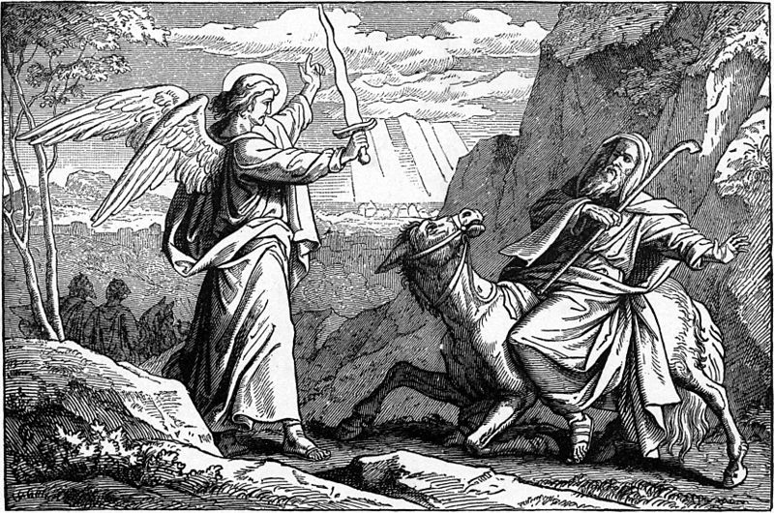

The Lord used Balaam's donkey as His instrument of truth because Balaam was behaving foolishly and selfishly.
Source: Public domain here http://upload.wikimedia.org/wikipedia/commons/thumb/d/d4/Foster_Bible_Pictures_0080-1_An_Angel_Met_Balaam_with_a_Sword.jpg/800px-Foster_Bible_Pictures_0080-1_An_Angel_Met_Balaam_with_a_Sword.jpg

Faith In Action

Pray
Ask the Holy Spirit to show you where you may either be rushing into a situation without a clear sense of God's instructions, or where you have been asked to support something in opposition to God's will, and then to show you where you may be flaunting sin before God and man.

Act
Today I will prayerfully consult the Word and inquire of the Holy Spirit so as to obtain God's perspective. No matter what others offer or say I will be steadfast in standing with God. I will share this challenging situation with one who is Biblically qualified as an elder and seek their prayerful counsel - and prayers in-agreement for strength and wisdom. I will confess, repent, request and receive forgiveness, and build an accountability system to avoid the sin I have previously been unaware that I was flaunting – or had been thinking I could get away with. It may be tempting my brother to stumble in the way that I act or dress, It may be making of worldly things something important – drawing others to prioritize them over the more-important things of God (activities, celebrities, entertainment, hobbies, possessions, power, sports; for example, I may be presenting a careless or crass attitude toward the things of God in an effort to set myself apart as a rebel).
Be Specific _____________________________________________

Saturday (Psalm 90)
Psalm 90
90:1 A prayer of Moses, the man of God.
O Lord, you have been our protector through all generations!
90:2 Even before the mountains came into existence, or you brought the world into being, you were the eternal God.
90:3 You make mankind return to the dust, and say, “Return, O people!”
90:4 Yes, in your eyes a thousand years are like yesterday that quickly passes, or like one of the divisions of the nighttime.
90:5 You bring their lives to an end and they “fall asleep.” In the morning they are like the grass that sprouts up;
90:6 in the morning it glistens and sprouts up; at evening time it withers and dries up.
90:7 Yes, we are consumed by your anger; we are terrified by your wrath.
90:8 You are aware of our sins; you even know about our hidden sins.
90:9 Yes, throughout all our days we experience your raging fury; the years of our lives pass quickly, like a sigh.
90:10 The days of our lives add up to seventy years, or eighty, if one is especially strong. But even one’s best years are marred by trouble and oppression. Yes, they pass quickly and we fly away.
90:11 Who can really fathom the intensity of your anger?
Your raging fury causes people to fear you.
90:12 So teach us to consider our mortality, so that we might live wisely.
90:13 Turn back toward us, O Lord!
How long must this suffering last?
Have pity on your servants!
90:14 Satisfy us in the morning with your loyal love!
Then we will shout for joy and be happy all our days!
90:15 Make us happy in proportion to the days you have afflicted us, in proportion to the years we have experienced trouble!
90:16 May your servants see your work!
May their sons see your majesty!
90:17 May our sovereign God extend his favor to us!
Make our endeavors successful!
Yes, make them successful!

Prayer
Lord, You are not like us; You have existed without beginning and will continue without end, Your holiness is offended by sin and honored by obedience. May I choose to live in obedience so that I may be a useful instrument rather than a useless-discarded tool.

Scripture In Perspective
Moses reflected upon the big picture history of the Lord's faithfulness to Israel.
He also honored the unique characteristics of God; the eternal One - with a long perspective vs the short-view humankind takes.
Moses emphasized the brevity of human life, exacerbated by our rebellious and self-destructive choices.
He asked that the Lord would help the people to better appreciate their mortality, so that rather than living frivolously they would live wisely before Him.
Moses appealed for blessing and grace.

Interact With The Text

Consider
Since the Lord God has existed forever, and humankind briefly, it would seem wise for us to always begin every consideration from His perspective.

Discuss
Why would Moses and the Israelites look at their troubled history, and short lives, as the consequence of God's anger?

Reflect
For the hundreds of years in Egyptian slavery, and decades of wandering, Moses asked for an equal time of peace and stability.

Share
When have you behaved as if you would live forever, without regard for the consequences of abuse to your body and the passage of time, only to discover the reality of your mortality?

KTALZ
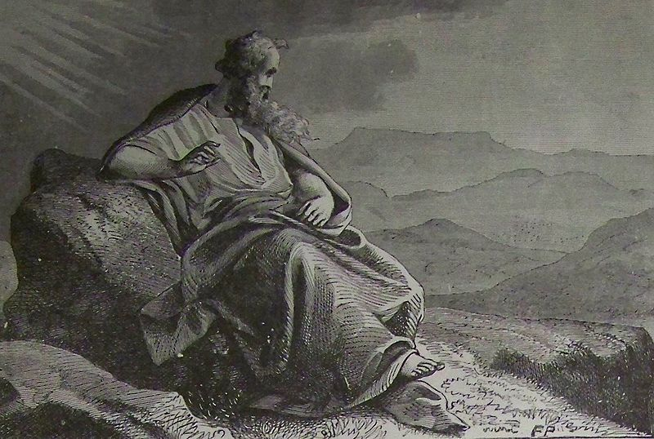

As Moses viewed the Promised Land he prayed.
Source: Public domain here http://upload.wikimedia.org/wikipedia/commons/thumb/d/d8/Moses_Viewing_the_Promised_Land.jpg/800px-Moses_Viewing_the_Promised_Land.jpg

Faith In Action

Pray
Ask the Holy Spirit to reveal to you a place where you are being a poor steward of health and of time.

Act
I will confess and repent of my poor stewardship, ask for and accept His forgiveness, then realign my priorities to His standard..
Be Specific _________________________________________________

All Bible text is from the NET unless otherwise indicated - http://bible.org
Note 1: These Studies often rely upon the guidance of the NET Translators from their associated notes. Careful attention has been given to cite that source where it has been quoted directly or closely paraphrased. Feedback is encouraged where credit has not been sufficiently assigned.
Note 2: When NET text is quoted in commentary and discussion all pronouns referring to God are capitalized, though they are lower-case in the original NET text.
Commentary text is from David M. Colburn, D.Min. unless otherwise noted.
Copyright © 2012 by David M. Colburn. This is a BibleSeven Study –“Genesis 3. Prepared by David M. Colburn and edited for bible.org in August of 2012. This text may be used for non-profit educational purposes only, with credit; all other usage requires prior written consent of the author.

