Judges 13 – 21
(The life of Samson, a cult rises, evil leads to violence.)
David M. Colburn
A Chronological Daily Bible Study of the Old Testament
7-Day Sections with a Summary-Commentary, Discussion Questions,
and a Practical Daily Application
Week 25

Sunday (Judges 13)
Samson’s Birth
13:1 The Israelites again did evil in the Lord’s sight, so the Lord handed them over to the Philistines for forty years.
13:2 There was a man named Manoah from Zorah, from the Danite tribe. His wife was infertile and childless. 13:3 The Lord’s angelic messenger appeared to the woman and said to her, “You are infertile and childless, but you will conceive and have a son. 13:4 Now be careful! Do not drink wine or beer, and do not eat any food that will make you ritually unclean. 13:5 Look, you will conceive and have a son. You must never cut his hair, for the child will be dedicated to God from birth. He will begin to deliver Israel from the power of the Philistines.”
13:6 The woman went and said to her husband, “A man sent from God came to me! He looked like God’s angelic messenger – he was very awesome. I did not ask him where he came from, and he did not tell me his name. 13:7 He said to me, ‘Look, you will conceive and have a son. So now, do not drink wine or beer and do not eat any food that will make you ritually unclean. For the child will be dedicated to God from birth till the day he dies.’”
13:8 Manoah prayed to the Lord, “Please, Lord, allow the man sent from God to visit us again, so he can teach us how we should raise the child who will be born.” 13:9 God answered Manoah’s prayer. God’s angelic messenger visited the woman again while she was sitting in the field. But her husband Manoah was not with her. 13:10 The woman ran at once and told her husband, “Come quickly, the man who visited me the other day has appeared to me!” 13:11 So Manoah got up and followed his wife. When he met the man, he said to him, “Are you the man who spoke to my wife?” He said, “Yes.” 13:12 Manoah said, “Now, when your announcement comes true, how should the child be raised and what should he do?” 13:13 The Lord’s messenger told Manoah, “Your wife should pay attention to everything I told her. 13:14 She should not drink anything that the grapevine produces. She must not drink wine or beer, and she must not eat any food that will make her ritually unclean. She should obey everything I commanded her to do.” 13:15 Manoah said to the Lord’s messenger, “Please stay here awhile, so we can prepare a young goat for you to eat.” 13:16 The Lord’s messenger said to Manoah, “If I stay, I will not eat your food. But if you want to make a burnt sacrifice to the Lord, you should offer it.” (He said this because Manoah did not know that he was the Lord’s messenger.) 13:17 Manoah said to the Lord’s messenger, “Tell us your name, so we can honor you when your announcement comes true.” 13:18 The Lord’s messenger said to him, “You should not ask me my name, because you cannot comprehend it.” 13:19 Manoah took a young goat and a grain offering and offered them on a rock to the Lord. The Lord’s messenger did an amazing thing as Manoah and his wife watched. 13:20 As the flame went up from the altar toward the sky, the Lord’s messenger went up in it while Manoah and his wife watched. They fell facedown to the ground.
13:21 The Lord’s messenger did not appear again to Manoah and his wife. After all this happened Manoah realized that the visitor had been the Lord’s messenger. 13:22 Manoah said to his wife, “We will certainly die, because we have seen a supernatural being!” 13:23 But his wife said to him, “If the Lord wanted to kill us, he would not have accepted the burnt offering and the grain offering from us. He would not have shown us all these things, or have spoken to us like this just now.”
13:24 Manoah’s wife gave birth to a son and named him Samson. The child grew and the Lord empowered him. 13:25 The Lord’s spirit began to control him in Mahaneh Dan between Zorah and Eshtaol.

Prayer
Lord, You showed the Israelites long before the coming of the Christ-child how You would bring The Deliverer into the world. May I be watchful for Your guiding hand in the world and live as You have taught me to live.

Scripture In Perspective
When the Israelites rebelled it resulted in forty years of bondage to the Philistines.
The Lord God heard their cries and sent his angelic messenger to guide Manoah's previously-infertile wife in the proper pre-natal care of, then both of them in the raising of their son, whom they named Samson.
She was to avoid alcoholic beverages and foods forbidden to Iraelites as ritually-unclean.
They asked the angelic messenger his name which he refused, saying that they could not comprehend it, and he then ascended back to Heaven along with the smoke of the goat-offering they made to the Lord God.

Interact with the text

Consider
Samson was to only begin the liberation of Israel.

Discuss
How many parallels are there between the prophesied birth of Samson and that of Jesus?

Reflect
The angelic messenger had to keep refocusing Manoah and his wife from their obsession with him and on to his purpose and to his message of the coming partial-deliverance of Israel from bondage through their son.

Share
When have you become so focused on the messenger, or observed that in others, that you had trouble even remembering the message?

KTALZ
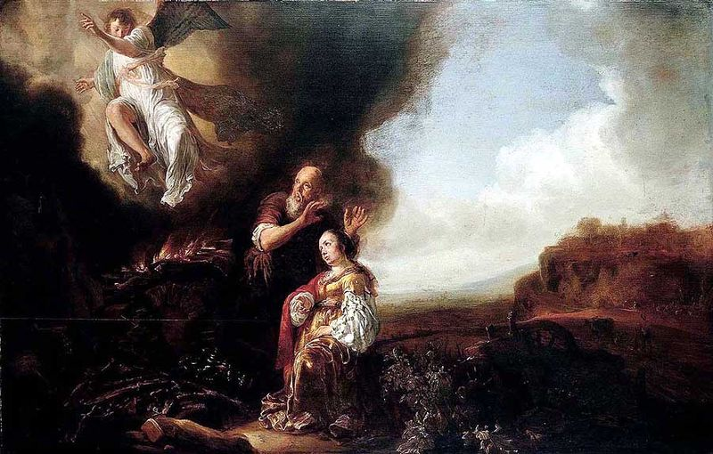

Manoah and his wife were so distracted by the angelic messenger he had to repeat his message – then ascended with the flames and smoke of their sacrificial fire.
Source: Public domain here http://upload.wikimedia.org/wikipedia/commons/thumb/6/6a/Salomon_de_Bray_The_Sacrifice_of_Manoah_1661.jpg/800px-Salomon_de_Bray_The_Sacrifice_of_Manoah_1661.jpg

Faith In Action

Pray
Ask the Holy Spirit to reveal to you a place where you have become too interested in the message or the mode of the message-delivery system that you are missing some of the essence of the message.

Act
Today I will repent of taking my eyes off of the Lord God and have not been fastidious in checking all teaching with His Word. It may be a 'celebrity preacher', a gifted musician, an unusual worship environment, or anything else. I will ask a fellow Believer to pray in-agreement that I will accept the guidance of the Holy Spirit and focus my attention on His message.
Be Specific ________________________________________________

Monday (Judges 14-15)
Samson’s Unconsummated Marriage
14:1 Samson went down to Timnah, where a Philistine girl caught his eye. 14:2 When he got home, he told his father and mother, “A Philistine girl in Timnah has caught my eye. Now get her for my wife.” 14:3 But his father and mother said to him, “Certainly you can find a wife among your relatives or among all our people! You should not have to go and get a wife from the uncircumcised Philistines.” But Samson said to his father, “Get her for me, because she is the right one for me.” 14:4 Now his father and mother did not realize this was the Lord’s doing, because he was looking for an opportunity to stir up trouble with the Philistines (for at that time the Philistines were ruling Israel).
14:5 Samson went down to Timnah. When he approached the vineyards of Timnah, he saw a roaring young lion attacking him. 14:6 The Lord’s spirit empowered him and he tore the lion in two with his bare hands as easily as one would tear a young goat. But he did not tell his father or mother what he had done.
14:7 Samson continued on down to Timnah and spoke to the girl. In his opinion, she was just the right one. 14:8 Some time later, when he went back to marry her, he turned aside to see the lion’s remains. He saw a swarm of bees in the lion’s carcass, as well as some honey. 14:9 He scooped it up with his hands and ate it as he walked along. When he returned to his father and mother, he offered them some and they ate it. But he did not tell them he had scooped the honey out of the lion’s carcass.
14:10 Then Samson’s father accompanied him to Timnah for the marriage. Samson hosted a party there, for this was customary for bridegrooms to do. 14:11 When the Philistines saw he had no attendants, they gave him thirty groomsmen who kept him company. 14:12 Samson said to them, “I will give you a riddle. If you really can solve it during the seven days the party lasts, I will give you thirty linen robes and thirty sets of clothes. 14:13 But if you cannot solve it, you will give me thirty linen robes and thirty sets of clothes.” They said to him, “Let us hear your riddle.” 14:14 He said to them,
“Out of the one who eats came something to eat;
out of the strong one came something sweet.”
They could not solve the riddle for three days.
14:15 On the fourth day they said to Samson’s bride, “Trick your husband into giving the solution to the riddle. If you refuse, we will burn up you and your father’s family. Did you invite us here to make us poor?” 14:16 So Samson’s bride cried on his shoulder and said, “You must hate me; you do not love me! You told the young men a riddle, but you have not told me the solution.” He said to her, “Look, I have not even told my father or mother. Do you really expect me to tell you?” 14:17 She cried on his shoulder until the party was almost over. Finally, on the seventh day, he told her because she had nagged him so much. Then she told the young men the solution to the riddle. 14:18 On the seventh day, before the sun set, the men of the city said to him,
“What is sweeter than honey?
What is stronger than a lion?”
He said to them,
“If you had not plowed with my heifer,
you would not have solved my riddle!”
14:19 The Lord’s spirit empowered him. He went down to Ashkelon and murdered thirty men. He took their clothes and gave them to the men who had solved the riddle. He was furious as he went back home. 14:20 Samson’s bride was then given to his best man.
Samson Versus the Philistines
15:1 Sometime later, during the wheat harvest, Samson took a young goat as a gift and went to visit his bride. He said to her father, “I want to have sex with my bride in her bedroom!” But her father would not let him enter. 15:2 Her father said, “I really thought you absolutely despised her, so I gave her to your best man. Her younger sister is more attractive than she is. Take her instead!” 15:3 Samson said to them, “This time I am justified in doing the Philistines harm!” 15:4 Samson went and captured three hundred jackals and got some torches. He tied the jackals in pairs by their tails and then tied a torch to each pair. 15:5 He lit the torches and set the jackals loose in the Philistines’ standing grain. He burned up the grain heaps and the standing grain, as well as the vineyards and olive groves. 15:6 The Philistines asked, “Who did this?” They were told, “Samson, the Timnite’s son-in-law, because the Timnite took Samson’s bride and gave her to his best man.” So the Philistines went up and burned her and her father. 15:7 Samson said to them, “Because you did this, I will get revenge against you before I quit fighting.” 15:8 He struck them down and defeated them. Then he went down and lived for a time in the cave in the cliff of Etam.
15:9 The Philistines went up and invaded Judah. They arrayed themselves for battle in Lehi. 15:10 The men of Judah said, “Why are you attacking us?” The Philistines said, “We have come up to take Samson prisoner so we can do to him what he has done to us.” 15:11 Three thousand men of Judah went down to the cave in the cliff of Etam and said to Samson, “Do you not know that the Philistines rule over us? Why have you done this to us?” He said to them, “I have only done to them what they have done to me.” 15:12 They said to him, “We have come down to take you prisoner so we can hand you over to the Philistines.” Samson said to them, “Promise me you will not kill me.” 15:13 They said to him, “We promise! We will only take you prisoner and hand you over to them. We promise not to kill you.” They tied him up with two brand new ropes and led him up from the cliff. 15:14 When he arrived in Lehi, the Philistines shouted as they approached him. But the Lord’s spirit empowered him. The ropes around his arms were like flax dissolving in fire, and they melted away from his hands. 15:15 He happened to see a solid jawbone of a donkey. He grabbed it and struck down a thousand men. 15:16 Samson then said,
“With the jawbone of a donkey
I have left them in heaps;
with the jawbone of a donkey
I have struck down a thousand men!”
15:17 When he finished speaking, he threw the jawbone down and named that place Ramath Lehi.
15:18 He was very thirsty, so he cried out to the Lord and said, “You have given your servant this great victory. But now must I die of thirst and fall into hands of the Philistines?” 15:19 So God split open the basin at Lehi and water flowed out from it. When he took a drink, his strength was restored and he revived. For this reason he named the spring En Hakkore. It remains in Lehi to this very day. 15:20 Samson led Israel for twenty years during the days of Philistine prominence.

Prayer
Lord, Your plan and timing was to begin the liberation of Israel from the Philistines, and Samson was the instrument you selected. May I not forget that merely because you select a person as Your instrument it does not mean that You endorse all that they are or all that they do. You say that revenge is Yours, and this story of Samson illustrates what happens when mere men take it upon themselves to deliver revenge. May I be wise enough to resist the fleshy temptation to attack another, verbally, physically, other otherwise in a fit of unrighteous rage.

Scripture In Perspective
The Lord God had said that it was His timing to begin the liberation of Israel from the Philistines.
The impulsive and immature Samson was a little like Moses, and even the Pharaoh was immature; their character defects created circumstances that God could use.
Samson went into the town and decided at first-sight he wanted to marry a Philistine woman upon whom he happened and returned home to inform his parents that they needed to get her for him. This was wrong on several levels; he was under a Nazirite vow and for him to marry a pagan risked spiritual pollution, he was acting impulsively which was immature and careless, and the text implies a rude and disrespectful demandingness toward his parents.
Samson and Timnah the Philistine were engaged, which according to the custom of the time meant that they were all-but-married except for the ceremony and consummation.
During his travels to and from the vineyard of Timnah's family Samson encountered a lion and the Holy Spirit came upon him, giving him superhuman strength, so that he tore the lion in half. Later on in his travels he discovered that a swarm of honeybees had nested in the carcass of the same lion and he scooped honey from it to eat himself and to share with his family.
As a Nazarite Samson was made ritually unclean by touching the carcass but he deceived others by not disclosing what he had done. (His choice would only impact him as they were unaware and thus could not sin by his violation of the ritual-law.)
When he arrived for the arranged wedding some of her male relatives gathered around so he decided to taunt them with a riddle. They threatened Timnah's family and she nagged Samson for days until he told her and they used it against him. He stormed out in anger, killed thirty of their kin in Ashkelon and then brought the men their clothes, then stormed off again. Timnah was quickly given to his bridegroom to deny her to Samson.
Samson, not yet aware that his bride (his wife, less the ceremony and consummation) had been given to another man, arrived with a gift and discovered what had been done. While their excuse was that they thought he despised her – their quick action, without first consulting him, suggested that their motive was to deny her to him.
They offered Samson Timnah's younger sister but in a fit of rage he instead caused the fields and orchards of the Philistines to burn by tying torches to 300 jackals tied in pairs by their tails. In revenge the Philistines killed Timnah and her father, with fire, which triggered Samson to kill many Philistines and then hide in a cave.
The Israelites, faced with an angry Philistine army invading their land to take revenge, took 1,000 men to capture Samson in order to give him to the Philistines but God caused the ropes to dissolve off of Samson and with the jawbone of a donkey he killed 1,000 Philistines. (In a prior miracle another man had killed 500 with such a bone. Samson may have been aware of that story and the Lord God likely chose the same weapon as a matter of consistency.)
Samson bragged of his victory, apparently giving no credit to God, but was still allowed by the Lord to serve as the leader of and equally-foolish Israel for twenty years.

Interact with the text

Consider
Samson's initial rebellious and selfish choices led to the death of Timnah and over a thousand others.

Discuss
The Lord God uses who He will in the way that He wills, He is not like us nor does He answer to our man-invented expectations. What other men in the history since the Garden of Eden can you recall being as impetuous and immature as Samson? How much power must God have given to Samson that he could round-up and use three hundred jackals, not friendly or pleasant creatures, in such a manner?

Reflect
Samson's impetuous nature and immaturity led him into several actions that were ultimately rebellious against God; e.g. touching the dead lion and rushing to marry a Philistine. The Philistines, not comprehending the source of Samson's moments of strength, repeatedly underestimated him.

Share
When have you rushed into a choice only to realize at some point you should have consulted God first, or paused long enough to remember that the character of God should guide your choice? When have you experienced or observed the backlash of revenge? What was the result?

KTALZ
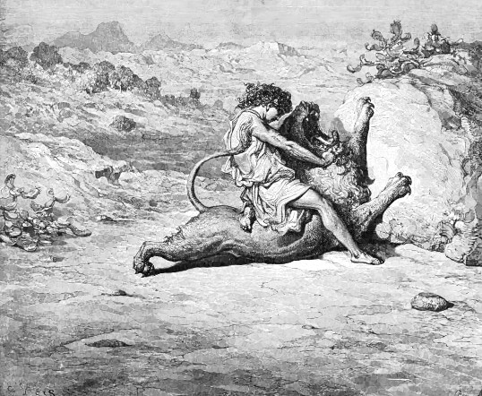

Samson was empowered by the Lord for Hos purposes but he frequently acted apart from the Lord – causing conflict – which the Lord turned for good.
Source: Public domain here http://www.wpclipart.com/religion_mythology/bible/Childs_story_of_Bible_2/young_Samson.jpg.html

Faith In Action

Pray
Ask the Holy Spirit to reveal to you a place in your life where you have a pattern of impetuous and/or immature choices and to reveal to you a place in your life where you may be tested and where you are weak enough to act from rage in revenge.

Act
Today I will confess and repent of my immaturity my impetuous actions. I will ask a fellow Believer to pray in-agreement that I will discipline myself to pause and to pray before I act in a way or say something that I know – or I should know – will not bring glory to God. I will also ask a fellow Believer to be my accountability partner and to pray in-agreement as I prayerfully partner with the Holy Spirit to learn to discipline my reaction to circumstances that may lead me into rage and revenge.
Be Specific _____________________________________________

Tuesday (Judges 16)
Samson’s Downfall
16:1 Samson went to Gaza. There he saw a prostitute and went in to have sex with her. 16:2 The Gazites were told, “Samson has come here!” So they surrounded the town and hid all night at the city gate, waiting for him to leave. They relaxed all night, thinking, “He will not leave until morning comes; then we will kill him!” 16:3 Samson spent half the night with the prostitute; then he got up in the middle of the night and left. He grabbed the doors of the city gate, as well as the two posts, and pulled them right off, bar and all. He put them on his shoulders and carried them up to the top of a hill east of Hebron.
16:4 After this Samson fell in love with a woman named Delilah, who lived in the Sorek Valley. 16:5 The rulers of the Philistines went up to visit her and said to her, “Trick him! Find out what makes him so strong and how we can subdue him and humiliate him. Each one of us will give you eleven hundred silver pieces.”
16:6 So Delilah said to Samson, “Tell me what makes you so strong and how you can be subdued and humiliated.” 16:7 Samson said to her, “If they tie me up with seven fresh bowstrings that have not been dried, I will become weak and be just like any other man.” 16:8 So the rulers of the Philistines brought her seven fresh bowstrings which had not been dried and they tied him up with them. 16:9 They hid in the bedroom and then she said to him, “The Philistines are here, Samson!” He snapped the bowstrings as easily as a thread of yarn snaps when it is put close to fire. The secret of his strength was not discovered.
16:10 Delilah said to Samson, “Look, you deceived me and told me lies! Now tell me how you can be subdued.” 16:11 He said to her, “If they tie me tightly with brand new ropes that have never been used, I will become weak and be just like any other man.” 16:12 So Delilah took new ropes and tied him with them and said to him, “The Philistines are here, Samson!” (The Philistines were hiding in the bedroom.) But he tore the ropes from his arms as if they were a piece of thread.
16:13 Delilah said to Samson, “Up to now you have deceived me and told me lies. Tell me how you can be subdued.” He said to her, “If you weave the seven braids of my hair into the fabric on the loom and secure it with the pin, I will become weak and be like any other man.” 16:14 So she made him go to sleep, wove the seven braids of his hair into the fabric on the loom, fastened it with the pin, and said to him, “The Philistines are here, Samson!” He woke up and tore away the pin of the loom and the fabric.
16:15 She said to him, “How can you say, ‘I love you,’ when you will not share your secret with me? Three times you have deceived me and have not told me what makes you so strong.” 16:16 She nagged him every day and pressured him until he was sick to death of it. 16:17 Finally he told her his secret. He said to her, “My hair has never been cut, for I have been dedicated to God from the time I was conceived. If my head were shaved, my strength would leave me; I would become weak, and be just like all other men.” 16:18 When Delilah saw that he had told her his secret, she sent for the rulers of the Philistines, saying, “Come up here again, for he has told me his secret.” So the rulers of the Philistines went up to visit her, bringing the silver in their hands. 16:19 She made him go to sleep on her lap and then called a man in to shave off the seven braids of his hair. She made him vulnerable and his strength left him. 16:20 She said, “The Philistines are here, Samson!” He woke up and thought, “I will do as I did before and shake myself free.” But he did not realize that the Lord had left him. 16:21 The Philistines captured him and gouged out his eyes. They brought him down to Gaza and bound him in bronze chains. He became a grinder in the prison. 16:22 His hair began to grow back after it had been shaved off.
Samson’s Death and Burial
16:23 The rulers of the Philistines gathered to offer a great sacrifice to Dagon their god and to celebrate. They said, “Our god has handed Samson, our enemy, over to us.” 16:24 When the people saw him, they praised their god, saying, “Our god has handed our enemy over to us, the one who ruined our land and killed so many of us!”
16:25 When they really started celebrating, they said, “Call for Samson so he can entertain us!” So they summoned Samson from the prison and he entertained them. They made him stand between two pillars. 16:26 Samson said to the young man who held his hand, “Position me so I can touch the pillars that support the temple. Then I can lean on them.” 16:27 Now the temple was filled with men and women, and all the rulers of the Philistines were there. There were three thousand men and women on the roof watching Samson entertain. 16:28 Samson called to the Lord, “O Master, Lord, remember me! Strengthen me just one more time, O God, so I can get swift revenge against the Philistines for my two eyes!” 16:29 Samson took hold of the two middle pillars that supported the temple and he leaned against them, with his right hand on one and his left hand on the other. 16:30 Samson said, “Let me die with the Philistines!” He pushed hard and the temple collapsed on the rulers and all the people in it. He killed many more people in his death than he had killed during his life. 16:31 His brothers and all his family went down and brought him back. They buried him between Zorah and Eshtaol in the tomb of Manoah his father. He had led Israel for twenty years.

Prayer
Lord, in our rebellion we do many foolish things, which lead to our worldly destruction, but You can even use our foolishness in your great plan. May I be less foolish so that I am useful to You as a productive instrument.

Scripture In Perspective
Samson continued in his foolish ways, this time visiting a prostitute. The Philistines planned to capture him in the morning but he left early and tore the city gates – carrying them to the top of a hill.
Then Samson became infatuated with another non-Israelite woman Delilah. The text does not state that he married her but it does describe his overnight stays in her home.
The Philistines leaders promised her a lot of money to trick him into disclosing the source of his extraordinary strength. She nagged him for many days and, after teasing her with false explanations, he finally gave in - as he had with the riddle to Timnah - and she told the Philistines.
Delilah cut Samson's hair, which was symbolic of his Nazarite vow, and his power-link to God was broken. The Philistines captured Samson, gouged-out his eyes, and made him work like a beast of burden in their prison.
The Philistine's had a great celebration and brought Samson as a source of entertainment – he appealed to God to give him strength one more time (his hair had grown back) – and he brought the building down on the 3,000+ Philistine leaders and wealthy citizens. This served as a major loss to the strength of the Philistines.

Interact With The Text

Consider
Samson seemed unable to learn from his mistakes, generally resulting from his lust for non-Israelite women.

Discuss
With the amazing blessing of the gift of extraordinary strength from God, plus his responsibility as the leader of Israel, why would Samson have been so foolish in his dealings with Philistine women?

Reflect
The Philistines feared Samson, though they should have feared the God from whom he received his strength, and in the end God used the foolishness of both Samson and the Philistines to further His goal of loosening the grip of the Philistines on Israel.

Share
When have you made a bad decision then later observed that God used some element of it for good?

KTALZ
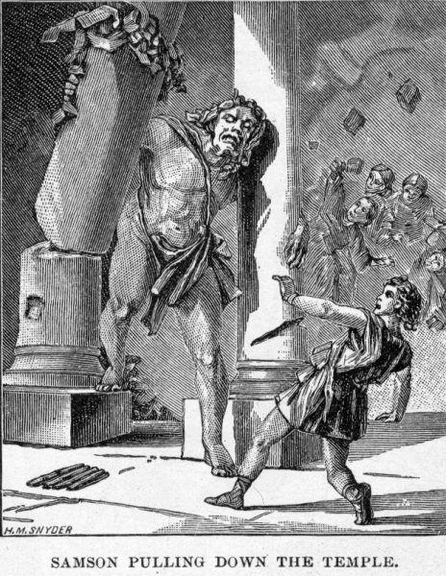

The image depicts Samson as a Goliath-like giant whereas the text offers no such description. Samson's persistent foolishness rendered him a mere a blunt weapon rather than a sophisticated tool in the hand of God.
Source: Public domain here http://www.coolnotions.com/PDImages/StoryOTB087_p219_SamsonPullingDownTheTemple.jpg

Faith In Action

Pray
Ask the Holy Spirit to reveal to you a place in your life where you are vulnerable to causing a test of faithfulness to the Lord God to become a temptation which then may lead to overt sin.

Act
Today I will prayerfully submit to the Lordship of Christ through the Holy Spirit in order to mature to where I am no longer vulnerable to temptation in the area He has revealed to me. It may be a place where I react to difficult circumstances with rage, where I engage in crude and foolish talk, dishonest dealings with others, gossip, laziness, pornography or other sexual sin, substance abuse, etc. I will ask another Believer to assist me with accountability and for prayer in-agreement.
Be Specific _________________________________________________

Wednesday (Judges 17)
Micah Makes His Own Religion
17:1 There was a man named Micah from the Ephraimite hill country. 17:2 He said to his mother, “You know the eleven hundred pieces of silver which were stolen from you, about which I heard you pronounce a curse? Look here, I have the silver. I stole it, but now I am giving it back to you.” His mother said, “May the Lord reward you, my son!” 17:3 When he gave back to his mother the eleven hundred pieces of silver, his mother said, “I solemnly dedicate this silver to the Lord. It will be for my son’s benefit. We will use it to make a carved image and a metal image.” 17:4 When he gave the silver back to his mother, she took two hundred pieces of silver to a silversmith, who made them into a carved image and a metal image. She then put them in Micah’s house. 17:5 Now this man Micah owned a shrine. He made an ephod and some personal idols and hired one of his sons to serve as a priest. 17:6 In those days Israel had no king. Each man did what he considered to be right.
Micah Hires a Professional
17:7 There was a young man from Bethlehem in Judah. He was a Levite who had been temporarily residing among the tribe of Judah. 17:8 This man left the town of Bethlehem in Judah to find another place to live. He came to the Ephraimite hill country and made his way to Micah’s house. 17:9 Micah said to him, “Where do you come from?” He replied, “I am a Levite from Bethlehem in Judah. I am looking for a new place to live.” 17:10 Micah said to him, “Stay with me. Become my adviser and priest. I will give you ten pieces of silver per year, plus clothes and food.” 17:11 So the Levite agreed to stay with the man; the young man was like a son to Micah. 17:12 Micah paid the Levite; the young man became his priest and lived in Micah’s house. 17:13 Micah said, “Now I know God will make me rich, because I have this Levite as my priest.”

Prayer
Lord, You warn us that everything we worship – directly or indirectly (when we divert our attention from You) will bring harm to us. May I be careful every day to be certain that You are first in all things.

Scripture In Perspective
Micah stole from his mother and then received compliments from her for returning what he had stolen – indicating that a distorted sense of values and a situational ethic had taken root.
Micah's mother made idols from some of the returned money and gave them to Micah, unwittingly initiating the fulfillment of the curse she had spoken against the one who has stolen from her.
Micah added more pagan religious articles in the form of personal idols and an ephod and then hired his son to serve as his private priest – all without consulting the Lord God.
A wandering Levite found his way to Micah's home and Micah hired him as his priest, imagining that the mere association with a Levite (even an apostate) would bring him blessings.
[Note: In the following text, Judges 18:1-6, despite his foolishness God still used the immature Levite for His purposes; sadly, the Danites made a series of unwise choices, further extending the impact of the curse.]

Interact With The Text

Consider
Micah knew the role of the Levites and therefore he knew of God's law, yet he behaved in a pagan manner in direct rebellion against God's law.

Discuss
Why would Micah disobey God and still expect that hiring an apostate Levite, who was untroubled by the presence of false idols, would bring him blessings from God?

Reflect
Mere association with a religious order or an association says nothing about ones character, nor ones standing before the Lord God, only fealty to His Word can serve as evidence of Biblical integrity as a leader.

Share
When have you experienced or observed a religious leader who was entrusted with responsibility but who was clearly functioning in opposition to God's Word?

KTALZ
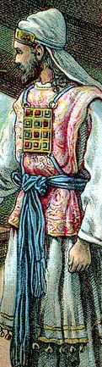

The ephod was a decorative piece of priestly garb, often including precious stones, which Micah would have created to imitate legitimacy.
Source: Public domain here http://upload.wikimedia.org/wikipedia/commons/6/6f/Kohen_Gadol_%28Bible_Card%29.jpg

Faith In Action

Pray
Ask the Holy Spirit to reveal to you a person or an organization in whom you have placed some trust but who may be unworthy of that trust.

Act
Today I will prayerfully review those whom I am trusting for accountability, discipleship, Christian fellowship and/or teaching to discern if the prompting of the Holy Spirit is that they are not worthy of my trust. I will be a good Berean and consult the Word and I will also solicit the prayers of a fellow Believer and the counsel of an organizationally-independent person who is Biblically-qualified to be an elder. As is practically-possible and appropriate I will communicate my concerns to the person whom I believe to be apostate and, unless they immediately repent and return to the Lord, I will immediately separate myself from the untrustworthy influence. To the degree that I have contributed to the problem I will remove from my possession any materials or objects that contain or reinforce bad teaching.
Be Specific ________________________________________________

Thursday (Judges 18)
The Tribe of Dan Finds an Inheritance
18:1 In those days Israel had no king. And in those days the Danite tribe was looking for a place to settle, because at that time they did not yet have a place to call their own among the tribes of Israel. 18:2 The Danites sent out from their whole tribe five representatives, capable men from Zorah and Eshtaol, to spy out the land and explore it. They said to them, “Go, explore the land.” They came to the Ephraimite hill country and spent the night at Micah’s house. 18:3 As they approached Micah’s house, they recognized the accent of the young Levite. So they stopped there and said to him, “Who brought you here? What are you doing in this place? What is your business here?” 18:4 He told them what Micah had done for him, saying, “He hired me and I became his priest.” 18:5 They said to him, “Seek a divine oracle for us, so we can know if we will be successful on our mission.” 18:6 The priest said to them, “Go with confidence. The Lord will be with you on your mission.”
18:7 So the five men journeyed on and arrived in Laish. They noticed that the people there were living securely, like the Sidonians do, undisturbed and unsuspecting. No conqueror was troubling them in any way. They lived far from the Sidonians and had no dealings with anyone. 18:8 When the Danites returned to their tribe in Zorah and Eshtaol, their kinsmen asked them, “How did it go?” 18:9 They said, “Come on, let’s attack them, for we saw their land and it is very good. You seem lethargic, but don’t hesitate to invade and conquer the land. 18:10 When you invade, you will encounter unsuspecting people. The land is wide! God is handing it over to you – a place that lacks nothing on earth!”
18:11 So six hundred Danites, fully armed, set out from Zorah and Eshtaol. 18:12 They went up and camped in Kiriath Jearim in Judah. (To this day that place is called Camp of Dan. It is west of Kiriath Jearim.) 18:13 From there they traveled through the Ephraimite hill country and arrived at Micah’s house. 18:14 The five men who had gone to spy out the land of Laish said to their kinsmen, “Do you realize that inside these houses are an ephod, some personal idols, a carved image, and a metal image? Decide now what you want to do.” 18:15 They stopped there, went inside the young Levite’s house (which belonged to Micah), and asked him how he was doing. 18:16 Meanwhile the six hundred Danites, fully armed, stood at the entrance to the gate. 18:17 The five men who had gone to spy out the land broke in and stole the carved image, the ephod, the personal idols, and the metal image, while the priest was standing at the entrance to the gate with the six hundred fully armed men. 18:18 When these men broke into Micah’s house and stole the carved image, the ephod, the personal idols, and the metal image, the priest said to them, “What are you doing?” 18:19 They said to him, “Shut up! Put your hand over your mouth and come with us! You can be our adviser and priest. Wouldn’t it be better to be a priest for a whole Israelite tribe than for just one man’s family?” 18:20 The priest was happy. He took the ephod, the personal idols, and the carved image and joined the group.
18:21 They turned and went on their way, but they walked behind the children, the cattle, and their possessions. 18:22 After they had gone a good distance from Micah’s house, Micah’s neighbors gathered together and caught up with the Danites. 18:23 When they called out to the Danites, the Danites turned around and said to Micah, “Why have you gathered together?” 18:24 He said, “You stole my gods that I made, as well as this priest, and then went away. What do I have left? How can you have the audacity to say to me, ‘What do you want?’” 18:25 The Danites said to him, “Don’t say another word to us, or some very angry men will attack you, and you and your family will die.” 18:26 The Danites went on their way; when Micah realized they were too strong to resist, he turned around and went home.
18:27 Now the Danites took what Micah had made, as well as his priest, and came to Laish, where the people were undisturbed and unsuspecting. They struck them down with the sword and burned the city. 18:28 No one came to the rescue because the city was far from Sidon and they had no dealings with anyone. The city was in a valley near Beth Rehob. The Danites rebuilt the city and occupied it. 18:29 They named it Dan after their ancestor, who was one of Israel’s sons. But the city’s name used to be Laish. 18:30 The Danites worshiped the carved image. Jonathan, descendant of Gershom, son of Moses, and his descendants served as priests for the tribe of Dan until the time of the exile. 18:31 They worshiped Micah’s carved image the whole time God’s authorized shrine was in Shiloh.

Prayer
Lord, You show us the good and right way to fellowship with You and with one-another but we all-too-often choose to go our own destructive and rebellious way. May I recognize Your provision and Your path and follow You all of my days.

Scripture In Perspective
The tribe of Dan had failed to fulfill God's instructions – to subdue then settle into a part of the promised land which God had given them – but some of them decided to act and found their way to Laish – then occupied by a people affiliated with the Sidonians but who had chosen to live in distant isolation – making them vulnerable.
They sent out spies who came upon Micah's home, with his hired personal Levite priest, his metal idol, personal idols, ephod, and pagan religious practices. They also discovered a nearby city which was not Israelite nor was it prepared against any potential attack.
They returned home and persuaded their tribe to gather and attack. The tribe of Dan traveled past the home of Micah where they took his hired personal Levite priest, his metal idol, his personal idols, his ephod, and worse of all his pagan religious practices.
Micah and his family pursued them but were persuaded to turn back as the Danites were much too strong for them.
The Danites took the city and settled there but sold-out to the pagan religion, a further spread of the curse of Micah's mother, and they remained in rebellion against God until the time of exile from the promised land.
This area would be known in New Testament times as Caesarea Philippi, and in modern times as the Golan Heights.

Interact With The Text

Consider
The Israelites were so prone to rebellion, despite all that the Lord God had shown them and had done for them, that He had chosen to give them no leader rather to allow them to choose freely (in their own wisdom) which way they would go.

Discuss
Given all that they had to known of their tribal history, and of the Lord God, why would the Danites act so foolishly?

Reflect
The Lord had warned what would happen if the people turned to idols, yet they did so anyhow.

Share
When have you thought that you had achieved something valuable, in the eyes of the world, only to discover that you had paid a price too high in your relationship with God and/or with fellow Believers?

KTALZ
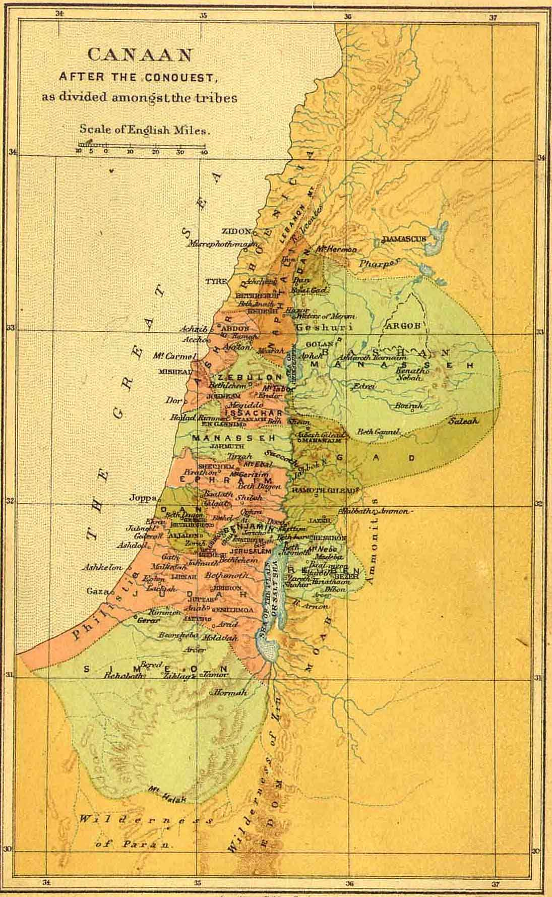

The area for Dan was in the the most north-central region of the promised land.
Source: Public domain here http://www.sacred-texts.com/bib/maps/img/002.jpg

Faith In Action

Pray
Ask the Holy Spirit to show you where you may be leaving God behind as you pursue something that the world says is valuable.

Act
Today I will acknowledge my drift away from the Lord in pursuit of a worldly value. I will repent of it and return to a balance that favors God over everything else.
Be Specific _____________________________________________

Friday (Judges 19)
Sodom and Gomorrah Revisited
19:1 In those days Israel had no king. There was a Levite living temporarily in the remote region of the Ephraimite hill country. He acquired a concubine from Bethlehem in Judah. 19:2 However, she got angry at him and went home to her father’s house in Bethlehem in Judah. When she had been there four months, 19:3 her husband came after her, hoping he could convince her to return. He brought with him his servant and a pair of donkeys. When she brought him into her father’s house and the girl’s father saw him, he greeted him warmly. 19:4 His father-in-law, the girl’s father, persuaded him to stay with him for three days, and they ate and drank together, and spent the night there. 19:5 On the fourth day they woke up early and the Levite got ready to leave. But the girl’s father said to his son-in-law, “Have a bite to eat for some energy, then you can go.” 19:6 So the two of them sat down and had a meal together. Then the girl’s father said to the man, “Why not stay another night and have a good time!” 19:7 When the man got ready to leave, his father-in-law convinced him to stay another night. 19:8 He woke up early in the morning on the fifth day so he could leave, but the girl’s father said, “Get some energy. Wait until later in the day to leave!” So they ate a meal together. 19:9 When the man got ready to leave with his concubine and his servant, his father-in-law, the girl’s father, said to him, “Look! The day is almost over! Stay another night! Since the day is over, stay another night here and have a good time. You can get up early tomorrow and start your trip home.” 19:10 But the man did not want to stay another night. He left and traveled as far as Jebus (that is, Jerusalem). He had with him a pair of saddled donkeys and his concubine.
19:11 When they got near Jebus, it was getting quite late and the servant said to his master, “Come on, let’s stop at this Jebusite city and spend the night in it.” 19:12 But his master said to him, “We should not stop at a foreign city where non-Israelites live. We will travel on to Gibeah.” 19:13 He said to his servant, “Come on, we will go into one of the other towns and spend the night in Gibeah or Ramah.” 19:14 So they traveled on, and the sun went down when they were near Gibeah in the territory of Benjamin. 19:15 They stopped there and decided to spend the night in Gibeah. They came into the city and sat down in the town square, but no one invited them to spend the night.
19:16 But then an old man passed by, returning at the end of the day from his work in the field. The man was from the Ephraimite hill country; he was living temporarily in Gibeah. (The residents of the town were Benjaminites.) 19:17 When he looked up and saw the traveler in the town square, the old man said, “Where are you heading? Where do you come from?” 19:18 The Levite said to him, “We are traveling from Bethlehem in Judah to the remote region of the Ephraimite hill country. That’s where I’m from. I had business in Bethlehem in Judah, but now I’m heading home. But no one has invited me into their home. 19:19 We have enough straw and grain for our donkeys, and there is enough food and wine for me, your female servant, and the young man who is with your servants. We lack nothing.” 19:20 The old man said, “Everything is just fine! I will take care of all your needs. But don’t spend the night in the town square.” 19:21 So he brought him to his house and fed the donkeys. They washed their feet and had a meal.
19:22 They were having a good time, when suddenly some men of the city, some good-for-nothings, surrounded the house and kept beating on the door. They said to the old man who owned the house, “Send out the man who came to visit you so we can have sex with him.” 19:23 The man who owned the house went outside and said to them, “No, my brothers! Don’t do this wicked thing! After all, this man is a guest in my house. Don’t do such a disgraceful thing! 19:24 Here are my virgin daughter and my guest’s concubine. I will send them out and you can abuse them and do to them whatever you like. But don’t do such a disgraceful thing to this man!” 19:25 The men refused to listen to him, so the Levite grabbed his concubine and made her go outside. They raped her and abused her all night long until morning. They let her go at dawn. 19:26 The woman arrived back at daybreak and was sprawled out on the doorstep of the house where her master was staying until it became light. 19:27 When her master got up in the morning, opened the doors of the house, and went outside to start on his journey, there was the woman, his concubine, sprawled out on the doorstep of the house with her hands on the threshold. 19:28 He said to her, “Get up, let’s leave!” But there was no response. He put her on the donkey and went home. 19:29 When he got home, he took a knife, grabbed his concubine, and carved her up into twelve pieces. Then he sent the pieces throughout Israel. 19:30 Everyone who saw the sight said, “Nothing like this has happened or been witnessed during the entire time since the Israelites left the land of Egypt! Take careful note of it! Discuss it and speak!”

Prayer
Lord, You have demonstrated over and over how much You hate sin, yet we persist in returning to our flesh-dominated and demon-manipulated ways over and over. May I intentionally seek the accountability, continuous discipleship, prayer-without-ceasing, and the time in Your Word that is necessary to keep me from drifting into such terrible sin.

Scripture In Perspective
While the Ark of the Covenant remained in the Tabernacle and the chief Priest, Phinehas “... son of Eleazar, son of Aaron” continued to practice the Lord God-prescribed religious rituals, much of Israel had reverted to paganism and self-governance apart from God - without a God-anointed and appointed prophet, judge, or king. Indeed, each man did as he thought best.
A Levite had taken for himself a young woman as a concubine – an act of selfish rebellion. He visited his concubine's father and after several days he moved on to a city in a region populated by Benjaminites. He was invited into the home of an older man who was from the “Ephraimite hill country; he was living temporarily in Gibeah”.
As had happened in Sodom and Gomorrah in the past, sin-crazed bi-sexual men surrounded the house and demanded that the man give them his guess to abuse sexually until he was dead.
The old man refused because custom required that a guest in your home be defended at all cost. He offered instead his “... virgin daughter and his guest's concubine” but they refused.
The Levite recognized the danger to the entire household and thus forced his concubine outside where she was raped repeatedly until he found her dead in the morning.
He brought her body home, cut it to pieces, and had the pieces delivered throughout the Israelite tribes as a challenge to the nation for justice.

Interact With The Text

Consider
The rampant rebellion against God, and His decision to abandon them to the consequences their own ways, had gone so far as to cause one of the tribes to drift all of the way back to the demon-controlled madness of Sodom and Gomorrah.

Discuss
What decision might the Benjamanites have made about their living circumstances which led to the demon-controlled mob?

Reflect
The purpose of the back-story is not to justify the Levite's taking of a concubine, nor the old man offering his virgin daughter and the concubine to the demon-controlled psychopaths in the city, nor the Levite sacrificing his concubine to the psychopaths for them to abuse. The Lord God was clearly not pleased with Israel and was allowing the crisis to be a teachable-moment to gain their attention.

Share
When have you observed a person, group, or fellowship drifting into rebellion – after which sin became rampant?
KTALZ
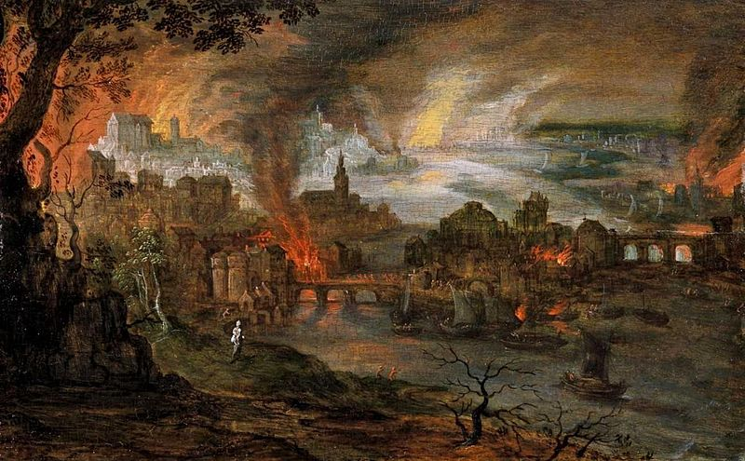

The same evil and selfish sin that led to the judgment and destruction of Sodom and Gomorrah had infected parts of the promised land.
Source: Public domain here http://upload.wikimedia.org/wikipedia/commons/thumb/a/ab/Pieter_Schoubroeck_-_De_verwoesting_van_Sodom_en_Gomorra.jpg/800px-Pieter_Schoubroeck_-_De_verwoesting_van_Sodom_en_Gomorra.jpg

Faith In Action

Pray
Ask the Holy Spirit to reveal to you a place in your life where your compromise with the world adds to the growing rebellion within your family, group, fellowship, or larger society.

Act
Today I will repent of my sin. It may be alcohol, food, or drug abuse. It may be debt or dishonesty, a lust for power or the lure of promiscuity, it may be laziness or the idolatry of perfectionism, it may be disrespecting God, parents, or fellow Christians who have Biblically-earned the right to be honored, respected, and trusted. I will create an intentional system of accountability, continuous discipleship, prayer-without-ceasing, and time in the Word that is necessary to keep me from drifting into terrible sin.
Be Specific _____________________________________________

Saturday (Judges 20-21)
Civil War Breaks Out
20:1 All the Israelites from Dan to Beer Sheba and from the land of Gilead left their homes and assembled together before the Lord at Mizpah. 20:2 The leaders of all the people from all the tribes of Israel took their places in the assembly of God’s people, which numbered four hundred thousand sword-wielding foot soldiers. 20:3 The Benjaminites heard that the Israelites had gone up to Mizpah. Then the Israelites said, “Explain how this wicked thing happened!” 20:4 The Levite, the husband of the murdered woman, spoke up, “I and my concubine stopped in Gibeah in the territory of Benjamin to spend the night. 20:5 The leaders of Gibeah attacked me and at night surrounded the house where I was staying. They wanted to kill me; instead they abused my concubine so badly that she died. 20:6 I grabbed hold of my concubine and carved her up and sent the pieces throughout the territory occupied by Israel, because they committed such an unthinkable atrocity in Israel. 20:7 All you Israelites, make a decision here!”
20:8 All Israel rose up in unison and said, “Not one of us will go home! Not one of us will return to his house! 20:9 Now this is what we will do to Gibeah: We will attack the city as the lot dictates. 20:10 We will take ten of every group of a hundred men from all the tribes of Israel (and a hundred of every group of a thousand, and a thousand of every group of ten thousand) to get supplies for the army. When they arrive in Gibeah of Benjamin they will punish them for the atrocity which they committed in Israel.” 20:11 So all the men of Israel gathered together at the city as allies.
20:12 The tribes of Israel sent men throughout the tribe of Benjamin, saying, “How could such a wicked thing take place? 20:13 Now, hand over the good-for-nothings in Gibeah so we can execute them and purge Israel of wickedness.” But the Benjaminites refused to listen to their Israelite brothers. 20:14 The Benjaminites came from their cities and assembled at Gibeah to make war against the Israelites. 20:15 That day the Benjaminites mustered from their cities twenty-six thousand sword-wielding soldiers, besides seven hundred well-trained soldiers from Gibeah. 20:16 Among this army were seven hundred specially-trained left-handed soldiers. Each one could sling a stone and hit even the smallest target. 20:17 The men of Israel (not counting Benjamin) had mustered four hundred thousand sword-wielding soldiers, every one an experienced warrior.
20:18 The Israelites went up to Bethel and asked God, “Who should lead the charge against the Benjaminites?” The Lord said, “Judah should lead.” 20:19 The Israelites got up the next morning and moved against Gibeah. 20:20 The men of Israel marched out to fight Benjamin; they arranged their battle lines against Gibeah. 20:21 The Benjaminites attacked from Gibeah and struck down twenty-two thousand Israelites that day.
20:22 The Israelite army took heart and once more arranged their battle lines, in the same place where they had taken their positions the day before. 20:23 The Israelites went up and wept before the Lord until evening. They asked the Lord, “Should we again march out to fight the Benjaminites, our brothers?” The Lord said, “Attack them!” 20:24 So the Israelites marched toward the Benjaminites the next day. 20:25 The Benjaminites again attacked them from Gibeah and struck down eighteen thousand sword-wielding Israelite soldiers.
20:26 So all the Israelites, the whole army, went up to Bethel. They wept and sat there before the Lord; they did not eat anything that day until evening. They offered up burnt sacrifices and tokens of peace to the Lord. 20:27 The Israelites asked the Lord (for the ark of God’s covenant was there in those days; 20:28 Phinehas son of Eleazar, son of Aaron, was serving the Lord in those days), “Should we once more march out to fight the Benjaminites our brothers, or should we quit?” The Lord said, “Attack, for tomorrow I will hand them over to you.”
20:29 So Israel hid men in ambush outside Gibeah. 20:30 The Israelites attacked the Benjaminites the next day; they took their positions against Gibeah just as they had done before. 20:31 The Benjaminites attacked the army, leaving the city unguarded. They began to strike down their enemy just as they had done before. On the main roads (one leads to Bethel, the other to Gibeah) and in the field, they struck down about thirty Israelites. 20:32 Then the Benjaminites said, “They are defeated just as before.” But the Israelites said, “Let’s retreat and lure them away from the city into the main roads.” 20:33 All the men of Israel got up from their places and took their positions at Baal Tamar, while the Israelites hiding in ambush jumped out of their places west of Gibeah. 20:34 Ten thousand men, well-trained soldiers from all Israel, then made a frontal assault against Gibeah – the battle was fierce. But the Benjaminites did not realize that disaster was at their doorstep. 20:35 The Lord annihilated Benjamin before Israel; the Israelites struck down that day 25,100 sword-wielding Benjaminites. 20:36 Then the Benjaminites saw they were defeated.
The Israelites retreated before Benjamin, because they had confidence in the men they had hid in ambush outside Gibeah. 20:37 The men hiding in ambush made a mad dash to Gibeah. They attacked and put the sword to the entire city. 20:38 The Israelites and the men hiding in ambush had arranged a signal. When the men hiding in ambush sent up a smoke signal from the city, 20:39 the Israelites counterattacked. Benjamin had begun to strike down the Israelites; they struck down about thirty men. They said, “There’s no doubt about it! They are totally defeated as in the earlier battle.” 20:40 But when the signal, a pillar of smoke, began to rise up from the city, the Benjaminites turned around and saw the whole city going up in a cloud of smoke that rose high into the sky. 20:41 When the Israelites turned around, the Benjaminites panicked because they could see that disaster was on their doorstep. 20:42 They retreated before the Israelites, taking the road to the wilderness. But the battle overtook them as men from the surrounding cities struck them down. 20:43 They surrounded the Benjaminites, chased them from Nohah, and annihilated them all the way to a spot east of Geba. 20:44 Eighteen thousand Benjaminites, all of them capable warriors, fell dead. 20:45 The rest turned and ran toward the wilderness, heading toward the cliff of Rimmon. But the Israelites caught five thousand of them on the main roads. They stayed right on their heels all the way to Gidom and struck down two thousand more. 20:46 That day twenty-five thousand sword-wielding Benjaminites fell in battle, all of them capable warriors. 20:47 Six hundred survivors turned and ran away to the wilderness, to the cliff of Rimmon. They stayed there four months. 20:48 The Israelites returned to the Benjaminite towns and put the sword to them. They wiped out the cities, the animals, and everything they could find. They set fire to every city in their path.
600 Brides for 600 Brothers
21:1 The Israelites had taken an oath in Mizpah, saying, “Not one of us will allow his daughter to marry a Benjaminite.” 21:2 So the people came to Bethel and sat there before God until evening, weeping loudly and uncontrollably. 21:3 They said, “Why, O Lord God of Israel, has this happened in Israel?” An entire tribe has disappeared from Israel today!”
21:4 The next morning the people got up early and built an altar there. They offered up burnt sacrifices and token of peace. 21:5 The Israelites asked, “Who from all the Israelite tribes has not assembled before the Lord?” They had made a solemn oath that whoever did not assemble before the Lord at Mizpah must certainly be executed. 21:6 The Israelites regretted what had happened to their brother Benjamin. They said, “Today we cut off an entire tribe from Israel! 21:7 How can we find wives for those who are left? After all, we took an oath in the Lord’s name not to give them our daughters as wives.” 21:8 So they asked, “Who from all the Israelite tribes did not assemble before the Lord at Mizpah?” Now it just so happened no one from Jabesh Gilead had come to the gathering. 21:9 When they took roll call, they noticed none of the inhabitants of Jabesh Gilead were there. 21:10 So the assembly sent 12,000 capable warriors against Jabesh Gilead. They commanded them, “Go and kill with your swords the inhabitants of Jabesh Gilead, including the women and little children. 21:11 Do this: exterminate every male, as well as every woman who has had sexual relations with a male. But spare the lives of any virgins.” So they did as instructed. 21:12 They found among the inhabitants of Jabesh Gilead four hundred young girls who were virgins – they had never had sexual relations with a male. They brought them back to the camp at Shiloh in the land of Canaan.
21:13 The entire assembly sent messengers to the Benjaminites at the cliff of Rimmon and assured them they would not be harmed. 21:14 The Benjaminites returned at that time, and the Israelites gave to them the women they had spared from Jabesh Gilead. But there were not enough to go around.
21:15 The people regretted what had happened to Benjamin because the Lord had weakened the Israelite tribes. 21:16 The leaders of the assembly said, “How can we find wives for those who are left? After all, the Benjaminite women have been wiped out. 21:17 The remnant of Benjamin must be preserved. An entire Israelite tribe should not be wiped out. 21:18 But we can’t allow our daughters to marry them, for the Israelites took an oath, saying, ‘Whoever gives a woman to a Benjaminite will be destroyed!’ 21:19 However, there is an annual festival to the Lord in Shiloh, which is north of Bethel (east of the main road that goes up from Bethel to Shechem) and south of Lebonah.” 21:20 So they commanded the Benjaminites, “Go hide in the vineyards, 21:21 and keep your eyes open. When you see the daughters of Shiloh coming out to dance in the celebration, jump out from the vineyards. Each one of you, catch yourself a wife from among the daughters of Shiloh and then go home to the land of Benjamin. 21:22 When their fathers or brothers come and protest to us, we’ll say to them, “Do us a favor and let them be, for we could not get each one a wife through battle. Don’t worry about breaking your oath! You would only be guilty if you had voluntarily given them wives.’”
21:23 The Benjaminites did as instructed. They abducted two hundred of the dancing girls to be their wives. They went home to their own territory, rebuilt their cities, and settled down. 21:24 Then the Israelites dispersed from there to their respective tribal and clan territories. Each went from there to his own property. 21:25 In those days Israel had no king. Each man did what he considered to be right.

Prayer
Lord, it is horrifying to a modern Christian to read the things that happened in the past, yet we have excused or tolerated equally terrible things (abortion, Crusades, religious persecutions, and even slavery) in our so-called civilized societies. May I not be blinded in my criticism of the sins of the past and miss the sins of today - displayed in the mirror of the Holy Spirit.

Scripture In Perspective
The people were horrified by what they thought could only happen in Sodom and Gomorrah, a place they knew that God had obliterated, had happened in a town inhabited by Benjaminites. In terror gathered four hundred thousand strong at the Tabernacle to decide what to do.
The text does not state that they consulted with and heard from God but they decided to surround Gibeah and demand the lives of those who had committed the terrible crime. The Benjaminites refused and instead gathered to do battle. The first two engagements went badly for the larger Israelite forces and nearly 40,000 died.
While God wanted the terrible sinfulness of the Benjaminites purged He was also keenly aware of the sinful rebellion of the rest of Israel – which was why they'd been left on their own for a time.
They consulted God each time and He told them to attack, yet the Benjaminites prevailed the first two times, so they stopped and sacrificed and wept and asked the Lord for His guidance - so on their third try He said that He would deliver the Benjaminites to them and He did so. The other tribes killed most of the Benjaminites, 25,000 of them – leaving only 600 of age to serve in battle - and for four months they systematically destroyed their cities and villages, animals and crops.
After four months of rampaging-destruction, their erstwhile purging of the evil among the Benjamintes, the other tribes realized that they had nearly obliterated an entire tribe and thus weakened the nation of twelve tribes appointed by the Lord God.
In their impetuous rush to separate themselves from the sin of the Benjaminites they had vowed that none of their tribes would give their daughters as wives to any Benjaminite.
In their next rush-to-act they decided that somehow they had to find wives for the remaining 600 Benjaminite men.
They discovered that one tribe was absent from their gathering, so they sent a force to wipe-out all but the young virgins, which resulted in 400 of the needed 600 wives.
Next they schemed that they'd allow the Benjamites to kidnap young virgins from an upcoming local celebration, which they arranged, and through which the final 200 wives were provided – all without directly violating their vow.
[Note: These were a primitive people in chronic rebellion against God. He could have justly obliterated them but rather chose to purge and maintain them as a people. Nothing in this text, relative to tribal violence (or violence against sinners) may be extrapolated to modern Christian practice. The apostle Paul taught about discipline within the fellowship of Believers.]

Interact With The Text

Consider
The Lord God had created the 12 tribes and He had declared them important, thereafter the identity of every Israelite was powerfully linked to a tribe, and through the tribe to the nation, and then of the nation to God. The utter loss of a tribe would have been unthinkable to them.

Discuss
One wonders if the “young virgins” of Shiloh were told that they were about to be kidnapped by the men of the tribe of Ben, if so were they all praying they would not be one of the 200? How must their parents have felt, knowing the recent vile history of the Benjamites, and that their daughter would be going to that decimated and dishonored tribe?

Reflect
The Lord God was clearly not pleased with Israel since He allowed ten percent (40,000) of their soldiers to be killed by the Benjaminites before He delivered the Benjaminites into their hands
The back-story was to explain just how terribly corrupt and rebellious all of Israel had become.
The people of Jabesh Gilead paid a terrible price for not showing up to worship that day. While most paid with their lives, the 400 young virgins found themselves displaced to the tribe of Ben after the death of everyone that they had known. Their loss became the Israelite sacrifice to preserve the tribe of Ben.

Share
When have you observed fear driving someone to over-react to circumstances?

KTALZ
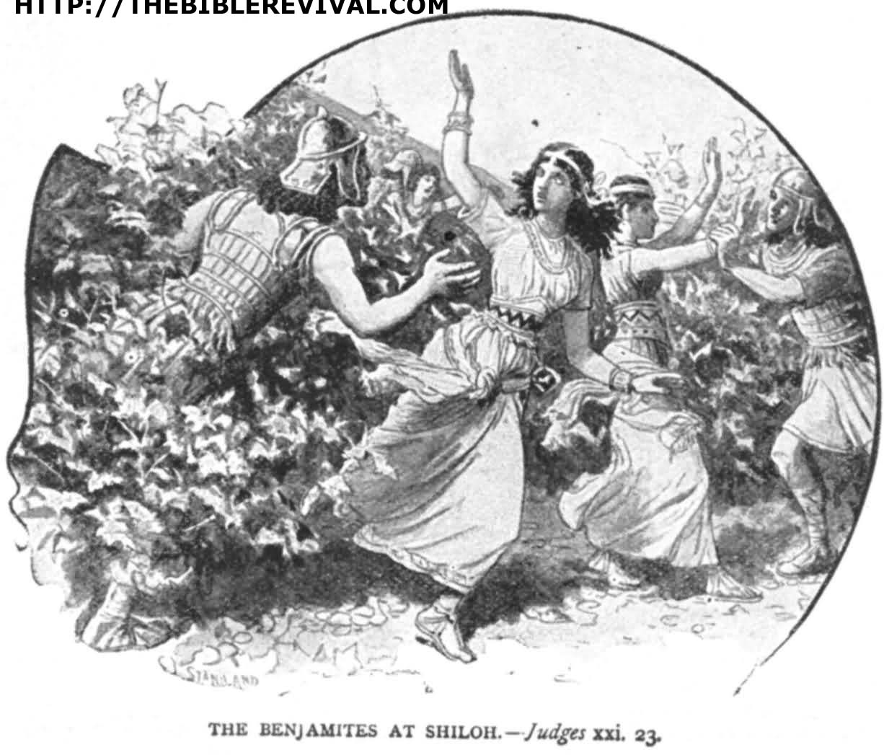

The Israelites were desperate to preserve the decimated Benjaminite tribe and their schemes to accomplish that were done without and record of consultation with God.
Source: Public domain here http://thebiblerevival.com/clipart/judges%2021%20-%2023%20the%20benjamites%20at%20shiloh.jpg

Faith In Action

Pray
Ask the Holy Spirit to reveal to you a way that you have, you are, or you can be used to preserve something that God says is valuable.

Act
Today I will pray, and ask at least one fellow Believer to pray in-agreement, for clarity as to how the Lord God wishes to use me to preserve something of value. It may be the memory of His faithfulness within a fellowship or family or an individual's life, it may be reminding Believers who are drifting away from a Biblical truth, or it may be something else. I agree to be attentive to His call.
Be Specific _________________________________________________

All Bible text is from the NET unless otherwise indicated - http://bible.org
Note 1: These Studies often rely upon the guidance of the NET Translators from their associated notes. Careful attention has been given to cite that source where it has been quoted directly or closely paraphrased. Feedback is encouraged where credit has not been sufficiently assigned.
Note 2: When NET text is quoted in commentary and discussion all pronouns referring to God are capitalized, though they are lower-case in the original NET text.
Commentary text is from David M. Colburn, D.Min. unless otherwise noted.
Copyright © 2012 by David M. Colburn. This is a BibleSeven Study –“Genesis 3. Prepared by David M. Colburn and edited for bible.org in August of 2012. This text may be used for non-profit educational purposes only, with credit; all other usage requires prior written consent of the author.

