Gospels in Chronological Order
David M. Colburn
A Daily Bible Study in 7-Day Sections with a
Summary-Commentary, Discussion Questions, and Daily Application
The Parallel Gospels in Chronological Order
Week Twelve of Twelve
Matthew 26:47–28:20; Mark 14:43–16:20; Luke 22:47–24:53; John 18:40–21:25

Sunday (Matthew 26:47-75; Mark 14:43-72; Luke 22:47-71; John 18:1-27)
Matthew
Betrayal and Arrest
26:47 While he was still speaking, Judas, one of the twelve, arrived. With him was a large crowd armed with swords and clubs, sent by the chief priests and elders of the people. 26:48 (Now the betrayer had given them a sign, saying, “The one I kiss is the man. Arrest him!”)
26:49 Immediately he went up to Jesus and said, “Greetings, Rabbi,” and kissed him. 26:50 Jesus said to him, “Friend, do what you are here to do.” Then they came and took hold of Jesus and arrested him.
26:51 But one of those with Jesus grabbed his sword, drew it out, and struck the high priest’s slave, cutting off his ear. 26:52 Then Jesus said to him, “Put your sword back in its place! For all who take hold of the sword will die by the sword. 26:53 Or do you think that I cannot call on my Father, and that he would send me more than twelve legions of angels right now? 26:54 How then would the scriptures that say it must happen this way be fulfilled?”
26:55 At that moment Jesus said to the crowd, “Have you come out with swords and clubs to arrest me like you would an outlaw? Day after day I sat teaching in the temple courts, yet you did not arrest me. 26:56 But this has happened so that the scriptures of the prophets would be fulfilled.” Then all the disciples left him and fled.
Condemned by the Sanhedrin
26:57 Now the ones who had arrested Jesus led him to Caiaphas, the high priest, in whose house the experts in the law and the elders had gathered. 26:58 But Peter was following him from a distance, all the way to the high priest’s courtyard. After going in, he sat with the guards to see the outcome. 26:59 The chief priests and the whole Sanhedrin were trying to find false testimony against Jesus so that they could put him to death. 26:60 But they did not find anything, though many false witnesses came forward. Finally two came forward 26:61 and declared, “This man said, ‘I am able to destroy the temple of God and rebuild it in three days.’” 26:62 So the high priest stood up and said to him, “Have you no answer? What is this that they are testifying against you?” 26:63 But Jesus was silent. The high priest said to him, “I charge you under oath by the living God, tell us if you are the Christ, the Son of God.” 26:64 Jesus said to him, “You have said it yourself. But I tell you, from now on you will see the Son of Man sitting at the right hand of the Power and coming on the clouds of heaven.” 26:65 Then the high priest tore his clothes and declared, “He has blasphemed! Why do we still need witnesses? Now you have heard the blasphemy! 26:66 What is your verdict?” They answered, “He is guilty and deserves death.” 26:67 Then they spat in his face and struck him with their fists. And some slapped him, 26:68 saying, “Prophesy for us, you Christ! Who hit you?”
Peter’s Denials
26:69 Now Peter was sitting outside in the courtyard. A slave girl came to him and said, “You also were with Jesus the Galilean.” 26:70 But he denied it in front of them all: “I don’t know what you’re talking about!” 26:71 When he went out to the gateway, another slave girl saw him and said to the people there, “This man was with Jesus the Nazarene.” 26:72 He denied it again with an oath, “I do not know the man!” 26:73 After a little while, those standing there came up to Peter and said, “You really are one of them too – even your accent gives you away!” 26:74 At that he began to curse, and he swore with an oath, “I do not know the man!” At that moment a rooster crowed. 26:75 Then Peter remembered what Jesus had said: “Before the rooster crows, you will deny me three times.” And he went outside and wept bitterly.
Mark
Betrayal and Arrest
14:43 Right away, while Jesus was still speaking, Judas, one of the twelve, arrived. With him came a crowd armed with swords and clubs, sent by the chief priests and experts in the law and elders. 14:44 (Now the betrayer had given them a sign, saying, “The one I kiss is the man. Arrest him and lead him away under guard.”) 14:45 When Judas arrived, he went up to Jesus immediately and said, “Rabbi!” and kissed him.
14:46 Then they took hold of him and arrested him. 14:47 One of the bystanders drew his sword and struck the high priest’s slave, cutting off his ear. 14:48 Jesus said to them, “Have you come with swords and clubs to arrest me like you would an outlaw? 14:49 Day after day I was with you, teaching in the temple courts, yet you did not arrest me. But this has happened so that the scriptures would be fulfilled.” 14:50 Then all the disciples left him and fled. 14:51 A young man was following him, wearing only a linen cloth. They tried to arrest him, 14:52 but he ran off naked, leaving his linen cloth behind.
Condemned by the Sanhedrin
14:53 Then they led Jesus to the high priest, and all the chief priests and elders and experts in the law came together. 14:54 And Peter had followed him from a distance, up to the high priest’s courtyard. He was sitting with the guards and warming himself by the fire. 14:55 The chief priests and the whole Sanhedrin were looking for evidence against Jesus so that they could put him to death, but they did not find anything. 14:56 Many gave false testimony against him, but their testimony did not agree. 14:57 Some stood up and gave this false testimony against him: 14:58 “We heard him say, ‘I will destroy this temple made with hands and in three days build another not made with hands.’” 14:59 Yet even on this point their testimony did not agree. 14:60 Then the high priest stood up before them and asked Jesus, “Have you no answer? What is this that they are testifying against you?” 14:61 But he was silent and did not answer. Again the high priest questioned him, “Are you the Christ, the Son of the Blessed One?” 14:62 “I am,” said Jesus, “and you will see the Son of Man sitting at the right hand of the Power and coming with the clouds of heaven.” 14:63 Then the high priest tore his clothes and said, “Why do we still need witnesses? 14:64 You have heard the blasphemy! What is your verdict?” They all condemned him as deserving death. 14:65 Then some began to spit on him, and to blindfold him, and to strike him with their fists, saying, “Prophesy!” The guards also took him and beat him.
Peter’s Denials
14:66 Now while Peter was below in the courtyard, one of the high priest’s slave girls came by. 14:67 When she saw Peter warming himself, she looked directly at him and said, “You also were with that Nazarene, Jesus.” 14:68 But he denied it: “I don’t even understand what you’re talking about!” Then he went out to the gateway, and a rooster crowed. 14:69 When the slave girl saw him, she began again to say to the bystanders, “This man is one of them.” 14:70 But he denied it again. A short time later the bystanders again said to Peter, “You must be one of them, because you are also a Galilean.” 14:71 Then he began to curse, and he swore with an oath, “I do not know this man you are talking about!” 14:72 Immediately a rooster crowed a second time. Then Peter remembered what Jesus had said to him: “Before a rooster crows twice, you will deny me three times.” And he broke down and wept.
Luke
Betrayal and Arrest
22:47 While he was still speaking, suddenly a crowd appeared, and the man named Judas, one of the twelve, was leading them. He walked up to Jesus to kiss him. 22:48 But Jesus said to him, “Judas, would you betray the Son of Man with a kiss?”
22:49 When those who were around him saw what was about to happen, they said, “Lord, should we use our swords?” 22:50 Then one of them struck the high priest’s slave, cutting off his right ear. 22:51 But Jesus said, “Enough of this!” And he touched the man’s ear and healed him.
22:52 Then Jesus said to the chief priests, the officers of the temple guard, and the elders who had come out to get him, “Have you come out with swords and clubs like you would against an outlaw? 22:53 Day after day when I was with you in the temple courts, you did not arrest me. But this is your hour, and that of the power of darkness!”
Jesus’ Condemnation and Peter’s Denials
22:54 Then they arrested Jesus, led him away, and brought him into the high priest’s house. But Peter was following at a distance. 22:55 When they had made a fire in the middle of the courtyard and sat down together, Peter sat down among them. 22:56 Then a slave girl, seeing him as he sat in the firelight, stared at him and said, “This man was with him too!” 22:57 But Peter denied it: “Woman, I don’t know him!” 22:58 Then a little later someone else saw him and said, “You are one of them too.” But Peter said, “Man, I am not!” 22:59 And after about an hour still another insisted, “Certainly this man was with him, because he too is a Galilean.” 22:60 But Peter said, “Man, I don’t know what you’re talking about!” At that moment, while he was still speaking, a rooster crowed.
22:61 Then the Lord turned and looked straight at Peter, and Peter remembered the word of the Lord, how he had said to him, “Before a rooster crows today, you will deny me three times.” 22:62 And he went outside and wept bitterly.
22:63 Now the men who were holding Jesus under guard began to mock him and beat him. 22:64 They blindfolded him and asked him repeatedly, “Prophesy! Who hit you?” 22:65 They also said many other things against him, reviling him.
22:66 When day came, the council of the elders of the people gathered together, both the chief priests and the experts in the law. Then they led Jesus away to their council 22:67 and said, “If you are the Christ, tell us.” But he said to them, “If I tell you, you will not believe, 22:68 and if I ask you, you will not answer. 22:69 But from now on the Son of Man will be seated at the right hand of the power of God.” 22:70 So they all said, “Are you the Son of God, then?” He answered them, “You say that I am.” 22:71 Then they said, “Why do we need further testimony? We have heard it ourselves from his own lips!”
John
Betrayal and Arrest
18:1 When he had said these things, Jesus went out with his disciples across the Kidron Valley. There was an orchard there, and he and his disciples went into it. 18:2 (Now Judas, the one who betrayed him, knew the place too, because Jesus had met there many times with his disciples.) 18:3 So Judas obtained a squad of soldiers and some officers of the chief priests and Pharisees. They came to the orchard with lanterns and torches and weapons.
18:4 Then Jesus, because he knew everything that was going to happen to him, came and asked them, “Who are you looking for?” 18:5 They replied, “Jesus the Nazarene.” He told them, “I am he.” (Now Judas, the one who betrayed him, was standing there with them.) 18:6 So when Jesus said to them, “I am he,” they retreated and fell to the ground. 18:7 Then Jesus asked them again, “Who are you looking for?” And they said, “Jesus the Nazarene.” 18:8 Jesus replied, “I told you that I am he. If you are looking for me, let these men go.” 18:9 He said this to fulfill the word he had spoken, “I have not lost a single one of those whom you gave me.”
18:10 Then Simon Peter, who had a sword, pulled it out and struck the high priest’s slave, cutting off his right ear. (Now the slave’s name was Malchus.) 18:11 But Jesus said to Peter, “Put your sword back into its sheath! Am I not to drink the cup that the Father has given me?”
Jesus Before Annas
18:12 Then the squad of soldiers with their commanding officer and the officers of the Jewish leaders arrested Jesus and tied him up. 18:13 They brought him first to Annas, for he was the father-in-law of Caiaphas, who was high priest that year. 18:14 (Now it was Caiaphas who had advised the Jewish leaders that it was to their advantage that one man die for the people.)
Peter’s First Denial
18:15 Simon Peter and another disciple followed them as they brought Jesus to Annas. (Now the other disciple was acquainted with the high priest, and he went with Jesus into the high priest’s courtyard.) 18:16 But Simon Peter was left standing outside by the door. So the other disciple who was acquainted with the high priest came out and spoke to the slave girl who watched the door, and brought Peter inside. 18:17 The girl who was the doorkeeper said to Peter, “You’re not one of this man’s disciples too, are you?” He replied, “I am not.” 18:18 (Now the slaves and the guards were standing around a charcoal fire they had made, warming themselves because it was cold. Peter also was standing with them, warming himself.)
Jesus Questioned by Annas
18:19 While this was happening, the high priest questioned Jesus about his disciples and about his teaching. 18:20 Jesus replied, “I have spoken publicly to the world. I always taught in the synagogues and in the temple courts, where all the Jewish people assemble together. I have said nothing in secret. 18:21 Why do you ask me? Ask those who heard what I said. They know what I said.” 18:22 When Jesus had said this, one of the high priest’s officers who stood nearby struck him on the face and said, “Is that the way you answer the high priest?” 18:23 Jesus replied, “If I have said something wrong, confirm what is wrong. But if I spoke correctly, why strike me?” 18:24 Then Annas sent him, still tied up, to Caiaphas the high priest.
Peter’s Second and Third Denials
18:25 Meanwhile Simon Peter was standing in the courtyard warming himself. They said to him, “You aren’t one of his disciples too, are you?” Peter denied it: “I am not!” 18:26 One of the high priest’s slaves, a relative of the man whose ear Peter had cut off, said, “Did I not see you in the orchard with him?” 18:27 Then Peter denied it again, and immediately a rooster crowed.

Prayer
Lord, the last days of Jesus were described in prophesy long before they occurred —no mistakes were made in foretelling what was to come, so there were no surprises as the events unfolded in the years to come. While I am saddened every time I read this text, I am reminded that You knew precisely what must and would happen, how fallen mankind would respond, and how easily the well-intentioned but weak make bad decisions when afraid and confused. Lord, help me to always remember to turn to You when I am afraid and confused.

Summary and Commentary
Judas led the religious leaders to the garden of Gethsemane to arrest Jesus. As they approached, Jesus challenged them, “Who are you looking for?” (John 18:4). They replied, “Jesus the Nazarene” (vs. 5). When He declared, “I am He” (vs. 6), they retreated and fell to the ground. [NET study notes “Jesus has applied to Himself the divine name of Exodus 3:14, “I AM”...which caused even His enemies to recoil and prostrate themselves.”] Jesus instructed the religious leaders to “let these men [His disciples] go” (vs. 9), a New Testament fulfillment of an Old Testament prophecy “Not one lost”.
Some of those gathered around Him asked if they may use their swords to defend Him? Peter, without awaiting a reply from Jesus, slashed-off the ear of the high priest’s slave. Jesus healed the man’s ear (illustrating His command to “love your enemies,” Matt. 5:4) and then rebuked Peter, reminding him that if was it not His time He could “call on My Father” (Matt. 26:53) Who would send legions of angels to defend Him.
Jesus chastised the crowd and religious leaders for treating Him as a common criminal, an “outlaw” (Luke 22:52) [which can refer to “one who stirs up rebellion,” (NET sn).] Jesus noted their cowardice in not having arrested Him when He was in the Temple courts day after day. Clearly their agenda had nothing to do with defending the truth of God. Jesus declared that their treatment of Him is “so that the scriptures would be fulfilled” (Mark 14:49).
Jesus also drew the spiritual parallel of the time of day “darkness” when they chose to come for Him and the “darkness” which they served in so doing.
All of the disciples fled from His side, fearing arrest, but Jesus allowed Himself to be arrested. Along the way Peter, who had “followed Him from a distance” (vs. 54), was three times challenged to admit that he was a follower of Jesus, and three times he denied knowing Jesus – before the rooster crowed twice – just as Jesus prophesied.
Peter’s third denial of Jesus left him broken, hopeless, weak, demoralized, and humbled to the point of being teachable — deeply grieved, “he went outside and wept bitterly” (Matt. 26:75). Peter remained in this humbled state until after the resurrection of Jesus.
Annas, high priest prior to the time of Caiaphas, first questioned Jesus “about His teaching” (John 18:19). Jesus suggests that if Annas needed further explanation of what He has been teaching to the world, he should “ask those who heard what I said. They know what I said” (vs. 21). A temple guard slapped Him, thinking Him disrespectful. Jesus challenged the guard to state what He had said wrong else find himself convicted of wrongful behavior for striking Him.
The religious leaders tried to find “evidence against Jesus so that they could put Him to death” (Mark 14:55), but after many false witnesses they were unable. Jesus was asked to say if He is “the Christ” (vs. 61). He replied “if I tell you, you will not believe” (Luke 22:67), despite all of the evidence they had seen — “But from now on the Son of Man will be seated at the right hand of the power of God” (vs. 69). [NET translators note that this is “an allusion to Ps. 110:1 (‘Sit at my right hand...’) and was a claim that Jesus shares authority with God in heaven.”] Jesus was then condemned by the religious authorities and tested by their mocking, blindfolding, spitting on, and hitting Him, all the while being taunted, “Prophesy! Who hit You?” (Luke 22:64).

Interaction

Consider
Have we observed people in business, political, or religious leadership who claim to be acting for righteous reasons, when it is obvious that their motives are selfish, non-Biblical, or tyrannical?

Discuss
Do we sometimes act like Peter, asking the Holy Spirit for guidance, but then rushing ahead without waiting for His instruction?

Reflect
Has God ever had to ‘clean up’ after you? Perhaps by facilitating the rebuilding of trust and the healing of wounded hearts, or by restoring a ministry or other organization that was damaged through your impetuous or unteachable attitudes?

Share
Have you made a declaration of anticipated bravery, but when the actual moment of challenge arrived, found yourself less than brave?

KTALZ

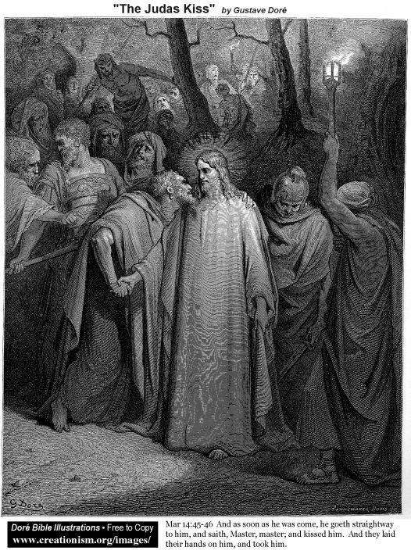

Judas, in his arrogance and greed, completed his shameful sell-out of Jesus to the religious leaders – just as Adam and Eve sold-out in the Garden.
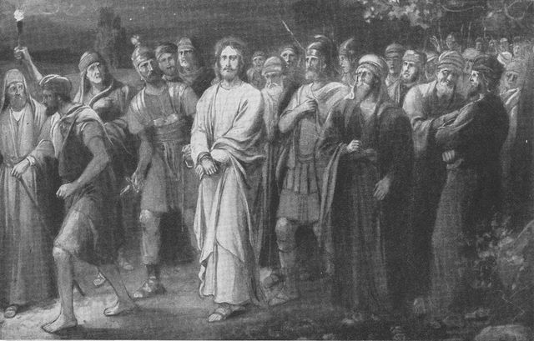

Jesus was arrested by a mob – at the behest of the religious leaders – under the cover of darkness and at the behest of the Prince of Darkness.

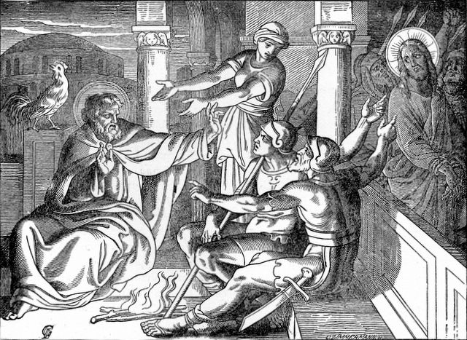

Peter, who earlier arrogantly-declared his certain bravery, cowered and lied to save himself – fulfilling the prophesy of Jesus.
Source: Public domain here http://www.lavistachurchofchrist.org/Pictures/

Faith In Action

Pray
I seek to be patient and wise, by asking for and waiting on the Holy Spirit of God for guidance.

Act
I will pray that business, political, and religious leaders not be in rebellion against God. I will pray the same for myself, and then wait to see the softening of my rebellious heart.
Be Specific _____________________________________________

Monday (Matthew 27:1-31; Mark 15:1-20; Luke 23:1-25; John 18:28–19:16a)
Matthew
Jesus Brought Before Pilate
27:1 When it was early in the morning, all the chief priests and the elders of the people plotted against Jesus to execute him. 27:2 They tied him up, led him away, and handed him over to Pilate the governor.
Judas’ Suicide
27:3 Now when Judas, who had betrayed him, saw that Jesus had been condemned, he regretted what he had done and returned the thirty silver coins to the chief priests and the elders, 27:4 saying, “I have sinned by betraying innocent blood!” But they said, “What is that to us? You take care of it yourself!” 27:5 So Judas threw the silver coins into the temple and left. Then he went out and hanged himself. 27:6 The chief priests took the silver and said, “It is not lawful to put this into the temple treasury, since it is blood money.” 27:7 After consulting together they bought the Potter’s Field with it, as a burial place for foreigners. 27:8 For this reason that field has been called the “Field of Blood” to this day. 27:9 Then what was spoken by Jeremiah the prophet was fulfilled: “They took the thirty silver coins, the price of the one whose price had been set by the people of Israel, 27:10 and they gave them for the potter’s field, as the Lord commanded me.”
Jesus and Pilate
27:11 Then Jesus stood before the governor, and the governor asked him, “Are you the king of the Jews?” Jesus said, “You say so.” 27:12 But when he was accused by the chief priests and the elders, he did not respond. 27:13 Then Pilate said to him, “Don’t you hear how many charges they are bringing against you?” 27:14 But he did not answer even one accusation, so that the governor was quite amazed.
27:15 During the feast the governor was accustomed to release one prisoner to the crowd, whomever they wanted. 27:16 At that time they had in custody a notorious prisoner named Jesus Barabbas. 27:17 So after they had assembled, Pilate said to them, “Whom do you want me to release for you, Jesus Barabbas or Jesus who is called the Christ?” 27:18 (For he knew that they had handed him over because of envy.) 27:19 As he was sitting on the judgment seat, his wife sent a message to him: “Have nothing to do with that innocent man; I have suffered greatly as a result of a dream about him today.” 27:20 But the chief priests and the elders persuaded the crowds to ask for Barabbas and to have Jesus killed. 27:21 The governor asked them, “Which of the two do you want me to release for you?” And they said, “Barabbas!” 27:22 Pilate said to them, “Then what should I do with Jesus who is called the Christ?” They all said, “Crucify him!” 27:23 He asked, “Why? What wrong has he done?” But they shouted more insistently, “Crucify him!”
Jesus is Condemned and Mocked
27:24 When Pilate saw that he could do nothing, but that instead a riot was starting, he took some water, washed his hands before the crowd and said, “I am innocent of this man’s blood. You take care of it yourselves!” 27:25 In reply all the people said, “Let his blood be on us and on our children!” 27:26 Then he released Barabbas for them. But after he had Jesus flogged, he handed him over to be crucified. 27:27 Then the governor’s soldiers took Jesus into the governor’s residence and gathered the whole cohort around him. 27:28 They stripped him and put a scarlet robe around him, 27:29 and after braiding a crown of thorns, they put it on his head. They put a staff in his right hand, and kneeling down before him, they mocked him: “Hail, king of the Jews!” 27:30 They spat on him and took the staff and struck him repeatedly on the head. 27:31 When they had mocked him, they stripped him of the robe and put his own clothes back on him. Then they led him away to crucify him.
Mark
Jesus Brought Before Pilate
15:1 Early in the morning, after forming a plan, the chief priests with the elders and the experts in the law and the whole Sanhedrin tied Jesus up, led him away, and handed him over to Pilate. 15:2 So Pilate asked him, “Are you the king of the Jews?” He replied, “You say so.” 15:3 Then the chief priests began to accuse him repeatedly. 15:4 So Pilate asked him again, “Have you nothing to say? See how many charges they are bringing against you!” 15:5 But Jesus made no further reply, so that Pilate was amazed.
Jesus and Barabbas
15:6 During the feast it was customary to release one prisoner to the people, whomever they requested. 15:7 A man named Barabbas was imprisoned with rebels who had committed murder during an insurrection. 15:8 Then the crowd came up and began to ask Pilate to release a prisoner for them, as was his custom. 15:9 So Pilate asked them, “Do you want me to release the king of the Jews for you?” 15:10 (For he knew that the chief priests had handed him over because of envy.) 15:11 But the chief priests stirred up the crowd to have him release Barabbas instead. 15:12 So Pilate spoke to them again, “Then what do you want me to do with the one you call king of the Jews?” 15:13 They shouted back, “Crucify him!” 15:14 Pilate asked them, “Why? What has he done wrong?” But they shouted more insistently, “Crucify him!” 15:15 Because he wanted to satisfy the crowd, Pilate released Barabbas for them. Then, after he had Jesus flogged, he handed him over to be crucified.
Jesus is Mocked
15:16 So the soldiers led him into the palace (that is, the governor’s residence) and called together the whole cohort. 15:17 They put a purple cloak on him and after braiding a crown of thorns, they put it on him. 15:18 They began to salute him: “Hail, king of the Jews!” 15:19 Again and again they struck him on the head with a staff and spit on him. Then they knelt down and paid homage to him. 15:20 When they had finished mocking him, they stripped him of the purple cloak and put his own clothes back on him. Then they led him away to crucify him.
Luke
Jesus Brought Before Pilate
23:1 Then the whole group of them rose up and brought Jesus before Pilate. 23:2 They began to accuse him, saying, “We found this man subverting our nation, forbidding us to pay the tribute tax to Caesar and claiming that he himself is Christ, a king.” 23:3 So Pilate asked Jesus, “Are you the king of the Jews?” He replied, “You say so.” 23:4 Then Pilate said to the chief priests and the crowds, “I find no basis for an accusation against this man.” 23:5 But they persisted in saying, “He incites the people by teaching throughout all Judea. It started in Galilee and ended up here!”
Jesus Brought Before Herod
23:6 Now when Pilate heard this, he asked whether the man was a Galilean. 23:7 When he learned that he was from Herod’s jurisdiction, he sent him over to Herod, who also happened to be in Jerusalem at that time. 23:8 When Herod saw Jesus, he was very glad, for he had long desired to see him, because he had heard about him and was hoping to see him perform some miraculous sign. 23:9 So Herod questioned him at considerable length; Jesus gave him no answer. 23:10 The chief priests and the experts in the law were there, vehemently accusing him. 23:11 Even Herod with his soldiers treated him with contempt and mocked him. Then, dressing him in elegant clothes, Herod sent him back to Pilate. 23:12 That very day Herod and Pilate became friends with each other, for prior to this they had been enemies.
Jesus Brought Before the Crowd
23:13 Then Pilate called together the chief priests, the rulers, and the people, 23:14 and said to them, “You brought me this man as one who was misleading the people. When I examined him before you, I did not find this man guilty of anything you accused him of doing. 23:15 Neither did Herod, for he sent him back to us. Look, he has done nothing deserving death. 23:16 I will therefore have him flogged and release him.”
23:17 [[EMPTY]]
23:18 But they all shouted out together, “Take this man away! Release Barabbas for us!” 23:19 (This was a man who had been thrown into prison for an insurrection started in the city, and for murder.) 23:20 Pilate addressed them once again because he wanted to release Jesus. 23:21 But they kept on shouting, “Crucify, crucify him!” 23:22 A third time he said to them, “Why? What wrong has he done? I have found him guilty of no crime deserving death. I will therefore flog him and release him.” 23:23 But they were insistent, demanding with loud shouts that he be crucified. And their shouts prevailed. 23:24 So Pilate decided that their demand should be granted. 23:25 He released the man they asked for, who had been thrown in prison for insurrection and murder. But he handed Jesus over to their will.
John
Jesus Brought Before Pilate
18:28 Then they brought Jesus from Caiaphas to the Roman governor’s residence. (Now it was very early morning.) They did not go into the governor’s residence so they would not be ceremonially defiled, but could eat the Passover meal. 18:29 So Pilate came outside to them and said, “What accusation do you bring against this man?” 18:30 They replied, “If this man were not a criminal, we would not have handed him over to you.”
18:31 Pilate told them, “Take him yourselves and pass judgment on him according to your own law!” The Jewish leaders replied, “We cannot legally put anyone to death.” 18:32 (This happened to fulfill the word Jesus had spoken when he indicated what kind of death he was going to die.)
Pilate Questions Jesus
18:33 So Pilate went back into the governor’s residence, summoned Jesus, and asked him, “Are you the king of the Jews?” 18:34 Jesus replied, “Are you saying this on your own initiative, or have others told you about me?” 18:35 Pilate answered, “I am not a Jew, am I? Your own people and your chief priests handed you over to me. What have you done?”
18:36 Jesus replied, “My kingdom is not from this world. If my kingdom were from this world, my servants would be fighting to keep me from being handed over to the Jewish authorities. But as it is, my kingdom is not from here.” 18:37 Then Pilate said, “So you are a king!” Jesus replied, “You say that I am a king. For this reason I was born, and for this reason I came into the world – to testify to the truth. Everyone who belongs to the truth listens to my voice.” 18:38 Pilate asked, “What is truth?”
When he had said this he went back outside to the Jewish leaders and announced, “I find no basis for an accusation against him. 18:39 But it is your custom that I release one prisoner for you at the Passover. So do you want me to release for you the king of the Jews?” 18:40 Then they shouted back, “Not this man, but Barabbas!” (Now Barabbas was a revolutionary.)
Pilate Tries to Release Jesus
19:1 Then Pilate took Jesus and had him flogged severely. 19:2 The soldiers braided a crown of thorns and put it on his head, and they clothed him in a purple robe. 19:3 They came up to him again and again and said, “Hail, king of the Jews!” And they struck him repeatedly in the face.
19:4 Again Pilate went out and said to the Jewish leaders, “Look, I am bringing him out to you, so that you may know that I find no reason for an accusation against him.” 19:5 So Jesus came outside, wearing the crown of thorns and the purple robe. Pilate said to them, “Look, here is the man!” 19:6 When the chief priests and their officers saw him, they shouted out, “Crucify him! Crucify him!” Pilate said, “You take him and crucify him! Certainly I find no reason for an accusation against him!” 19:7 The Jewish leaders replied, “We have a law, and according to our law he ought to die, because he claimed to be the Son of God!”
19:8 When Pilate heard what they said, he was more afraid than ever, 19:9 and he went back into the governor’s residence and said to Jesus, “Where do you come from?” But Jesus gave him no answer. 19:10 So Pilate said, “Do you refuse to speak to me? Don’t you know I have the authority to release you, and to crucify you?” 19:11 Jesus replied, “You would have no authority over me at all, unless it was given to you from above. Therefore the one who handed me over to you is guilty of greater sin.”
19:12 From this point on, Pilate tried to release him. But the Jewish leaders shouted out, “If you release this man, you are no friend of Caesar! Everyone who claims to be a king opposes Caesar!” 19:13 When Pilate heard these words he brought Jesus outside and sat down on the judgment seat in the place called “The Stone Pavement” (Gabbatha in Aramaic). 19:14 (Now it was the day of preparation for the Passover, about noon.) Pilate said to the Jewish leaders, “Look, here is your king!”
19:15 Then they shouted out, “Away with him! Away with him! Crucify him!” Pilate asked, “Shall I crucify your king?” The high priests replied, “We have no king except Caesar!” 19:16 Then Pilate handed him over to them to be crucified.

Prayer
Lord, when it is Your time for events to occur, they occur. The actions of mere humans may vary, but the conclusion will always be as You have ordained. May I trust that You are always in control.

Summary and Commentary
The religious leaders, united in their plan to have Jesus killed, “led Him away, and handed Him over to Pilate” (Matthew 27:2). When observing that Jesus, instead of rising up as a military leader or using His powers to protect Himself from harm, rather allowed Himself to be falsely accused and condemned by the religious leaders, Judas “regretted what he had done” (vs. 3). Saying, “I have sinned by betraying innocent blood!” (vs. 4), he tried to return the money, but the religious leaders discounted it as unimportant to them, So Judas threw the coins into the temple. The religious leaders used the money he threw away to buy a burial place for foreigners—it was blood money which could not be put in the offering. Judas went away and hung himself.
Pilate attempted to question Jesus, but He “gave him no answer” (John 19:9), other than acknowledging that Pilate was powerless except for the secular authority “given to you from above” (vs. 11) – God permitted Caesar to empower Pilate [Note: God could have arranged for someone like Cyrus to be in power but it was His timing for the normal course of bad men to be allowed to rule without intervention.] and declared that “the one who handed Me over to you [the religious rulers] is guilty of greater sin” (ibid).
Pilate tried to pass off the responsibility of Jesus to Herod, when he learned that Jesus was a Galilean “from Herod’s jurisdiction” (Luke 23:7). Herod, merely hoping to see Jesus do a miracle, was disinterested in truth—and after abusing and mocking Jesus, he “sent Him back to Pilate” (vs. 11).
Pilate’s wife experienced a dream and warned him to “have nothing to do with that innocent man” (Matthew 27:19), but Pilate was more concerned about the social unrest being stirred up by the religious leaders. Declaring the innocence of Jesus, but capitulating to the demands of the people to “crucify him!” (Mark 15:14), Pilate released the true criminal Barabbas in exchange for surrendering the innocent Jesus to the religious leaders to be murdered.
[Note: The crowd was stirred up by the religious rulers, their “Crucify Him!” chant wasn't spontaneous but rather manipulated.]

Interaction

Consider
Do leaders still do the wrong things for “political” reasons, despite their obvious awareness that it was wrong?

Discuss
Jesus had the authority to exercise divine power, to prevent His suffering, yet He chose to not do so for our sakes. Have you known someone who voluntarily endured loss or suffering for the sake of another?

Reflect
Judas realized too late what a terrible mistake he had made and tried to undo it, to no avail.

Share
Have you ever observed an innocent person being mocked by the less-than innocent? Have you been in a situation where someone tried to prevent the unfolding consequences of their wrongful choice(s), but was blocked by someone in authority?

KTALZ
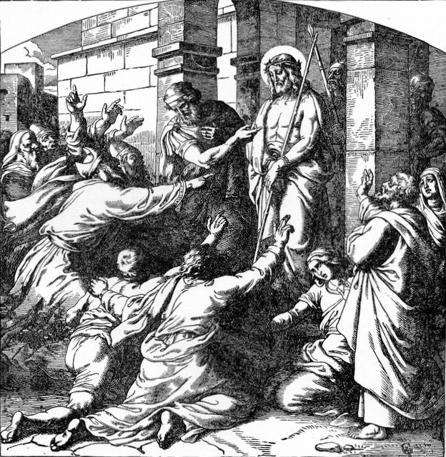

Pilate knew that what was asked of him was wrong but was more interested in avoiding conflict than enforcing justice.
Source: Public domain here http://www.lavistachurchofchrist.org/Pictures/

Faith In Action

Pray
I will pray that leaders look only to God to discern right from wrong, and in so doing they acquire the character to do the right thing, no matter the political or social consequences.

Act
Today I will come alongside of in support, in prayer and perhaps in practical ways as well, someone who has sacrificed for righteousness’ sake and who endures criticism or faces difficulty for it.
Be Specific _____________________________________________

Tuesday (Matthew 27:32-44; Mark 15:21-32; Luke 23:26-43; John 19:16b-27)
Matthew
The Crucifixion
27:32 As they were going out, they found a man from Cyrene named Simon, whom they forced to carry his cross.
27:33 They came to a place called Golgotha (which means “Place of the Skull”) 27:34 and offered Jesus wine mixed with gall to drink. But after tasting it, he would not drink it.
27:35 When they had crucified him, they divided his clothes by throwing dice. 27:36 Then they sat down and kept guard over him there.
27:37 Above his head they put the charge against him, which read: “This is Jesus, the king of the Jews.” 27:38 Then two outlaws were crucified with him, one on his right and one on his left. 27:39 Those who passed by defamed him, shaking their heads 27:40 and saying, “You who can destroy the temple and rebuild it in three days, save yourself! If you are God’s Son, come down from the cross!” 27:41 In the same way even the chief priests – together with the experts in the law and elders – were mocking him: 27:42 “He saved others, but he cannot save himself! He is the king of Israel! If he comes down now from the cross, we will believe in him! 27:43 He trusts in God – let God, if he wants to, deliver him now because he said, ‘I am God’s Son’!” 27:44 The robbers who were crucified with him also spoke abusively to him.
Mark
The Crucifixion
15:21 The soldiers forced a passerby to carry his cross, Simon of Cyrene, who was coming in from the country (he was the father of Alexander and Rufus). 15:22 They brought Jesus to a place called Golgotha (which is translated, “Place of the Skull”). 15:23 They offered him wine mixed with myrrh, but he did not take it. 15:24 Then they crucified him and divided his clothes, throwing dice for them, to decide what each would take.
15:25 It was nine o’clock in the morning when they crucified him. 15:26 The inscription of the charge against him read, “The king of the Jews.” 15:27 And they crucified two outlaws with him, one on his right and one on his left. 15:28 [[EMPTY]] 15:29 Those who passed by defamed him, shaking their heads and saying, “Aha! You who can destroy the temple and rebuild it in three days, 15:30 save yourself and come down from the cross!” 15:31 In the same way even the chief priests – together with the experts in the law – were mocking him among themselves: “He saved others, but he cannot save himself! 15:32 Let the Christ, the king of Israel, come down from the cross now, that we may see and believe!” Those who were crucified with him also spoke abusively to him.
Luke
The Crucifixion
23:26 As they led him away, they seized Simon of Cyrene, who was coming in from the country. They placed the cross on his back and made him carry it behind Jesus.
23:27 A great number of the people followed him, among them women who were mourning and wailing for him. 23:28 But Jesus turned to them and said, “Daughters of Jerusalem, do not weep for me, but weep for yourselves and for your children. 23:29 For this is certain: The days are coming when they will say, ‘Blessed are the barren, the wombs that never bore children, and the breasts that never nursed!’ 23:30 Then they will begin to say to the mountains, ‘Fall on us!’ and to the hills, ‘Cover us!’ 23:31 For if such things are done when the wood is green, what will happen when it is dry?”
23:32 Two other criminals were also led away to be executed with him. 23:33 So when they came to the place that is called “The Skull,” they crucified him there, along with the criminals, one on his right and one on his left. 23:34 [But Jesus said, “Father, forgive them, for they don’t know what they are doing.”] Then they threw dice to divide his clothes. 23:35 The people also stood there watching, but the rulers ridiculed him, saying, “He saved others. Let him save himself if he is the Christ of God, his chosen one!” 23:36 The soldiers also mocked him, coming up and offering him sour wine, 23:37 and saying, “If you are the king of the Jews, save yourself!” 23:38 There was also an inscription over him, “This is the king of the Jews.”
23:39 One of the criminals who was hanging there railed at him, saying, “Aren’t you the Christ? Save yourself and us!”
23:40 But the other rebuked him, saying, “Don’t you fear God, since you are under the same sentence of condemnation? 23:41 And we rightly so, for we are getting what we deserve for what we did, but this man has done nothing wrong.” 23:42 Then he said, “Jesus, remember me when you come in your kingdom.” 23:43 And Jesus said to him, “I tell you the truth, today you will be with me in paradise.”
John
The Crucifixion
So they took Jesus, 19:17 and carrying his own cross he went out to the place called “The Place of the Skull” (called in Aramaic Golgotha). 19:18 There they crucified him along with two others, one on each side, with Jesus in the middle. 19:19 Pilate also had a notice written and fastened to the cross, which read: “Jesus the Nazarene, the king of the Jews.” 19:20 Thus many of the Jewish residents of Jerusalem read this notice, because the place where Jesus was crucified was near the city, and the notice was written in Aramaic, Latin, and Greek. 19:21 Then the chief priests of the Jews said to Pilate, “Do not write, ‘The king of the Jews,’ but rather, ‘This man said, I am king of the Jews.’” 19:22 Pilate answered, “What I have written, I have written.”
19:23 Now when the soldiers crucified Jesus, they took his clothes and made four shares, one for each soldier, and the tunic remained. (Now the tunic was seamless, woven from top to bottom as a single piece.) 19:24 So the soldiers said to one another, “Let’s not tear it, but throw dice to see who will get it.” This took place to fulfill the scripture that says, “They divided my garments among them, and for my clothing they threw dice.” So the soldiers did these things.
19:25 Now standing beside Jesus’ cross were his mother, his mother’s sister, Mary the wife of Clopas, and Mary Magdalene.
19:26 So when Jesus saw his mother and the disciple whom he loved standing there, he said to his mother, “Woman, look, here is your son!” 19:27 He then said to his disciple, “Look, here is your mother!” From that very time the disciple took her into his own home.

Prayer
Your plan, Lord, worked out through the man-God Jesus - was surrounded by the ugliness of hate-filled humans; but Jesus found moments to teach the beauty of Truth along the way. May I be found teachable and listening for Your message hidden in every circumstance.

Summary and Commentary
Jesus began His journey to Golgotha carrying the cross-beam himself, as was the general practice, then it would be attached to the vertical post already on the hill. Along the way, Simon of Cyrene was conscripted “to carry His cross” (Matt. 27:32) the rest of the way because Jesus had been physically weakened from the physical abuse that He suffered.
Jesus prophesied to the wailing women following Him to not cry for Him, but to “weep for yourselves” (Luke 23:28) — because the violence poured out upon Him is only the beginning of suffering for Believers. “Judgment now comes on the nation [of Israel] (see Luke 19:41-44) for this judgment of Jesus” (NET sn).
Jesus was crucified, nailed to the cross with a sign ordered by Pilate (“Jesus the Nazarene, the king of the Jews,” John 19:19) posted above His head. The chief priests objected, suggesting it should read “This man said, I am king of the Jews” (vs. 21, italics added). Pilate insisted “what I have written, I have written” (vs. 22), most probably to disown responsibility, and “as a subtle way of getting back at the Jewish authorities who had pressured him into the execution of one he considered to be an innocent man” (NET sn).
“One of the criminals who was hanging there railed at Him” (Luke 23:39) and joined the religious authorities, soldiers, and others in mocking Jesus. The criminal hanging on the other side of Jesus rebuked the first and, in an act of faith, recognized Him as The Christ and requested His blessing. Jesus not only forgave the respectful and repentant (“we are getting what we deserve,” Luke 23:41) criminal, but promised him salvation for his faith—”today you will be with Me in paradise” (vs. 43).
They “divided His clothes, throwing dice for them,” (Mark 15:24) is an allusion to Psalm 22:18, another Old Testament prophesy fulfilled.
Jesus directed His mother Mary to treat His disciple John as her son, and for John to accept Mary as his mother — “the disciple took her into his own home” (John 19:27). [Note: Any mention of Joseph, the father of Jesus, ceased long prior to this in the Gospel accounts; it appears that Mary was a widow. No reason is given in Scripture as to why one of her other sons, actual brothers of Jesus, did not take her in.]

Interaction

Consider
Jesus knew that His death was necessary to meet the judicial requirements of God’s perfect justice. Profoundly aware of the evil hatred swirling about the crowds, and that His severe suffering was needed to grab and to hold man’s attention across time and space, on He walked — voluntarily — to His death.

Discuss
Those believing Jesus to be the Christ watched His arrest, His being lead away to be crucified, and His crucifixion. May they have wondered how their liberator could be so quickly subdued and judged like a common criminal? What was to happen to them without Him?

Reflect
Jesus was nailed to the Cross, He forgave the soldiers as ignorant of what they were doing to the Son of God, and then He blessed the thief who surrendered to Him while on the cross. Such love, such presence. The disciples cowered in the shadows, heartbroken and powerless. Souls emptied and hearts aching, they were utterly humbled.

Share
When have you observed someone having such selfless purpose while in the midst of enduring a crisis? Someone acting with the presence of mind and compassion of Jesus, Who provided a home and a caregiver for His mother and arranged for John to have an amazing woman of faith like Mary to share his home with?

KTALZ
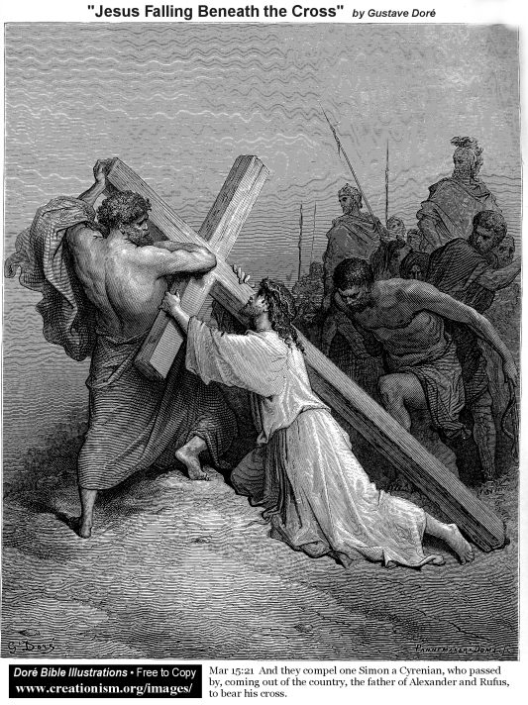

It is probable that Jesus only carried the cross-beam as the post part of the assembled cross was likely permanently mounted at the site of the crucifixion. Even so, after His savage treatment, He would have been physically weakened – which is why Simon the Cyrene was forced to finish the carrying of the beam for Him.
Source: Public domain as in the picture.

Faith In Action

Pray
Today I will take the time to prayerfully ponder the Cross. I will ask the Holy Spirit to give me the strength to endure hardships, so that I may better serve others with the sacrificial love of God.

Act
I will pray for someone who is dealing with a loss (death of a loved one or the loss of a home, savings, business, job) or a challenge (divorce, major illness, injury, the integrity of a relationship). I will ask the Lord to show me the way to go beyond prayer to truly helpful service.
Be Specific ____________________________________________

Wednesday (Matthew 27:45-61; Mark 15:33-47; Luke 23:44-56; John 19:28-42)
Matthew
Jesus’ Death
27:45 Now from noon until three, darkness came over all the land. 27:46 At about three o’clock Jesus shouted with a loud voice, “Eli, Eli, lema sabachthani?” that is, “My God, my God, why have you forsaken me?” 27:47 When some of the bystanders heard it, they said, “This man is calling for Elijah.” 27:48 Immediately one of them ran and got a sponge, filled it with sour wine, put it on a stick, and gave it to him to drink. 27:49 But the rest said, “Leave him alone! Let’s see if Elijah will come to save him.” 27:50 Then Jesus cried out again with a loud voice and gave up his spirit.
27:51 Just then the temple curtain was torn in two, from top to bottom. The earth shook and the rocks were split apart. 27:52 And tombs were opened, and the bodies of many saints who had died were raised. 27:53 (They came out of the tombs after his resurrection and went into the holy city and appeared to many people.) 27:54 Now when the centurion and those with him who were guarding Jesus saw the earthquake and what took place, they were extremely terrified and said, “Truly this one was God’s Son!”
27:55 Many women who had followed Jesus from Galilee and given him support were also there, watching from a distance. 27:56 Among them were Mary Magdalene, Mary the mother of James and Joseph, and the mother of the sons of Zebedee.
Jesus’ Burial
27:57 Now when it was evening, there came a rich man from Arimathea, named Joseph, who was also a disciple of Jesus. 27:58 He went to Pilate and asked for the body of Jesus. Then Pilate ordered that it be given to him. 27:59 Joseph took the body, wrapped it in a clean linen cloth, 27:60 and placed it in his own new tomb that he had cut in the rock. Then he rolled a great stone across the entrance of the tomb and went away. 27:61 (Now Mary Magdalene and the other Mary were sitting there, opposite the tomb.)
Mark
Jesus’ Death
15:33 Now when it was noon, darkness came over the whole land until three in the afternoon. 15:34 Around three o’clock Jesus cried out with a loud voice, “Eloi, Eloi, lema sabachthani?” which means, “My God, my God, why have you forsaken me?” 15:35 When some of the bystanders heard it they said, “Listen, he is calling for Elijah!” 15:36 Then someone ran, filled a sponge with sour wine, put it on a stick, and gave it to him to drink, saying, “Leave him alone! Let’s see if Elijah will come to take him down!” 15:37 But Jesus cried out with a loud voice and breathed his last.
15:38 And the temple curtain was torn in two, from top to bottom. 15:39 Now when the centurion, who stood in front of him, saw how he died, he said, “Truly this man was God’s Son!”
15:40 There were also women, watching from a distance. Among them were Mary Magdalene, and Mary the mother of James the younger and of Joses, and Salome. 15:41 When he was in Galilee, they had followed him and given him support. Many other women who had come up with him to Jerusalem were there too.
Jesus’ Burial
15:42 Now when evening had already come, since it was the day of preparation (that is, the day before the Sabbath), 15:43 Joseph of Arimathea, a highly regarded member of the council, who was himself looking forward to the kingdom of God, went boldly to Pilate and asked for the body of Jesus. 15:44 Pilate was surprised that he was already dead. He called the centurion and asked him if he had been dead for some time. 15:45 When Pilate was informed by the centurion, he gave the body to Joseph. 15:46 After Joseph bought a linen cloth and took down the body, he wrapped it in the linen and placed it in a tomb cut out of the rock. Then he rolled a stone across the entrance of the tomb. 15:47 Mary Magdalene and Mary the mother of Joses saw where the body was placed.
Luke
23:44 It was now about noon, and darkness came over the whole land until three in the afternoon, 23:45 because the sun’s light failed. The temple curtain was torn in two. 23:46 Then Jesus, calling out with a loud voice, said, “Father, into your hands I commit my spirit!” And after he said this he breathed his last.
23:47 Now when the centurion saw what had happened, he praised God and said, “Certainly this man was innocent!” 23:48 And all the crowds that had assembled for this spectacle, when they saw what had taken place, returned home beating their breasts. 23:49 And all those who knew Jesus stood at a distance, and the women who had followed him from Galilee saw these things.
Jesus’ Burial
23:50 Now there was a man named Joseph who was a member of the council, a good and righteous man. 23:51 (He had not consented to their plan and action.) He was from the Judean town of Arimathea, and was looking forward to the kingdom of God. 23:52 He went to Pilate and asked for the body of Jesus. 23:53 Then he took it down, wrapped it in a linen cloth, and placed it in a tomb cut out of the rock, where no one had yet been buried. 23:54 It was the day of preparation and the Sabbath was beginning. 23:55 The women who had accompanied Jesus from Galilee followed, and they saw the tomb and how his body was laid in it. 23:56 Then they returned and prepared aromatic spices and perfumes.
On the Sabbath they rested according to the commandment.
John
Jesus’ Death
19:28 After this Jesus, realizing that by this time everything was completed, said (in order to fulfill the scripture), “I am thirsty!” 19:29 A jar full of sour wine was there, so they put a sponge soaked in sour wine on a branch of hyssop and lifted it to his mouth. 19:30 When he had received the sour wine, Jesus said, “It is completed!” Then he bowed his head and gave up his spirit.
19:31 Then, because it was the day of preparation, so that the bodies should not stay on the crosses on the Sabbath (for that Sabbath was an especially important one), the Jewish leaders asked Pilate to have the victims’ legs broken and the bodies taken down. 19:32 So the soldiers came and broke the legs of the two men who had been crucified with Jesus, first the one and then the other. 19:33 But when they came to Jesus and saw that he was already dead, they did not break his legs. 19:34 But one of the soldiers pierced his side with a spear, and blood and water flowed out immediately. 19:35 And the person who saw it has testified (and his testimony is true, and he knows that he is telling the truth), so that you also may believe. 19:36 For these things happened so that the scripture would be fulfilled, “Not a bone of his will be broken.” 19:37 And again another scripture says, “They will look on the one whom they have pierced.”
Jesus’ Burial
19:38 After this, Joseph of Arimathea, a disciple of Jesus (but secretly, because he feared the Jewish leaders), asked Pilate if he could remove the body of Jesus. Pilate gave him permission, so he went and took the body away. 19:39 Nicodemus, the man who had previously come to Jesus at night, accompanied Joseph, carrying a mixture of myrrh and aloes weighing about seventy-five pounds. 19:40 Then they took Jesus’ body and wrapped it, with the aromatic spices, in strips of linen cloth according to Jewish burial customs. 19:41 Now at the place where Jesus was crucified there was a garden, and in the garden was a new tomb where no one had yet been buried. 19:42 And so, because it was the Jewish day of preparation and the tomb was nearby, they placed Jesus’ body there.

Prayer
Father, Your Son’s sacrifice of life was needed to both satisfy the law and to precede His return to Heaven, in order to make it possible to separate us from our sin and to gain us admittance us into Heaven. May I be mindful to rejoice that You loved me so much that You made a way where there was none.

Summary and Commentary
On the cross, Jesus cried out, “My God, My God, why have You forsaken Me?” (Matt. 27:46, Mark 15:34). His words, “Father, into Your hands I commit my Spirit” (Luke 23:46) and “I am thirsty!” (John 19:28), are evidence of both His humanity and His divinity. [Note: Due to our sin, which Jesus took upon Himself at the cross, it was required that the discernible-presence of God depart from Him for a time—the man Jesus was suddenly alone and absent God’s indwelling presence. This separation does not negate the unity of Jesus with the Trinity, it merely describes the separation the divine Son of God suffered on earth while in the form of the human son of man - on the cross.]
Jesus declared His thirst after first acknowledging that “everything was completed,” everything except the final prophesy fulfilled by “I am thirsty,” [see Psalms 22:5; 69:21]. His thirst may have referenced the “water of life”, the Holy Spirit, Whose presence Jesus was deeply missing during His separation from the Godhead.
It is the eve of “an especially important” (John 19:31) Sabbath, and the religious leaders wanted to get on with their religious traditions, so they asked Pilate to order the breaking of the legs of the criminals on the cross. But, because Jesus was already dead, “they did not break His legs” (John 19:33), fulfilling another Old Testament prophecy (“Not a bone of His will be broken,” Psalms 34:20). [Note: Breaking the legs of men crucified was commonly done to quicken death—it eliminated their ability to lift themselves enough to take one more breath.]
In the end, the soldiers “pierced His side with a spear” (John 19:34), again fulfilling Old Testament prophecy (see Zechariah 12–14). The blood and water released by the piercing of His flesh was proof of His physical death. [Note: It is noteworthy that the Disciple Thomas would later be challenged by the resurrected Jesus to insert his hand into His side wound. It is possible that Thomas did so, but equally possible that merely seeing Jesus’ wounds was sufficient to cause the doubting Thomas to finally believe.]
Jesus’ burial, at the hands of the only religious leader directly identified as not consenting to His condemnation and murder, is done by “Joseph...a good and righteous man” (Luke 23:50). Jesus’ body is quickly wrapped and placed in the tomb where He will later be embalmed. [Note: It is probable that Nicodemus did not agree either, though his weakness – fear of the religious authorities – may have resulted in his tacit agreement.]

interaction

Consider
The innocent and sinless Jesus, burdened by our sin, was briefly deprived of the comfort of the indwelling presence of God. No impurity may exist in the presence of God without being destroyed, so the Father had to turn away from the Son so as to not destroy Him (who bore our sin), leaving Christ desperately lonely.

Discuss
Can you imagine the self-deceiving hatred of those who attacked the God they claimed to worship? (How carelessly they played a part in His death!)

Reflect
In the crucifixion of a single man, the only One Whose blood truly saves, all of the required Old Testament laws of blood sacrifice were summarized and satisfied.

Share
When have you felt as though you carried the emotional or spiritual burdens of others, to the point where it seemed that you might drown? What did you do to keep yourself afloat—cry out to God as did Jesus?

KTALZ
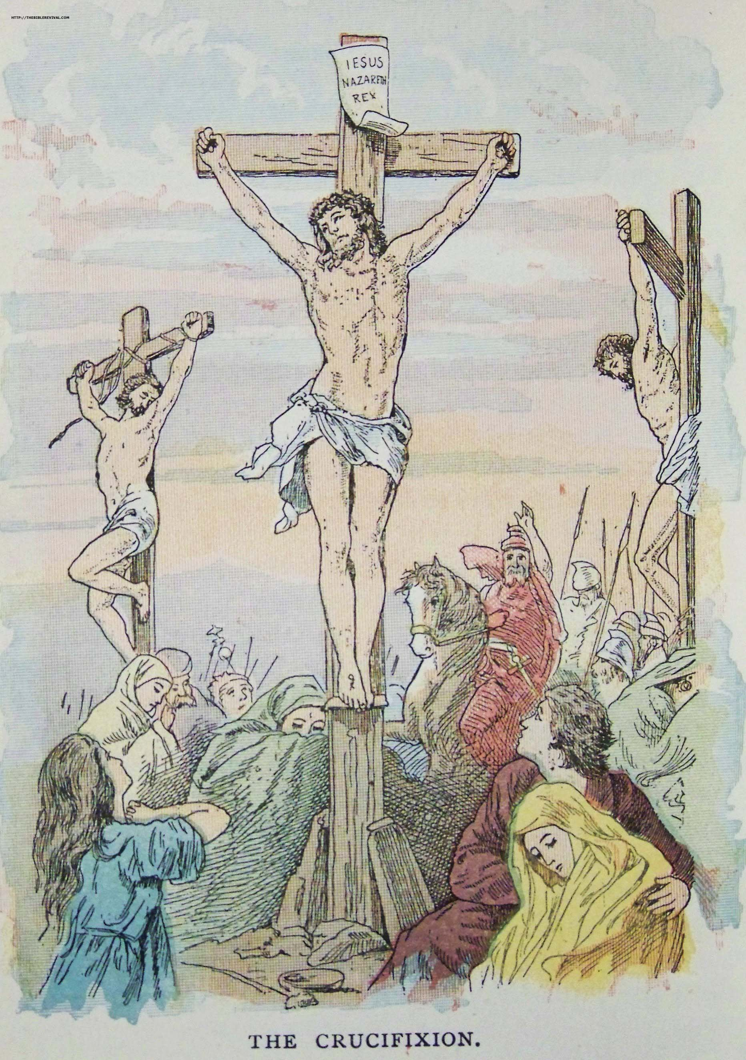

As someone has written “He died for us, will we live for Him?”
Source: Public domain here http://thebiblerevival.com/clipart/1899lifeofchristforyoungpeople/thecrucifixion.jpg

Faith In Action

Pray
Today I will ask the Holy Spirit to identify someone – for whom He wants me to pray - who has been blind to the truth of Who Jesus was, and is.

Act
I will pray for the Lord to move in the heart of the one who resists the drawing of the Holy Spirit and that if there is any way that I may be a useful instrument in moving them that He will find me available and willing.
Be Specific _____________________________________________

Thursday (Matthew 27:62–28:15; Mark 16; Luke 24:1-12; John 20:1-9)
Matthew
The Guard at the Tomb
27:62 The next day (which is after the day of preparation) the chief priests and the Pharisees assembled before Pilate 27:63 and said, “Sir, we remember that while that deceiver was still alive he said, ‘After three days I will rise again.’ 27:64 So give orders to secure the tomb until the third day. Otherwise his disciples may come and steal his body and say to the people, ‘He has been raised from the dead,’ and the last deception will be worse than the first.” 27:65 Pilate said to them, “Take a guard of soldiers. Go and make it as secure as you can.” 27:66 So they went with the soldiers of the guard and made the tomb secure by sealing the stone.
The Resurrection
28:1 Now after the Sabbath, at dawn on the first day of the week, Mary Magdalene and the other Mary went to look at the tomb. 28:2 Suddenly there was a severe earthquake, for an angel of the Lord descending from heaven came and rolled away the stone and sat on it. 28:3 His appearance was like lightning, and his clothes were white as snow. 28:4 The guards were shaken and became like dead men because they were so afraid of him. 28:5 But the angel said to the women, “Do not be afraid; I know that you are looking for Jesus, who was crucified. 28:6 He is not here, for he has been raised, just as he said. Come and see the place where he was lying. 28:7 Then go quickly and tell his disciples, ‘He has been raised from the dead. He is going ahead of you into Galilee. You will see him there.’ Listen, I have told you!” 28:8 So they left the tomb quickly, with fear and great joy, and ran to tell his disciples. 28:9 But Jesus met them, saying, “Greetings!” They came to him, held on to his feet and worshiped him. 28:10 Then Jesus said to them, “Do not be afraid. Go and tell my brothers to go to Galilee. They will see me there.”
The Guards’ Report
28:11 While they were going, some of the guard went into the city and told the chief priests everything that had happened. 28:12 After they had assembled with the elders and formed a plan, they gave a large sum of money to the soldiers, 28:13 telling them, “You are to say, ‘His disciples came at night and stole his body while we were asleep.’ 28:14 If this matter is heard before the governor, we will satisfy him and keep you out of trouble.” 28:15 So they took the money and did as they were instructed. And this story is told among the Jews to this day.
Mark
The Resurrection
16:1 When the Sabbath was over, Mary Magdalene, Mary the mother of James, and Salome bought aromatic spices so that they might go and anoint him. 16:2 And very early on the first day of the week, at sunrise, they went to the tomb. 16:3 They had been asking each other, “Who will roll away the stone for us from the entrance to the tomb?” 16:4 But when they looked up, they saw that the stone, which was very large, had been rolled back. 16:5 Then as they went into the tomb, they saw a young man dressed in a white robe sitting on the right side; and they were alarmed. 16:6 But he said to them, “Do not be alarmed. You are looking for Jesus the Nazarene, who was crucified. He has been raised! He is not here. Look, there is the place where they laid him. 16:7 But go, tell his disciples, even Peter, that he is going ahead of you into Galilee. You will see him there, just as he told you.” 16:8 Then they went out and ran from the tomb, for terror and bewilderment had seized them. And they said nothing to anyone, because they were afraid.
The Longer Ending of Mark
[[16:9 Early on the first day of the week, after he arose, he appeared first to Mary Magdalene, from whom he had driven out seven demons. 16:10 She went out and told those who were with him, while they were mourning and weeping. 16:11 And when they heard that he was alive and had been seen by her, they did not believe.
16:12 After this he appeared in a different form to two of them while they were on their way to the country. 16:13 They went back and told the rest, but they did not believe them. 16:14 Then he appeared to the eleven themselves, while they were eating, and he rebuked them for their unbelief and hardness of heart, because they did not believe those who had seen him resurrected. 16:15 He said to them, “Go into all the world and preach the gospel to every creature. 16:16 The one who believes and is baptized will be saved, but the one who does not believe will be condemned. 16:17 These signs will accompany those who believe: In my name they will drive out demons; they will speak in new languages; 16:18 they will pick up snakes with their hands, and whatever poison they drink will not harm them; they will place their hands on the sick and they will be well.” 16:19 After the Lord Jesus had spoken to them, he was taken up into heaven and sat down at the right hand of God. 16:20 They went out and proclaimed everywhere, while the Lord worked with them and confirmed the word through the accompanying signs.]]
Luke
The Resurrection
24:1 Now on the first day of the week, at early dawn, the women went to the tomb, taking the aromatic spices they had prepared. 24:2 They found that the stone had been rolled away from the tomb, 24:3 but when they went in, they did not find the body of the Lord Jesus. 24:4 While they were perplexed about this, suddenly two men stood beside them in dazzling attire. 24:5 The women were terribly frightened and bowed their faces to the ground, but the men said to them, “Why do you look for the living among the dead? 24:6 He is not here, but has been raised! Remember how he told you, while he was still in Galilee, 24:7 that the Son of Man must be delivered into the hands of sinful men, and be crucified, and on the third day rise again.” 24:8 Then the women remembered his words, 24:9 and when they returned from the tomb they told all these things to the eleven and to all the rest. 24:10 Now it was Mary Magdalene, Joanna, Mary the mother of James, and the other women with them who told these things to the apostles. 24:11 But these words seemed like pure nonsense to them, and they did not believe them. 24:12 But Peter got up and ran to the tomb. He bent down and saw only the strips of linen cloth; then he went home, wondering what had happened.
John
The Resurrection
20:1 Now very early on the first day of the week, while it was still dark, Mary Magdalene came to the tomb and saw that the stone had been moved away from the entrance. 20:2 So she went running to Simon Peter and the other disciple whom Jesus loved and told them, “They have taken the Lord from the tomb, and we don’t know where they have put him!” 20:3 Then Peter and the other disciple set out to go to the tomb. 20:4 The two were running together, but the other disciple ran faster than Peter and reached the tomb first. 20:5 He bent down and saw the strips of linen cloth lying there, but he did not go in. 20:6 Then Simon Peter, who had been following him, arrived and went right into the tomb. He saw the strips of linen cloth lying there, 20:7 and the face cloth, which had been around Jesus’ head, not lying with the strips of linen cloth but rolled up in a place by itself. 20:8 Then the other disciple, who had reached the tomb first, came in, and he saw and believed. 20:9 (For they did not yet understand the scripture that Jesus must rise from the dead.)

Prayer
Lord, the reality of the empty tomb and what it means is powerful. Many witnessed the events of this miracle as it unfolded and yet perceived it differently. May I remember to always view what I see through the lens of Your Word, and then all things will be clear to me.

Summary and Commentary
The religious leaders reminded Pilate that “while that deceiver was still alive he said, ‘After three days I will rise again’” (Matt. 27:63) — they were paranoid that the followers of Jesus would “steal His body” and claim that He had been resurrected, so they petitioned for and received permission to seal the tomb and to post a guard.
At dawn Sunday following the Saturday Sabbath, “an angel of the Lord” (Matt. 28:2), during what the guards experienced as an earthquake, rolled away the stone at the entrance to the tomb and sat on it. The guards froze in fear and “became like dead men” (vs. 4).
The women who had followed Jesus arrived to embalm His body and were greeted by “two men...in dazzling attire” (Luke 24:4). The angel asked, “Why do you look for the living among the dead?” (vs. 5). The angel instructed them to go in and see “the place where they laid Him” (Mark 16:6), and to then go and tell His disciples. Jesus met them along the way, allowed them to worship Him, [only God or a fraud would allow that] and encouraged them to “tell My brothers to go to Galilee” (Matt. 28:10) where He would join them.
The disciples believed the story to be “pure nonsense” (Luke 24:11). Yet both John and Peter ran to the tomb and, although John arrived first, Peter “went right in” (John 20:6). Peter found only the strips of linen cloth and was confused to not find Jesus’ body there. He went away “wondering what had happened” (vs. 12). ) — perhaps he was still emotionally distraught from his not-yet-forgiven triple denial of Jesus. John “came in, and he saw and he believed” (John 20:8) that Jesus had been resurrected.
The guards reported “everything that had happened” (Matthew 28:11) to the religious leaders, who bribed them to lie and say that Jesus’ disciples “stole His body while we were asleep” (vs. 13).
[Note: When reading the four different Gospel resurrection accounts, it is notable that several of the details are in a different order and some have different minor factual content. Much (not all) of the Matthew, Mark, and John text was from their first-hand experience (hearing from the women or entering the tomb), while Luke’s text was assembled from the collected accounts of the experiences and observations of others.]

Interaction

Consider
Peter and John had a foot-race to the tomb. John arrived first then hesitated, but the impetuous Peter forgot caution and charged on in. John’s pause may have been what was needed to discern the true meaning of the empty tomb, whereas Peter was already convinced that the women were wrong and so typically rushed to act without thinking.

Discuss
Humor may be found in imagining the angel, who had just tossed aside the giant stone, sitting upon it and smiling at the guards’ perplexity. Admittedly, this requires taking literary license; however, smile again at Heaven’s unintended humor when the angel says to the Mary’s, “Why do you look for the living among the dead?”

Reflect
The corruption of the religious leaders continued unabated and undeterred despite the obvious fulfillment of prophesy; they compound their sin by bribing the guards to lie rather than speak the truth about Jesus. Lies which continue to this day (see Matt. 28:15).

Share
When have you experienced a moment when you were emotionally charged and raced to see something, only to discover that it was not what you expected to see? Perhaps at a so-called Christian concert or retreat, or during an unusual church format. Did you, like John, find that pausing a moment provided you some time to gain a more thoughtful perspective?

KTALZ
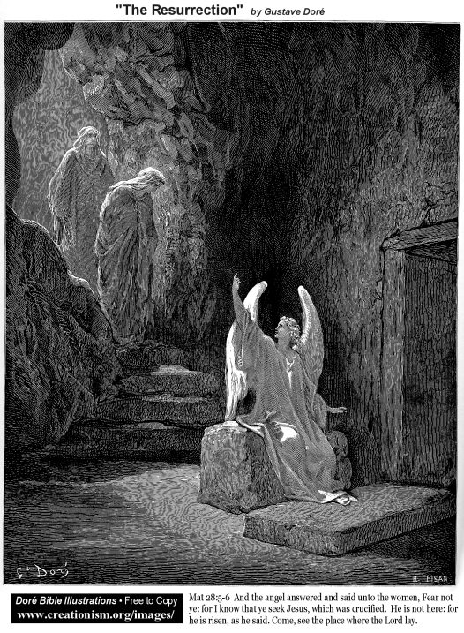

Jesus prophesied He would rise again after three days but no one believed Him, even though He had – clearly in God's strength, not His own (solely His human flesh) – raise Lazarus from the dead.
Source” Public domain as in image.

Faith In Action

Pray
Thank You God for the resurrection of Christ, Who defeated death itself. And for the living Holy Spirit of God dwelling within me and making me one of ‘the living among the dead’.

Act
I will pray for the business, political, and religious leaders who prefer the convenient lies of the world, which allows them to make excuses for their rebellion against God, over the truth of Jesus.
Be Specific ____________________________________________

Friday (Luke 24:13-43; John 20:10-23)
Luke
Jesus Walks the Road to Emmaus
24:13 Now that very day two of them were on their way to a village called Emmaus, about seven miles from Jerusalem. 24:14 They were talking to each other about all the things that had happened. 24:15 While they were talking and debating these things, Jesus himself approached and began to accompany them 24:16 (but their eyes were kept from recognizing him). 24:17 Then he said to them, “What are these matters you are discussing so intently as you walk along?” And they stood still, looking sad. 24:18 Then one of them, named Cleopas, answered him, “Are you the only visitor to Jerusalem who doesn’t know the things that have happened there in these days?” 24:19 He said to them, “What things?” “The things concerning Jesus the Nazarene,” they replied, “a man who, with his powerful deeds and words, proved to be a prophet before God and all the people; 24:20 and how our chief priests and rulers handed him over to be condemned to death, and crucified him. 24:21 But we had hoped that he was the one who was going to redeem Israel. Not only this, but it is now the third day since these things happened. 24:22 Furthermore, some women of our group amazed us. They were at the tomb early this morning, 24:23 and when they did not find his body, they came back and said they had seen a vision of angels, who said he was alive. 24:24 Then some of those who were with us went to the tomb, and found it just as the women had said, but they did not see him.” 24:25 So he said to them, “You foolish people – how slow of heart to believe all that the prophets have spoken! 24:26 Wasn’t it necessary for the Christ to suffer these things and enter into his glory?” 24:27 Then beginning with Moses and all the prophets, he interpreted to them the things written about himself in all the scriptures.
24:28 So they approached the village where they were going. He acted as though he wanted to go farther, 24:29 but they urged him, “Stay with us, because it is getting toward evening and the day is almost done.” So he went in to stay with them.
24:30 When he had taken his place at the table with them, he took the bread, blessed and broke it, and gave it to them. 24:31 At this point their eyes were opened and they recognized him. Then he vanished out of their sight. 24:32 They said to each other, “Didn’t our hearts burn within us while he was speaking with us on the road, while he was explaining the scriptures to us?” 24:33 So they got up that very hour and returned to Jerusalem. They found the eleven and those with them gathered together 24:34 and saying, “The Lord has really risen, and has appeared to Simon!” 24:35 Then they told what had happened on the road, and how they recognized him when he broke the bread.
Jesus Makes a Final Appearance
24:36 While they were saying these things, Jesus himself stood among them and said to them, “Peace be with you.” 24:37 But they were startled and terrified, thinking they saw a ghost. 24:38 Then he said to them, “Why are you frightened, and why do doubts arise in your hearts? 24:39 Look at my hands and my feet; it’s me! Touch me and see; a ghost does not have flesh and bones like you see I have.” 24:40 When he had said this, he showed them his hands and his feet. 24:41 And while they still could not believe it (because of their joy) and were amazed, he said to them, “Do you have anything here to eat?” 24:42 So they gave him a piece of broiled fish, 24:43 and he took it and ate it in front of them.
John
Jesus’ Appearance to Mary Magdalene
20:10 So the disciples went back to their homes. 20:11 But Mary stood outside the tomb weeping. As she wept, she bent down and looked into the tomb. 20:12 And she saw two angels in white sitting where Jesus’ body had been lying, one at the head and one at the feet. 20:13 They said to her, “Woman, why are you weeping?” Mary replied, “They have taken my Lord away, and I do not know where they have put him!” 20:14 When she had said this, she turned around and saw Jesus standing there, but she did not know that it was Jesus.
20:15 Jesus said to her, “Woman, why are you weeping? Who are you looking for?” Because she thought he was the gardener, she said to him, “Sir, if you have carried him away, tell me where you have put him, and I will take him.” 20:16 Jesus said to her, “Mary.” She turned and said to him in Aramaic, “Rabboni” (which means Teacher). 20:17 Jesus replied, “Do not touch me, for I have not yet ascended to my Father. Go to my brothers and tell them, ‘I am ascending to my Father and your Father, to my God and your God.’” 20:18 Mary Magdalene came and informed the disciples, “I have seen the Lord!” And she told them what Jesus had said to her.
Jesus’ Appearance to the Disciples
20:19 On the evening of that day, the first day of the week, the disciples had gathered together and locked the doors of the place because they were afraid of the Jewish leaders. Jesus came and stood among them and said to them, “Peace be with you.” 20:20 When he had said this, he showed them his hands and his side. Then the disciples rejoiced when they saw the Lord. 20:21 So Jesus said to them again, “Peace be with you. Just as the Father has sent me, I also send you.” 20:22 And after he said this, he breathed on them and said, “Receive the Holy Spirit. 20:23 If you forgive anyone’s sins, they are forgiven; if you retain anyone’s sins, they are retained.”

Prayer
Lord, the resurrection of Jesus helped His followers to rightly understand what You had done for them and to rightly respond to that. May I recognize, in gratitude for the great gift You have given to me, that I am also responsible to go and tell others of this great gift.

Summary and Commentary
Jesus was walking along the road when He came alongside two of His followers walking and talking in great angst. “But their eyes were kept from recognizing Him” (Luke 24:16) when He asked them to explain the things they were discussing so intently. When it was clear that they had misunderstood the critical spiritual essence of His ministry, Jesus recited again for them the prophesies fulfilled in Him and interpreted “the things written about Himself” (vs. 27).
The disciples invited Jesus to stay the night. When they were at table, “He took the bread, blessed and broke it, and gave it to them” (vs. 30) — “their eyes were opened and they recognized Him” (vs. 31). [Note: When Believers today have communion, in response to Jesus’ instruction to “do this in remembrance of Me” (Luke 22:19), our eyes are also opened to remember Who He is; our Lord and our Savior.]
Jesus appeared to the gathered disciples and challenged them to, “Look at My hands and my feet....Touch Me and see” (Luke 24:39) that He was alive. Yet even after seeing His hands and feet, “they still could not believe” (vs. 41), so Jesus took a piece of fish and ate it in front of them, demonstrating that He was truly a resurrected living human being.
Jesus breathed on His disciples, saying “Receive the Holy Spirit. If you forgive anyone’s sins, they are forgiven; if you retain anyone’s sins, they are retained” (John 20:22-23). To “forgive” is not an arbitrary apostolic power given them. Rather, with the help of the Holy Spirit (based on Luke 24:49 not indwelling), Whom they had just been given (unique to the disciples until Pentecost), they had the discernment to know who was truly repentant and who was not. Therefore, when proclaiming forgiveness, they did so with the certain knowledge given them by the Spirit of God.

Interaction

Consider
The Holy Spirit came out from Jesus and in to His disciples, uniting them in spirit and with power for a purpose.

Discuss
Have we often missed the message of the Lord when we are in a rush to explain things from a worldly, not a Heavenly, perspective?

Reflect
We may miss the power and presence of the Lord as it is manifested in the body of Christ, the Church, if we are not united in the Spirit.

Share
When have you experienced people so busy promoting a doctrine or a philosophy that they miss the simple and obvious message of Jesus?

KTALZ
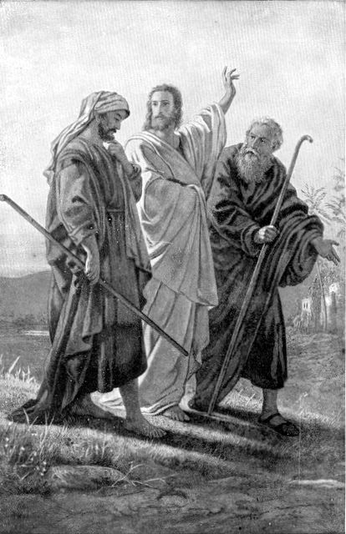

Jesus walked with two disciples who were confused, He enlightened them, and as He broke bread at their home they finally recognized Him.
Source: Public domain here http://www.lavistachurchofchrist.org/Pictures/

Faith In Action

Pray
Today I will ask the Holy Spirit to make me profoundly aware of His presence, His provisions for me, and His workings in and through me.

Act
I will pray for the awareness of God in someone struggling with living-out their faith and, to encourage them, I will share with them how and when I see God moving in their life.
Be Specific _____________________________________________

Saturday (Matthew 28:16-20; Luke 24:44-53; John 20:24–21)
Matthew
The Great Commission
28:16 So the eleven disciples went to Galilee to the mountain Jesus had designated. 28:17 When they saw him, they worshiped him, but some doubted. 28:18 Then Jesus came up and said to them, “All authority in heaven and on earth has been given to me. 28:19 Therefore go and make disciples of all nations, baptizing them in the name of the Father and the Son and the Holy Spirit, 28:20 teaching them to obey everything I have commanded you. And remember, I am with you always, to the end of the age.”
Luke
Jesus’ Final Commission
24:44 Then he said to them, “These are my words that I spoke to you while I was still with you, that everything written about me in the law of Moses and the prophets and the psalms must be fulfilled.” 24:45 Then he opened their minds so they could understand the scriptures, 24:46 and said to them, “Thus it stands written that the Christ would suffer and would rise from the dead on the third day, 24:47 and repentance for the forgiveness of sins would be proclaimed in his name to all nations, beginning from Jerusalem. 24:48 You are witnesses of these things. 24:49 And look, I am sending you what my Father promised. But stay in the city until you have been clothed with power from on high.”
Jesus’ Departure
24:50 Then Jesus led them out as far as Bethany, and lifting up his hands, he blessed them. 24:51 Now during the blessing he departed and was taken up into heaven. 24:52 So they worshiped him and returned to Jerusalem with great joy, 24:53 and were continually in the temple courts blessing God.
John
The Response of Thomas
20:24 Now Thomas (called Didymus), one of the twelve, was not with them when Jesus came. 20:25 The other disciples told him, “We have seen the Lord!” But he replied, “Unless I see the wounds from the nails in his hands, and put my finger into the wounds from the nails, and put my hand into his side, I will never believe it!”
20:26 Eight days later the disciples were again together in the house, and Thomas was with them. Although the doors were locked, Jesus came and stood among them and said, “Peace be with you!” 20:27 Then he said to Thomas, “Put your finger here, and examine my hands. Extend your hand and put it into my side. Do not continue in your unbelief, but believe.” 20:28 Thomas replied to him, “My Lord and my God!” 20:29 Jesus said to him, “Have you believed because you have seen me? Blessed are the people who have not seen and yet have believed.”
20:30 Now Jesus performed many other miraculous signs in the presence of the disciples, which are not recorded in this book. 20:31 But these are recorded so that you may believe that Jesus is the Christ, the Son of God, and that by believing you may have life in his name.
Jesus’ Appearance to the Disciples in Galilee
21:1 After this Jesus revealed himself again to the disciples by the Sea of Tiberias. Now this is how he did so. 21:2 Simon Peter, Thomas (called Didymus), Nathanael (who was from Cana in Galilee), the sons of Zebedee, and two other disciples of his were together. 21:3 Simon Peter told them, “I am going fishing.” “We will go with you,” they replied. They went out and got into the boat, but that night they caught nothing.
21:4 When it was already very early morning, Jesus stood on the beach, but the disciples did not know that it was Jesus. 21:5 So Jesus said to them, “Children, you don’t have any fish, do you?” They replied, “No.” 21:6 He told them, “Throw your net on the right side of the boat, and you will find some.” So they threw the net, and were not able to pull it in because of the large number of fish.
21:7 Then the disciple whom Jesus loved said to Peter, “It is the Lord!” So Simon Peter, when he heard that it was the Lord, tucked in his outer garment (for he had nothing on underneath it), and plunged into the sea. 21:8 Meanwhile the other disciples came with the boat, dragging the net full of fish, for they were not far from land, only about a hundred yards.
21:9 When they got out on the beach, they saw a charcoal fire ready with a fish placed on it, and bread. 21:10 Jesus said, “Bring some of the fish you have just now caught.” 21:11 So Simon Peter went aboard and pulled the net to shore. It was full of large fish, one hundred fifty-three, but although there were so many, the net was not torn. 21:12 “Come, have breakfast,” Jesus said. But none of the disciples dared to ask him, “Who are you?” because they knew it was the Lord. 21:13 Jesus came and took the bread and gave it to them, and did the same with the fish. 21:14 This was now the third time Jesus was revealed to the disciples after he was raised from the dead.
Peter’s Restoration
21:15 Then when they had finished breakfast, Jesus said to Simon Peter, “Simon, son of John, do you love me more than these do?” He replied, “Yes, Lord, you know I love you.” Jesus told him, “Feed my lambs.” 21:16 Jesus said a second time, “Simon, son of John, do you love me?” He replied, “Yes, Lord, you know I love you.” Jesus told him, “Shepherd my sheep.” 21:17 Jesus said a third time, “Simon, son of John, do you love me?” Peter was distressed that Jesus asked him a third time, “Do you love me?” and said, “Lord, you know everything. You know that I love you.” Jesus replied, “Feed my sheep. 21:18 I tell you the solemn truth, when you were young, you tied your clothes around you and went wherever you wanted, but when you are old, you will stretch out your hands, and others will tie you up and bring you where you do not want to go.” 21:19 (Now Jesus said this to indicate clearly by what kind of death Peter was going to glorify God.) After he said this, Jesus told Peter, “Follow me.”
Peter and the Disciple Jesus Loved
21:20 Peter turned around and saw the disciple whom Jesus loved following them. (This was the disciple who had leaned back against Jesus’ chest at the meal and asked, “Lord, who is the one who is going to betray you?”) 21:21 So when Peter saw him, he asked Jesus, “Lord, what about him?” 21:22 Jesus replied, “If I want him to live until I come back, what concern is that of yours? You follow me!” 21:23 So the saying circulated among the brothers and sisters that this disciple was not going to die. But Jesus did not say to him that he was not going to die, but rather, “If I want him to live until I come back, what concern is that of yours?”
A Final Note
21:24 This is the disciple who testifies about these things and has written these things, and we know that his testimony is true. 21:25 There are many other things that Jesus did. If every one of them were written down, I suppose the whole world would not have room for the books that would be written.

Prayer
Lord, Your final commission is for us to partner with You in what has been at the heart of Your work in the world since Adam and Eve first rebelled in the Garden: To invite all humans to faith in You. May I be found diligent and joyful in sharing the Good News.

Summary and Commentary
Thomas was not with them when Jesus came to the first gathering of the disciples. When he heard that He had appeared to them, he declared that unless he saw the wounds on Jesus’ body, “I will never believe it!” (John 20:25). Days later Jesus confronted Thomas with his unbelief and he melted in humble recognition and submission to his Lord.
Jesus appeared a third time to the disciples — “but the disciples did not know that it was Jesus” (John 21:4) — by the sea in Galilee, instructing them to cast their nets, which were then miraculously overfilled with fish after a night of nothing caught. John declared to Peter “It is the Lord!” (vs. 7), who then in joyful response lept into the water to greet Jesus on the shore. Jesus later joined them all in a meal, and they were still amazed—yet now “they knew it was the Lord” (vs. 12).
Peter was restored by Jesus after having denied Him three times. He challenged Peter three times Do you love Me?, leading him incrementally toward a properly- humbled heart:
First, Jesus spoke the challenge, “Do you love me more than these do?” (John 21:15, italics added) in light of Peter’s bragging before the crucifixion, 'If they all fall away...I never will.' Peter dismisses His ‘more than these do’ qualifier when replying You know I love You. Jesus simply responded by telling Peter to Feed My lambs.
Second, He repeated Do you love me? to Peter, this time removing the challenge ‘more than these’. When Peter replied again that he loved Him, Jesus told Peter to “Shepherd My sheep” (John 21:16). [Note: Anyone can feed sheep, but a shepherd must be willing to die to protect his sheep.]
Third, He brought Peter to frustrated-humility when making it clear to him that he was not in charge, Jesus was — Peter’s humility was indicated by his confession, “Lord, You know everything. You know that I love You” (John 21:17). The arrogant Peter had been brought to his knees, and now he was at last ready to be trusted to feed and to shepherd the Shepherd’s sheep. [Note: The ‘sheep’ needed to be fed the Word, so they would be equipped when Peter (and the others) were jailed or killed. Jesus’ ministry must continue and multiply, with or without shepherds.]
Jesus’ final commission began with Him opening their minds (“so they could understand the scriptures,” Luke 24:45) and reviewing the Law, Prophets, and Psalms fulfilled in Him. He advised them to wait in the city “until you have been clothed with power from on high” (vs. 49), in reference to the coming of the Holy Spirit.
[Note: John 20:22 might be interpreted that “breathed” meant the giving of the indwelling Holy Spirit to the apostles but Luke 24:49 makes it clear it that was not to happen until Pentecost.]
The disciples worshiped Jesus in Galilee, “but some doubted” (Matt. 28:17) and would continue to doubt until the departure of Jesus to Heaven. He told them, “All authority in heaven and on earth has been given Me. Therefore go and make disciples of all nations, baptizing them in the name of the Father and the Son and the Holy Spirit, teaching them to obey everything I have commanded you. And remember, I am with you always, to the end of the age” (Matt. 28:18-20, italics added).
[Note: What has become known as The Great Commission is loaded: Jesus noted that 1) ultimate control over the world/death had been wrested from Satan and given to Him, 2) He sent His followers out to disciple the world, 3) He reiterated the Trinity, 4) He commanded obedience from His followers, and 5) He concluded by encouraging them to remember that they would never be alone in their ministry to others for Him.]
[Note: The “end of the age” (Matt. 28:20) refers to the age of man’s independence from God. All truly-saved people have surrendered their free will; their independence. Therefore, once past the final judgment, when everything sinful has been obliterated, that age will have ended — All God’s children will then be in Heaven with Him, rather than Jesus needing to minister to us in this fallen world.]
Jesus blessed His disciples and was “taken up into heaven” (Luke 24:51). In response to their witness of His ascension, the disciples worshiped Him and returned to Jerusalem in great joy, sharing His story in the Temple courts and “blessing God” (vs. 53) for what He had done.
John concluded with the final note that “his testimony is true” (21:24) and that there are many other things Jesus did and said that could have been recorded, but “the whole world would not have room for the books that would be written” (vs. 25).

Interaction

Consider
There are meanings embedded in the Final Commission of Jesus, both in His promises to and His expectations of us.

Discuss
Jesus humbled Peter, which prepared him for leadership. Has He likewise humbled and prepared you?

Reflect
Jesus challenged Peter three times: To not think more of himself than others, to be a humble shepherd, and to be intentional in preparing others to carry on after he too is gone.

Share
When have you observed leadership that modeled humble, yet bold, in service to the Lord?

KTALZ
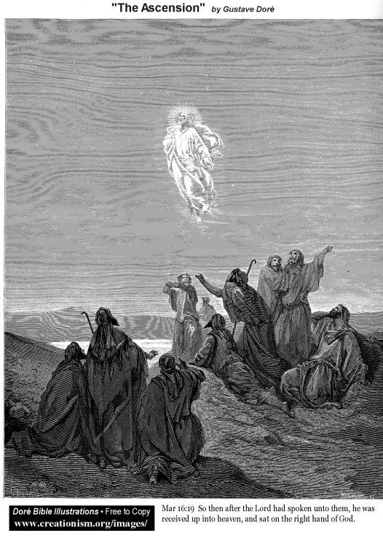

Jesus received-back His glory as He ascended back home to Heaven.
Source: Public domain as in image.

Faith In Action

Pray
I rejoice that Jesus overcame my doubt, forgave my rebellion, and is now equipping me to serve Him with love, energy, and integrity.

Act
I prayerfully commit to remember that it is always about Him, He has prepared the way, and He expects me to never rest in telling His story.
Be Specific ____________________________________________
All Bible text is from the NET unless otherwise indicated - http://bible.org
Note 1: These Studies often rely upon the guidance of the NET Translators from their associated notes. Careful attention has been given to cite that source where it has been quoted directly or closely paraphrased. Feedback is encouraged where credit has not been sufficiently assigned.
Note 2: When NET text is quoted in commentary and discussion all pronouns referring to God are capitalized, though they are lower-case in the original NET text.
Commentary text is from David M. Colburn, D.Min. unless otherwise noted.
Copyright © 2012, 2013, 2014 by David M. Colburn. This is a BibleSeven Study –”The Chronological Gospels” – “Week 12 of 12” - prepared by David M. Colburn and edited for bible.org in Fall 2013/Spring 2014. This text may be used for non-profit educational purposes only, with credit; all other usage requires prior written consent of the author.

