Genesis 1 - 3
(Creation & Fall)
David M. Colburn
A Chronological Daily Bible Study of the Old Testament
7-Day Sections with a Summary-Commentary, Discussion Questions,
and a Practical Daily Application
Genesis Study - Week 1 of 7

Sunday (Genesis 1:1-5)
The Creation of the World
1:1 In the beginning God created the heavens and the earth.
1:2 Now the earth was without shape and empty,
and darkness was over the surface of the watery deep,
but the Spirit of God was moving over the surface of the water.
1:3 God said, “Let there be light.” And there was light!
1:4 God saw that the light was good, so God separated the light from the darkness.
1:5 God called the light “day” and the darkness “night.”
There was evening, and there was morning, marking the first day.

Prayer
Lord, You created, You defined, You imparted value “it was good”, and You created time where only timelessness had existed. I stand in awe of You!

Summary and Commentary
Moses was the chosen author of God. If one does not take the text to describe any part of pre-Genesis history, and one takes the Creation narrative to refer in every detail to literal 24 hour days, then the Book of Genesis covers approximately 2400 years.
It has been estimated that Moses recorded the essence of the book of Genesis sometime after the time of the exodus from Egypt in 15th Century BC. While he may have had access to oral history and artifacts, perhaps even some Egyptian documents, it was God who would have inspired and informed his writing. (This doesn't address when he may have recorded the events of the Book of Exodus.)
Chapter One introduces the creative expression of God. He spoke a previously timeless existence into a 24 hour linear-time-contained physical reality (events flow in order). Chapter One summarizes the first six days of His Creation.
There is a good deal of debate in theological circles as to the precise meaning of the words, “In the beginning,” the resolution of which is very significant. If one takes the text to be an introduction to a mere allegory or parable then that perspective serves as a precedent for much of the Biblical text that follow. If one takes the words to refer to the beginning of everything created external to Heaven, and as a literal record, then that has a substantially different impact on the following texts. This Bible study/discipleship tool will lean toward the latter rather than the former understanding, though with a caveat or two.
“God created” tells us that He did so both without any help and ex nihilo, a Latin phrase meaning “out of nothing” or without any preexisting resource (that is, no source other than Himself).
“The heavens and the earth” may be taken to refer broadly to everything external to the Kingdom of Heaven or to very narrowly to refer only to the sky and solid ground referenced in verses 6-9. This study takes vs. 1:1 to be a general statement of God's creation in general..
Note: The text of the Bible is written for the purpose of earth-centric humankind; therefore, “the earth” is literally our planet whereas “the heavens” represents the rest of Creation apart from the earth.
“Now” alerts the reader that what comes next was a modification of the previous statement.
The phrase, “without shape and empty, and darkness was over the surface,” leads the reader to understand that the Lord God had not yet given physical definition and purpose to "the earth", which He had just created.
"the Spirit of God was moving,” alerts the reader to the presence of a specific member of the Trinity (the Holy Spirit) and that action is about to take place to transform the shapeless, empty, dark earth.
The third verse describes God's method in creating and transforming by mere spoken word: He said, "Let there be light. And there was light!” The sovereign power of God to create, transform, give meaning and purpose to, and cause order are all clearly observable in this brief segment of Biblical text.
[Note: It would appear that He was, until the third day vss 1:14-16, the source of the light.]
The powerful phrase, “God saw that the light was good,” shows the Lord assessing what He had created, deeming it worthy of Himself, and establishing the light as "good" in contrast to the prior state of darkness or lack of definition.

Interaction

Consider
Apart from sometimes-esoteric debates about 'new earth' versus 'old earth,' or six- thousand years since Creation versus six-billion years, there may be no question in the mind of a Biblical-Christian as to Who did the creating. The Lord God leaves no room for doubt in His Word.

Discuss
How does the belief that the Lord God literally created everything as described in Genesis impact your view of science; discovery about God or discovery without God?

Reflect
When this fallen world, of which Satan is the temporary Prince, seeks to raise doubt in us about our faith - we may return to the book of Genesis to be restored in the words, “In the beginning God.” Imagine the majesty and power of the One Who created.

Share
When have you contemplated what it means for God to live outside of the constraints of linear time as we know it?

KTALZ
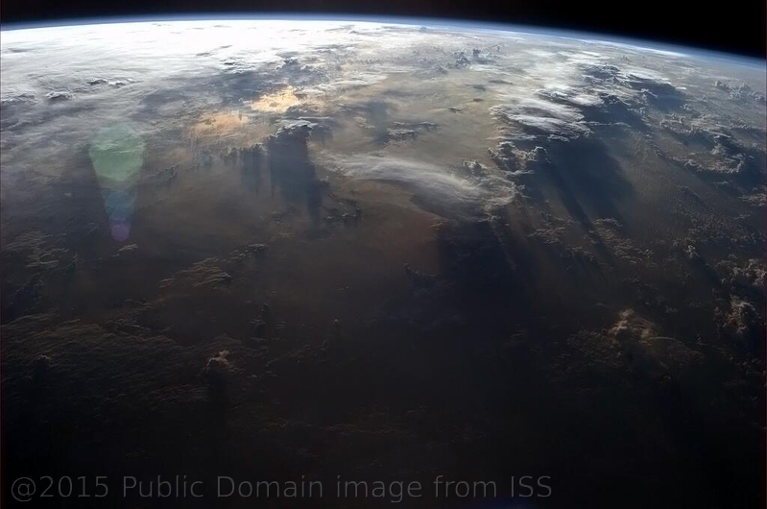

It's difficult to imagine the shapelessness of “the earth” prior to God's next step in Creation – does this public domain picture, taken from the International Space Station in 2013, help?

Faith In Action

Pray
Ask the Holy Spirit to inspire in you a renewed sense of awe for God.

Act
Today I will confess my drift away from an innocent sense of awe for the majestic God Who created billions of stars, time, and then life on planet Earth – including humankind in His (partial) image – He alone is my strength and the Lord of my life.
Be Specific ________________________________________________

Monday (Genesis 1:6-25)
1:6 God said, “Let there be an expanse in the midst of the waters
and let it separate water from water.
1:7 So God made the expanse
and separated the water under the expanse from the water above it.
It was so.
1:8 God called the expanse “sky.”
There was evening, and there was morning, a second day.

1:9 God said, “Let the water under the sky be gathered to one place and let dry ground appear.” It was so.
1:10 God called the dry ground “land” and the gathered waters he called “seas.”
God saw that it was good.
1:11 God said, “Let the land produce vegetation: plants yielding seeds according to their kinds, and trees bearing fruit with seed in it according to their kinds.”
It was so.
1:12 The land produced vegetation – plants yielding seeds according to their kinds, and trees bearing fruit with seed in it according to their kinds.
God saw that it was good.
1:13 There was evening, and there was morning, a third day.

1:14 God said, “Let there be lights in the expanse of the sky to separate the day from the night,
and let them be signs to indicate seasons and days and years,
1:15 and let them serve as lights in the expanse of the sky to give light on the earth.”
It was so.
1:16 God made two great lights – the greater light to rule over the day and the lesser light to rule over the night.
He made the stars also.
1:17 God placed the lights in the expanse of the sky to shine on the earth,
1:18 to preside over the day and the night,
and to separate the light from the darkness.
God saw that it was good.
1:19 There was evening, and there was morning, a fourth day.

1:20 God said, “Let the water swarm with swarms of living creatures
and let birds fly above the earth across the expanse of the sky.”
1:21 God created the great sea creatures and every living and moving thing with which the water swarmed, according to their kinds,
and every winged bird according to its kind.
God saw that it was good.
1:22 God blessed them and said, “Be fruitful and multiply and fill the water in the seas, and let the birds multiply on the earth.”
1:23 There was evening, and there was morning, a fifth day.

1:24 God said, “Let the land produce living creatures according to their kinds:
cattle, creeping things, and wild animals, each according to its kind.”
It was so.
1:25 God made the wild animals according to their kinds,
the cattle according to their kinds,
and all the creatures that creep along the ground according to their kinds.
God saw that it was good.

Prayer
Lord, Your power and vision are beyond anything known to mere man, You not only designed an entire planet and populated it with life – You did so in a way that was perfectly harmonious. May I find joy in the knowledge that our Lord Jesus is preparing a place for us that is restored to Your origin plan.

Summary and Commentary
The Lord God decided how He would proceed with His creation, then made it so “So God made the expanse”.
The Lord God altered the climate system by separating, with an “expanse” translated “sky,” the moisture in the outer atmosphere above the earth from the water on the earth's surface.
With a word God created the climate system: The cycle of moisture from the surface of the earth moves in to the upper atmosphere, around the earth, and is then deposited elsewhere – keeping the balance of humidity without occurrence of flooding or drought (prior to the 'Fall').
After creating an atmospheric shell so that the surface (covered by water) was surrounded by sky and contained by that shell the Lord God then separated bodies of land and sea.
Each part, atmospheric shell, sky, water, and land served a different function, just as parts of the human body do, and each contributed to the whole ecosystem in a unique but critical way.
The Lord God then called the plants and trees into being, each also with a unique purpose, and each reproducing only its own kind.
"There was evening, and there was morning, a third day" (vs 13).
As Moses recorded the story of Creation he used descriptive images and phrases from a primitive era, it is important as we read to not misunderstand his limited experience-based vocabulary as mere allegory, but rather allow the Holy Spirit to enhance our understanding.
The Lord God created the sun “... the greater light”, moon “... the lesser light”, and stars. The interaction of these bodies resulted in “... seasons and days and years.” As humankind has studied the relationship between the sun, moon, stars, and other planets their location has been found to be associated with day, night, season, and years and they have also been valuable in land-based geo-location and water-bound navigation.
[Note: Until this moment in Creation, the earth was held together by the Lord-alone. He set in place the rest of the cosmos in order to make it a self-sustaining yet highly interdependent system, though at all times it exists only as He empowers and permits. In its fallen-away broken state all of Creation would collapse without His constant intervention. Read Colossians 1:17.]
"There was evening, and there was morning, a fourth day" (vs 19).
[Note: The most-legitimate challenge to the presumption that a "day", in the Genesis Creation account, equals what we know as 24 hours; and that challenge is, at least theoretically, found in Day 4, vss 1:14-18 where the elements which cause a “Day” to be 24 hours were first created by God. The repeated expression "There was evening, and there was morning, a fifth day" may be no more than a rhetorical flourish (common throughout the Word of God) than as a phrase intended to require a literal 24 hours. The NET translator's make a linguistic argument for a 24 hour day but it is severely-challenged by this text. On the other side of the debate - the text of the “fourth day” also does not require the prior days to be anything other than what humankind came to know as twenty-four hour days. Prior to Day 4 a “Day” could have been twenty-four nanoseconds - God is never restrained by His creation; why would He take twenty-four of 'our' hours to form something He easily could create with a "word" or a "thought"? These can be challenging texts - one must approach them with awe for God and skepticism toward any effort to either undermine the integrity of the whole Word or to impose a traditional reading as immutably correct.]
The Lord God looked upon His Creation, water separated from sky and space, water and land separated, then plants and trees created upon the land; all of it deemed good – perfect in harmony.
He then decided that the sky and sea should also have living things, so the Lord created sea creatures and birds.
The Lord God did as He had with the plants and trees and equipped the creatures of the sky and sea to reproduce, multiplying from the few to the many, “each according to their kind”.
"There was evening, and there was morning, a fifth day." (vs 23).
The Lord God followed His decision to populate the sky and water with life-forms specific to those environments with a decision to populate the land with creatures as well.
The text describes three rough categories; crawling creatures (e.g. insects and lizards), large animals – with an implication of suitability to be domesticated (e.g. buffalo, camels, cattle, goats, sheep), and a variety of other wild animals.
As before the Lord spoke them into being then, as He did the fish and fowl, empowered them to reproduce “according to their kind” without the need of His direct Creative action.
Created first on the sixth day are "living creatures according to their kinds" (vs 24).

Interaction

Consider
At Creation everything worked in perfect symmetry. The plants and trees were given the gift of life then set free to multiply remaining true to their unique created form. Land and sea are both source for the critical elements of water and dry surface needed for growth; each were created in perfect balance and order. What has now become imperfect, a 'machine' barely held together with loose and broken parts, surrounded by debris flying through space, with dark comets all-but-invisible to detection threatening to slam into planet earth and wreak terrible havoc; this was once a beautiful and perfectly balanced galactic system of God's design. The land was self-sustaining without creatures in the air and water, it was only the creative Spirit of the Lord God Who envisioned, then perfectly-created them. Despite many unsupportable details imposed upon the text by mere men (some fanciful, some venal, and some carelessly-conjectured by the rare few actually seeking truth) the Bible is essentially silent as to details of the creatures the Lord God created and set loose upon the earth. We see only the distortions of His perfect Creation long after the Fall. We must remember that Eden was sealed – so nothing of perfection is visible to us.

Discuss
How might you help someone to recognize the literal physical massiveness of each step in Creation? How might your fellowship teach an appreciation for the difference between the original flawless Creation and the fallen-away remnant in which we live? How might you help believers to understand the confused-thinking of those who invent notions about the animals in pre-Fall Eden, and/or those who deny Eden entirely in to justify their scientifically-challenged belief in a Godless and essentially-random evolution-by-accident fable?
[Note: When challenged with mathematical, physical, and observational realities, those who challenge creationism retreat to magical thinking such as aliens from space deposited life on earth, while ignoring the obvious rhetorical 'elephant in the room' - aliens would still require an 'ex nihilo' origin sometime in the past. Also, in 2015 Darwinian-environmentalists confessed that they could no longer defend his “Tree of Life” postulate, though they continued to cling to hope for a non-Biblical explanation.]

Reflect
Summer and winter, spring and fall, rain and snow, sunshine and darkness; each are now far less-perfect than the original pre-Fall creation, yet each is critical to the balance of the Created system; a miraculous work of God. Prior to Day Four of Creation, God had held everything in place by mere thought; then He added a multitude of interdependent solar systems, each with gravity, all in perfect harmony, and all contributing to the balanced whole. Diversity, independence, peaceful coexistence; this was the design - and then the Fall. The land animals were different in kind and purpose from the plants and trees, birds and sea creatures that came before them, yet all were similar in that they were equipped and released to live and to multiply. All of Creation to this point was either non-sentient (unable to experience pain or pleasure), or sentient (able to experience pain or pleasure) - yet all were non-reflective (non-sapient).

Share
When have you paused to consider the perfect balance of God's original climatology and praise Him? When have you experienced the inspiring teaching of someone contrasting perfection with imperfection and the promise that one day we will know the perfection for which we were created? When have you observed a creative person at work and how they envision something in their mind and then create it with their body? When have you paused to ponder what must have been the magnificence of God's creation and then mourned the mess that we've (through the Fall) made of it?

KTALZ
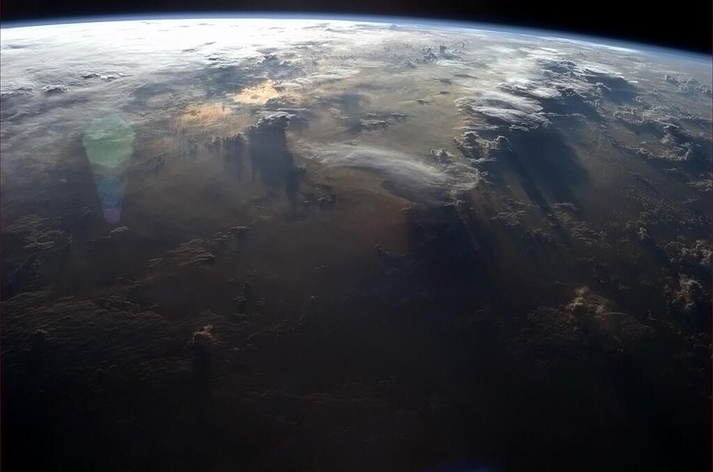





The earth takes shape, then flowers and plants, and living creatures – all created and established by God – flourish.
Source: First picture public domain via International Space Station, the other two copyright this author as watermarked on images.

Faith In Action

Pray
Ask the Holy Spirit to help you to look past the broken and imperfect world around you and instead dwell upon God's amazing Creation - to invest the time to pause and to observe a land animal (either directly or via a live Internet cam) and as you do so to celebrate the beauty and incredible detail of the creature and the way that it interacts with its environment, and to observe the obvious differences between that creature and the higher form of a human being.

Act
Today I will celebrate the beauty and incredible detail of the creature(s) I have observed and the way it/they interact(s) with its(their) environment. As the Lord provides I will share with another, in person or electronically, the amazing evidences of the Lord God's creative touch. I will give God all of the glory.
Be Specific _____________________________________________

Tuesday (Genesis 1:26-2:4)
1:26 Then God said, “Let us make humankind in our image, after our likeness,
so they may rule over the fish of the sea and the birds of the air, over the cattle, and over all the earth, and over all the creatures that move on the earth.”
1:27 God created humankind in his own image,
in the image of God he created them,
male and female he created them.
1:28 God blessed them and said to them, “Be fruitful and multiply! Fill the earth and subdue it!
Rule over the fish of the sea and the birds of the air and every creature that moves on the ground.”
1:29 Then God said, “I now give you every seed-bearing plant on the face of the entire earth and every tree that has fruit with seed in it. They will be yours for food.
1:30 And to all the animals of the earth, and to every bird of the air, and to all the creatures that move on the ground – everything that has the breath of life in it – I give every green plant for food.”
It was so.
1:31 God saw all that he had made – and it was very good!
There was evening, and there was morning, the sixth day.
2:1 The heavens and the earth were completed with everything that was in them. 2:2 By the seventh day God finished the work that he had been doing, and he ceased on the seventh day all the work that he had been doing. 2:3 God blessed the seventh day and made it holy because on it he ceased all the work that he had been doing in creation.
2:4 This is the account of the heavens and the earth when they were created – when the Lord God made the earth and heavens.

Prayer
Lord, You made us in Your partial image, and You gave us stewardship of Your Creation. While we made a mess of things may I remember that Your work was flawless and Your unique and eternal flawlessness is to be praised.

Summary and Commentary
The text uses the plural term “us” when the Lord God refers to Himself, it is the first of many occasions from Genesis through Revelation where the plurality of the “Godhead” or “Trinity” is expressly or is indirectly testified.
[Note: The NET translator's notes share several of the perspectives upon the plural reference to the Lord God and only the Trinitarian view is consistent with the rest of the text. As is the case throughout the Bible, every major matter is affirmed elsewhere, thus this study will not quibble with the natural meaning of the plural.]
The Lord God created humankind, unique and separate from all of the other creatures, in His own image (“... after our likeness” means a partial reflection of features of the Lord God).
Human beings are both a sentient (perceiving the environment via seven physical senses) and a sapient (capable of processing sentient data in an intentionally-rational manner) creation.
Humankind was plural in form, male and female, linked spiritually to the Lord God in a type of Trinitarian essence. (Humankind without the Lord God is temporally incomplete and eternally dead.)
Humankind is capable of sensing pain and pleasure as well as engaging in intentionally reflective, thoughtful, and volitional relationships.
Humankind is more than merely instinctive as is the case with all other living things.
Humankind alone was given the capacity for relationship in the spiritual realm.
Humankind alone was purposed to receive the delegated authority and responsibility to rule over the rest of Creation.
Humankind was given the fruit of the seed-bearing plants and seed-bearing fruit of the trees as food.
[Note: There is an implicit absence of permission to eat non seed-bearing fruit, apparently only found on a single tree in the Garden, and also note that a non seed-bearing fruit is incapable of reproduction (without artificial human intervention e.g. via budding or grafting – thus it is an inherently single-generation tree.]
"God saw all that he had made – and it was very good! There was evening, and there was morning, the sixth day" (vs 31).
Chapter two of Genesis revisits the Creation narrative presented in chapter one, adding detail to descriptions of the relationship between Adam and Eve, their relationship with the Lord God, and their interaction with the rest of God's Creation.
The Lord God had completed all of His creative work prior to the beginning of the seventh day and ceased His work. Nothing that occurred after the end of the sixth day involved a new creative work.
The Lord God then did an amazing thing: He set aside the seventh day and declared it a holy day, a 'holyday' holiday of sorts, during which He wanted His Creation to remember His work of the first six days in an exceptional way, by ceasing from all work (labor) as He Himself had modeled. It is very important that we understand why God set aside the seventh day as a holy day and how it was part of purpose of the Law.
[Note: Until Jesus the Christ made the way on the Cross, His resurrection, & His ascension a return to Creation was blocked. With Christ all things were made new, we look forward to a New Creation, we no longer look back to the old Fall-destroyed Creation.]
The Lord's perfectly-planned Creation was unique, in timeless eternity and in the just-created linear time-bound physical universe He had just spoken into being – that event was therefore holy and worthy of pause to praise.
[Note: The NET Bible translator's notes offer a valuable paraphrase of the first four or five words of Genesis 2:4: “This is what became of the heavens and the earth.” When one reads the NET translator's paraphrase the text is revealed as declaring the literal nature of the Creation record while it also introduces additional detail – to be followed by the sad story of rebellion and Fall.]

Interaction

Consider
These events are pre-Fall, so man is innocent and lives in perfect harmony with the Lord God and everything in His Creation. What the Lord God did in His act of Creation was real, He spoke and it was.

Discuss
How might you lead others to a greater appreciation of the Lord God through a comparison of attributes in real world application?
[Example: Humankind may maintain few truly intimate relationships, typically limited to about 12 in a meaningful group interaction, whereas the Lord God may have simultaneous intimate relationships with 6 billion+ humans and communicate with each individually.]

Reflect
Mankind was male and female living in harmony; they were different yet of a common essence, possessed of an essential unity - much like the holy Trinity of God. The creation of every new human life is a partnership between man and God; while God delegated the capacity to reproduce, and everyone since the Fall is imperfect, it is He-alone Who adds the spiritual essence which separates man from beast.
On the Sunday 'holyday' for Christians we recognize our new covenant with God, and we celebrate the new creation that He has provided for us, through the life and death of Jesus the Christ.
It is a remarkable reality that, when the Lord God created the heavens and the earth, 1) He was self-sufficient, 2) He needed nothing external to Himself but did so as an act of love, 3) He chose to create so that He might share Himself with man.

Share
When you have been in a fellowship where attention was brought to the Lord's creative work and there was celebration of His perfection then – and a reminder that the New Creation will restore perfection to us in heaven?

KTALZ


Beautiful and peaceful was God's plan.
Source: Copyright as watermarked on the image and as stated in the study week footnote.

Faith In Action

Pray
Ask the Holy Spirit to reveal to you something new about His Creative genius through our scientific observations about the human body, something that will underscore my understanding that His Creation that is too-profound to have happened accidentally – even over billions of years, to lead you to take the time to celebrate on this Sunday by ceasing from the busyness of life “work” to reflect upon the beauty of the Lord God's original perfect Creation, and to lead you to a more profound awareness that the Lord God created humankind with the free will to either love or reject Him.

Act
Today I will stand in front of a mirror and be amazed that, considering the ravages of the Fall, the Lord God's creative hand remains so visible in my complex bio-mechanical machine (my physical self) and in the indwelling Holy Spirit (the perfect Counselor to my spiritual self). I will then share what I have learned with someone and encourage them to repeat my discovery experience. I will celebrate life. I will thank the Lord God for His gift of life to me and especially for my new life in Christ. I will encourage and pray for the one(s) whom He has identified. I will pause and reflect and celebrate and I will share with a fellow Believer. As the Holy Spirit provides I will also share, with one who is considering-Christ, the truth of the new creation that the Lord has promised to those who place their faith fully in His Son Jesus.
Be Specific _________________________________________________

Wednesday (Genesis 2:5-17)
2:5 Now no shrub of the field had yet grown on the earth, and no plant of the field had yet sprouted, for the Lord God had not caused it to rain on the earth, and there was no man to cultivate the ground. 2:6 Springs would well up from the earth and water the whole surface of the ground. 2:7 The Lord God formed the man from the soil of the ground and breathed into his nostrils the breath of life, and the man became a living being.
2:8 The Lord God planted an orchard in the east, in Eden; and there he placed the man he had formed.
2:9 The Lord God made all kinds of trees grow from the soil, every tree that was pleasing to look at and good for food. (Now the tree of life and the tree of the knowledge of good and evil were in the middle of the orchard.)
2:10 Now a river flows from Eden to water the orchard, and from there it divides into four headstreams. 2:11 The name of the first is Pishon; it runs through the entire land of Havilah, where there is gold. 2:12 (The gold of that land is pure; pearls and lapis lazuli are also there). 2:13 The name of the second river is Gihon; it runs through the entire land of Cush. 2:14 The name of the third river is Tigris; it runs along the east side of Assyria. The fourth river is the Euphrates.
2:15 The Lord God took the man and placed him in the orchard in Eden to care for it and to maintain it.
2:16 Then the Lord God commanded the man, “You may freely eat fruit from every tree of the orchard, 2:17 but you must not eat from the tree of the knowledge of good and evil, for when you eat from it you will surely die.”

Prayer
Lord, as I once-again read the flow of Your Creation, and the purpose for which You created everything, I am in awe. May I never forget that You breathed life into the first human, as You do with each and every human, and that we rely upon You for life itself.

Summary and Commentary
Genesis Chapter 2 is a fleshing-out of detail the story of what the Lord God Created, followed in Chapter 3 by what man did with His incredible gift of Creation and divine relationship.
God informs the reader that, whereas He had caused life to exist in the form of plants and creatures of the air, land, and sea, there were not yet cultivated plants for food —cultivation requires a cultivator and He had not yet created man. This observation is included to remind the reader that God's intent was to delegate management of certain elements of His Creation to man.
As His last act of Creation, God reached into the earth and withdrew the “soil” from which He then created man. This illustrates that everything in Creation is linked, which explains the commonalities of DNA in all life forms today — bananas, fish, monkeys, and humans.
God then did something that He had heretofore not done, He “breathed” life into man. Previously He had merely spoken His Creation into existence and it had life, but breathing life in to man gifted him with the capacity for something very unique.
[Note: The NET translator's notes list two characteristics which God breathed in to man: “spiritual understanding" (Job 32:8) and "a functioning conscience" (Proverbs 20:27). Some would label this as the “soul.”]
[Note: The NET translator's notes observe that the reference to “East” would have been in relationship to the land of Israel because that is the location of the rivers the text also referenced.]
The Lord God selected from his collection of trees, which He had previously created, some suitable for an orchard and then set them in Eden, where He also placed man.
All of these selected and beautiful trees bore deliciously edible fruit, but even more unique were two, “the tree of life and the tree of the knowledge of good and evil.” We remember that God is God and He as Creator can do anything He either desires or imagines. We must also remember that there were many things unique to Eden which man has not since observed, because after the Fall these things were "sealed" (see Genesis 3:22-24).
Verses 10-14 serve two obvious purposes: they establish the richness of God's provision in Eden and they establish the geographical reality of the story versus an imaginary one. It is theoretically possible to read the word “now” as indicating that Moses was describing the location of Eden in his time rather than in the time of the Eden narrative, but that is a long-stretch — there simply is no apparent added value to the narrative to suddenly make reference to a more-modern time and place.
The Lord God placed humankind in the Garden of Eden to fulfill their purpose, caring for it, and He then instructed them as to His boundaries: “You may freely eat fruit from every tree of the orchard, but you must not eat from the tree of the knowledge of good and evil, for when you eat from it you will surely die.”
There are several essentials worthy of note in this segment:
The reference to “caring for” or “maintaining” should not be understood to imply that there were any imperfections in the Garden; this might be rendered “observing closely” or something similar, observe also that fruit and berries were food.
Humankind was offered but not guaranteed eternal life - they were told by the Lord God that they could freely eat from every tree, including “the tree of life”, and there was nothing created pre-Fall that would have caused them to die (other than eating of the fruit of the forbidden “tree of knowledge”) – but until they reached and ate of the “tree of life” they were vulnerable.
Humankind was capable of dying instantly, both physically and in their spiritual relationship with the Lord God, but only if He determined that such an intervention was necessary. Eventually, after rebelling against God, they lost access to “the tree of life”, destructive-imperfections entered, and death became a normative expectation.
Humankind was given free will, the capacity and the freedom to choose among options, and this included the most important decisions of their lives.
Humankind was given everything needed, the capacity to both relate spiritually with and to be empowered by the Lord God with authority, knowledge, and strength — thus it was reasonable that they were expected to make wise choices.

Interaction

Consider
The Lord God had always planned His Creation such that man would partner with Him in managing His Creation. Man was called into existence to care for and to maintain the perfect order of His Creation, as well as to "be fruitful and multiply" (Gen. 1:28), to fulfill His plan and purpose. The Lord God reminds us in this text that, in the Garden, He had provided for Adam and Eve everything they would ever need – literally, everything. The Lord God calls all Christians to a very similar partnership: we are to care for one another, keep things in order, and partner in spiritually-multiplying the family of God.

Discuss
How would you help people to understand the impact of “free will” - noting that from the beginning the Lord God did not guarantee humankind unlimited certainty of eternal life, without consequences for their choices?

Reflect
The way that the Lord God chose to breathe both spiritual and physical life into humankind is remarkable. Try to imagine the importance of a genuine freely-chosen relationship to the Lord God - He gave Adam and Eve everything they needed, all in the context of a perfect creation, yet He still gave them the capacity to choose to be righteous or to be rebellious. [Note: He stated “may”, “may not”, and then consequences – so the concept – if not realization - of death predated the Fall.]

Share
When have you experienced that love offered is not always love accepted and love shared is not always love nurtured and sustained? (The Lord God risked rejection and rebellion when He created lesser beings with the free will to reject or rebel against Him rather than to love Him.) When have you been in a situation where all of your important needs were met yet you still made choices which disrespected your providers and placed their provision for you at risk?

KTALZ
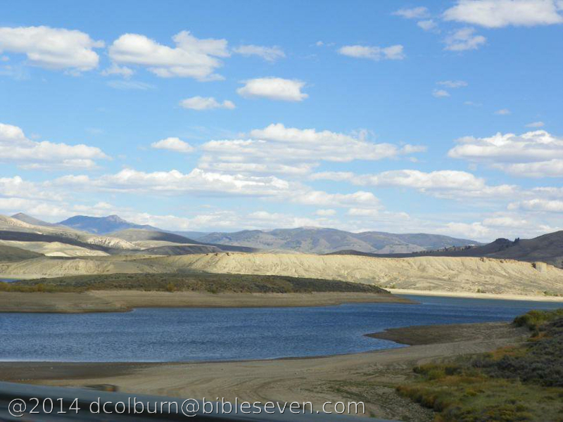

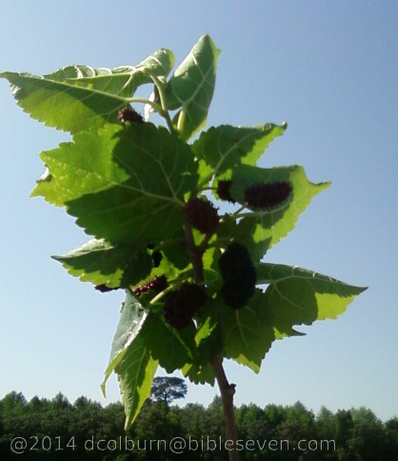

Imagine the great pure-water rivers and the perfect berries and fruits and nuts and seeds of Eden. No invasive weeds, no destructive insects, animals eating what they need without destroying crops. Perfect harmony of all things.
Source: Copyright as watermarks on the images and as in the footnote text.

Faith In Action

Pray
Ask the Spirit to reveal to you a better understanding of what the Lord God intended when He gave you the gifts of spiritual understanding and of a functioning conscience. Also request a greater understanding of one or more ways that He has made special provision for specific needs and where your response has been ungrateful neglect and/or rebellion.

Act
Today I will pray, reflect, and study to apprehend what the Holy Spirit has unveiled to me and I will share what I have learned with a fellow Believer for shared edification and praise. I will confess and repent of my carelessness, disrespect, and rebellion. I will repent (turn away from), request and accept His forgiveness for my sin.
Be Specific ________________________________________________

Thursday (Genesis 2:18-25)
2:19 The Lord God formed out of the ground every living animal of the field and every bird of the air. He brought them to the man to see what he would name them, and whatever the man called each living creature, that was its name.
2:20 So the man named all the animals, the birds of the air, and the living creatures of the field.

2:18 The Lord God said, “It is not good for the man to be alone. I will make a companion for him who corresponds to him.”

20b … but for Adam no companion who corresponded to him was found. 2:21 So the Lord God caused the man to fall into a deep sleep, and while he was asleep, he took part of the man’s side and closed up the place with flesh.
2:22 Then the Lord God made a woman from the part he had taken out of the man, and he brought her to the man. 2:23 Then the man said,
“This one at last is bone of my bones
and flesh of my flesh;
this one will be called ‘woman,’
for she was taken out of man.”
2:24 That is why a man leaves his father and mother and unites with his wife, and they become a new family.
2:25 The man and his wife were both naked, but they were not ashamed.

Prayer
Lord, You Created the creatures then allowed them to be named by Your “in Our likeness” creation (Adam), transferring authority along with responsibility. May I recognize that any authority and responsibility which I have in this world, broken and distorted as it is, is given for the purpose of Your priorities. Since the first human was not designed to self-reproduce You then drew Eve out of Adam just as You had drawn Adam from the soil. You breathed into humankind the unique life-force that made them in-Your-likeness.

Summary and Commentary
The Lord God created the creatures from the soil He had already made, both animal and humankind, yet one recalls that He only “breathed life” into the human.
He then brought each creature to man and allowed that man, rather than Himself, to be the one to name them.
[Note: It is understood, according to ancient traditions, that 'naming' was an expression of mastery or ownership. In the same way, Jesus would later give new names to His apostles (because God rightly claims ownership of man).]
God said He would make a companion for Adam but after drawing all of the different animals from the soil none were like Adam, because he was a unique creation, and because only into Adam had God “breathed life”.
God was teaching the uniqueness of humankind “in His partial image”.
Verse 18 is more naturally-understood together with verses 2:20b-24 than when presented prior to verse 19, that is why it was presented slightly out-of-sequence.
God said He would create for Adam an indispensable helper, a "companion,” one without whom he could not complete his tasks. This companion would not be a subordinate nor one to whom tasks were delegated, rather one who would perform the tasks which the man could not.
In keeping with His former pattern, and maintaining a continuity in Creation, God (Who had created Adam from the previously-created soil) took flesh and bone from Adam's side to create his companion and partner in Eden.
Adam did not continue in the process of naming what he owned when he said, "this one will be called woman," he was merely describing her intimate similarity due to the flesh and bone link caused by her being "taken out of man."
[Note: Only after the Fall, as evidence of one element of the curse ('naming' implies ownership or superiority), was the categorical descriptive word “woman” replaced by the Adam-chosen name “Eve” (see Gen. 3:20).]
“The man and his wife were both naked, but they were not ashamed,” speaks of their integrity-via-innocence; because pre-Fall they had no cause to be ashamed of anything.
They were not ashamed because they were truly innocent, unaware of anything imperfect or of any different state of being. They were free of the knowledge of evil, which would have been the source of their embarrassment when standing naked before one another, or their Lord God.
Adam and Eve were presented with the “test of the tree” by God but not yet been challenged (by Satan) to allow it to become a temptation – and absent that temptation they had not yet fallen into sin.

Interaction

Consider
The Lord God created, and thus had legitimate dominion over, all of the creatures; yet He chose to delegate that to humankind. The text teaches that it was not the original intent of the Lord God that man and woman be unequal and competitive in relationship; such only became the nature of things after the Fall. When we think of Adam and Eve, “humankind” prior to the Fall, we cannot fully comprehend who they were because - other than Jesus - no other human has ever been as innocent of sin (though Jesus was painfully aware of the sin all around Him, as well as the physiological imperfections in His earthly body).

Discuss
When we think of our place in Heaven, may we rightly look at pre-Fall Adam and Eve (and Jesus) as models of the innocence we too will possess – blessedly-absent the capacity to rebel? Is the true measure of a faith-saving relationship with Christ the absolute surrender of our free will to His Lordship?

Reflect
How well do we comprehend what it means for the Lord God to have “mastery” or “ownership” over every truly-saved Believer? (Hint: It is the Lord God's loving-desire that men and women serve Him together in perfect harmony. We have Jesus Christ to thank for providing our way home to a better-than-Eden “New heaven and new earth”.)

Share
When have you experienced the naming a child or a pet? When have you observed children or adults functioning in synchronicity, helping and sharing with one another, all free of apparent competition and conflict? When have you been truly transparent before the Lord God, and/or before a fellow Believer, and the Holy Spirit gave you a special sense of purity and innocence in His forgiveness and grace?

KTALZ
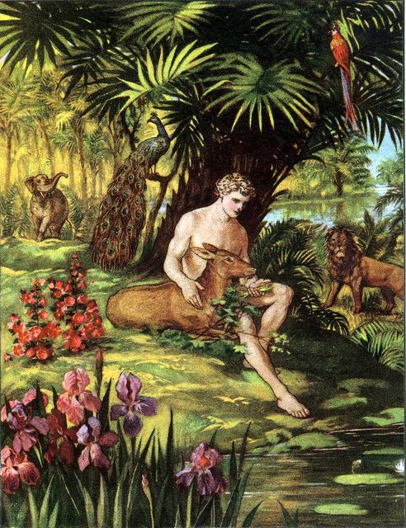

Innocent in paradise … for this we were Created and to this – a New Creation - we will be restored when Jesus returns.
Source: Public domain here http://biblelessonsite.org/images/creation.jpg

Faith In Action

Pray
Ask the Holy Spirit to amplify your understanding of the importance of separating pre-Fall from post-Fall events and why you need to avoid extrapolating modern-day expectations (without regard to the original context) - and to grant you a sense of innocence (through Christ) before the Lord.

Act
Today I will engage a fellow Christian in discussion about the way that God has named and claimed us, as well as our innate longing for our pre-Fall intimate relationship with the Lord God, with His perfect Creation, and with one another. We will give thanks for the promise of Heaven and ask for comfort and patience as we live in this Fallen-away world. Today I will join with a fellow Believer in a prayerfully-reflective celebration of God's promise of eternity in Heaven.
Be Specific _____________________________________________

Friday (Genesis 3:1-13)
The Temptation and the Fall

3:1 Now the serpent was more shrewd than any of the wild animals that the Lord God had made.
He said to the woman, “Is it really true that God said, ‘You must not eat from any tree of the orchard’?”
3:2 The woman said to the serpent, “We may eat of the fruit from the trees of the orchard;
3:3 but concerning the fruit of the tree that is in the middle of the orchard God said, ‘You must not eat from it, and you must not touch it, or else you will die.’” 3:4 The serpent said to the woman, “Surely you will not die,
3:5 for God knows that when you eat from it your eyes will open and
you will be like divine beings who know good and evil.”

3:6 When the woman saw that the tree produced fruit that was good for food, was attractive to the eye,
and was desirable for making one wise,
she took some of its fruit and ate it.
She also gave some of it to her husband who was with her, and he ate it.
3:7 Then the eyes of both of them opened, and they knew they were naked;
so they sewed fig leaves together and made coverings for themselves.

3:8 Then the man and his wife heard the sound of the Lord God moving about in the orchard at the breezy time of the day,
and they hid from the Lord God among the trees of the orchard.
3:9 But the Lord God called to the man and said to him, “Where are you?”
3:10 The man replied, “I heard you moving about in the orchard, and I was afraid because I was naked, so I hid.”
3:11 And the Lord God said, “Who told you that you were naked?
Did you eat from the tree that I commanded you not to eat from?”
3:12 The man said, “The woman whom you gave me,
she gave me some fruit from the tree and I ate it.”
3:13 So the Lord God said to the woman, “What is this you have done?”
And the woman replied, “The serpent tricked me, and I ate.”

Prayer
Lord, as I read this terrible moment in history, second only to the crucifixion of Christ, I am convicted that I am just as ready to allow a test to become a temptation as were Adam and Eve. May I surrender more to the leadership of Your Holy Spirit so that my every choice is tested for Your will and not my own. We are all the same as Eve, looking for what appeals to our flesh rather than the best in us – that which the Holy Spirit empowers and nurtures. May my faith be in the perfection that I see in You, and may I desire that above all. I am shocked to read the dialogue between You and Adam and Eve, because I am certain that You've had that same dialogue with me. May I be convicted and reminded that I am responsible to You for every choice that I make.

Summary and Commentary
Chapters One and Two presented the Creation narrative. Chapter 3:1-13 describes the horribly wrong choice of Adam and Eve.
Based on the prior text of Genesis, where the difference between the fundamental nature of humans versus other creatures was described, we know that the serpent - like Balaam's donkey (Numbers 22:22-35) - was a sentient being (able to respond only based upon awareness of and memory of patterns of pain and pleasure).
The serpent was, however, like Balaam's donkey - non-sapient (lacking the ability to either reflect or make decisions based on acquired wisdom and also lacking the unique human capacity to interact intentionally in the spiritual realm).
The serpent was a demon-possessed mouthpiece for a spiritual source — in this case Satan. (There is the case of the swine in Mathew 8:30-32 and Mark 5:11-13 when demons were sent into pigs by Jesus, but in that case they were merely neutral agents - non-communicating physical 'containers' for those demons.)
Speculation that animals in pre–Fall Eden were capable of verbal communication with humans, and with one another, is based on suspect extra-Biblical sources (not part of the “canon” of the Bible.
[Note: Non-canonical books are not believed to be approved by the Lord God for inclusion, such as Jubilee 3:28 and Josephus Antiquities 1.1.4 – 1.41) and are thus not to be given credibility in the absence of any supporting canonical Biblical text.]
There is also no value-added, and considerable distraction spawned, by such speculation. The text following (see Gen. 3:14) parallels the serpent with the other “wild animals” and notes that this one was different is a special way.
The evil tempting spirit speaking through the serpent challenged the integrity of the relationship between Eve and the Lord God. This included a challenge to the very Lordship of God by deliberately using the name "God" not preceded by the title “Lord,”. Eve made a choice to do the same – converting the 'test' of her faithfulness into a 'temptation' to overtly rebel and sin.
When Satan, through the serpent, asked, “is it really true...?” he was attacking the integrity of the Lord God and His sovereign authority. This was a direct challenge to Eve to wonder if the Lord God was truthful. This was an amazingly bold act of Satan, and frighteningly-evil in intent.
In reply to the serpent's challenge, Eve restated the Lord God's warning about eating from "the tree that is in the middle of the orchard” (by implication, the tree of the knowledge of good and evil); however, she altered both Satan's words and the actual command of the Lord God. Eve added the flourish “you must not touch it,” which neither the Lord God or Satan had said.
Satan then issued the full-out challenge to the Lord God's integrity and authority, “Surely you will not die, for God knows that when you eat from it your eyes will open and you will be like divine beings who know good and evil.”
“Divine beings” refers to the Lord God, Satan, and the angels, both the faithful and the fallen.
The command from the Lord God “You must not eat from it”, qualified by “or you will surely die” was not lost on Adam and Eve. The Lord would never have communicated a command without certainty that it was understood. They would likely have understood “die” as something associated with their relationship with Him (and also with the things that they had eaten).
They became what it was that they thought wanted to escape (in terms of accountability and Lordship) when they chose to fail the test, to entertain temptation, and then sin – drowning in accountability and lost to anything close to “divine”.
Humankind (Adam and Eve) were already capable of spiritual interaction, but had to-date no need to be cognizant of “evil”, other than to know that the fruit of one tree contained the power to draw them into that knowledge.
When Eve entertained Satan's challenge to the integrity and Lordship of God, apparently without any effort to consult the Lord nor fear of negative consequences, she voluntarily crossed the threshold from 'test' to 'temptation' – because she turned her eyes-of-faith from Him to herself.
The key to understanding this text, especially as it applies to the rest of the Bible, is choice. Eve (then Adam) had a choice to make, and that was the purpose of 'the test of the tree'.
Eve (then Adam) did not have to believe the Serpent, they easily could have consulted the Lord God, and they easily could have corrected his error in deleting “Lord” from “Lord God”. They chose to not do so because they chose their flesh over their Father.
Eve failed the test when she conspired with the serpent to ignore the Lordship of God. She relied only on her fleshy senses, she observed that the fruit of the forbidden tree appealed to her eye and stomach, and she was tempted to believe that it could magically give her the God-making “wisdom” that the serpent promised. Eve acted upon that temptation and decided to reach out and eat of it.
Adam, whose whereabouts were previously unknown in the story, was described as “with her,” (at the time of her viewing and tasting the “fruit”) and when given the fruit he also choose to eat of it.
[Note: The “with her” likely refers to his physical proximity, though it may also report that he was “with her” in her rebellion. The text does not require “with her” to mean either that he was there all along, or that he had been elsewhere, but that at this moment in the story Adam was “with her” both physically and in rebellion. It is notable that Eve spoke of the “tree” as if it were not immediately present where she and the serpent were speaking. It is uncertain if any of the alternative readings matter much to the story; though if one takes Adam to have been physically present throughout the test, temptation, and fall of Eve, one must ponder why he failed to intervene and why he was not also addressed in the story. In general, the best translation defaults to the most-simple solution, unless the text under consideration (or other Biblical texts) support a more complex result. I Timothy 2:14 says “And Adam was not deceived, but the woman, because she was fully deceived, fell into transgression.” It simply makes no sense that Adam was present with the serpent yet was not equally “deceived” - the most the text provides is that Adam knowingly accepted the forbidden fruit from Eve without questioning it. (One might reasonably postulate that Eve, having been “deceived”, then eating of the fruit was suddenly equipped with the evil capacity to deceive Adam, who was still “innocent”.)]
Once "fallen," they were immediately aware of their newly imperfect state (and that their fellowship with a holy and pure Lord God has been instantly broken), and they rushed to cover themselves.
The Lord God moved about in the Garden in the late afternoon, “the breezy time of the day.”
[Note: Wishful thinking, and inadequate attention to detail in some translations, have rendered the idea that God was coming for His daily friendly stroll together with Adam and Eve in the Garden — but a right-rendering of the Biblical text does not appear to support such a conjecture. More probable is that, after their misdeeds together with the serpent, the Lord God arrived to challenge them and was intentionally thrashing about the Garden as if seeking His missing children – of course knowing precisely where they were. He was righteously angry.]
The Lord God called to Adam, “Where are you?” not because He could not find Adam, but to challenge Adam to recognize where he had caused himself to be – which was apart from Him. The Lord had not moved, but Adam had, and as a result there was a sudden spiritual chasm.
Adam replied, “I heard you moving about,” so the sound created by God in the Garden was not sensed by Adam as friendly. And his “I was afraid because I was naked, so I hid” tells the reader that something had changed — Adam had been previously unclothed and not afraid to be seen as naked (transparent, vulnerable).
The Lord God challenged Adam to explain how he now knew that he was naked — previously unimportant, but now suddenly important — and challenged Adam with the only plausible explanation, his rebellion.
Adam's effort to play innocent and to thrust the blame on Eve (if one accepts the reading that Adam was not present during the serpent's initial temptation “deception” of Eve and her decision to sin) one may argue that Adam was engaging in a form of idol worship ― "God gave me Eve , so I trusted her, and she said it was OK." It's an effort to defraud or even to blame the Lord, of course; however, at this point, Adam loses either way.
The Lord God then turned to Eve, which appears to grant partial credibility to Adam's blame-shifting, and challenged her to defend her actions (adding credence to the view that Adam was not present during her testing, her choice to engage in temptation, and her decision to be “deceived” - then to sin).
Eve completed the 'passing of the buck' by declaring “the serpent tricked me, and I ate” in an attempt to absolve herself of responsibility for her choice. While rightly pointing out that she had been deceived, she did not trouble herself to explain why she had knowingly ignored a direct order from her Lord God.

Interaction

Consider
We have the same choice(s) as Eve, every minute of every day. Believers must never allow an implied doubt to stand as to the character and integrity and promises of the Lord God. Satan tried the same attack on Jesus that he used on Eve, and he is still using the same old lie on people today. Do we understand that when we choose temptation rather than holiness - when confronted with a test, that we enter into a conspiracy with Satan to disrespect the Lord God? How we often have we blamed others for our own choices, perhaps we've even blamed the Lord God?

Discuss
How would you help people to understand that if we go where the Lord God says not to go, do what God says not to do, and dwell upon the things God tells us to avoid, that we too disrespect the Lordship of God and side with Satan? How would you explain the importance of understanding that our lusts and our physical senses are the playground of Satan – who manipulates us through misunderstandings and misplaced priorities? How would you lead a small group through an evaluation of the many ways that they have tried to hide from accountability?

Reflect
Every choice carries consequences, some good, some bad. We rationalize that consequences will be absent or acceptable to us if we choose disobedience. If we are saved we build walls that block the blessings of the Lord God. It is bad enough to agree to convert a test in to a temptation, and then in to overt sin; however, to then multiply our sin by drawing others who trust us into the same sin is even worse. (See the curse of the Fall in the following sections.) Nothing about choices has changed since this moment – the enemy wants us to believe the lie that we can do life without God as our Lord, and the Lord wants us to choose Him as Lord of everything in our lives.

Share
When was there a time that you doubted the Lord God? What were the consequences? What is a circumstance in your life where you clearly knew that what you were doing was wrong yet you rationalized that it served a momentary desire? What were the consequences? What is a circumstance when something you did caused you to have a 'guilty conscience' such that when an authority figure approached you felt nervous or startled?

KTALZ
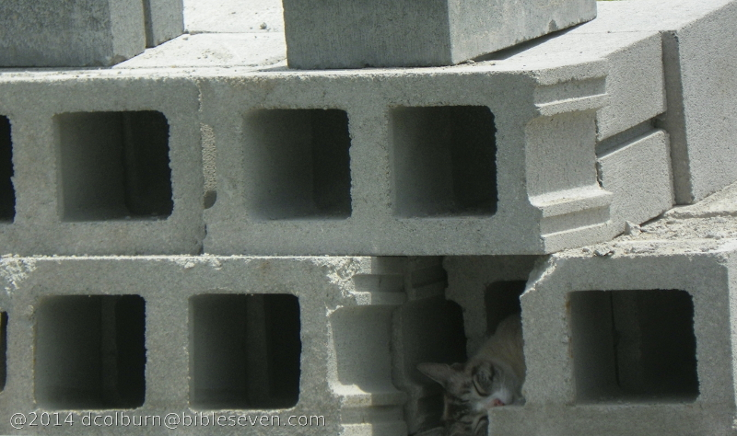

Just as the gray cat only thinks she cannot be spotted in the gray blocks, imagine Adam and Eve thinking that they could hide from God … we do it too.
Source: Image copyright as in watermark and in footnote of this study.

Faith In Action

Pray
Ask the Holy Spirit to reveal to you a lie in your life that causes you to rationalize
disobedience to God, and one place in your life where you have allowed the satisfaction of your physical senses to overwhelm your obligation to honor the Lord your God. Perhaps it is eating or drinking too much, going where I may view people in a way that is appealing to my fallen-flesh but offensive to God (e.g., driving by the beach to view partially-clothed people, surfing inappropriate sites on the Internet, watching television where people are demeaned, listening to music or watching movies that distort a holy view of man, abusing substances, avoiding activities that promote fitness of my body “the temple of the Holy Spirit,” or participating in thrill-seeking activities that “test the Lord my God”), and a place in your life where you find yourself deflecting blame to another or engaging in a pattern of avoiding accountability.

Act
Today I will make a change in my thinking, and in my actions, and rather than partner with the Enemy I will partner with the Holy Spirit as He makes this a real rather than merely an intellectual life-changing choice. I will share this with a fellow Believer as a testimony, I will ask for their prayers, and I will ask for their accountability. I will move to diminish the thing that the Holy Spirit has revealed as offensive to the Lord and destructive to me. The goal is to eradicate them from my life; perhaps immediately, perhaps after some perseverance, but eventually permanently through the power of prayer and peer-accountability. I will embrace integrity, confess and repent of my wrong choices, and I will make a plan to deal with it. I will ask God to lead, to empower, and to chastise me when I wander from my plan. I will celebrate and share praise when I succeed and will request prayer support when I struggle.
Be Specific _____________________________________________

Saturday (Genesis 3:14-24)
The Judgment Oracles of God at the Fall
3:14 The Lord God said to the serpent,
“Because you have done this,
cursed are you above all the wild beasts
and all the living creatures of the field!
On your belly you will crawl
and dust you will eat all the days of your life.
3:15 And I will put hostility between you and the woman
and between your offspring and her offspring;
her offspring will attack your head,
and you will attack her offspring’s heel.”

3:16 To the woman he said,
“I will greatly increase your labor pains;
with pain you will give birth to children.
You will want to control your husband,
but he will dominate you.”
3:17 But to Adam he said,
“Because you obeyed your wife
and ate from the tree about which I commanded you,
‘You must not eat from it,’
cursed is the ground thanks to you;
in painful toil you will eat of it all the days of your life.
3:18 It will produce thorns and thistles for you,
but you will eat the grain of the field.
3:19 By the sweat of your brow you will eat food
until you return to the ground,
for out of it you were taken;
for you are dust, and to dust you will return.”
3:20 The man named his wife Eve,
because she was the mother of all the living.
3:21 The Lord God made garments from skin for Adam and his wife,
and clothed them.
3:22 And the Lord God said, “Now that the man has become like one of us, knowing good and evil,
he must not be allowed to stretch out his hand and take also from the tree of life and eat, and live forever.”
3:23 So the Lord God expelled him from the orchard in Eden to cultivate the ground from which he had been taken.
3:24 When he drove the man out,
he placed on the eastern side of the orchard in Eden
angelic sentries who used the flame of a whirling sword to guard the way to the tree of life.

Prayer
Lord, the temporary alliance between the serpent and Eve is the same as the evil- one still seeks with us, one where he tries to lead us to displace You in favor of our flesh. May I remember when I am tested that the choices are always the same, I choose You or the Enemy. May I mature in my faith daily so that I increasingly choose You in all things. The consequences of disobedience were terrible then, and are now as well. May I be mindful that when I wander from Your Lordship I also wander from Your protection and wisdom. Even though You had to be profoundly-troubled and righteously-offended Your grace triumphed and Your loving-care was displayed. May I rest in the certainty that I am loved, beyond my foolish sin, by the One true Lord God of Creation. Humankind made a terribly-wrong choice and You graciously blocked their path (to the Tree of Eternal Life) to protect them from unrecoverable harm. May I trust You so that when it becomes obvious that you have blocked a path or have closed a door I will not rebel. Purity, in Your eyes, means peace with You. May I seek after the purity that You desire for me so that I may be at peace with Your and find my peace in You.

Summary and Commentary
According to the NET Greek/Hebrew dictionary the qualifying term “tricked” that Eve used of “The serpent” indicates an authoritative, perhaps king-like, relationship to Eve in which she felt unequal. Given her life-experience, versus that of the Enemy, she may have felt at a disadvantage - but that didn't excuse her failure to consult the Lord God first.
God immediately addressed the serpent ― asking no questions, hearing no lies, speaking only truth ― declaring that the serpent had indeed deceived Eve, that Eve had joined him in rebellion, and that she had then solicited Adam to join them in rebellion.
The “serpent” was a symbolic vehicle for Satan, who had indwelt the creature, much like Balaam's donkey was a 'vehicle' later in the Biblical text.
God declared the curse upon the serpent: “Because you have done this, cursed are you above all the wild beasts and all the living creatures of the field!” So all of the wild beasts and living creatures of the field were now cursed, but even more so the serpent, who was estranged and isolated from them and condemned "on your belly you will crawl" humiliated to wallow in the dust rather than merely walk upon it.
[Note: The literal created animal, the “serpent”, may have had legs or perhaps traveled only in the trees, but in either case crawling on the ground – now made even less-pleasant due to the Fall – would have been a significant change.]
The serpent's choice and consequence is later echoed in Cain, the child of Adam and Eve who chose to rebel against bringing a proper sacrifice – he also was isolated and cursed.
The animals lived in harmony with one another and man, but now cursed they (all of the animals, humankind, and the serpent alike) would have to struggle, strive, suffer, and die. Adam's mastery/ownership of the animals doomed them to his fate.
The alliance of the serpent with Eve was more than terminated, it became adversarial, her descendants versus his ― “her offspring will attack your head, and you will attack her offspring's heel.” Both are potentially fatal attacks; the bite to the heel being toxic (sin), the blow to the head being destructive (righteous judgment).
Despite their devastating rebellion the Lord God still allowed Adam and Eve to experience the awe of “creation” through their bodies.
The Lord God addressed the consequences of the choices made by the woman, declaring that reproduction would become an uncomfortable process; knowing that her children and her children's-children would come into a fallen world and that the Fall was largely her fault. She would also experience physical pain as a result of her pre-Fall imperfect choices - though her existential pain would prove the most-troubling.
As the first human agent in the promotion of sin, Eve enticed Adam to join her in rebellion; consequently, as part of the curse, she would continue in her efforts to control him, but the Lord God said that Adam would have the upper hand – a dominant role. The Lord defined the nature of the male-female relationship post-Fall as a constant ebb and flow of females using manipulation to gain control and males using power to dominate.
Humankind and fallen-angel/serpent cooperated in rebellion via the unauthorized use of a particular fruit tree, thus Adam was cursed to sweat for his food, the ground would produce thorns where it previously produced only beautiful vegetation, and the serpent would crawl in the dust.
The Lord God addressed the hapless Adam, reminding him that because he had chosen Eve over His Lord, when he joined her in rebellion, he became the agent of the curse of the “ground.”
[Note: Gen. 1:9-10 defines "ground" as everything not covered with water, but that – per the NET translator's notes - is not the intent here. This curse of the "ground" means that every effort to reap the formerly easy bounty of food would henceforth require intense effort and sacrifice.]
The Lord commanded that humankind would now suffer in the process of acquiring food to eat because it was in eating-rebelliously that humans caused the Fall.
[Note: Food became an important part of the sacrificial system, carrying-forward the message.]
The first man and woman pridefully accepted the temptation of Satan. They, like him, attempted to become peers with the Lord God in immortality, knowledge, and power, but they were instead doomed to live frustrated, limited, and difficult lives.
[Note: The NET translator's notes include the following powerful observation: “In general, the themes of the curse oracles are important in the NT teaching that Jesus became the cursed one hanging on the tree. In his suffering and death, all of the motifs are drawn together: the tree, the sweat, the thorns, and the dust of death (see Ps. 22:15). Jesus experienced it all, to have victory over it through the resurrection.”]
Adam, post-Fall, was empowered by the Lord God to dominate the relationship, and it was only then that he 'named' Eve.
[Note: Previously we observed that Adam named the animals but not his God-given "helper"; rather, he gave the title “woman” to her, illustrating her status as his equal partner in caring for Creation. The Fall changed everything and the "woman" became "Eve." The name Eve was drawn from her role as the “life-giver,” the one who bears children, and the one from whom all future children would descend.]
Despite His righteous anger the Lord God still provided for His children, giving them garments made of animal skins. By so doing God both recognized that the mere leafy coverings Adam and Eve had fashioned would not be adequate in the fallen world and that disharmony now reigned – man would draw his needs from the beasts - and the rest of Creation - at a cost to his fellow creatures in Creation.
[Note: Covering Adam and Eve through the sacrifice of the animals for their skins was the first time God provided for a proxy animal sacrifice-based covering for sin – Jesus would later become the ultimate proxy-sacrifice – but between this text and that God would give humankind many chances to 'do it their way'.]
The essence of the consequences of Adam and Eve's failure of 'the test of the tree' was that humankind had 'illegally' acquired an unplanned and unhealthy (because they were not equipped to handle it) attribute of the Lord God - not originally given to them.
The knowledge of good and evil was a major new paradigm, for which they were unprepared, and for which said acquisition required a major act of rebellion.
Humankind now had to be protected from the worst of the consequences - eating from the tree of life – for that would have condemned them to be forever and irredeemably trapped in an alliance with Satan and at-enmity with the Lord.
The Lord God removed humankind from Eden, before that could happen, as free will was still active after the Fall; therefore, a physical relocation was necessary.
So serious was the threat, so powerful the temptation (and perhaps now so undeserving of Eden was humankind), that the Lord God posted Heavenly sentries with whirling swords of flame to keep them and their descendants from ever returning to the Garden (and “the Tree of Eternal Life”) in their unredeemed condition.
Only Jesus the Christ could create the circumstances where humankind could regain access to the gift of eternal life – without the curse.

Interaction

Consider
Everything changed in all of Creation as a result of the events recorded in Genesis Chapter 3. Not only were Adam and Eve and the serpent/Satan cursed, but all of Creation. Because the Lord God had already given Creation over to “man”, when man turned from the Lordship of God to the Lordship of Satan, so also went the way of Creation. We must not expect to be comfortable in this life; the Lord God said it would not be so. Modern research in DNA has suggested that all races of man may be traced back to a single female source, from the region known as northeast Africa — the regional locators match the geographical markers for Eden given in Genesis 2:10-14.

Discuss
Are the similarities of the Fall similar enough to the popular story of Robin Hood to be used as a lesson-illustration? (In the story when King Richard left for the Crusades his less-ethical brother John assumed power and was entrusted with the care of Nottingham and Sherwood Forest, and he turned a beautiful place to one of conflict and evil.) How might we best use every blessing of God to equip ourselves to resist the fleshy temptations to both contest with one another and to place fleshy things before the priorities of the Lord? How would you use these texts to help people to understand that the nature of this fallen world is one of conflict, difficulty, and hopelessness and that genuine hope is found only in the Lord? How would you help others to understand that when man 'stole' an attribute of the Lord God – one expressly forbidden to them - it was then that the trouble (estrangement and striving) began?

Reflect
The consequences of Satan dragging man into the spiritual warfare between himself and the Lord God, when he successfully recruited Adam and Even into a state of rebellion, have been terrible. Are we not combatants in that battle whether we want to be or not? (Jesus took Satan's final deadly attack for us so that He could set us free.) Are we appropriately amazed to see the connections across the entirety of the Word of God, from Genesis through Revelation, and how the themes and truths of God reign supreme? The Lord God so loved Adam and Eve, and their descendants, that He provided for their physical needs and their pathway to salvation from the consequences of their rebellion. We sometimes rebel the same as Adam and Eve: 1) exercising pride that causes us to brush aside the counsel of the Holy Spirit, 2) functionally-worshiping 'idols' such as fame, money, pleasure, power, or 3) neglecting those things that the Lord God says must be the priorities of our lives as Believers.

Share
What is your understanding of the teaching that we have the authority to “crush the head” of Satan (however he presents himself)? How may we exercise caution that Satan is not successful in his attack upon our “heel,” our very vulnerable areas in day-to-day life choices? When have you hear a teaching that explained the fact that man is treated in a fundamentally different way than the rest of Creation — all Creation is subservient to man as he navigates his way through life and back towards a right relationship with the Lord God? What are some ways that you have found yourself, or those around you, striving for perfection to gain access to/recreate an "Eden" by pressing against “gates” that are guarded with flaming swords (knowing that the “new Eden” is accessible only via Jesus and only at the end of created-time?

KTALZ


How often have we struggled against weeds to grow something, in our gardens, our hearts, our families, and our communities?

Faith In Action

Pray
Ask the Holy Spirit to reveal to you at least one circumstance in your life, past or present, which still impacts you – a circumstance over which you have little or no control — and to show me how you can give it to Him “at the foot of the Cross” and never allow Satan to use it to define me again, a place where the temptations of the flesh are repeatedly used by Satan to drag you down from the holy lifestyle-place that the Lord God has prepared for you — be it gluttony, lust, pride, self-loathing, toys, or anything else that gets in the way, something specific about you that will remind you of the wonderful creative hand of God, and/or a specific way that you attempt to return to Eden via an effort to artificially re-create a place of perfection and/or of extreme safety.

Act
Today I will stop and thank Jesus for standing in the gap for me. I will also acknowledge that there are some things confusing and distracting me – some, perhaps, that I have done (or that were done to me), some imperfection(s), or some difficult person — the key is my knowing (and understanding) that such things are proof that this is a fallen world. I will refuse to be abused by the Prince of Darkness and I will choose to stand with the Jesus, Prince of Light. I will confess and repent, request and accept the forgiveness of the Lord God, and then I will develop and implement an accountability plan to resist that temptation. I will ask a fellow believer to pray in-agreement and to be my accountability partner.
Be Specific _________________________________________________

All Bible text is from the NET unless otherwise indicated - http://bible.org
Note 1: These Studies often rely upon the guidance of the NET Translators from their associated notes. Careful attention has been given to cite that source where it has been quoted directly or closely paraphrased. Feedback is encouraged where credit has not been sufficiently assigned.
Note 2: When NET text is quoted in commentary and discussion all pronouns referring to God are capitalized, though they are lower-case in the original NET text.
Commentary text is from David M. Colburn, D.Min. unless otherwise noted.
Copyright © 2012, 2013, 2014, 2015 by David M. Colburn. This is a BibleSeven Study –“Genesis 1-3. Prepared by David M. Colburn and originally edited for bible.org. This text may be used for non-profit educational purposes only, with credit; all other usage requires prior written consent of the author.

