Esther 1 - 10
(Trust, protection, blessing)
David M. Colburn
A Chronological Daily Bible Study of the Old Testament
7-Day Sections with a Summary-Commentary, Discussion Questions,
and a Practical Daily Application
Week 50

Sunday (Esther 1)
1:1 The King Throws a Lavish Party
The following events happened in the days of Ahasuerus. (I am referring to that Ahasuerus who used to rule over a hundred and twenty-seven provinces extending all the way from India to Ethiopia.) 1:2 In those days, as King Ahasuerus sat on his royal throne in Susa the citadel, 1:3 in the third year of his reign he provided a banquet for all his officials and his servants. The army of Persia and Media was present, as well as the nobles and the officials of the provinces.
1:4 He displayed the riches of his royal glory and the splendor of his majestic greatness for a lengthy period of time – a hundred and eighty days, to be exact! 1:5 When those days were completed, the king then provided a seven-day banquet for all the people who were present in Susa the citadel, for those of highest standing to the most lowly. It was held in the court located in the garden of the royal palace. 1:6 The furnishings included linen and purple curtains hung by cords of the finest linen and purple wool on silver rings, alabaster columns, gold and silver couches displayed on a floor made of valuable stones of alabaster, mother-of-pearl, and mineral stone. 1:7 Drinks were served in golden containers, all of which differed from one another. Royal wine was available in abundance at the king’s expense. 1:8 There were no restrictions on the drinking, for the king had instructed all of his supervisors that they should do as everyone so desired. 1:9 Queen Vashti also gave a banquet for the women in King Ahasuerus’ royal palace.
Queen Vashti is Removed from Her Royal Position
1:10 On the seventh day, as King Ahasuerus was feeling the effects of the wine, he ordered Mehuman, Biztha, Harbona, Bigtha, Abagtha, Zethar, and Carcas, the seven eunuchs who attended him, 1:11 to bring Queen Vashti into the king’s presence wearing her royal high turban. He wanted to show the people and the officials her beauty, for she was very attractive. 1:12 But Queen Vashti refused to come at the king’s bidding conveyed through the eunuchs. Then the king became extremely angry, and his rage consumed him.
1:13 The king then inquired of the wise men who were discerners of the times – for it was the royal custom to confer with all those who were proficient in laws and legalities. 1:14 Those who were closest to him were Carshena, Shethar, Admatha, Tarshish, Meres, Marsena, and Memucan. These men were the seven officials of Persia and Media who saw the king on a regular basis and had the most prominent offices in the kingdom. 1:15 The king asked, “By law, what should be done to Queen Vashti in light of the fact that she has not obeyed the instructions of King Ahasuerus conveyed through the eunuchs?”
1:16 Memucan then replied to the king and the officials, “The wrong of Queen Vashti is not against the king alone, but against all the officials and all the people who are throughout all the provinces of King Ahasuerus. 1:17 For the matter concerning the queen will spread to all the women, leading them to treat their husbands with contempt, saying, ‘When King Ahasuerus gave orders to bring Queen Vashti into his presence, she would not come.’ 1:18 And this very day the noble ladies of Persia and Media who have heard the matter concerning the queen will respond in the same way to all the royal officials, and there will be more than enough contempt and anger! 1:19 If the king is so inclined, let a royal edict go forth from him, and let it be written in the laws of Persia and Media that cannot be repealed, that Vashti may not come into the presence of King Ahasuerus, and let the king convey her royalty to another who is more deserving than she. 1:20 And let the king’s decision which he will enact be disseminated throughout all his kingdom, vast though it is. Then all the women will give honor to their husbands, from the most prominent to the lowly.”
1:21 The matter seemed appropriate to the king and the officials. So the king acted on the advice of Memucan. 1:22 He sent letters throughout all the royal provinces, to each province according to its own script and to each people according to its own language, that every man should be ruling his family and should be speaking the language of his own people.

Prayer
Lord, when a government of men has as its highest authority the opinions of mere men, it is doomed to foolishness and failure. May I always remember that the King of kings and Lord of lords is You – and that as a Biblical Christian my ultimate authority is You.

Scripture In Perspective
At the height of the worldly-glory of the Medo-Persian empire, then king Ahasuerus, offered a reception for special guests, army officials, and others that lasted a hundred and eighty days. During this time he flaunted his great wealth and possessions. The Queen, Vashti, also hosted a party for the women.
Then for seven days the king, and separately the queen, indulged their guests in a banquet. By the seventh-day the king was drunk and ordered his servants to find the queen and require her to appear before his guests wearing her high-turban; she was to be displayed as yet another of his possessions. She refused his order.
Furious, the king consulted his seven advisers as to what should be done about Vashti, and one recommended that he issue an edict that Vashti be removed as queen and replaced, and to further add that every woman must obey her husband – no matter what.
Once enacted, according to tradition, such an edict applied from the king on down and could not be waived - even by the king.

Interact with the text

Consider
The king may well have been rendered less-than-wise by alcohol-poisoning.

Discuss
Might Vashti have been aware that the king was drunk, and that he'd regret trying to humiliate her, so she did not expect him to react in such an extreme way?

Reflect
The king's advisers seem to have been manipulating the situation to impose draconian obligations upon every wife in the kingdom – to blindly obey any order, any whim, no matter how drunk or otherwise impaired their husband might be. (These ancient advisers are not alone in their extreme attitude toward married women.)

Share
When have you made a bad decision, or been the victim of one, as the result of the impaired condition of someone with greater authority? Was that person manipulated into an out-of-character and/or an out-of-proportion action by others?

KTALZ
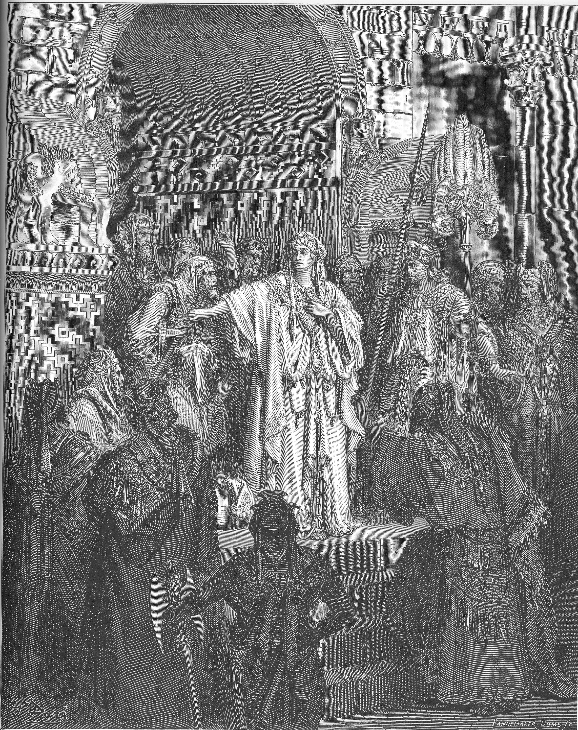

The king foolishly allowed himself to get drunk then was manipulated by evil advisers who resented the independence of Queen Vashti.
Source: Public domain here http://commons.wikimedia.org/wiki/file:114.queen_vashti_refuses_to_obey_ahasuerus%27_command.jpg

Faith In Action

Pray
Ask the Holy Spirit to reveal to you something in your life where you hold to an extreme standard, not supported by Biblical teaching, and/or an out-of-proportion reaction to circumstances.

Act
Today I will humbly acknowledge the truth of what the Holy Spirit has revealed. I will confess, repent, and accept His forgiveness. I will request the prayers and accountability of a spiritually-mature fellow Believer as I restore balance in my life. It may be rigidity in business, family, social, or religious matters, an intentional lack of boundaries in reaction to the rigidity of others, or some other imbalance.
Be Specific ________________________________________________

Monday (Esther 2)
Esther Becomes Queen in Vashti’s Place
2:1 When these things had been accomplished and the rage of King Ahasuerus had diminished, he remembered Vashti and what she had done and what had been decided against her. 2:2 The king’s servants who attended him said, “Let a search be conducted in the king’s behalf for attractive young women. 2:3 And let the king appoint officers throughout all the provinces of his kingdom to gather all the attractive young women to Susa the citadel, to the harem under the authority of Hegai, the king’s eunuch who oversees the women, and let him provide whatever cosmetics they desire. 2:4 Let the young woman whom the king finds most attractive become queen in place of Vashti.” This seemed like a good idea to the king, so he acted accordingly.
2:5 Now there happened to be a Jewish man in Susa the citadel whose name was Mordecai. He was the son of Jair, the son of Shimei, the son of Kish, a Benjaminite, 2:6 who had been taken into exile from Jerusalem with the captives who had been carried into exile with Jeconiah king of Judah, whom Nebuchadnezzar king of Babylon had taken into exile. 2:7 Now he was acting as the guardian of Hadassah (that is, Esther), the daughter of his uncle, for neither her father nor her mother was alive. This young woman was very attractive and had a beautiful figure. When her father and mother died, Mordecai had raised her as if she were his own daughter.
2:8 It so happened that when the king’s edict and his law became known many young women were taken to Susa the citadel to be placed under the authority of Hegai. Esther also was taken to the royal palace to be under the authority of Hegai, who was overseeing the women. 2:9 This young woman pleased him, and she found favor with him. He quickly provided her with her cosmetics and her rations; he also provided her with the seven specially chosen young women who were from the palace. He then transferred her and her young women to the best quarters in the harem.
2:10 Now Esther had not disclosed her people or her lineage, for Mordecai had instructed her not to do so. 2:11 And day after day Mordecai used to walk back and forth in front of the court of the harem in order to learn how Esther was doing and what might happen to her.
2:12 At the end of the twelve months that were required for the women, when the turn of each young woman arrived to go to King Ahasuerus – for in this way they had to fulfill their time of cosmetic treatment: six months with oil of myrrh, and six months with perfume and various ointments used by women – 2:13 the woman would go to the king in the following way: Whatever she asked for would be provided for her to take with her from the harem to the royal palace. 2:14 In the evening she went, and in the morning she returned to a separate part of the harem, to the authority of Shaashgaz the king’s eunuch who was overseeing the concubines. She would not go back to the king unless the king was pleased with her and she was requested by name.
2:15 When it became the turn of Esther daughter of Abihail the uncle of Mordecai (who had raised her as if she were his own daughter) to go to the king, she did not request anything except what Hegai the king’s eunuch, who was overseer of the women, had recommended. Yet Esther met with the approval of all who saw her. 2:16 Then Esther was taken to King Ahasuerus at his royal residence in the tenth month (that is, the month of Tebeth) in the seventh year of his reign. 2:17 And the king loved Esther more than all the other women, and she met with his loving approval more than all the other young women. So he placed the royal high turban on her head and appointed her queen in place of Vashti. 2:18 Then the king prepared a large banquet for all his officials and his servants – it was actually Esther’s banquet. He also set aside a holiday for the provinces, and he provided for offerings at the king’s expense.
Mordecai Learns of a Plot against the King
2:19 Now when the young women were being gathered again, Mordecai was sitting at the king’s gate. 2:20 Esther was still not divulging her lineage or her people, just as Mordecai had instructed her. Esther continued to do whatever Mordecai said, just as she had done when he was raising her.
2:21 In those days while Mordecai was sitting at the king’s gate, Bigthan and Teresh, two of the king’s eunuchs who protected the entrance, became angry and plotted to assassinate King Ahasuerus. 2:22 When Mordecai learned of the conspiracy, he informed Queen Esther, and Esther told the king in Mordecai’s behalf. 2:23 The king then had the matter investigated and, finding it to be so, had the two conspirators hanged on a gallows. It was then recorded in the daily chronicles in the king’s presence.

Prayer
Lord, even in the midst of the inherent-ugliness of a pagan kingdom, You are at work. May I be always mindful and watchful for Your mighty hand despite the foolish machinations of mere humans.

Scripture In Perspective
When the king had recovered from his drunken and egotistical rage he remembered his extreme action versus Vashti and his advisers quickly suggested a means to acquire a new queen.
The advisers recommended a search of the kingdom for the most attractive young women, a process of vetting, then his selection – he agreed and Esther was among the candidates.
[Note: This does not appear to be a volunteer candidacy but rather these young women were pressed into service much like a man into the army.]
Esther's natural beauty, personal humility, and quick learning from the harem-eunuch resulted in the king's selection of her as his new queen. Esther had not disclosed her Jewish nationality as her adoptive uncle Mordecai had adviser her not to do so.
Mordecai overheard the scheming of two of the eunuchs assigned to the king's court to murder him, he informed Esther who informed the king, the two men were captured and hanged and the details of their discovery and punishment was recorded in the record of activities in the king's court.

Interact with the text

Consider
The king had acted when chemically-impaired and in a fit of ego-driven rage. His advisers had taken advantage of his vulnerability to get rid of the independent Vashti and to impose a form of relational-slavery upon every married woman in the kingdom.

Discuss
Did the king's advisers quickly recommend the process of replacing Vashti with a beautiful young woman because they knew that would appeal to his ego and lust, thus distracting him from recognizing how they had manipulated him into dethroning Vashti by edict?

Reflect
How demeaning must it have been for a young Jewish woman to be pulled from her home into the pagan king's harem, subjected to a year's preparation, then subjected to his sexual and social evaluation - with the possibility of being rejected and no longer a virgin available for a Jewish husband? (The preferred marriage for a young Jewish woman, for which she had certainly been encouraged to dream and to plan, was as a virgin to a good Jewish man – not a pagan king.)

Share
When have you experienced or observed a young woman whose dreams have been diverted due to an unexpected marriage, or marriage-equivalent intimacy, and which created a high risk of a very bad outcome?

KTALZ
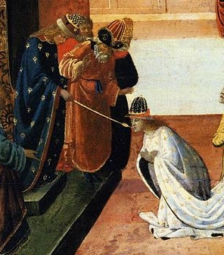

Forced into the king's harem Esther was selected as his queen. It was a barbaric culture, and the Jews were there due to their sinful rebellion, but God would use Esther's terrible circumstances to protect His people from a worse disaster.
Source: Public domain here http://theheavensdeclare.net/?p=15248

Faith In Action

Pray
Ask the Holy Spirit to reveal to you a challenging situation where His plan for you is not yet clear – but always certain to come.

Act
Today I will gratefully receive the assurance of the Lord God that despite my circumstances He has a plan for me. I will humbly submit to His Lordship in my circumstances, I will allow Him to be my strength in difficulties so that I may persevere with excellence (striving toward His standard), and be watchful for His directives to me.
Be Specific _____________________________________________

Tuesday (Esther 3)
Haman Conspires to Destroy the Jews
3:1 Some time later King Ahasuerus promoted Haman the son of Hammedatha, the Agagite, exalting him and setting his position above that of all the officials who were with him. 3:2 As a result, all the king’s servants who were at the king’s gate were bowing and paying homage to Haman, for the king had so commanded. However, Mordecai did not bow, nor did he pay him homage.
3:3 Then the servants of the king who were at the king’s gate asked Mordecai, “Why are you violating the king’s commandment?” 3:4 And after they had spoken to him day after day without his paying any attention to them, they informed Haman to see whether this attitude on Mordecai’s part would be permitted. Furthermore, he had disclosed to them that he was a Jew.
3:5 When Haman saw that Mordecai was not bowing or paying homage to him, he was filled with rage. 3:6 But the thought of striking out against Mordecai alone was repugnant to him, for he had been informed of the identity of Mordecai’s people. So Haman sought to destroy all the Jews (that is, the people of Mordecai) who were in all the kingdom of Ahasuerus.
3:7 In the first month (that is, the month of Nisan), in the twelfth year of King Ahasuerus’ reign, pur (that is, the lot) was cast before Haman in order to determine a day and a month. It turned out to be the twelfth month (that is, the month of Adar).
3:8 Then Haman said to King Ahasuerus, “There is a particular people that is dispersed and spread among the inhabitants throughout all the provinces of your kingdom whose laws differ from those of all other peoples. Furthermore, they do not observe the king’s laws. It is not appropriate for the king to provide a haven for them. 3:9 If the king is so inclined, let an edict be issued to destroy them. I will pay ten thousand talents of silver to be conveyed to the king’s treasuries for the officials who carry out this business.”
3:10 So the king removed his signet ring from his hand and gave it to Haman the son of Hammedatha, the Agagite, who was hostile toward the Jews. 3:11 The king replied to Haman, “Keep your money, and do with those people whatever you wish.”
3:12 So the royal scribes were summoned in the first month, on the thirteenth day of the month. Everything Haman commanded was written to the king’s satraps and governors who were in every province and to the officials of every people, province by province according to its script and people by people according to its language. In the name of King Ahasuerus it was written and sealed with the king’s signet ring. 3:13 Letters were sent by the runners to all the king’s provinces stating that they should destroy, kill, and annihilate all the Jews, from youth to elderly, both women and children, on a particular day, namely the thirteenth day of the twelfth month (that is, the month of Adar), and to loot and plunder their possessions. 3:14 A copy of this edict was to be presented as law throughout every province; it was to be made known to all the inhabitants, so that they would be prepared for this day. 3:15 The messengers scurried forth with the king’s order. The edict was issued in Susa the citadel. While the king and Haman sat down to drink, the city of Susa was in an uproar!

Prayer
Lord, the failure of a leader to be obedient and completely-eliminate an enemy (in the OT this was usually a pagan people, in the NT it would refer to a sin or a sin-promoting situation) always resulted in trouble later on. May I remember that there is no such thing as committing a sin, or spending too much time spent in a sin-promoting situation, without eventual negative consequences.

Scripture In Perspective
King Ahasuerus promoted Haman to the highest rank in his court and ordered that he be treated as royalty, including the submission of bowing at his passing, and immediate obedience.
Mordecai, Esther's adoptive uncle, refused to bow to Haman – which infuriated him. Upon discovering that he was a Jew Haman sought to attack all Jews, rather than Mordecai as an isolated individual, as that seemed to be beneath the station of a member of royalty.
Haman took the opportunity of a special moment on the Medo-Persian royal calendar to request a favor of the king. He asked that a foreign people, whose cultural laws kept them from keeping the king's laws, be destroyed – and he even offered to pay for it. The king told him to keep his money and to make it so – giving him his signet ring as the symbol of authority.
Haman had the scribes write the edit to obliterate the Jews and couriers to deliver it throughout the kingdom. There in Susa, as the king and Haman dined, the city outside was in an uproar.

Interact With The Text

Consider
It is believed that Haman, the Agagite, was a descendant of Agag of the Amalekites. King Saul was supposed to have destroyed them but failed to do so – leaving a remnant to remain as long-term enemies of the Jews.

Discuss
The text does not say that Haman knew of the relationship between Queen Esther and Mordecai, but if he did, might that help to explain his reluctance to attack Mordecai directly?

Reflect
King Ahasuerus seemed to be prone to easy manipulation and Haman to carelessness when it came to details – failing to discover ahead of time that the queen was a Jew and was related to Mordecai.

Share
When have you experienced or observed the petty anger of someone who had been entrusted with authority causing trouble for many?

KTALZ
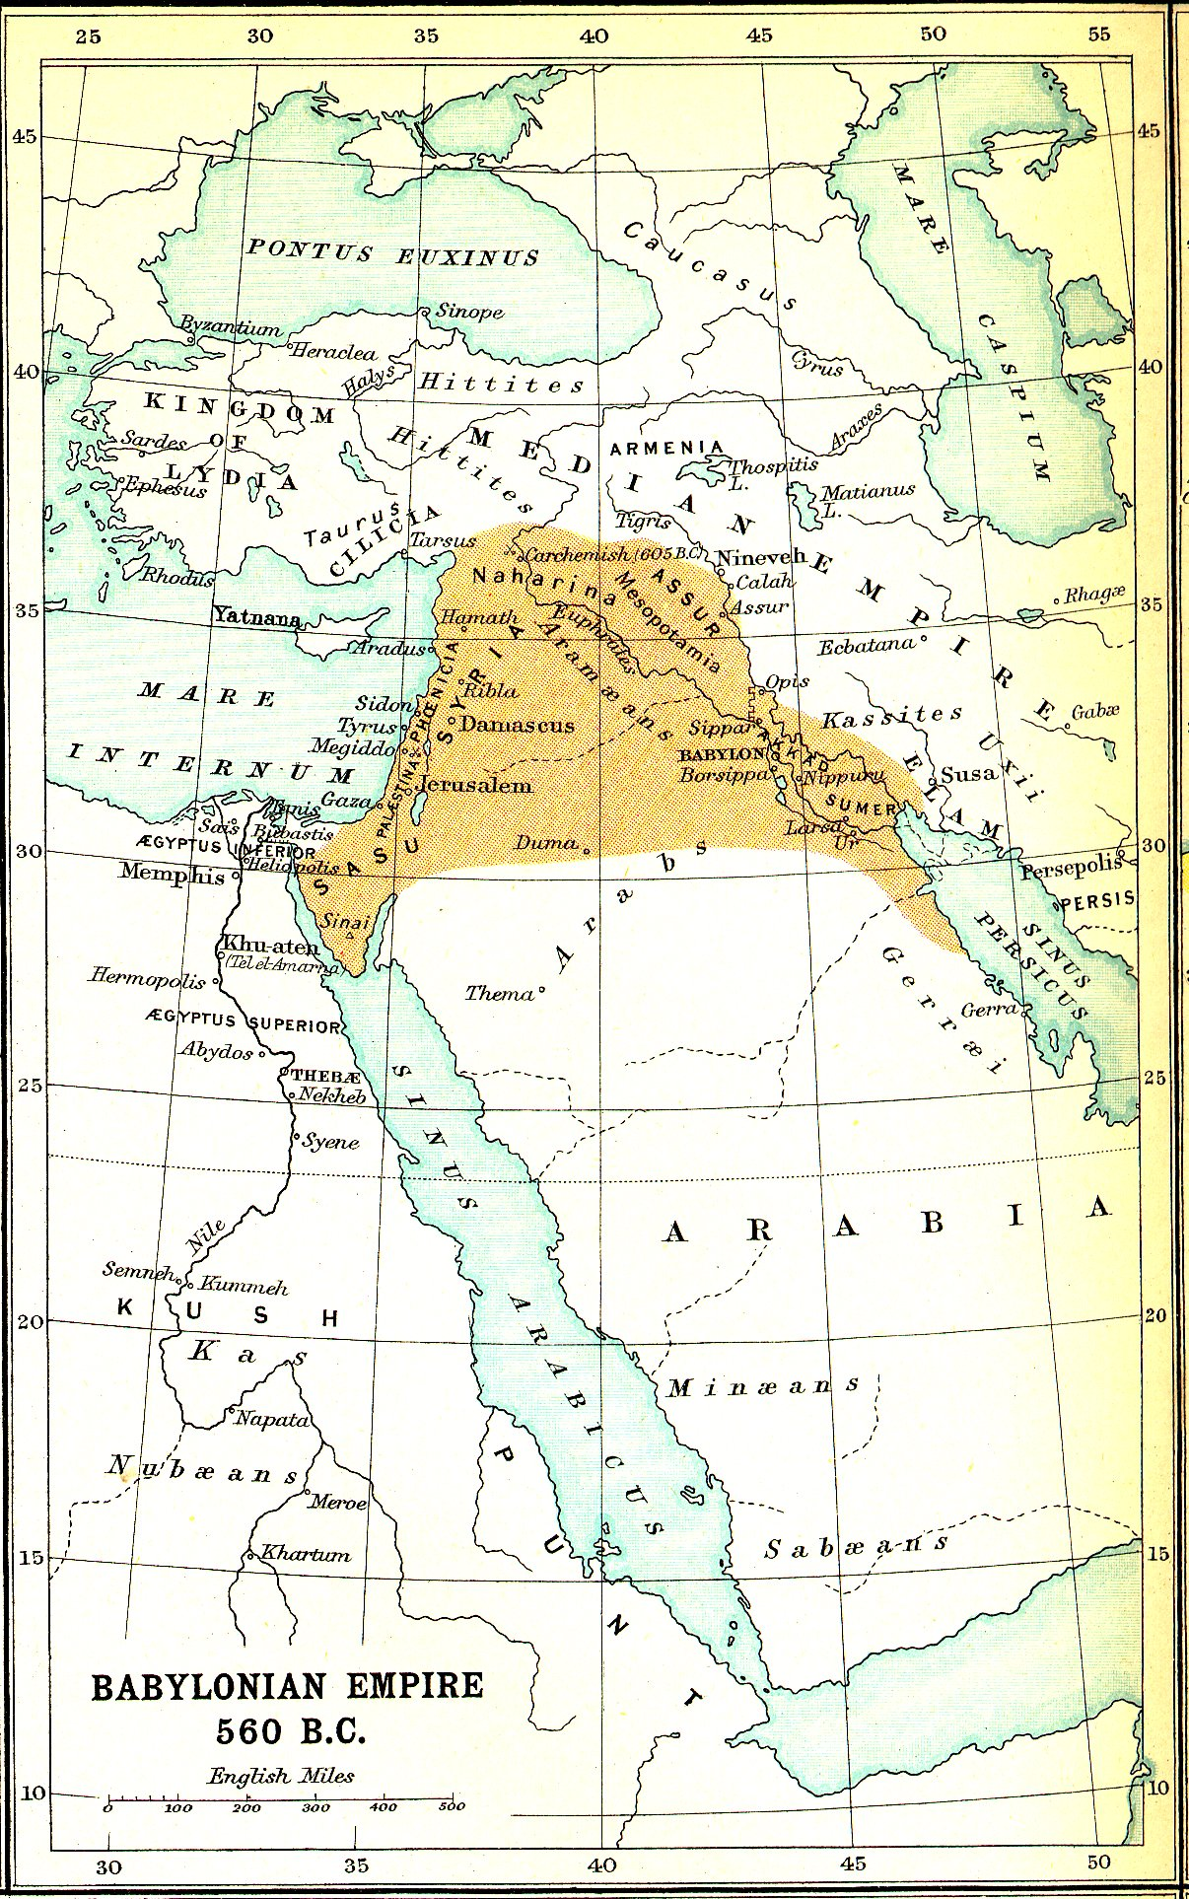

Captive Jews across the massive Medo-Persian empire were threatened with genocide.
Source: Public domain here http://www.biblesnet.com/atlas/

Faith In Action

Pray
Ask the Holy Spirit to reveal to you a sin that you have left unaddressed, or a sin-promoting situation in which you linger too long, and which will at some point harm you, and possibly others.

Act
Today I will confess, repent of, and accept the Lord's forgiveness for a sin which I am committing and/or am tolerating, and I agree to act promptly to deal with it. It may be an unhealthy environment that I could avoid or change, for myself - or those over whom I have authority - or a repeated activity that I could prevent.
Be Specific _________________________________________________

Wednesday (Esther 4 - 5)
Esther Decides to Risk Everything in order to Help Her People
4:1 Now when Mordecai became aware of all that had been done, he tore his garments and put on sackcloth and ashes. He went out into the city, crying out in a loud and bitter voice. 4:2 But he went no further than the king’s gate, for no one was permitted to enter the king’s gate clothed in sackcloth. 4:3 Throughout each and every province where the king’s edict and law were announced there was considerable mourning among the Jews, along with fasting, weeping, and sorrow. Sackcloth and ashes were characteristic of many. 4:4 When Esther’s female attendants and her eunuchs came and informed her about Mordecai’s behavior, the queen was overcome with anguish. Although she sent garments for Mordecai to put on so that he could remove his sackcloth, he would not accept them. 4:5 So Esther called for Hathach, one of the king’s eunuchs who had been placed at her service, and instructed him to find out the cause and reason for Mordecai’s behavior. 4:6 So Hathach went to Mordecai at the plaza of the city in front of the king’s gate. 4:7 Then Mordecai related to him everything that had happened to him, even the specific amount of money that Haman had offered to pay to the king’s treasuries for the Jews to be destroyed. 4:8 He also gave him a written copy of the law that had been disseminated in Susa for their destruction so that he could show it to Esther and talk to her about it. He also gave instructions that she should go to the king to implore him and petition him on behalf of her people. 4:9 So Hathach returned and related Mordecai’s instructions to Esther.
4:10 Then Esther replied to Hathach with instructions for Mordecai: 4:11 “All the servants of the king and the people of the king’s provinces know that there is only one law applicable to any man or woman who comes uninvited to the king in the inner court – that person will be put to death, unless the king extends to him the gold scepter, permitting him to be spared. Now I have not been invited to come to the king for some thirty days!”
4:12 When Esther’s reply was conveyed to Mordecai, 4:13 he said to take back this answer to Esther: 4:14 “Don’t imagine that because you are part of the king’s household you will be the one Jew who will escape. If you keep quiet at this time, liberation and protection for the Jews will appear from another source, while you and your father’s household perish. It may very well be that you have achieved royal status for such a time as this!”
4:15 Then Esther sent this reply to Mordecai: 4:16 “Go, assemble all the Jews who are found in Susa and fast in my behalf. Don’t eat and don’t drink for three days, night or day. My female attendants and I will also fast in the same way. Afterward I will go to the king, even though it violates the law. If I perish, I perish!”
4:17 So Mordecai set out to do everything that Esther had instructed him.
Esther Appeals to the King for Help
5:1 It so happened that on the third day Esther put on her royal attire and stood in the inner court of the palace, opposite the king’s quarters. The king was sitting on his royal throne in the palace, opposite the entrance. 5:2 When the king saw Queen Esther standing in the court, she met with his approval. The king extended to Esther the gold scepter that was in his hand, and Esther approached and touched the end of the scepter.
5:3 The king said to her, “What is on your mind, Queen Esther? What is your request? Even as much as half the kingdom will be given to you!”
5:4 Esther replied, “If the king is so inclined, let the king and Haman come today to the banquet that I have prepared for him.” 5:5 The king replied, “Find Haman quickly so that we can do as Esther requests.”
So the king and Haman went to the banquet that Esther had prepared. 5:6 While at the banquet of wine, the king said to Esther, “What is your request? It shall be given to you. What is your petition? Ask for as much as half the kingdom, and it shall be done!”
5:7 Esther responded, “My request and my petition is this: 5:8 If I have found favor in the king’s sight and if the king is inclined to grant my request and perform my petition, let the king and Haman come tomorrow to the banquet that I will prepare for them. At that time I will do as the king wishes.
Haman Expresses His Hatred of Mordecai
5:9 Now Haman went forth that day pleased and very much encouraged. But when Haman saw Mordecai at the king’s gate, and he did not rise nor tremble in his presence, Haman was filled with rage toward Mordecai. 5:10 But Haman restrained himself and went on to his home.
He then sent for his friends to join him, along with his wife Zeresh. 5:11 Haman then recounted to them his fabulous wealth, his many sons, and how the king had magnified him and exalted him over the king’s other officials and servants. 5:12 Haman said, “Furthermore, Queen Esther invited only me to accompany the king to the banquet that she prepared! And also tomorrow I am invited along with the king. 5:13 Yet all of this fails to satisfy me so long as I have to see Mordecai the Jew sitting at the king’s gate.”
5:14 Haman’s wife Zeresh and all his friends said to him, “Have a gallows seventy-five feet high built, and in the morning tell the king that Mordecai should be hanged on it. Then go with the king to the banquet contented.”
It seemed like a good idea to Haman, so he had the gallows built.

Prayer
Lord, You are in our future and where Your great plan is involved You make a way, while still allowing mere men to wander about in their confused rebellion and half-hearted relationship with You. May I be watchful for those moments where You give me a rare opportunity to be your uniquely-prepared instrument – knowing that You will find another way should I fail to step-up.

Scripture In Perspective
Mordecai, along with many Jews throughout the kingdom, mourned the evil edict in sackcloth. Esther heard that Mordecai was in sackcloth and sent a servant to inquire as to the reason.
Mordecai sent an explanation, a copy of the edict, and a request that she plead with the king to revoke the edict. Esther responded that she had not been granted permission to appear in the king's court for thirty days and that the law required death of anyone who appeared there uninvited – unless the king extended his scepter – granting mercy.
Mordecai explained that she, and her whole family, may suffer death from the edict - and the Lord God would defend His people through another means – but that she may have been placed where she was (as queen) so that she could be His instrument of rescue. Esther acknowledged the truth of his wise counsel, agreed to risk her life and approach the king uninvited, and asked that Mordecai and others fast and pray along with her and her attendants for three days.
After three days Esther went to the king and he granted her favor to approach, though uninvited, and asked her what she wanted – saying that she might have as much as half of his kingdom. She asked he and Haman to join her for a banquet she would prepare.
At the banquet the king again asked what was her desire and she responded that if they would come again to a second banquet at that time she would share her request, and they agreed.
Haman bragged to family and friends of his great possessions, power, and prestige, and to have alone been invited by the queen to join the king at two banquets. Haman also confessed that the refusal of Mordecai to be submissive to him poisoned the well of his happiness.
“Haman’s wife Zeresh and all his friends said to him, “Have a gallows seventy-five feet high built, and in the morning tell the king that Mordecai should be hanged on it. Then go with the king to the banquet contented.”” Haman did so.

Interact With The Text

Consider
Mordecai was certain that the Lord God would not allow all of His people to be destroyed, but feared a nightmare along the way, and was sorrowful that such a scheme would even exist.

Discuss
Why would Haman allow the disrespect of one man, in an entire kingdom, to spoil his happiness – given all that he had? [Recall that Haman was an Agagite, old enemies of the Jews, who were supposed to have been annihilated by Saul.]

Reflect
Haman's scheme to obliterate a nation, due to the offense of a single individual, may reasonably motivate the reader to wonder if he may have been manipulated by a demonic evil (seeking a victory in a generations-old battle with the Lord God) rather than mere dislike of one man.

Share
When have you been confronted with an ethical decision which could cost you a great deal and may or may not have led even to a true opportunity to make a difference?

KTALZ
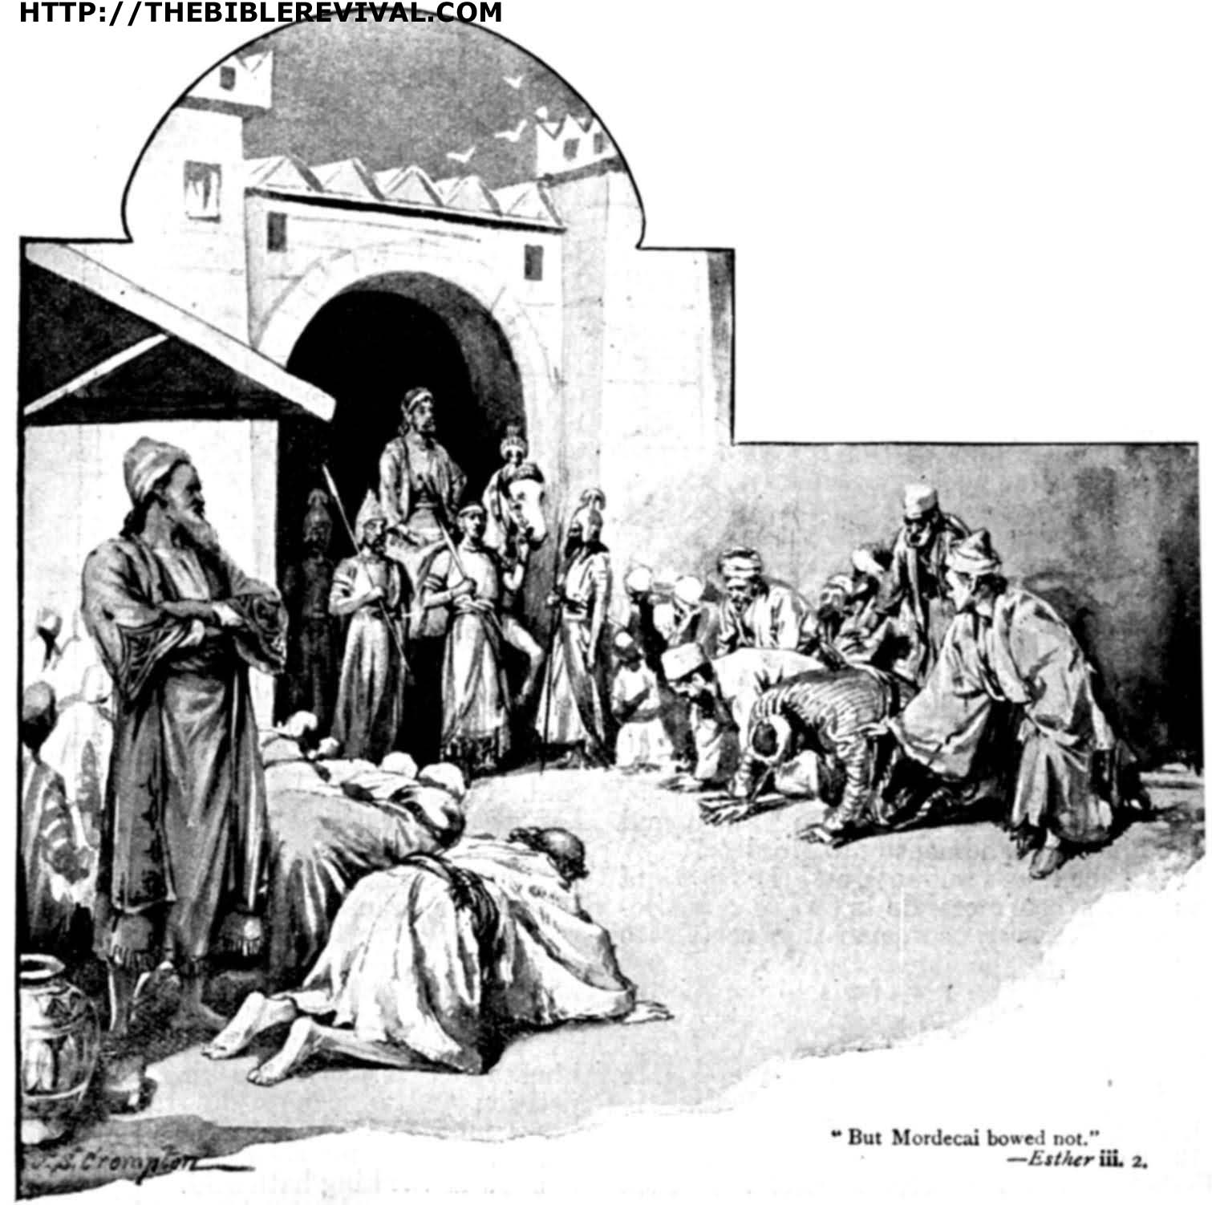

Mordecai obeyed God and refused to bow to Haman, who wanted worship rather than a mere humble posture.
Source: Public domain here http://thebiblerevival.com/clipart9.htm

Faith In Action

Pray
Ask the Holy Spirit to reveal to you an opportunity in your life for which He has prepared you uniquely to be His instrument.

Act
Today I will humbly acknowledge and accept the calling of the Lord God to serve Him. I will accept His strength and draw up courage from Him in order to step-out in faith despite the worldly-threats that await. I will ask at least one fellow Believer to pray in-agreement with me for courage, protection, and wisdom.
Be Specific ________________________________________________

Thursday (Esther 6 - 7)
The Turning Point: The King Honors Mordecai
6:1 Throughout that night the king was unable to sleep, so he asked for the book containing the historical records to be brought. As the records were being read in the king’s presence, 6:2 it was found written that Mordecai had disclosed that Bigthana and Teresh, two of the king’s eunuchs who guarded the entrance, had plotted to assassinate King Ahasuerus.
6:3 The king asked, “What great honor was bestowed on Mordecai because of this?” The king’s attendants who served him responded, “Not a thing was done for him.”
6:4 Then the king said, “Who is that in the courtyard?” Now Haman had come to the outer courtyard of the palace to suggest that the king hang Mordecai on the gallows that he had constructed for him. 6:5 The king’s attendants said to him, “It is Haman who is standing in the courtyard.” The king said, “Let him enter.”
6:6 So Haman came in, and the king said to him, “What should be done for the man whom the king wishes to honor?” Haman thought to himself, “Who is it that the king would want to honor more than me?” 6:7 So Haman said to the king, “For the man whom the king wishes to honor, 6:8 let them bring royal attire which the king himself has worn and a horse on which the king himself has ridden – one bearing the royal insignia! 6:9 Then let this clothing and this horse be given to one of the king’s noble officials. Let him then clothe the man whom the king wishes to honor, and let him lead him about through the plaza of the city on the horse, calling before him, ‘So shall it be done to the man whom the king wishes to honor!’”
6:10 The king then said to Haman, “Go quickly! Take the clothing and the horse, just as you have described, and do as you just indicated to Mordecai the Jew who sits at the king’s gate. Don’t neglect a single thing of all that you have said.”
6:11 So Haman took the clothing and the horse, and he clothed Mordecai. He led him about on the horse throughout the plaza of the city, calling before him, “So shall it be done to the man whom the king wishes to honor!”
6:12 Then Mordecai again sat at the king’s gate, while Haman hurried away to his home, mournful and with a veil over his head. 6:13 Haman then related to his wife Zeresh and to all his friends everything that had happened to him. These wise men, along with his wife Zeresh, said to him, “If indeed this Mordecai before whom you have begun to fall is Jewish, you will not prevail against him. No, you will surely fall before him!”
6:14 While they were still speaking with him, the king’s eunuchs arrived. They quickly brought Haman to the banquet that Esther had prepared.
The King Has Haman Executed
7:1 So the king and Haman came to dine with Queen Esther. 7:2 On the second day of the banquet of wine the king asked Esther, “What is your request, Queen Esther? It shall be granted to you. And what is your petition? Ask up to half the kingdom, and it shall be done!”
7:3 Queen Esther replied, “If I have met with your approval, O king, and if the king is so inclined, grant me my life as my request, and my people as my petition. 7:4 For we have been sold – both I and my people – to destruction and to slaughter and to annihilation! If we had simply been sold as male and female slaves, I would have remained silent, for such distress would not have been sufficient for troubling the king.”
7:5 Then King Ahasuerus responded to Queen Esther, “Who is this individual? Where is this person to be found who is presumptuous enough to act in this way?”
7:6 Esther replied, “The oppressor and enemy is this evil Haman!”
Then Haman became terrified in the presence of the king and queen. 7:7 In rage the king arose from the banquet of wine and withdrew to the palace garden. Meanwhile, Haman stood to beg Queen Esther for his life, for he realized that the king had now determined a catastrophic end for him.
7:8 When the king returned from the palace garden to the banquet of wine, Haman was throwing himself down on the couch where Esther was lying. The king exclaimed, “Will he also attempt to rape the queen while I am still in the building!”
As these words left the king’s mouth, they covered Haman’s face. 7:9 Harbona, one of the king’s eunuchs, said, “Indeed, there is the gallows that Haman made for Mordecai, who spoke out in the king’s behalf. It stands near Haman’s home and is seventy-five feet high.”
The king said, “Hang him on it!” 7:10 So they hanged Haman on the very gallows that he had prepared for Mordecai. The king’s rage then abated.

Prayer
Lord, amidst the petty pride and insane rage of men with power, You work Your will to preserve Your people. May I never fear those who conspire to block Your path – they will be swept aside.

Scripture In Perspective
On the eve of the second banquet with Esther the king's sleep was troubled so he asked to see the book of events of his royal court. When he came to the story of Mordecai discovering and reporting the assassins he asked what great honor had been given Mordecai as a reward. Discovering that nothing had been done he pondered how to make things right.
Haman, consumed by his hatred of Mordecai had arrived in the courtyard, hoping for an audience with the king where he hoped to persuade him to have Mordecai hanged on the huge gallows he had built.
The king inquired as to who was in the courtyard and when he heard it was Haman he summoned him. The king asked Haman how he should greatly-honor a man and Haman, also consumed by pride, presuming that he was the intended-beneficiary he described a grandiose display.
The king ordered him to personally implement his scheme for Mordecai. Haman did so then covered his face and returned to his family and associates. When he described his terrible humiliation they warned him that if Mordecai was indeed a Jew that he, not Mordecai, would be destroyed should he continue his crusade against him. Just as they spoke the royal eunuchs arrived to escort him to Esther's banquet.
The king challenged Esther, wanting to know what was her request, and again offering up to half of his kingdom as a gift to her. She asked him for her life, and that of her people, qualifying that had they been sold into slavery she would not have troubled him – but they were to be annihilated.
The king, as before with Vashti, flew into an indignant rage and demanded to know who was responsible – at which time Esther named Haman. The King stormed out onto the patio and while he was out there Haman threw himself upon Esther to plead for mercy – the king returning to the room imagined Haman was sexually-assaulting the queen and his rage escalated.
A nearby eunuch suggested the king hang Haman on the gallows he had built for Mordecai, and the king agreed, only ceasing from his rage once Haman was dead.

Interact With The Text

Consider
The Lord God is neither mocked nor thwarted, yet He has an apparent sense of humor, hoisting those who conspire against His people on their own petard. (Haman was forced to personally deliver to his nemesis, Mordecai, the public display of the king's affection that he wrongly believed was coming to him.)

Discuss
What element of history might have prompted Haman's wife and associates have sensed that Haman faced certain doom – predicated on the new information that Mordecai was a Jew?

Reflect
The same (then alcohol-fueled) rage of the king which, manipulated by his advisers, led to Vashti's banishment and the imposition of slave-like regulations upon all of the married women in the kingdom now was turned against the evil Haman by God.

Share
When have you observed a pattern of bad turned to good by the Lord God?

KTALZ
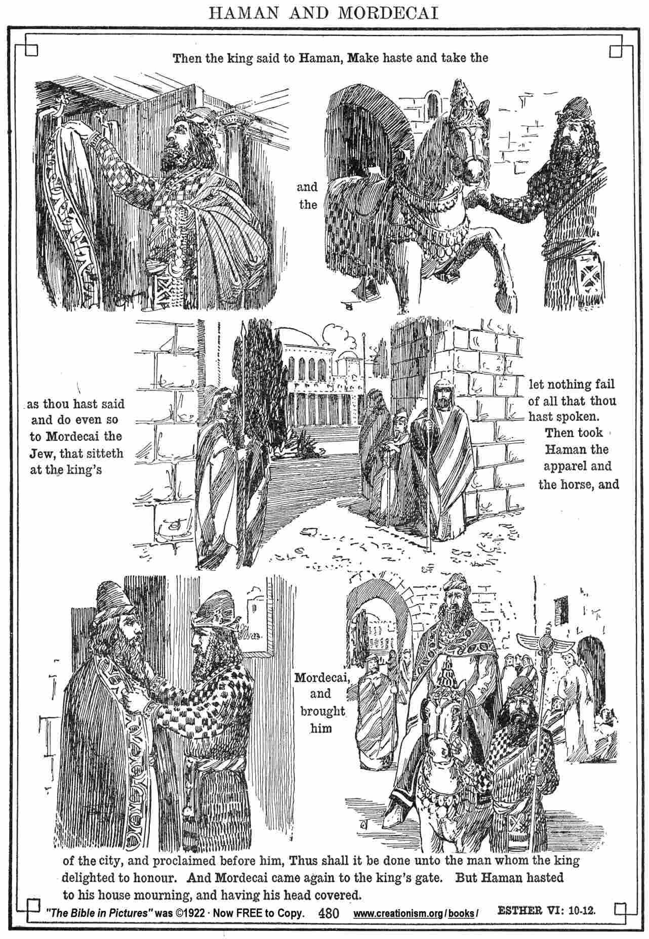

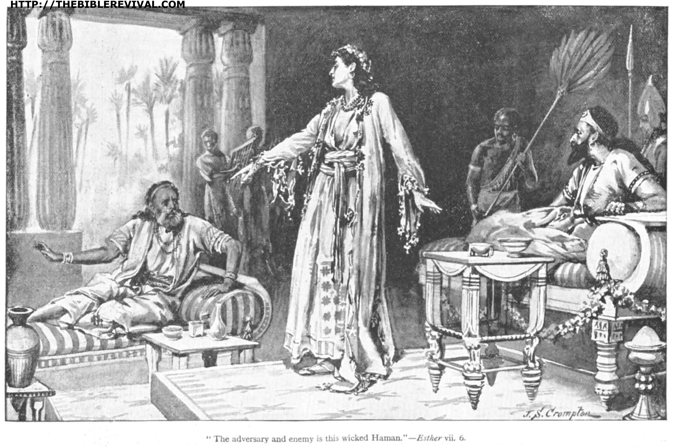

Mordecai was finally rewarded, at the expense of Haman's ego, for saving the king's life then Esther accused him of trying to obliterate her and her people.
Source: Public domain here http://creationism.org/books/bibleinpictures/bible17est06_10-12.htm and here http://thebiblerevival.com/clipart7.htm

Faith In Action

Pray
Ask the Holy Spirit to reveal to you a place where you have felt overwhelmed by a sense of hopelessness

Act
Today I will confess my fears and accept the Lord's assurance of loving protection.
Be Specific _____________________________________________

Friday (Esther 8)
The King Acts to Protect the Jews
8:1 On that same day King Ahasuerus gave the estate of Haman, that adversary of the Jews, to Queen Esther. Now Mordecai had come before the king, for Esther had revealed how he was related to her. 8:2 The king then removed his signet ring (the very one he had taken back from Haman) and gave it to Mordecai. And Esther designated Mordecai to be in charge of Haman’s estate.
8:3 Then Esther again spoke with the king, falling at his feet. She wept and begged him for mercy, that he might nullify the evil of Haman the Agagite which he had intended against the Jews. 8:4 When the king extended to Esther the gold scepter, she arose and stood before the king.
8:5 She said, “If the king is so inclined and if I have met with his approval and if the matter is agreeable to the king and if I am attractive to him, let an edict be written rescinding those recorded intentions of Haman the son of Hammedatha, the Agagite, which he wrote in order to destroy the Jews who are throughout all the king’s provinces. 8:6 For how can I watch the calamity that will befall my people, and how can I watch the destruction of my relatives?”
8:7 King Ahasuerus replied to Queen Esther and to Mordecai the Jew, “Look, I have already given Haman’s estate to Esther, and he has been hanged on the gallows because he took hostile action against the Jews. 8:8 Now you write in the king’s name whatever in your opinion is appropriate concerning the Jews and seal it with the king’s signet ring. Any decree that is written in the king’s name and sealed with the king’s signet ring cannot be rescinded.
8:9 The king’s scribes were quickly summoned – in the third month (that is, the month of Sivan), on the twenty-third day. They wrote out everything that Mordecai instructed to the Jews and to the satraps and the governors and the officials of the provinces all the way from India to Ethiopia – a hundred and twenty-seven provinces in all – to each province in its own script and to each people in their own language, and to the Jews according to their own script and their own language. 8:10 Mordecai wrote in the name of King Ahasuerus and sealed it with the king’s signet ring. He then sent letters by couriers on horses, who rode royal horses that were very swift.
8:11 The king thereby allowed the Jews who were in every city to assemble and to stand up for themselves – to destroy, to kill, and to annihilate any army of whatever people or province that should become their adversaries, including their women and children, and to confiscate their property. 8:12 This was to take place on a certain day throughout all the provinces of King Ahasuerus – namely, on the thirteenth day of the twelfth month (that is, the month of Adar). 8:13 A copy of the edict was to be presented as law throughout each and every province and made known to all peoples, so that the Jews might be prepared on that day to avenge themselves from their enemies.
8:14 The couriers who were riding the royal horses went forth with the king’s edict without delay. And the law was presented in Susa the citadel as well.
8:15 Now Mordecai went out from the king’s presence in purple and white royal attire, with a large golden crown and a purple linen mantle. The city of Susa shouted with joy. 8:16 For the Jews there was radiant happiness and joyous honor. 8:17 Throughout every province and throughout every city where the king’s edict and his law arrived, the Jews experienced happiness and joy, banquets and holidays. Many of the resident peoples pretended to be Jews, because the fear of the Jews had overcome them.

Prayer
Lord, it is often not merely enough to stop the sin, You know that the aftereffects continue and they also must be addressed. May I recognize that when sin happens it always has collateral consequences, and those ongoing consequences must not be ignored.

Scripture In Perspective
Haman's extensive estate was given to Esther who appointed Mordecai as executor.
Esther also explained to the king her relationship with Mordecai and then pleaded with him to save her people.
The king explained that his edict could not be undone but he then gave Mordecai his royal signet ring and encouraged Esther and Mordecai to do whatever was necessary to neutralize it indirectly.
Mordecai summoned the scribes and had them dispatch the new orders. The new orders were for the Jews to arm themselves for self-defense and to aggressively defend themselves against anyone of any age or any position who threatened them. Many pretended to be Jews out of fear.
Mordecai went into the streets of Susa in royal court attire and there were great celebrations.

Interact With The Text

Consider
Haman had been punished for his attempted genocide, but the monstrous plot he had set in motion was still just that, in motion.

Discuss
Why could not the king merely issue another proclamation declaring the first one null and void, and be assured that nothing would happen?

Reflect
The Lord God had turned what Haman, servant of Satan, had intended for terrible evil – against the Jews – to good beyond what anyone may have expected. Not only was Haman stopped, all of those who hated the Jews in the kingdom were themselves in mortal danger from the Jews (by order of the king), and the second and third most powerful people in the kingdom (within which they were captive subjects) were now Jews.

Share
When have you experienced or observed the Lord God turning something that the enemy clearly intended for evil into something that contained blessing and glory to Him?

KTALZ
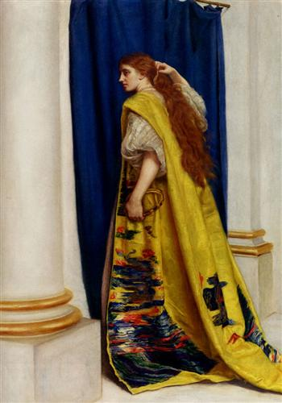

Esther again plead for the lives of her fellow Jews.
Source: Public domain here http://uploads6.wikiart.org/images/john-everett-millais/esther.jpg

Faith In Action

Pray
Ask the Holy Spirit to remind you of a blessing He had caused in a place where you only saw the possibility of evil or greater evil.

Act
Today I will share the story of the Lord God's intervention with at least one fellow Believer and together we will praise and worship Him.
Be Specific _____________________________________________

Saturday (Esther 9 - 10)
The Jews Prevail over Their Enemies
9:1 In the twelfth month (that is, the month of Adar), on its thirteenth day, the edict of the king and his law were to be executed. It was on this day that the enemies of the Jews had supposed that they would gain power over them. But contrary to expectations, the Jews gained power over their enemies. 9:2 The Jews assembled themselves in their cities throughout all the provinces of King Ahasuerus to strike out against those who were seeking their harm. No one was able to stand before them, for dread of them fell on all the peoples. 9:3 All the officials of the provinces, the satraps, the governors and those who performed the king’s business were assisting the Jews, for the dread of Mordecai had fallen on them. 9:4 Mordecai was of high rank in the king’s palace, and word about him was spreading throughout all the provinces. His influence continued to become greater and greater.
9:5 The Jews struck all their enemies with the sword, bringing death and destruction, and they did as they pleased with their enemies. 9:6 In Susa the citadel the Jews killed and destroyed five hundred men. 9:7 In addition, they also killed Parshandatha, Dalphon, Aspatha, 9:8 Poratha, Adalia, Aridatha, 9:9 Parmashta, Arisai, Aridai, and Vaizatha, 9:10 the ten sons of Haman son of Hammedatha, the enemy of the Jews. But they did not confiscate their property.
9:11 On that same day the number of those killed in Susa the citadel was brought to the king’s attention. 9:12 Then the king said to Queen Esther, “In Susa the citadel the Jews have killed and destroyed five hundred men and the ten sons of Haman! What then have they done in the rest of the king’s provinces? What is your request? It shall be given to you. What other petition do you have? It shall be done.”
9:13 Esther replied, “If the king is so inclined, let the Jews who are in Susa be permitted to act tomorrow also according to today’s law, and let them hang the ten sons of Haman on the gallows.”
9:14 So the king issued orders for this to be done. A law was passed in Susa, and the ten sons of Haman were hanged. 9:15 The Jews who were in Susa then assembled on the fourteenth day of the month of Adar, and they killed three hundred men in Susa. But they did not confiscate their property.
9:16 The rest of the Jews who were throughout the provinces of the king assembled in order to stand up for themselves and to have rest from their enemies. They killed seventy-five thousand of their adversaries, but they did not confiscate their property. 9:17 All of this happened on the thirteenth day of the month of Adar. They then rested on the fourteenth day and made it a day for banqueting and happiness.
The Origins of the Feast of Purim
9:18 But the Jews who were in Susa assembled on the thirteenth and fourteenth days, and rested on the fifteenth, making it a day for banqueting and happiness. 9:19 This is why the Jews who are in the rural country – those who live in rural cities – set aside the fourteenth day of the month of Adar as a holiday for happiness, banqueting, holiday, and sending gifts to one another.
9:20 Mordecai wrote these matters down and sent letters to all the Jews who were throughout all the provinces of King Ahasuerus, both near and far, 9:21 to have them observe the fourteenth and the fifteenth day of the month of Adar each year 9:22 as the time when the Jews gave themselves rest from their enemies – the month when their trouble was turned to happiness and their mourning to a holiday. These were to be days of banqueting, happiness, sending gifts to one another, and providing for the poor.
9:23 So the Jews committed themselves to continue what they had begun to do and to what Mordecai had written to them. 9:24 For Haman the son of Hammedatha, the Agagite, the enemy of all the Jews, had devised plans against the Jews to destroy them. He had cast pur (that is, the lot) in order to afflict and destroy them. 9:25 But when the matter came to the king’s attention, the king gave written orders that Haman’s evil intentions that he had devised against the Jews should fall on his own head. He and his sons were hanged on the gallows. 9:26 For this reason these days are known as Purim, after the name of pur. 9:27 Therefore, because of the account found in this letter and what they had faced in this regard and what had happened to them, the Jews established as binding on themselves, their descendants, and all who joined their company that they should observe these two days without fail, just as written and at the appropriate time on an annual basis. 9:28 These days were to be remembered and to be celebrated in every generation and in every family, every province, and every city. The Jews were not to fail to observe these days of Purim; the remembrance of them was not to cease among their descendants.
9:29 So Queen Esther, the daughter of Abihail, and Mordecai the Jew wrote with full authority to confirm this second letter about Purim. 9:30 Letters were sent to all the Jews in the hundred and twenty-seven provinces of the empire of Ahasuerus – words of true peace – 9:31 to establish these days of Purim in their proper times, just as Mordecai the Jew and Queen Esther had established, and just as they had established both for themselves and their descendants, matters pertaining to fasting and lamentation. 9:32 Esther’s command established these matters of Purim, and the matter was officially recorded.
Mordecai’s Fame Increases
10:1 King Ahasuerus then imposed forced labor on the land and on the coastlands of the sea. 10:2 Now all the actions carried out under his authority and his great achievements, along with an exact statement concerning the greatness of Mordecai, whom the king promoted, are they not written in the Book of the Chronicles of the Kings of Media and Persia? 10:3 Mordecai the Jew was second only to King Ahasuerus. He was the highest-ranking Jew, and he was admired by his numerous relatives. He worked enthusiastically for the good of his people and was an advocate for the welfare of all his descendants.

Prayer
Lord, from time to time You have purged evil people from a land, sometimes by Your own hand and sometimes using mere humans to accomplish Your will. May I be as aggressive in purging evil from my life as You have been in purging it from the lives of Your people in the past.

Scripture In Perspective
The Jews met their enemies throughout the kingdom and killed 75,000 who were allied with the evil genocidal scheme of Haman.
In Susa the ten sons of Haman were hanged on the same gallows as he - three hundred other co-conspirators were killed as well.
The Jews did not take any of the property of those who were killed.
Two days of celebration and remembrance, Purim, were added to the Jewish calendar.
Mordecai continued to serve as the king's second-in-command and did well by the king and his own people.

Interact With The Text

Consider
Despite the second edict some 75,000 in the kingdom still tried to destroy the Jews.

Discuss
Was the reason that the Jews did not take any of the property of the enemies - whom they killed – that they wanted it clear that they acted in self-defense, free of any selfish self-interest?

Reflect
The celebration of Purim was in some ways a shadow of the Passover, celebrating their God-assured survival of another attempt at a man-made purge.

Share
When have you observed someone resisting the temptation to abuse righteous-power for selfish advantage?
KTALZ
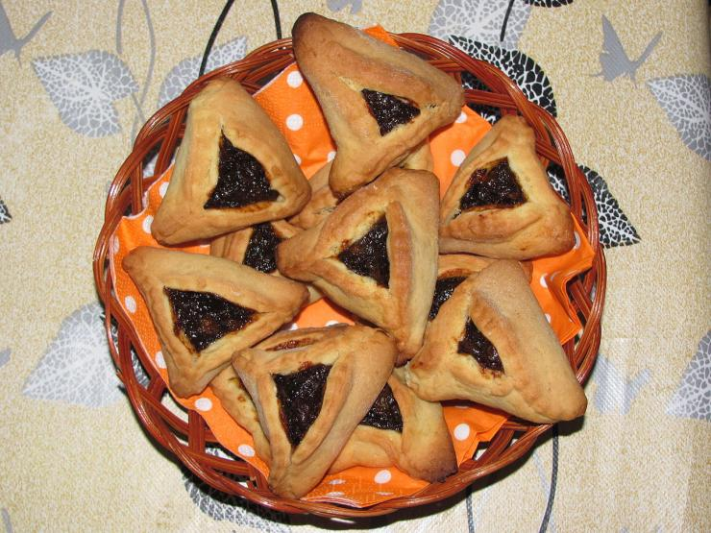

The Jews refused to take the property of their enemies, even though the edict allowed it, and then celebrated God's protection in a foreign land.
Source: Appears to be public domain here http://s1.ibtimes.com/sites/www.ibtimes.com/files/styles/v2_article_large/public/2015/03/03/purim.jpg

Faith In Action

Pray
Ask the Holy Spirit to reveal to you a wrong against which He wants you to stand.

Act
Today I will prayerfully discern the mission of the Holy Spirit. I will ask one who meets the Biblical definition of “elder” to pray for confirmation, and to then pray in-agreement for courage and wisdom. It may standing against the invasion of sin into a home or other gathering of Believers, it may be standing for integrity in school or the workplace, it may be standing against efforts to misuse the power of government to attack Christians.
Be Specific _________________________________________________

All Bible text is from the NET unless otherwise indicated - http://bible.org
Note 1: These Studies often rely upon the guidance of the NET Translators from their associated notes. Careful attention has been given to cite that source where it has been quoted directly or closely paraphrased. Feedback is encouraged where credit has not been sufficiently assigned.
Note 2: When NET text is quoted in commentary and discussion all pronouns referring to God are capitalized, though they are lower-case in the original NET text.
Commentary text is from David M. Colburn, D.Min. unless otherwise noted.
Copyright © 2012 by David M. Colburn. This is a BibleSeven Study –“Genesis 3. Prepared by David M. Colburn and edited for bible.org in August of 2012. This text may be used for non-profit educational purposes only, with credit; all other usage requires prior written consent of the author.

