Deuteronomy 1 - 16
(Preparation for the Promised Land)
David M. Colburn
A Chronological Daily Bible Study of the Old Testament
7-Day Sections with a Summary-Commentary, Discussion Questions,
and a Practical Daily Application
Week 21

Sunday (Deuteronomy 1 - 4)
Please read Deuteronomy 1-3 in your Bible or at these links:
http://net.bible.org/bible.php?book=Deu&chapter=1#n12

http://net.bible.org/bible.php?book=Deu&chapter=2#n52

http://net.bible.org/bible.php?book=Deu&chapter=3#n43

Deuteronomy 4

The Privileges of the Covenant
4:1 Now, Israel, pay attention to the statutes and ordinances I am about to teach you, so that you might live and go on to enter and take possession of the land that the Lord, the God of your ancestors, is giving you. 4:2 Do not add a thing to what I command you nor subtract from it, so that you may keep the commandments of the Lord your God that I am delivering to you. 4:3 You have witnessed what the Lord did at Baal Peor, how he eradicated from your midst everyone who followed Baal Peor. 4:4 But you who remained faithful to the Lord your God are still alive to this very day, every one of you. 4:5 Look! I have taught you statutes and ordinances just as the Lord my God told me to do, so that you might carry them out in the land you are about to enter and possess. 4:6 So be sure to do them, because this will testify of your wise understanding to the people who will learn of all these statutes and say, “Indeed, this great nation is a very wise people.” 4:7 In fact, what other great nation has a god so near to them like the Lord our God whenever we call on him? 4:8 And what other great nation has statutes and ordinances as just as this whole law that I am about to share with you today?
Reminder of the Horeb Covenant
4:9 Again, however, pay very careful attention, lest you forget the things you have seen and disregard them for the rest of your life; instead teach them to your children and grandchildren. 4:10 You stood before the Lord your God at Horeb and he said to me, “Assemble the people before me so that I can tell them my commands. Then they will learn to revere me all the days they live in the land, and they will instruct their children.” 4:11 You approached and stood at the foot of the mountain, a mountain ablaze to the sky above it and yet dark with a thick cloud. 4:12 Then the Lord spoke to you from the middle of the fire; you heard speech but you could not see anything – only a voice was heard. 4:13 And he revealed to you the covenant he has commanded you to keep, the ten commandments, writing them on two stone tablets. 4:14 Moreover, at that same time the Lord commanded me to teach you statutes and ordinances for you to keep in the land which you are about to enter and possess.
The Nature of Israel’s God
4:15 Be very careful, then, because you saw no form at the time the Lord spoke to you at Horeb from the middle of the fire. 4:16 I say this so you will not corrupt yourselves by making an image in the form of any kind of figure. This includes the likeness of a human male or female, 4:17 any kind of land animal, any bird that flies in the sky, 4:18 anything that crawls on the ground, or any fish in the deep waters of the earth. 4:19 When you look up to the sky and see the sun, moon, and stars – the whole heavenly creation – you must not be seduced to worship and serve them, for the Lord your God has assigned them to all the people of the world. 4:20 You, however, the Lord has selected and brought from Egypt, that iron-smelting furnace, to be his special people as you are today. 4:21 But the Lord became angry with me because of you and vowed that I would never cross the Jordan nor enter the good land that he is about to give you. 4:22 So I must die here in this land; I will not cross the Jordan. But you are going over and will possess that good land. 4:23 Be on guard so that you do not forget the covenant of the Lord your God that he has made with you, and that you do not make an image of any kind, just as he has forbidden you. 4:24 For the Lord your God is a consuming fire; he is a jealous God.
Threat and Blessing following Covenant Disobedience
4:25 After you have produced children and grandchildren and have been in the land a long time, if you become corrupt and make an image of any kind and do other evil things before the Lord your God that enrage him, 4:26 I invoke heaven and earth as witnesses against you today that you will surely and swiftly be removed from the very land you are about to cross the Jordan to possess. You will not last long there because you will surely be annihilated. 4:27 Then the Lord will scatter you among the peoples and there will be very few of you among the nations where the Lord will drive you. 4:28 There you will worship gods made by human hands – wood and stone that can neither see, hear, eat, nor smell. 4:29 But if you seek the Lord your God from there, you will find him, if, indeed, you seek him with all your heart and soul. 4:30 In your distress when all these things happen to you in the latter days, if you return to the Lord your God and obey him 4:31 (for he is a merciful God), he will not let you down or destroy you, for he cannot forget the covenant with your ancestors that he confirmed by oath to them.
The Uniqueness of Israel’s God
4:32 Indeed, ask about the distant past, starting from the day God created humankind on the earth, and ask from one end of heaven to the other, whether there has ever been such a great thing as this, or even a rumor of it. 4:33 Have a people ever heard the voice of God speaking from the middle of fire, as you yourselves have, and lived to tell about it? 4:34 Or has God ever before tried to deliver a nation from the middle of another nation, accompanied by judgments, signs, wonders, war, strength, power, and other very terrifying things like the Lord your God did for you in Egypt before your very eyes? 4:35 You have been taught that the Lord alone is God – there is no other besides him. 4:36 From heaven he spoke to you in order to teach you, and on earth he showed you his great fire from which you also heard his words. 4:37 Moreover, because he loved your ancestors, he chose their descendants who followed them and personally brought you out of Egypt with his great power 4:38 to dispossess nations greater and stronger than you and brought you here this day to give you their land as your property. 4:39 Today realize and carefully consider that the Lord is God in heaven above and on earth below – there is no other! 4:40 Keep his statutes and commandments that I am setting forth today so that it may go well with you and your descendants and that you may enjoy longevity in the land that the Lord your God is about to give you as a permanent possession.
The Narrative Concerning Cities of Refuge
4:41 Then Moses selected three cities in the Transjordan, toward the east. 4:42 Anyone who accidentally killed someone without hating him at the time of the accident could flee to one of those cities and be safe. 4:43 These cities are Bezer, in the desert plateau, for the Reubenites; Ramoth in Gilead for the Gadites; and Golan in Bashan for the Manassehites.
The Setting and Introduction of the Covenant
4:44 This is the law that Moses set before the Israelites. 4:45 These are the stipulations, statutes, and ordinances that Moses spoke to the Israelites after he had brought them out of Egypt, 4:46 in the Transjordan, in the valley opposite Beth Peor, in the land of King Sihon of the Amorites, who lived in Heshbon. (It is he whom Moses and the Israelites attacked after they came out of Egypt. 4:47 They possessed his land and that of King Og of Bashan – both of whom were Amorite kings in the Transjordan, to the east. 4:48 Their territory extended from Aroer at the edge of the Arnon valley as far as Mount Siyon – that is, Hermon – 4:49 including all the Arabah of the Transjordan in the east to the sea of the Arabah, beneath the watershed of Pisgah.)

Prayer
Lord, I am in awe of Your patience and Your provision as I read Your history with the Israelites during their post-Exodus travels. What You teach us is always important and must always be remembered. May I continue to write Your Word on my heart and gain wisdom for living from it.

Scripture In Perspective
The Lord God led Moses to review the recent history of the Israelites as they paused in their travels in the “transjordanian wasteland”, which the NET translators clarify as ones perspective from anywhere within view of the Jordan river valley - in this specific case, Moab.
Events at Horeb
Moses recalled that the Lord God instructed the nation of Israel to remain no longer at the mountain and begin their travel to the promised land.
Instructions at Kadesh Barnea
Moses recalled that they spied-out the promised land and discovered that it was a very fertile and beautiful land, just as God had promised.
Disobedience at Kadesh Barnea
Moses recalled that instead of stepping-out in faith to take the promised land the people were instead incited to fear and refused to enter. Despite all of the evidence of power and provision and protection from the Lord God they rebelled.
Judgment at Kadesh Barnea
Moses recalled that all of the adult males (elsewhere labeled “military men”) who incited the rebellion and all who followed (only Caleb and Joshua did not rebel) were condemned to die in the wilderness.
Unsuccessful Conquest of Canaan
Moses recalled that when they heard God's judgment some of those who had rebelled attacked the Amorites, without God, and were devastated by them.
The Journey from Kadesh Barnea to Moab
Moses recalled that they spent 38 years wandering in the wilderness.
Instructions Concerning Ammon
Moses recalled that God redirected them so that He could challenge them to defeat and dispossess the Amorites.
Defeat of Sihon, King of Heshbon
Moses recalled that despite efforts to negotiate Sihon attacked and the Lord delivered them into the hands of Israel.
Defeat of King Og of Bashan
Moses recalled that Og attacked and the Lord delivered them into the hands of Israel.
Distribution of the Transjordanian Allotments
Moses recalled that some of the tribal nation requested prime grazing land in view of the promised land but on the opposite side from the rest. This was granted.
Instructions to the Transjordanian Tribes
Moses recalled that they agreed to provide military support for the conquest of the rest before settling in their new land.
Denial to Moses of the Promised Land
Moses recalled that the Lord God denied him physical entry into the promised land because of the chronic rebellion of the people.
The Lord God commanded the people, through Moses, to ad or subtract nothing but to remember and obey all that he [He] was telling them.
He warned them that it was necessary for them to “... live and go on to enter and take possession of the land ...”
As for the statutes and ordinances they were to carry them out “... because this will testify of your wise understanding to the people ...”
They were to “teach them to … [their] … your children and grandchildren.”
They were warned that God is a jealous and consuming God so to avoid making or worshiping idols.
They were warned that if they drifted into idolatry God would drive them far away from the land into the hands of pagans and they would for a time be subject to false gods, but not forgotten or abandoned.
They were reminded that, since the beginning of time, what God had done for them had never been done for anyone else anywhere.
They were reminded of the cities of refuge and of the context of the covenant.

Interact with the text

Consider
The Lord God was involved in the changes of tribal control of other lands (Chapter 2). What they were told about themselves, about God, about His expectations of them, about His promises, and about His warnings was to be unchanged and lived-out faithfully.

Discuss
Why would Moses repeat all of this history? How special in all of history must they have felt, hearing that nothing had ever been done by God for anyone else as it had been done for them?

Reflect
When recalling that the Lord God would not allow him physical entry into the promised land Moses blamed the people's chronic rebellion. He neglected to note in the Deuteronomy text that he had chosen to sin in his anger and that it was at that specific moment that God said he would not enter the land. God warned that if they rebelled and brought idolatry into the promised land - God would banish them, as in Eden, and subject them to those false Gods and to those pagan worshipers.

Share
When have you found it valuable to review your history with God prior to making an important decision? When have you forgotten the many blessings of God and acted in rebellion against His teachings?

KTALZ
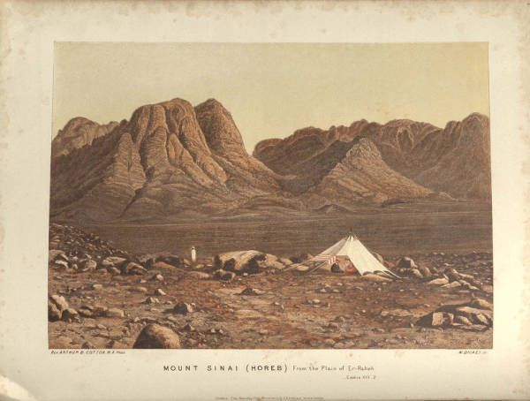

This image shows some of the “transjodanian wasteland” which, broadly construed, according to the NET translators referred to ones perspective from anywhere within view of the Jordan river valley - in this text, Moab.
Source: Public domain here https://www.pinterest.com/pin/462463455457059764/

Faith In Action

Pray
Ask the Holy Spirit to remind you of God's faithfulness in your life and to show you where you need to remember one of God's teachings.

Act
Today I will read and meditate upon the Word God has given me. I will pray and seek understanding so that my knowledge plus understanding will become wisdom. I will then apply that wisdom to my life. I will share what God does for me with a fellow Believer and together we will celebrate His Lordship of our lives.
Be Specific ________________________________________________

Monday (Deuteronomy 5)
The Opening Exhortation
5:1 Then Moses called all the people of Israel together and said to them: “Listen, Israel, to the statutes and ordinances that I am about to deliver to you today; learn them and be careful to keep them! 5:2 The Lord our God made a covenant with us at Horeb. 5:3 He did not make this covenant with our ancestors but with us, we who are here today, all of us living now. 5:4 The Lord spoke face to face with you at the mountain, from the middle of the fire. 5:5 (I was standing between the Lord and you at that time to reveal to you the message of the Lord, because you were afraid of the fire and would not go up the mountain.) He said:
The Ten Commandments
5:6 “I am the Lord your God, he who brought you from the land of Egypt, from the place of slavery. 5:7 You must not have any other gods besides me. 5:8 You must not make for yourself an image of anything in heaven above, on earth below, or in the waters beneath. 5:9 You must not worship or serve them, for I, the Lord your God, am a jealous God. I punish the sons, grandsons, and great-grandsons for the sin of the fathers who reject me, 5:10 but I show covenant faithfulness to the thousands who choose me and keep my commandments. 5:11 You must not make use of the name of the Lord your God for worthless purposes, for the Lord will not exonerate anyone who abuses his name that way. 5:12 Be careful to observe the Sabbath day just as the Lord your God has commanded you. 5:13 You are to work and do all your tasks in six days, 5:14 but the seventh day is the Sabbath of the Lord your God. On that day you must not do any work, you, your son, your daughter, your male slave, your female slave, your ox, your donkey, any other animal, or the foreigner who lives with you, so that your male and female slaves, like yourself, may have rest. 5:15 Recall that you were slaves in the land of Egypt and that the Lord your God brought you out of there by strength and power. That is why the Lord your God has commanded you to observe the Sabbath day. 5:16 Honor your father and your mother just as the Lord your God has commanded you to do, so that your days may be extended and that it may go well with you in the land that he is about to give you. 5:17 You must not murder. 5:18 You must not commit adultery. 5:19 You must not steal. 5:20 You must not offer false testimony against another. 5:21 You must not desire another man’s wife, nor should you crave his house, his field, his male and female servants, his ox, his donkey, or anything else he owns.”
The Narrative of the Sinai Revelation and Israel’s Response
5:22 The Lord said these things to your entire assembly at the mountain from the middle of the fire, the cloud, and the darkness with a loud voice, and that was all he said. Then he inscribed the words on two stone tablets and gave them to me. 5:23 Then, when you heard the voice from the midst of the darkness while the mountain was ablaze, all your tribal leaders and elders approached me. 5:24 You said, “The Lord our God has shown us his great glory and we have heard him speak from the middle of the fire. It is now clear to us that God can speak to human beings and they can keep on living. 5:25 But now, why should we die, because this intense fire will consume us! If we keep hearing the voice of the Lord our God we will die! 5:26 Who is there from the entire human race who has heard the voice of the living God speaking from the middle of the fire as we have, and has lived? 5:27 You go near so that you can hear everything the Lord our God is saying and then you can tell us whatever he says to you; then we will pay attention and do it.” 5:28 When the Lord heard you speaking to me, he said to me, “I have heard what these people have said to you – they have spoken well. 5:29 If only it would really be their desire to fear me and obey all my commandments in the future, so that it may go well with them and their descendants forever. 5:30 Go and tell them, ‘Return to your tents!’ 5:31 But as for you, remain here with me so I can declare to you all the commandments, statutes, and ordinances that you are to teach them, so that they can carry them out in the land I am about to give them.” 5:32 Be careful, therefore, to do exactly what the Lord your God has commanded you; do not turn right or left! 5:33 Walk just as he has commanded you so that you may live, that it may go well with you, and that you may live long in the land you are going to possess.

Prayer
Lord, You initiate a covenant we each Believer and ask us to respond in faithful trust and obedience. May my walk with You honor the terms of Your merciful covenant.

Scripture In Perspective
Moses reminded the people that God's covenant with them was not the one made with Abraham or anyone else but directly with them, communicated via him, and initiated only very recently at Horeb.
He reminded them that they were expected to learn and obey the terms of the covenant.
He reminded them that although near to God and the holy fire of His presence they were not consumed, and that even though he had been allowed to approach more-closely, he still had not been harmed.
He reminded them that the Lord God desired to bless them and that their responsibility to continue in His blessings was to obey.

Interact with the text

Consider
Theirs was a new covenant, one made just with them, and one they entered into voluntarily.

Discuss
Once Moses had reviewed the Commandments and the rest of the covenant how could the Israelites ever claim that they had an excuse for disobedience?

Reflect
With knowledge of God's expectations comes the responsibility to obey.

Share
When have you know the right thing to do but chosen to do otherwise?

KTALZ
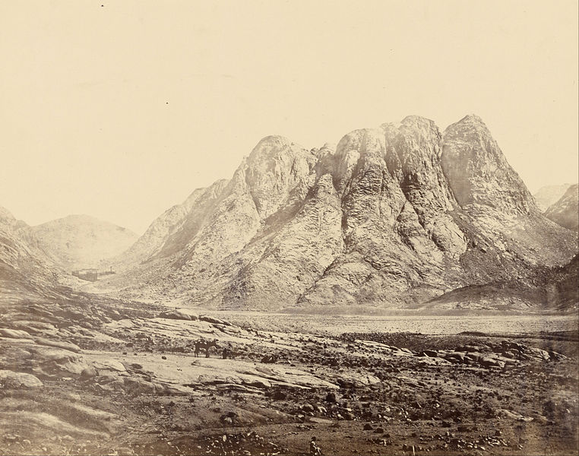

Moses continued to review history and God's future expectations.
Source: Public domain here: http://upload.wikimedia.org/wikipedia/commons/thumb/6/64/Francis_Frith_%28English_-_Mount_Horeb%2C_Sinai_-_Google_Art_Project.jpg/762px-Francis_Frith_%28English_-_Mount_Horeb%2C_Sinai_-_Google_Art_Project.jpg

Faith In Action

Pray
Ask the Holy Spirit to reveal to you in which part of His Word He wants you to invest additional study so that you will understand and obey Him more closely.

Act
Today I will take the time to pray, read, and pray again as I obtain greater knowledge of the Word of God and then I will humbly allow the Holy Spirit to lead me to understanding. I will apply His revealed wisdom to my life. I will share that experience with a fellow Believer.
Be Specific _____________________________________________

Tuesday (Deuteronomy 6)
Exhortation to Keep the Covenant Principles
6:1 Now these are the commandments, statutes, and ordinances that the Lord your God instructed me to teach you so that you may carry them out in the land where you are headed 6:2 and that you may so revere the Lord your God that you will keep all his statutes and commandments that I am giving you – you, your children, and your grandchildren – all your lives, to prolong your days. 6:3 Pay attention, Israel, and be careful to do this so that it may go well with you and that you may increase greatly in number – as the Lord, God of your ancestors, said to you, you will have a land flowing with milk and honey.
The Essence of the Covenant Principles
6:4 Listen, Israel: The Lord is our God, the Lord is one! 6:5 You must love the Lord your God with your whole mind, your whole being, and all your strength.
Exhortation to Teach the Covenant Principles
6:6 These words I am commanding you today must be kept in mind, 6:7 and you must teach them to your children and speak of them as you sit in your house, as you walk along the road, as you lie down, and as you get up. 6:8 You should tie them as a reminder on your forearm and fasten them as symbols on your forehead. 6:9 Inscribe them on the doorframes of your houses and gates.
Exhortation to Worship the Lord Exclusively
6:10 Then when the Lord your God brings you to the land he promised your ancestors Abraham, Isaac, and Jacob to give you – a land with large, fine cities you did not build, 6:11 houses filled with choice things you did not accumulate, hewn out cisterns you did not dig, and vineyards and olive groves you did not plant – and you eat your fill, 6:12 be careful not to forget the Lord who brought you out of Egypt, that place of slavery. 6:13 You must revere the Lord your God, serve him, and take oaths using only his name. 6:14 You must not go after other gods, those of the surrounding peoples, 6:15 for the Lord your God, who is present among you, is a jealous God and his anger will erupt against you and remove you from the land.
Exhortation to Obey the Lord Exclusively
6:16 You must not put the Lord your God to the test as you did at Massah. 6:17 Keep his commandments very carefully, as well as the stipulations and statutes he commanded you to observe. 6:18 Do whatever is proper and good before the Lord so that it may go well with you and that you may enter and occupy the good land that he promised your ancestors, 6:19 and that you may drive out all your enemies just as the Lord said.
Exhortation to Remember the Past
6:20 When your children ask you later on, “What are the stipulations, statutes, and ordinances that the Lord our God commanded you?” 6:21 you must say to them, “We were Pharaoh’s slaves in Egypt, but the Lord brought us out of Egypt in a powerful way. 6:22 And he brought signs and great, devastating wonders on Egypt, on Pharaoh, and on his whole family before our very eyes. 6:23 He delivered us from there so that he could give us the land he had promised our ancestors. 6:24 The Lord commanded us to obey all these statutes and to revere him so that it may always go well for us and he may preserve us, as he has to this day. 6:25 We will be innocent if we carefully keep all these commandments before the Lord our God, just as he demands.”

Prayer
Lord, You teach us the what, the why, and the how of life. May I accept the gift of understanding so that Your wisdom will guide my life.

Scripture In Perspective
Moses reminded Israel that “the land of milk and honey” would only be a lasting blessing if they learned and obeyed God's commands.
Moses delivered the Lord God's instruction that they teach the children and that they make every effort to keep God's teaching before themselves – literally posting it around their home and reciting it constantly – so that it was central to their lives.
Moses reminded them to worship and obey the Lord God only – and he reminded them of God's past response to their past forays into disobedient pagan worship.
Moses instructed them to memorize his review of God's miracle of exodus, of His provision, and of His protection - so that they might teach their children.

Interact With The Text

Consider
God's blessing is conditional; it is based upon obedience.

Discuss
With all that was ahead of them, fighting their way into the promised land, living in tents then settling-into permanent homes, how challenging must the instruction to keep God's Word constantly before them have been?

Reflect
Adults teaching the children would also help them to keep the Word in front of themselves.

Share
When have you observed that God's blessings flow more readily to you, and through you to others, when you have been obedient versus disobedient?

KTALZ
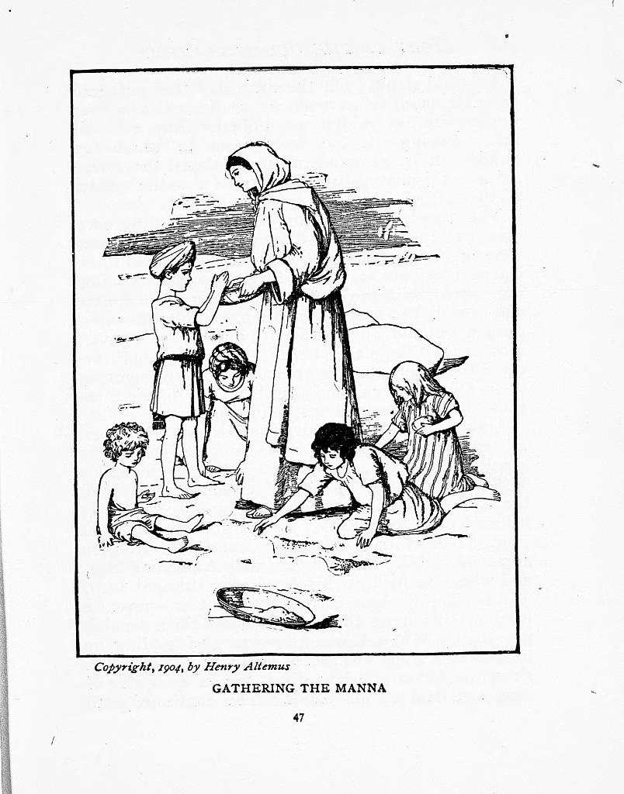

The children were to be well-instructed as to God's words, deeds, expectations, and promises.
Source: Public domain here http://homeschoolcommons.com/wp-content/uploads/2012/01/Gathering-the-manna.jpg

Faith In Action

Pray
Ask the Holy Spirit to show you where you might help to teach the children about God's Word.

Act
Today I will adjust my priorities and resources to be certain that I am both keeping God's Word before myself and I am helping to teach it to children, and to new “like a child” Believers, and to humble “like a child” older Believers alike.
Be Specific _________________________________________________

Wednesday (Deuteronomy 7 - 10)
The Dispossession of Nonvassals
7:1 When the Lord your God brings you to the land that you are going to occupy and forces out many nations before you – Hittites, Girgashites, Amorites, Canaanites, Perizzites, Hivites, and Jebusites, seven nations more numerous and powerful than you – 7:2 and he delivers them over to you and you attack them, you must utterly annihilate them. Make no treaty with them and show them no mercy! 7:3 You must not intermarry with them. Do not give your daughters to their sons or take their daughters for your sons, 7:4 for they will turn your sons away from me to worship other gods. Then the anger of the Lord will erupt against you and he will quickly destroy you. 7:5 Instead, this is what you must do to them: You must tear down their altars, shatter their sacred pillars, cut down their sacred Asherah poles, and burn up their idols. 7:6 For you are a people holy to the Lord your God. He has chosen you to be his people, prized above all others on the face of the earth.
The Basis of Israel’s Election
7:7 It is not because you were more numerous than all the other peoples that the Lord favored and chose you – for in fact you were the least numerous of all peoples. 7:8 Rather it is because of his love for you and his faithfulness to the promise he solemnly vowed to your ancestors that the Lord brought you out with great power, redeeming you from the place of slavery, from the power of Pharaoh king of Egypt. 7:9 So realize that the Lord your God is the true God, the faithful God who keeps covenant faithfully with those who love him and keep his commandments, to a thousand generations, 7:10 but who pays back those who hate him as they deserve and destroys them. He will not ignore those who hate him but will repay them as they deserve! 7:11 So keep the commandments, statutes, and ordinances that I today am commanding you to do.
Promises of Good for Covenant Obedience
7:12 If you obey these ordinances and are careful to do them, the Lord your God will faithfully keep covenant with you as he promised your ancestors. 7:13 He will love and bless you, and make you numerous. He will bless you with many children, with the produce of your soil, your grain, your new wine, your oil, the offspring of your oxen, and the young of your flocks in the land which he promised your ancestors to give you. 7:14 You will be blessed beyond all peoples; there will be no barrenness among you or your livestock. 7:15 The Lord will protect you from all sickness, and you will not experience any of the terrible diseases that you knew in Egypt; instead he will inflict them on all those who hate you.
Exhortation to Destroy Canaanite Paganism
7:16 You must destroy all the people whom the Lord your God is about to deliver over to you; you must not pity them or worship their gods, for that will be a snare to you. 7:17 If you think, “These nations are more numerous than I – how can I dispossess them?” 7:18 you must not fear them. You must carefully recall what the Lord your God did to Pharaoh and all Egypt, 7:19 the great judgments you saw, the signs and wonders, the strength and power by which he brought you out – thus the Lord your God will do to all the people you fear. 7:20 Furthermore, the Lord your God will release hornets among them until the very last ones who hide from you perish. 7:21 You must not tremble in their presence, for the Lord your God, who is present among you, is a great and awesome God. 7:22 He, the God who leads you, will expel the nations little by little. You will not be allowed to destroy them all at once lest the wild animals overrun you. 7:23 The Lord your God will give them over to you; he will throw them into a great panic until they are destroyed. 7:24 He will hand over their kings to you and you will erase their very names from memory. Nobody will be able to resist you until you destroy them. 7:25 You must burn the images of their gods, but do not covet the silver and gold that covers them so much that you take it for yourself and thus become ensnared by it; for it is abhorrent to the Lord your God. 7:26 You must not bring any abhorrent thing into your house and thereby become an object of divine wrath along with it. You must absolutely detest and abhor it, for it is an object of divine wrath.
The Lord’s Provision in the Desert
8:1 You must keep carefully all these commandments I am giving you today so that you may live, increase in number, and go in and occupy the land that the Lord promised to your ancestors. 8:2 Remember the whole way by which he has brought you these forty years through the desert so that he might, by humbling you, test you to see if you have it within you to keep his commandments or not. 8:3 So he humbled you by making you hungry and then feeding you with unfamiliar manna. He did this to teach you that humankind cannot live by bread alone, but also by everything that comes from the Lord’s mouth. 8:4 Your clothing did not wear out nor did your feet swell all these forty years. 8:5 Be keenly aware that just as a parent disciplines his child, the Lord your God disciplines you. 8:6 So you must keep his commandments, live according to his standards, and revere him. 8:7 For the Lord your God is bringing you to a good land, a land of brooks, springs, and fountains flowing forth in valleys and hills, 8:8 a land of wheat, barley, vines, fig trees, and pomegranates, of olive trees and honey, 8:9 a land where you may eat food in plenty and find no lack of anything, a land whose stones are iron and from whose hills you can mine copper. 8:10 You will eat your fill and then praise the Lord your God because of the good land he has given you.

Exhortation to Remember That Blessing Comes from God
8:11 Be sure you do not forget the Lord your God by not keeping his commandments, ordinances, and statutes that I am giving you today. 8:12 When you eat your fill, when you build and occupy good houses, 8:13 when your cattle and flocks increase, when you have plenty of silver and gold, and when you have abundance of everything, 8:14 be sure you do not feel self-important and forget the Lord your God who brought you from the land of Egypt, the place of slavery, 8:15 and who brought you through the great, fearful desert of venomous serpents and scorpions, an arid place with no water. He made water flow from a flint rock and 8:16 fed you in the desert with manna (which your ancestors had never before known) so that he might by humbling you test you and eventually bring good to you. 8:17 Be careful not to say, “My own ability and skill have gotten me this wealth.” 8:18 You must remember the Lord your God, for he is the one who gives ability to get wealth; if you do this he will confirm his covenant that he made by oath to your ancestors, even as he has to this day. 8:19 Now if you forget the Lord your God at all and follow other gods, worshiping and prostrating yourselves before them, I testify to you today that you will surely be annihilated. 8:20 Just like the nations the Lord is about to destroy from your sight, so he will do to you because you would not obey him.

Theological Justification of the Conquest
9:1 Listen, Israel: Today you are about to cross the Jordan so you can dispossess the nations there, people greater and stronger than you who live in large cities with extremely high fortifications. 9:2 They include the Anakites, a numerous and tall people whom you know about and of whom it is said, “Who is able to resist the Anakites?” 9:3 Understand today that the Lord your God who goes before you is a devouring fire; he will defeat and subdue them before you. You will dispossess and destroy them quickly just as he has told you. 9:4 Do not think to yourself after the Lord your God has driven them out before you, “Because of my own righteousness the Lord has brought me here to possess this land.” It is because of the wickedness of these nations that the Lord is driving them out ahead of you. 9:5 It is not because of your righteousness, or even your inner uprightness, that you have come here to possess their land. Instead, because of the wickedness of these nations the Lord your God is driving them out ahead of you in order to confirm the promise he made on oath to your ancestors, to Abraham, Isaac, and Jacob. 9:6 Understand, therefore, that it is not because of your righteousness that the Lord your God is about to give you this good land as a possession, for you are a stubborn people!
The History of Israel’s Stubbornness
9:7 Remember – don’t ever forget – how you provoked the Lord your God in the desert; from the time you left the land of Egypt until you came to this place you were constantly rebelling against him. 9:8 At Horeb you provoked him and he was angry enough with you to destroy you. 9:9 When I went up the mountain to receive the stone tablets, the tablets of the covenant that the Lord made with you, I remained there forty days and nights, eating and drinking nothing. 9:10 The Lord gave me the two stone tablets, written by the very finger of God, and on them was everything he said to you at the mountain from the midst of the fire at the time of that assembly. 9:11 Now at the end of the forty days and nights the Lord presented me with the two stone tablets, the tablets of the covenant. 9:12 And he said to me, “Get up, go down at once from here because your people whom you brought out of Egypt have sinned! They have quickly turned from the way I commanded them and have made for themselves a cast metal image.” 9:13 Moreover, he said to me, “I have taken note of these people; they are a stubborn lot! 9:14 Stand aside and I will destroy them, obliterating their very name from memory, and I will make you into a stronger and more numerous nation than they are.”
9:15 So I turned and went down the mountain while it was blazing with fire; the two tablets of the covenant were in my hands. 9:16 When I looked, you had indeed sinned against the Lord your God and had cast for yourselves a metal calf; you had quickly turned aside from the way he had commanded you! 9:17 I grabbed the two tablets, threw them down, and shattered them before your very eyes. 9:18 Then I again fell down before the Lord for forty days and nights; I ate and drank nothing because of all the sin you had committed, doing such evil before the Lord as to enrage him. 9:19 For I was terrified at the Lord’s intense anger that threatened to destroy you. But he listened to me this time as well. 9:20 The Lord was also angry enough at Aaron to kill him, but at that time I prayed for him too. 9:21 As for your sinful thing that you had made, the calf, I took it, melted it down, ground it up until it was as fine as dust, and tossed the dust into the stream that flows down the mountain. 9:22 Moreover, you continued to provoke the Lord at Taberah, Massah, and Kibroth-Hattaavah. 9:23 And when he sent you from Kadesh-Barnea and told you, “Go up and possess the land I have given you,” you rebelled against the Lord your God and would neither believe nor obey him. 9:24 You have been rebelling against him from the very first day I knew you!

Moses’ Plea on Behalf of the Lord’s Reputation
9:25 I lay flat on the ground before the Lord for forty days and nights, for he had said he would destroy you. 9:26 I prayed to him: O, Lord God, do not destroy your people, your valued property that you have powerfully redeemed, whom you brought out of Egypt by your strength. 9:27 Remember your servants Abraham, Isaac, and Jacob; ignore the stubbornness, wickedness, and sin of these people. 9:28 Otherwise the people of the land from which you brought us will say, “The Lord was unable to bring them to the land he promised them, and because of his hatred for them he has brought them out to kill them in the desert.” 9:29 They are your people, your valued property, whom you brought out with great strength and power.

The Opportunity to Begin Again
10:1 At that same time the Lord said to me, “Carve out for yourself two stone tablets like the first ones and come up the mountain to me; also make for yourself a wooden ark. 10:2 I will write on the tablets the same words that were on the first tablets you broke, and you must put them into the ark.” 10:3 So I made an ark of acacia wood and carved out two stone tablets just like the first ones. Then I went up the mountain with the two tablets in my hands. 10:4 The Lord then wrote on the tablets the same words, the ten commandments, which he had spoken to you at the mountain from the middle of the fire at the time of that assembly, and he gave them to me. 10:5 Then I turned, went down the mountain, and placed the tablets into the ark I had made – they are still there, just as the Lord commanded me.
Conclusion of the Historical Resume
10:6 “During those days the Israelites traveled from Beeroth Bene-Yaaqan to Moserah. There Aaron died and was buried, and his son Eleazar became priest in his place. 10:7 From there they traveled to Gudgodah, and from Gudgodah to Jotbathah, a place of flowing streams. 10:8 At that time the Lord set apart the tribe of Levi to carry the ark of the Lord’s covenant, to stand before the Lord to serve him, and to formulate blessings in his name, as they do to this very day. 10:9 Therefore Levi has no allotment or inheritance among his brothers; the Lord is his inheritance just as the Lord your God told him. 10:10 As for me, I stayed at the mountain as I did the first time, forty days and nights. The Lord listened to me that time as well and decided not to destroy you. 10:11 Then he said to me, “Get up, set out leading the people so they may go and possess the land I promised to give to their ancestors.”
An Exhortation to Love Both God and People
10:12 Now, Israel, what does the Lord your God require of you except to revere him, to obey all his commandments, to love him, to serve him with all your mind and being, 10:13 and to keep the Lord’s commandments and statutes that I am giving you today for your own good? 10:14 The heavens – indeed the highest heavens – belong to the Lord your God, as does the earth and everything in it. 10:15 However, only to your ancestors did he show his loving favor, and he chose you, their descendants, from all peoples – as is apparent today. 10:16 Therefore, cleanse your heart and stop being so stubborn! 10:17 For the Lord your God is God of gods and Lord of lords, the great, mighty, and awesome God who is unbiased and takes no bribe, 10:18 who justly treats the orphan and widow, and who loves resident foreigners, giving them food and clothing. 10:19 So you must love the resident foreigner because you were foreigners in the land of Egypt. 10:20 Revere the Lord your God, serve him, be loyal to him and take oaths only in his name. 10:21 He is the one you should praise; he is your God, the one who has done these great and awesome things for you that you have seen. 10:22 When your ancestors went down to Egypt, they numbered only seventy, but now the Lord your God has made you as numerous as the stars of the sky.

Prayer
Lord, Your power and Your holiness go together. May I never forget that You are a holy God. You provide for us in ways we rarely recognize. May I be ever-humble before You because I stand only in Your strength and I advance only in Your power. Everything belongs to You and yet You choose to pour Your love into us. May I remember that Your gift deserves the loving obedience of a grateful recipient.

Scripture In Perspective
Moses reminded the Israelites that the Lord God had kept them humble by meeting their need for food via the manna. That was His first step to then teach them that they did not live by bread alone but by every Word of God's teaching.
Moses told them that the promised land was filled with wonderful food and land and water.
He reminded them to always remember that all good things came from God and that to worship a false God would bring upon them the same annihilation He had prophesied upon those nations currently in the promised land.
He reminded them that it was the evil of the current occupants that caused them to be driven out, and that despite their physical size and number He would sweep them away before the Israelites.
He humbled them by informing them that it was not their righteousness that earned them access to the promised land but it was the Lord God's promise to their predecessors such as Abraham.
He further humbled them by reminding them of their persistent rebellion and stubbornness.
He concluded by reminding them that he had prayed on his face for forty days that the Lord would bring glory to His name by honoring His promises to Abraham, Isaac, and Jacob – despite the rebellion and stubbornness of the Israelites.
Moses reminded them of the circumstances surrounding the second set of tablets of the commandments - God's second chance for them following their terrible betrayal with the golden calf.
He also revisited the calling of the Levis, away from life as they had known it, and into the priesthood.
He reminded the people that their obligation to God was reverence, obedience, love, and service.
He challenged them to cleanse their hearts of the idolatry of tradition, and of the things of the world, and to cease from resisting God as He sought to be at the center of their lives.
Just as God was not required by His perfect justice to refrain from destroying Adam and Eve for their rebellion in the Garden, so also was it not required that He refrain from obliterating Israel – other than for the plea of Moses that they were useful in demonstrating both His power and His grace. (God had caused Moses as their leader to understand that.)
Moses delivered God's message that among those who must be driven from the promised land were seven nations which were bigger and stronger than they. He promised to deliver them to the Israelites but required them to obliterate those nations and to destroy all of their religious idols and temples. He forbade inter-marriage and warned against any contact with their pagan gods.

Interact With The Text

Consider
When God says to have no fear we may be certain that we have nothing to fear. God allowed the pagan peoples to occupy and work the promised land in order to prepare it for His people – He never intended for them to remain there. As worshipers of false gods, facades for the enemy, they were implacable enemies of the Lord God.

Discuss
Why would God remind them so many times to be careful to not drift into the beliefs and values of the pagans? How difficult might it have been for the proud and stubborn Israelites to hear God's rebuke through Moses, and to be humbled over and over therein? Why would God judge it necessary to repeatedly remind the Israelites of their humble standing, total dependence, and obligation to Him?

Reflect
God reminded them of their calling, not because they were a great nation, in order to keep them humble. God is always faithful to His sovereign prophesy even when we are rebellious and stubborn in areas of His moral/preferential (non-sovereign) will for us. It is apparent that religious practices and regulations were insufficient to keep the Israelites faithful, while they had multiplied in number from seventy to nearly a million, their hearts were clearly not yet His.

Share
When have you found yourself drifting away from God because you immersed yourself in too much of the world? When have you discovered God's faithfulness despite your lack of faith and your disobedience? When have you discovered that you have fallen into a religious practice but that your relationship with God was not growing there?

KTALZ
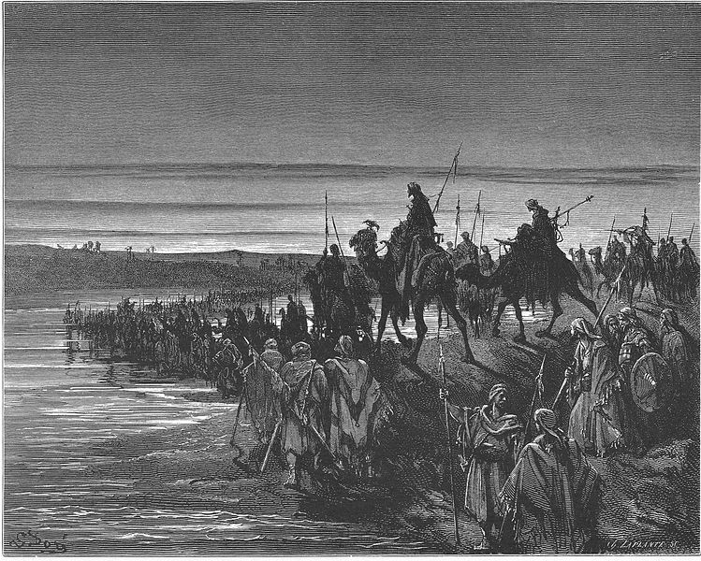

As the Israelite nation paused at the edge of the Jordan River God, through Moses, discipled them.
Source: Public domain here https://upload.wikimedia.org/wikipedia/commons/thumb/f/fe/044._The_Israelites_Cross_the_Jordan_River.jpg/749px-044._The_Israelites_Cross_the_Jordan_River.jpg

Faith In Action

Pray
Ask the Holy Spirit to show you one place or thing or perhaps person(s) that you need to remove from your life because it or they are drawing you away from God, to show you where you may need to be more humble before Him, and to reveal to you a place in your walk where you need to make a more intentional effort to allow Him to have Lordship - where you are currently resisting Him.

Act
Today I will consult a fellow Believer, who meets the Biblical requirement of an elder, to prayerfully review my priorities to discover what it is the Holy Spirit needs me to change. I will pray for the courage to make that change, no matter the cost. I will read these verses again and reflect upon those areas in my life where I tend to be rebellious and stubborn toward God's perfect moral/preferential will for my life. I will make a list and agree to pray for the Holy Spirit to guide me back on the right path – the path of God's blessing. I will surrender that place in my life where the Holy Spirit does not yet have full Lordship. I will share this with a fellow believer for accountability and for prayer.
Be Specific ________________________________________________

Thursday (Deuteronomy 11 - 12)
Reiteration of the Call to Obedience
11:1 You must love the Lord your God and do what he requires; keep his statutes, ordinances, and commandments at all times.
11:2 Bear in mind today that I am not speaking to your children who have not personally experienced the judgments of the Lord your God, which revealed his greatness, strength, and power.
11:3 They did not see the awesome deeds he performed in the midst of Egypt against Pharaoh king of Egypt and his whole land, 11:4 or what he did to the army of Egypt, including their horses and chariots, when he made the waters of the Red Sea overwhelm them while they were pursuing you and he annihilated them.
11:5 They did not see what he did to you in the desert before you reached this place, 11:6 or what he did to Dathan and Abiram, sons of Eliab the Reubenite, when the earth opened its mouth in the middle of the Israelite camp and swallowed them, their families, their tents, and all the property they brought with them.
11:7 I am speaking to you because you are the ones who saw all the great deeds of the Lord!

The Abundance of the Land of Promise
11:8 Now pay attention to all the commandments I am giving you today, so that you may be strong enough to enter and possess the land where you are headed, 11:9 and that you may enjoy long life in the land the Lord promised to give to your ancestors and their descendants, a land flowing with milk and honey.
11:10 For the land where you are headed is not like the land of Egypt from which you came, a land where you planted seed and which you irrigated by hand like a vegetable garden.
11:11 Instead, the land you are crossing the Jordan to occupy is one of hills and valleys, a land that drinks in water from the rains, 11:12 a land the Lord your God looks after. He is constantly attentive to it from the beginning to the end of the year.
11:13 Now, if you pay close attention to my commandments that I am giving you today and love the Lord your God and serve him with all your mind and being, 11:14 then he promises, “I will send rain for your land in its season, the autumn and the spring rains, so that you may gather in your grain, new wine, and olive oil. 11:15 I will provide pasture for your livestock and you will eat your fill.”

Exhortation to Instruction and Obedience
11:16 Make sure you do not turn away to serve and worship other gods! 11:17 Then the anger of the Lord will erupt against you and he will close up the sky so that it does not rain. The land will not yield its produce, and you will soon be removed from the good land that the Lord is about to give you.
11:18 Fix these words of mine into your mind and being, and tie them as a reminder on your hands and let them be symbols on your forehead.
11:19 Teach them to your children and speak of them as you sit in your house, as you walk along the road, as you lie down, and as you get up.
11:20 Inscribe them on the doorframes of your houses and on your gates 11:21 so that your days and those of your descendants may be extended in the land which the Lord promised to give to your ancestors, like the days of heaven itself. 11:22 For if you carefully observe all of these commandments I am giving you and love the Lord your God, live according to his standards, and remain loyal to him, 11:23 then he will drive out all these nations ahead of you, and you will dispossess nations greater and stronger than you.
11:24 Every place you set your foot will be yours; your border will extend from the desert to Lebanon and from the River (that is, the Euphrates) as far as the Mediterranean Sea.
11:25 Nobody will be able to resist you; the Lord your God will spread the fear and terror of you over the whole land on which you walk, just as he promised you.

Anticipation of a Blessing and Cursing Ceremony
11:26 Take note – I am setting before you today a blessing and a curse: 11:27 the blessing if you take to heart the commandments of the Lord your God that I am giving you today, 11:28 and the curse if you pay no attention to his commandments and turn from the way I am setting before you today to pursue other gods you have not known.
11:29 When the Lord your God brings you into the land you are to possess, you must pronounce the blessing on Mount Gerizim and the curse on Mount Ebal. 11:30 Are they not across the Jordan River, toward the west, in the land of the Canaanites who live in the Arabah opposite Gilgal near the oak of Moreh?
11:31 For you are about to cross the Jordan to possess the land the Lord your God is giving you, and you will possess and inhabit it.
11:32 Be certain to keep all the statutes and ordinances that I am presenting to you today.

The Central Sanctuary
12:1 These are the statutes and ordinances you must be careful to obey as long as you live in the land the Lord, the God of your ancestors, has given you to possess.
12:2 You must by all means destroy all the places where the nations you are about to dispossess worship their gods – on the high mountains and hills and under every leafy tree.
12:3 You must tear down their altars, shatter their sacred pillars, burn up their sacred Asherah poles, and cut down the images of their gods; you must eliminate their very memory from that place.
12:4 You must not worship the Lord your God the way they worship.
12:5 But you must seek only the place he chooses from all your tribes to establish his name as his place of residence, and you must go there. 12:6 And there you must take your burnt offerings, your sacrifices, your tithes, the personal offerings you have prepared, your votive offerings, your freewill offerings, and the firstborn of your herds and flocks.
12:7 Both you and your families must feast there before the Lord your God and rejoice in all the output of your labor with which he has blessed you.
12:8 You must not do like we are doing here today, with everyone doing what seems best to him, 12:9 for you have not yet come to the final stop and inheritance the Lord your God is giving you.
12:10 When you do go across the Jordan River and settle in the land he is granting you as an inheritance and you find relief from all the enemies who surround you, you will live in safety.
12:11 Then you must come to the place the Lord your God chooses for his name to reside, bringing everything I am commanding you – your burnt offerings, sacrifices, tithes, the personal offerings you have prepared, and all your choice votive offerings which you devote to him.
12:12 You shall rejoice in the presence of the Lord your God, along with your sons, daughters, male and female servants, and the Levites in your villages (since they have no allotment or inheritance with you).
12:13 Make sure you do not offer burnt offerings in any place you wish, 12:14 for you may do so only in the place the Lord chooses in one of your tribal areas – there you may do everything I am commanding you.

Regulations for Profane Slaughter
12:15 On the other hand, you may slaughter and eat meat as you please when the Lord your God blesses you in all your villages. Both the ritually pure and impure may eat it, whether it is a gazelle or an ibex.
12:16 However, you must not eat blood – pour it out on the ground like water. 12:17 You will not be allowed to eat in your villages your tithe of grain, new wine, olive oil, the firstborn of your herd and flock, any votive offerings you have vowed, or your freewill and personal offerings.
12:18 Only in the presence of the Lord your God may you eat these, in the place he chooses. This applies to you, your son, your daughter, your male and female servants, and the Levites in your villages. In that place you will rejoice before the Lord your God in all the output of your labor.
12:19 Be careful not to overlook the Levites as long as you live in the land.

The Sanctity of Blood
12:20 When the Lord your God extends your borders as he said he would do and you say, “I want to eat meat just as I please,” you may do so as you wish. 12:21 If the place he chooses to locate his name is too far for you, you may slaughter any of your herd and flock he has given you just as I have stipulated; you may eat them in your villages just as you wish. 12:22 Like you eat the gazelle or ibex, so you may eat these; the ritually impure and pure alike may eat them. 12:23 However, by no means eat the blood, for the blood is life itself – you must not eat the life with the meat! 12:24 You must not eat it! You must pour it out on the ground like water. 12:25 You must not eat it so that it may go well with you and your children after you; you will be doing what is right in the Lord’s sight. 12:26 Only the holy things and votive offerings that belong to you, you must pick up and take to the place the Lord will choose.
12:27 You must offer your burnt offerings, both meat and blood, on the altar of the Lord your God; the blood of your other sacrifices you must pour out on his altar while you eat the meat.
12:28 Pay careful attention to all these things I am commanding you so that it may always go well with you and your children after you when you do what is good and right in the sight of the Lord your God.

The Abomination of Pagan Gods
12:29 When the Lord your God eliminates the nations from the place where you are headed and you dispossess them, you will settle down in their land.
12:30 After they have been destroyed from your presence, be careful not to be ensnared like they are; do not pursue their gods and say, “How do these nations serve their gods? I will do the same.”
12:31 You must not worship the Lord your God the way they do! For everything that is abhorrent to him, everything he hates, they have done when worshiping their gods. They even burn up their sons and daughters before their gods!
Idolatry and False Prophets
12:32 (13:1) You must be careful to do everything I am commanding you. Do not add to it or subtract from it!

Prayer
Lord, You chose to bless Israel, just as You choose to bless us today. May I be both grateful and faithful to You.

Scripture In Perspective
Moses was addressing those who were not of military age at the time of the rebellion against God's first call to enter the promised land (because they were too young) but who were still old enough to remember to remember the pre-Exodus events in Egypt and all that followed. (The others were either too young to remember or dead.)
If they were under the age of 20 then they'd have been 59 or younger following 40 years after the time of punishment-wandering.
They were reminded again that God desired to bless them greatly in a “land of milk and honey” which He would cause to provide for them abundantly, almost like the Garden of Eden.
They were reminded of God's promise to empty the land of the current temporary occupants and to protect them, as well as to bless the produce of the land, but only as long as they remained faithful to Him (including teaching their children to know and to do the same). Otherwise they would lose all of those blessings.
Moses instructed them that as they entered the land they were to conduct a ceremony where they announced blessings from Mount Gerizim and curses from Mount Ebal, on opposite sides of the Jordan. This would be yet one more symbolic reminder of their responsibility to be faithful in return for God's intervention in an otherwise hostile environment.
They were instructed to destroy every place of pagan worship and to worship the Lord God only in the single location He directed for their tribe.
If they wished to eat of their offerings they must first bring them to the central place of worship and surrender them to God through the priests – and in that place they could join in the eating of them. They may, however eat meat, not of the firstborn for the offering, anywhere – but to never eat the blood as that was symbolic of life.
They were reminded again to avoid the pagan false gods and to not try to mix the way they worship the Lord God with the way the pagans worshiped their false gods (the technical term is "syncretism"). They were reminded again to not alter any of God's teaching; to neither add to or subtract from it.

Interact With The Text

Consider
Blessings for obedience, curses for disobedience – repeated again and again by God – knowing that they were a “stiff-necked” (stubborn) people.

Discuss
Do you see the continuum of God's Word here? From the description of an Eden-like land, to the law of blessing vs curse, to the symbolism of life in blood (Jesus on the Cross), and to the warning to not alter the meaning of His Word in any way (Rev. 22:18-19)?

Reflect
Once again God warned the Israelites to alter nothing about His teaching; neither to add nor to subtract, nor to sell-out in even small ways to the pagans around them.

Share
When have you found yourself teaching those who are younger in age, or 'younger' in their Christian walk, about things that you learned and/or experienced from the past – information which you paired with knowledge so that they would have the wisdom to walk rightly before the Lord God?

KTALZ
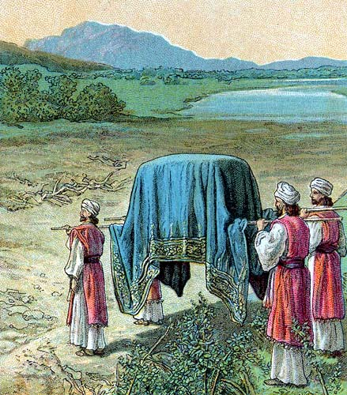

The Promised Land was beautiful and fruitful – a gift to the Israelites that God would protect only if they remained faithful.
Source: Public domain here http://upload.wikimedia.org/wikipedia/commons/4/46/Israel_Enters_the_Promised_Land.jpg

Faith In Action

Pray
Ask the Holy Spirit to show you a place in your walk where you have an incomplete or incorrect understanding of something in His Word.

Act
Today I will accept the challenge of the Holy Spirit to re-examine my understanding of something I have misunderstood in the Word of God. I will prayerfully surrender to His leading toward greater understanding. I will consult those who are Biblically-qualified as “elders” and seek their counsel and prayers toward my understanding. I will praise the Lord!
Be Specific _____________________________________________

Friday (Deuteronomy 13 - 14)
13:1 Suppose a prophet or one who foretells by dreams should appear among you and show you a sign or wonder, 13:2 and the sign or wonder should come to pass concerning what he said to you, namely, “Let us follow other gods” – gods whom you have not previously known – “and let us serve them.”
13:3 You must not listen to the words of that prophet or dreamer, for the Lord your God will be testing you to see if you love him with all your mind and being.
13:4 You must follow the Lord your God and revere only him; and you must observe his commandments, obey him, serve him, and remain loyal to him.
13:5 As for that prophet or dreamer, he must be executed because he encouraged rebellion against the Lord your God who brought you from the land of Egypt, redeeming you from that place of slavery, and because he has tried to entice you from the way the Lord your God has commanded you to go. In this way you must purge out evil from within.

False Prophets in the Family
13:6 Suppose your own full brother, your son, your daughter, your beloved wife, or your closest friend should seduce you secretly and encourage you to go and serve other gods that neither you nor your ancestors have previously known, 13:7 the gods of the surrounding people (whether near you or far from you, from one end of the earth to the other).
13:8 You must not give in to him or even listen to him; do not feel sympathy for him or spare him or cover up for him.
13:9 Instead, you must kill him without fail! Your own hand must be the first to strike him, and then the hands of the whole community.
13:10 You must stone him to death because he tried to entice you away from the Lord your God, who delivered you from the land of Egypt, that place of slavery. 13:11 Thus all Israel will hear and be afraid; no longer will they continue to do evil like this among you.

Punishment of Community Idolatry
13:12 Suppose you should hear in one of your cities, which the Lord your God is giving you as a place to live, that 13:13 some evil people have departed from among you to entice the inhabitants of their cities, saying, “Let’s go and serve other gods” (whom you have not known before).
13:14 You must investigate thoroughly and inquire carefully. If it is indeed true that such a disgraceful thing is being done among you, 13:15 you must by all means slaughter the inhabitants of that city with the sword; annihilate with the sword everyone in it, as well as the livestock. 13:16 You must gather all of its plunder into the middle of the plaza and burn the city and all its plunder as a whole burnt offering to the Lord your God. It will be an abandoned ruin forever – it must never be rebuilt again. 13:17 You must not take for yourself anything that has been placed under judgment. Then the Lord will relent from his intense anger, show you compassion, have mercy on you, and multiply you as he promised your ancestors.
13:18 Thus you must obey the Lord your God, keeping all his commandments that I am giving you today and doing what is right before him.

The Holy and the Profane
14:1 You are children of the Lord your God. Do not cut yourselves or shave your forehead bald for the sake of the dead. 14:2 For you are a people holy to the Lord your God. He has chosen you to be his people, prized above all others on the face of the earth.
14:3 You must not eat any forbidden thing. 14:4 These are the animals you may eat: the ox, the sheep, the goat, 14:5 the ibex, the gazelle, the deer, the wild goat, the antelope, the wild oryx, and the mountain sheep. 14:6 You may eat any animal that has hooves divided into two parts and that chews the cud. 14:7 However, you may not eat the following animals among those that chew the cud or those that have divided hooves: the camel, the hare, and the rock badger. (Although they chew the cud, they do not have divided hooves and are therefore ritually impure to you). 14:8 Also the pig is ritually impure to you; though it has divided hooves, it does not chew the cud. You may not eat their meat or even touch their remains.
14:9 These you may eat from among water creatures: anything with fins and scales you may eat, 14:10 but whatever does not have fins and scales you may not eat; it is ritually impure to you.
14:11 All ritually clean birds you may eat. 14:12 These are the ones you may not eat: the eagle, the vulture, the black vulture, 14:13 the kite, the black kite, the dayyah after its species, 14:14 every raven after its species, 14:15 the ostrich, the owl, the seagull, the falcon after its species, 14:16 the little owl, the long-eared owl, the white owl, 14:17 the jackdaw, the carrion vulture, the cormorant, 14:18 the stork, the heron after its species, the hoopoe, the bat, 14:19 and any winged thing on the ground are impure to you – they may not be eaten.
14:20 You may eat any clean bird.
14:21 You may not eat any corpse, though you may give it to the resident foreigner who is living in your villages and he may eat it, or you may sell it to a foreigner. You are a people holy to the Lord your God. Do not boil a young goat in its mother’s milk.

The Offering of Tribute
14:22 You must be certain to tithe all the produce of your seed that comes from the field year after year. 14:23 In the presence of the Lord your God you must eat from the tithe of your grain, your new wine, your olive oil, and the firstborn of your herds and flocks in the place he chooses to locate his name, so that you may learn to revere the Lord your God always.
14:24 When he blesses you, if the place where he chooses to locate his name is distant, 14:25 you may convert the tithe into money, secure the money, and travel to the place the Lord your God chooses for himself. 14:26 Then you may spend the money however you wish for cattle, sheep, wine, beer, or whatever you desire. You and your household may eat there in the presence of the Lord your God and enjoy it.
14:27 As for the Levites in your villages, you must not ignore them, for they have no allotment or inheritance along with you.
14:28 At the end of every three years you must bring all the tithe of your produce, in that very year, and you must store it up in your villages. 14:29 Then the Levites (because they have no allotment or inheritance with you), the resident foreigners, the orphans, and the widows of your villages may come and eat their fill so that the Lord your God may bless you in all the work you do.

Prayer
Lord, protecting Your sovereign truth among Your people was always a high priority. May I be vigilant in my life, and my fellowships, in resisting false teaching.

Scripture In Perspective
False prophets, despite the appearance of miracles, were to be executed to keep them from misleading the people away from the Lord God.
Loved-ones who promoted any false religion were to be killed.
A city, town, or village that turned away from God and to a false god was to be utterly destroyed; everyone and everything in it piled up and burned as an offering to God.
The regulations as to clean and unclean food were reviewed as well together with the eating of offerings.

Interact With The Text

Consider
A false prophet is an emissary of Satan.

Discuss
Did it not make sense that if someone came to deceive people into leaving the one true God in favor of a false God that they were mortal enemies, the same as an attacking warrior?

Reflect
Merely because the deceiver is a family member or loved one does not make them any less an enemy of truth and light and genuine eternal hope. Some religious traditions, not Biblically-based, may be false – one must test all things against the Word of God.

Share
When have you experienced or observed the impact of a false prophet or teacher in a fellowship? What was the result?

KTALZ
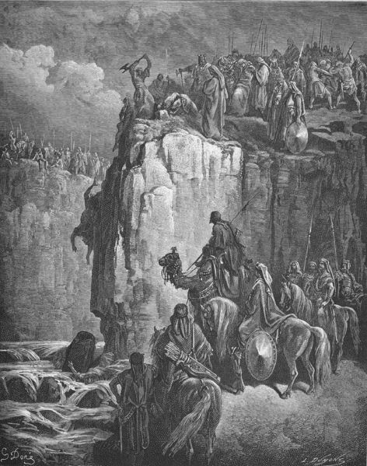

Just as the false prophets of Baal were shown to be frauds, then killed, so also were other who would lead the Israelites away from the one true God of eternal freedom.
Source: Public domain here http://upload.wikimedia.org/wikipedia/commons/thumb/2/26/090.The_Prophets_of_Baal_Are_Slaughtered.jpg/472px-090.The_Prophets_of_Baal_Are_Slaughtered.jpg

Faith In Action

Pray
Ask the Holy Spirit to reveal to you a promoter of false teaching; it may be someone in your fellowship, at work, in school, on the Internet, on the radio, or on the television.

Act
Today I will acknowledge the truth of God versus false teaching. Insofar as I am able I will communicate the Biblical alternative to the falsehoods, which the Holy Spirit (and the Word) reveals to me, to the false teacher. If he or she is not repentant then I will communicate their refusal to repent to the appropriate theological authorities (denominational or associational leaders). If they are either not under authority, or their authority shares their false message, I will communicate the falsehood to Believers and also to those considering-Christ, via whatever means is available.
Be Specific _____________________________________________

Saturday (Deuteronomy 15 - 16)
Release for Debt Slaves
15:1 At the end of every seven years you must declare a cancellation of debts. 15:2 This is the nature of the cancellation: Every creditor must remit what he has loaned to another person; he must not force payment from his fellow Israelite, for it is to be recognized as “the Lord’s cancellation of debts.”
15:3 You may exact payment from a foreigner, but whatever your fellow Israelite owes you, you must remit.
15:4 However, there should not be any poor among you, for the Lord will surely bless you in the land that he is giving you as an inheritance, 15:5 if you carefully obey him by keeping all these commandments that I am giving you today. 15:6 For the Lord your God will bless you just as he has promised; you will lend to many nations but will not borrow from any, and you will rule over many nations but they will not rule over you.

The Spirit of Liberality
15:7 If a fellow Israelite from one of your villages in the land that the Lord your God is giving you should be poor, you must not harden your heart or be insensitive to his impoverished condition.
15:8 Instead, you must be sure to open your hand to him and generously lend him whatever he needs.
15:9 Be careful lest you entertain the wicked thought that the seventh year, the year of cancellation of debts, has almost arrived, and your attitude be wrong toward your impoverished fellow Israelite and you do not lend him anything; he will cry out to the Lord against you and you will be regarded as having sinned. 15:10 You must by all means lend to him and not be upset by doing it, for because of this the Lord your God will bless you in all your work and in everything you attempt.
15:11 There will never cease to be some poor people in the land; therefore, I am commanding you to make sure you open your hand to your fellow Israelites who are needy and poor in your land.

Release of Debt Slaves
15:12 If your fellow Hebrew – whether male or female – is sold to you and serves you for six years, then in the seventh year you must let that servant go free.
15:13 If you set them free, you must not send them away empty-handed. 15:14 You must supply them generously from your flock, your threshing floor, and your winepress – as the Lord your God has blessed you, you must give to them. 15:15 Remember that you were a slave in the land of Egypt and the Lord your God redeemed you; therefore, I am commanding you to do this thing today. 15:16 However, if the servant says to you, “I do not want to leave you,” because he loves you and your household, since he is well off with you, 15:17 you shall take an awl and pierce a hole through his ear to the door. Then he will become your servant permanently (this applies to your female servant as well).
15:18 You should not consider it difficult to let him go free, for he will have served you for six years, twice the time of a hired worker; the Lord your God will bless you in everything you do.

Giving God the Best
15:19 You must set apart for the Lord your God every firstborn male born to your herds and flocks. You must not work the firstborn of your bulls or shear the firstborn of your flocks. 15:20 You and your household must eat them annually before the Lord your God in the place he chooses.
15:21 If they have any kind of blemish – lameness, blindness, or anything else – you may not offer them as a sacrifice to the Lord your God. 15:22 You may eat it in your villages, whether you are ritually impure or clean, just as you would eat a gazelle or an ibex. 15:23 However, you must not eat its blood; you must pour it out on the ground like water.

The Passover-Unleavened Bread Festival
16:1 Observe the month Abib and keep the Passover to the Lord your God, for in that month he brought you out of Egypt by night. 16:2 You must sacrifice the Passover animal (from the flock or the herd) to the Lord your God in the place where he chooses to locate his name.
16:3 You must not eat any yeast with it; for seven days you must eat bread made without yeast, symbolic of affliction, for you came out of Egypt hurriedly. You must do this so you will remember for the rest of your life the day you came out of the land of Egypt. 16:4 There must not be a scrap of yeast within your land for seven days, nor can any of the meat you sacrifice on the evening of the first day remain until the next morning.
16:5 You may not sacrifice the Passover in just any of your villages that the Lord your God is giving you, 16:6 but you must sacrifice it in the evening in the place where he chooses to locate his name, at sunset, the time of day you came out of Egypt.
16:7 You must cook and eat it in the place the Lord your God chooses; you may return the next morning to your tents. 16:8 You must eat bread made without yeast for six days. The seventh day you are to hold an assembly for the Lord your God; you must not do any work on that day.

The Festival of Weeks
16:9 You must count seven weeks; you must begin to count them from the time you begin to harvest the standing grain. 16:10 Then you are to celebrate the Festival of Weeks before the Lord your God with the voluntary offering that you will bring, in proportion to how he has blessed you.
16:11 You shall rejoice before him – you, your son, your daughter, your male and female slaves, the Levites in your villages, the resident foreigners, the orphans, and the widows among you – in the place where the Lord chooses to locate his name. 16:12 Furthermore, remember that you were a slave in Egypt, and so be careful to observe these statutes.

The Festival of Temporary Shelters
16:13 You must celebrate the Festival of Temporary Shelters for seven days, at the time of the grain and grape harvest. 16:14 You are to rejoice in your festival, you, your son, your daughter, your male and female slaves, the Levites, the resident foreigners, the orphans, and the widows who are in your villages.
16:15 You are to celebrate the festival seven days before the Lord your God in the place he chooses, for he will bless you in all your productivity and in whatever you do; so you will indeed rejoice!
16:16 Three times a year all your males must appear before the Lord your God in the place he chooses for the Festival of Unleavened Bread, the Festival of Weeks, and the Festival of Temporary Shelters; and they must not appear before him empty-handed.
16:17 Every one of you must give as you are able, according to the blessing of the Lord your God that he has given you.

Provision for Justice
16:18 You must appoint judges and civil servants for each tribe in all your villages that the Lord your God is giving you, and they must judge the people fairly.
16:19 You must not pervert justice or show favor. Do not take a bribe, for bribes blind the eyes of the wise and distort the words of the righteous.
16:20 You must pursue justice alone so that you may live and inherit the land the Lord your God is giving you.

Examples of Legal Cases
16:21 You must not plant any kind of tree as a sacred Asherah pole near the altar of the Lord your God which you build for yourself. 16:22 You must not erect a sacred pillar, a thing the Lord your God detests.

Prayer
Lord, you anticipate our foolishness and provide ways that we may assist one-another. May I listen for Your invitation to be Your conduit of blessing to fellow believers.

Scripture In Perspective
Every seven years creditors were to cancel all debts owed to fellow Israelites. If the people were faithful then there would be no poor as God would be blessing them.
There was a requirement that those who have debts must keep current on their payments, in this way someone could not incur a debt and fail to pay for seven years only to then expect to be released from the obligation without out any prior effort to repay.
Foreigners were not included in the seven-year debt cancellation, this was only for God's family of Israelites.
Loans to fellow Israelites in need were to be given generously as God promised to bless those who did so. They were also not to worry, even if the 7 year forgiveness date was near, as God would bless them for doing so - even then.
Debt servants were to be set free with gifts from flocks and other resources. If they chose to remain, because of an emotional-attachment to the family, then an awl-hole in their ear would mark them as a permanent slave.
The Israelites were reminded that all sacrifices were to be from the first and the best, the unblemished. They were also reminded of the various festivals.
The Lord God provided for a system of justice, one that was to be free of bribery and/or favoritism, and for the right of appeal to a higher court from among the Levitical priests.

Interact With The Text

Consider
There would be no poor Israelites if all Israelites obeyed the Lord.

Discuss
Would it not require great faith and trust in God to loan a person money near to a 7 year cancellation of debts?

Reflect
A slave, despite the opportunity to go free with animals and other resources – free to start anew – might actually become so attached to his or her master's family that they'd choose to remain a slave to them permanently.

Share
When have you assisted or been assisted by a fellow Believer who had no expectation that you could every repay them?

KTALZ
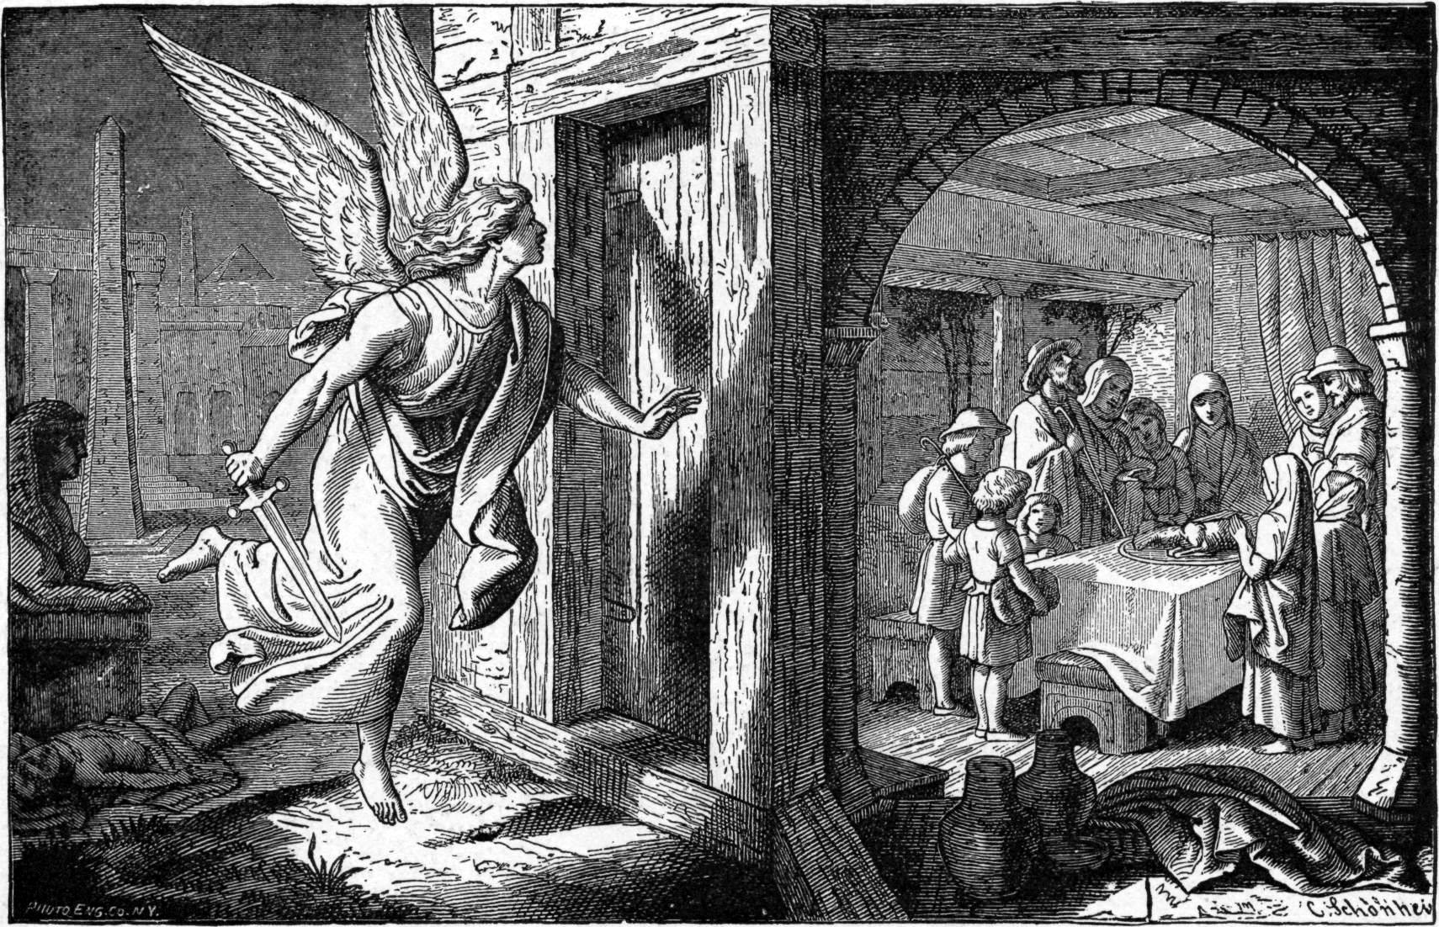

Among the festivals the Lord God requires the Israelites to remember was the passover.
Source: Public domain here http://upload.wikimedia.org/wikipedia/commons/3/34/Foster_Bible_Pictures_0062-1_The_Angel_of_Death_and_the_First_Passover.jpg

Faith In Action

Pray
Ask the Holy Spirit to show you an opportunity to bless someone with generous assistance, in their time of need, from the resources that God has generously given to you.

Act
Today I will prayerfully, and as-needed in consultation with one or more who are Biblically-qualified as elders, discern a legitimate need for assistance to a brother or sister in the Lord. I will wisely assist them, which may mean paying a bill rather than giving money, as sometimes people are not themselves wise in handling their funds; however, as I have good cause to trust them then I will give them money to use as they deem best. My assistance may instead be fixing something, providing transportation, spending time in encouragement, prayer, food, child care, or other need-meeting sacrifice of my time and physical resources. I will share a report of God's blessing to them poured-out through me, not as a testimony to me but to Him.
Be Specific _________________________________________________

All Bible text is from the NET unless otherwise indicated - http://bible.org
Note 1: These Studies often rely upon the guidance of the NET Translators from their associated notes. Careful attention has been given to cite that source where it has been quoted directly or closely paraphrased. Feedback is encouraged where credit has not been sufficiently assigned.
Note 2: When NET text is quoted in commentary and discussion all pronouns referring to God are capitalized, though they are lower-case in the original NET text.
Commentary text is from David M. Colburn, D.Min. unless otherwise noted.
Copyright © 2012 by David M. Colburn. This is a BibleSeven Study –“Genesis 3. Prepared by David M. Colburn and edited for bible.org in August of 2012. This text may be used for non-profit educational purposes only, with credit; all other usage requires prior written consent of the author.

