ACTS
David M. Colburn
A Daily Bible Study in 7-Day Sections with a
Summary-Commentary, Discussion Questions, and Daily Application
Week One of Five
Acts 1-5

Book Introduction

The author of the Book of Acts is generally considered to have been Luke. It is addressed to Theophilus, the same as the Book of Luke. "Theophilus" translates to "friend of God" and because of Luke's manner of address "the most excellent" Theophilus is thought to have been a Roman of some stature, perhaps an military officer or a high official.
Jesus had been crucified and resurrected and at the end of the four Gospels had ascended back to His home in Heaven. The Apostles, disciples, believers, observers, and religious leaders were left to sort out what had happened and what it meant.

Sunday (Acts 1)
Jesus Ascends to Heaven
1:1 I wrote the former account, Theophilus, about all that Jesus began to do and teach 1:2 until the day he was taken up to heaven, after he had given orders by the Holy Spirit to the apostles he had chosen.
1:3 To the same apostles also, after his suffering, he presented himself alive with many convincing proofs. He was seen by them over a forty-day period and spoke about matters concerning the kingdom of God.
1:4 While he was with them, he declared, “Do not leave Jerusalem, but wait there for what my Father promised, which you heard about from me. 1:5 For John baptized with water, but you will be baptized with the Holy Spirit not many days from now.”
1:6 So when they had gathered together, they began to ask him, “Lord, is this the time when you are restoring the kingdom to Israel?” 1:7 He told them, “You are not permitted to know the times or periods that the Father has set by his own authority. 1:8 But you will receive power when the Holy Spirit has come upon you, and you will be my witnesses in Jerusalem, and in all Judea and Samaria, and to the farthest parts of the earth.”
1:9 After he had said this, while they were watching, he was lifted up and a cloud hid him from their sight. 1:10 As they were still staring into the sky while he was going, suddenly two men in white clothing stood near them 1:11 and said, “Men of Galilee, why do you stand here looking up into the sky? This same Jesus who has been taken up from you into heaven will come back in the same way you saw him go into heaven.”
A Replacement for Judas is Chosen
1:12 Then they returned to Jerusalem from the mountain called the Mount of Olives (which is near Jerusalem, a Sabbath day’s journey away). 1:13 When they had entered Jerusalem, they went to the upstairs room where they were staying. Peter and John, and James, and Andrew, Philip and Thomas, Bartholomew and Matthew, James son of Alphaeus and Simon the Zealot, and Judas son of James were there.
1:14 All these continued together in prayer with one mind, together with the women, along with Mary the mother of Jesus, and his brothers.
1:15 In those days Peter stood up among the believers (a gathering of about one hundred and twenty people) and said, 1:16 “Brothers, the scripture had to be fulfilled that the Holy Spirit foretold through David concerning Judas – who became the guide for those who arrested Jesus – 1:17 for he was counted as one of us and received a share in this ministry.” 1:18 (Now this man Judas acquired a field with the reward of his unjust deed, and falling headfirst he burst open in the middle and all his intestines gushed out. 1:19 This became known to all who lived in Jerusalem, so that in their own language they called that field Hakeldama, that is, “Field of Blood.”) 1:20 “For it is written in the book of Psalms, ‘Let his house become deserted, and let there be no one to live in it,’ and ‘Let another take his position of responsibility.’
1:21 Thus one of the men who have accompanied us during all the time the Lord Jesus associated with us, 1:22 beginning from his baptism by John until the day he was taken up from us – one of these must become a witness of his resurrection together with us.”
1:23 So they proposed two candidates: Joseph called Barsabbas (also called Justus) and Matthias. 1:24 Then they prayed, “Lord, you know the hearts of all. Show us which one of these two you have chosen 1:25 to assume the task of this service and apostleship from which Judas turned aside to go to his own place.” 1:26 Then they cast lots for them, and the one chosen was Matthias; so he was counted with the eleven apostles.

Prayer
Lord, I will pray that every Christian will come to know the truth of the Bible about the return of Jesus so that they will never be deceived by false Christs. I also pray that all believers, be they male or female, old or young, rich or poor, across every nationality and race will find fellowships where they may pray and study and worship as peers.

Summary and Commentary
Luke briefly reviewed the final days of Jesus' post-resurrection ministry “... all that Jesus began to do and teach until the day He was taken up to heaven … He presented himself alive with many convincing proofs ... spoke about matters concerning the kingdom of God.”
Luke noted the instructions of Jesus as to the coming of the Holy Spirit and the responsibility of His Apostles to "... be my witnesses in Jerusalem, and in all of Judea and Samaria, and to the farthest parts of the earth." As they watched His ascent home to Heaven angels appeared next to them to remind them that He would return in the same way.

They traveled the half of a mile back to Jerusalem and gathered in the upstairs room that had become their most recent temporary place for fellowship; the gathered included the eleven living apostles, many believing men and women, Mary the mother of Jesus and His brothers, and together the gathering of about one hundred and twenty prayed.
Peter addressed the group, reminding them of the prophesy that Jesus would be betrayed by someone close to Him, and then that they were [according to Psalms 109:8) fill Judas' now-vacant place of responsibility. They prayed and the Holy Spirit led them to choose Matthias.

Interaction

Consider
Jesus instructed the apostles, to pass this on to all believers, that we are to "... be My witnesses in Jerusalem, and in all of Judea and Samaria, and to the farthest parts of the earth."

Discuss
How could anyone believe a false claim to be the Messiah-returned for the One True Jesus?
[Note: There are many speculations from people as to the return of Christ. Observe again the clear message of the Gospels, repeated here in Acts, that Jesus will return as He departed - down from the clouds in plain view. Elsewhere we read that everyone will see His return all at once, accompanied by the blowing of horns.]

Reflect
There was, and is, an intimate and peer-like relationship between men and women of true Biblical-Christian faith. Many of the institutional religious hierarchies, and the separation of the genders, are not seen in this part of the Word of God.

Share
When have you experienced or observed the powerful and unique sense of family in a gathering of Christian believers?

KTALZ
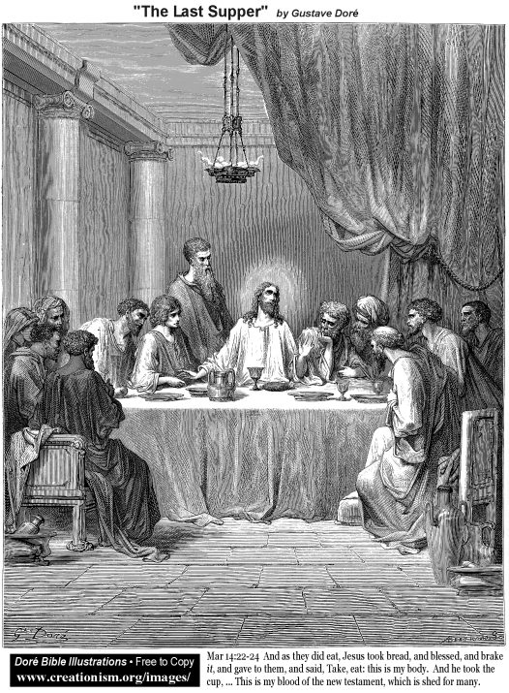

The “upper room” where the apostles gathered, along with many other believers, would have been more crowded but likely the same location as that of the “last supper”. It was the first post-ascension and pre-Pentecost gathering of the “church”.
Source” Public domain as in the image.

Faith in Action

Prayer
Ask the Holy Spirit to reveal to you how He would have you "... be My witnesses in Jerusalem, and in all of Judea and Samaria, and to the farthest parts of the earth.

Action
Today I will humbly receive Your mission and I will prayerfully, in consultation with mature fellow believers, make plans to fulfill Your calling. It may be to share Your story with a fellow student or co-worker, a friend or family member, or the leader of a community in a far away land. It may be, rather, to assist a person or group in their efforts to reach a person or persons with the message of salvation.

Be Specific ______________________________________________________

Monday (Acts 2:1-2:41)
The Holy Spirit and the Day of Pentecost
2:1 Now when the day of Pentecost had come, they were all together in one place. 2:2 Suddenly a sound like a violent wind blowing came from heaven and filled the entire house where they were sitting. 2:3 And tongues spreading out like a fire appeared to them and came to rest on each one of them. 2:4 All of them were filled with the Holy Spirit, and they began to speak in other languages as the Spirit enabled them.
2:5 Now there were devout Jews from every nation under heaven residing in Jerusalem. 2:6 When this sound occurred, a crowd gathered and was in confusion, because each one heard them speaking in his own language. 2:7 Completely baffled, they said, “Aren’t all these who are speaking Galileans? 2:8 And how is it that each one of us hears them in our own native language? 2:9 Parthians, Medes, Elamites, and residents of Mesopotamia, Judea and Cappadocia, Pontus and the province of Asia, 2:10 Phrygia and Pamphylia, Egypt and the parts of Libya near Cyrene, and visitors from Rome, 2:11 both Jews and proselytes, Cretans and Arabs – we hear them speaking in our own languages about the great deeds God has done!” 2:12 All were astounded and greatly confused, saying to one another, “What does this mean?” 2:13 But others jeered at the speakers, saying, “They are drunk on new wine!”
Peter’s Address on the Day of Pentecost
2:14 But Peter stood up with the eleven, raised his voice, and addressed them: “You men of Judea and all you who live in Jerusalem, know this and listen carefully to what I say. 2:15 In spite of what you think, these men are not drunk, for it is only nine o’clock in the morning. 2:16 But this is what was spoken about through the prophet Joel:
2:17 ‘And in the last days it will be,’ God says,
‘that I will pour out my Spirit on all people,
and your sons and your daughters will prophesy,
and your young men will see visions,
and your old men will dream dreams.
2:18 Even on my servants, both men and women,
I will pour out my Spirit in those days, and they will prophesy.
2:19 And I will perform wonders in the sky above
and miraculous signs on the earth below,
blood and fire and clouds of smoke.
2:20 The sun will be changed to darkness
and the moon to blood
before the great and glorious day of the Lord comes.
2:21 And then everyone who calls on the name of the Lord will be saved.’
2:22 “Men of Israel, listen to these words: Jesus the Nazarene, a man clearly attested to you by God with powerful deeds, wonders, and miraculous signs that God performed among you through him, just as you yourselves know – 2:23 this man, who was handed over by the predetermined plan and foreknowledge of God, you executed by nailing him to a cross at the hands of Gentiles. 2:24 But God raised him up, having released him from the pains of death, because it was not possible for him to be held in its power. 2:25 For David says about him,
‘I saw the Lord always in front of me,
for he is at my right hand so that I will not be shaken.
2:26 Therefore my heart was glad and my tongue rejoiced;
my body also will live in hope,
2:27 because you will not leave my soul in Hades,
nor permit your Holy One to experience decay.
2:28 You have made known to me the paths of life;
you will make me full of joy with your presence.’
2:29 “Brothers, I can speak confidently to you about our forefather David, that he both died and was buried, and his tomb is with us to this day. 2:30 So then, because he was a prophet and knew that God had sworn to him with an oath to seat one of his descendants on his throne, 2:31 David by foreseeing this spoke about the resurrection of the Christ, that he was neither abandoned to Hades, nor did his body experience decay. 2:32 This Jesus God raised up, and we are all witnesses of it. 2:33 So then, exalted to the right hand of God, and having received the promise of the Holy Spirit from the Father, he has poured out what you both see and hear. 2:34 For David did not ascend into heaven, but he himself says,
‘The Lord said to my lord,
“Sit at my right hand
2:35 until I make your enemies a footstool for your feet.”’
2:36 Therefore let all the house of Israel know beyond a doubt that God has made this Jesus whom you crucified both Lord and Christ.”
The Response to Peter’s Address
2:37 Now when they heard this, they were acutely distressed and said to Peter and the rest of the apostles, “What should we do, brothers?” 2:38 Peter said to them, “Repent, and each one of you be baptized in the name of Jesus Christ for the forgiveness of your sins, and you will receive the gift of the Holy Spirit. 2:39 For the promise is for you and your children, and for all who are far away, as many as the Lord our God will call to himself.” 2:40 With many other words he testified and exhorted them saying, “Save yourselves from this perverse generation!” 2:41 So those who accepted his message were baptized, and that day about three thousand people were added.

Prayer
Lord, You offer blessings and gifts, sometimes people accept them – many do not. May I accept the wisdom of your indwelling Holy Spirit and receive what You offer as an equipping for service to You.

Summary & Commentary
The Holy Spirit came upon the Apostles, and perhaps many or all of the other 120 members of the close-knit group of believers who had gathered in the upstairs room. They were in a public area surrounded by "Jews from every nation under Heaven" as well as non-Jewish converts to Judaism, Cretans, and Arabs who had gathered for the celebration of Pentecost.
Verse 2:4 is very clear that when the Holy Spirit came upon them they spoke in "other languages" and in 2:8 that those languages represented the native tongues of people in the crowd.
The curious among them wondered what it could mean, the unteachable among them jeered and accused them of being drunk - though such a claim had no relevance to the evidence before them.
Peter declared to those gathered for Pentecost that they not drunk but rather fulfilling prophesy from Joel and Jesus.
Many people responded repentantly to Peter's message and about three thousand were baptized. [Note: vss 2:40-41 include the text ""Save yourselves from this perverse generation!" So those who accepted his message were baptized," a clear statement that while the invitation was broadly-given the voluntary choice belonged to each individual.]

Interaction

Consider
God chose to bring the Holy Spirit upon the believers in the presence of non-believers across many ethnicities, nationalities, races, and religious traditions.

Discuss
There was a fundamental difference between the scoffers and those who sought truth, and the resultant understanding of those seeking truth vs the blindness of the others. Have you observed the same divergent response among modern listeners?

Reflect
Reflect upon the various teachings about "speaking in tongues" and how this text only addresses the miracle of a capacity to share the truth of God in a foreign language previously unknown to the speaker - but native to his or her listener. It does not say here that a "heavenly language" does not exist, it merely excludes this specific text from support of such a "gift". Reflect upon the various teachings as to how one comes to the final moment of saving faith, some which claim all will be saved, others which claim only those predestined will be saved, and yet another claim that only those who persist in "good works" will be saved -- this text says otherwise -- that those who heard God's truth and believed came forward to be affirmed and baptized. [Note: It is not the baptism that saved them but their prior acknowledgment of God's truth and their willing submission to it.]

Share
When have you been among a group of people who experienced the same event yet interpreted the meaning of the differently?

KTALZ
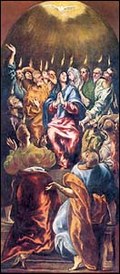

First upon the 120 then later upon many in the large crowd.
Source: Public domain here http://www.joyfulheart.com/pentecost/images/

Faith in Action

Prayer
I will ask the Lord for the boldness to share His story with someone who is teachable but unfamiliar with the language and message of the Bible - perhaps they have never heard or have only heard man-made religious distortions or the lies of the Enemy. I will also prayerfully seek an opportunity to share with a fellow believer something new that God has revealed to me that previously seemed like a foreign language but now is clear.

Action
Today I will step-put in faith, and with the boldness and clarity of the Holy Spirit, to be His instrument of hope and of truth.

Be Specific ______________________________________________________

Tuesday (Acts 2:42-47)
The Fellowship of the Early Believers
2:42 They were devoting themselves to the apostles’ teaching and to fellowship, to the breaking of bread and to prayer.
2:43 Reverential awe came over everyone, and many wonders and miraculous signs came about by the apostles.
2:44 All who believed were together and held everything in common, 2:45 and they began selling their property and possessions and distributing the proceeds to everyone, as anyone had need.
2:46 Every day they continued to gather together by common consent in the temple courts, breaking bread from house to house, sharing their food with glad and humble hearts, 2:47 praising God and having the good will of all the people. And the Lord was adding to their number every day those who were being saved.

Prayer
Lord, You call the members of Your family into an intimate relationship with you and one-another, and into interdependent relationships with one-another. May I invest in fellow believers so that we may be come more-faithful in caring for each other and growing together in You.

Summary & Commentary
The fellowship among the early believers consisted of a pattern of disciplines; "... devoting themselves to the apostles' teaching", "...and to fellowship", "... to the breaking or bread", "and to prayer."
The apostles taught the message of Jesus as the fulfillment of prophesy in the context of the narratives of the Creation, Fall, and the history that followed.
[Note: Study of the Word of God, facilitated by those who have demonstrated Biblical knowledge and spiritual maturity, is an important model for Christians.]

The fellowship of the believers is shown here as a continuous and intentional investment of energy and time.
[Note: Fellowship among believers built community, intimacy, and a sense of 'family' that went beyond the mere genetic or legal traditional family.]
For the early believers breaking bread together served both social and symbolic purposes.
[Note: Breaking bread has two possible meanings, one is the "Lord's Supper", also known as communion, as it is part of a special time of structured worship, the other possible meaning refers to a meal shared with others, not necessarily believers, especially in the common use of the term. In verse 2:42 it likely refers to a casual reenactment of the Lord's Supper whereas in 2:46 it likely refers to sharing a meal with others.]
Their investment of time and attention in prayer is an explanation of their intimacy with God and their power to endure suffering and experience due to the power of God's presence.
[Note: The pattern of prayer modeled by Jesus found an early and important emphasis throughout the text of the New Testament texts. As the early believers studied under the apostles they learned about prayer throughout the history of prophets, and other faithful servants of God, and were reminded of prayer in the life of Jesus and His closest followers.]
"Reverential awe" for the power of God came upon them all as a result of these disciplines which was enhanced by "... many wonders and miraculous signs ... by the apostles."
[Note: Their faithfulness to the "Greatest Commandment" of Jesus created a spiritual environment where God's power flowed freely.]
"All who believed were together and held everything in common ..." so that resources were fully shared within the family of Christ.
[Note: This was at the inspiration of the Holy Spirit, not a mandate of the secular State, nor by the manipulative guilt-motivation of a charismatic human.]
"And the Lord was adding to their number every day those who were being saved."
[Note: Because of their faithfulness God was able to use them powerfully and trust them to disciple those whom He sent.]

Interaction

Consider
Consider your spiritual disciplines, do they include study, fellowship, breaking of bread, and prayer?

Discuss
Do you take those disciplines "to the streets" among fellow believers; sharing resources, sharing meals, enjoying fellowship, praising God, and building good will?

Reflect
As your fellowship matures is God sending more?

Share
When have you experienced or observed a truly-intimate Christian fellowship?

KTALZ
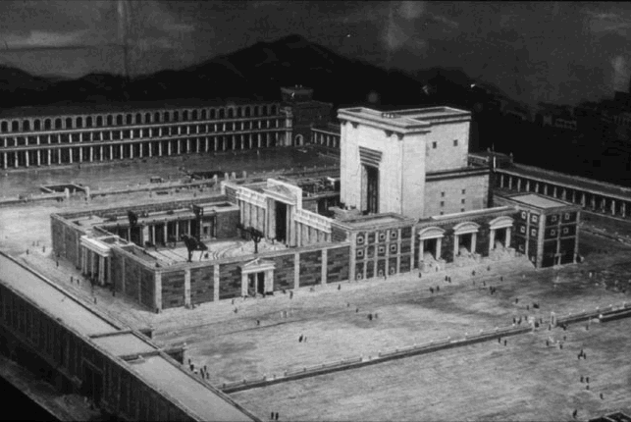

The “temple courts” included large mostly-open areas outside the increasingly-formal inner chambers and also a huge walled area all around the main temple structure.
Source: Public domain status – unclear http://www.bible-architecture.info/4.The_8.gif

Faith in Action

Prayer
Ask the Holy Spirit to motivate you to be faithful to mature quickly through intentional discipline, dedicated fellowship, and service in His name so that He may bless your fellowship with others who may also share in His blessings and then go forth to multiply the model into similar fellowships.

Action
Today I will prayerfully review my daily and weekly disciplines in order to make study, fellowship, the breaking of bread, and prayer represent a non-negotiable core. I will also look at my calendar to assure that sharing resources, sharing meals, enjoying fellowship, praising God, and building good will are integral to it.

Be Specific ______________________________________________________

Wednesday (Acts 3)
Peter and John Heal a Lame Man at the Temple
3:1 Now Peter and John were going up to the temple at the time for prayer, at three o’clock in the afternoon. 3:2 And a man lame from birth was being carried up, who was placed at the temple gate called “the Beautiful Gate” every day so he could beg for money from those going into the temple courts. 3:3 When he saw Peter and John about to go into the temple courts, he asked them for money. 3:4 Peter looked directly at him (as did John) and said, “Look at us!” 3:5 So the lame man paid attention to them, expecting to receive something from them. 3:6 But Peter said, “I have no silver or gold, but what I do have I give you. In the name of Jesus Christ the Nazarene, stand up and walk!” 3:7 Then Peter took hold of him by the right hand and raised him up, and at once the man’s feet and ankles were made strong. 3:8 He jumped up, stood and began walking around, and he entered the temple courts with them, walking and leaping and praising God. 3:9 All the people saw him walking and praising God, 3:10 and they recognized him as the man who used to sit and ask for donations at the Beautiful Gate of the temple, and they were filled with astonishment and amazement at what had happened to him.
Peter Addresses the Crowd
3:11 While the man was hanging on to Peter and John, all the people, completely astounded, ran together to them in the covered walkway called Solomon’s Portico. 3:12 When Peter saw this, he declared to the people, “Men of Israel, why are you amazed at this? Why do you stare at us as if we had made this man walk by our own power or piety?
3:13 The God of Abraham, Isaac, and Jacob, the God of our forefathers, has glorified his servant Jesus, whom you handed over and rejected in the presence of Pilate after he had decided to release him. 3:14 But you rejected the Holy and Righteous One and asked that a man who was a murderer be released to you. 3:15 You killed the Originator of life, whom God raised from the dead. To this fact we are witnesses! 3:16 And on the basis of faith in Jesus’ name, his very name has made this man – whom you see and know – strong. The faith that is through Jesus has given him this complete health in the presence of you all.
3:17 And now, brothers, I know you acted in ignorance, as your rulers did too. 3:18 But the things God foretold long ago through all the prophets – that his Christ would suffer – he has fulfilled in this way. 3:19 Therefore repent and turn back so that your sins may be wiped out, 3:20 so that times of refreshing may come from the presence of the Lord, and so that he may send the Messiah appointed for you – that is, Jesus. 3:21 This one heaven must receive until the time all things are restored, which God declared from times long ago through his holy prophets.
3:22 Moses said, ‘The Lord your God will raise up for you a prophet like me from among your brothers. You must obey him in everything he tells you. 3:23 Every person who does not obey that prophet will be destroyed and thus removed from the people.’
3:24 And all the prophets, from Samuel and those who followed him, have spoken about and announced these days. 3:25 You are the sons of the prophets and of the covenant that God made with your ancestors, saying to Abraham, ‘And in your descendants all the nations of the earth will be blessed.’ 3:26 God raised up his servant and sent him first to you, to bless you by turning each one of you from your iniquities.”

Prayer
Lord, You proclaimed the coming of the Messiah from the moment You declared the consequences of Adam and Eve's rebellion in the Garden, then over and over throughout history, because only a perfect One of Heaven could redeem us. May I never forget that all hope and all power for good comes from You.

Summary & Commentary
Peter and John healed a lame man at the Temple, he wanted money, they gave him the miracle gift of healing "... on the basis of faith in Jesus' name". Once healed he responded with uninhibited praise for God.
Peter used the wonder of those observing the miracle as an occasion to chastise them to repentance. He noted that it was the power of God and not their "power or piety" which caused the healing.
He reminded them that they killed the "Originator of Life" and that their only hope for redemption was found in Him.
[Note: One may read "Originator of Life" in two ways, or as a combination of both; Jesus was literally “The Creator” - God, or a member of the Trinity, or “Jesus provided the way to eternal life.]
In vs 3:26 Peter reminded them that their "iniquities" were not singular but multiple; that they were not only guilty of rejecting and murdering Jesus but were also guilty of other sins.

Interaction

Consider
The people knew enough from the Old Testament prophets to have recognized the Messiah, yet they were blinded by bad teaching and sick hearts, and so they not only killed Him – they continued to resist His offer of redemption.

Discuss
Why was it so important that Peter make clear that the healing was totally a work of Christ and that he was merely His instrument?

Reflect
There were many things for which the death and resurrection of Christ provided forgiveness, the obvious one is our prior rejection of Him, but what of the many ways that our rebellion against God has showed itself in a variety of sins?

Share
When have you, or someone you know, been healed. Did you, or they, respond with uninhibited praise for God?

KTALZ
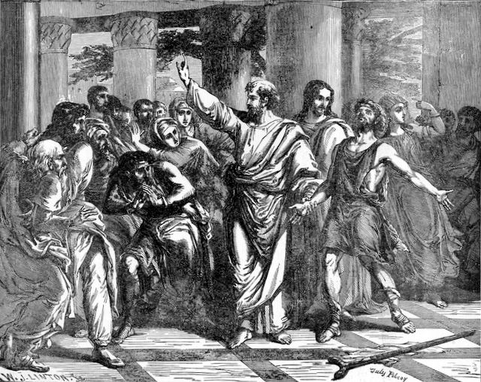

Peter and John were available tools of God to heal the lame man as evidence of the powerful presence of His Holy Spirit.
Source: Public domain here http://www.lavistachurchofchrist.org/Pictures/

Faith in Action

Prayer
Ask the Holy Spirit to remind me of a healing work He has done in you. It may be emotional, intellectual, physical, or spiritual. In each case it would have been something that you could not done of your own strengths or talents

Action
Today I will share with another believer my uninhibited praise for God Who has forgiven me and I will praise Him specifically for at least one healing He has done and/or one sin from which He has set me free.

Be Specific ______________________________________________________

Thursday (Acts 4:1-31)
The Arrest and Trial of Peter and John
4:1 While Peter and John were speaking to the people, the priests and the commander of the temple guard and the Sadducees came up to them, 4:2 angry because they were teaching the people and announcing in Jesus the resurrection of the dead. 4:3 So they seized them and put them in jail until the next day (for it was already evening). 4:4 But many of those who had listened to the message believed, and the number of the men came to about five thousand.
4:5 On the next day, their rulers, elders, and experts in the law came together in Jerusalem. 4:6 Annas the high priest was there, and Caiaphas, John, Alexander, and others who were members of the high priest’s family. 4:7 After making Peter and John stand in their midst, they began to inquire, “By what power or by what name did you do this?” 4:8 Then Peter, filled with the Holy Spirit, replied, “Rulers of the people and elders, 4:9 if we are being examined today for a good deed done to a sick man – by what means this man was healed – 4:10 let it be known to all of you and to all the people of Israel that by the name of Jesus Christ the Nazarene whom you crucified, whom God raised from the dead, this man stands before you healthy. 4:11 This Jesus is the stone that was rejected by you, the builders, that has become the cornerstone. 4:12 And there is salvation in no one else, for there is no other name under heaven given among people by which we must be saved.”
4:13 When they saw the boldness of Peter and John, and discovered that they were uneducated and ordinary men, they were amazed and recognized these men had been with Jesus. 4:14 And because they saw the man who had been healed standing with them, they had nothing to say against this. 4:15 But when they had ordered them to go outside the council, they began to confer with one another, 4:16 saying, “What should we do with these men? For it is plain to all who live in Jerusalem that a notable miraculous sign has come about through them, and we cannot deny it. 4:17 But to keep this matter from spreading any further among the people, let us warn them to speak no more to anyone in this name.” 4:18 And they called them in and ordered them not to speak or teach at all in the name of Jesus. 4:19 But Peter and John replied, “Whether it is right before God to obey you rather than God, you decide, 4:20 for it is impossible for us not to speak about what we have seen and heard.” 4:21 After threatening them further, they released them, for they could not find how to punish them on account of the people, because they were all praising God for what had happened. 4:22 For the man, on whom this miraculous sign of healing had been performed, was over forty years old.
The Followers of Jesus Pray for Boldness
4:23 When they were released, Peter and John went to their fellow believers and reported everything the high priests and the elders had said to them. 4:24 When they heard this, they raised their voices to God with one mind and said, “Master of all, you who made the heaven, the earth, the sea, and everything that is in them, 4:25 who said by the Holy Spirit through your servant David our forefather, ‘Why do the nations rage, and the peoples plot foolish things?
4:26 The kings of the earth stood together, and the rulers assembled together, against the Lord and against his Christ.’
4:27 “For indeed both Herod and Pontius Pilate, with the Gentiles and the people of Israel, assembled together in this city against your holy servant Jesus, whom you anointed, 4:28 to do as much as your power and your plan had decided beforehand would happen. 4:29 And now, Lord, pay attention to their threats, and grant to your servants to speak your message with great courage, 4:30 while you extend your hand to heal, and to bring about miraculous signs and wonders through the name of your holy servant Jesus.” 4:31 When they had prayed, the place where they were assembled together was shaken, and they were all filled with the Holy Spirit and began to speak the word of God courageously.

Prayer
Lord, Your truth is undeniable, You make certain that none who seek truth will fail to find it in You. May I intentionally and prayerfully seek truth so that I am always seeking You.

Summary & Commentary
The religious leaders arrested Peter and John for preaching and teaching Christ because five thousand "men" reportedly believed.
[Note: The reference to only to the males (or husbands) in the count was traditional, as it was when the Gospel texts described Jesus feeding the two large gatherings of people. It is difficult to accurately extrapolate to the true numbers, to include all of the women plus all of the children or youth who had reached the age of accountability.]
On the next morning the religious leaders brought Peter and John to trial – the Holy Spirit through Peter challenged them with the declaration that Jesus was the power that healed the lame man and was the only One "... by which we must be saved.” The religious leaders were unable to deny the truth of the healing so they sent the men out and conferred as to how to silence them - they dared not punish them for fear of the people - so they warned them to be silent.
Peter and John explained that silence was not possible, so they were warned again and then set free.
Peter and John shared what had happened and the followers of Jesus prayed for boldness. Their confidence was strengthened by the Holy Spirit and they "... began to speak the word of God courageously."
[Note: The references to the Holy Spirit in these verses (e.g. vs 4:8 “filled with the Holy Spirit”) are about the indwelling (post-Pentecost) Holy Spirit enabling and equipping Believers and when doing so using common languages. As the NET translator's notes observe “this fulfills Luke 12:11 (1Pet3:15)”. There is no new coming of the Holy Spirit, since He is already dwelling within Peter, described or implied herein.]

Interaction

Consider
All of those with worldly power at that time were aligned against Christ-followers.

Discuss
When challenged by the a resistant seeker or a rebellious enemy of truth which is your most common reaction; flee, apologize and be quiet, angrily confront with your human arguments, or a prayer for peace and wisdom from the Holy Spirit followed by a simple recitation of His-story of our needs met with His sacrificial provision and His blessings for our obedience (which the content of most Biblical “prophesy”)?

Reflect
Recalling the boldness of Peter and John - reflect upon your own boldness in the proclamation and teaching of the Word of God.

Share
When have you experienced or observed false charges being brought against someone and their boldness in the truth caused them to be set free?

KTALZ
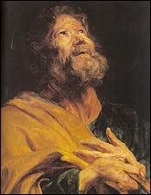

Peter, who once denied Jesus, in Acts 4 is used by God to fearlessly declare His deity and salvation before the same evil religious leaders who abused and condemned Jesus.
Source: Public domain here http://www.jesuswalk.com/1peter/peter_artwork.htm

Faith in Action

Prayer
Ask the Holy Spirit to give you the courage to be a good witness for Christ in your life, to quietly and respectfully tell His-story when challenged for your faith, and to resist being drawn into debates or discussions with an unteachable unsaved person that can only happen on a walled-off emotional and intellectual level, closed-off to spiritual change.

Action
Today I will, as the Lord trusts and uses me, reach out to a teachable person who is considering-Christ and I will share His-story.

Be Specific ______________________________________________________

Friday (Acts 4:32-5:11)
Conditions Among the Early Believers
4:32 The group of those who believed were of one heart and mind, and no one said that any of his possessions was his own, but everything was held in common. 4:33 With great power the apostles were giving testimony to the resurrection of the Lord Jesus, and great grace was on them all. 4:34 For there was no one needy among them, because those who were owners of land or houses were selling them and bringing the proceeds from the sales 4:35 and placing them at the apostles’ feet. The proceeds were distributed to each, as anyone had need. 4:36 So Joseph, a Levite who was a native of Cyprus, called by the apostles Barnabas (which is translated “son of encouragement”), 4:37 sold a field that belonged to him and brought the money and placed it at the apostles’ feet.
The Judgment on Ananias and Sapphira
5:1 Now a man named Ananias, together with Sapphira his wife, sold a piece of property. 5:2 He kept back for himself part of the proceeds with his wife’s knowledge; he brought only part of it and placed it at the apostles’ feet. 5:3 But Peter said, “Ananias, why has Satan filled your heart to lie to the Holy Spirit and keep back for yourself part of the proceeds from the sale of the land? 5:4 Before it was sold, did it not belong to you? And when it was sold, was the money not at your disposal? How have you thought up this deed in your heart? You have not lied to people but to God!”
5:5 When Ananias heard these words he collapsed and died, and great fear gripped all who heard about it. 5:6 So the young men came, wrapped him up, carried him out, and buried him. 5:7 After an interval of about three hours, his wife came in, but she did not know what had happened. 5:8 Peter said to her, “Tell me, were the two of you paid this amount for the land?” Sapphira said, “Yes, that much.” 5:9 Peter then told her, “Why have you agreed together to test the Spirit of the Lord? Look! The feet of those who have buried your husband are at the door, and they will carry you out!” 5:10 At once she collapsed at his feet and died. So when the young men came in, they found her dead, and they carried her out and buried her beside her husband. 5:11 Great fear gripped the whole church and all who heard about these things.

Prayer
Lord, You have invited humankind to learn and to share in Your love. May I seek You in all things, especially in my relationships with fellow Christians.

Summary & Commentary
The context of this teaching was multi-faceted; a. everyone involved was a Holy Spirit-indwelt Christian, b. everyone was actively participating in both evangelism and discipleship – placing God first and honoring both the Greatest Commandment (love) and the Great Commission (go and tell), and c. everyone made choices about their resource-sharing voluntarily (influenced, of course, by the Holy Spirit of God.
Conditions among early believers were like the most healthy and loving family, sharing every resource necessary to assure that no member of the family was in need.
[Note: This was not forced, as in a political statement from the community leaders (the Apostles), but rather was a voluntary response to the blessings and power of God communicated through the Apostles and being poured out among the Believers.]
Barnabas was one member who sold a field and brought the proceeds to the Apostles for distribution to needy believers. [Note: He did so voluntarily and chose to give all of the proceeds. It would have been fine for him to hold back some of the proceeds if he had obligations.]
Ananias and Sapphira, seeking the praise of man without true sacrifice, sold property and lied to Peter and the Church claiming to have done as Barnabas in giving the entire proceeds.
[The discernment of the Holy Spirit in Peter revealed their deception and God took their lives. It was not necessary for them to give all of the proceeds, it was merely expected that they be honest as to what they were sharing.]

Interaction

Consider
Verse 5:11 is the first place in ACTS where the text refers to the believing Christian community as "the church". Confusion began when people started to refer to buildings and man-made organizations as "the church" in contradiction to God's purpose for that term.

Discuss
Have you ever observed Christians who make a big show of doing or giving, overstating what they were doing or giving so as to garner praise? Were the leaders aware of the deception and did they correct or ignore it? What was the result?

Reflect
Have you been among largely-unselfish people, who shared a common value system, and who shared everything so that none in the group had a need? Perhaps it was on a retreat or a missions trip or as part of a sports-related activity or some other small group. Try to imagine that as a whole-life 24/7 philosophy of life.

Share
When have you observed confusion between the priorities implicit to man-made institutions and organizations versus those of a truly-Biblical fellowship of Believers 'The Church?'

KTALZ
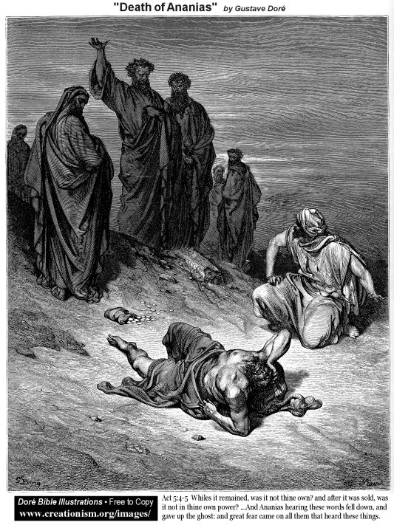

Blaspheming the Holy Spirit is the only unforgivable sin. Lying to “The Church” was lying to the Holy Spirit – it was unforgivable in this world.
Source: Public domain as in image.

Faith in Action

Prayer
Ask the Holy Spirit reveal to you someone for whom He wants you to encourage and pray who is generous toward fellow believers.

Action
Today I will encourage and pray for someone who is generous toward fellow believers in loving response to them as "eternal family in Christ". I will pray for small communities of believers to become more intentional in serving one-another from the bounty and gifts and talents God has given. I will also pray for the gift of discernment for leaders to recognize and challenge deception and selfish self-promotion within the Christian family.

Be Specific ______________________________________________________

Saturday (Acts 5:12-42)
The Apostles Perform Miraculous Signs and Wonders
5:12 Now many miraculous signs and wonders came about among the people through the hands of the apostles. By common consent they were all meeting together in Solomon’s Portico. 5:13 None of the rest dared to join them, but the people held them in high honor. 5:14 More and more believers in the Lord were added to their number, crowds of both men and women. 5:15 Thus they even carried the sick out into the streets, and put them on cots and pallets, so that when Peter came by at least his shadow would fall on some of them. 5:16 A crowd of people from the towns around Jerusalem also came together, bringing the sick and those troubled by unclean spirits. They were all being healed.
Further Trouble for the Apostles
5:17 Now the high priest rose up, and all those with him (that is, the religious party of the Sadducees), and they were filled with jealousy. 5:18 They laid hands on the apostles and put them in a public jail. 5:19 But during the night an angel of the Lord opened the doors of the prison, led them out, and said, 5:20 “Go and stand in the temple courts and proclaim to the people all the words of this life.” 5:21 When they heard this, they entered the temple courts at daybreak and began teaching.
Now when the high priest and those who were with him arrived, they summoned the Sanhedrin – that is, the whole high council of the Israelites – and sent to the jail to have the apostles brought before them. 5:22 But the officers who came for them did not find them in the prison, so they returned and reported, 5:23 “We found the jail locked securely and the guards standing at the doors, but when we opened them, we found no one inside.” 5:24 Now when the commander of the temple guard and the chief priests heard this report, they were greatly puzzled concerning it, wondering what this could be. 5:25 But someone came and reported to them, “Look! The men you put in prison are standing in the temple courts and teaching the people!” 5:26 Then the commander of the temple guard went with the officers and brought the apostles without the use of force (for they were afraid of being stoned by the people).
5:27 When they had brought them, they stood them before the council, and the high priest questioned them, 5:28 saying, “We gave you strict orders not to teach in this name. Look, you have filled Jerusalem with your teaching, and you intend to bring this man’s blood on us!” 5:29 But Peter and the apostles replied, “We must obey God rather than people. 5:30 The God of our forefathers raised up Jesus, whom you seized and killed by hanging him on a tree. 5:31 God exalted him to his right hand as Leader and Savior, to give repentance to Israel and forgiveness of sins. 5:32 And we are witnesses of these events, and so is the Holy Spirit whom God has given to those who obey him.”
5:33 Now when they heard this, they became furious and wanted to execute them. 5:34 But a Pharisee whose name was Gamaliel, a teacher of the law who was respected by all the people, stood up in the council and ordered the men to be put outside for a short time. 5:35 Then he said to the council, “Men of Israel, pay close attention to what you are about to do to these men. 5:36 For some time ago Theudas rose up, claiming to be somebody, and about four hundred men joined him. He was killed, and all who followed him were dispersed and nothing came of it. 5:37 After him Judas the Galilean arose in the days of the census, and incited people to follow him in revolt. He too was killed, and all who followed him were scattered. 5:38 So in this case I say to you, stay away from these men and leave them alone, because if this plan or this undertaking originates with people, it will come to nothing, 5:39 but if it is from God, you will not be able to stop them, or you may even be found fighting against God.” He convinced them, 5:40 and they summoned the apostles and had them beaten. Then they ordered them not to speak in the name of Jesus and released them. 5:41 So they left the council rejoicing because they had been considered worthy to suffer dishonor for the sake of the name. 5:42 And every day both in the temple courts and from house to house, they did not stop teaching and proclaiming the good news that Jesus was the Christ.

Prayer
Lord, You heal through Your willing instruments as You deem best, and You allow the troubles of the world to afflict those same servants as a witness to Your power to carry them through and to illustrate the wickedness of the world. May I trust You to use me perfectly, no matter what.

Summary & Commentary
The apostles continued to gather in "Solomon's Portico" which was an open area and part of the larger Temple complex. While the population of the believers continued to grow many others avoided them, in public, for fear of the corrupt and evil religious authorities.
People brought the physically and spiritually ill for the Apostles to heal. The Apostles were used of God to perform other miraculous signs and wonders as evidence of God's anointing.
The religious authorities were jealous, a mixture of their desire to preserve the purity of their religious traditions and their more personal selfish desire to retain the devotion of the people for themselves. They had the Apostles arrested and jailed but early in the morning an Angel released them from the jail, without disturbing the locked doors or alerting the guards, and sent them to preach and teach again.
The religious authorities sent for them, requesting that they come peaceably as the crowds favored the Apostles, and the Apostles came. The religious leaders chastised them for preaching and teaching when they had told them to not do so - to which they replied that they must obey God and not man. The religious authorities were furious and wanted to execute them but Gamaliel reminded them that men with small followings before had been killed and their followings dispersed, so let them go and let God sort out what would happen.
The religious authorities had them lashed "forty times minus one" for disobedience to them then released them with a warning to not preach and teach. They left celebrating that their faithfulness to God had resulted in worthiness to be punished by His enemies then resumed their preaching and teaching in the Temple court and house to house.

Interaction

Consider
Do you know of people in your neighborhood, school, workplace, or other network of associates who avoid Christian gatherings and/or discussions for fear of the opinions of others? Or are you struggling with that yourself?

Discuss
Have you experienced, or observed, punishment for faithfulness to God?

Reflect
Was the response a celebration that the faithfulness so challenged others that they punished you/them? Did you, or they, persevere in preaching and teaching His-story despite the risks?

Share
When have you observed people in religious or secular authority persecuting those whom they believe have violated some custom or tradition that they hold valuable, even though it is either non-Biblical or simply silly even in a secular world? Have you done that in the past?

KTALZ
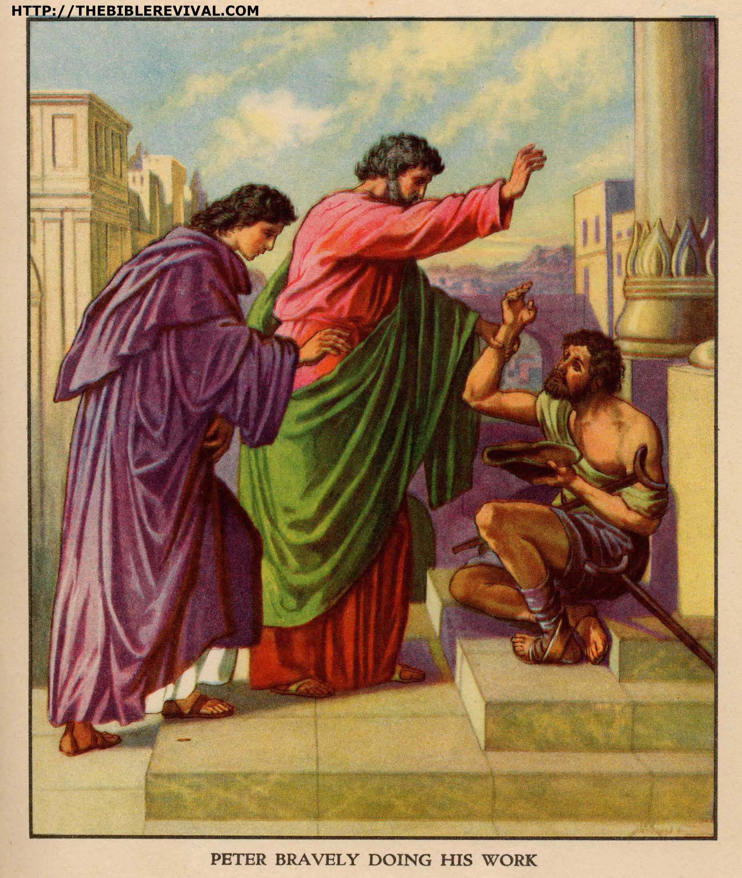

Despite threats, and even flogging, the apostles fearlessly continued to preach the good news of Jesus.
Source: Public domain here http://thebiblerevival.com/clipart/

Faith in Action

Prayer
Ask the Holy Spirit to grant freedom from fear, for myself or others, so that God's truth will be more important than the opinions of mere humans. Also, that people in authority will allow their eyes to be opened by the Holy Spirit to the difference between their petty human customs and traditions and the truth of God.

Action
Today I will identify someone in local, national, or international ministry, perhaps missions or public service or a religious role who has been or is being persecuted for their Christian faith and pray in agreement for perseverance, protection, and power. I will also attempt to respectfully communicate a word of encouragement via E-mail or letter.

Be Specific ______________________________________________________

All Bible text is from the NET unless otherwise indicated - http://bible.org
Note 1: These Studies often rely upon the guidance of the NET Translators from their associated notes. Careful attention has been given to cite that source where it has been quoted directly or closely paraphrased. Feedback is encouraged where credit has not been sufficiently assigned.
Note 2: When NET text is quoted in commentary and discussion all pronouns referring to God are capitalized, though they are lower-case in the original NET text.
Commentary text is from David M. Colburn, D.Min. unless otherwise noted.

Copyright © 2011 by David M. Colburn. This is a BibleSeven Study – Section 1 (Chapters 1 - 5) of the series, “Acts” – prepared by David M. Colburn and edited for bible.org in October of 2011. This text may be used for non-profit educational purposes only, with credit; all other usage requires prior written consent of the author.

