2 Corinthians 6-13
David M. Colburn
A Daily Bible Study in 7-Day Sections with a Summary-Commentary, Discussion Questions, and Daily Application

Sunday (2 Corinthians 6)
God’s Suffering Servants
6:1 Now because we are fellow workers, we also urge you not to receive the grace of God in vain. 6:2 For he says, “I heard you at the acceptable time, and in the day of salvation I helped you.” Look, now is the acceptable time; look, now is the day of salvation!
6:3 We do not give anyone an occasion for taking an offense in anything, so that no fault may be found with our ministry. 6:4 But as God’s servants, we have commended ourselves in every way, with great endurance, in persecutions, in difficulties, in distresses, 6:5 in beatings, in imprisonments, in riots, in troubles, in sleepless nights, in hunger, 6:6 by purity, by knowledge, by patience, by benevolence, by the Holy Spirit, by genuine love, 6:7 by truthful teaching, by the power of God, with weapons of righteousness both for the right hand and for the left, 6:8 through glory and dishonor, through slander and praise; regarded as impostors, and yet true; 6:9 as unknown, and yet well-known; as dying and yet—see!—we continue to live; as those who are scourged and yet not executed; 6:10 as sorrowful, but always rejoicing, as poor, but making many rich, as having nothing, and yet possessing everything.
6:11 We have spoken freely to you, Corinthians; our heart has been opened wide to you.
6:12 Our affection for you is not restricted, but you are restricted in your affections for us.
6:13 Now as a fair exchange—I speak as to my children—open wide your hearts to us also.
Unequal Partners
6:14 Do not become partners with those who do not believe, for what partnership is there between righteousness and lawlessness, or what fellowship does light have with darkness?
6:15 And what agreement does Christ have with Beliar? Or what does a believer share in common with an unbeliever?
6:16 And what mutual agreement does the temple of God have with idols? For we are the temple of the living God, just as God said, “I will live in them and will walk among them, and I will be their God, and they will be my people.”
6:17 Therefore “come out from their midst, and be separate,” says the Lord, “and touch no unclean thing, and I will welcome you, 6:18 and I will be a father to you, and you will be my sons and daughters,” says the All-Powerful Lord.

Prayer
Lord, You have drawn us near to You and indwell us through Your Holy Spirit, and so we have become eternally-separated from the world and it’s temporary Prince, Satan. May I avoid “partnerships” with unbelievers, as they cannot comprehend why I make many of the decisions that I do, and avoid “partnership” with anything that is sinful.

Summary & Commentary
Paul described the sacrifices he had made to be certain that nothing in him could give cause for anyone to question his preaching and teaching of Christ.
He challenged them “… not to receive the grace of God in vain” but to accept and live in the freedom of grace and making sacrifices—so that they neither squander the gift through unrighteous living or fail to make it attractive to others.
[Note: Paul quoted vs 6:1 from Isaiah 48:8 “I heard you at the acceptable time, and in the day of salvation I helped you.” Look, now is the acceptable time; look, now is the day of salvation!” - which in-context refers to faithful leaders within the then-divided and scattered nation/people of Israel.]
He also challenged them “Do not become partners with those who do not believe…” because they cannot comprehend the reasons that a believer chooses righteous and sacrificial living in the absence of the Holy Spirit and His inspiration of the Word of God.
[Note: The NET Bible notes explain that vs 6:16-17 refers to Lev 26:11-12 but that Paul modifies it “...as the Spirit) dwelling in his people, since he calls believers “the temple of the living God” in the previous clause, imagery he uses elsewhere in his writings (1 Cor 3:16; Eph 2:21-22).
” and Lev 26:12 “... also similar to Jer 32:38; Ezek 37:27.
” and Isa 52:11.”]

Interaction

Consider
Paul ascribes great importance to a Believer's intentionally-faithful witness of the presence and power of the Lord God through His Holy Spirit in a Believer’s daily walk.

Discuss
How might one avoid “…receive the grace of God in vain”? List some ways that a believer may live in grace and avoid drifting into life choices which misrepresent Christ.

Reflect
Paul’s challenge was to “… not become partners with those who do not believe”, which refers to both business and romance.

Share
When have you experienced being "partnered" with a non-believer where they simply could not comprehend your Holy Spirit-guided choices for righteousness over profit or fame or pleasure?

KTALZ


Light and darkness cannot coexist – where one dominates the other fades. Where they collide is temporary - neither one or the other. A Believer cannot claim the light and live partly in darkness. Jesus said “Be hot or cold, if you are lukewarm, I'll spit you out.”

Faith in Action

Prayer
Ask the Holy Spirit to reveal to you a place in your life where you drift into non-Christlike choices.

Action
Today I will ask a fellow believer to pray in agreement with me that I accept the wisdom and strength of the Holy Spirit to repent and move toward maturity through more righteous living.

Be Specific ______________________________________________________

Monday (2 Corinthians 7)
Self-Purification
7:1 Therefore, since we have these promises, dear friends, let us cleanse ourselves from everything that could defile the body and the spirit, and thus accomplish holiness out of reverence for God.
7:2 Make room for us in your hearts; we have wronged no one, we have ruined no one, we have exploited no one. 7:3 I do not say this to condemn you, for I told you before that you are in our hearts so that we die together and live together with you.
A Letter That Caused Sadness
7:4 I have great confidence in you; I take great pride on your behalf. I am filled with encouragement; I am overflowing with joy in the midst of all our suffering.
7:5 For even when we came into Macedonia, our body had no rest at all, but we were troubled in every way—struggles from the outside, fears from within. 7:6 But God, who encourages the downhearted, encouraged us by the arrival of Titus.
7:7 We were encouraged not only by his arrival, but also by the encouragement you gave him, as he reported to us your longing, your mourning, your deep concern for me, so that I rejoiced more than ever.
7:8 For even if I made you sad by my letter, I do not regret having written it (even though I did regret it, for I see that my letter made you sad, though only for a short time).
7:9 Now I rejoice, not because you were made sad, but because you were made sad to the point of repentance. For you were made sad as God intended, so that you were not harmed in any way by us.
7:10 For sadness as intended by God produces a repentance that leads to salvation, leaving no regret, but worldly sadness brings about death.
7:11 For see what this very thing, this sadness as God intended, has produced in you: what eagerness, what defense of yourselves, what indignation, what alarm, what longing, what deep concern, what punishment! In everything you have proved yourselves to be innocent in this matter.
7:12 So then, even though I wrote to you, it was not on account of the one who did wrong, or on account of the one who was wronged, but to reveal to you your eagerness on our behalf before God.
7:13 Therefore we have been encouraged. And in addition to our own encouragement, we rejoiced even more at the joy of Titus, because all of you have refreshed his spirit. 7:14 For if I have boasted to him about anything concerning you, I have not been embarrassed by you, but just as everything we said to you was true, so our boasting to Titus about you has proved true as well.
7:15 And his affection for you is much greater when he remembers the obedience of you all, how you welcomed him with fear and trembling. 7:16 I rejoice because in everything I am fully confident in you.

Prayer
Lord, You convict us of sin, which makes us sad due to the unease of the Holy Spirit within. May I respond with renewed vigor toward righteousness rather than sulking like Cain or Judas or even King David (before he repented because he had a teachable-heart).

Summary & Commentary
Paul issues yet another call to righteous living “… let us cleanse ourselves from everything that could defile the body and spirit, and thus accomplish holiness out of reverence for God.”
He notes that while in Macedonia he was “troubled in every way--struggles from the outside, fears from within” but that the arrival of Titus and word of caring from the fellowship in Corinth encouraged him.
He also notes that his letter of challenge brought them to repentance and therefore led to maturity rather than his fear that it might have caused them to withdraw.
He described their treatment of Titus “… you have refreshed his spirit”, followed by “… you welcomed him with fear and trembling”, an indication that they were hoping that he would find them to be making an intentional effort to live rightly before God rather than in the toleration-of-sin for which Paul had chastised them.

Interaction

Consider
Paul’s role model for leaders “… we have wronged no one, we have ruined no one, we have exploited no one.”

Discuss
What things “…could defile the body and spirit” and how may one may drift into them? How does one avoid and/or escape them?

Reflect
The is great power for good in the encouragement of fellow believers.

Share
When has a word of rebuke, though hard to hear, helped you to recognize a problem and to move toward repentance?

KTALZ
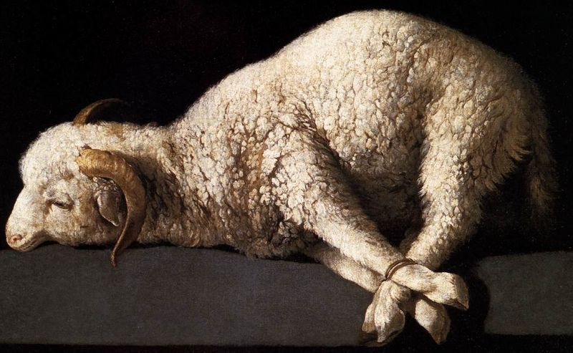

Just as sacrifices were cleansed prior to being placed on the altar we also are to be cleansed.
Source: Public domain here http://www.marysrosaries.com/collaboration/images/b/b3/Sacrificial_Lamb_of_God_006_a.jpg

Faith in Action

Prayer
Ask the Holy Spirit to reveal to you a fellow believer who needs a word of encouragement.

Action
Today I will encourage a fellow believer. I will also thank a fellow believer who was, in the past, the Lord God’s messenger of rebuke—and as a result I repented and became a more mature believer.

Be Specific ______________________________________________________

Tuesday (2 Corinthians 8-9)
Completing the Collection for the Saints
8:1 Now we make known to you, brothers and sisters, the grace of God given to the churches of Macedonia, 8:2 that during a severe ordeal of suffering, their abundant joy and their extreme poverty have overflowed in the wealth of their generosity. 8:3 For I testify, they gave according to their means and beyond their means. They did so voluntarily, 8:4 begging us with great earnestness for the blessing and fellowship of helping the saints.
8:5 And they did this not just as we had hoped, but they gave themselves first to the Lord and to us by the will of God.
8:6 Thus we urged Titus that, just as he had previously begun this work, so also he should complete this act of kindness for you. 8:7 But as you excel in everything—in faith, in speech, in knowledge, and in all eagerness and in the love from us that is in you—make sure that you excel in this act of kindness too. 8:8 I am not saying this as a command, but I am testing the genuineness of your love by comparison with the eagerness of others.
8:9 For you know the grace of our Lord Jesus Christ, that although he was rich, he became poor for your sakes, so that you by his poverty could become rich.
8:10 So here is my opinion on this matter: It is to your advantage, since you made a good start last year both in your giving and your desire to give, 8:11 to finish what you started, so that just as you wanted to do it eagerly, you can also complete it according to your means. 8:12 For if the eagerness is present, the gift itself is acceptable according to whatever one has, not according to what he does not have. 8:13 For I do not say this so there would be relief for others and suffering for you, but as a matter of equality.
8:14 At the present time, your abundance will meet their need, so that one day their abundance may also meet your need, and thus there may be equality, 8:15 as it is written: “The one who gathered much did not have too much, and the one who gathered little did not have too little.”
The Mission of Titus
8:16 But thanks be to God who put in the heart of Titus the same devotion I have for you, 8:17 because he not only accepted our request, but since he was very eager, he is coming to you of his own accord. 8:18 And we are sending along with him the brother who is praised by all the churches for his work in spreading the gospel. 8:19 In addition, this brother has also been chosen by the churches as our traveling companion as we administer this generous gift to the glory of the Lord himself and to show our readiness to help. 8:20 We did this as a precaution so that no one should blame us in regard to this generous gift we are administering.
8:21 For we are concerned about what is right not only before the Lord but also before men.
8:22 And we are sending with them our brother whom we have tested many times and found eager in many matters, but who now is much more eager than ever because of the great confidence he has in you. 8:23 If there is any question about Titus, he is my partner and fellow worker among you; if there is any question about our brothers, they are messengers of the churches, a glory to Christ. 8:24 Therefore show them openly before the churches the proof of your love and of our pride in you.
Preparing the Gift
9:1 For it is not necessary for me to write you about this service to the saints, 9:2 because I know your eagerness to help. I keep boasting to the Macedonians about this eagerness of yours, that Achaia has been ready to give since last year, and your zeal to participate has stirred up most of them. 9:3 But I am sending these brothers so that our boasting about you may not be empty in this case, so that you may be ready just as I kept telling them.
9:4 For if any of the Macedonians should come with me and find that you are not ready to give, we would be humiliated (not to mention you) by this confidence we had in you. 9:5 Therefore I thought it necessary to urge these brothers to go to you in advance and to arrange ahead of time the generous contribution you had promised, so this may be ready as a generous gift and not as something you feel forced to do.
9:6 My point is this: The person who sows sparingly will also reap sparingly, and the person who sows generously will also reap generously.
9:7 Each one of you should give just as he has decided in his heart, not reluctantly or under compulsion, because God loves a cheerful giver.
9:8 And God is able to make all grace overflow to you so that because you have enough of everything in every way at all times, you will overflow in every good work. 9:9 Just as it is written, “He has scattered widely, he has given to the poor; his righteousness remains forever.”
9:10 Now God who provides seed for the sower and bread for food will provide and multiply your supply of seed and will cause the harvest of your righteousness to grow. 9:11 You will be enriched in every way so that you may be generous on every occasion, which is producing through us thanksgiving to God, 9:12 because the service of this ministry is not only providing for the needs of the saints but is also overflowing with many thanks to God.
9:13 Through the evidence of this service they will glorify God because of your obedience to your confession in the gospel of Christ and the generosity of your sharing with them and with everyone. 9:14 And in their prayers on your behalf they long for you because of the extraordinary grace God has shown to you.
9:15 Thanks be to God for his indescribable gift!

Prayer
Lord, You call upon believers to give from hearts of gratitude and love, not coerced by political or religious leaders. May I be found generous without coercion, seeking-out what are the needs, giving as Your blessing to others from the surplus You have given to me.

Summary & Commentary
Paul reported the generosity of the Macedonian fellowship, even as they were impoverished, and the past generosity of the Corinthian fellowship to the Macedonians. He asks that they “… complete it according to your means”.
One may observe in this chapter the origins of elements of philosophy in the vernacular of many cultures with a historic awareness of Paul’s writing; “What goes around comes around”, and caring for the poor.
Paul discussed “equity”, not in a political-socialist construct where it is forced upon an unwilling populace by a secular authority, but in a purely voluntary way and for those with whom they shared a Christian faith.
Paul reminded them that when they are generous toward the brothers in Macedonia, during their financially troubled times, tomorrow the circumstances may be reversed.
Paul noted that he has delegated oversight of the distribution of their donated funds to someone generally held in high esteem for his independence and integrity so as to prevent any cause for distrust or false accusation that could undermine the primary mission of sharing Christ.
Paul observed that God wanted them to give based on a loving response to the observed necessity among their brothers and sisters in Macedonia, and not begrudgingly out of an artificial sense of duty, so that God may bless them and provide also for them.

Interaction

Consider
A blessing comes to both the giver and the recipient when assistance is provided from a heart of love for brothers and sisters.

Discuss
In what ways has caring for others, with an expectation of returned-favors distorted Paul’s message, especially in the hands of non-believers and governments?

Reflect
In what ways may you and your fellowship support believers whom you know to be truly in need as you avoid diverting God’s resources to non-believers and/or to causes that are not of Christ.

Share
When have you given sacrificially to assist a believer, not asking to be recognized and not anticipating any worldly blessing, and God blessed you in some way that was even more than you blessed another?

KTALZ


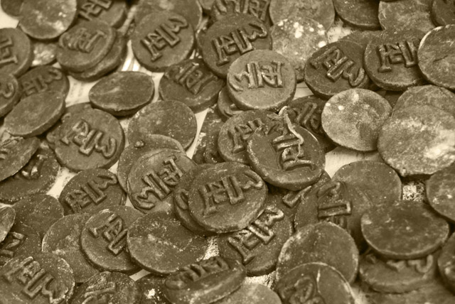

Just as ancient Israelites poured-out their treasures, acquired during the exodus from slavery in Egypt, in order to provide the gold necessary to supply the desert tabernacle - so also are we to share as brothers and sisters have need.
Sources: Public domain here http://www.pdpics.com/preview/preview14/2601-gold-jewelry.jpg and here http://www.pdpics.com/preview/preview4/667-old-ancient-coins.jpg

Faith in Action

Prayer
Ask the Holy Spirit to reveal to you a way to bless a fellow believer in need.

Action
Today I will assist a fellow-believer, asking for no recognition, and seeking no reward. I will pray for them in their need and that others will also come alongside.

Be Specific ______________________________________________________

Wednesday (2 Corinthians 10)
Paul’s Authority from the Lord
10:1 Now I, Paul, appeal to you personally by the meekness and gentleness of Christ (I who am meek when present among you, but am full of courage toward you when away!)—10:2 now I ask that when I am present I may not have to be bold with the confidence that (I expect) I will dare to use against some who consider us to be behaving according to human standards.
10:3 For though we live as human beings, we do not wage war according to human standards, 10:4 for the weapons of our warfare are not human weapons, but are made powerful by God for tearing down strongholds. We tear down arguments 10:5 and every arrogant obstacle that is raised up against the knowledge of God, and we take every thought captive to make it obey Christ.
10:6 We are also ready to punish every act of disobedience, whenever your obedience is complete.
10:7 You are looking at outward appearances. If anyone is confident that he belongs to Christ, he should reflect on this again: Just as he himself belongs to Christ, so too do we.
10:8 For if I boast somewhat more about our authority that the Lord gave us for building you up and not for tearing you down, I will not be ashamed of doing so.
10:9 I do not want to seem as though I am trying to terrify you with my letters, 10:10 because some say, “His letters are weighty and forceful, but his physical presence is weak and his speech is of no account.” 10:11 Let such a person consider this: What we say by letters when we are absent, we also are in actions when we are present.
Paul’s Mission
10:12 For we would not dare to classify or compare ourselves with some of those who recommend themselves. But when they measure themselves by themselves and compare themselves with themselves, they are without understanding.
10:13 But we will not boast beyond certain limits, but will confine our boasting according to the limits of the work to which God has appointed us, that reaches even as far as you. 10:14 For we were not overextending ourselves, as though we did not reach as far as you, because we were the first to reach as far as you with the gospel about Christ.
10:15 Nor do we boast beyond certain limits in the work done by others, but we hope that as your faith continues to grow, our work may be greatly expanded among you according to our limits, 10:16 so that we may preach the gospel in the regions that lie beyond you, and not boast of work already done in another person’s area.
10:17 But the one who boasts must boast in the Lord. 10:18 For it is not the person who commends himself who is approved, but the person the Lord commends.

Prayer
Lord, You call for unity and for a process of accountability and discipline among believers in fellowships, and that all is done with the recognition that You are the source of truth and the object of worship. May I encourage unity-in-truth and be unafraid to discipline those who refuse to be accountable, to confess, and to repent of sin.

Summary & Commentary
Paul asked them to recognize that he had been consistent in letters and when physically present—that he had challenged them about the same matters of righteousness—and that he had done so as God has commanded, intentionally avoiding any human-based alterations to His Word.
He explained that those he needed to discipline would only be effectively disciplined when the rest of the fellowship had completed their confession and repentance and were in-agreement with the discipline. [Constable’s Notes from bible.org observes that even today there is little point to a leader attempting discipline of a member of a fellowship unless the fellowship is in-agreement.]
Paul provided a checklist for them to evaluate his methods:
- “…we live as human beings, we do not wage war according to human standards”
- “…the weapons of our warfare are not human weapons”
- “…but are made powerful by God for tearing down strongholds”
- “We tear down arguments … raised up against the knowledge of God”
- “…and every arrogant obstacle … raised up against the knowledge of God”
- “…and we take every thought captive to make it obey Christ”
- “We are also ready to punish every act of disobedience”
- “… if I boast somewhat more about our authority that the Lord gave us for building you up and not for tearing you down, I will not be ashamed of doing so.”
Paul addressed an apparent problem with others who boasted about themselves and who were accountable only to themselves, saying “they are without understanding”.
He noted that within the area of influence assigned by God he had pressed to the edge and prayed that their maturity would result in further growth within that same area.
Paul concluded with a double challenge, that one boast only in the Lord, and that one is only approved by the Lord and never by his own claims about himself.

Interaction

Consider
Paul’s instruction that “… we take every thought captive to make it obey Christ”. Every sin begins with a thought, David on the roof of the castle, Peter reacting fearfully and denying Christ, Ananias and Sapphira lying about their gift to God’s ministry.

Discuss
In what ways may the Lord God use knowledge of Christ to tear down the strongholds of ignorance and arrogant human wisdom? Perhaps referring to non-Biblical religions, the zealotry of people imposing philosophical theories or neo-scientific postulates, or of people in fellowships who value man-made traditions over the truth of God?

Reflect
There is a perplexing problem when some in leadership are arrogant and boastful yet careless with the Word of God; not only does that cause them to fail those who trust them, it also brings confusion about the integrity of Christ and His Word.

Share
When have you experienced or observed a situation where a leader’s careful witness in living an intentionally-righteous life has reinforced their teaching of God’s Word? How that impacted your faith and walk in a positive way?

KTALZ
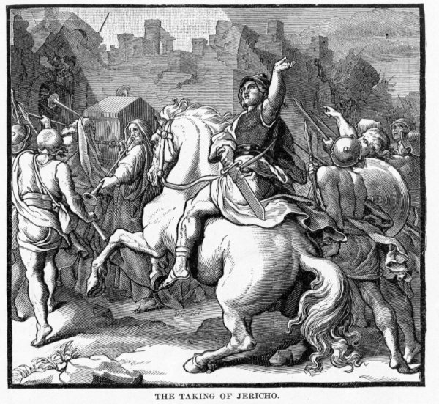

Just as through His power the stronghold that was the Wall of Jericho fell so also will Believers be “made powerful by God for tearing down strongholds” - emotional, intellectual, and spiritual.
Source: Public domain here http://www.coolnotions.com/PDImages/StoryOTB073_p183_TheTakingOfJericho.jpg

Faith in Action

Prayer
Ask the Holy Spirit to “shine a light and reveal any dark place” in your life.

Action
Today I will take a hard look at my thought life for any dark places—as the Holy Spirit guides—then I will repent (turn away) from it/them. I will ask a fellow believer to pray in agreement for a fearless look and a courageous response. I share with them my victory through Christ.

Be Specific ______________________________________________________

Thursday (2 Corinthians 11)
Paul and His Opponents
11:1 I wish that you would be patient with me in a little foolishness, but indeed you are being patient with me! 11:2 For I am jealous for you with godly jealousy, because I promised you in marriage to one husband, to present you as a pure virgin to Christ.
11:3 But I am afraid that just as the serpent deceived Eve by his treachery, your minds may be led astray from a sincere and pure devotion to Christ.
11:4 For if someone comes and proclaims another Jesus different from the one we proclaimed, or if you receive a different spirit than the one you received, or a different gospel than the one you accepted, you put up with it well enough!
11:5 For I consider myself not at all inferior to those “super-apostles.” 11:6 And even if I am unskilled in speaking, yet I am certainly not so in knowledge. Indeed, we have made this plain to you in everything in every way.
11:7 Or did I commit a sin by humbling myself so that you could be exalted, because I proclaimed the gospel of God to you free of charge? 11:8 I robbed other churches by receiving support from them so that I could serve you! 11:9 When I was with you and was in need, I was not a burden to anyone, for the brothers who came from Macedonia fully supplied my needs. I kept myself from being a burden to you in any way, and will continue to do so.
11:10 As the truth of Christ is in me, this boasting of mine will not be stopped in the regions of Achaia. 11:11 Why? Because I do not love you? God knows I do!
11:12 And what I am doing I will continue to do, so that I may eliminate any opportunity for those who want a chance to be regarded as our equals in the things they boast about. 11:13 For such people are false apostles, deceitful workers, disguising themselves as apostles of Christ.
11:14 And no wonder, for even Satan disguises himself as an angel of light. 11:15 Therefore it is not surprising his servants also disguise themselves as servants of righteousness, whose end will correspond to their actions.
Paul’s Sufferings for Christ
11:16 I say again, let no one think that I am a fool. But if you do, then at least accept me as a fool, so that I too may boast a little. 11:17 What I am saying with this boastful confidence I do not say the way the Lord would. Instead it is, as it were, foolishness. 11:18 Since many are boasting according to human standards, I too will boast. 11:19 For since you are so wise, you put up with fools gladly.
11:20 For you put up with it if someone makes slaves of you, if someone exploits you, if someone takes advantage of you, if someone behaves arrogantly toward you, if someone strikes you in the face. 11:21 (To my disgrace I must say that we were too weak for that!) But whatever anyone else dares to boast about (I am speaking foolishly), I also dare to boast about the same thing. 11:22 Are they Hebrews? So am I. Are they Israelites? So am I. Are they descendants of Abraham? So am I. 11:23 Are they servants of Christ? (I am talking like I am out of my mind!) I am even more so: with much greater labors, with far more imprisonments, with more severe beatings, facing death many times. 11:24 Five times I received from the Jews forty lashes less one. 11:25 Three times I was beaten with a rod. Once I received a stoning. Three times I suffered shipwreck. A night and a day I spent adrift in the open sea. 11:26 I have been on journeys many times, in dangers from rivers, in dangers from robbers, in dangers from my own countrymen, in dangers from Gentiles, in dangers in the city, in dangers in the wilderness, in dangers at sea, in dangers from false brothers, 11:27 in hard work and toil, through many sleepless nights, in hunger and thirst, many times without food, in cold and without enough clothing. 11:28 Apart from other things, there is the daily pressure on me of my anxious concern for all the churches. 11:29 Who is weak, and I am not weak? Who is led into sin, and I do not burn with indignation? 11:30 If I must boast, I will boast about the things that show my weakness.
11:31 The God and Father of the Lord Jesus, who is blessed forever, knows I am not lying. 11:32 In Damascus, the governor under King Aretas was guarding the city of Damascus in order to arrest me, 11:33 but I was let down in a rope-basket through a window in the city wall, and escaped his hands.

Prayer
Lord, You gave us life with You in the Garden of Eden—Satan deceived Eve (and through her compromised Adam) into destroying that. You gave us Jesus and His saving truth—Satan manipulated many into lying about that to confuse people. You gave us Your Word so that we could know the difference between truth and lies. May I be a good Berean and, with the guidance of Your Holy Spirit, check the teaching of everyone against Your whole Word.

Summary & Commentary
Paul took on the “false apostles”, sarcastically labeling them “super-apostles”. As he had previously warned his readers - Believers must beware the deception of the Enemy, because he is devious, the same as he had deceived Eve.
He noted, as he had previously, the skills of the “super-apostles” at speaking were not matched by their felicity to Christ; he declared that they taught “another Jesus … a different spirit … a different gospel” and he cautioned them to remember that “… even Satan disguises himself as an angel of light.”
Paul wondered if maybe not requiring the Corinthians to contribute something to his support may have undermined his credibility with them, or perhaps their need for an investment in his teaching, since the “super-apostles” were accepting support and were being trusted by many. He refused to alter his non-support policy as it was a buffer against any financial efforts to manipulate him.
He listed his many sacrifices for Christ, in order to neutralize the false worldly claims of the false apostles in their deceptive efforts to supplant him.

Interaction

Consider
Paul’s admonition was that we beware deceivers, and that we ask the Holy Spirit to give us the discernment, to root-out the subtle deceptions of smooth-talking leaders whose representation of Christ may be careless or worse.

Discuss
What are some of the positives and negatives of giving - as it impacts your sense of investment in, and ownership of, the success of God’s ministry?

Reflect
When has a gifted orator captured your imagination but caused you to accept something you later discovered to be untrue? How might you have better defended yourself against that false teacher or teaching?

Share
When have you experienced a situation where someone who had sacrificed much for the ministry of Christ was later protected from false attack because of their history of faithful service?

KTALZ
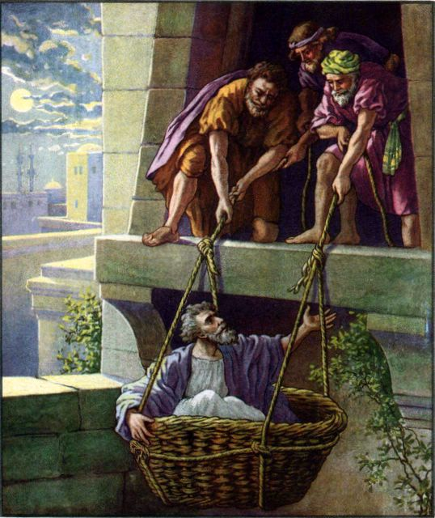

One of Paul's many challenges was to be lowered in a basket from a window outside the city walls of Damascus in order to escape murder.
Source: Public domain here http://www.lavistachurchofchrist.org/Pictures/The%20Early%20Church%20Artwork/images/paul_preaching_christ.jpg

Faith in Action

Prayer
Ask the Holy Spirit to reveal to you a false teachers who need to be exposed and expelled and a true teacher who needs to be recognized and supported.

Action
Today I will pray for faithful leaders among Believers and that the Lord God’s message will be received with new vigor. I will share a word of encouragement with one who has been especially faithful.

Be Specific ______________________________________________________

Friday (2 Corinthians 12)
Paul’s Thorn in the Flesh
12:1 It is necessary to go on boasting. Though it is not profitable, I will go on to visions and revelations from the Lord. 12:2 I know a man in Christ who fourteen years ago (whether in the body or out of the body I do not know, God knows) was caught up to the third heaven. 12:3 And I know that this man (whether in the body or apart from the body I do not know, God knows) 12:4 was caught up into paradise and heard things too sacred to be put into words, things that a person is not permitted to speak. 12:5 On behalf of such an individual I will boast, but on my own behalf I will not boast, except about my weaknesses.
12:6 For even if I wish to boast, I will not be a fool, for I would be telling the truth, but I refrain from this so that no one may regard me beyond what he sees in me or what he hears from me, 12:7 even because of the extraordinary character of the revelations. Therefore, so that I would not become arrogant, a thorn in the flesh was given to me, a messenger of Satan to trouble me—so that I would not become arrogant. 12:8 I asked the Lord three times about this, that it would depart from me. 12:9 But he said to me, “My grace is enough for you, for my power is made perfect in weakness.” So then, I will boast most gladly about my weaknesses, so that the power of Christ may reside in me.
12:10 Therefore I am content with weaknesses, with insults, with troubles, with persecutions and difficulties for the sake of Christ, for whenever I am weak, then I am strong.
The Signs of an Apostle
12:11 I have become a fool. You yourselves forced me to do it, for I should have been commended by you. For I lack nothing in comparison to those “super-apostles,” even though I am nothing.
12:12 Indeed, the signs of an apostle were performed among you with great perseverance by signs and wonders and powerful deeds.
12:13 For how were you treated worse than the other churches, except that I myself was not a burden to you? Forgive me this injustice!
12:14 Look, for the third time I am ready to come to you, and I will not be a burden to you, because I do not want your possessions, but you. For children should not have to save up for their parents, but parents for their children.
12:15 Now I will most gladly spend and be spent for your lives! If I love you more, am I to be loved less?
12:16 But be that as it may, I have not burdened you. Yet because I was a crafty person, I took you in by deceit!
12:17 I have not taken advantage of you through anyone I have sent to you, have I? 12:18 I urged Titus to visit you and I sent our brother along with him. Titus did not take advantage of you, did he? Did we not conduct ourselves in the same spirit? Did we not behave in the same way? 12:19 Have you been thinking all this time that we have been defending ourselves to you? We are speaking in Christ before God, and everything we do, dear friends, is to build you up.
12:20 For I am afraid that somehow when I come I will not find you what I wish, and you will find me not what you wish. I am afraid that somehow there may be quarreling, jealousy, intense anger, selfish ambition, slander, gossip, arrogance, and disorder.
12:21 I am afraid that when I come again, my God may humiliate me before you, and I will grieve for many of those who previously sinned and have not repented of the impurity, sexual immorality, and licentiousness that they have practiced.

Prayer
Lord, You called and equipped and sent the apostle Paul, yet the Corinthians preferred false teachers. May I always be careful to “test the Spirit” before trusting any leader.

Summary & Commentary
Paul reiterated that his boasting was only in Christ because there is no limit to the sacrifices any true Christian would make for the cause of Jesus.
He testified to the comfort and provision of God to those who trust Him - no matter what.
Paul reminded them in a third-person style that he could boast of having been taken up “to the third heaven” but noted that such would not benefit anyone and so, unlike the “super-apostles”, he would not.
He shared with them that God had allowed him to suffer “a thorn in the flesh … a messenger of Satan to trouble me--so I would not become arrogant” then shared “I asked the Lord three times about this, that it would depart from me. But He said to me, “My grace is perfect [or perfected] in weakness … Therefore I am content with weaknesses, with insults, with troubles, with persecutions, and difficulties for the sake of Christ”
Paul clarified for them that he had not been defending himself but “… speaking in Christ before God, and everything we do, dear friends is to build you up.”
He expressed a concern that upon his visit there may be disappointment and conflict because they were stuck in their sin, that the Lord God might “humiliate” him in order to teach them, and that it would be his duty to discipline them.

Interaction

Consider
The difficult intellectual and social tension between Paul’s humility before Christ and his need to expose the false teachers though a comparison of faith-walk credentials.

Discuss
Isn’t the challenge of confronting Believers who are stuck in sin, with the hope that they will confess and repent, and the fear that they will defend and rebel, what causes many in leadership to look the other way—to avoid conflict?

Reflect
Paul’s "thorn in the flesh from Satan" was not revealed by him in its specific form so that it could serve as a principle of humility.

Share
When have you experienced a situation where a thorn in your flesh was used by God to keep you from arrogance? Perhaps a visible flaw, a flaw in your speech, a flaw in your ability to master some area of learning, or a limitation on your income? e.g. God knows that too much money would become a snare to you.

KTALZ
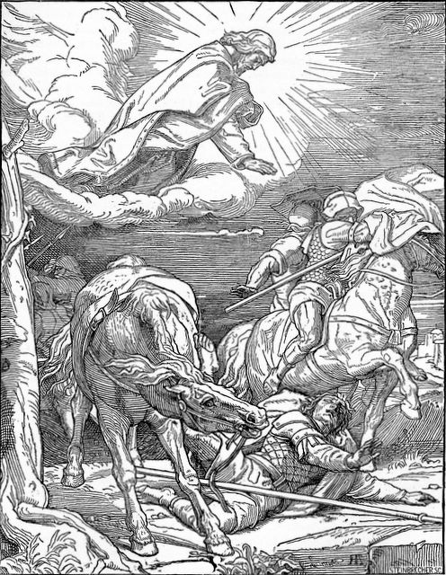

In addition to seeing Jesus on the road to Damascus Paul also experienced additional visions of Heaven.
Source: Public domain here http://www.lavistachurchofchrist.org/Pictures/Treasures%20of%20the%20Bible%20%28Church%20Age%29/images/scan0008.jpg

Faith in Action

Prayer
Ask the Holy Spirit to reveal to you a thorn in your flesh, from which you have been pleading with God for relief, but which is your ‘humbleness-thorn’.

Action
Today I will cease asking for relief and will instead thank Him for my ‘humbleness-thorn’. I will share this with a fellow believer.

Be Specific ______________________________________________________

Saturday (2 Corinthians 13)
Paul’s Third Visit to Corinth
13:1 This is the third time I am coming to visit you. By the testimony of two or three witnesses every matter will be established.
13:2 I said before when I was present the second time and now, though absent, I say again to those who sinned previously and to all the rest, that if I come again, I will not spare anyone, 13:3 since you are demanding proof that Christ is speaking through me. He is not weak toward you but is powerful among you.
13:4 For indeed he was crucified by reason of weakness, but he lives because of God’s power. For we also are weak in him, but we will live together with him, because of God’s power toward you.
13:5 Put yourselves to the test to see if you are in the faith; examine yourselves! Or do you not recognize regarding yourselves that Jesus Christ is in you—unless, indeed, you fail the test!
13:6 And I hope that you will realize that we have not failed the test! 13:7 Now we pray to God that you may not do anything wrong, not so that we may appear to have passed the test, but so that you may do what is right even if we may appear to have failed the test.
13:8 For we cannot do anything against the truth, but only for the sake of the truth.
13:9 For we rejoice whenever we are weak, but you are strong. And we pray for this: that you may become fully qualified.
13:10 Because of this I am writing these things while absent, so that when I arrive I may not have to deal harshly with you by using my authority—the Lord gave it to me for building up, not for tearing down!
Final Exhortations and Greetings
13:11 Finally, brothers and sisters, rejoice, set things right, be encouraged, agree with one another, live in peace, and the God of love and peace will be with you.
13:12 Greet one another with a holy kiss. All the saints greet you. 13:13 The grace of the Lord Jesus Christ and the love of God and the fellowship of the Holy Spirit be with you all.
13:14 [[EMPTY]]

Prayer
Lord, You are the arbiter of good and evil, right and wrong, You bless obedience and withhold blessing for disobedience, You encourage righteousness and punish unrighteousness. May I choose to live a Biblically-disciplined life so that I do not have to be disciplined by You.

Summary & Commentary
Paul predicted that his third visit would be one in which they would be without excuse and one where “I will not spare anyone since you are demanding proof that Christ is speaking through me.”
He challenged them to test themselves as possessing the presence of God though the Holy Spirit and that His power was visible in their right-living.
Paul warned them to apply what he had told them in his letter and to get themselves right before the Lord God so that when he arrived he would not have to “deal harshly” with them using his “authority” because “… the Lord gave it to me for building up, not tearing down!”
Paul concluded the final chapter of his second letter to the Corinthians with several exhortations and greetings:
- “Finally, brothers and sisters, rejoice …”
- “… set things right”
- “… be encouraged”
- “… agree with one another”
- “… live in peace”
- “… and the God of love and peace will be with you.”
- “Greet one another with a holy kiss …”
- “All the saints greet you.”
And finally a prayer of blessing or “benediction”:
“The grace of the Lord Jesus Christ and the love of God and the fellowship of the Holy Spirit be with you all.”

Interaction

Consider
Paul’s desire was that his authority from God be used to build up, yet he recognized that it may need to become a rod of discipline for the well-being of the fellowship. Discipline is part of the process of discipleship and if we do not discipline ourselves then the Lord God may choose to bring discipline upon us.

Discuss
Why would those who were under the leadership authority of one called by the Lord God constantly challenge his authority? Did they not understand that the Lord God had empowered Paul to chastise and discipline them as necessary?

Reflect
Paul’s exhortation was for them to rejoice, to set things right, to be encouraged, to agree with one another, and to live in peace.

Share
Share your heart-reaction to Paul’s closing prayer. Does the Holy Spirit stir your spirit when you read those words?

KTALZ
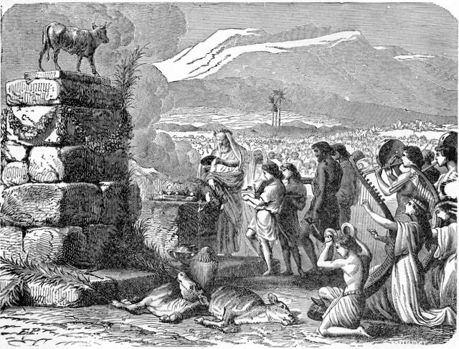

Just as God disciplined the ancient Israelites for their idolotry and rebellion He used Paul to discipline false teachers and rebellious Believers – and He disciplines us today as well.
Source: Public domain here http://www.lavistachurchofchrist.org/Pictures/Treasures%20of%20the%20Bible%20%28Moses%29/images/scan0007.jpg

Faith in Action

Prayer
Ask the Holy Spirit to reveal, from your words, deeds, and heart any evidence that once agreeing to submission to the leader - under whose shepherding the Lord God has placed me - I have then inappropriately-challenged his authority and/or teaching.

Action
Today, unless I have a Biblical cause to raise such a challenge—and I am doing so respectfully and through the proper Biblical process—I will repent of any form of rebellion and I will seek forgiveness and reconciliation.

Be Specific _____________________________________________________
All Bible text is from the NET unless otherwise indicated - http://bible.org
Note 1: These Studies often rely upon the guidance of the NET Translators from their associated notes. Careful attention has been given to cite that source where it has been quoted directly or closely paraphrased. Feedback is encouraged where credit has not been sufficiently assigned.
Note 2: When NET text is quoted in commentary and discussion all pronouns referring to God are capitalized, though they are lower-case in the original NET text.
Commentary text is from David M. Colburn, D.Min. unless otherwise noted.
Copyright © 2011 by David M. Colburn. This is a BibleSeven Study—Section 1 of the series, “2 Corinthians” — prepared by David M. Colburn and edited for bible.org in December of 2011. This text may be used for non-profit educational purposes only, with credit; all other usage requires prior written consent of the author.

