2 Corinthians 1 – 5
David M. Colburn
A Daily Bible Study in 7-Day Sections with a Summary-Commentary, Discussion Questions, and Daily Application

Sunday (2 Corinthians 1)
Salutation
1:1 From Paul, an apostle of Christ Jesus by the will of God, and Timothy our brother, to the church of God that is in Corinth, with all the saints who are in all Achaia. 1:2 Grace and peace to you from God our Father and the Lord Jesus Christ!
Thanksgiving for God’s Comfort
1:3 Blessed is the God and Father of our Lord Jesus Christ, the Father of mercies and God of all comfort, 1:4 who comforts us in all our troubles so that we may be able to comfort those experiencing any trouble with the comfort with which we ourselves are comforted by God.
1:5 For just as the sufferings of Christ overflow toward us, so also our comfort through Christ overflows to you.
1:6 But if we are afflicted, it is for your comfort and salvation; if we are comforted, it is for your comfort that you experience in your patient endurance of the same sufferings that we also suffer.
1:7 And our hope for you is steadfast because we know that as you share in our sufferings, so also you will share in our comfort.
1:8 For we do not want you to be unaware, brothers and sisters, regarding the affliction that happened to us in the province of Asia, that we were burdened excessively, beyond our strength, so that we despaired even of living. 1:9 Indeed we felt as if the sentence of death had been passed against us, so that we would not trust in ourselves but in God who raises the dead.
1:10 He delivered us from so great a risk of death, and he will deliver us. We have set our hope on him that he will deliver us yet again, 1:11 as you also join in helping us by prayer, so that many people may give thanks to God on our behalf for the gracious gift given to us through the help of many.
Paul Defends His Changed Plans
1:12 For our reason for confidence is this: the testimony of our conscience, that with pure motives and sincerity which are from God—not by human wisdom but by the grace of God—we conducted ourselves in the world, and all the more toward you.
1:13 For we do not write you anything other than what you can read and also understand. But I hope that you will understand completely 1:14 just as also you have partly understood us, that we are your source of pride just as you also are ours in the day of the Lord Jesus.
1:15 And with this confidence I intended to come to you first so that you would get a second opportunity to see us, 1:16 and through your help to go on into Macedonia and then from Macedonia to come back to you and be helped on our way into Judea by you. 1:17 Therefore when I was planning to do this, I did not do so without thinking about what I was doing, did I? Or do I make my plans according to mere human standards so that I would be saying both “Yes, yes” and “No, no” at the same time?
1:18 But as God is faithful, our message to you is not “Yes” and “No.” 1:19 For the Son of God, Jesus Christ, the one who was proclaimed among you by us—by me and Silvanus and Timothy—was not “Yes” and “No,” but it has always been “Yes” in him. 1:20 For every one of God’s promises are “Yes” in him; therefore also through him the “Amen” is spoken, to the glory we give to God.
1:21 But it is God who establishes us together with you in Christ and who anointed us, 1:22 who also sealed us and gave us the Spirit in our hearts as a down payment.
Why Paul Postponed His Visit
1:23 Now I appeal to God as my witness, that to spare you I did not come again to Corinth. 1:24 I do not mean that we rule over your faith, but we are workers with you for your joy, because by faith you stand firm.

Prayer
Lord, You are the one true God and You give us comfort, deliverance as instruments of Your work, and purpose in Your service. May I rest in Your comfort, be bold knowing that You are with me, and encouraged that You choose to use me—in my obedience—for Your good purposes.

Summary & Commentary
Paul celebrated the blessedness of the Lord Who comforts those who suffer - for His name - so that they may in turn comfort others who suffer.
He illustrated with his own experience —reaching the point where he “despaired even of living” that God comforted and delivered him -- he then solicited the prayers of the Corinthian Believers that God would again deliver him.
Paul emphasized that it was he-alone (not the Lord God) who had communicated an intention to come to them but that he found his course altered by God. [He wanted to leave no opportunity for the Enemy to misrepresent the facts and thereby create doubt as to the perfect record of God’s promise-keeping.]
Paul appealed to God to assure them in the Spirit that he was being fully honest with them about his desire to visit and his valid reason to postpone that visit.

Interaction

Consider
The pure heart of Paul. He was intentionally-careful to assure that nothing imperfect in him could be imposed upon the perfection of God in the minds of those over whom God had given him spiritual authority.

Discuss
How many times can you recall, in the Bible and reported by people whom you know, that the Lord God has comforted His children in times of trouble?

Reflect
Paul’s certainty was remarkable - that the Lord God Who had comforted and delivered Him in the past would do so again and his intentional-request for the believers in Corinth to pray in-agreement - so they might share in God’s miracle for Paul.

Share
When have you, or someone you know well, experienced God’s comfort and delivery from a time of trouble?

KTALZ
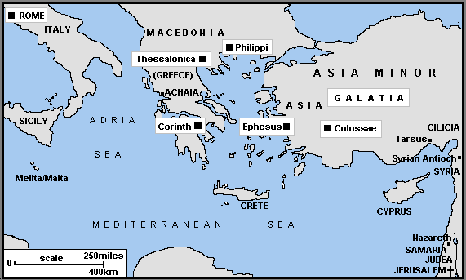

Paul traveled widely as may be seen in this map. In the text he was trapped in a jail in Macedonia, to the north, but wrote to Believers further south in Corinth.
Source: “Maps by Gordon Smith can be used without further permission. Please quote http://www.ccel.org/bible/phillips/JBPhillips.htm”

Faith in Action

Prayer
Ask the Holy Spirit to remind you of His provision of comfort and deliverance in your life.

Action
Today I will share, with a fellow believer, the story of God’s comfort and delivery in my life as a means of celebration and encouragement.

Be Specific ______________________________________________________

Monday (2 Corinthians 2)
2:1 So I made up my own mind not to pay you another painful visit. 2:2 For if I make you sad, who would be left to make me glad but the one I caused to be sad?
2:3 And I wrote this very thing to you, so that when I came I would not have sadness from those who ought to make me rejoice, since I am confident in you all that my joy would be yours.
2:4 For out of great distress and anguish of heart I wrote to you with many tears, not to make you sad, but to let you know the love that I have especially for you.
2:5 But if anyone has caused sadness, he has not saddened me alone, but to some extent (not to exaggerate) he has saddened all of you as well.
2:6 This punishment on such an individual by the majority is enough for him, 2:7 so that now instead you should rather forgive and comfort him. This will keep him from being overwhelmed by excessive grief to the point of despair.
2:8 Therefore I urge you to reaffirm your love for him.
2:9 For this reason also I wrote you: to test you to see if you are obedient in everything.
2:10 If you forgive anyone for anything, I also forgive him—for indeed what I have forgiven (if I have forgiven anything) I did so for you in the presence of Christ, 2:11 so that we may not be exploited by Satan (for we are not ignorant of his schemes).
2:12 Now when I arrived in Troas to proclaim the gospel of Christ, even though the Lord had opened a door of opportunity for me,
2:13 I had no relief in my spirit, because I did not find my brother Titus there. So I said good-bye to them and set out for Macedonia.
Apostolic Ministry
2:14 But thanks be to God who always leads us in triumphal procession in Christ and who makes known through us the fragrance that consists of the knowledge of him in every place.
2:15 For we are a sweet aroma of Christ to God among those who are being saved and among those who are perishing—2:16 to the latter an odor from death to death, but to the former a fragrance from life to life. And who is adequate for these things?
2:17 For we are not like so many others, hucksters who peddle the word of God for profit, but we are speaking in Christ before God as persons of sincerity, as persons sent from God.

Prayer
Lord, You walked with Adam and Eve, spoke to Noah and Jacob, gave the Law to Israel via Moses, proclaimed the coming of the Messiah via Isaiah and John the Baptist, came in human form as Jesus the Christ, and when He returned Home You indwelt believers as the Holy Spirit. It has always been You showing us the way Home from the Fall, You are the One Who empowers human leaders to exhort and to teach, and it's You Who transforms us from death to life. May I give You all of the glory and all of myself.

Summary & Commentary
Paul explained that he wanted to avoid a second visit where his need to challenge them to deal with extreme sin in their fellowship might harm their sense of joy in the Lord and damage his relationship with them.
Paul reminded them that their obedience “in everything” required them to offer forgiveness to the member who had sinned so blatantly so as to not cause him grief which could lead to “despair”.
Paul added an odd and incompletely explained parenthetical in 2:12-13 where he acknowledges a provision from the Lord of “a door of opportunity” in Troas “to proclaim the gospel of Christ” yet due to the absence of Titus he “had no relief in his spirit” and thus moved on to Macedonia.
[Note: It is reasonable to speculate that he may have been drawing a parallel between his experience of longing for the positive encouragement of a brother (for affirmation) to that of the fellowship in Corinth struggling due to the failed visit of Paul. It may also be that there was some cultural affirmation of his call to minister in Troas that could come through Titus and not directly though Paul alone. One may recall Jesus’ instruction to the disciples that should they not be welcomed in a town they should move on as the Holy Spirit had not yet prepared it.]
Paul concluded with a celebration that those who are “speaking in Christ before God as persons of sincerity, as persons sent from God” are a “sweet aroma of Christ to God … life to life” in the midst of those “being-saved” – and of “death to death” to those “who are perishing”.
[Note: Paul's point is that in sincerely speaking the Truth we are Christ's presence wherever we are. The choices, and consequences, of those who hear are their own.]

Interaction

Consider
The challenge of Paul was to be obedient to God in all things, not just the comfortable or convenient, but in all things.

Discuss
Isn’t it an amazing presence of the Lord God through His Holy Spirit that when a person speaks so purely from the Word of God, not in style but in integrity of content and life-example, that they are a "sweet aroma of Christ to God"?

Reflect
How would you decide when discipline and the "putting-out" a formerly unrepentant, and now repentant, sinner had been concluded? How would you deliver forgiveness without any confusion that the fellowship was in no way downplaying or endorsing the seriousness of sin?

Share
When have you had an experience where you’d planned a challenging ministry outreach, and believed that God had prepared it, but the absence of a partner in that ministry caused you to hesitate and/or postpone?

KTALZ


We are all familiar with the sweet aroma of flowers – Paul described a similar sense of joy in the spiritual realm that flows from the sincere sharing of God's Truth.

Faith in Action

Prayer
Ask the Holy Spirit to reveal to you one area where you have chosen comfort or convenience over obedience to God

Action
Today I will ask a fellow believer to pray in agreement with me for the strength and persistence to take a new step toward maturity in my walk.

Be Specific ______________________________________________________

Tuesday (2 Corinthians 3)
A Living Letter
3:1 Are we beginning to commend ourselves again? We don’t need letters of recommendation to you or from you as some other people do, do we?
3:2 You yourselves are our letter, written on our hearts, known and read by everyone, 3:3 revealing that you are a letter of Christ, delivered by us, written not with ink but by the Spirit of the living God, not on stone tablets but on tablets of human hearts.
3:4 Now we have such confidence in God through Christ.
3:5 Not that we are adequate in ourselves to consider anything as if it were coming from ourselves, but our adequacy is from God, 3:6 who made us adequate to be servants of a new covenant not based on the letter but on the Spirit, for the letter kills, but the Spirit gives life.
The Greater Glory of the Spirit’s Ministry
3:7 But if the ministry that produced death—carved in letters on stone tablets—came with glory, so that the Israelites could not keep their eyes fixed on the face of Moses because of the glory of his face (a glory which was made ineffective), 3:8 how much more glorious will the ministry of the Spirit be?
3:9 For if there was glory in the ministry that produced condemnation, how much more does the ministry that produces righteousness excel in glory!
3:10 For indeed, what had been glorious now has no glory because of the tremendously greater glory of what replaced it.
3:11 For if what was made ineffective came with glory, how much more has what remains come in glory!
3:12 Therefore, since we have such a hope, we behave with great boldness, 3:13 and not like Moses who used to put a veil over his face to keep the Israelites from staring at the result of the glory that was made ineffective.
3:14 But their minds were closed. For to this very day, the same veil remains when they hear the old covenant read. It has not been removed because only in Christ is it taken away.
3:15 But until this very day whenever Moses is read, a veil lies over their minds, 3:16 but when one turns to the Lord, the veil is removed.
3:17 Now the Lord is the Spirit, and where the Spirit of the Lord is present, there is freedom.
3:18 And we all, with unveiled faces reflecting the glory of the Lord, are being transformed into the same image from one degree of glory to another, which is from the Lord, who is the Spirit.

Prayer
Lord, You replace the Law with Grace. May I praise You with my life for that freedom.

Summary & Commentary
Paul observed that he no longer required a letter of reference since the very existence of a fellowship of believers in Corinth, the fruits of his faithful service to God, was his living reference. [The Net translator’s Notes speculate that this was in response to some apparent challenge to his credentials.]
The “new covenant” was not, Paul reminded them, a new law (“for the letter kills”) it was of “the Spirit [Who] brings life”.
Paul reminded them that Moses bore a shadow of the glory of God when he returned from the mountain and his ministry, the bringing of the Law, also possessed Glory. He elaborated that such glory faded as it was associated with the conviction of the Law—which none but Jesus could ever have kept perfectly. Paul then compared it to the “ministry of the Spirit” —which replaced the ineffectiveness of the Law with “the ministry that produces righteousness”.
He observed that the same veil that Moses bore to keep the Israelites from staring at his shining face, to focus them on the Law, is like the veil on the hearts of those who hear the words of Moses yet fail to see Christ in them.
[Note: One might consider “the baptism of John” versus the completed baptism of Jesus which includes the indwelling Holy Spirit. Note also that it's been reported that in public gatherings Jews generally do not read certain parts of Isaiah because the text so clearly describes Jesus.]
Paul concluded that the presence of the Spirit [in every true Believer] transforms them from the glory of the promise given to Moses into the fulfillment of that promise in Christ.

Interaction

Consider
The credentials of Paul are found in the testimony of those whom God had drawn near in salvation and discipleship as a result of his faithful service.

Discuss
How do you explain to someone considering-Christ, or a new (or stuck at new) Believer the amazing transition from pre-resurrection to post-resurrection where God delivered His new covenant of grace - displacing the old covenant of law?

Reflect
Freedom from the convicting and impossible-to-achieve challenge of the Law into the completing and freedom-bringing blessing of grace is an incredible gift of the Lord God.

Share
Your experience of being "veiled" from a full appreciation of, and empowerment by, the Lord God—which comes only from salvation and the indwelling Holy Spirit. What happened when you finally surrendered and received the gift of salvation?

KTALZ
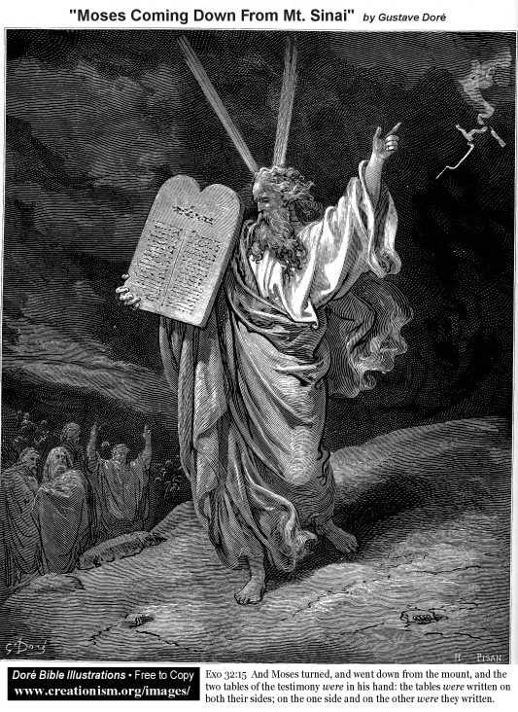

This picture attempts to portray Moses bring the tablets but forgets his veil – made necessary because his face glowed from his nearness to the glory of God – a distraction from the message on the tablets. The veil in the Temple was torn when Jesus was crucified. When we receive the Holy Spirit the veil of rebellion is removed from our minds.

Faith in Action

Prayer
Ask the Holy Spirit to remind you of your experience of transition from “veiled” to “seeing clearly” as a result of your salvation.

Action
Today I will share with a potential believer, via E-mail (or other electronic communication), letter, phone call, or face-to-face conversation, my experience of transition from "veiled" to "seeing clearly" as a result of my salvation.

Be Specific ______________________________________________________

Wednesday (2 Corinthians 4:1-6)
Paul’s Perseverance in Ministry
4:1 Therefore, since we have this ministry, just as God has shown us mercy, we do not become discouraged.
4:2 But we have rejected shameful hidden deeds, not behaving with deceptiveness or distorting the word of God, but by open proclamation of the truth we commend ourselves to everyone’s conscience before God.
4:3 But even if our gospel is veiled, it is veiled only to those who are perishing, 4:4 among whom the god of this age has blinded the minds of those who do not believe so they would not see the light of the glorious gospel of Christ, who is the image of God.
4:5 For we do not proclaim ourselves, but Jesus Christ as Lord, and ourselves as your slaves for Jesus’ sake.
4:6 For God, who said “Let light shine out of darkness,” is the one who shined in our hearts to give us the light of the glorious knowledge of God in the face of Christ.

Prayer
Lord, You give so much to use and ask that we be careful to tell Your story truthfully, and that we be humble at all times. May I be found faithful in both.

Summary & Commentary
Paul contrasted the positive virtue of faithfulness to the Word against the sin of those who engage in “shameful hidden deeds … behaving with deceptiveness … distorting the Word of God”.
He reminded them that those who are unable to perceive “the light of the glorious gospel” are those “who do not believe”, that it is God Who said “Let light shine out of darkness” Who “shined in our hearts to give us the light of the glorious knowledge of God in the face of Christ.”
Paul re-emphasized the need for humility, using the illustration of “clay jars” to describe believers [especially those who dedicate themselves to preaching and teaching Christ], and noted that “the extraordinary power belongs to God”.
Paul provided a checklist of struggles and of the Lord God’s power:
- “We are experiencing trouble on every side, but are not crushed”
- “we are perplexed, but not driven to despair”
- “we are persecuted, but not abandoned”
- “we are knocked down, but not destroyed”
- “always carrying around in our body the death of Jesus, so that the life of Jesus may also be visible in our body”
Paul observed two final things; that many more are joining in “thanksgiving … to the glory of God”, and that “our momentary, light suffering, is producing for us an eternal weight of glory”

Interaction

Consider
It is an amazing truth that, despite our humble standing as like the simple clay jar of Paul’s time, God chooses to pour Himself out through us. We have a responsibility to remain humble as none of it is from us.

Discuss
How should believers respond to the problem of people claiming the name of Christ and then engaging in “shameful hidden deeds … behaving with deceptiveness … distorting the Word of God”?

Reflect
It is humbling to read the list Paul provided of struggles faced by serious Christians and of the provision of God.

Share
When have you experienced the Lord God causing "light [to] shine out of darkness" through you for the benefit of another?

KTALZ


“For God, who said “Let light shine out of darkness,””

Faith in Action

Prayer
Ask the Holy Spirit to reveal to you an example in your life, of struggles faced by Christians, from the list Paul provide.

Action
Today I will celebrate together with a fellow believer the awesome God who makes provision for me.

Be Specific ______________________________________________________

Thursday (2 Corinthians 7-18)
An Eternal Weight of Glory
4:7 But we have this treasure in clay jars, so that the extraordinary power belongs to God and does not come from us.
4:8 We are experiencing trouble on every side, but are not crushed; we are perplexed, but not driven to despair; 4:9 we are persecuted, but not abandoned; we are knocked down, but not destroyed, 4:10 always carrying around in our body the death of Jesus, so that the life of Jesus may also be made visible in our body.
4:11 For we who are alive are constantly being handed over to death for Jesus’ sake, so that the life of Jesus may also be made visible in our mortal body.
4:12 As a result, death is at work in us, but life is at work in you.
4:13 But since we have the same spirit of faith as that shown in what has been written, “I believed; therefore I spoke,” we also believe, therefore we also speak.
4:14 We do so because we know that the one who raised up Jesus will also raise us up with Jesus and will bring us with you into his presence.
4:15 For all these things are for your sake, so that the grace that is including more and more people may cause thanksgiving to increase to the glory of God.
4:16 Therefore we do not despair, but even if our physical body is wearing away, our inner person is being renewed day by day.
4:17 For our momentary, light suffering is producing for us an eternal weight of glory far beyond all comparison
4:18 because we are not looking at what can be seen but at what cannot be seen. For what can be seen is temporary, but what cannot be seen is eternal.

Prayer
Lord, You give so much to use and ask that we be careful to tell Your story truthfully, and that we be humble at all times. May I be found faithful in both.

Summary & Commentary
Paul contrasted the positive virtue of faithfulness to the Word against the sin of those who engage in “shameful hidden deeds … behaving with deceptiveness … distorting the Word of God”.
He reminded them that those who are unable to perceive “the light of the glorious gospel” are those “who do not believe”, that it is God Who said “Let light shine out of darkness” Who “shined in our hearts to give us the light of the glorious knowledge of God in the face of Christ.”
Paul re-emphasized the need for humility, using the illustration of “clay jars” to describe believers [especially those who dedicate themselves to preaching and teaching Christ], and noted that “the extraordinary power belongs to God”.
Paul provided a checklist of struggles and of the Lord God’s power:
- “We are experiencing trouble on every side, but are not crushed”
- “we are perplexed, but not driven to despair”
- “we are persecuted, but not abandoned”
- “we are knocked down, but not destroyed”
- “always carrying around in our body the death of Jesus, so that the life of Jesus may also be visible in our body”
Paul observed two final things; that many more are joining in “thanksgiving … to the glory of God”, and that “our momentary, light suffering, is producing for us an eternal weight of glory”
[Note: Constables Notes suggests that 2 Cor. vs 4:13 “But since we have the same spirit of faith as that shown in what has been written, “I believed; therefore I spoke,” we also believe, therefore we also speak.” refers to Psalms 115:2-3a “Why should the nations say,
“Where is their God?”
Our God is in heaven!”]

Interaction

Consider
It is an amazing truth that, despite our humble standing as like the simple clay jar of Paul’s time, God chooses to pour Himself out through us. We have a responsibility to remain humble as none of it is from us.

Discuss
How should believers respond to the problem of people claiming the name of Christ and then engaging in “shameful hidden deeds … behaving with deceptiveness … distorting the Word of God”?

Reflect
It is humbling to read the list Paul provided of struggles faced by serious Christians and of the provision of God.

Share
When have you experienced the Lord God causing "light [to] shine out of darkness" through you for the benefit of another?

KTALZ
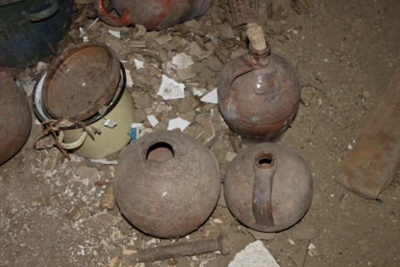



We are like these old clay pots. God cleans us up and allows us to be His instruments in pouring-out His grace and truth.
Source: Public domain here http://publicphoto.org/household/old-ceramic-pots-dusty-clay-pots/

Faith in Action

Prayer
Ask the Holy Spirit to reveal to you an example in your life from the list Paul provided of struggles faced by Christians.

Action
Today I will celebrate together with a fellow believer the awesome God who makes provision for me and Who allows me to be His instrument.

Be Specific ______________________________________________________

Friday (2 Corinthians 5:1-10)
Living by Faith, Not by Sight
5:1 For we know that if our earthly house, the tent we live in, is dismantled, we have a building from God, a house not built by human hands, that is eternal in the heavens.
5:2 For in this earthly house we groan, because we desire to put on our heavenly dwelling, 5:3 if indeed, after we have put on our heavenly house, we will not be found naked.
5:4 For we groan while we are in this tent, since we are weighed down, because we do not want to be unclothed, but clothed, so that what is mortal may be swallowed up by life.
5:5 Now the one who prepared us for this very purpose is God, who gave us the Spirit as a down payment.
5:6 Therefore we are always full of courage, and we know that as long as we are alive here on earth we are absent from the Lord—5:7 for we live by faith, not by sight.
5:8 Thus we are full of courage and would prefer to be away from the body and at home with the Lord.
5:9 So then whether we are alive or away, we make it our ambition to please him.
5:10 For we must all appear before the judgment seat of Christ, so that each one may be paid back according to what he has done while in the body, whether good or evil.

Prayer
Lord, You created us to dwell in the Garden of Eden, and after the Fall destroyed that, in the new Heaven and the new Earth - where there is no sin and there is no temptation. May I remember that I was not made for this imperfect place and that it is right that I never feel quite at home here.

Summary & Commentary
Paul challenged his readers to acknowledge their temporary physical condition in fallen bodies in a fallen world and our natural groaning for Heaven.
He reminded them that the indwelling Holy Spirit of God was a “down payment” from God upon a Believer's guaranteed place in Heaven.
He noted that once one is saved one is an eternal citizen of Heaven, and while here, “absent from the Lord”, one therefore lives “by faith” [In the Lord, Who awaits our arrival] “not by sight” [because we cannot see Him].
He challenged his readers to “make it our ambition to please Him”, whether on earth or in Heaven, and to chose carefully what one does “while in the body”.
[Note: Paul used himself as an example in these verses and stood as a role model for those who would follow. He said as much in his instructions to the Corinthians about singleness and also when writing to Timothy and Titus. He is also speaking to Believers about their lives after surrendering to Christ.]
Paul noted that the world judges by human appearance and that he had seen Christ on the road to Damascus, but that now all Believers must join him in seeing Christ and fellow Believers through the eternal perspective of Heaven.
Paul wrote the following series of steps to understanding:
- “… if anyone is in Christ, he is a new creation;
- “what is old has passed away -- look, what is new has come!”
- “… all these things are from God Who reconciled us to Himself through Christ”
- “… Who has given us the ministry of reconciliation”
- “… not counting people’s trespasses against them”
- “He has given us the message of reconciliation”
- “… we are ambassadors of Christ”
- “as though God were making His plea through us”

Interaction

Consider
Paul challenged us to "make it our ambition to please Him", whether on earth or in Heaven, and to chose carefully what we do "while in the body".

Discuss
How do Paul’s steps to understanding help you?

Reflect
Paul’s words are encouraging—it is appropriate that we “groan” for Heaven as the new person-in-Christ. We no longer belong to this world, we live by faith having not seen Christ but knowing Him through the indwelling presence of the Holy Spirit, and that we are to be intentional about seeing everything through the lens of Heaven and not earth.

Share
When have you had an experience where viewing things here on earth through the lens of Heaven brought comfort and understanding where before there was fear and confusion?

KTALZ


Just as the shell of a hermit crab is temporary so are our fallen-bodies here on earth. Paul used the image of a tent, perhaps a one-man tent, for the same purpose.
Source: Public domain as in the picture.

Faith in Action

Prayer
Ask the Holy Spirit to reveal to you a particularly challenging relationship in your life to which He wants me to apply this subset of Paul’s steps to understanding; “… the ministry of reconciliation … not counting people’s trespasses against them … the message of reconciliation”.

Action
Today I will submit to the Holy Spirit as He walks with me through the process of reconciliation. I will share the result with a fellow believer, whom I will also ask (in advance), to pray for courage and wisdom as I do this.

Be Specific ______________________________________________________

Saturday (2 Corinthians 5:11-21)
The Message of Reconciliation
5:11 Therefore, because we know the fear of the Lord, we try to persuade people, but we are well known to God, and I hope we are well known to your consciences too. 5:12 We are not trying to commend ourselves to you again, but are giving you an opportunity to be proud of us, so that you may be able to answer those who take pride in outward appearance and not in what is in the heart.
5:13 For if we are out of our minds, it is for God; if we are of sound mind, it is for you.
5:14 For the love of Christ controls us, since we have concluded this, that Christ died for all; therefore all have died.
5:15 And he died for all so that those who live should no longer live for themselves but for him who died for them and was raised.
5:16 So then from now on we acknowledge no one from an outward human point of view. Even though we have known Christ from such a human point of view, now we do not know him in that way any longer.
5:17 So then, if anyone is in Christ, he is a new creation; what is old has passed away—look, what is new has come!
5:18 And all these things are from God who reconciled us to himself through Christ, and who has given us the ministry of reconciliation.
5:19 In other words, in Christ God was reconciling the world to himself, not counting people’s trespasses against them, and he has given us the message of reconciliation.
5:20 Therefore we are ambassadors for Christ, as though God were making His plea through us. We plead with you on Christ’s behalf, “Be reconciled to God!”
5:21 God made the one who did not know sin to be sin for us, so that in him we would become the righteousness of God.

Prayer
Lord, You created us to be in relationship with You. May I be faithful as your instrument so that Your judgment of my life in-faith will be of faithful service.

Summary & Commentary
Paul reminded his readers that he brought truth to non-believers and that they should emulate him – because of God.
He reminded them that they should live for Christ because He died for them.
Paul explained that when one is "in Christ" one "is" (present-tense, completed) a "new creation" which means that nothing prior to that moment may be held against him/her in this world or at judgment.
He further explained that Christ's ministry of reconciliation with Believers should also be our ministry to one-another and our motivation to reach others so they also may be blessed.

Interaction

Consider
Paul's faithfulness is to be our role model.

Discuss
How would you explain Paul's teaching about becoming a “new creation” to a new Believer?

Reflect
Jesus the Christ is reconciling with us so we are to be reconciled to one-another.

Share
When have you had an experience where a fellowship was truly committed to living “for Christ” because He died for them?

KTALZ
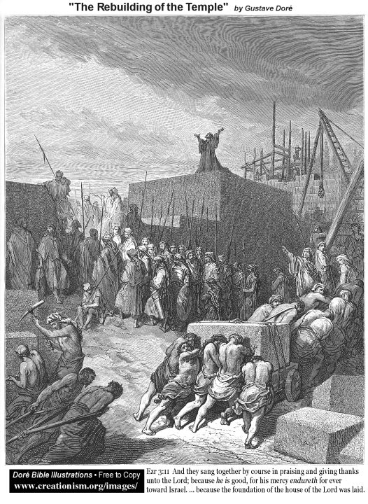

Just as the ancient Israelites repented and physically rebuilt the Temple so are we to repent, be reconciled to Christ, and then He will make us a “new creation”.
Source: Public domain as cited in the image.

Faith in Action

Prayer
Ask the Holy Spirit to reveal to you an opportunity to share Paul's teaching about a “new creation”.

Action
Today I will seize the opportunity to share Paul's teaching. I will ask a fellow Believer to pray in-agreement that I will be bold, gentle, humble, and patient.

Be Specific ______________________________________________________
All Bible text is from the NET unless otherwise indicated - http://bible.org
Note 1: These Studies often rely upon the guidance of the NET Translators from their associated notes. Careful attention has been given to cite that source where it has been quoted directly or closely paraphrased. Feedback is encouraged where credit has not been sufficiently assigned.
Note 2: When NET text is quoted in commentary and discussion all pronouns referring to God are capitalized, though they are lower-case in the original NET text.
Commentary text is from David M. Colburn, D.Min. unless otherwise noted.
Copyright © 2011, 2012, 2013, 2014 by David M. Colburn. This is a BibleSeven Study of 2 Corinthians — prepared by David M. Colburn and edited for bible.org in Fall 2014. This text may be used for non-profit educational purposes only, with credit; all other usage requires prior written consent of the author.

