1 Kings 12 – 14, 2 Chronicles 10 – 12, 1 Kings 15:1-24, 2 Chronicles 13 – 16, 1 Kings 15:25 – 16, 2 Chronicles 17
(Various Kings Rise and Fall)
David M. Colburn
A Chronological Daily Bible Study of the Old Testament
7-Day Sections with a Summary-Commentary, Discussion Questions,
and a Practical Daily Application
Week 38

Sunday (1 Kings 12:1-24, 2 Chronicles 10 – 11:4)
1 Kings
Rehoboam Loses His Kingdom
12:1 Rehoboam traveled to Shechem, for all Israel had gathered in Shechem to make Rehoboam king. 12:2 When Jeroboam son of Nebat heard the news, he was still in Egypt, where he had fled from King Solomon and had been living ever since. 12:3 They sent for him, and Jeroboam and the whole Israelite assembly came and spoke to Rehoboam, saying, 12:4 “Your father made us work too hard. Now if you lighten the demands he made and don’t make us work as hard, we will serve you.” 12:5 He said to them, “Go away for three days, then return to me.” So the people went away.
12:6 King Rehoboam consulted with the older advisers who had served his father Solomon when he had been alive. He asked them, “How do you advise me to answer these people?” 12:7 They said to him, “Today if you show a willingness to help these people and grant their request, they will be your servants from this time forward.” 12:8 But Rehoboam rejected their advice and consulted the young advisers who served him, with whom he had grown up. 12:9 He asked them, “How do you advise me to respond to these people who said to me, ‘Lessen the demands your father placed on us’?” 12:10 The young advisers with whom Rehoboam had grown up said to him, “Say this to these people who have said to you, ‘Your father made us work hard, but now lighten our burden.’ Say this to them: ‘I am a lot harsher than my father! 12:11 My father imposed heavy demands on you; I will make them even heavier. My father punished you with ordinary whips; I will punish you with whips that really sting your flesh.’”
12:12 Jeroboam and all the people reported to Rehoboam on the third day, just as the king had ordered when he said, “Return to me on the third day.” 12:13 The king responded to the people harshly. He rejected the advice of the older men 12:14 and followed the advice of the younger ones. He said, “My father imposed heavy demands on you; I will make them even heavier. My father punished you with ordinary whips; I will punish you with whips that really sting your flesh.” 12:15 The king refused to listen to the people, because the Lord was instigating this turn of events so that he might bring to pass the prophetic announcement he had made through Ahijah the Shilonite to Jeroboam son of Nebat.
12:16 When all Israel saw that the king refused to listen to them, the people answered the king, “We have no portion in David, no share in the son of Jesse! Return to your homes, O Israel! Now, look after your own dynasty, O David!” So Israel returned to their homes. 12:17 (Rehoboam continued to rule over the Israelites who lived in the cities of Judah.) 12:18 King Rehoboam sent Adoniram, the supervisor of the work crews, out after them, but all Israel stoned him to death. King Rehoboam managed to jump into his chariot and escape to Jerusalem. 12:19 So Israel has been in rebellion against the Davidic dynasty to this very day. 12:20 When all Israel heard that Jeroboam had returned, they summoned him to the assembly and made him king over all Israel. No one except the tribe of Judah remained loyal to the Davidic dynasty.
12:21 When Rehoboam arrived in Jerusalem, he summoned 180,000 skilled warriors from all of Judah and the tribe of Benjamin to attack Israel and restore the kingdom to Rehoboam son of Solomon. 12:22 But God told Shemaiah the prophet, 12:23 “Say this to King Rehoboam son of Solomon of Judah, and to all Judah and Benjamin, as well as the rest of the people, 12:24 ‘The Lord says this: “Do not attack and make war with your brothers, the Israelites. Each of you go home, for I have caused this to happen.”’” They obeyed the Lord and went home as the Lord had ordered them to do.

2 Chronicles
The Northern Tribes Rebel
10:1 Rehoboam traveled to Shechem, for all Israel had gathered in Shechem to make Rehoboam king. 10:2 When Jeroboam son of Nebat heard the news, he was still in Egypt, where he had fled from King Solomon. Jeroboam returned from Egypt. 10:3 They sent for him and Jeroboam and all Israel came and spoke to Rehoboam, saying, 10:4 “Your father made us work too hard! Now if you lighten the demands he made and don’t make us work as hard, we will serve you.” 10:5 He said to them, “Go away for three days, then return to me.” So the people went away.
10:6 King Rehoboam consulted with the older advisers who had served his father Solomon when he had been alive. He asked them, “How do you advise me to answer these people?” 10:7 They said to him, “If you are fair to these people, grant their request, and are cordial to them, they will be your servants from this time forward.” 10:8 But Rehoboam rejected their advice and consulted the young advisers who served him, with whom he had grown up. 10:9 He asked them, “How do you advise me to respond to these people who said to me, ‘Lessen the demands your father placed on us’?” 10:10 The young advisers with whom Rehoboam had grown up said to him, “Say this to these people who have said to you, ‘Your father made us work hard, but now lighten our burden’ – say this to them: ‘I am a lot harsher than my father! 10:11 My father imposed heavy demands on you; I will make them even heavier. My father punished you with ordinary whips; I will punish you with whips that really sting your flesh.’”
10:12 Jeroboam and all the people reported to Rehoboam on the third day, just as the king had ordered when he said, “Return to me on the third day.” 10:13 The king responded to the people harshly. He rejected the advice of the older men 10:14 and followed the advice of the younger ones. He said, “My father imposed heavy demands on you; I will make them even heavier. My father punished you with ordinary whips; I will punish you with whips that really sting your flesh.” 10:15 The king refused to listen to the people, because God was instigating this turn of events so that he might bring to pass the prophetic announcement he had made through Ahijah the Shilonite to Jeroboam son of Nebat.
10:16 When all Israel saw that the king refused to listen to them, the people answered the king, “We have no portion in David – no share in the son of Jesse! Return to your homes, O Israel! Now, look after your own dynasty, O David!” So all Israel returned to their homes. 10:17 (Rehoboam continued to rule over the Israelites who lived in the cities of Judah.) 10:18 King Rehoboam sent Hadoram, the supervisor of the work crews, out after them, but the Israelites stoned him to death. King Rehoboam managed to jump into his chariot and escape to Jerusalem. 10:19 So Israel has been in rebellion against the Davidic dynasty to this very day.
11:1 When Rehoboam arrived in Jerusalem, he summoned 180,000 skilled warriors from Judah and Benjamin to attack Israel and restore the kingdom to Rehoboam. 11:2 But the Lord told Shemaiah the prophet, 11:3 “Say this to King Rehoboam son of Solomon of Judah and to all the Israelites in Judah and Benjamin, 11:4 ‘The Lord says this: “Do not attack and make war with your brothers. Each of you go home, for I have caused this to happen.”’” They obeyed the Lord and called off the attack against Jeroboam.

Prayer
Lord, when You bless You do so in response to obedience, and when You withdraw Your blessing it is always a challenging time. May I keep You first in all things so that I never have to experience a loss of Your blessing.

Scripture In Perspective
After a forty year reign King Solomon died and his son Rehoboam took the throne. When the people gathered to crown Rehoboam representatives of the tribes called for Jeroboam to return from Egypt to challenge him to make changes to some of Solomon's practices.
Rehoboam was immediately challenged to reduce the heavy burdens Solomon had imposed to support his massive building projects and his luxurious lifestyle and his 1,000 concubines and wives.
Rehoboam asked the older advisers from Solomon's days if he should lighten the load of the people and they recommended that he curry favor with the people by lightening their burden
He did not want to lose the resources they provided so he asked his young friends and they advised him to be even rougher to prove he was in charge and he liked the sound of that, and so he did.
The Lord God further hardened Rehoboam's arrogant and hard heart in order to expedite the fulfillment of His prophetic judgment. The Lord had decided to punish the people for their drift into the worship of false Gods and other sins.
All of the tribes, other than Judah and Benjamin, rebelled. Jereboam became the leader of Israel – less Judah and Benjamin – and Rehoboam the leader of the Israelites in Judah and Benjamin.
Rehoboam gathered his army to attack but the Lord God stopped him through the prophet Shemiah, saying that He had caused the division of Israel, and Lord told the people not to participate and so they went home.

Interact with the text

Consider
The arrogance of youth, combined with the inheritance of the costly-opulence of a disobedient Solomon, created a test for Rehoboam – which he turned into a temptation to be equally unwise in his own leadership.

Discuss
Why would the people think that Rehoboam might be persuaded by Jeroboam to lighten their burdens?

Reflect
Depriving the nation of unity, and the exceptional resources of His blessing, created a less-stable environment where the leaders had a reason to reflect and to make better choices.

Share
When have you observed a person, family, fellowship, business, or political entity with tremendous blessings behave foolishly and squander them?
KTALZ
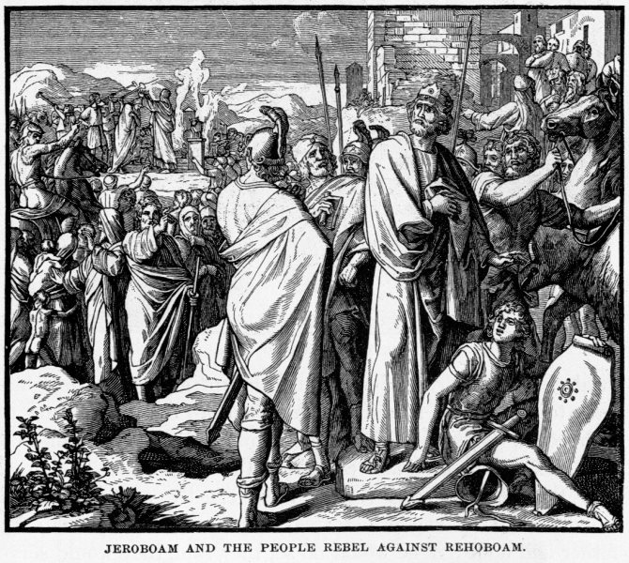

Fulfilling prophesy God further-hardened the immature and selfish heart of Reheboam which led to 10 northern tribes to reject him as Solomon's successor.
Source: Public domain here http://www.coolnotions.com/PDImages/StoryOTB133_p326-Jeroboam-and-the-people-rebel-against-Rehoboam.jpg

Faith In Action

Pray
Ask the Holy Spirit to reveal to you a place where you may be taking Him for granted, drifting into a careless lifestyle, and/or creating places of conflict.

Act
I will confess, repent, seek and accept the forgiveness of the Lord, then reassess and prioritize my life with the Lord first in all things.
Be Specific ________________________________________________

Monday (1 Kings 12:25 – 13:32)
Jeroboam Makes Golden Calves
12:25 Jeroboam built up Shechem in the Ephraimite hill country and lived there. From there he went out and built up Penuel. 12:26 Jeroboam then thought to himself: “Now the Davidic dynasty could regain the kingdom. 12:27 If these people go up to offer sacrifices in the Lord’s temple in Jerusalem, their loyalty could shift to their former master, King Rehoboam of Judah. They might kill me and return to King Rehoboam of Judah.” 12:28 After the king had consulted with his advisers, he made two golden calves. Then he said to the people, “It is too much trouble for you to go up to Jerusalem. Look, Israel, here are your gods who brought you up from the land of Egypt.” 12:29 He put one in Bethel and the other in Dan. 12:30 This caused Israel to sin; the people went to Bethel and Dan to worship the calves.
12:31 He built temples on the high places and appointed as priests people who were not Levites. 12:32 Jeroboam inaugurated a festival on the fifteenth day of the eighth month, like the festival celebrated in Judah. On the altar in Bethel he offered sacrifices to the calves he had made. In Bethel he also appointed priests for the high places he had made.
A Prophet from Judah Visits Bethel
12:33 On the fifteenth day of the eighth month (a date he had arbitrarily chosen) Jeroboam offered sacrifices on the altar he had made in Bethel. He inaugurated a festival for the Israelites and went up to the altar to offer sacrifices.
13:1 Just then a prophet from Judah, sent by the Lord, arrived in Bethel, as Jeroboam was standing near the altar ready to offer a sacrifice. 13:2 With the authority of the Lord he cried out against the altar, “O altar, altar! This is what the Lord says, ‘Look, a son named Josiah will be born to the Davidic dynasty. He will sacrifice on you the priests of the high places who offer sacrifices on you. Human bones will be burned on you.’” 13:3 That day he also announced a sign, “This is the sign the Lord has predetermined: The altar will be split open and the ashes on it will fall to the ground.” 13:4 When the king heard what the prophet cried out against the altar in Bethel, Jeroboam, standing at the altar, extended his hand and ordered, “Seize him!” The hand he had extended shriveled up and he could not pull it back. 13:5 The altar split open and the ashes fell from the altar to the ground, in fulfillment of the sign the prophet had announced with the Lord’s authority. 13:6 The king pled with the prophet, “Seek the favor of the Lord your God and pray for me, so that my hand may be restored.” So the prophet sought the Lord’s favor and the king’s hand was restored to its former condition. 13:7 The king then said to the prophet, “Come home with me and have something to eat. I’d like to give a present.” 13:8 But the prophet said to the king, “Even if you were to give me half your possessions, I could not go with you and eat and drink in this place. 13:9 For the Lord gave me strict orders, ‘Do not eat or drink there and do not go home the way you came.’” 13:10 So he started back on another road; he did not travel back on the same road he had taken to Bethel.
13:11 Now there was an old prophet living in Bethel. When his sons came home, they told their father everything the prophet had done in Bethel that day and all the words he had spoken to the king. 13:12 Their father asked them, “Which road did he take?” His sons showed him the road the prophet from Judah had taken. 13:13 He then told his sons, “Saddle the donkey for me.” When they had saddled the donkey for him, he mounted it 13:14 and took off after the prophet, whom he found sitting under an oak tree. He asked him, “Are you the prophet from Judah?” He answered, “Yes, I am.” 13:15 He then said to him, “Come home with me and eat something.” 13:16 But he replied, “I can’t go back with you or eat and drink with you in this place. 13:17 For the Lord gave me strict orders, ‘Do not eat or drink there; do not go back the way you came.’” 13:18 The old prophet then said, “I too am a prophet like you. An angel told me with the Lord’s authority, ‘Bring him back with you to your house so he can eat and drink.’” But he was lying to him. 13:19 So the prophet went back with him and ate and drank in his house.
13:20 While they were sitting at the table, the Lord spoke through the old prophet 13:21 and he cried out to the prophet from Judah, “This is what the Lord says, ‘You have rebelled against the Lord and have not obeyed the command the Lord your God gave you. 13:22 You went back and ate and drank in this place, even though he said to you, “Do not eat or drink there.” Therefore your corpse will not be buried in your ancestral tomb.’”
13:23 When the prophet from Judah finished his meal, the old prophet saddled his visitor’s donkey for him. 13:24 As the prophet from Judah was traveling, a lion attacked him on the road and killed him. His corpse was lying on the road, and the donkey and the lion just stood there beside it. 13:25 Some men came by and saw the corpse lying in the road with the lion standing beside it. They went and reported what they had seen in the city where the old prophet lived. 13:26 When the old prophet who had invited him to his house heard the news, he said, “It is the prophet who rebelled against the Lord. The Lord delivered him over to the lion and it ripped him up and killed him, just as the Lord warned him.” 13:27 He told his sons, “Saddle my donkey,” and they did so. 13:28 He went and found the corpse lying in the road with the donkey and the lion standing beside it; the lion had neither eaten the corpse nor attacked the donkey. 13:29 The old prophet picked up the corpse of the prophet, put it on the donkey, and brought it back. The old prophet then entered the city to mourn him and to bury him. 13:30 He put the corpse into his own tomb, and they mourned over him, saying, “Ah, my brother!” 13:31 After he buried him, he said to his sons, “When I die, bury me in the tomb where the prophet is buried; put my bones right beside his bones, 13:32 for the prophecy he announced with the Lord’s authority against the altar in Bethel and against all the temples on the high places in the cities of the north will certainly be fulfilled.”

Prayer
Lord, You have high expectations of those who lead in Your name, and are righteously offended when they betray Your trust. May I be careful to listen closely to Your Holy Spirit so that I do not wander.

Scripture In Perspective
Jeroboam feared allowing the people to worship in Jerusalem, worrying that they might return to Rehoboam, so he made two golden calves and told them to worship them instead. This was a rebellion against the Lord God similar to that of Solomon at the end of his reign.
Jeroboam invented his own locations and schedules for sacrifices but was challenged by a young prophet of the Lord God who announced that the priests themselves would be sacrificed on their altar of rebellion – indeed that the altar itself would be broken in half.
Jeroboam reached out his hand in anger against the prophet, commanding his guards to seize him, but the Lord God caused Jeroboam's hand to shrivel. Jeroboam begged the prophet to ask God to restore his hand, which he did, and the Lord did so.
Jeroboam invited the prophet home but God had warned His prophet to neither eat or drink nor visit anywhere.
An old prophet met the young prophet and lied to him saying that an angel of God said it was OK to come home with him, and the young prophet failed to consult God, which resulted in his own death for disobedience.

Interact with the text

Consider
Jeroboam seemed unable to learn from the experience of others or from warnings from God.

Discuss
Why would the young prophet have not sensed the lie of the older prophet, or at least paused long enough to check with the Lord God, when a clear and direct command of God was being brought into question?

Reflect
Jeroboam knew what was right but continued to act in ways that he should have known would anger the Lord God, perhaps it was the impact of sudden power, or perhaps it was the evil influence of the false gods his father Solomon had allowed into Israel.

Share
When have you experienced a time, or observed it in others, where what was obviously wrong before the Lord God was rationalized and rebellion flourished for a moment or longer?
KTALZ
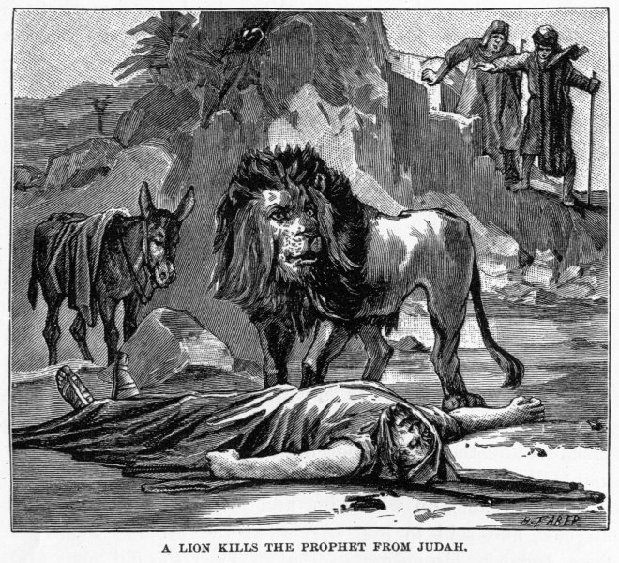

God did not allow any animal to dismember the disobedient young prophet but only the lion to kill him. He was clearly too easily deceived to be trusted.
Source: Public domain here http://www.coolnotions.com/PDImages/StoryOTB135_p330-A-lion-kills-the-prophet-from-Judah.jpg

Faith In Action

Pray
Ask the Holy Spirit to reveal to you someone in leadership who needs prayer as they appear to be making poor choices and are not responding to efforts to cause them to correct them.

Act
Today I will pray for someone in business, education, political, or religious leadership. I will make no judgment as to their salvation nor even my certainty that the Lord God objects to the path they are taking. Like Judas, and others, they may be serving a purpose in His great plan – albeit negative from a worldly perspective. I will, however, pray for their salvation, that they will hear rightly from the Lord, and that they will fully obey.
Be Specific _____________________________________________

Tuesday (1 Kings 13:33 – 14:20)
A Prophet Announces the End of Jeroboam’s Dynasty
13:33 After this happened, Jeroboam still did not change his evil ways; he continued to appoint common people as priests at the high places. Anyone who wanted the job he consecrated as a priest. 13:34 This sin caused Jeroboam’s dynasty to come to an end and to be destroyed from the face of the earth.

14:1 At that time Jeroboam’s son Abijah became sick. 14:2 Jeroboam told his wife, “Disguise yourself so that people cannot recognize you are Jeroboam’s wife. Then go to Shiloh; Ahijah the prophet, who told me I would rule over this nation, lives there. 14:3 Take ten loaves of bread, some small cakes, and a container of honey and visit him. He will tell you what will happen to the boy.”
14:4 Jeroboam’s wife did as she was told. She went to Shiloh and visited Ahijah. Now Ahijah could not see; he had lost his eyesight in his old age. 14:5 But the Lord had told Ahijah, “Look, Jeroboam’s wife is coming to find out from you what will happen to her son, for he is sick. Tell her so-and-so. When she comes, she will be in a disguise.” 14:6 When Ahijah heard the sound of her footsteps as she came through the door, he said, “Come on in, wife of Jeroboam! Why are you pretending to be someone else? I have been commissioned to give you bad news. 14:7 Go, tell Jeroboam, ‘This is what the Lord God of Israel says: “I raised you up from among the people and made you ruler over my people Israel. 14:8 I tore the kingdom away from the Davidic dynasty and gave it to you. But you are not like my servant David, who kept my commandments and followed me wholeheartedly by doing only what I approve. 14:9 You have sinned more than all who came before you. You went and angered me by making other gods, formed out of metal; you have completely disregarded me. 14:10 So I am ready to bring disaster on the dynasty of Jeroboam. I will cut off every last male belonging to Jeroboam in Israel, including even the weak and incapacitated. I will burn up the dynasty of Jeroboam, just as one burns manure until it is completely consumed. 14:11 Dogs will eat the members of your family who die in the city, and the birds of the sky will eat the ones who die in the country.”’ Indeed, the Lord has announced it!
14:12 “As for you, get up and go home. When you set foot in the city, the boy will die. 14:13 All Israel will mourn him and bury him. He is the only one in Jeroboam’s family who will receive a decent burial, for he is the only one in whom the Lord God of Israel found anything good. 14:14 The Lord will raise up a king over Israel who will cut off Jeroboam’s dynasty. It is ready to happen! 14:15 The Lord will attack Israel, making it like a reed that sways in the water. He will remove Israel from this good land he gave to their ancestors and scatter them beyond the Euphrates River, because they angered the Lord by making Asherah poles. 14:16 He will hand Israel over to their enemies because of the sins which Jeroboam committed and which he made Israel commit.”
14:17 So Jeroboam’s wife got up and went back to Tirzah. As she crossed the threshold of the house, the boy died. 14:18 All Israel buried him and mourned for him, just as the Lord had predicted through his servant the prophet Ahijah.

Jeroboam’s Reign Ends
14:19 The rest of the events of Jeroboam’s reign, including the details of his battles and rule, are recorded in the scroll called the Annals of the Kings of Israel. 14:20 Jeroboam ruled for twenty-two years; then he passed away. His son Nadab replaced him as king.

Prayer
Lord, You have told us what You expect – loyalty and respect toward You. May I be careful to compare my deeds to Your Word and my heart-condition to Your expectation of growing holiness.

Scripture In Perspective
Jeroboam failed to learn from the warning of the young prophet and continued to sin.
His son fell ill so he sent his wife in disguise to the blind prophet who had first told him he'd inherit the kingdom. The Lord God warned the prophet to expect her and he pronounced the disastrous end to Jeroboam's rebellious kingship.
Jeroboam had received a great gift and had responded with more disobedience than any king before him. His son died.
[Note: It is important to observe that like Adam and Eve, Cain, Esau, the residents of Sodom & Gomorrah, and the Israelites – over and over as they traveled from Egypt – the people of the ten tribes were willing accomplices in Jeroboam's sin.]
After Jeroboam died one of his remaining sons, Nadab, became king.

Interact With The Text

Consider
Jeroboam seemed unable to learn from the experience of others or from warnings from God.

Discuss
Why would Jeroboam behave so foolishly?

Reflect
Jeroboam knew what was right but continued to act in ways that he should have known would anger the Lord God; perhaps it was the impact of sudden power, or perhaps it was the evil influence of the false gods his father Solomon had allowed into Israel.

Share
When have you experienced a time, or observed it in others, where what was obviously wrong before the Lord God was rationalized and rebellion flourished for a moment or longer?
KTALZ
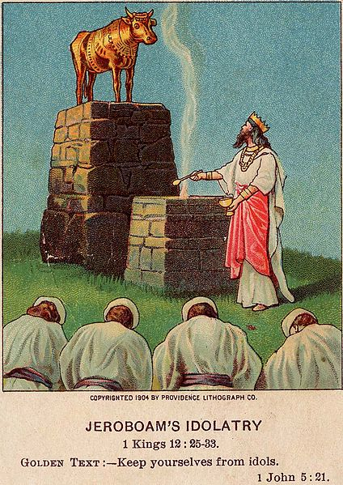

Despite all of the history, and Solomon's warning about servants becoming kings, Jeroboam chose unwisely and squandered his opportunity.
Source: Public domain here http://upload.wikimedia.org/wikipedia/commons/thumb/5/54/Jeroboam%27s_Idolatry_%28Bible_card%29.jpg/424px-Jeroboam%27s_Idolatry_%28Bible_card%29.jpg

Faith In Action

Pray
Ask the Holy Spirit to reveal to you someone in leadership who needs prayer as they appear to be making poor choices and are not responding to efforts to cause them to correct them.

Act
Today I will confess, repent, seek and receive the forgiveness of the Lord for my own rebellion, great and/or small. I will then take meaningful steps to change direction and establish meaningful accountability so that I do not drift back into rebellion.
Be Specific _________________________________________________

Wednesday (2 Chronicles 11:5-12, 1 Kings 14:21-31)
2 Chronicles
Rehoboam’s Reign
11:5 Rehoboam lived in Jerusalem; he built up these fortified cities throughout Judah: 11:6 Bethlehem, Etam, Tekoa, 11:7 Beth Zur, Soco, Adullam, 11:8 Gath, Mareshah, Ziph, 11:9 Adoraim, Lachish, Azekah, 11:10 Zorah, Aijalon, and Hebron. These were the fortified cities in Judah and Benjamin. 11:11 He fortified these cities and placed officers in them, as well as storehouses of food, olive oil, and wine. 11:12 In each city there were shields and spears; he strongly fortified them. Judah and Benjamin belonged to him.
11:13 The priests and Levites who lived throughout Israel supported him, no matter where they resided. 11:14 The Levites even left their pasturelands and their property behind and came to Judah and Jerusalem, for Jeroboam and his sons prohibited them from serving as the Lord’s priests. 11:15 Jeroboam appointed his own priests to serve at the worship centers and to lead in the worship of the goat idols and calf idols he had made. 11:16 Those among all the Israelite tribes who were determined to worship the Lord God of Israel followed them to Jerusalem to sacrifice to the Lord God of their ancestors. 11:17 They supported the kingdom of Judah and were loyal to Rehoboam son of Solomon for three years; they followed the edicts of David and Solomon for three years.
11:18 Rehoboam married Mahalath the daughter of David’s son Jerimoth and of Abihail, the daughter of Jesse’s son Eliab. 11:19 She bore him sons named Jeush, Shemariah, and Zaham. 11:20 He later married Maacah the daughter of Absalom. She bore to him Abijah, Attai, Ziza, and Shelomith. 11:21 Rehoboam loved Maacah daughter of Absalom more than his other wives and concubines. He had eighteen wives and sixty concubines; he fathered twenty-eight sons and sixty daughters.
11:22 Rehoboam appointed Abijah son of Maacah as the leader over his brothers, for he intended to name him his successor. 11:23 He wisely placed some of his many sons throughout the regions of Judah and Benjamin in the various fortified cities. He supplied them with abundant provisions and acquired many wives for them.
12:1 After Rehoboam’s rule was established and solidified, he and all Israel rejected the law of the Lord. 12:2 Because they were unfaithful to the Lord, in King Rehoboam’s fifth year, King Shishak of Egypt attacked Jerusalem. 12:3 He had 1,200 chariots, 60,000 horsemen, and an innumerable number of soldiers who accompanied him from Egypt, including Libyans, Sukkites, and Cushites. 12:4 He captured the fortified cities of Judah and marched against Jerusalem.
12:5 Shemaiah the prophet visited Rehoboam and the leaders of Judah who were assembled in Jerusalem because of Shishak. He said to them, “This is what the Lord says: ‘You have rejected me, so I have rejected you and will hand you over to Shishak.’” 12:6 The leaders of Israel and the king humbled themselves and said, “The Lord is just.” 12:7 When the Lord saw that they humbled themselves, he gave this message to Shemaiah: “They have humbled themselves, so I will not destroy them. I will deliver them soon. My anger will not be unleashed against Jerusalem through Shishak. 12:8 Yet they will become his subjects, so they can experience how serving me differs from serving the surrounding nations.”
12:9 King Shishak of Egypt attacked Jerusalem and took away the treasures of the Lord’s temple and of the royal palace; he took everything, including the gold shields that Solomon had made. 12:10 King Rehoboam made bronze shields to replace them and assigned them to the officers of the royal guard who protected the entrance to the royal palace. 12:11 Whenever the king visited the Lord’s temple, the royal guards carried them and then brought them back to the guardroom.
12:12 So when Rehoboam humbled himself, the Lord relented from his anger and did not annihilate him; Judah experienced some good things. 12:13 King Rehoboam solidified his rule in Jerusalem; he was forty-one years old when he became king and he ruled for seventeen years in Jerusalem, the city the Lord chose from all the tribes of Israel to be his home. Rehoboam’s mother was an Ammonite named Naamah. 12:14 He did evil because he was not determined to follow the Lord.
12:15 The events of Rehoboam’s reign, from start to finish, are recorded in the Annals of Shemaiah the prophet and of Iddo the seer that include genealogical records. 12:16 Then Rehoboam passed away and was buried in the City of David. His son Abijah replaced him as king.

1 Kings
Rehoboam’s Reign over Judah
14:21 Now Rehoboam son of Solomon ruled in Judah. He was forty-one years old when he became king and he ruled for seventeen years in Jerusalem, the city the Lord chose from all the tribes of Israel to be his home. His mother was an Ammonite woman named Naamah.
14:22 Judah did evil in the sight of the Lord. They made him more jealous by their sins than their ancestors had done. 14:23 They even built for themselves high places, sacred pillars, and Asherah poles on every high hill and under every green tree. 14:24 There were also male cultic prostitutes in the land. They committed the same horrible sins as the nations that the Lord had driven out from before the Israelites.
14:25 In King Rehoboam’s fifth year, King Shishak of Egypt attacked Jerusalem. 14:26 He took away the treasures of the Lord’s temple and of the royal palace; he took everything, including all the golden shields that Solomon had made. 14:27 King Rehoboam made bronze shields to replace them and assigned them to the officers of the royal guard who protected the entrance to the royal palace. 14:28 Whenever the king visited the Lord’s temple, the royal guard carried them and then brought them back to the guardroom.
14:29 The rest of the events of Rehoboam’s reign, including his accomplishments, are recorded in the scroll called the Annals of the Kings of Judah. 14:30 Rehoboam and Jeroboam were continually at war with each other. 14:31 Rehoboam passed away and was buried with his ancestors in the city of David. His mother was an Ammonite named Naamah. His son Abijah replaced him as king.

Prayer
Lord, You have Your perfect plan and even the rebellion of kings will not deter You. May I be more attentive to Your plans than my own, may I never fear man more than You, and may I actively seek to more nearly follow You in all that I say, think, and do.

Scripture In Perspective
Rehoboam heavily fortified Judah and Benjamin and solidified his rule as king.
Those who desired to continue to follow the Lord gathered in Judah and Benjamin and left Israel, but as soon as Rehoboam felt secure in his power he turned away from the Lord God and, like his father Solomon, he began to worship the false gods of his concubines and wives.
Rehoboam behaved in just as disrespectful a way toward the Lord God in Jerusalem, capital of the single-tribe nation of Judah, as Jeroboam was behaving as leader of the other nine tribes of Israel. The countryside was littered with altars and idols and shrines to false gods.
The Lord God allowed King Shishak of Egypt to attack and capture the fortified cities of Judah and to take treasures from Jerusalem, including the massive gold shields, so Rehoboam had them replaced with brass and locked them in the guardroom when not in use.
He left behind a humbled Rehoboam as a subject-king.
Rehoboam and Jeroboam warred with each other continually.
Rehoboam died and was replaced by his son Abijah.

Interact With The Text

Consider
The Egyptians figured out that Judah was vulnerable and that Israel would not help them, so they were an easy target for attack, and Solomon had foolishly showed-off all of their riches to everyone.

Discuss
Given the contrast between the great blessings of Solomon, while he was faithful to the Lord God, and the troubled times when there was rebellion why would Rehoboam not have figured out the cause of the troubles?

Reflect
The Lord God often allowed the natural flesh-based impulses of pagans to function as His tools of judgment upon Israel.

Share
When have you observed a new leader follow a failed leader and copy their destructive choices, despite the clear evidence that they would suffer the same outcome?

KTALZ
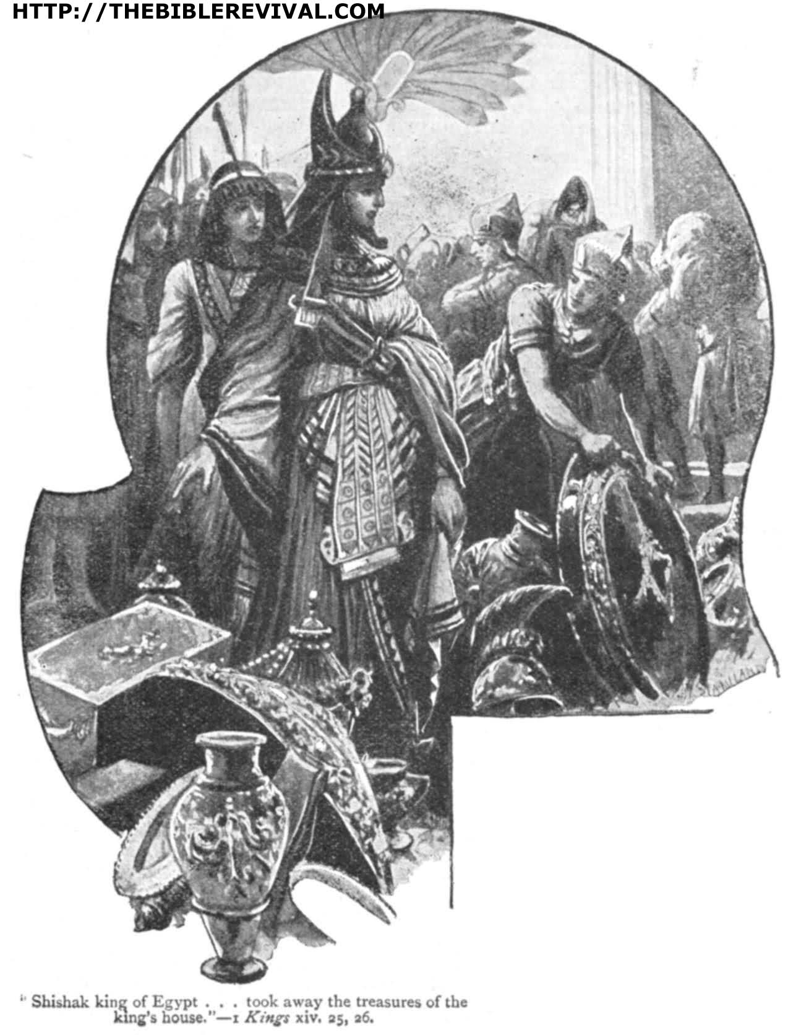

In his foolishness Solomon had bragged about and displayed Israel's great wealth in Jerusalem – so when they became vulnerable the Egyptians knew just where to go.
Source: Public domain here http://thebiblerevival.com/clipart/i%20kings%2014%20-%2025%20shishak%20king%20of%20egypt.jpg

Faith In Action

Pray
Ask the Holy Spirit to reveal to you a place in your life where you are tolerating evil and as a result are making yourself vulnerable to the agents of the enemy.

Act
Today I will humbly accept the chastising of the Holy Spirit and I will immediately remove from my life the “altars”, “idols”, and “shrines” to the world that are polluting my spiritual life. They may be obsessions with money, power, and/or sex, the abuse of alcohol and/or drugs, experimentation with the occult, the idolatry of celebrities, or some other worldly obsession which interferes with the pursuit of a more righteous walk.
Be Specific ________________________________________________

Thursday (1 Kings 15:1-24, 2 Chronicles 13 - 16)
1 Kings
Abijah’s Reign over Judah
15:1 In the eighteenth year of the reign of Jeroboam son of Nebat, Abijah became king over Judah. 15:2 He ruled for three years in Jerusalem. His mother was Maacah, the daughter of Abishalom. 15:3 He followed all the sinful practices of his father before him. He was not wholeheartedly devoted to the Lord his God, as his ancestor David had been. 15:4 Nevertheless for David’s sake the Lord his God maintained his dynasty in Jerusalem by giving him a son to succeed him and by protecting Jerusalem. 15:5 He did this because David had done what he approved and had not disregarded any of his commandments his entire lifetime, except for the incident involving Uriah the Hittite. 15:6 Rehoboam and Jeroboam were continually at war with each other throughout Abijah’s lifetime. 15:7 The rest of the events of Abijah’s reign, including all his accomplishments, are recorded in the scroll called the Annals of the Kings of Judah. Abijah and Jeroboam had been at war with each other. 15:8 Abijah passed away and was buried in the city of David. His son Asa replaced him as king.
Asa’s Reign over Judah
15:9 In the twentieth year of Jeroboam’s reign over Israel, Asa became the king of Judah. 15:10 He ruled for forty-one years in Jerusalem. His grandmother was Maacah daughter of Abishalom. 15:11 Asa did what the Lord approved like his ancestor David had done. 15:12 He removed the male cultic prostitutes from the land and got rid of all the disgusting idols his ancestors had made. 15:13 He also removed Maacah his grandmother from her position as queen because she had made a loathsome Asherah pole. Asa cut down her Asherah pole and burned it in the Kidron Valley. 15:14 The high places were not eliminated, yet Asa was wholeheartedly devoted to the Lord throughout his lifetime. 15:15 He brought the holy items that he and his father had made into the Lord’s temple, including the silver, gold, and other articles.
15:16 Now Asa and King Baasha of Israel were continually at war with each other. 15:17 King Baasha of Israel attacked Judah and established Ramah as a military outpost to prevent anyone from leaving or entering the land of King Asa of Judah. 15:18 Asa took all the silver and gold that was left in the treasuries of the Lord’s temple and of the royal palace and handed it to his servants. He then told them to deliver it to Ben Hadad son of Tabrimmon, the son of Hezion, king of Syria, ruler in Damascus, along with this message: 15:19 “I want to make a treaty with you, like the one our fathers made. See, I have sent you silver and gold as a present. Break your treaty with King Baasha of Israel, so he will retreat from my land.” 15:20 Ben Hadad accepted King Asa’s offer and ordered his army commanders to attack the cities of Israel. They conquered Ijon, Dan, Abel Beth Maacah, and all the territory of Naphtali, including the region of Kinnereth. 15:21 When Baasha heard the news, he stopped fortifying Ramah and settled down in Tirzah. 15:22 King Asa ordered all the men of Judah (no exemptions were granted) to carry away the stones and wood that Baasha had used to build Ramah. King Asa used the materials to build up Geba (in Benjamin) and Mizpah.
15:23 The rest of the events of Asa’s reign, including all his successes and accomplishments, as well as a record of the cities he built, are recorded in the scroll called the Annals of the Kings of Judah. Yet when he was very old he developed a foot disease. 15:24 Asa passed away and was buried with his ancestors in the city of his ancestor David. His son Jehoshaphat replaced him as king.

2 Chronicles
Abijah’s Reign
13:1 In the eighteenth year of the reign of King Jeroboam, Abijah became king over Judah. 13:2 He ruled for three years in Jerusalem. His mother was Michaiah, the daughter of Uriel from Gibeah.
There was war between Abijah and Jeroboam. 13:3 Abijah launched the attack with 400,000 well-trained warriors, while Jeroboam deployed against him 800,000 well-trained warriors.
13:4 Abijah ascended Mount Zemaraim, in the Ephraimite hill country, and said: “Listen to me, Jeroboam and all Israel! 13:5 Don’t you realize that the Lord God of Israel has given David and his dynasty lasting dominion over Israel by a formal agreement? 13:6 Jeroboam son of Nebat, a servant of Solomon son of David, rose up and rebelled against his master. 13:7 Lawless good-for-nothing men gathered around him and conspired against Rehoboam son of Solomon, when Rehoboam was an inexperienced young man and could not resist them. 13:8 Now you are declaring that you will resist the Lord’s rule through the Davidic dynasty. You have a huge army, and bring with you the gold calves that Jeroboam made for you as gods. 13:9 But you banished the Lord’s priests, Aaron’s descendants, and the Levites, and appointed your own priests just as the surrounding nations do! Anyone who comes to consecrate himself with a young bull or seven rams becomes a priest of these fake gods! 13:10 But as for us, the Lord is our God and we have not rejected him. Aaron’s descendants serve as the Lord’s priests and the Levites assist them with the work. 13:11 They offer burnt sacrifices to the Lord every morning and every evening, along with fragrant incense. They arrange the Bread of the Presence on a ritually clean table and light the lamps on the gold lampstand every evening. Certainly we are observing the Lord our God’s regulations, but you have rejected him. 13:12 Now look, God is with us as our leader. His priests are ready to blow the trumpets to signal the attack against you. You Israelites, don’t fight against the Lord God of your ancestors, for you will not win!”
13:13 Now Jeroboam had sent some men to ambush the Judahite army from behind. The main army was in front of the Judahite army; the ambushers were behind it. 13:14 The men of Judah turned around and realized they were being attacked from the front and the rear. So they cried out for help to the Lord. The priests blew their trumpets, 13:15 and the men of Judah gave the battle cry. As the men of Judah gave the battle cry, the Lord struck down Jeroboam and all Israel before Abijah and Judah. 13:16 The Israelites fled from before the Judahite army, and God handed them over to the men of Judah. 13:17 Abijah and his army thoroughly defeated them; 500,000 well-trained Israelite men fell dead. 13:18 That day the Israelites were defeated; the men of Judah prevailed because they relied on the Lord God of their ancestors.
13:19 Abijah chased Jeroboam; he seized from him these cities: Bethel and its surrounding towns, Jeshanah and its surrounding towns, and Ephron and its surrounding towns. 13:20 Jeroboam did not regain power during the reign of Abijah. The Lord struck him down and he died. 13:21 Abijah’s power grew; he had fourteen wives and fathered twenty-two sons and sixteen daughters.
13:22 The rest of the events of Abijah’s reign, including his deeds and sayings, are recorded in the writings of the prophet Iddo.
14:1 Abijah passed away and was buried in the City of David. His son Asa replaced him as king. During his reign the land had rest for ten years.
Asa’s Religious and Military Accomplishments
14:2 Asa did what the Lord his God desired and approved. 14:3 He removed the pagan altars and the high places, smashed the sacred pillars, and cut down the Asherah poles. 14:4 He ordered Judah to seek the Lord God of their ancestors and to observe his law and commands. 14:5 He removed the high places and the incense altars from all the cities of Judah. The kingdom had rest under his rule.
14:6 He built fortified cities throughout Judah, for the land was at rest and there was no war during those years; the Lord gave him peace. 14:7 He said to the people of Judah: “Let’s build these cities and fortify them with walls, towers, and barred gates. The land remains ours because we have followed the Lord our God and he has made us secure on all sides.” So they built the cities and prospered.
14:8 Asa had an army of 300,000 men from Judah, equipped with large shields and spears. He also had 280,000 men from Benjamin who carried small shields and were adept archers; they were all skilled warriors. 14:9 Zerah the Cushite marched against them with an army of 1,000,000 men and 300 chariots. He arrived at Mareshah, 14:10 and Asa went out to oppose him. They deployed for battle in the Valley of Zephathah near Mareshah.
14:11 Asa prayed to the Lord his God: “O Lord, there is no one but you who can help the weak when they are vastly outnumbered. Help us, O Lord our God, for we rely on you and have marched on your behalf against this huge army. O Lord our God, don’t let men prevail against you!” 14:12 The Lord struck down the Cushites before Asa and Judah. The Cushites fled, 14:13 and Asa and his army chased them as far as Gerar. The Cushites were wiped out; they were shattered before the Lord and his army. The men of Judah carried off a huge amount of plunder. 14:14 They defeated all the cities surrounding Gerar, for the Lord caused them to panic. The men of Judah looted all the cities, for they contained a huge amount of goods. 14:15 They also attacked the tents of the herdsmen in charge of the livestock. They carried off many sheep and camels and then returned to Jerusalem.
15:1 God’s Spirit came upon Azariah son of Oded. 15:2 He met Asa and told him, “Listen to me, Asa and all Judah and Benjamin! The Lord is with you when you are loyal to him. If you seek him, he will respond to you, but if you reject him, he will reject you. 15:3 For a long time Israel had no true God, or priest to instruct them, or law. 15:4 Because of their distress, they turned back to the Lord God of Israel. They sought him and he responded to them. 15:5 In those days no one could travel safely, for total chaos had overtaken all the people of the surrounding lands. 15:6 One nation was crushed by another, and one city by another, for God caused them to be in great turmoil. 15:7 But as for you, be strong and don’t get discouraged, for your work will be rewarded.”
15:8 When Asa heard these words and the prophecy of Oded the prophet, he was encouraged. He removed the detestable idols from the entire land of Judah and Benjamin and from the cities he had seized in the Ephraimite hill country. He repaired the altar of the Lord in front of the porch of the Lord’s temple.
15:9 He assembled all Judah and Benjamin, as well as the settlers from Ephraim, Manasseh, and Simeon who had come to live with them. Many people from Israel had come there to live when they saw that the Lord his God was with him. 15:10 They assembled in Jerusalem in the third month of the fifteenth year of Asa’s reign. 15:11 At that time they sacrificed to the Lord some of the plunder they had brought back, including 700 head of cattle and 7,000 sheep. 15:12 They solemnly agreed to seek the Lord God of their ancestors with their whole heart and being. 15:13 Anyone who would not seek the Lord God of Israel would be executed, whether they were young or old, male or female. 15:14 They swore their allegiance to the Lord, shouting their approval loudly and sounding trumpets and horns. 15:15 All Judah was happy about the oath, because they made the vow with their whole heart. They willingly sought the Lord and he responded to them. He made them secure on every side.
15:16 King Asa also removed Maacah his grandmother from her position as queen mother because she had made a loathsome Asherah pole. Asa cut down her Asherah pole and crushed and burned it in the Kidron Valley. 15:17 The high places were not eliminated from Israel, yet Asa was wholeheartedly devoted to the Lord throughout his lifetime. 15:18 He brought the holy items that his father and he had made into God’s temple, including the silver, gold, and other articles.
Asa’s Failures
15:19 There was no more war until the thirty-fifth year of Asa’s reign.
16:1 In the thirty-sixth year of Asa’s reign, King Baasha of Israel attacked Judah, and he established Ramah as a military outpost to prevent anyone from leaving or entering the land of King Asa of Judah. 16:2 Asa took all the silver and gold that was left in the treasuries of the Lord’s temple and of the royal palace and sent it to King Ben Hadad of Syria, ruler in Damascus, along with this message: 16:3 “I want to make a treaty with you, like the one our fathers made. See, I have sent you silver and gold. Break your treaty with King Baasha of Israel, so he will retreat from my land.” 16:4 Ben Hadad accepted King Asa’s offer and ordered his army commanders to attack the cities of Israel. They conquered Ijon, Dan, Abel Maim, and all the storage cities of Naphtali. 16:5 When Baasha heard the news, he stopped fortifying Ramah and abandoned the project. 16:6 King Asa ordered all the men of Judah to carry away the stones and wood that Baasha had used to build Ramah. He used the materials to build up Geba and Mizpah.
16:7 At that time Hanani the prophet visited King Asa of Judah and said to him: “Because you relied on the king of Syria and did not rely on the Lord your God, the army of the king of Syria has escaped from your hand. 16:8 Did not the Cushites and Libyans have a huge army with chariots and a very large number of horsemen? But when you relied on the Lord, he handed them over to you! 16:9 Certainly the Lord watches the whole earth carefully and is ready to strengthen those who are devoted to him. You have acted foolishly in this matter; from now on you will have war. 16:10 Asa was so angry at the prophet, he put him in jail. Asa also oppressed some of the people at that time.
Asa’s Reign Ends
16:11 The events of Asa’s reign, from start to finish, are recorded in the Scroll of the Kings of Judah and Israel. 16:12 In the thirty-ninth year of his reign, Asa developed a foot disease. Though his disease was severe, he did not seek the Lord, but only the doctors. 16:13 Asa passed away in the forty-first year of his reign. 16:14 He was buried in the tomb he had carved out in the City of David. They laid him to rest on a bier covered with spices and assorted mixtures of ointments. They made a huge bonfire to honor him.

Prayer
Lord, You bless the faithful and allow calamity to come to the unfaithful. May I remember that blessing is conditioned upon my choice to be faithful – You are a holy God Who does not reward rebellion.

Scripture In Perspective
Rehoboam died and was replaced by his son Abijah.
Abijah attacked Israel in an effort to reunite the kingdom. His army was out-numbered 800,000 to 400,000 but he trusted in the Lord and Jeroboam was delivered to him. 500,000 Israelite solders who followed Jereboam in worshiping false gods were killed, as was Jeroboam, and several cities were taken.
Abijah emulated the rebellious practices of his father and lived only three years as king. He died and Asa replaced him as king.
Asa used the stone and wood from the abandoned fortified city to build up cities in Judah.
Asa purged Judah of most of the pagan places of worship, except for the high places Solomon had built.
He removed the Ashera poles and male cultic prostitutes, restored David's articles of worship to the Temple, and otherwise obeyed the Lord God. He failed to destroy the altars and shrines to false gods in the high places.
He was attacked by the Cushites, out-numbered – as Abijah had been – this time 1,000,000 to 580,000. he cried out to the Lord and the Lord destroyed the Cushites. Asa's army captured several cities and gather huge amounts of plunder – offering large sacrifices of plunder to the Lord.
Asa was continually at war with King Baasha of Israel.
Baasha attacked Judah and began building a fortified base from which to control access and egress to Jerusalem. Asa used the remaining gold and silver in the treasury to hire the king of Syria to attack Israel, which he did, causing Baasha to withdraw from Jerusalem.
The prophet informed Asa that because he had chosen Syria as his rescuer rather than the Lord God that he would spend his remaining days at war. Asa had the prophet jailed and abused the people. He was stricken with a foot disease but refused to ask the Lord God for healing, only the mere human doctors, and so he died.
He was replaced by Jehoshaphat.

Interact With The Text

Consider
Chronicles brings a stark reminder of the simple relationship between obedience and blessing versus disobedience and trouble.

Discuss
Why would Asa have turned away from the Lord God after experiencing God's mighty hand in the battle with the Cushites?

Reflect
Abijah was twice the fool, having seen the consequences of both Solomon's and his Rehoboam's rebellion result in disaster, he still did not turn back to the Lord God. Despite all of the blessings of the Lord God Solomon left a destructive legacy; pagan worship and an obsession with Pharaoh-like construction projects.

Share
When have you observed a new leader follow a failed leader and copy their destructive choices, despite the clear evidence that they would suffer the same outcome?
KTALZ
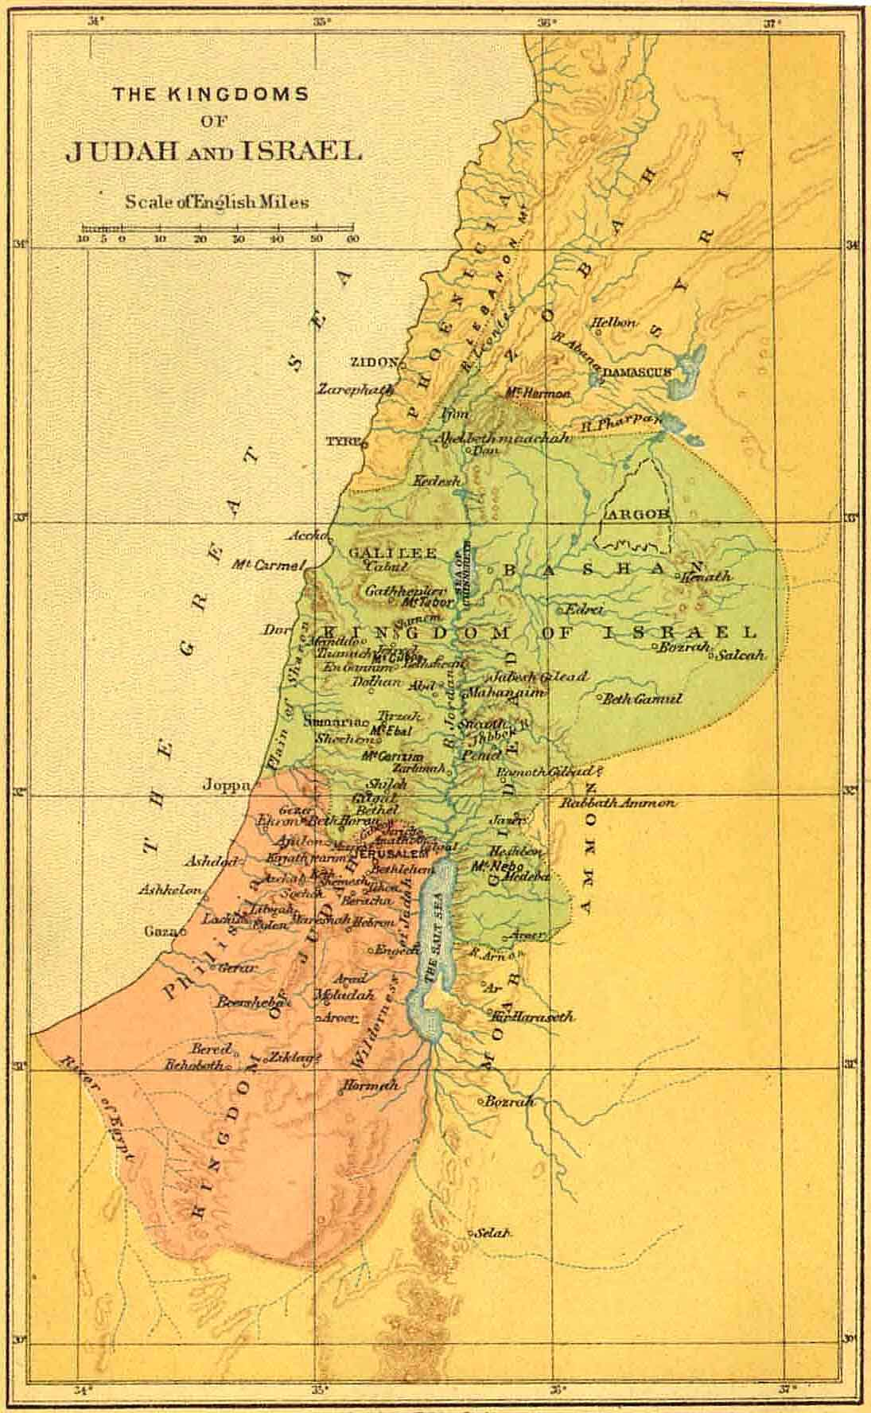

The divided nation continued their civil war for decades, in the midst of which Asa alternatively trusted then failed to trust the Lord.
Source: Public domain here http://www.sacred-texts.com/bib/maps/img/004.jpg

Faith In Action

Pray
Ask the Holy Spirit to reveal to you a place in your life where you are tolerating evil and to reveal to you a place in your life where priorities are out of God's-order.

Act
Today I will humbly submit to the guidance of the Holy Spirit and renew my trust in the Lord first rather than the people and things of the world.
Be Specific _____________________________________________

Friday (1 Kings 15:25 - 16)
Nadab’s Reign over Israel
15:25 In the second year of Asa’s reign over Judah, Jeroboam’s son Nadab became the king of Israel; he ruled Israel for two years. 15:26 He did evil in the sight of the Lord. He followed in his father’s footsteps and encouraged Israel to sin.
15:27 Baasha son of Ahijah, from the tribe of Issachar, conspired against Nadab and assassinated him in Gibbethon, which was in Philistine territory. This happened while Nadab and all the Israelite army were besieging Gibbethon. 15:28 Baasha killed him in the third year of Asa’s reign over Judah and replaced him as king. 15:29 When he became king, he executed Jeroboam’s entire family. He wiped out everyone who breathed, just as the Lord had predicted through his servant Ahijah the Shilonite. 15:30 This happened because of the sins which Jeroboam committed and which he made Israel commit. These sins angered the Lord God of Israel.
15:31 The rest of the events of Nadab’s reign, including all his accomplishments, are recorded in the scroll called the Annals of the Kings of Israel. 15:32 Asa and King Nadab of Israel were continually at war with each other.
Baasha’s Reign over Israel
15:33 In the third year of Asa’s reign over Judah, Baasha son of Ahijah became king over all Israel in Tirzah; he ruled for twenty-four years. 15:34 He did evil in the sight of the Lord; he followed in Jeroboam’s footsteps and encouraged Israel to sin.
16:1 Jehu son of Hanani received from the Lord this message predicting Baasha’s downfall: 16:2 “I raised you up from the dust and made you ruler over my people Israel. Yet you followed in Jeroboam’s footsteps and encouraged my people Israel to sin; their sins have made me angry. 16:3 So I am ready to burn up Baasha and his family, and make your family like the family of Jeroboam son of Nebat. 16:4 Dogs will eat the members of Baasha’s family who die in the city, and the birds of the sky will eat the ones who die in the country.”
16:5 The rest of the events of Baasha’s reign, including his accomplishments and successes, are recorded in the scroll called the Annals of the Kings of Israel. 16:6 Baasha passed away and was buried in Tirzah. His son Elah replaced him as king. 16:7 The prophet Jehu son of Hanani received from the Lord the message predicting the downfall of Baasha and his family because of all the evil Baasha had done in the sight of the Lord. His actions angered the Lord (including the way he had destroyed Jeroboam’s dynasty), so that his family ended up like Jeroboam’s.
Elah’s Reign over Israel
16:8 In the twenty-sixth year of King Asa’s reign over Judah, Baasha’s son Elah became king over Israel; he ruled in Tirzah for two years. 16:9 His servant Zimri, a commander of half of his chariot force, conspired against him. While Elah was drinking heavily at the house of Arza, who supervised the palace in Tirzah, 16:10 Zimri came in and struck him dead. (This happened in the twenty-seventh year of Asa’s reign over Judah.) Zimri replaced Elah as king. 16:11 When he became king and occupied the throne, he killed Baasha’s entire family. He did not spare any male belonging to him; he killed his relatives and his friends. 16:12 Zimri destroyed Baasha’s entire family, just as the Lord had predicted to Baasha through Jehu the prophet. 16:13 This happened because of all the sins which Baasha and his son Elah committed and which they made Israel commit. They angered the Lord God of Israel with their worthless idols.
16:14 The rest of the events of Elah’s reign, including all his accomplishments, are recorded in the scroll called the Annals of the Kings of Israel.
Zimri’s Reign over Israel
16:15 In the twenty-seventh year of Asa’s reign over Judah, Zimri became king over Israel; he ruled for seven days in Tirzah. Zimri’s revolt took place while the army was deployed in Gibbethon, which was in Philistine territory. 16:16 While deployed there, the army received this report: “Zimri has conspired against the king and assassinated him.” So all Israel made Omri, the commander of the army, king over Israel that very day in the camp. 16:17 Omri and all Israel went up from Gibbethon and besieged Tirzah. 16:18 When Zimri saw that the city was captured, he went into the fortified area of the royal palace. He set the palace on fire and died in the flames. 16:19 This happened because of the sins he committed. He did evil in the sight of the Lord and followed in Jeroboam’s footsteps and encouraged Israel to continue sinning.
16:20 The rest of the events of Zimri’s reign, including the details of his revolt, are recorded in the scroll called the Annals of the Kings of Israel.
Omri’s Reign over Israel
16:21 At that time the people of Israel were divided in their loyalties. Half the people supported Tibni son of Ginath and wanted to make him king; the other half supported Omri. 16:22 Omri’s supporters were stronger than those who supported Tibni son of Ginath. Tibni died; Omri became king.
16:23 In the thirty-first year of Asa’s reign over Judah, Omri became king over Israel. He ruled for twelve years, six of them in Tirzah. 16:24 He purchased the hill of Samaria from Shemer for two talents of silver. He launched a construction project there and named the city he built after Shemer, the former owner of the hill of Samaria. 16:25 Omri did more evil in the sight of the Lord than all who were before him. 16:26 He followed in the footsteps of Jeroboam son of Nebat and encouraged Israel to sin; they angered the Lord God of Israel with their worthless idols.
16:27 The rest of the events of Omri’s reign, including his accomplishments and successes, are recorded in the scroll called the Annals of the Kings of Israel. 16:28 Omri passed away and was buried in Samaria. His son Ahab replaced him as king.
Ahab Promotes Idolatry
16:29 In the thirty-eighth year of Asa’s reign over Judah, Omri’s son Ahab became king over Israel. Ahab son of Omri ruled over Israel for twenty-two years in Samaria. 16:30 Ahab son of Omri did more evil in the sight of the Lord than all who were before him. 16:31 As if following in the sinful footsteps of Jeroboam son of Nebat were not bad enough, he married Jezebel the daughter of King Ethbaal of the Sidonians. Then he worshiped and bowed to Baal. 16:32 He set up an altar for Baal in the temple of Baal he had built in Samaria. 16:33 Ahab also made an Asherah pole; he did more to anger the Lord God of Israel than all the kings of Israel who were before him.
16:34 During Ahab’s reign, Hiel the Bethelite rebuilt Jericho. Abiram, his firstborn son, died when he laid the foundation; Segub, his youngest son, died when he erected its gates, just as the Lord had warned through Joshua son of Nun.

Prayer
Lord, the path of rebellion is common to fallen man, and the negative consequences are predictable. May I act upon the wisdom of the Holy Spirit and refrain from offending You.

Scripture In Perspective
Jeroboam's son Nadab emulated his father in sin so the Lord God allowed Baasha to seize control of Israel after only two years. Baasha fulfilled the prophesy that Jeroboam's family would be obliterated.
Baasha was no better than Jeroboam or Nadab but was allowed to rule for twenty-four years. Because of his sin as king his family also was doomed to destruction.
Baasha's son Elah followed him for only two years when Zimri killed him and seized power. The army and tribal leaders immediately rebelled and chose Omri instead and when he attacked the palace Zimri set it ablaze and died in the fire. Omri ruled Israel for twelve years.
Omni was even more evil before the Lord than those who came before, he died after twelve years and his son Ahab followed. Ahab was no better but led Israel for twenty-two years.

Interact With The Text

Consider
Baasha was the tool through which the prophesied destruction of Jeroboam's family was accomplished. Because he obliterated them for selfish reasons (eliminating competition), rather than to purge the evil in Israel, Baasha's family received the same punishment.

Discuss
Knowing the prophesy against Jeroboam for his sin why would Nadab have continued it when he became king, rather than turning toward the Lord God with some hope for mercy?

Reflect
Solomon opened the door to evil and most of those who followed him seemed unable to bring themselves to purge it from the land.

Share
When have you observed a leader of a fellowship who allowed sin to linger unchallenged among their leaders and/or flock? What was the result?
KTALZ
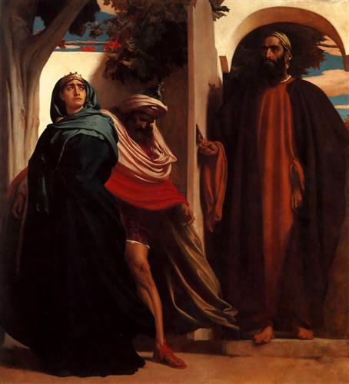

Source: Public domain here http://uploads0.wikiart.org/images/frederic-leighton/jezebel-and-ahab-met-by-elijah.jpg!Blog.jpg

Faith In Action

Pray
Ask the Holy Spirit to reveal to you a place where you have tolerated the influence of evil.

Act
Today I will purge the evil where I have the authority to do so. It may be as a community leader, an educator, a ministry leader, a parent, a peer-leader, or some other role (including choices I make that appear to only impact me). It may be dishonest practices, unhealthy influences, the failure to enforce Biblical directives for accountability and discipline, wrong doctrine, disrespect toward “elders” or peers, self-destructive behaviors, etc.
Be Specific _____________________________________________

Saturday (2 Chronicles 17)
Jehoshaphat Becomes King
17:1 His son Jehoshaphat replaced him as king and solidified his rule over Israel. 17:2 He placed troops in all of Judah’s fortified cities and posted garrisons throughout the land of Judah and in the cities of Ephraim that his father Asa had seized.
17:3 The Lord was with Jehoshaphat because he followed in his ancestor David’s footsteps at the beginning of his reign. He did not seek the Baals, 17:4 but instead sought the God of his ancestors and obeyed his commands, unlike the Israelites. 17:5 The Lord made his kingdom secure; all Judah brought tribute to Jehoshaphat, and he became very wealthy and greatly respected. 17:6 He was committed to following the Lord; he even removed the high places and Asherah poles from Judah.
17:7 In the third year of his reign he sent his officials Ben-Hail, Obadiah, Zechariah, Nethanel, and Micaiah to teach in the cities of Judah. 17:8 They were accompanied by the Levites Shemaiah, Nethaniah, Zebadiah, Asahel, Shemiramoth, Jehonathan, Adonijah, Tobijah, and Tob-Adonijah, and by the priests Elishama and Jehoram. 17:9 They taught throughout Judah, taking with them the scroll of the law of the Lord. They traveled to all the cities of Judah and taught the people.
17:10 The Lord put fear into all the kingdoms surrounding Judah; they did not make war with Jehoshaphat. 17:11 Some of the Philistines brought Jehoshaphat tribute, including a load of silver. The Arabs brought him 7,700 rams and 7,700 goats from their flocks.
17:12 Jehoshaphat’s power kept increasing. He built fortresses and storage cities throughout Judah. 17:13 He had many supplies stored in the cities of Judah and an army of skilled warriors stationed in Jerusalem. 17:14 These were their divisions by families:
There were a thousand officers from Judah. Adnah the commander led 300,000 skilled warriors, 17:15 Jehochanan the commander led 280,000, 17:16 and Amasiah son of Zikri, who volunteered to serve the Lord, led 200,000 skilled warriors.
17:17 From Benjamin, Eliada, a skilled warrior, led 200,000 men who were equipped with bows and shields, 17:18 and Jehozabad led 180,000 trained warriors.
17:19 These were the ones who served the king, besides those whom the king placed in the fortified cities throughout Judah.

Prayer
Lord, we often begin well, and You bless us in our faithfulness. May I endeavor to begin well every day so that You may bless others through me.

Scripture In Perspective
The Lord was initially “with” Jehoshaphat, as king of Judah, because he followed the faithful elements of David's reign as king.
Jehoshaphat removed the high places of worship to false gods that Solomon had built.
He sent priests throughout the kingdom to teach about the worship of the Lord God.
The Lord God caused the nations around Israel to be in fear and even some Philistines paid tribute, including silver, and Arabs brought rams and goats.
[Note: The Hebrew translation suggests that “Arab” refers to the “Bedouins”, a nomadic people, likely partial descendants of Ishmael. 2 Chronicles 21:17 adds the descriptor “Next to the Ethiopians”, which could refer to the modern regions of Sudan (to the West) or Saudi Arabia (to the east).]
He fortified Israel and build food storage facilities.
He built-up the military and equipped them well.
The Lord blessed him with victory in battle, great wealth, and respect.

Interact With The Text

Consider
Jehoshaphat made a wise choice to obey the Lord God, and wiser still to teach the people to do the same.

Discuss
How fearful of the obvious blessing and presence of the Lord must have been the Philistines to bring tribute to their sworn enemies?

Reflect
God's purpose in blessing is always clear, always purposeful, and never random.

Share
When have you observed non-Christian individuals or groups providing resources to a Christian-based organization? (e.g. the Salvation Army.)

KTALZ
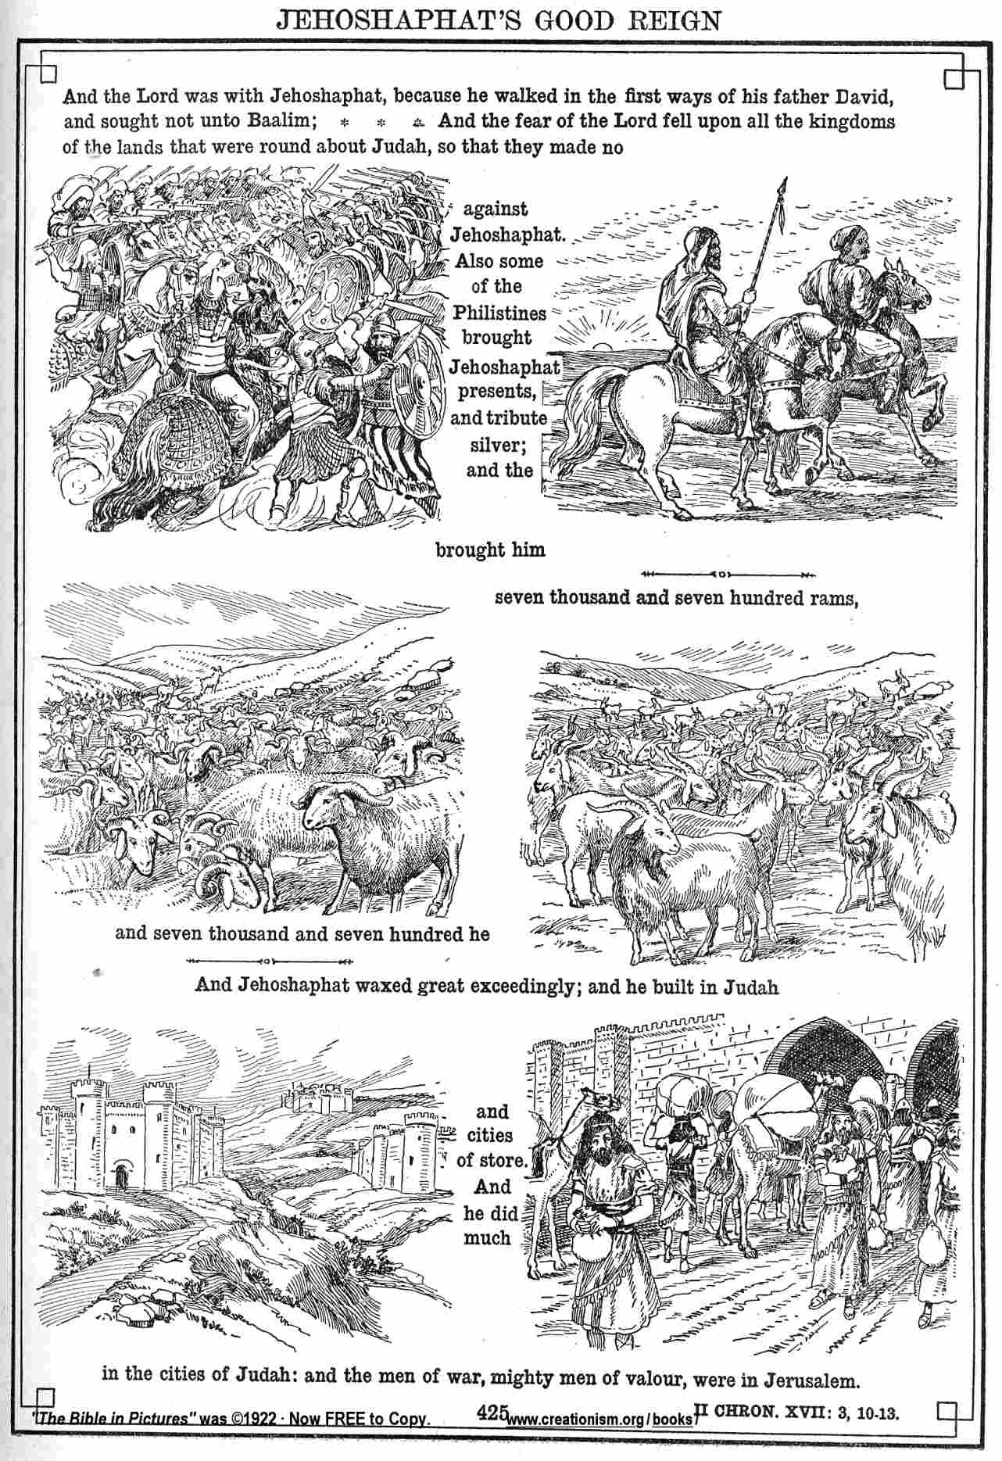

Jehosaphat made all the right moves, faithful to God, in his early days as king.
Source: Public domain here http://www.creationism.org/books/BibleInPictures/Bible142Ch17_03-13.htm

Faith In Action

Pray
Ask the Holy Spirit to show you where you might remove pagan influences and increase Biblical ones.

Act
I will humbly and energetically act, within my authority, to excise influences which offend the Lord and replace them with those which encourage righteousness.
Be Specific _________________________________________________

All Bible text is from the NET unless otherwise indicated - http://bible.org
Note 1: These Studies often rely upon the guidance of the NET Translators from their associated notes. Careful attention has been given to cite that source where it has been quoted directly or closely paraphrased. Feedback is encouraged where credit has not been sufficiently assigned.
Note 2: When NET text is quoted in commentary and discussion all pronouns referring to God are capitalized, though they are lower-case in the original NET text.
Commentary text is from David M. Colburn, D.Min. unless otherwise noted.
Copyright © 2012 by David M. Colburn. This is a BibleSeven Study –“Genesis 3. Prepared by David M. Colburn and edited for bible.org in August of 2012. This text may be used for non-profit educational purposes only, with credit; all other usage requires prior written consent of the author.

